Studio1

Exercise 1: Qitao Xu, Jiangnan Liu, Zhe Wang

Exercise 2: linuxlab006.seas.wustl.edu

Exercise 3: Nothing special required

Exercise 4:

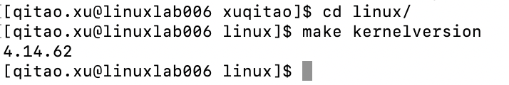

Exercise 5:

Option’s name: CONFIG_LOCALVERSION

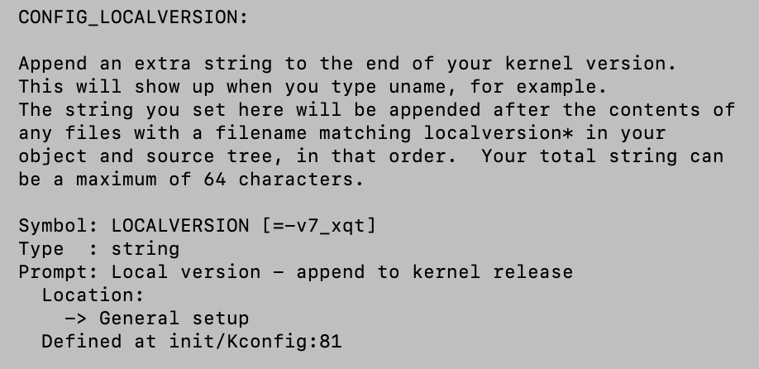

Exercise6:

Begin time: 3:31 pm

End time: 3:38 pm

It took 7 minutes to compile the kernel.