Studio2

Exercise1: Qitao Xu, Jiangnan Liu, Zhe Wang

Exercise2:

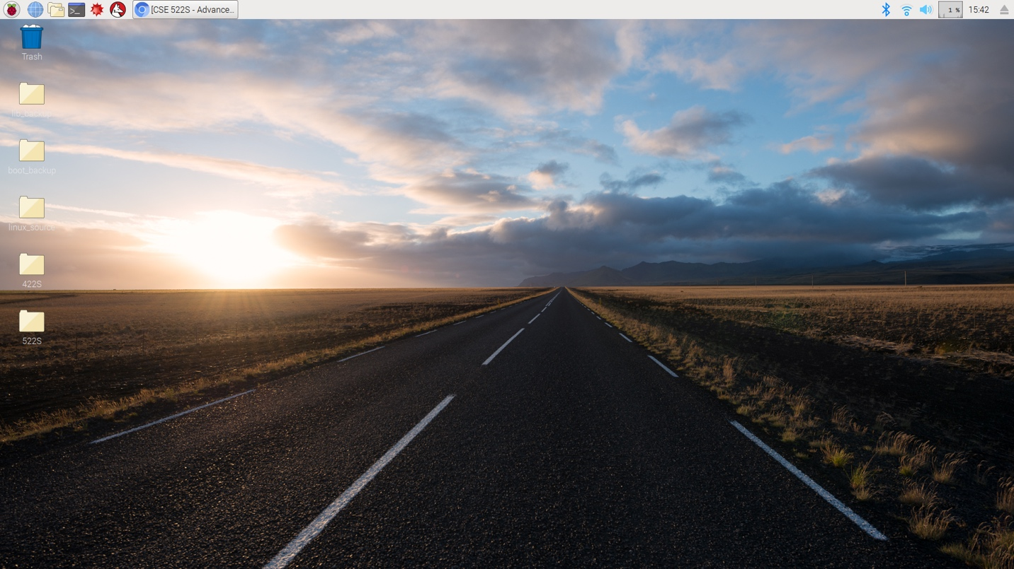

Exercise3:

Set Locale…

Set Timezone…

Set WiFi Country…

Exercise4:

Yes

Exercise5:

IP address

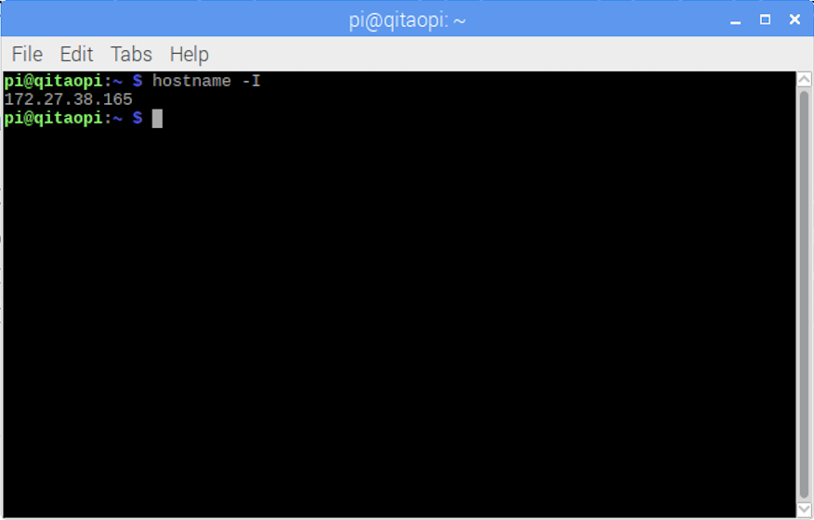

Exercise6:

