Studio3

Exercise1: Qitao Xu, Jiangnan Liu, Zhe Wang

Exercise2:

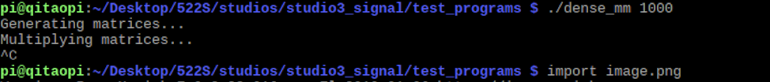

Exercise3:

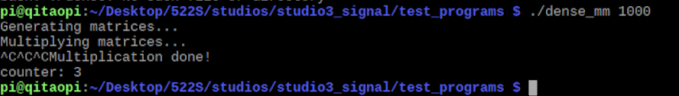

Exercise4:

Exercise5:

For program dense_mm:

