Studio4

Exercise1: Qitao Xu, Jiangnan Liu, Zhe Wang

Exercise2:

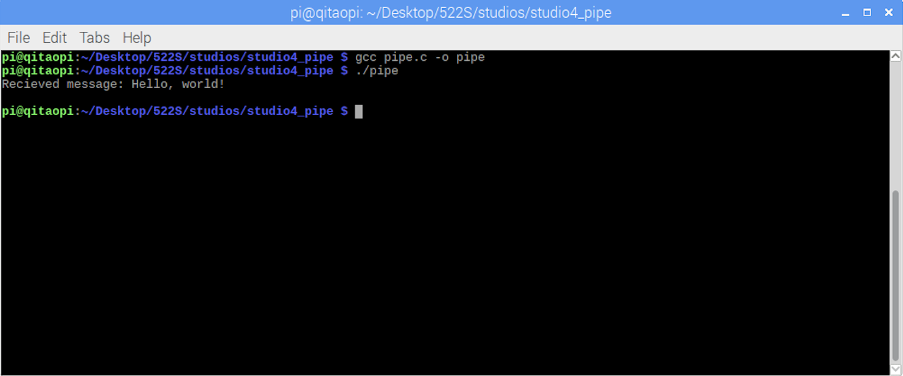

Exercise3:

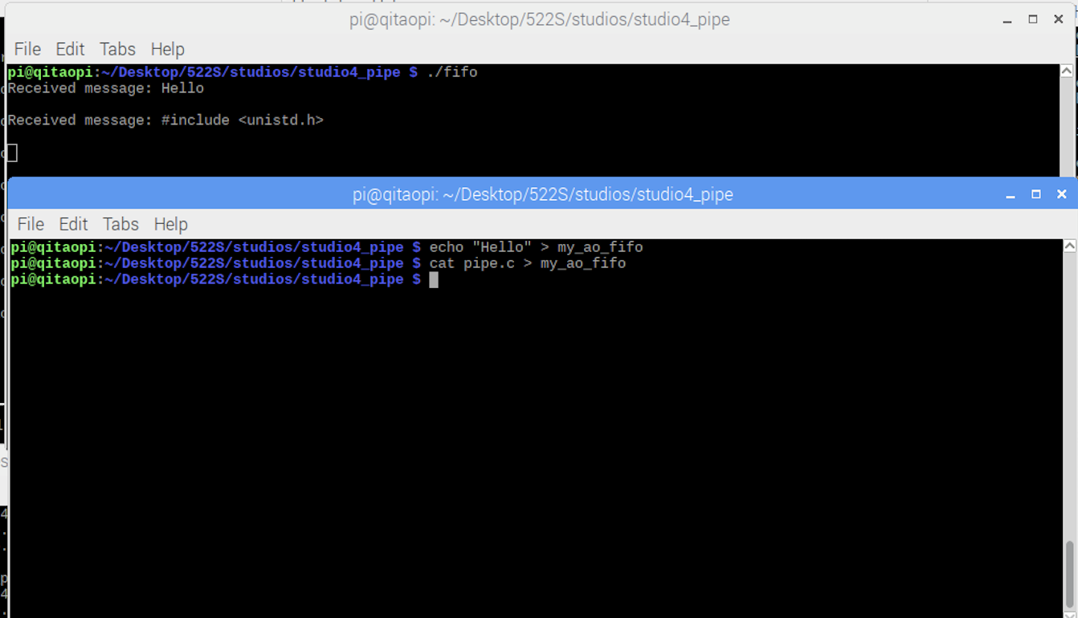

Exercise4:

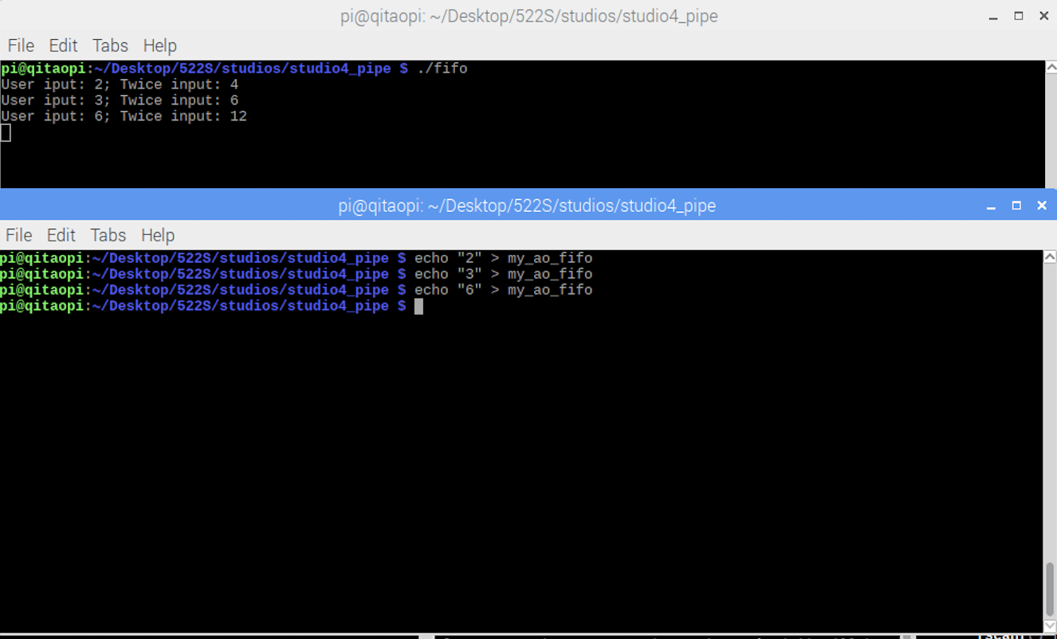

Exercise5:

