Studio5

**Exercise1:** Qitao Xu, Jiangnan Liu, Zhe Wang

**Exercise2**: Code for server

#include <stdio.h> //For printf()

#include <stdlib.h> //for exit() and atoi()

#include <signal.h>

#include <string.h>

#include <errno.h>

#include <unistd.h> // for write()

#include <sys/types.h>

#include <sys/socket.h> // for bind(), socket()

#include <sys/un.h> // for unix()

#define SOCKET_PATH "/home/pi/Socket"

#define LISTEN_BACKLOG 50

#define BUF_SIZE 50

char buf[BUF_SIZE];

int main( int argc, char* argv[] ){

int skt, ret_bind, ret_listen, accept_skt, ret_unlink, ret_read;

struct sockaddr_un skt_addr, peer_addr;

socklen_t peer_addr_size;

skt = socket(AF_UNIX, SOCK_STREAM, 0);

if (skt < 0) {

printf("Error: socket() system call failed! Reason: %s\n", strerror(errno));

exit(-1);

}

memset(&skt_addr, 0, sizeof(struct sockaddr_un));

skt_addr.sun_family = AF_UNIX;

strncpy(skt_addr.sun_path, SOCKET_PATH, strlen(SOCKET_PATH));

ret_bind = bind(skt, (struct sockaddr *)&skt_addr, sizeof(struct sockaddr_un));

if (ret_bind < 0) {

printf("Error: bind() system call failed! Reason: %s\n", strerror(errno));

exit(-1);

}

ret_listen = listen(skt, LISTEN_BACKLOG);

if (ret_listen < 0) {

printf("Error: listen() system call failed! Reason: %s\n", strerror(errno));

exit(-1);

}

peer_addr_size = sizeof(struct sockaddr_un);

accept_skt = accept(skt, (struct sockaddr *)&peer_addr, &peer_addr_size);

if (accept_skt < 0) {

printf("Error: accept() system call failed! Reason: %s\n", strerror(errno));

exit(-1);

}

memset(buf, 0, BUF_SIZE);

while(1) {

     ret_read = read(accept_skt, buf, BUF_SIZE);

if (ret_read > 0) {

printf("%s", buf);

memset(buf, 0, BUF_SIZE);

}

}

ret_unlink = unlink(skt_addr.sun_path);

if (ret_unlink < 0) {

printf("Error: unlink() system call failed! Reason: %s\n", strerror(errno));

exit(-1);

}

return 0;

}

**Exercise3**:

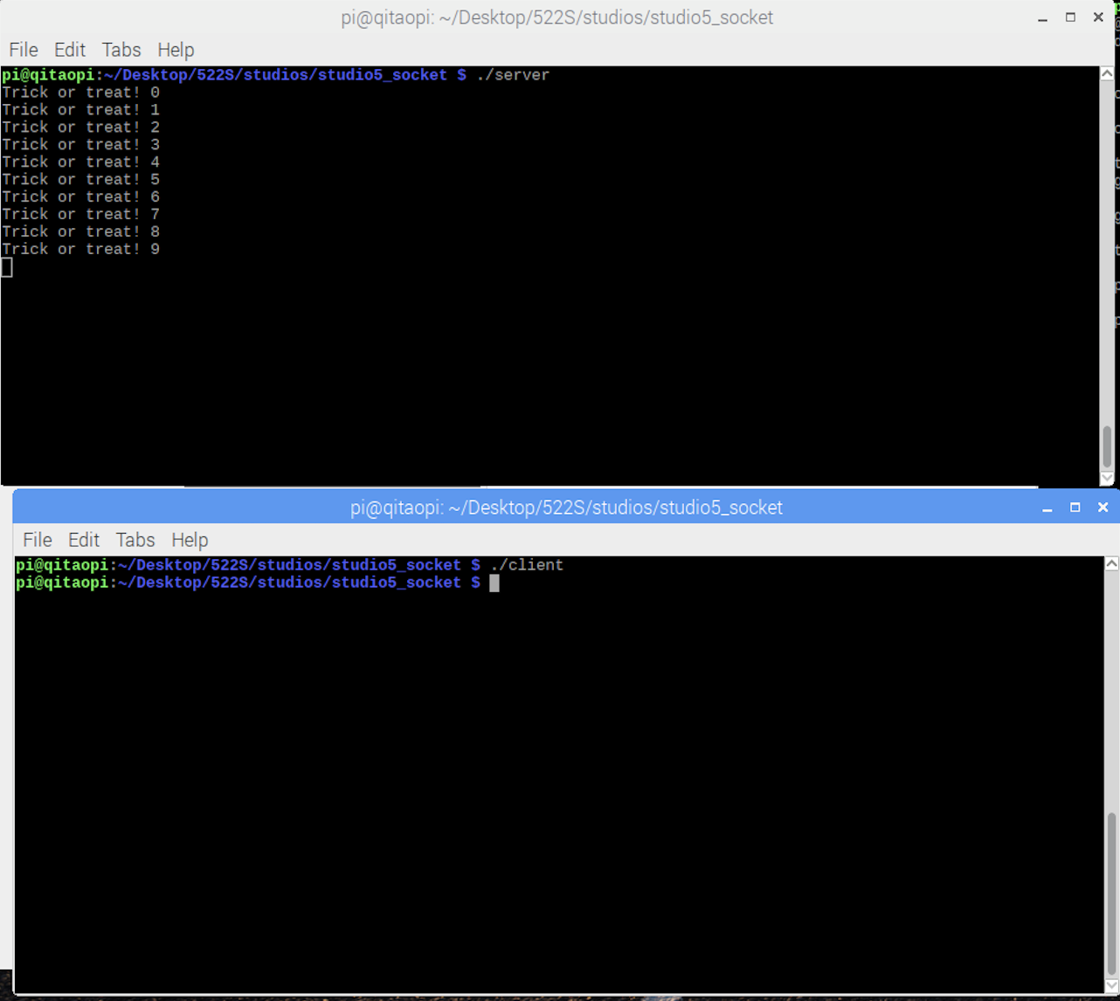

**Exercise4**:

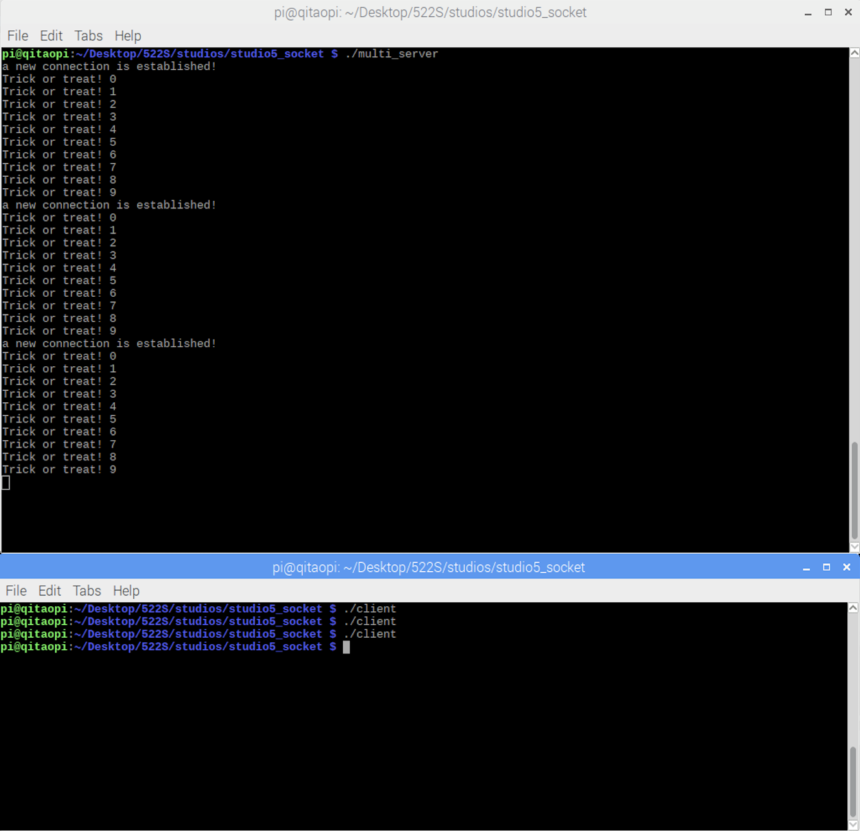

**Exercise5**:

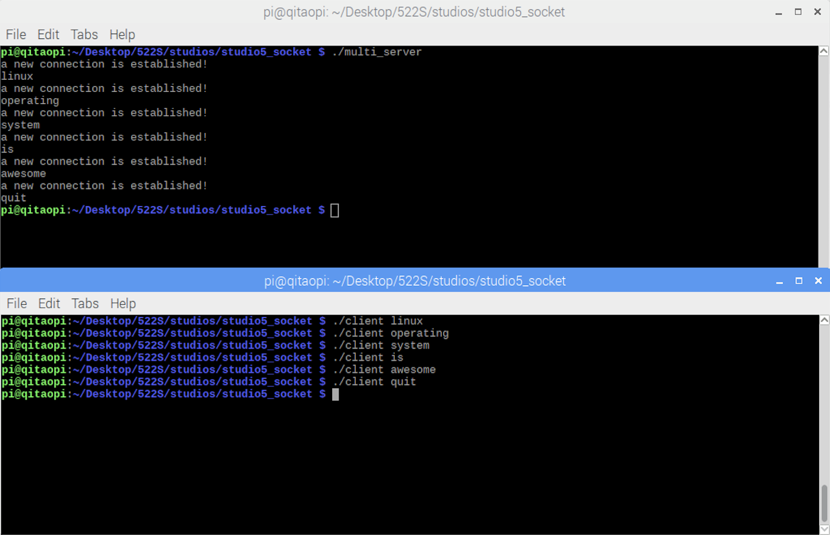

**Exercise6**:

