Studio2

Exercise1: Qitao Xu, Jiangnan Liu, Zhe Wang

Exercise2:

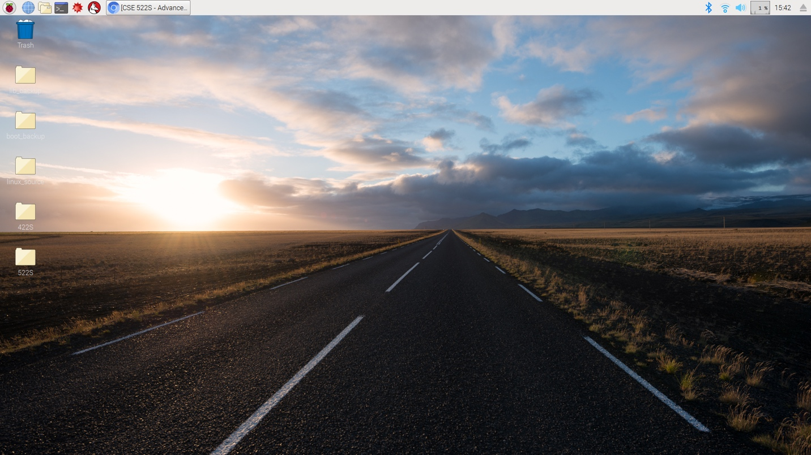

Exercise3:

Set Locale - Country: GB (United Kingdom).

Set Timezone - Area: Etc; Location: UTC.

Set Keyboard - Country: United Kingdom; Variant: English (UK).

Set WiFi Country - Country: AD Andorra.

Exercise4:

Yes. Yes. Yes. Yes. Yes.

Exercise5:

IP address

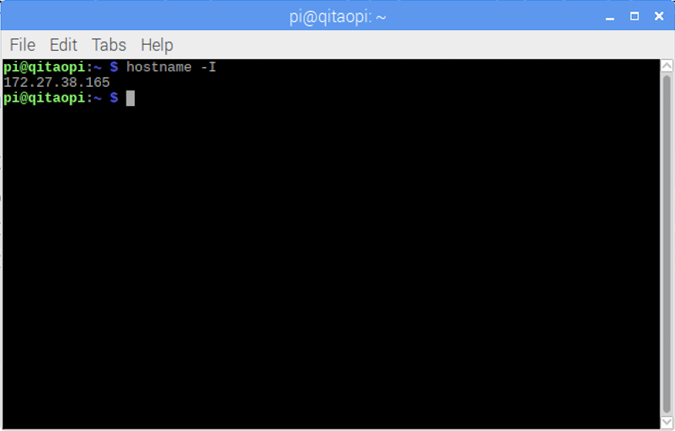

Exercise6:

