Studio4

Exercise1: Qitao Xu, Jiangnan Liu, Zhe Wang

Exercise2:



Exercise3:

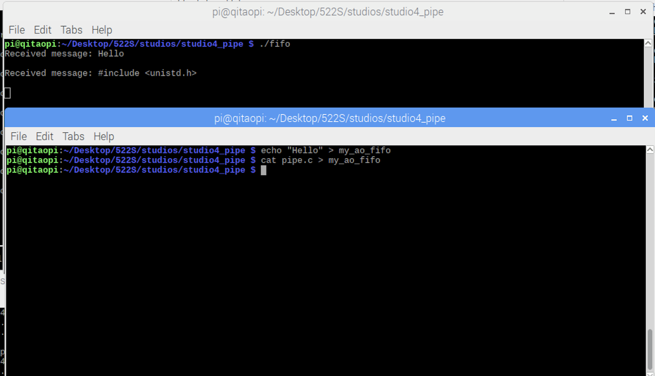

Exercise4:

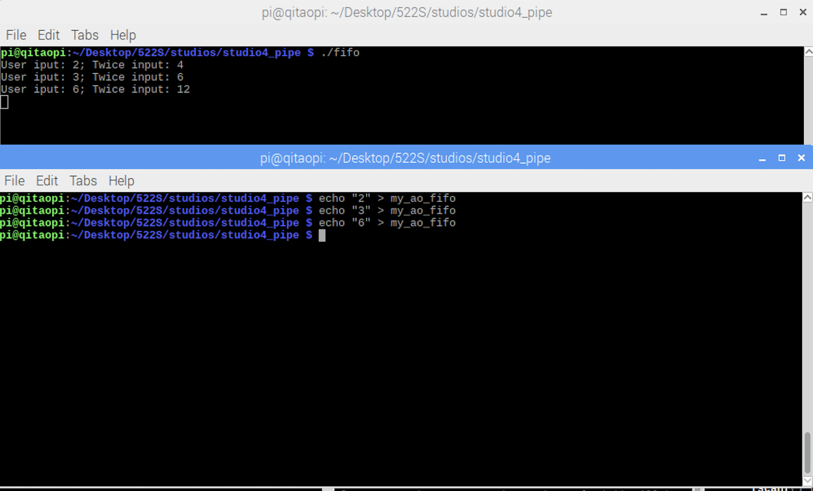

Exercise5:

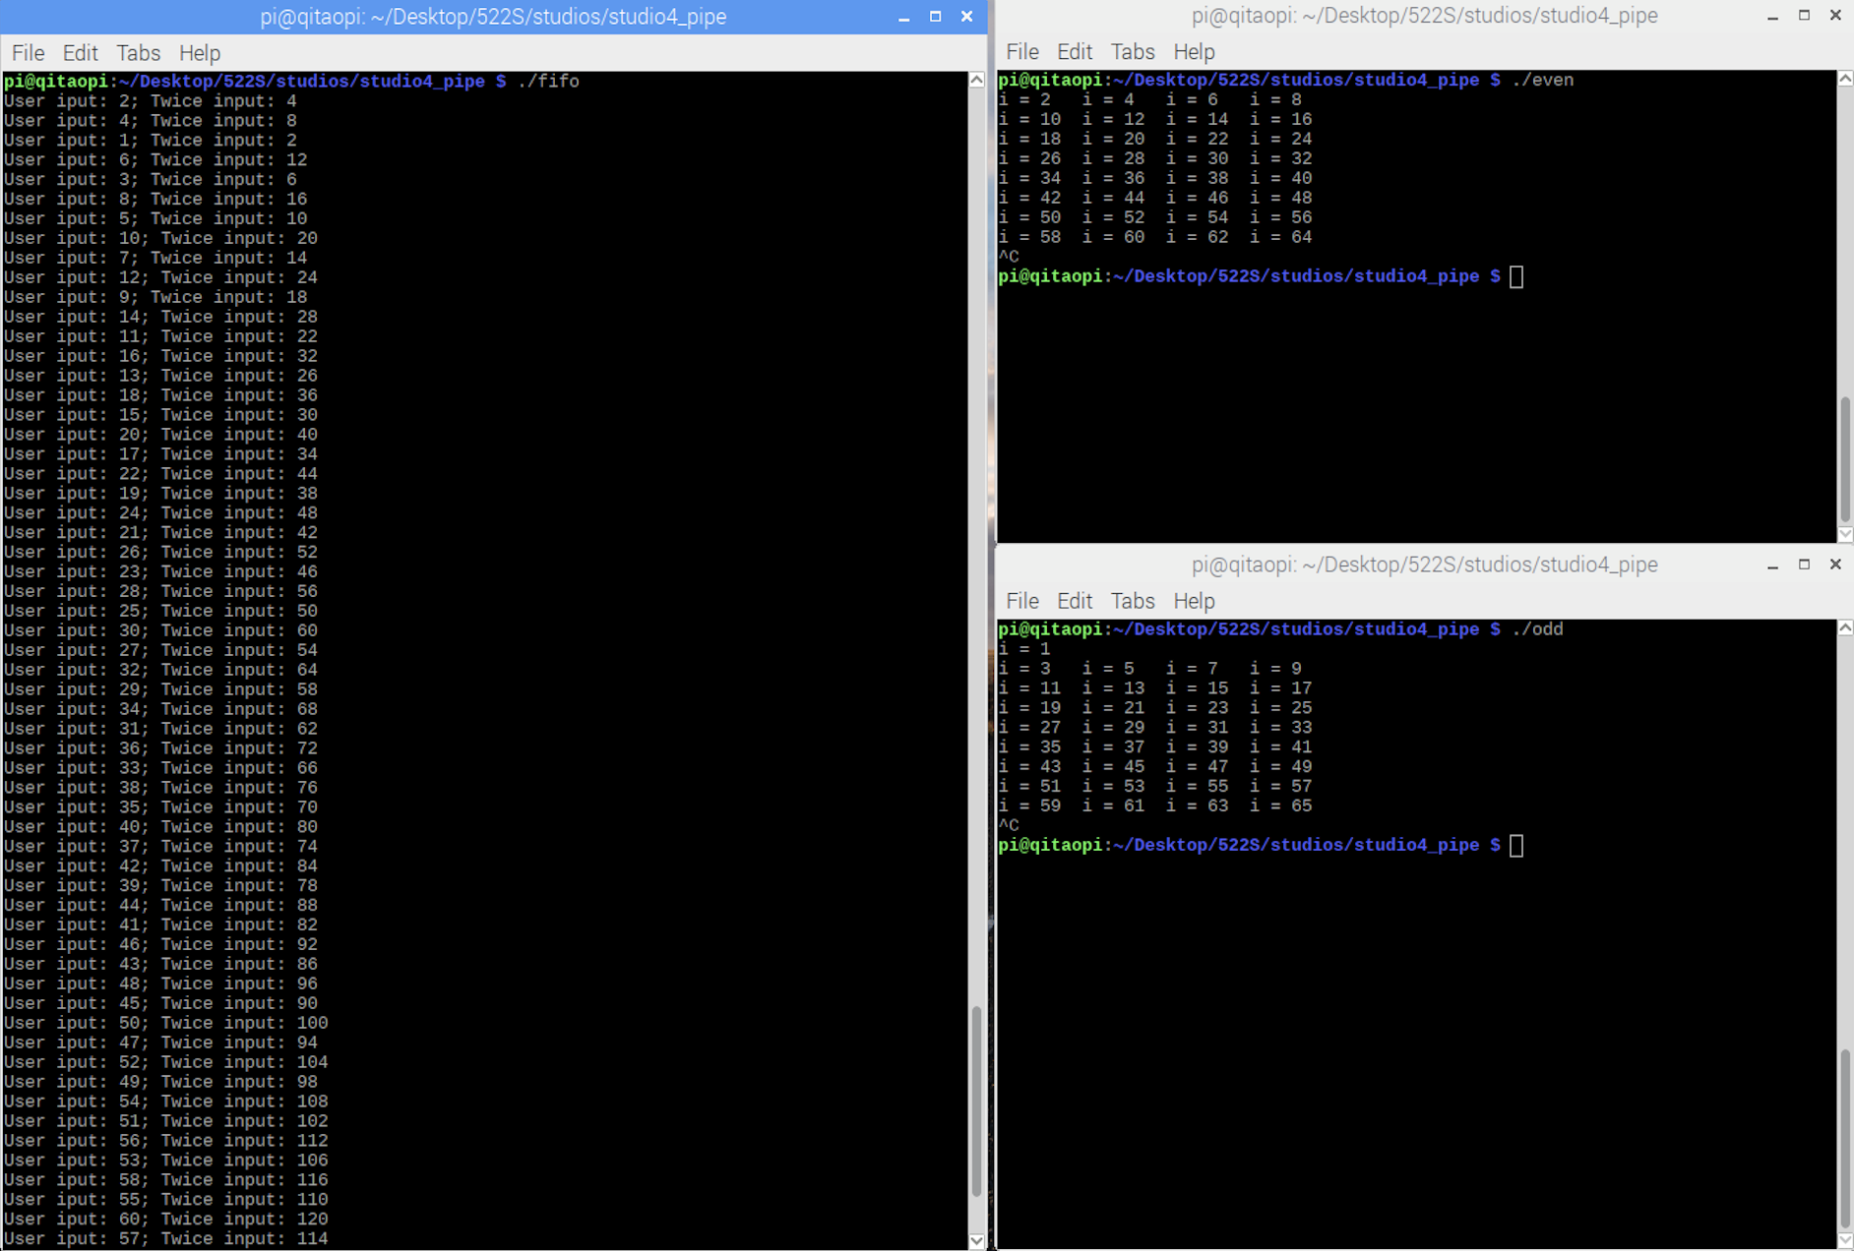

Since we can see when two processes concurrently write numbers to the same FIFO, all those numbers are queued according to their order. Numbers form different processes are interleaved. But, numbers from the same processes, are still in order.