(Black background)(start frame.png在四个角，字出现在中央)

Once upon a time,

there was a knight named Knight trapped in a cottage with a cat named Cat.

(这里想做那种滚动字幕的效果，上一句显示之后，玩家click，上一句向上滑动并变透明，下一句从下滑到中间fade in)

She was cute and smart, covered with beautiful, short dark blue fur.

But she was capricious and needy right now and would only let Knight go if he fed her.

(转场，这里会有三个房间，起始在有猫的房间。画面中上放whitebg.png，两侧放arrow.png，点击即可切换房间)

(猫房间装潢：shelf, bowl, cat, cat’s tail, shelf_s 有三个，分别放在shelf的三个抽屉处。Hungrymeow放cat的左上角。)

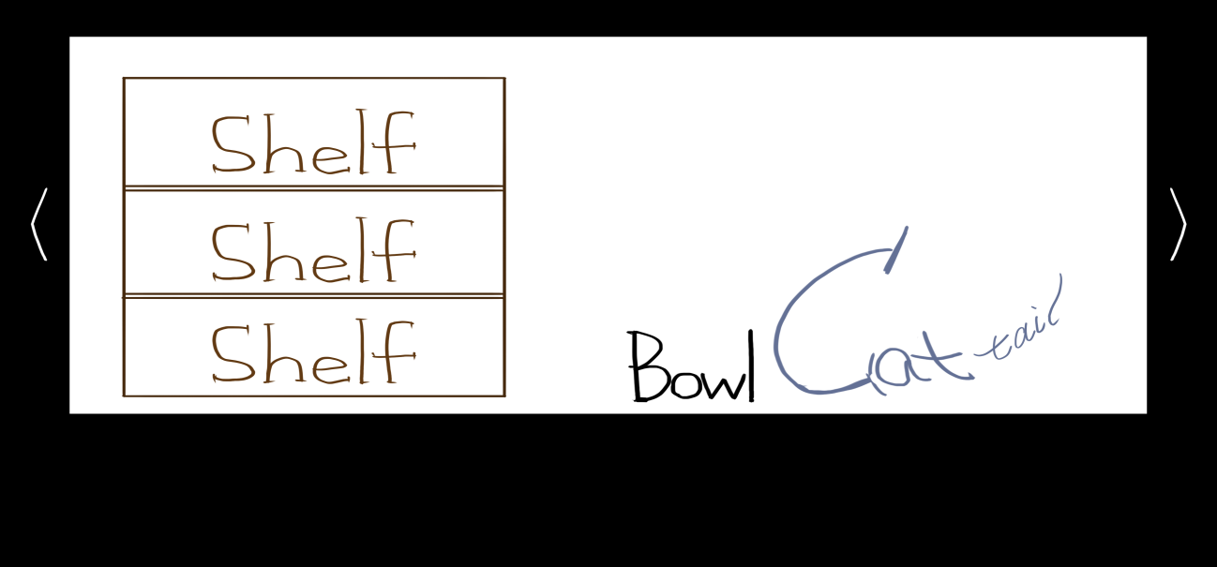

(厨房装潢：friger, friger_s x 2与shelf同理, table, milk放在table上面。)

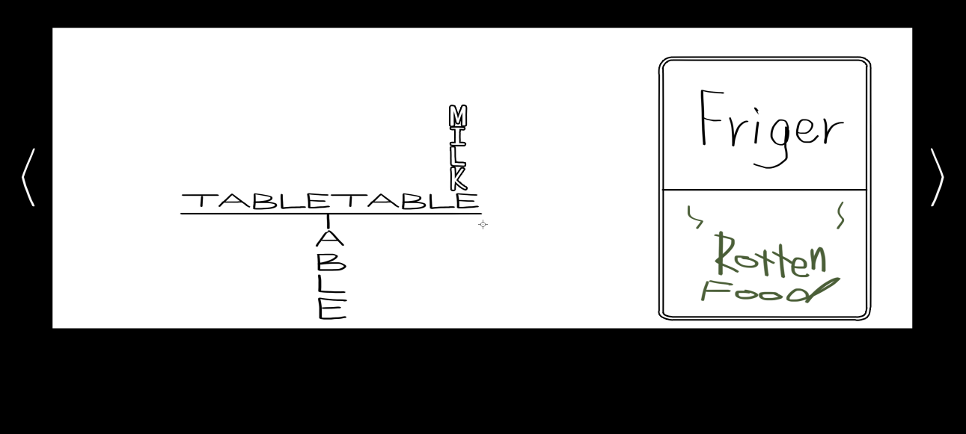

(玄关装潢：catpicframe, catpic在frame中间, lockeddoor, rosetable。)

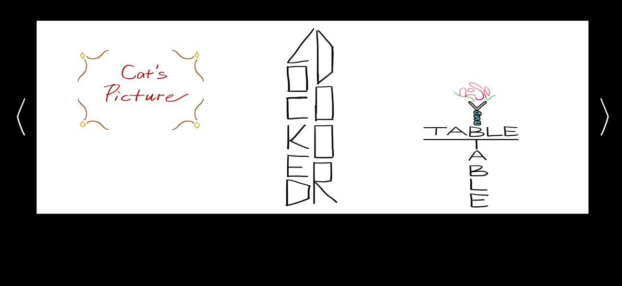

(基本所有物品点击即可对话，望分配好触发框。字幕出现在正下方，选项在字幕下方一字排开。Bowl被拾取之后应该会在右下角？)

(接下来会分别解释每件物品被点击的对话。)

(开场，在猫房间)

In a word, Knight needs to look for a way to feed Cat. His journey has just begun. He can't be trapped here forever...

(之后再回到猫房间)

Cat is here.

(点击bowl)

This is an empty bowl...

(选项)

Pick it up.

(pick)(bowl消失，出现在右下角)

Time to find some food.

(点击cat)

Meow…

(点击tail)

Aww. You don’t want to try that.

(点击最上方的shelf)

Oops! You cannot reach that high.

(点击中间的shelf)(shelf_s 变成 seconddrawer)(注，点击其他的东西调查后，该图片会变回shelf_s。之后将统一标注为temporary。若有永久性改变会标注为permanent。)

There lies the owner's diary and a bunch of other stuffs.

(选项)

Read the diary.

Leave it there.

(read)

……

It’s full of compliments about Cat.

You close it.

(leave, 图片变回原样)

You close the drawer.

(点击下面的 shelf)(shelf_s 变成 doratos) (temporary)

Look what you found! Doratos!

You would really love to have some. But Cat is still hungry...

(选项)

Eat some.

Give some to Cat.

(eat)

...

...

...tasted good, just as you expected.

(give)

(如果没有拿bowl)

Ah-oh. You need to have something to hold the food.

(如果有bowl)

(此处触发第一条开门的方法。这之后其余方法将不会被触发了。Doratos_inbowl出现在bowl的里面。Hungrymeow变成thankful meow。Lockeddoor变成opened door。)

Mmm...

...

You hear something from the hallway.

(此时与bowl对话)

Doratos.

(此时与cat对话)

Cat is staring at the bowl.

(此时与抽屉里的doratos对话，只会有eat的选项)

(厨房。刚进入：)

This seems to be the kitchen.

(点击上面的friger)

You would really like to know what is there.

And you are really not tall enough.

(点击下面的friger)(friger_s变成 rottenfood)

Ew! Look at what you found.

That's a smell you will never forget in your life.

(之后再次点击rottenfood)

If you could, you would not like to smell this again.

(选项)  
Eat some.

Give some to Cat.

(eat)

...

You do not feel very good.

Your eyesight starts to blur...

(之后跳转到end scene)

(give)

(如果没有拿bowl)

Ah-oh. You need to have something to hold the food.

(如果有bowl)

(传送回catroom，此处触发第二条开门的方法。这之后其余方法将不会被触发了。rottenfood_inbowl出现在bowl的里面。Hungrymeow消失。Cat变成shockedcat。Tail变成shockedtail。Lockeddoor变成opened door。)

Mmm...

...

You hear something from the hallway.

(此时与bowl对话)

You do not want to approach it.

(此时与cat对话)

Scared? Angry?

You cannot read Cat's face.

(点击milk)

That's milk!

Unfortunately, you can't reach it...

(点击table)

The table doesn't seem very heavy...

(选项)

Shove.

(累计shove 5 次之后)

The milk box is falling...

It seems like you only have 10 seconds left...

(此对话在倒计时结束前不会因为切场景而消失。10会倒计时到0，如果没有拿bowl，milk变成milk_onfloor在floor上，Permanent。)

Uh-oh.

(此时点击上方friger)

Spilled milk does not make you any taller.

(之后每次回到kitchen之后显示的话变为)

Uh-oh.

(如果事前拿了bowl, 此时会显示选项：)

“I got the bowl!”

(点击选项，bowl会出现在桌下，milk ->milk_inbowl。)

Safe.

(切换到猫房间之后：)

(此处触发第三条开门的方法。这之后其余方法将不会被触发了。milk_inbowl出现在bowl的里面。Hungrymeow变成cheerful meow。Lockeddoor变成opened door。)

Mmm...

...

You hear something from the hallway.

(此时与bowl对话)

Yummy milk.

(此时与cat对话)

Cat looks happy.

You are relieved.

(玄关)

There the door is.

(点击door)

Double checked: it’s locked.

(点击pic)

(此处只要点击一次，就会显示cat的心情图。默认是catpic_normal。 喂过牛奶后变成catpic_cheer。喂过rottenfood变成catpic_angry。)(permanent)

That’s Cat.

(点击rosetable)

Magic roses still need water.

(通关任意路线点击opened door, knight出现在door旁边)

Knight gets out of the cottage.