#这一部分是横版rpg。主角控制Knight，行走图就是前一part的knight。我还没做lvl design，所以你就先随便摆摆。我把几个重点的地形和npc说一下。

#首先出来之后，最左面是house.png和hugedoor.png，脚下有grass和ground，还有flower。（其实可以随便排排，我暑假之后回去再改）然后排版方面我没有给黑框，不过大体和catroom类似，只不过两侧的箭头处的黑底也变成白色。基本上用两个黑色长方形盖住上下就可以了，下面留的位置多一点，来放字幕。

Suddenly, everything becomes brighter and more meaningful. Not a closed, giant room, this is a real, vivid town.

Knight knows what he needs to do.

#之后便可以自由行动。理想状态是左下角有一个摇杆控制左右，右下角有一个键是跳跃/交互。遇到可以交互的地方字幕会提示。

#ground和grass都是可以踩在上面行走的。 浮空的是brick。我拆开来存是因为还有一个问号块，可以和brick组合使用，例如BR?ICK。砖块每个字母和问号都可以顶（参考马里奥），普通字母有可能顶出东西，问号必顶出东西。可以顶出的东西包括：coin，treasure chest，mushroom. Coin就是加钱，这里的金币显示在右上角吧，在顶出第一个钱之后再显示。Treasure chest可以开出coin，sword，empty。开出sword后自动装备，行走图加上sword.png。下面放一些treasure的对话：

A treasure chest! Open it? (可交互状态时)

How lucky! It is filled with coins. Coin + 500.

What is this…! You just found a magic sword!

You found nothing but rusty metals. You closed it.

#mushroom则可以让knight暂时变大。因此可以跳到更高的地方去。这个要是不好做咱们也可以讨论一下别的功效……也许使他无敌？

#在去城堡的路上会遇见一个oldlady。与之对话：

Old Lady:

Oh--brave young Knight!

The King must have been waiting long for thy coming... (sob)

#然后一直往右走，走到城堡，进入，到新地图。城堡的外观长这样：

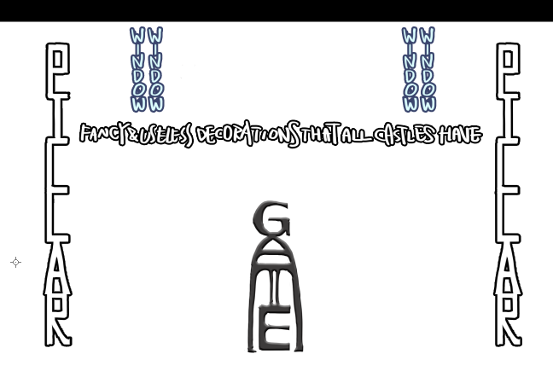

#里面长这样：

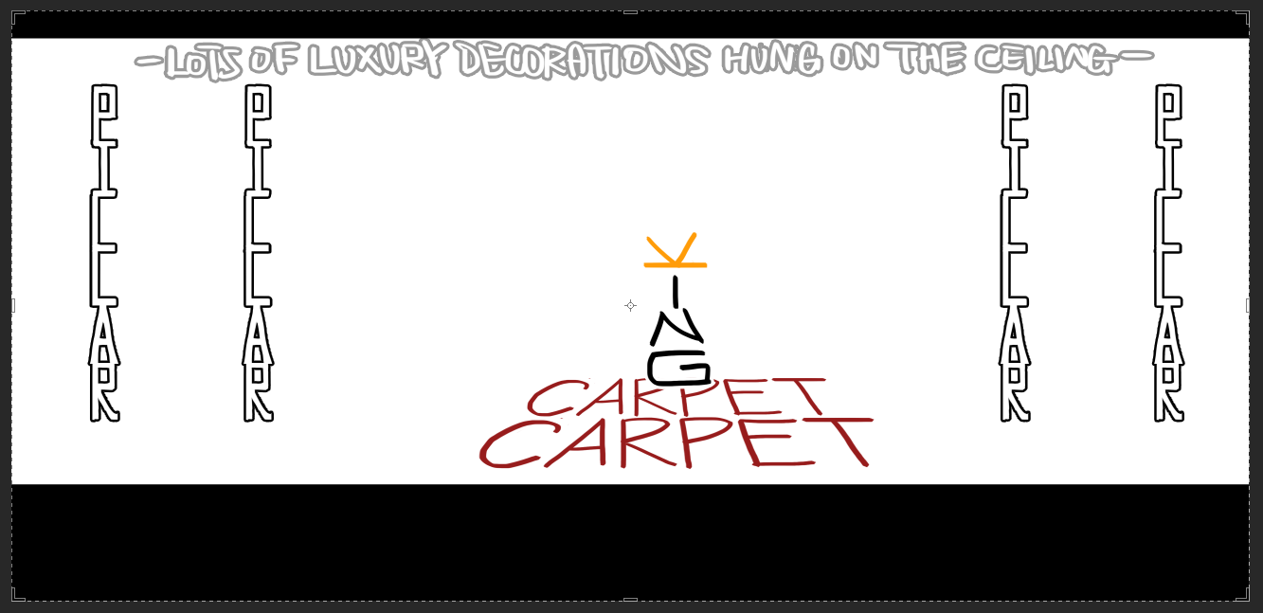

#然后和king对话：

King:

I shall await thy return with Princess, my brave Knight.

#选项：Ask where Princess went. Leave.

(Ask)

King:

The princess Princess was taken away by the accursed Dragon out of the town. Long has he become the threat of our land.

King:

So I say unto thee - vanquish the evil monster hiding under the darkness, and bring Princess back to me.

May the victory be with you, Knight!

#此时注意，城堡里会放一个treasure chest。Chest里会固定开出一把magic sword。

#然后就可以离开城堡了。会传送回原地图，然后继续往右走会问：

Do you want to leave the town?

#选择是就可以离开。下一地图的grass和tree的比例会增多，但还是有宝藏之类的。同时增加了spike，踩上去会掉血。过图的时候主角有三颗血会在左上角显示出来。中途可以遇见一个child。

#当主角未打开过宝箱时：

Child:

Shh – you’ll scare away the spirit of treasure!

Child:

You don’t know. According to my calculation, here has been hidden a loooot of buried treasures.

And I’ll definitely be the first one to discover them!

#当主角打开过：（自动判定最后一次抽到的东西）

Child:

Wh-what? You found treasure chests? What did you get?

#如果是coin

Child:

...Huh? Coins? What do we need coins for?

#如果是宝剑

Child:

Magic sword?!!!

You – you must be the chosen one…

#如果什么都没有

Child:

Nothing? Such bad luck! Please stay away from me.

#一直走到最右面就遇到dragon了。

…

…!

The dragon appears!

#dragon的部位我是分开存的，为了以后做动画，现在就暂且瞎拼拼吧。回合制。龙喷的火焰会随着次数增长而逐渐变多。在喷到3次之后就会一直喷3次。点击火焰可以灭掉，否则每个火焰会造成一点伤害。龙喷三次的时候脖子（d和r之间）会出现weakness，在场上火焰数少于等于1时，点击可以击杀龙。（这里也有动画，还是等我回去做吧）击杀之后，龙消失，公主出现。

#以下是文字：

#自己回合准备战斗:

Knight needs to find the weakness of Dragon...

#此时还可以选择逃跑。

#自己回合击中：  
Knight attacks! Dragon takes 1 point of damage.

#自己回合没有剑时击中：

Knight can’t attack without weapons!  
#龙回合攻击：

Dragon attacks! Knight has xx seconds to avoid…

#成功回避：

Knight successfully avoids Dragon's fire attack!

#失败回避

Knight takes xx point of damage. (每个火=1 damage)

#在场上还有超过1个火焰时点击weakness：

Knight can't see it clearly with so much fire!

Dragon attacks! Knight has xx seconds to avoid…

#在场上小于1个火焰时点击weakness，直接播放击杀动画。Princess出现。

A girl appears in front of Knight.

#逃跑成功后：

Knight successfully escapes!

#逃跑成功回到 town:

What an adventure! Maybe you need to improve your ability first.