PROCON
PROCESS CONTROL LABORATORY
LEVEL/FLOW PROCESS RIG

PROCON Lab 3 - Ziegler-Nichols (ZN) Tuning (BPR)

Pre-Lab
Read Chapter 6: Tuning PID Controllers from the PROCON Student Manual.

Lab Assignments
Turn on the Process Interface (38-200) and the Process Controller (38-300). Open the Espial Course Presenter and go to Lab 3. Perform the ZN-Tuning and Autotune lab practicals.

Questions for Practical 1 (Continuous Cycling Tuning)

- Given the Continuous Cycling tuning method, determine the parameters PB_{cr} and T_{cr}.

Pb_cr = 3
T_cr = 16s

- Using the table of recommended settings met in the background and reproduced below, calculate all parameters for P, PI and PID control of your process plant.

Control Algorithm PB (%) T_{r} T_{d}  P $$2 {PB}_{cr}$$ - -  PI $$2.2 {PB}_{cr}$$ $$\frac{T_{cr}}{1.2}$$ -  PID $$1.7 {PB}_{cr}$$ $$\frac{T_{cr}}{2}$$ $$\frac{T_{cr}}{8}$$ | Control Algorithm PB (%) T_{r} T_{d}  P 6 - -  PI 6.6 13.33 -  PID 5.1 8 2

Questions for Practical 2 (Reaction Curve Tuning)

- Sketch the reaction curve and clearly show on your sketch the parameter values for N, u, and L.

N = 0.31
Du = 17
L = 4

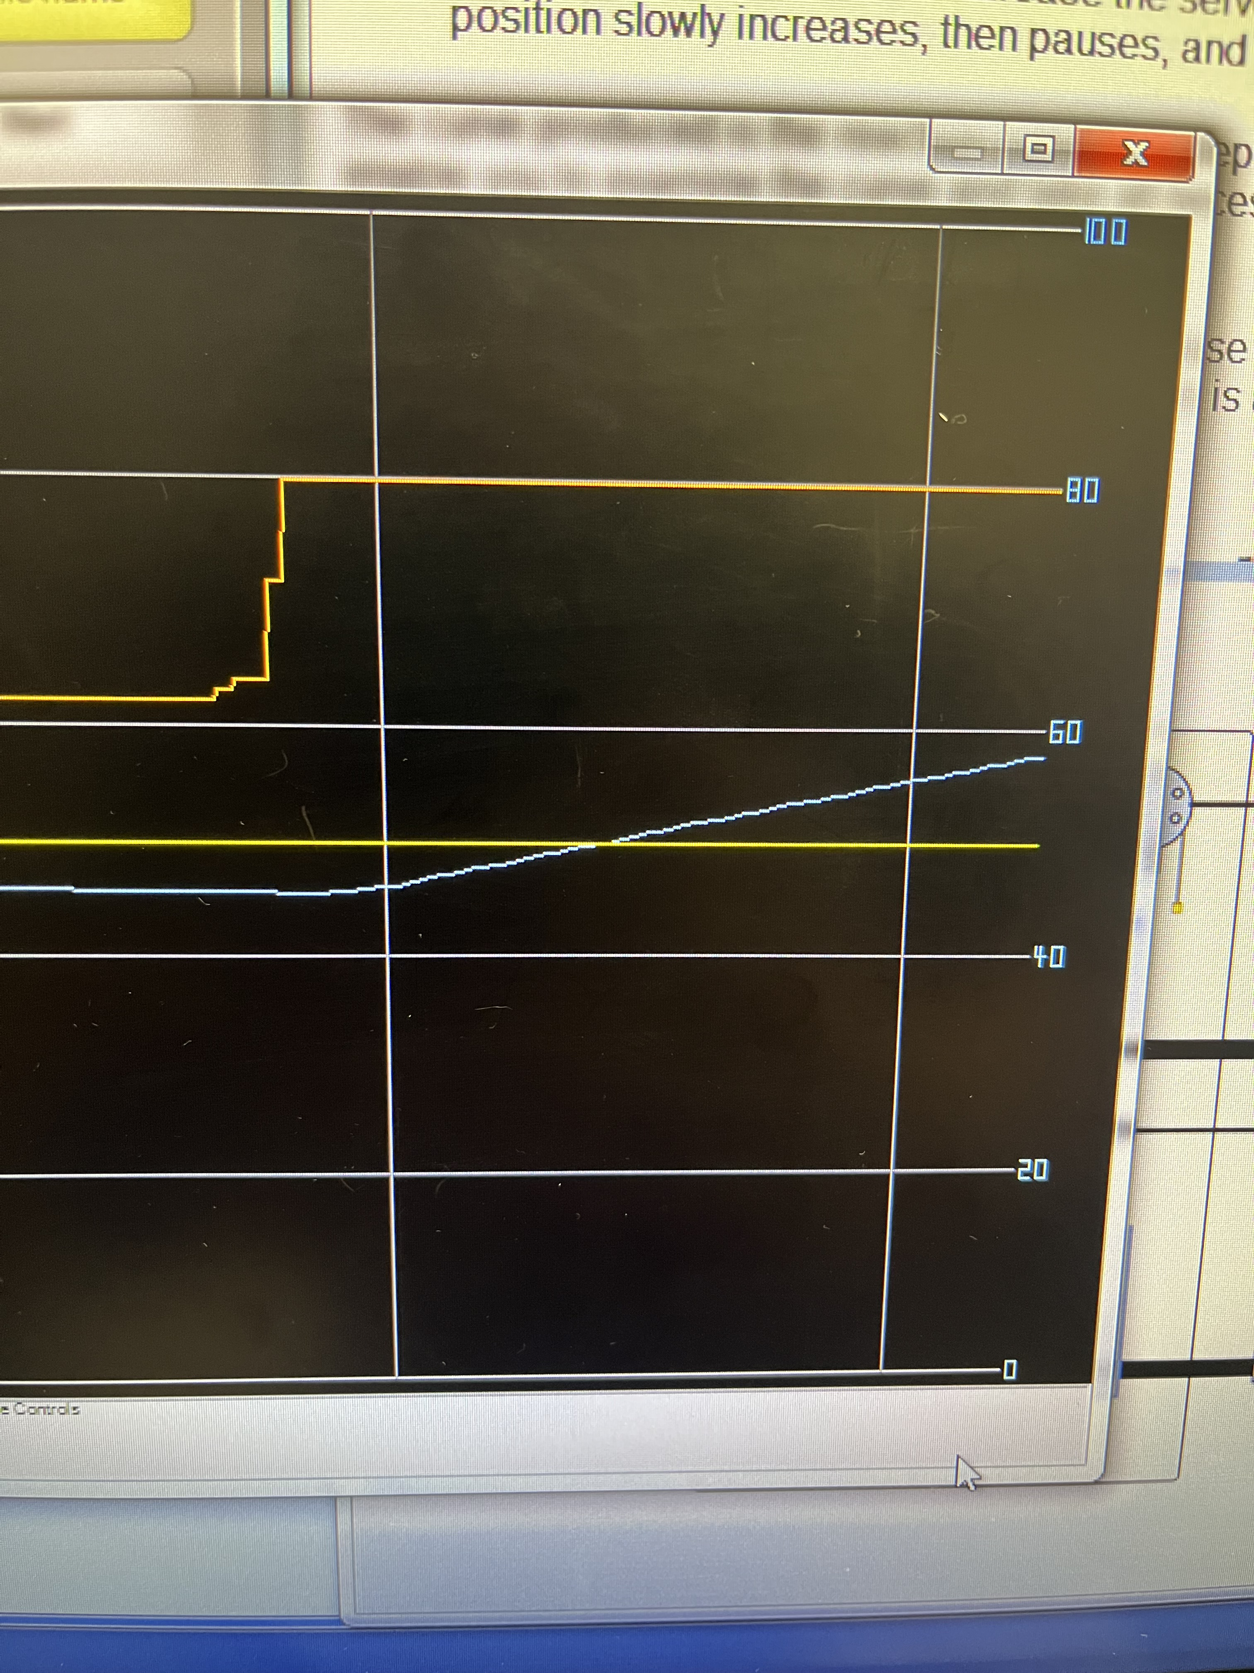
Figure 1 Curve fitting

- Using the table of recommended settings met in the background to this practical and reproduced below, calculate all parameters for P, PI and PID control of your process plant.

Reaction Curve Tuning Method
Control Algorithm | K_{p} | PB (%) | T_{r} | T_{d}
P | $$\frac{∆u}{NL}$$ | $$100\frac{NL}{∆u}$$ | - | -
PI | $$0.9\frac{∆u}{NL}$$ | $$100\frac{NL}{0.9∆u}$$ | $$\frac{L}{0.3}$$ | -
PID | $$1.2\frac{∆u}{NL}$$ | $$100\frac{NL}{1.2∆u}$$ | $$\frac{L}{0.5}$$ | $$\frac{L}{2}$$
Calculated Results
Control Algorithm | K_{p} | PB (%) | T_{r} | T_{d}
P | 13.71 | 7.29 | - | -
PI | 12.33 | 8.1 | 1.33 | -
PID | 15.25 | 6.066 | 8 | 2

Questions for Practical 3 (ZN-Tuning Parameter Response)

- Implement the PID control parameters from both the Continuous Cycling and the Reaction Curve tuning methods. Compare and contrast the different methods of control parameter tuning and their respective responses to change in level set points.

Reactive tuning has a higher servo oscillation amplitude vs Continuous Tuning the other results were very similar. Reactive tuning had a very slightly higher steady state oscillation error but its very slight.

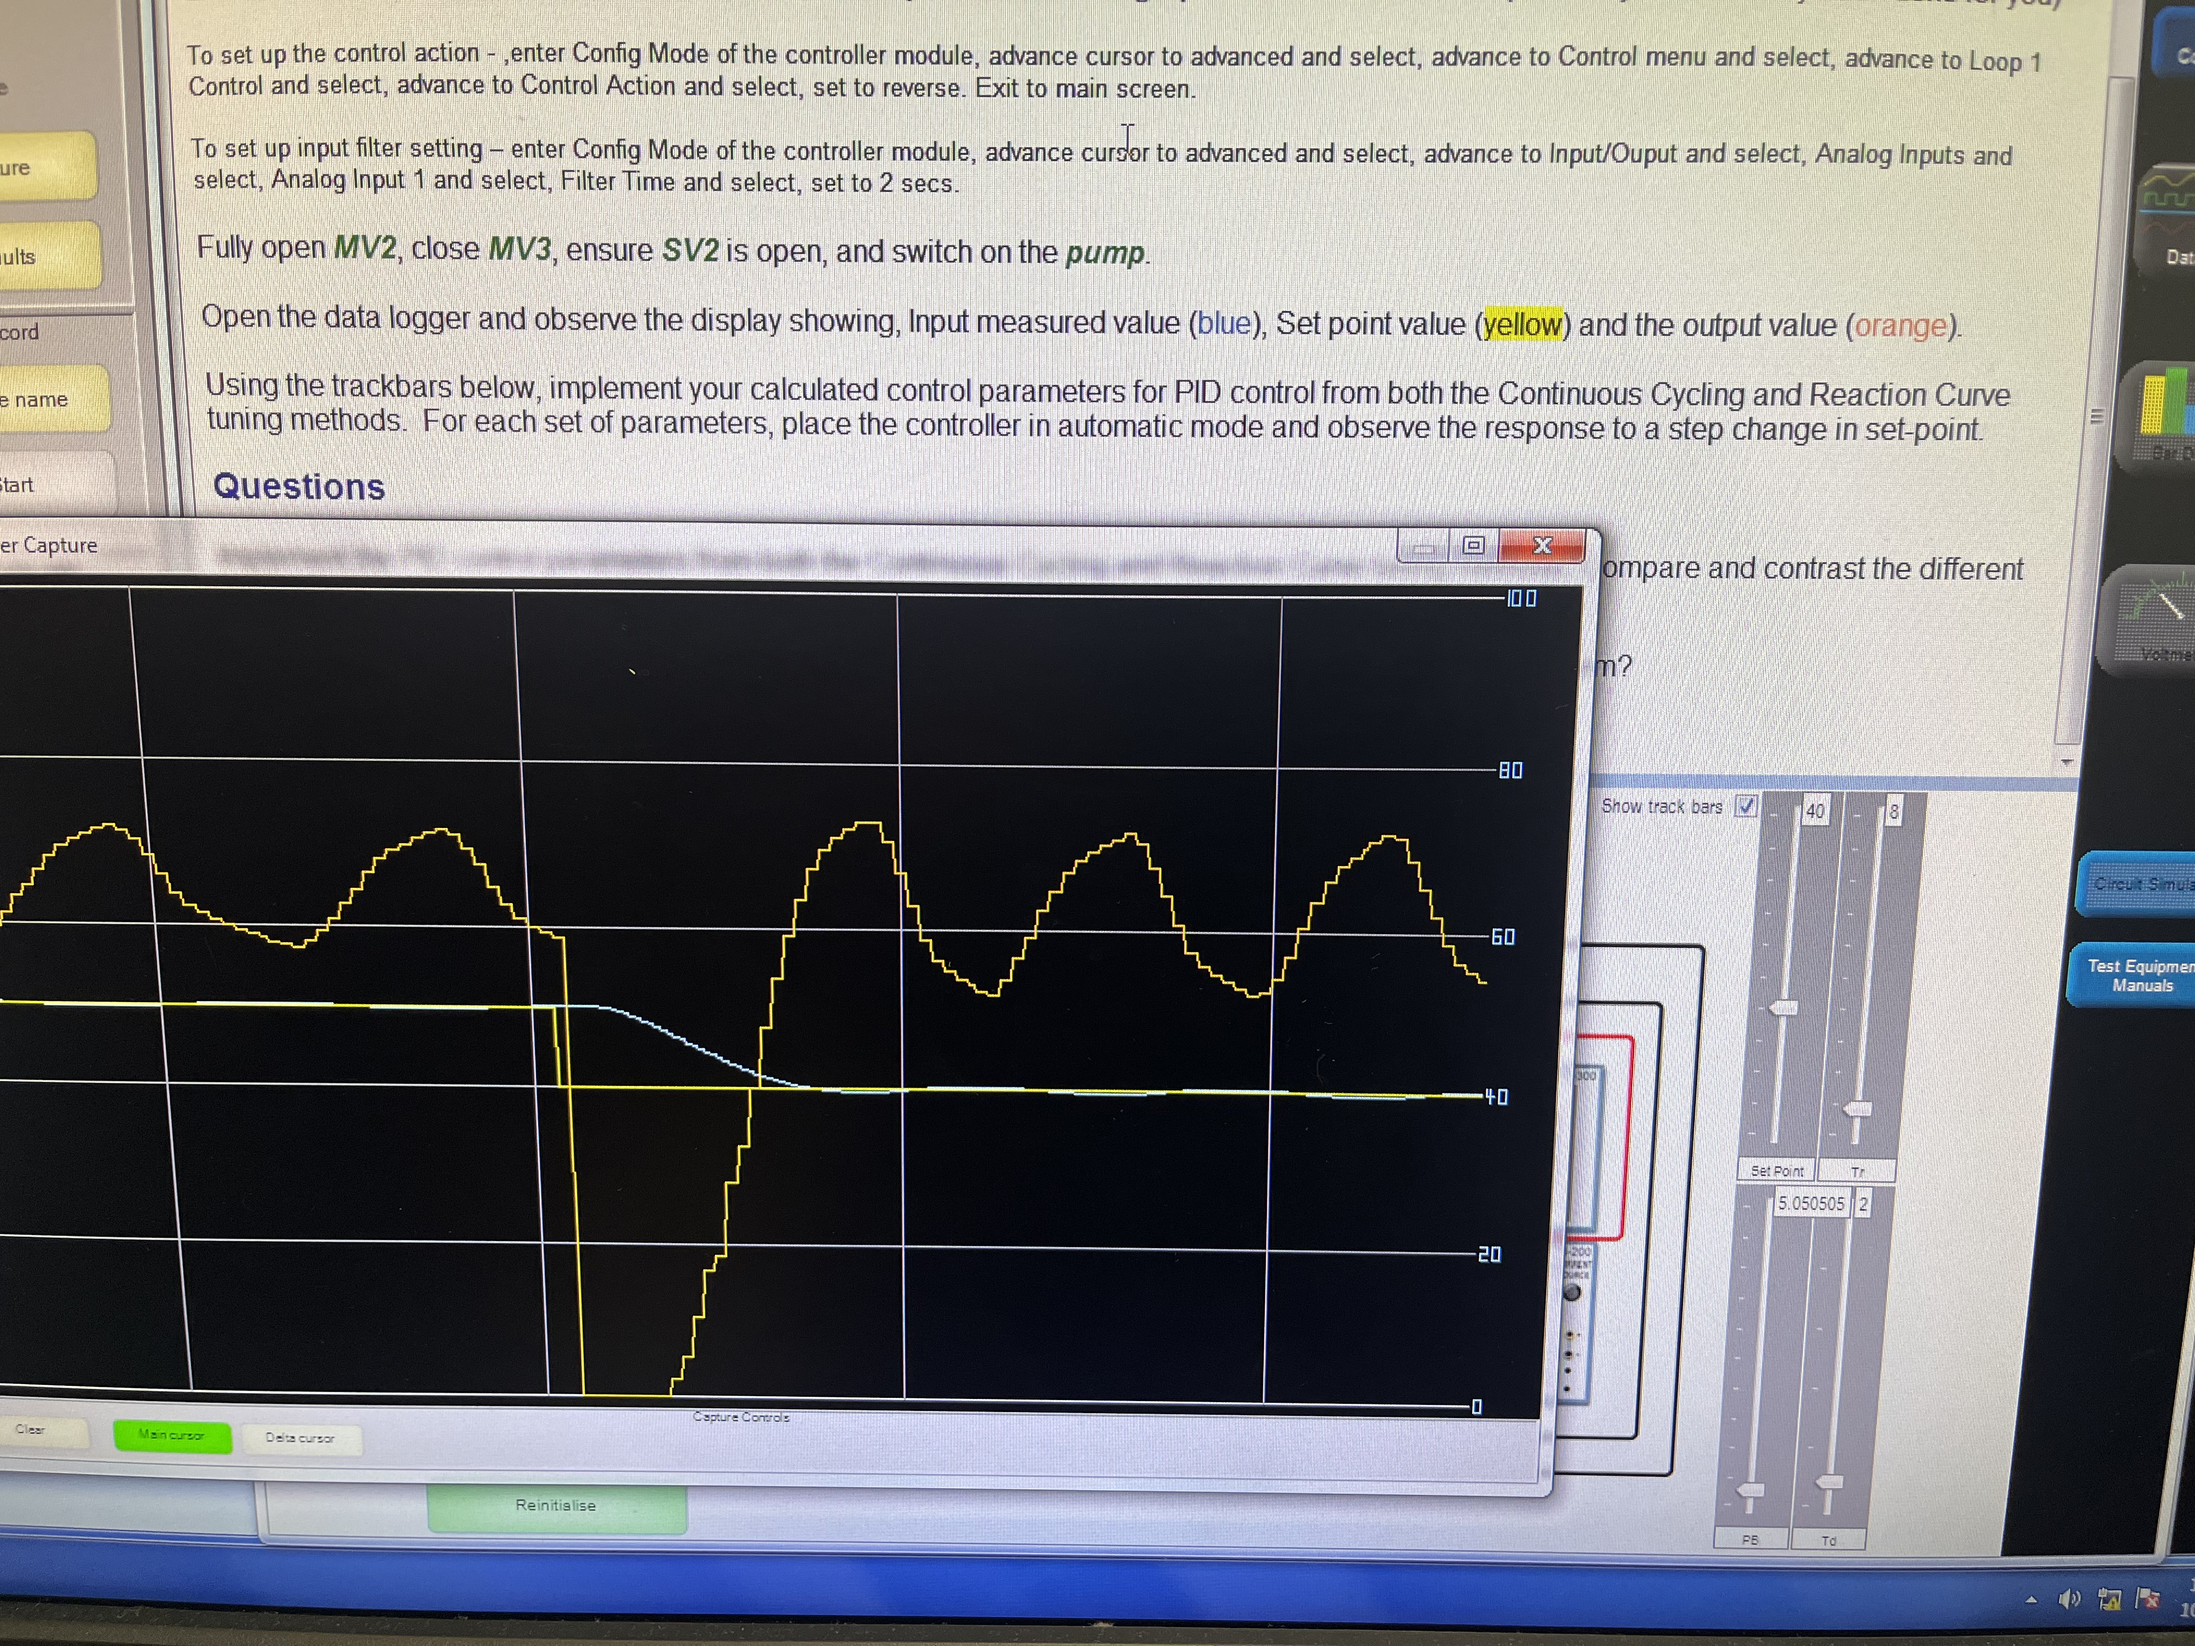
Figure 2 Continuous Reactive Tuning
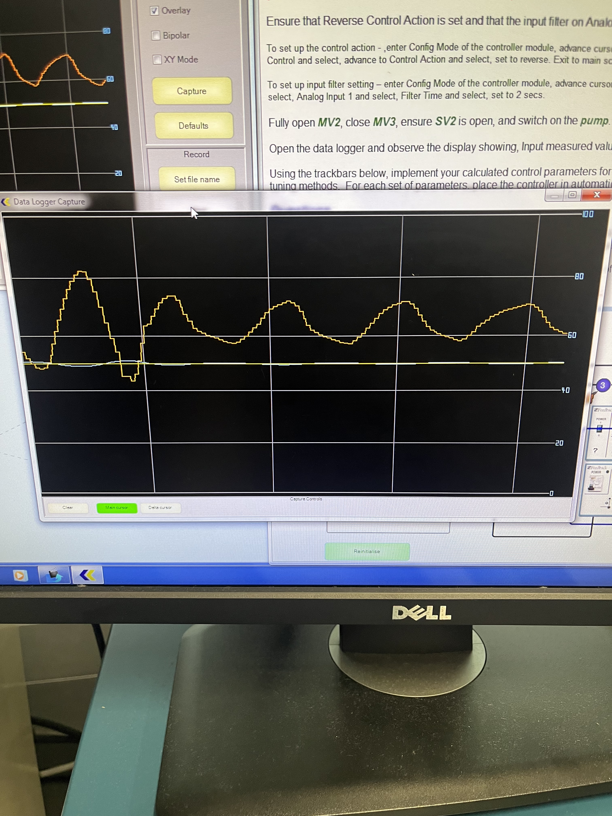
Figure 3 Reactive Curve tuning

- Compare the advantages and disadvantages of both methods and what type of systems are more suited to them?

Based on our results, they both got the same results.
Questions for Practical 4 (Autotune)

- What values of PB, T_{r} and T_{d} did Autotune choose for the system? How do these values compare to the parameters from the Continuous Cycling and Reaction Curve tuning methods?

Pb = 25.5%
Tr = 17s
Td =4.3s

Hand calc Pb is down, Tr and Td is halved.

- Introduce a step change to the process and observe the response. How does the response using the Autotune parameters compare to the response using the hand-calculated ZN-tuning parameters?

Pb =24.7
Tr = 16
Td =4.1

Hand calc Pb is down, Tr and Td is halved.

