ME352 QUBE Lab #4:
Motor Position Control
Prof. Baglione, Prof. Luchtenburg
Technical staﬀ: Michael Giglia
The Cooper Union Department of Mechanical Engineering
(last updated 10/31/25)

1 Objective
In this lab, you will regulate the position of the Qube motor shaft and disc using a PID controller. You will determine controller gains from time domain specifications and study the effects of derivative and integral action on the transient and steady-state response and disturbance effects.

2 Pre-lab Background Questions
A block diagram of the closed-loop system for control of motor position is shown in Fig. 1. Fig. 1 separates the motor plant model (dotted box) into electrical and mechanical inputs and outputs so that we can model different types of disturbance effects. The controller outputs a voltage, u, which produces a torque proportional to the armature current (T = k_{t} i_{a}), which causes the motor to rotate. Assuming negligible armature inductance, the motor model can be derived in terms of the back-emf motor constant k_{e}, the electrical motor armature resistance R_{m}, and the equivalent moment of inertia of the motor pivot J_{eq}. A direct disturbance applied to the inertial wheel is represented by the disturbance torque variable T_{d} and a simulated disturbance voltage is denoted by the variable V_{sd}.
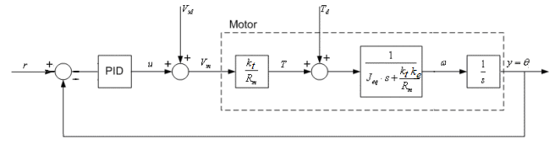
Figure 1: DC Motor PID position control closed-loop block diagram.
The plant transfer function, , for the DC motor position system can be written in terms of the open-loop motor gain constant, K, and the time constant, τ :
$$P(s)=\frac{Θ(s)}{V_{m}(s)}=\frac{K}{s(τs+1)}$$
Complete the following questions before attending the lab.

- Consider PD Control and determine the closed-loop transfer function from the position reference, r, to the angular position output, ϴ in radians, i.e., Y(s)/ R(s), in terms of K, τ, k_{p} and k_{d}.
- Determine k_{p} and k_{d} in terms of the closed-loop natural frequency, ω_{n}, damping ratio, ζ, motor time constant, τ, and motor gain constant, K.
- Determine the steady-state error to a unit step input and the DC Gain of the closed-loop motor position system.
- Now consider PID control. Determine the closed-loop disturbance to position transfer function, Y(s)/T_{d}(s), assuming zero reference input and zero disturbance torque (T_{d}), in terms of J_{eq}, K, τ, k_{p,} k_{i} and k_{d}. In this lab we will simulate the torque disturbance (T_{d}), by applying a simulated voltage disturbance (V_{sd}), which is why we assume T_{d} is zero. The voltage applied to the motor is V_{m} is equal to the controller output, u, plus the simulated disturbance voltage, V_{sd}:
$$V_{m}\left(s\right)=U\left(s\right)+\frac{T_{d}τ}{KJ_{eq}}$$
Hint: It is helpful to start by recognizing Y(s) = P(s) V_{m}(s) and U(s) = C(s) [R(s)-Y(s)] where R(s)=0 and then solve for Y(s)/T_{d}(s). The algebra in the Laplace domain is less tedious if you leave the plant in the form: $P\left(s\right)=\frac{K}{s(τs+1)}$ .
- Determine the steady-state error to a step disturbance of magnitude, T_{do} , given PD (i.e. set k_{i} = 0).
- Determine the steady-state error to a step disturbance of magnitude, T_{do} , given PID-Control.
- Consider the standard characteristic equation for a third-order system:
Determine k_{p,} k_{i,} and k_{d} in terms of the closed-loop natural frequency, ω_{n}, the damping ratio, ζ, the motor gain constant, K, and the location of the pole, p_{o}. (Hint: You do not need to derive the closed-loop transfer function for PID Control. You already determined the characteristic equation for the system with PID Control in question #4.)
Before you begin the lab, you should check that you correctly determined k_{p}, k_{i} and k_{d} !
Prelab:
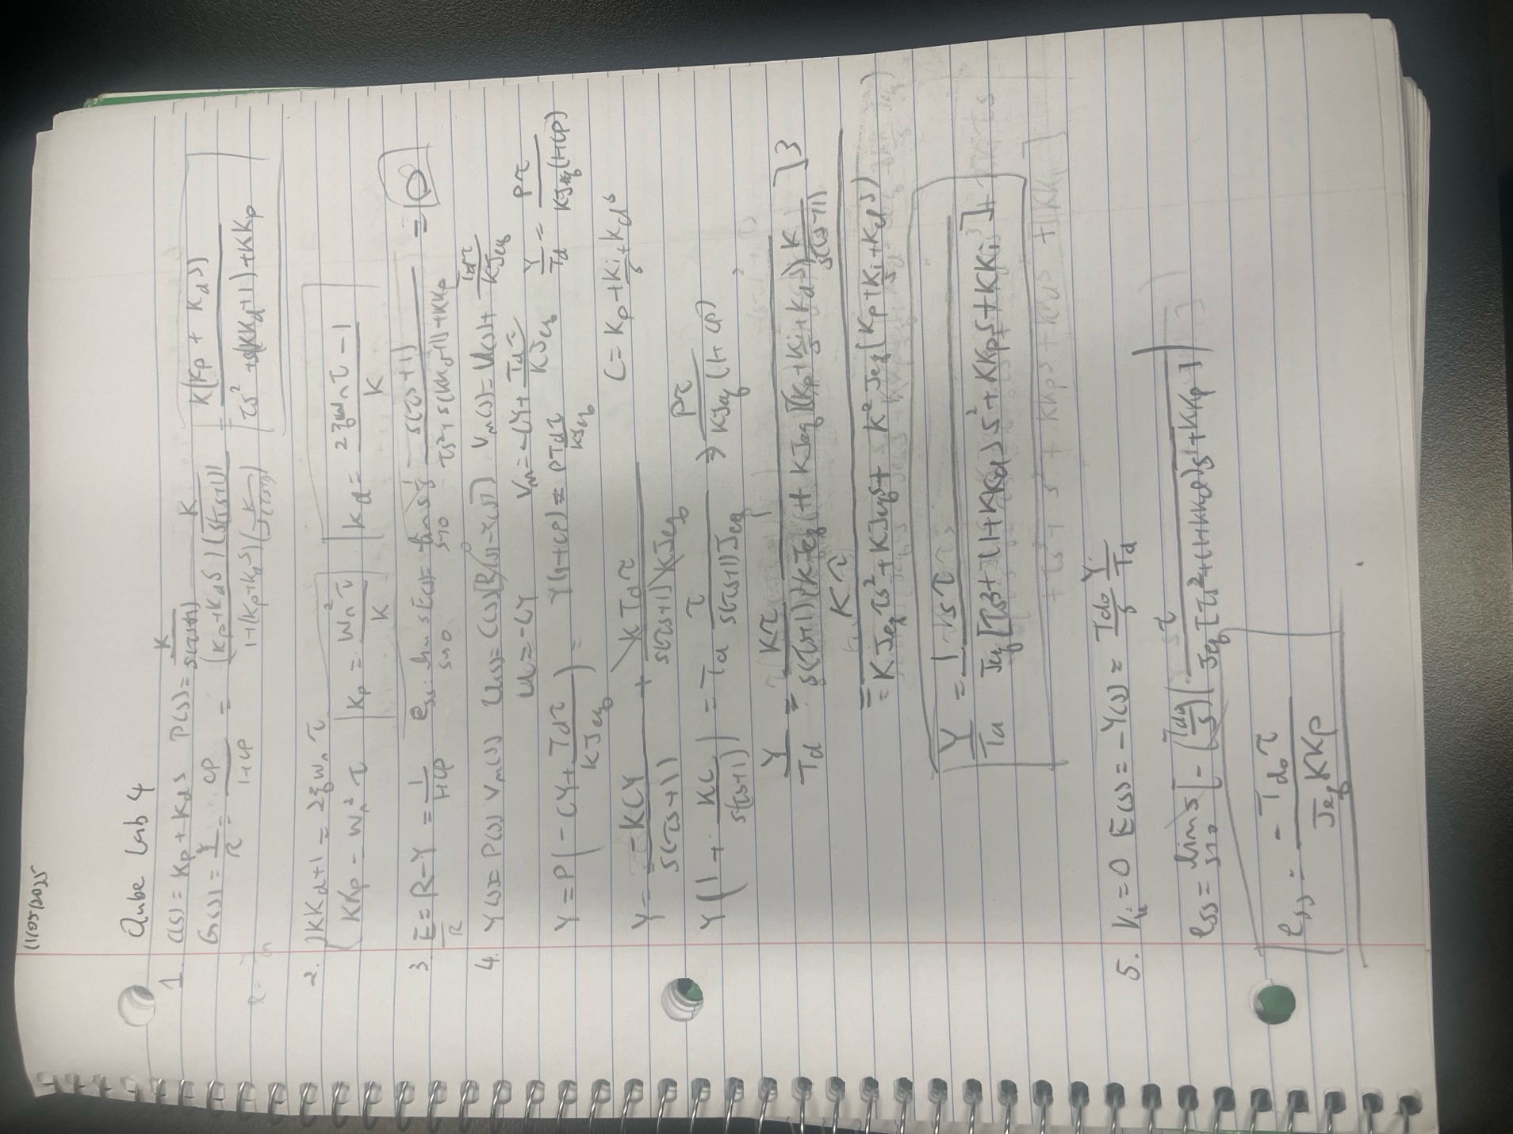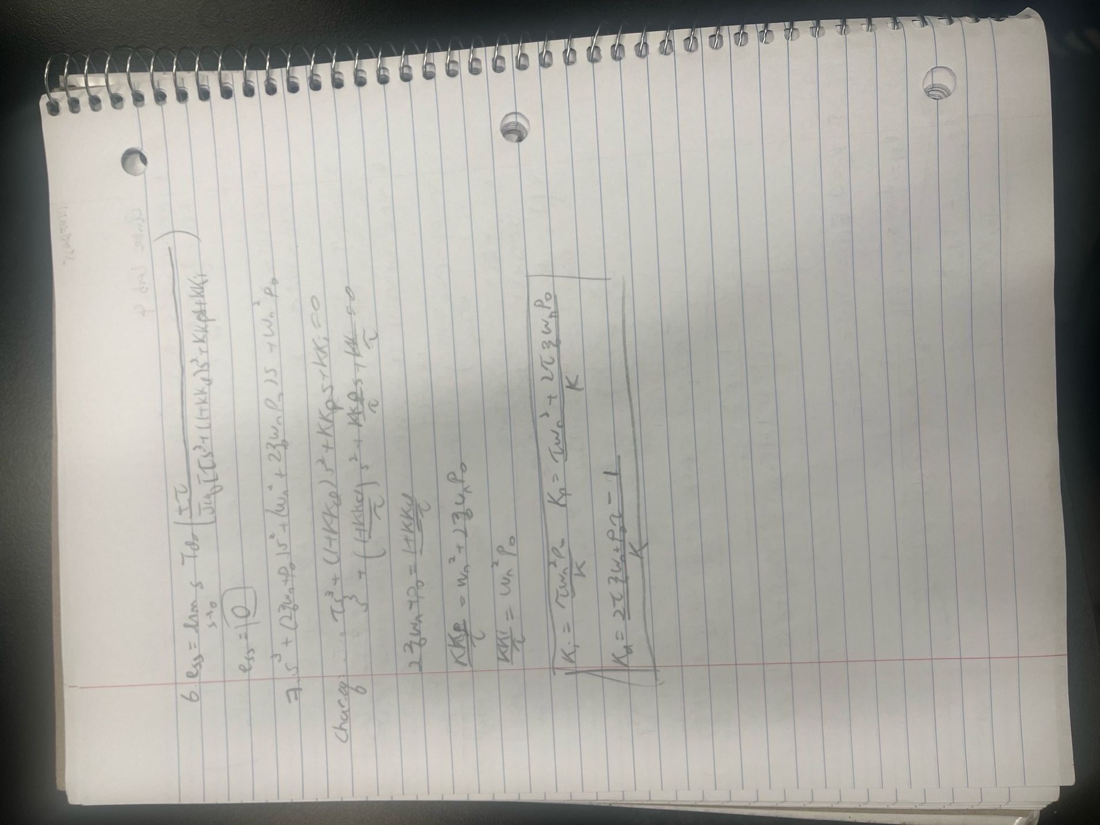

3 Position Control Simulink Model and Experiment Setup

Outputting encoder position
Firstly, follow the instructions taped on every monitor labelled “Instructions to follow before every QUBE DC Motor Lab.”
Begin by opening MATLAB. Ensure it is version “R2021b” Search in the QUBE_STUDENT folder for the “Lab 2 -Speed Control” folder. In the “matlab_files” folder double click on the lab2_speed_control.sltx template. Simulink will open, and a warning message will pop up. Click on OK and click on lab2_speed_control under Template to create model on the screen.
We will now modify the Simulink file to control position instead of speed. To do this, save the template as a new Simulink file. Double click on the Qube_Plant subsystem block.
Inside the subsystem block the motor encoder signal is converted from pulse count to radians, then to angular velocity using a low-pass derivative block. For this lab, we need to output the position, ϴ, for feedback control as shown in Fig. 2. To do this, delete the low-pass derivative block, reconnect the radian signal to the output block and rename the output from Omega to Theta.
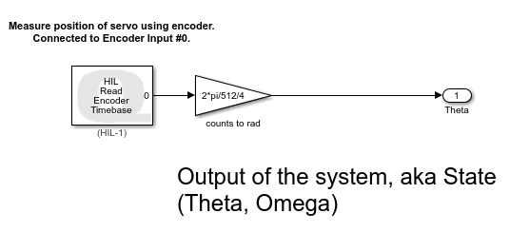
Figure 2: Qube Plant Subsystem Block

Updating position control plant model
Navigate back to the Theoretical Model subsystem block and double-click on the Transfer Fcn block and add an integrator (pole at the origin) and rename the output to Theta as shown in Fig. 3. Note, this can also be accomplished by adding an integrator block after the existing first-order transfer function block. Change the names of the scopes from Omega or Velocity to Theta or Position in radians.
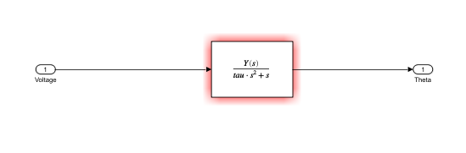
Figure 3: Theoretical Model Subsystem Block

Adding derivative term to Controller Block
Modify the block diagram to add a derivative block and gain to the Controller Block. Do this by double clicking on the summation block and adding a “+”. In the Simulation tab, click on Library Brower, and search for the Derivative block. Rename the gain block to indicate “Derivative Gain”.
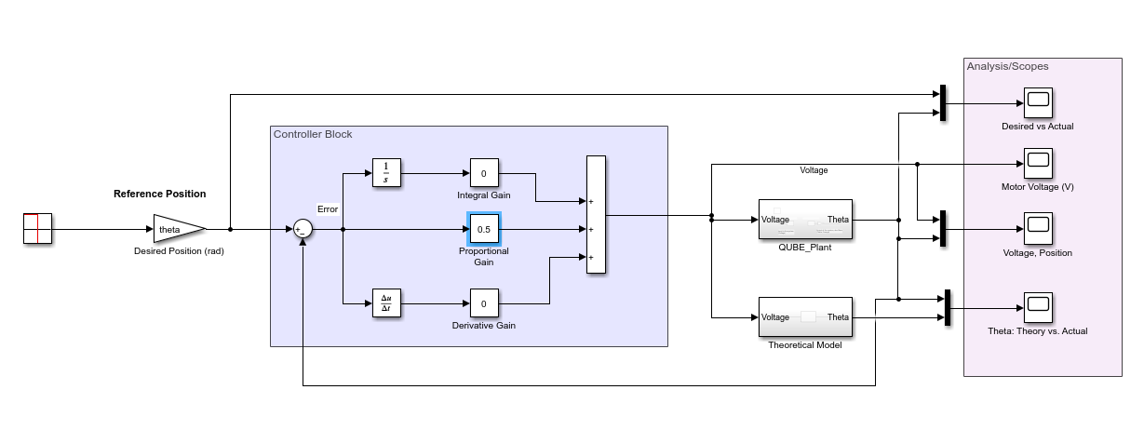
Figure 4: Controller Block with PID Control

Changing reference input
Change the input to vary the desired position from 0$°$ to 360$°$ (one rotation). Double click on the gain after the square wave and change the name to theta. Change the labels on the input gain to indicate position. Make sure the square wave signal block generates an amplitude of 0.5 V and frequency of 0.2 Hz with the offset of 0.5 added to the summation block.
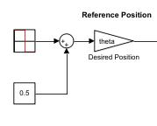
Figure 5: Square Wave Reference Input with offset and Theta Gain Block

Running parameter file and Simulink model
Open the lab2_params.m file. Change the input name from w to theta and change the theta to 2$π$(theta = 2*pi).Save the parameter file as lab4_params.m and run the parameter file.
Align the disc so that the etching aligns with the 0$°$-degree marking so you can observe the disc as it rotates 360$°$.
Set the proportional gain to 0.5 and derivative and integral gains to 0. Click Monitor & Tune and observe the disc and desired vs. actual position in the scope. You may wish to change the default scope settings in the “Configure Parameters” menu to limit logging data points from 5K to 20K.


4 Position Control Lab Assignment

Qualitative PD Control
- Examine the desired vs. actual position scope and describe the behavior of the measured position with respect to the reference position. Click View then Legend to display the scope legend. Indicate the approximate overshoot and steady-state error in rad and percent.
Ref 6.283 rad to exp 5.937 rad ss error -> 5.8 % error
Overshoot: 7.768 rad to 6.283 reference ->23.6% overshoot
- Increment the proportional gain and observe the change in behavior. Determine the overshoot and steady-state error when k_{p} = 3.85.
Overshoot: 10 rad to 6.283 rad -> 60% overshoot
Ss error: 0.04% or 0.003 rad error
Higher Kp means more oscillation and more overshoot and decrease steady state error
- Increment the derivative gain, k_{d}, by steps of 0.01 V.s/rad. Describe the changes in the measured signal with respect to the reference signal. Explain the performance difference of changing kd.
As we increase Kd and keep Kp the same. There is a reduction in oscillation and an increase in rise time. The percent overshoot also decreases.

PD Control according to Specifications
- Calculate k_{p} and k_{d} necessary for ζ = 0.6 , ω_{n} = 20 rad/s. This corresponds to an approximate overshoot of 10% and rise time less than 1/10 second. Implement the controller gains. Examine the measured position response. Explain why there is an error between the reference and measured position. For your calculations use the K and τ calculated using the QUBE Servo 2 motor specifications.
Kp = 1.6807 and Kd = 0.0588 for K = 23.8 and tau = 0.1 rise time is slower than 1/10s and overshoot is about 13% greater than 10%
There is a steady state error because we assumed that the motor didn’t experience viscous friction and air resistance so these contribute to slight losses in the system.
- Calculate k_{p} and k_{d} if the damping ratio, ζ , is increased to 0.7 (keep ω_{n} = 20 rad/s). Implement the controller gains. What effect does changing the specification for ζ have on the calculated controller gains and the experimental measured position response.
Kp = 1.6807 and Kd = 0.0756 for K = 23.8 and tau = 0.1
It changed the Kd but left Kp alone. Overshoot was decreased from 13% to about 7% which is good and steady state error is decreased too. However it slightly increased the rise time.
- With ζ = 0.6, calculate the controller gains for natural frequencies of 15 rad/s and 30 rad/s . Implement the controller gains. What effect does changing the specification ω_{n} have on the calculated controller gains and the measured position response?

Wn = 15 rad/s Kp = 0.9454 and Kd = 0.0336
Wn = 30 rad/s Kp = 3.7815 and Kd = 0.1096
Mainly increasing the Wn decreased the overshoot percentage. Decreased steady state error. Decrease effect on rise time.

Response to Load Disturbance
- In the signal block set the Amplitude = 0 rad and for the offset set Constant value = 0 rad. With k_{p} = 1.54 V/rad and k_{d} =0.054 V-s/rad (ζ = 0.6 , ω_{n} = 20 rad/s), observe the disc position and desired and actual position scope, which should show a reference of 0$°.$ Gently try to move the disc with your finger causing a small torque disturbance of no more than 1 radian. Describe the effect of the disturbance on the measured position.
I caused a 0.8 rad disturbance and there is a steady state error of -0.1 rad. The position changed positively when I spin it clockwise and negatively counter clockwise.

Response to Simulated Voltage Disturbance
Now modify the Simulink model to be able to systematically apply a disturbance by applying a voltage disturbance to simulate a torque disturbance. Stop the hardware and navigate to the Library Browser in the Simulation tab. In the Library search for a Manual Switch. Add two constant blocks to the inputs of the switch – one labeled “Voltage Disturbance” with a Constant Value = 1 and one labeled “No Disturbance” with a Constant Value = 0. Connect the output of the switch to a summation block that you add to the output of the controller block as show in Fig. 6.
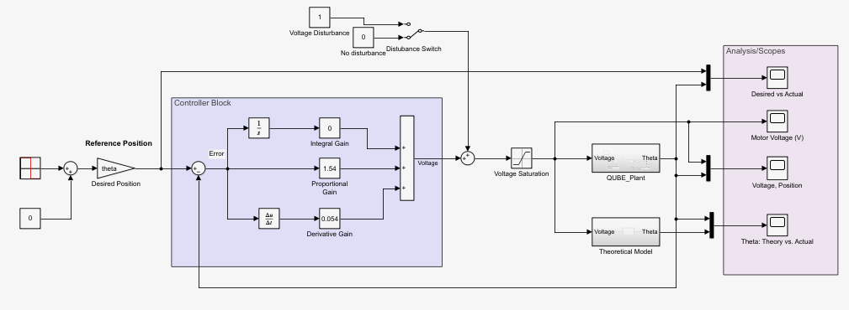
Figure 6: Position Control Simulink with Simulated Voltage Disturbance Switch
Note, in Fig. 6, a saturation block was added to saturate the modeled motor voltage since the Quanser motor controller is only able to output a maximum of +/-18V even if the controller requests more. Note adding this block is not absolutely necessary since it will not change the experimental results but saturating the motor voltage will allow the modeled results to reflect the hardware limitations more accurately. If you decide to add this block in your model make sure to change the saturation limits to +/-18V.
- Start with the Disturbance switch to input zero disturbance. Then toggle the switch to input a simulated 1 Volt disturbance and observe the resulting steady-state angle. Now calculate k_{p}, k_{i}, and k_{d} for a PID Controller where the pole, p_{o} = 1. Implement the controller gains and then switch on the disturbance. Explain the difference in the disturbance response with the integral action added.
Steady state angle = 45 degree to 1v disturbance.
Po = 1 : Kp = 3.9328, Kd = 0.1134, Ki= 3.7815
The integral action made it so there are no steady state error, but the rise time is greatly increased.
- Calculate the controller gains if you move the pole location, p_{o}, from 1 to 3. Before you implement the new gains, switch the disturbance off. Once the new gains are implemented, switch the disturbance on and examine the disturbance response. Explain what happens to the disturbance response when the pole is placed further into the left-half plane.
Po = 3: Kp = 4.2353, Kd = 0.1218, Ki = 11.3445 It has a shorter rise time when the pole is placed further to the left.
If you model the Quanser Qube motor position control system and simulate the closed-loop unit-step response, you should observe that the steady-state error for a P-Controller is zero (note as is the case for step inputs for Type 1 systems, i.e., systems with a pole at zero in the loop transfer function!). However, you should have seen in your experimental position control results that there was some steady-state error for step type inputs.
Extra Credit
- For extra credit, with the disturbance switched off in Simulink and k_{p}=3.85, k_{d}=0.1, k_{i}=0, change the Signal type in the Signal Generator block to a Triangle wave. Submit a plot of the experimental desired vs. actual measured position and determine the steady-state offset. Compare the offset to calculations of the error to a ramp input using the final value theorem. Show your calculations.
- Now implement a PID Controller and show whether you are able to eliminate the offset. Show the response and indicate the gain values you select.
You may work in groups of one or 2 on the lab assignment but you must turn in your own work that reflects your own understanding!

