ME352 QUBE Motor Lab 2:

Motor Speed PI Control

Prof. Baglione, Prof. Luchtenburg

The Cooper Union Department of Mechanical Engineering

last updated: 10/9/25 with extra extra credit

Overview
In this lab we will apply feedback control to the QUBE DC motor system with the goal of acceptable transient response and tracking. Proportional control (P) offers the advantage of fast transient response and reducing steady state error. While higher gains yield better performance, they come at the expense of increased sensitivity to noise. We will learn that integral control (I) offers the advantage of zero steady-state error for a step input to this system. (This is not generally true for all systems). Unfortunately, however, as the gain of I is increased to improve rise time, overshoot and instability will also increase. We will see that combining P and I (PI control) is better than either P or I alone by simultaneously offering the advantages of quick transient response, zero steady-state error and decreased sensitivity to noise.

Goals
Our hands-on goals for this lab are to:

  - Learn how to work as a designer. Use a model of the DC motor system to design a suitable controller which is implemented in an experiment.
  - Design a feedback controller for reference tracking using P, I, and PI control approaches.
  - Compare measured responses to those simulated for the modeled system.

Pre-lab Questions
Come prepared to your scheduled lab session with the pre-lab questions answered. Turn in the pre-lab questions with the lab assignment.

Parameter identification
Recall from lab 1 that the first-order transfer function of the motor plant is given by:
K

P (s) =

τs + 1
(1)

- Write down the calculated values for K and τ you determined in lab 1, including units, using the QUBE-Servo manufacturer values of R = 8.4 Ω , J_{m} = 4.65x10⁻⁶ kg-m² (this value includes the hub attachment inertia), motor torque constant K_{m} = 0.042 N m/A, and motor back-emf constant K_{b}= 0.042 V/(rad/s). To calculate the load disc inertia, J_{d}, assume the disc has a mass of 0.053 kg and radius of 0.0248 m. Assume the motor damping/friction and the armature inductance are negligible.

Proportional (P), Integral (I) and Proportional-Integral (PI) control
A common block diagram for reference tracking is shown in Fig. 1. Recall that a proportional- integral controller has transfer function:
$C\left(s\right)= k_{p}+\frac{k_{i}}{s}$ (2)

Controller Plant
r
e
u
y
−
K
τs + 1
C(s)

Figure 1: Block diagram for error-based feedback control (reference tracking).

In the following, we consider proportional, integral and proportional-integral control for the motor-tachometer system. For all three types of control our goal is to design a controller such that:
  - the rise time is less than 0.2 seconds
  - the steady-state error is less than 1%

  - the overshoot is less than 20%

  - the noise in the input signal (applied motor voltage) is small. The spread of the amplitude with respect to the mean signal should be less than 0.25 volts.
You, the control designer, need to find out if you can meet all prescribed specifications.

Proportional control
First, we consider proportional control, i.e. C(s) = k_{p}.
- Use the final value theorem and reference-to-error transfer function (or determine the error from system type and error constants) to write the steady-state error to a unit step input in terms of the system parameters (K and/or τ) and the proportional control constant, k_{p},
- Design P-controllers such that the steady state error is respectively less than 30, 10 and 1%. Calculate the respective ranges of k_{p} values to meet each steady-state error specification.
- Find the closed-loop pole and closed-loop time constant for the k_{p} value corresponding to 1% steady-state error.

Proportional-Integral control
In the proportional-integral controller case, $C\left(s\right)= k_{p}+\frac{k_{i}}{s}$, we can combine the favorable features of both P and I control, namely quick response, zero steady state error, and low sensitivity to noise.
- Find the closed-loop transfer function for P-I control. Which property of the closed-loop system is influenced by k_{p}? Similarly, for k_{i}?
- Design a PI-controller (determine k_{p} and k_{i}) for rise time t_{r} ≤ 0.2 seconds, less than 1% steady state error, and overshoot less than 20%.
Note, if you did the calculations correctly, you should see the k_{p} gain required to meet the specifications using P-control only is much higher than in the PI-control case. In fact, the theoretical calculations should reveal that you should be able to meet specifications (i)-(iii) with I-control only. During the lab we will see if this is possible in practice.

Lab Assignment: Tracking the motor speed
Firstly, follow the instructions taped on every monitor labelled “Instructions to follow before every QUBE DC Motor Lab.”
Begin by opening MATLAB. Ensure it is version “R2021b” Search in the QUBE_STUDENT folder for the “Lab 2 -Speed Control” folder. In the “matlab_files” folder double click on the lab2_speed_control.sltx template. Simulink will open, and a warning message will pop up. Click on OK and click on lab2_speed_control under Template to create model on the screen. Save the Simulink file locally. Run the lab2_params.m file in MATLAB to load the parameters and click the Monitor & Tune button in the Hardware Tab.
In the Simulink “Smooth Signal Generator” block, set the amplitude to 0.5 and frequency to 0.2 Hz. An offset block of 0.5 is added to the signal generator signal which yields a square wave signal that is multiplied by the “desired angular velocity” gain block which is set to 50 rad/s in the parameter file.
Update the K and τ in the lab2_params.m file to match the calculated values based on the QUBE-Servo manufacturer parameters. If you recall in the first motor modeling lab, the actual K and τ for the motor you are running for this lab could vary slightly. Compare your theoretical model with the actual DC motor angular velocity by comparing the model step response with the actual QUBE motor step response. Use the “Omega: Theory vs. Actual” scope. Note here the input to the plant is the voltage applied to the motor, which for the closed-loop system is output by the controller. As a control system designer, you need to decide whether to use manufacturer values or values from actual testing to model the system, but for this lab the whole class will use the manufacturer parameters.

Prelab:
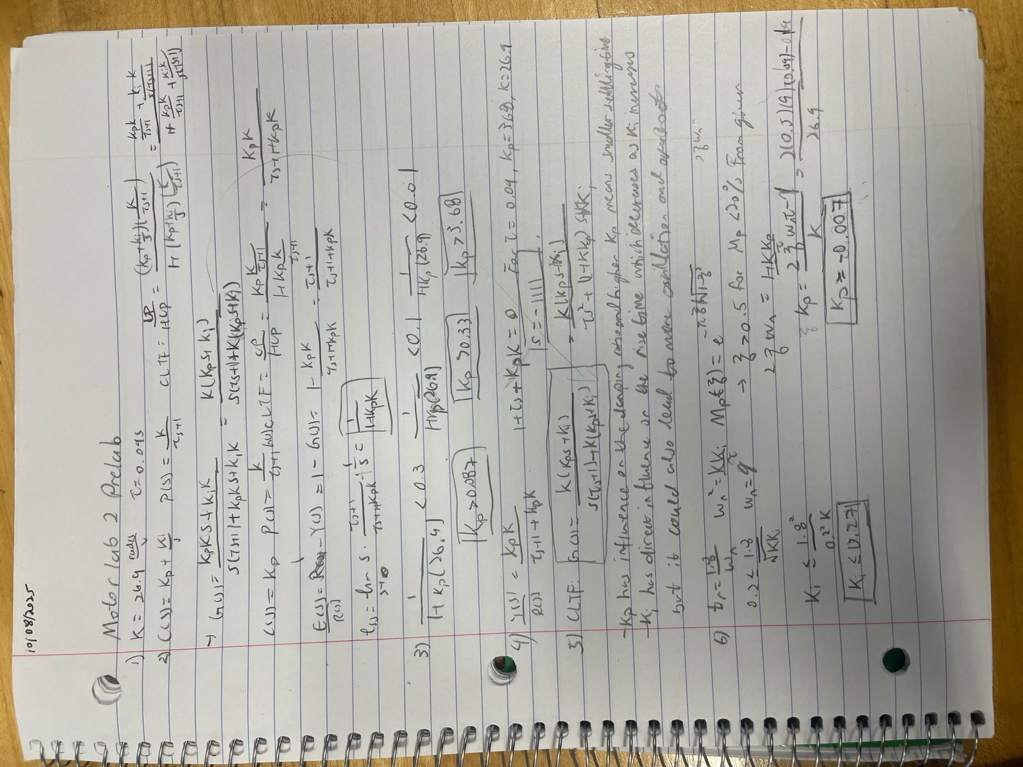

Proportional control implementation
Now let’s implement proportional control with the k_{p} values calculated in the pre-lab assignment.
- Implement the k_{p} values from (3). Set k_{i} to 0 by clicking on the integral gain block. Set k_{p} by clicking on the proportional gain block. Discuss how the response changes as you increase k_{p} and whether you are able to meet the specifications for (i)-(iii). You should view the closed-loop response by clicking on the “Desired vs. Actual” scope block. Simulink limits the number of data points stored in the scope by default. To increase the data points, click “View”, then “Configuration Properties”, and on the “Logging” tab, change the “Limit data points to last” to 20,000 and click “Apply”. You can also add a legend and change the scope. You can copy and paste the scopes as a figure by clicking “File” and “Copy to Clipboard”.
- At 30% steady error, Kp = 0.09 the actual motor steady state error appeared to match the 30% predicted
- At theory = 10% steady state error, Kp = 0.33 the actual error appeared to be around 12%
- At theory = 1% steady state error, Kp = 3.68 and the actual error was really small at about 1%
- The response gets more volatile and takes longer to settle but the steady state error decreases as Kp increases.

- Verify in an experiment whether you can meet all design specifications (i)-(iv)! The noise in the input signal (applied motor voltage) should be small (The spread of the amplitude with respect to the mean signal should be less than 0.25 volts. Use the “Motor Voltage” or “Voltage, Velocity” scopes to view the spread of the applied voltage noise.). Do the controllers operate as you expect? Why or why not?
- Satisfies rise time, steady state error, overshoot, but the applied motor voltage has a lot of noise in the input signal about 2 volts of variation. Because there is a damping within the motor and the spinning disc that we are not accounting for. And also there is a high gain amplifying any amount of small noise.

Integral control implementation
Next, we consider integral control only, i.e., $C\left(s\right)= \frac{k_{i}}{s}$
- Implement an integral controller (set k_{p} =0) using the rise time tr ≤ 0.2 s, less than 1% steady state error, and overshoot less than 20% specifications. The noise in the input signal (applied motor voltage) is desired to be small. (The spread of the amplitude with respect to the mean signal should be less than 0.25 volts.). Can you meet all design specifications (i)-(iv)? Why or why not? Do the controllers operate as you expect based on your theoretical model?
- For only integral control the 0 < Ki < 0.24 satisfies the requirements for steady state error and overshoot but the rise time is going to be greater than 0.2s. And with only Ki the amplitude of the noise is about 0.15v which is less than the 0.25 volts. The reason why Integral control does not meet the rise time specifications is because the role of Kp is to make the system approach the steady state faster and with it set to 0 the system will be slower. The control operated as expected since a lower overall gain means less noise is amplified.

Proportional-Integral control implementation
Now, let’s implement the proportional-integral controller
- Keeping integral control, start with a very low k_{p} gain and gradually increase k_{p} to see the change in response with a large k_{p} gain. Observe how increasing k_{p} affects the response. Vary both gains to see if you can meet the specifications from (i)-(iv). The noise in the input signal (applied motor voltage) should be small. (The spread of the amplitude with respect to the mean signal should be less than 0.25 volts – Look at the motor voltage scope!). How can k_{p} and k_{i} be traded off with each other to achieve the desired system behavior? List your final k_{p} and k_{i} and whether you were able to meet all the specifications.
- Increasing Ki decreases the rise time while increasing Kp decreases the % overshoot but increasing both will decrease the settling time which is undesirable, and by having a Ki it should automatically decrease the steady error to 0.
- Ki = 0.6 and Kp = 0.035

Effect of Pole Location on Response
- Use the following Matlab code to plot the root locus for the system with P-control. Sketch or turn in a Matlab plot of the root locus plot. The × should show the location of the open loop pole which should be $s= -\frac{1}{τ}$.
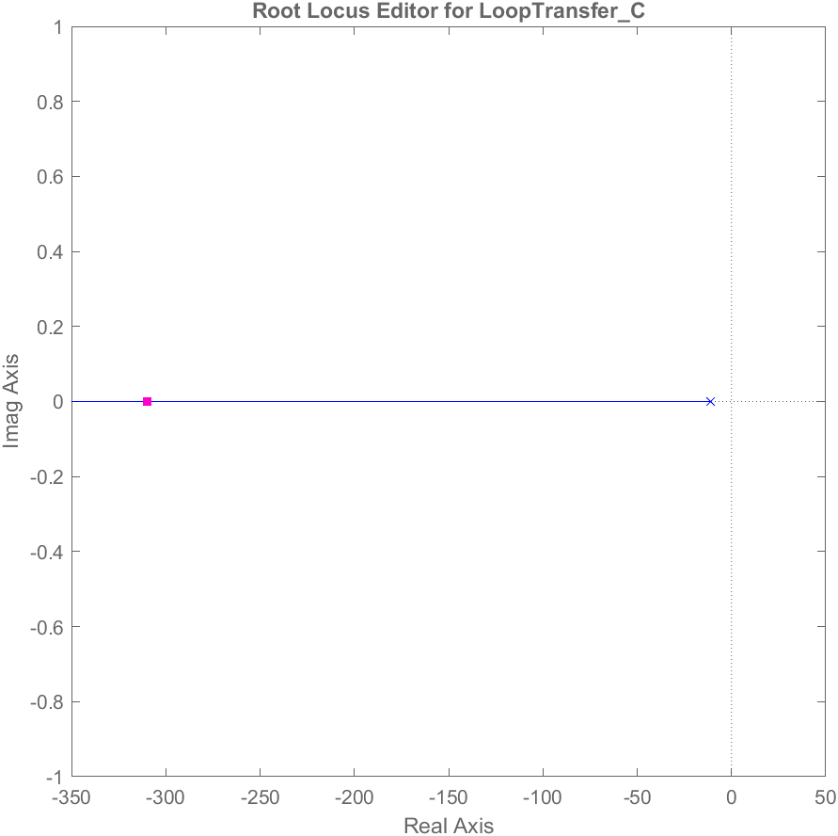
s = tf('s');
sys = K /(tau*s + 1);
rlocus(sys)
- You can also use the Control System Designer Matlab application and GUI using the command controlSystemDesigner(sys). This will allow you to adjust the loop gain by dragging the closed-loop pole location (shown as a pink square).
- You can preview the adjusted value of the loop gain, in this case k_{p}, by clicking C in the Controller and Fixed Block Window and view the corresponding modeled Step Response. You can also see the Bode Plot which will be covered later.
- Try dragging the closed-loop pole to the value that yields the k_{p} gain you calculated in (4). You can double-click C and enter the k_{p} value that corresponds to 1% error in the Compensator Editor window if you get tired of dragging! The value of the closed-loop pole should agree with your calculations in (4).
- Add Matlab code or modify the system to plot the root locus for the system with I-control. (Remember to use the open-loop transfer function, sys = K / (s *(tau*s + 1))!) Sketch or turn in a Matlab plot of the root locus for the system with I-control. Do not include the k_{i} gain as this is the parameter being varied in the root locus plot.

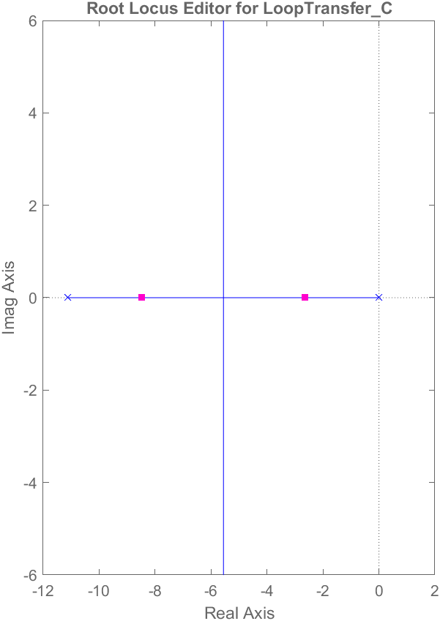
- What happens to the root loci branches (and corresponding closed-loop poles) as you increase k_{i} and how does this affect the closed-loop time response characteristics?
- Ki = C = 0.448
- Increasing Ki decreases the rise time and increases overshoot. The branches go to infinity as Ki increases to infinity.

- Try dragging the closed-loop poles to the find the controller gain C value that yields the ki gain corresponding to the rise time tr ≤ 0.2 s, less than 1% steady state error, and overshoot less than 20% specifications.
- Note, you can right click on the Root Locus Editor, select “Design Requirements” and click “New” to visualize the time domain specifications on the root locus. You should see, at least in theory, there is a range of possible k_{i} gains that, at least in theory, meet the specified requirements (i)-(iii).
- Similarly, you can right click on the step response (IOTransfer_r2y: step window) to add and visualize the time domain specifications.

Lab Discussion
- Why do we need a model of the motor-speed control system (plant)?

The plant needs a model because this is how we control how fast the disc spins. The open loop model allows us to use the root locus model.

- What are the advantages of a P-controller? What are its disadvantages? Similarly, for an I-controller?
The P-controller have the advantage of simple implementation and decreases overshoot of the system, but it will have a steady state error. The I-controller has 0 steady state error, but the system will have a slower rise time and slower settling time.

- What are the advantages of a PI-controller? Justify your answer based on your experimental results!
The PI-controller has the advantage of zero steady state error and relatively fast rise time and settling time. Based on my results from part 10 the Kp and Ki values for the motor was able to meet all the requirements for rise time, overshoot error, and steady state error.
- Why are the choices for the gains limited in practice?

Because the real-world machines have a limit to how quickly it can respond to controller inputs as well as there is a limit to how fast and how big of a range for a controller can implement inputs onto the machine.

Extra Credit

- Extra Credit: For your final k_{p} and k_{i} values in #10 rewrite the controller into the form$C(s)=\frac{Kc }{s}\left(s+\frac{1}{T_{r}}\right)$ and plot the root locus showing the location of the closed-loop poles for your k_{p} and k_{i} gains (and corresponding K_{c} and T_{r} values), and compare the control System Design response to your response. Does it meet the specifications?
- Extra Credit: Build a Simulink block diagram to track a sinusoidal signal with a frequency of 1 rad/s. How does your controller perform?

Actually, the QUBE motor has an encoder and a Simulink block is used to convert the position of the servo encoder to angular velocity using a low-pass derivative filter.
F or this lab, use the approximation that rise time from 10-90% of steady-state is t_{r} $≈\frac{1.8}{ω_{n}}$. Note this is only a rough approximation based on the behavior of second-order systems with no zeros. For first-order systems, the transient behavior can be better characterized by the time constant, which is related to the pole location.
You may recall or will learn overshoot, $M_{p}(ξ)=e^{-πξ/\sqrt{1-ξ^{2}}}$, which approximately yields ζ > 0.5 for M_{p} < 20%.
You should learn the root-locus design method, in which you use the open-loop transfer function, in this case C(s)P(s) since the system has unity feedback, and indicate the open-loop poles (and zeros, if any, in this case there are no open-loop zeros). Either with hand calculations or using Matlab, root loci branches can be plotted, which show the locations of all possible closed-loop poles as you vary one parameter in the system, usually a controller gain, between 0 and ∞. There are good Root Locus Controller Design and other Matlab & Simulink Control Design tutorials here: https://ctms.engin.umich.edu/CTMS/index.php?example=Introduction&section=ControlRootLocus (or Google CTMS tutorials).

