**Name : Nguyen Quoc Thang**

**ID: 104193360**

**Lab3 : Submission**

**4. Now wire-up a 4-bit big-endian register with D Flip Flops in Logisim. Do this by using 4 pins for each input, and connect 4 LEDS to the output.**

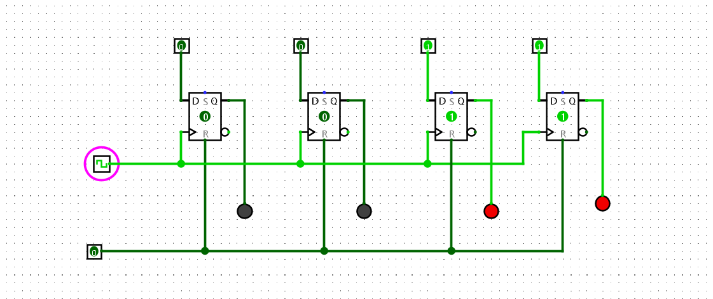

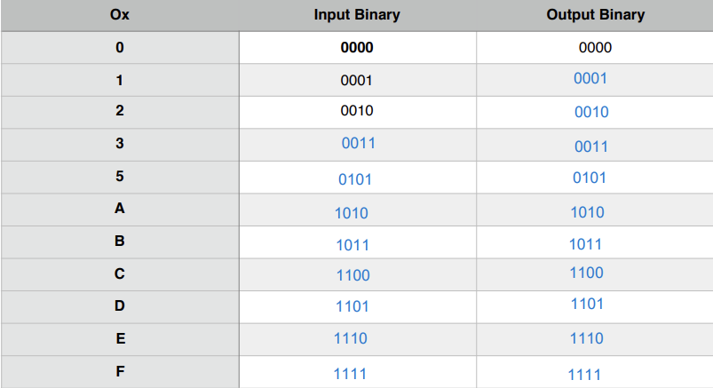

**7. Counters are fundamental to modern computing architectures. Review the lecture slides on counters and answer the following questions:**

**7.1. Name one crucial role (hardware) counters play in modern computing architectures ?**

It is used for measuring and storing the number of time the modern computing architecture even and proccess occurs

**7.2. Describe in a few sentences how a ripple counter works. How does the “ripple” occur ?**

A Ripple counter is an asynchronous counter because the clock is only synchronized with the first clock edge, and the output of the previous flip-flop becomes the clock for the next flip-flop. The Ripple counter operates based on negative edge triggering. When the clock signal transitions from high to low, its output will change.

**8. We are going to build a big-endian 3-bit ripple counter out of JK Flip-Flops**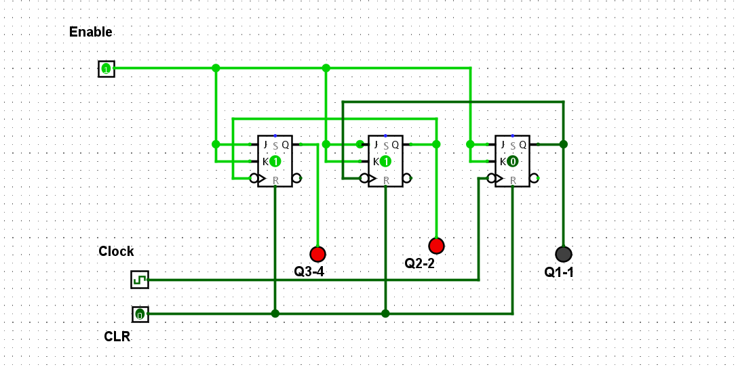

**12. Now build a big-endian 3-bit “count down” counter, that counts from 111 to 000. Review  
the week 3 lecture slides to get some hints on this, and discuss your plan with your lab  
demonstrator if you need to**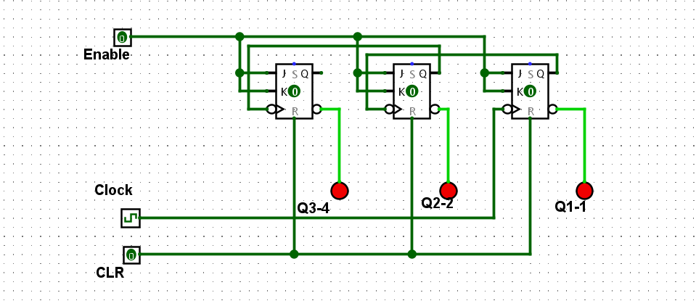

**14. Take your original counter from Step 9 and modify it so it now counts from 0 to 111 using a common clock. That is, each flip flop receives a clock pulse at the same time**

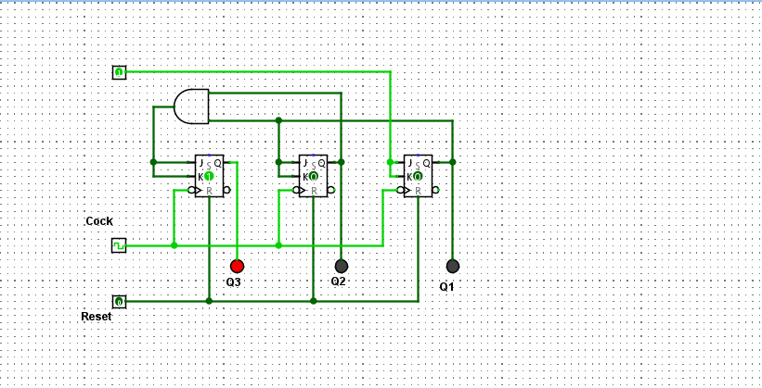

**16. Now modify your clock from Step 14 so it counts from 0 to 5 (i.e, MOD 6), and then wraps around back to 0. Think about how you are going to detect the upper limit, and how you are then going to set things back to 0 when you reach 6 (110)**

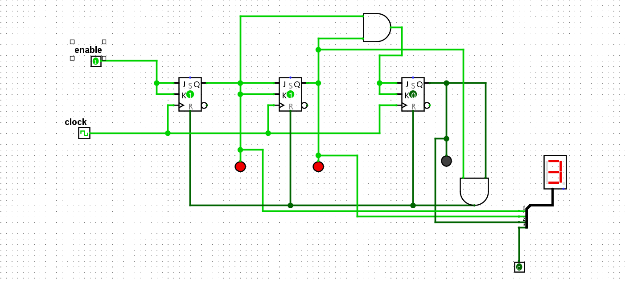

**17.2. Why is handling such things important ?**

It is prevent illegal state occur in our circuit ,it will allow the circuit can run without any error.

**18. Display your counter output using the HEX Digit Display. Note that the Logisim HEX Display uses a single pin input with a 4 bit width. That means a 4 bit integer is expected along a single wire. Because our wires are carrying only 1 bit at a time, we will require a “Splitter” (in reverse) to combine multiple bit streams into a 4-bit “wire bundle” that is fed into the HEX display. See the video tutorial linked at the top of this lab sheet for how touse the splitter to combine single bit streams into a single wire**

