_Name: Nguyen Quoc Thang

ID: 104193360

Lab 9 : SUBMISSTION

**Exercise 9.1.1**

1. **Write a simple ARMlite assembly program that draws a single line of the same length across the second row (starting from the left-most column) in Low-res display mode**

1. **Add to your assembly program code that draws a single line of the same length vertically, down the middle of the display in Low-res display mode**

**Exercise 9.1.3**

**(a) Explain what specifically makes this code an example of indirect addressing ? How is it using indrect addressing to draw each pixel ?**

The code snippet is an example of indirect addressing because it uses the values R1 and R3 to calculate the byte offset of each pixel, that byte offset is used as the address, which is stored in R4 and stored the value of each color of the pixel into R2

**(b)  Once you're confident yo understand the code, modify the program so that it draws a line of the same length along the second row of the Mid-res display.**

**(c)  Further modify your program so that it also draws a line of the same length vertically down the middle of the display.**

**Excercise 9.2.1**

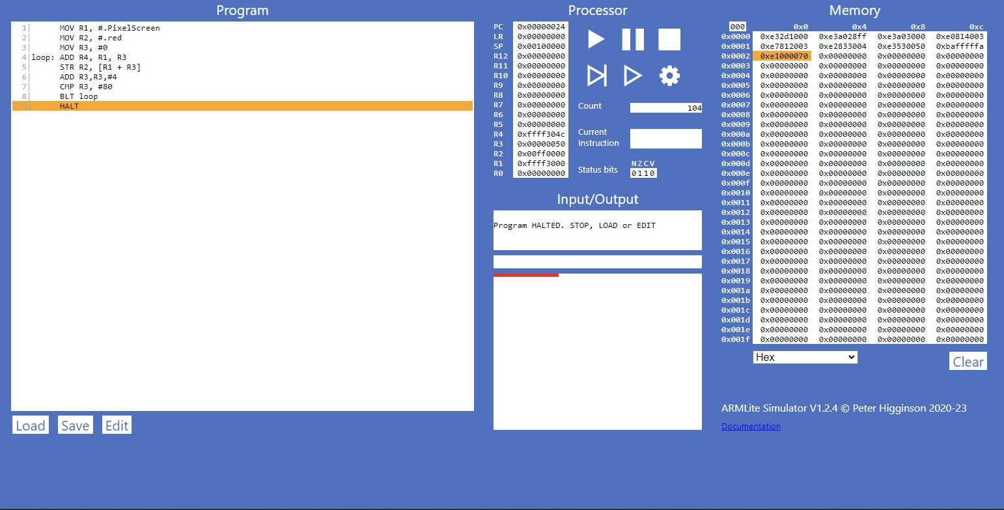

#### ****Excercise 9.2.2****

#### ****Excercise 9.3.1 (a)****

The above code defines an array of 10 32 bit integers.   What is the purpose of the .Align 256 instruction ?

* The .Align 256 instruction is used to align the starting address of arrayLength in memory to ensure that the label is located at an address that is divisible by 256.

#### ****Excercise 9.3.1 (b)****

Add a line of code to the above to read the 5th value of the array to register R0  (i.e,. it should use indirect addressing to access the 5th cell in the array)

MOV R2, #arrayData

MOV R1, #16

LDR R0, [R2 + R1]

HALT

.ALIGN256

arrayLength: 10   
arrayData: 9

8

7

6

5

4

3

2

1

0

#### ****Excercise 9.3.1 (c)****

Now modify your code so that the index to read from in the array is provided in R1.

#### ****Excercise 9.3.2****

Now modify  your code so that it adds up all the values in the array.  Your program should use indexed addressing to access each value and write the result to R0.

#### ****Excercise 9.3.3****

#### ****Excercise 9.4.1****

Using the original array defintiion give in Part 9.3, write an ARMlite program copies all the values from this array into another array of equal size (in reverse order).

#### ****Excercise 9.4.2****

