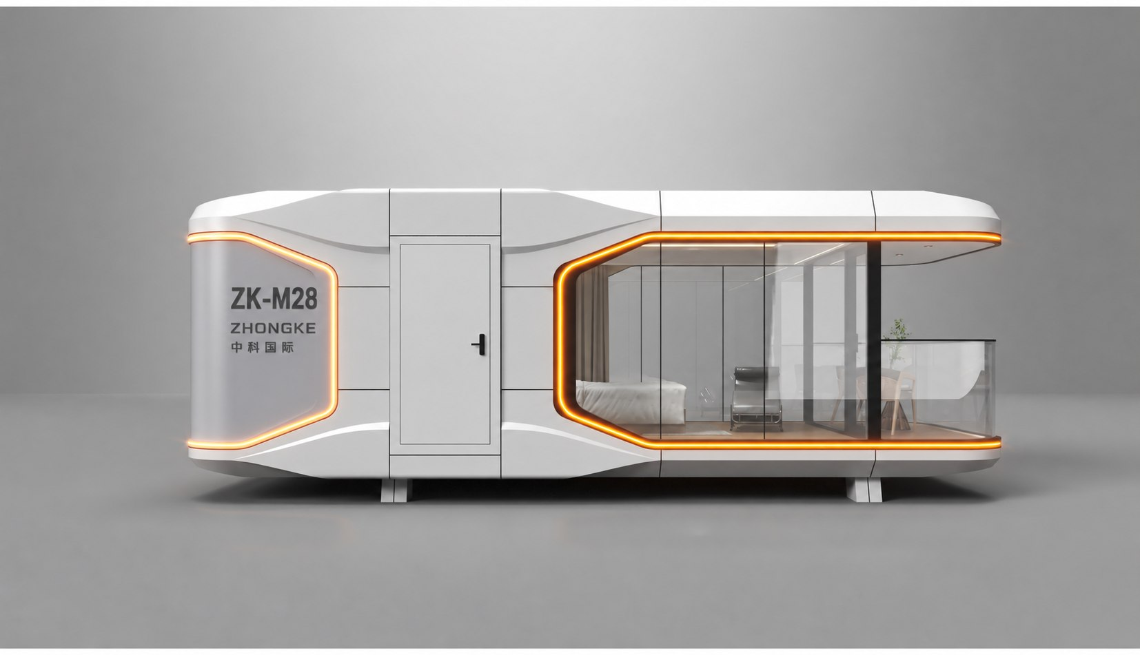
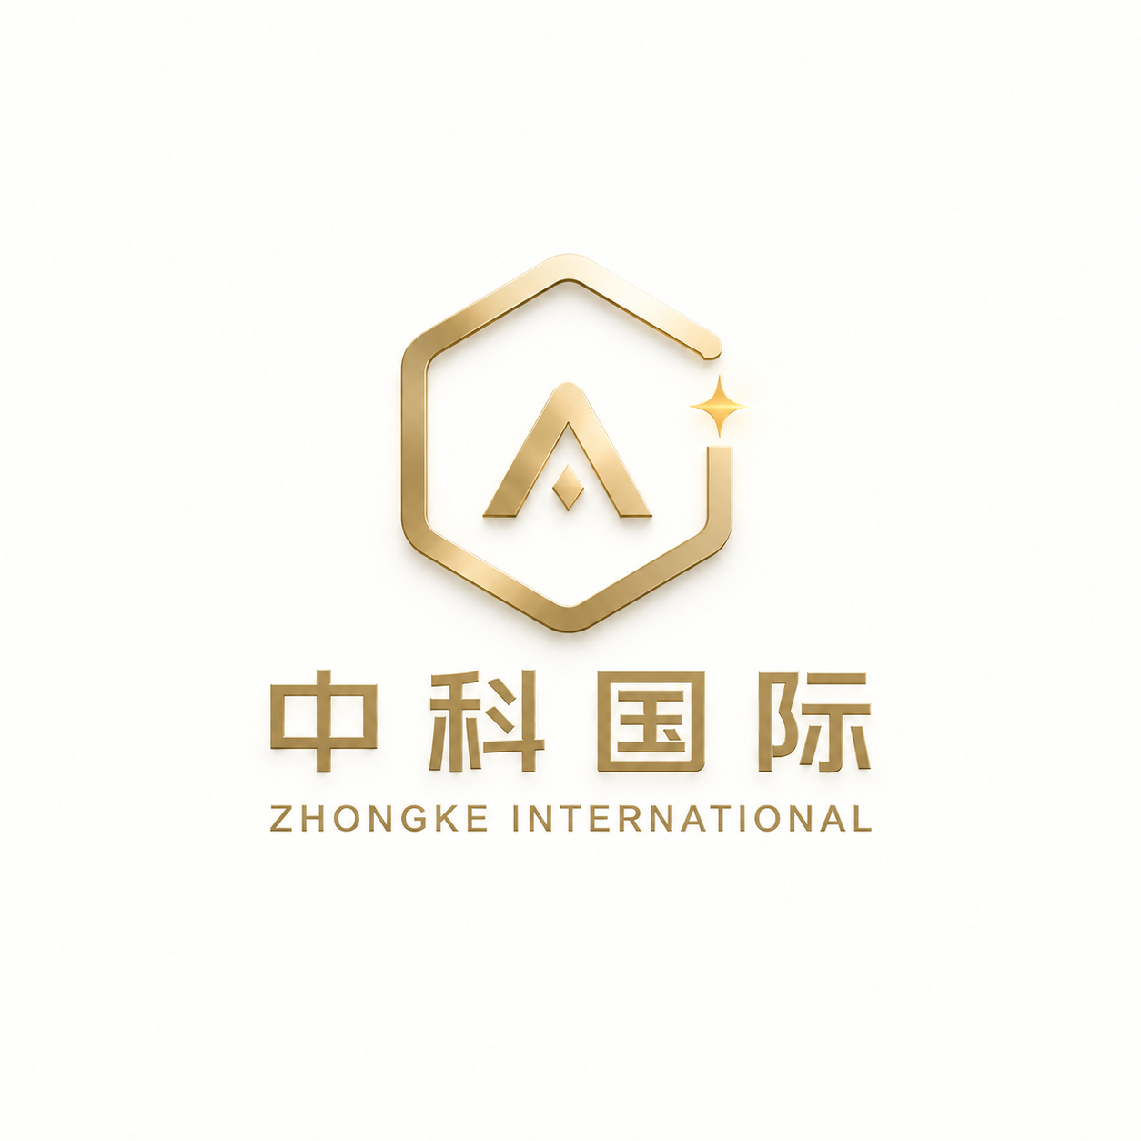
Zhongke Capsule Product Catalog
SMART CAPSULE SERIES | HOSPITALITY SERIES
PRODUCT MODELS | EXTERIOR VIEWS | FLOOR PLANS

Product Model Index
Smart Capsule Series & Hospitality Series
Model | Product Name | Series | Floor Area / Reference Area | Pages
ZK01 | Basic Living Capsule | Smart Capsule Series | Approx. 28 m² | 3–4
ZK02 | Green Luxury Capsule | Smart Capsule Series | Approx. 38 m² | 5–6
ZK03 | Culture & Education Capsule | Smart Capsule Series | Approx. 38 m² | 7–8
ZK04 | Medical Service Capsule | Smart Capsule Series | Approx. 38 m² | 9–10
ZK05 | Terrace Capsule | Smart Capsule Series |  | 11–12
ZK06 | Stacked Resort Suite Capsule | Smart Capsule Series | Approx. 32 m² per capsule; 64 m² in two levels | 13–14
ZK07 | Commercial Service Capsule | Smart Capsule Series | Approx. 18-30 m² | 15–16
ZK08 | Emergency Command Capsule | Smart Capsule Series | Approx. 28-40 m² | 17–18
ZK09 | Flagship Custom Capsule | Smart Capsule Series | 38-44 m² | 19–20
ABADI | Premium Customized Smart Capsule | Smart Capsule Series |  | 21–22
ZK-ME | Compact Capsule | Hospitality Series |  | 23
ZK-M22 | Classic View Capsule | Hospitality Series | 22.44 m² | 24–25
ZK-M28 | Panoramic King Bed Capsule | Hospitality Series | 28 m² | 26–27
ZK-M28T | Panoramic Twin Bed Capsule | Hospitality Series |  | 28–29
ZK-M38 | Family View Capsule | Hospitality Series | 38 m² | 30–31
ZK-MF | Panoramic Flagship Capsule | Hospitality Series |  | 32–34

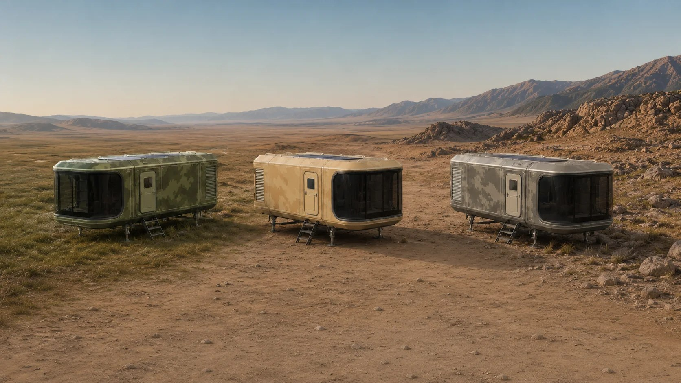
ZK01 Basic Living Capsule
Smart Capsule Series Reference area: Approx. 28 m²
Applications: Standard accommodation and basic campsite units
A standardized living space designed for everyday accommodation.
ZK01 Exterior View

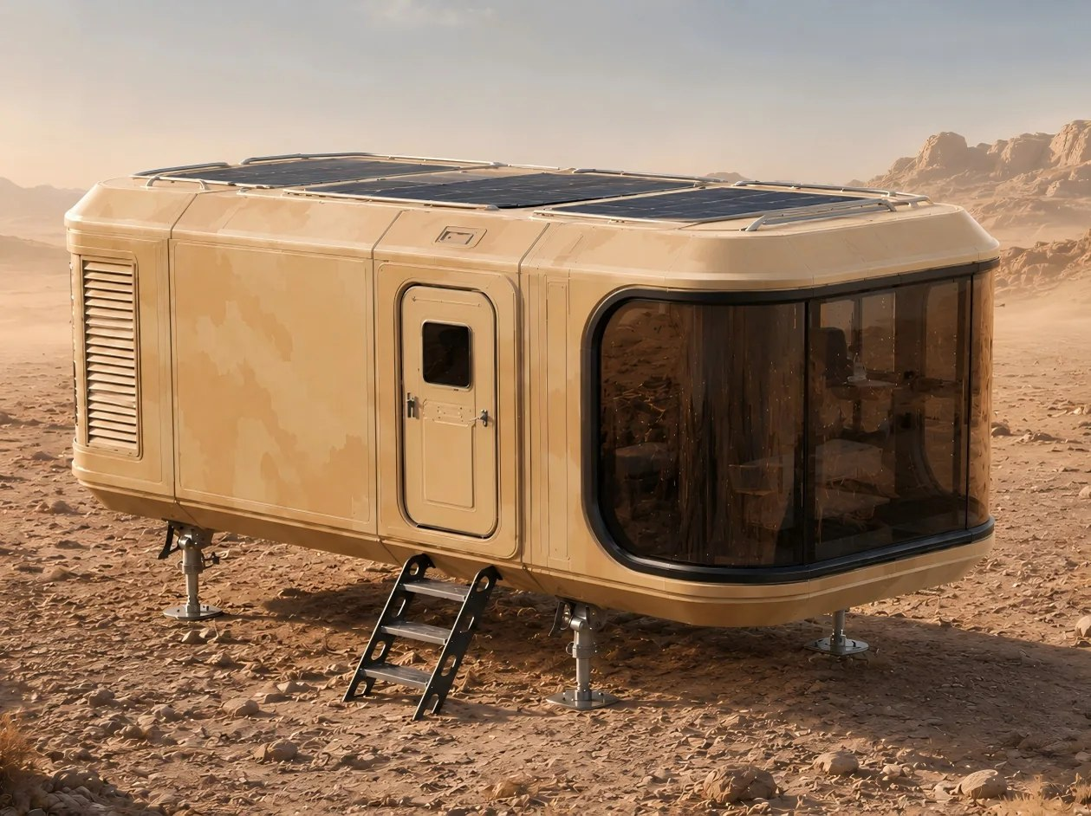
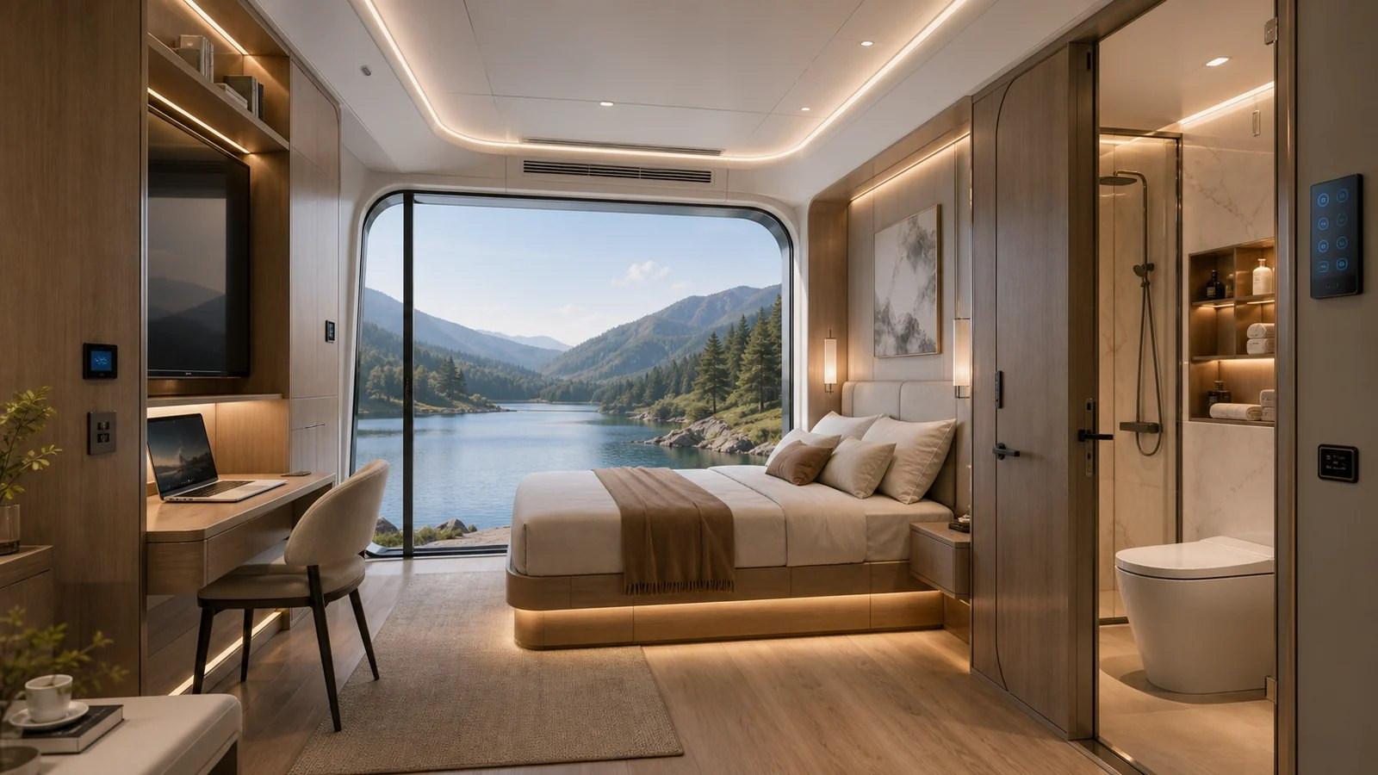
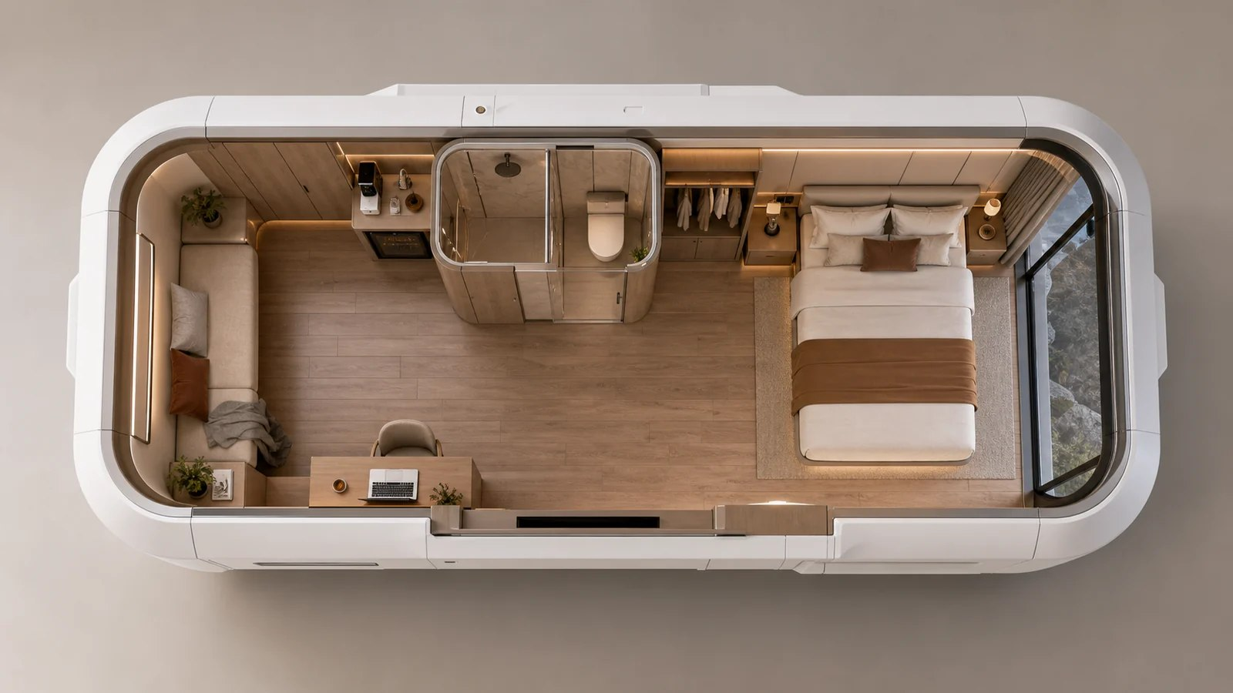
ZK01 Interiors & Floor Plans
Basic Living Capsule INTERIORS & FLOOR PLANS
ZK01 Main Product View
ZK01 Interior 3D Illustration
ZK01 Floor Plan 3D Illustration

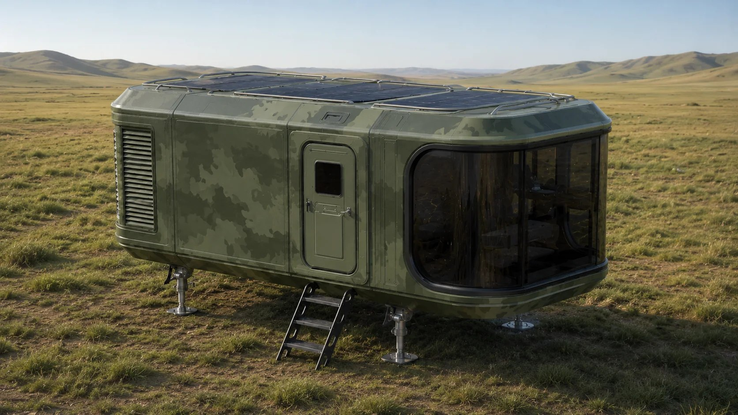
ZK02 Green Luxury Capsule
Smart Capsule Series Reference area: Approx. 38 m²
Applications: Off-grid accommodation, eco-resorts and energy demonstration projects
A quality resort capsule combining comfortable accommodation with green energy options.
ZK02 Exterior View

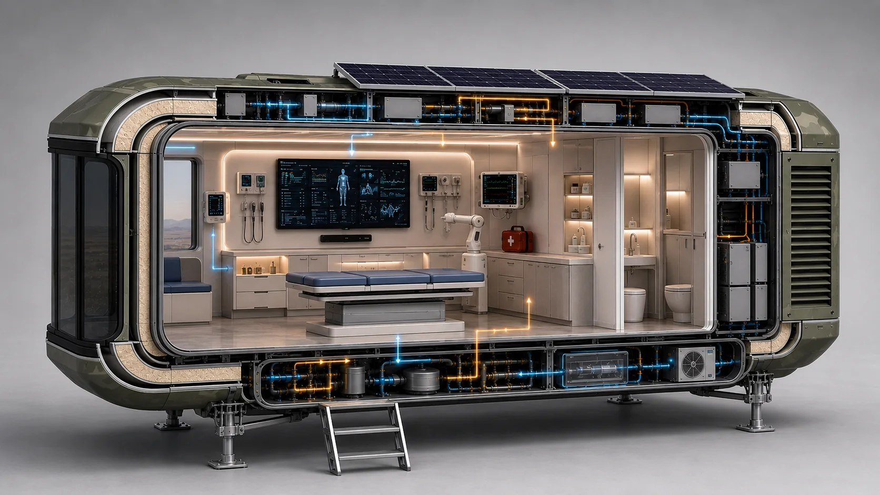
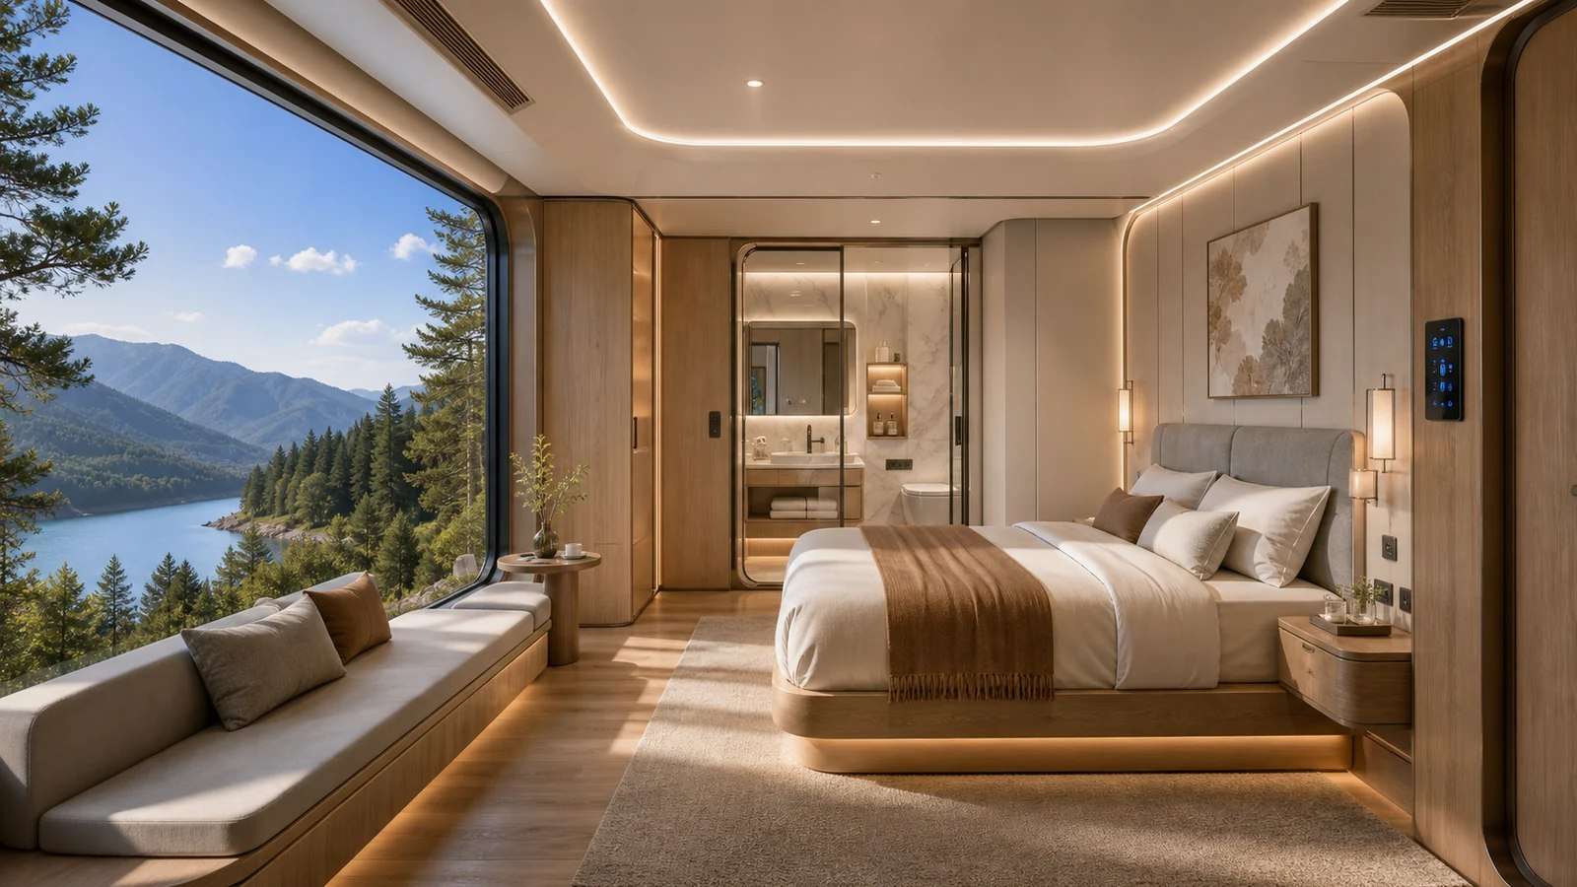
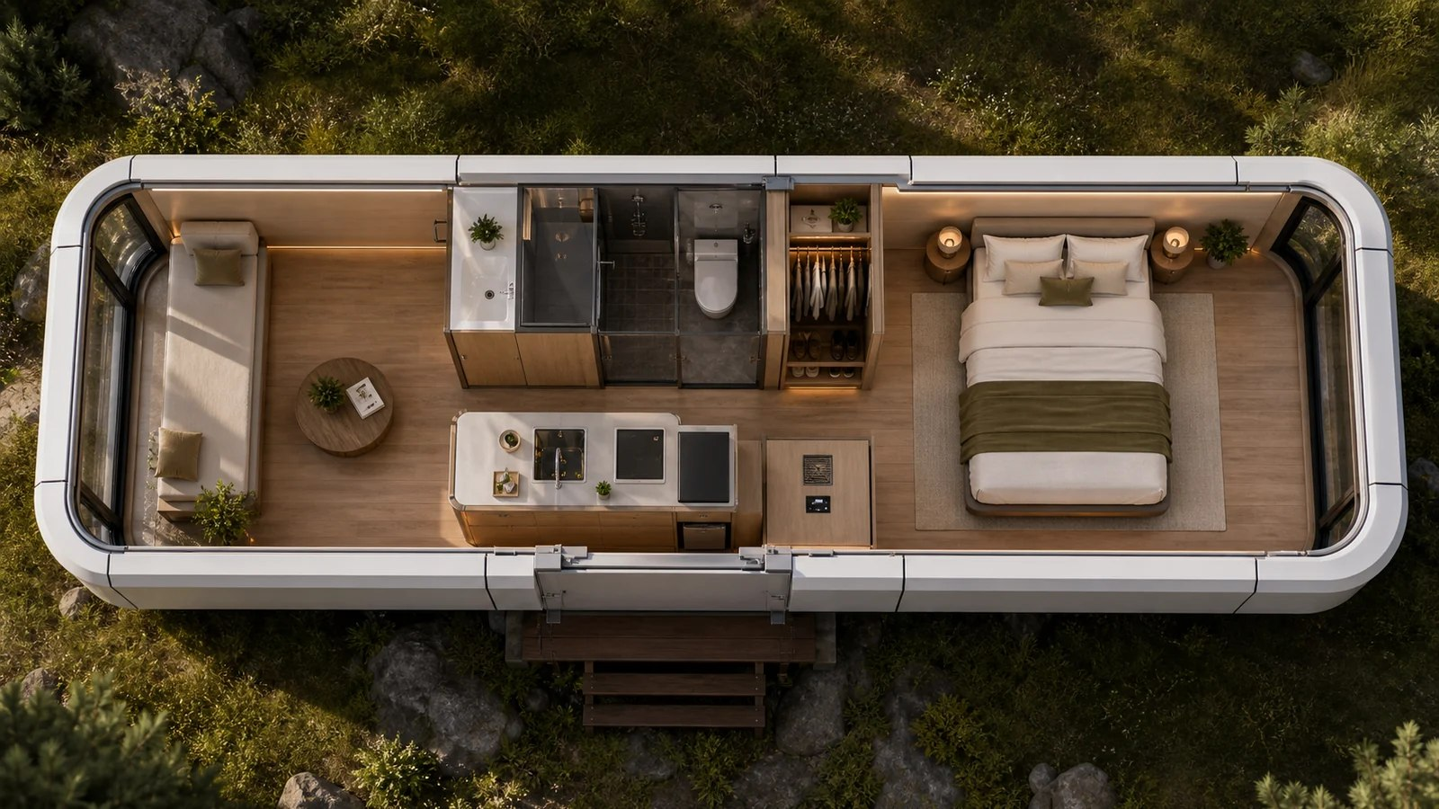
ZK02 Interiors & Floor Plans
Green Luxury Capsule INTERIORS & FLOOR PLANS
ZK02 Solar PV Configuration
ZK02 Interior 3D Illustration
ZK02 Floor Plan 3D Illustration

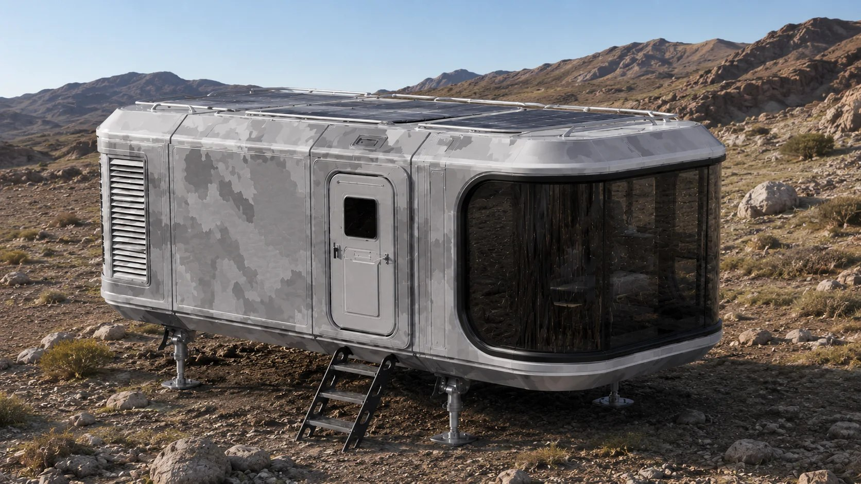
ZK03 Culture & Education Capsule
Smart Capsule Series Reference area: Approx. 38 m²
Applications: Exhibitions, education, training and remote meetings
A compact mobile space for communication, training and interactive exhibitions.
ZK03 Exterior View

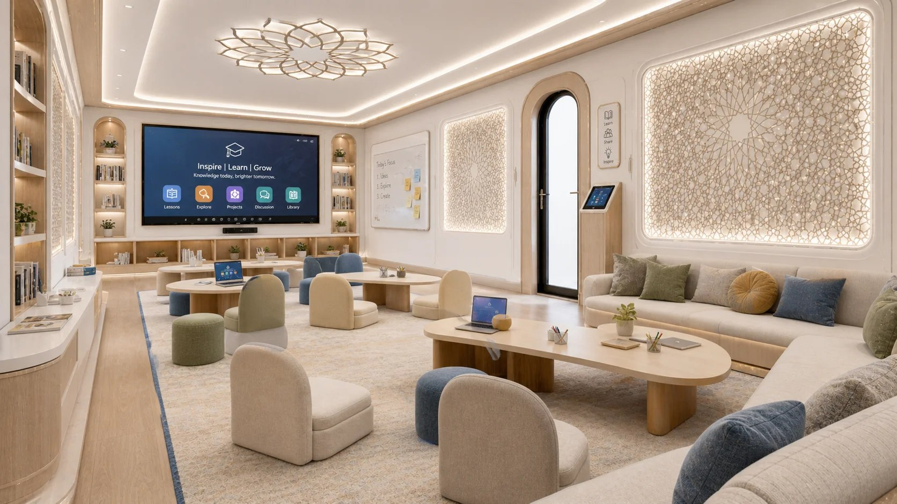
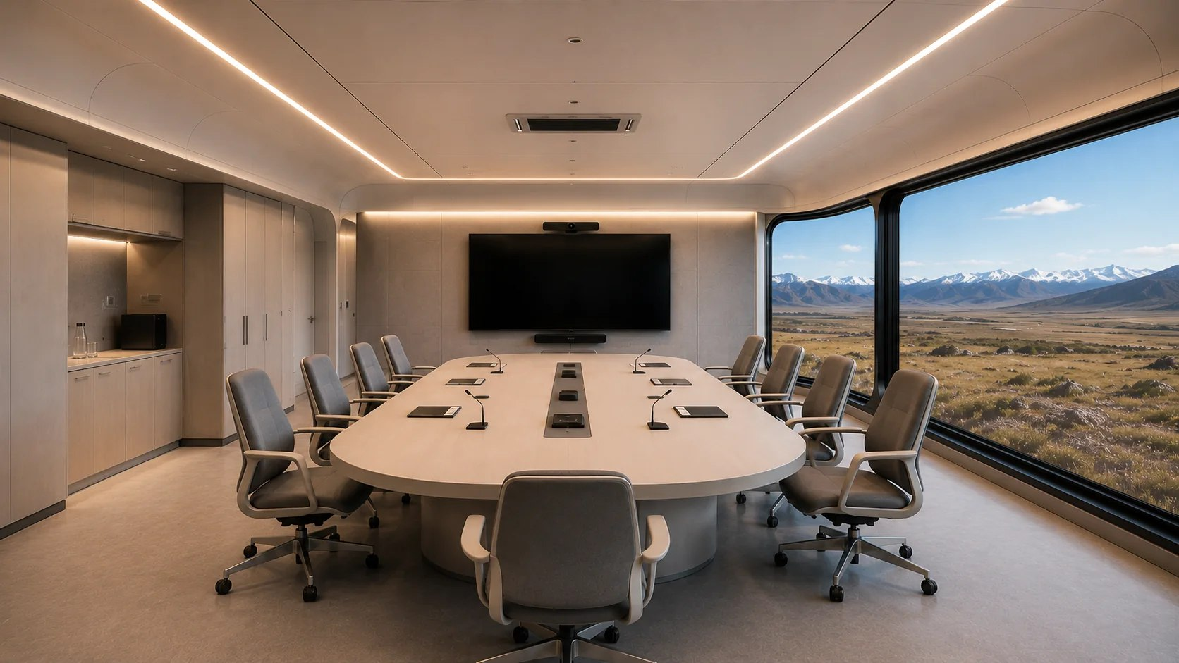
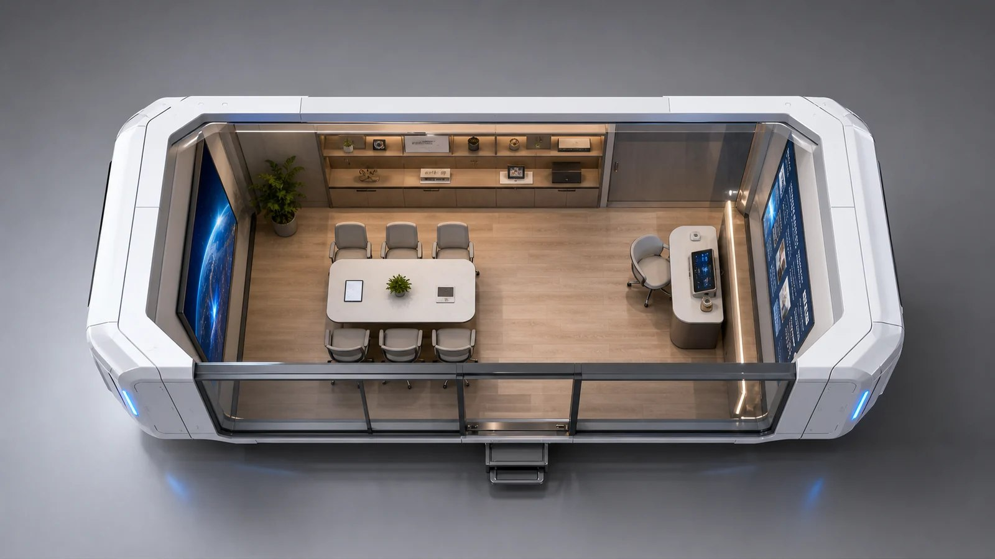
ZK03 Interiors & Floor Plans
Culture & Education Capsule INTERIORS & FLOOR PLANS
ZK03 Education Space Interior
ZK03 Meeting Space Interior
ZK03 Floor Plan 3D Illustration

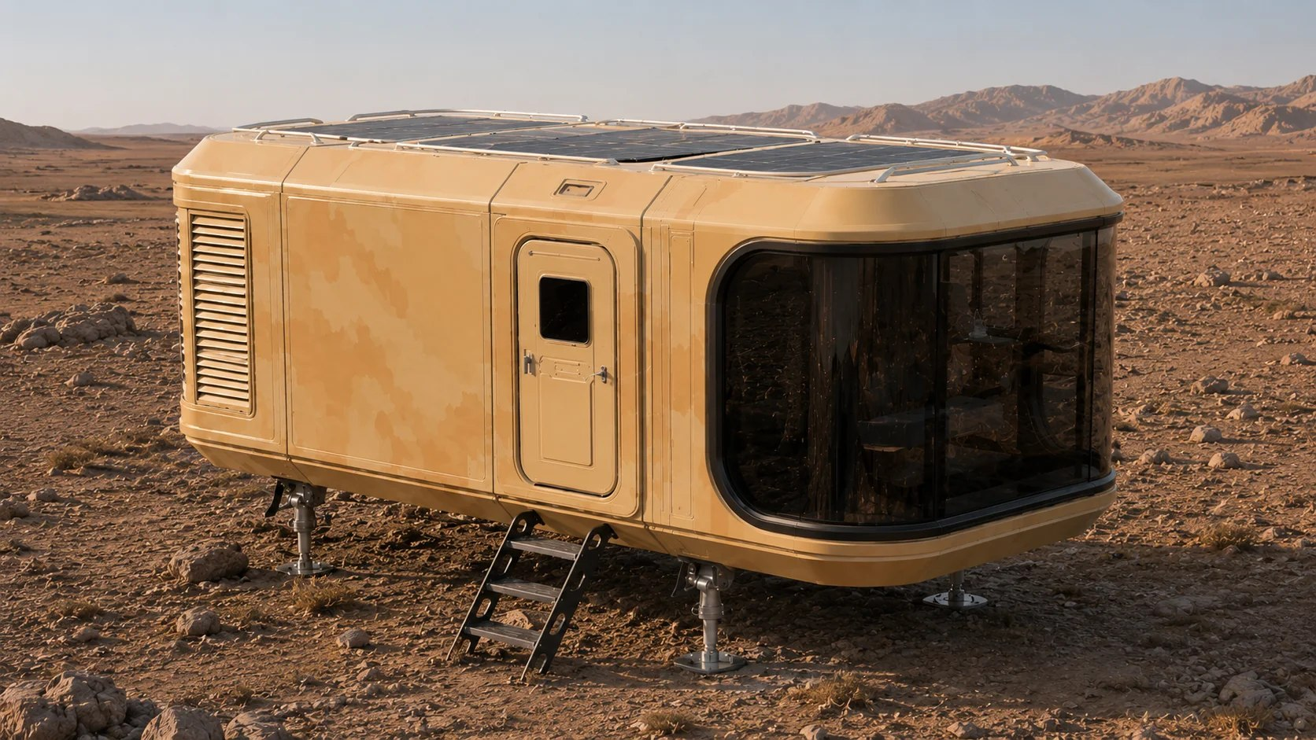
ZK04 Medical Service Capsule
Smart Capsule Series Reference area: Approx. 38 m²
Applications: Telemedicine, basic testing and emergency health services
A dedicated space bringing consultation, testing and health support to the service location.
ZK04 Medical Capsule Exterior

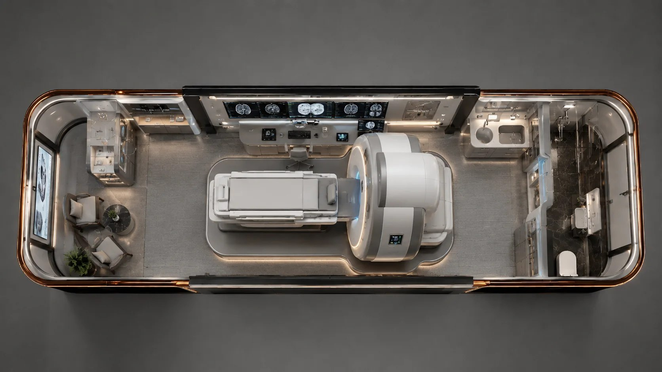
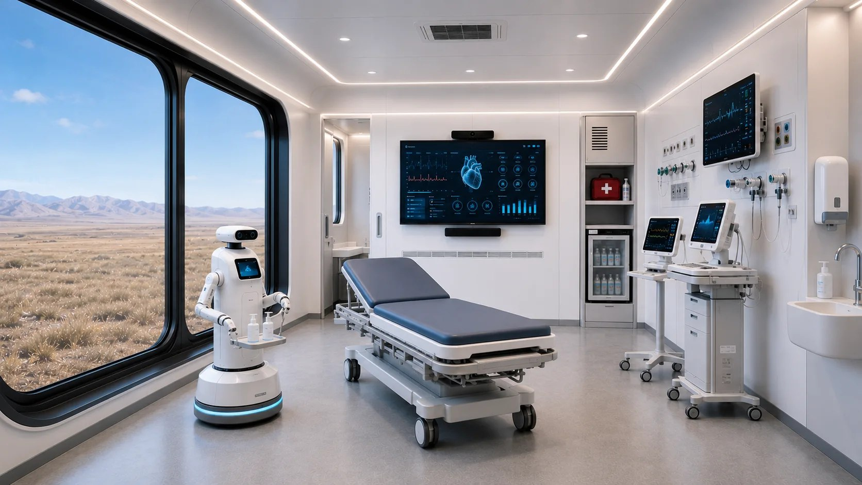
ZK04 Interiors & Floor Plans
Medical Service Capsule INTERIORS & FLOOR PLANS
ZK04 Interior View
ZK04 Medical Space Interior

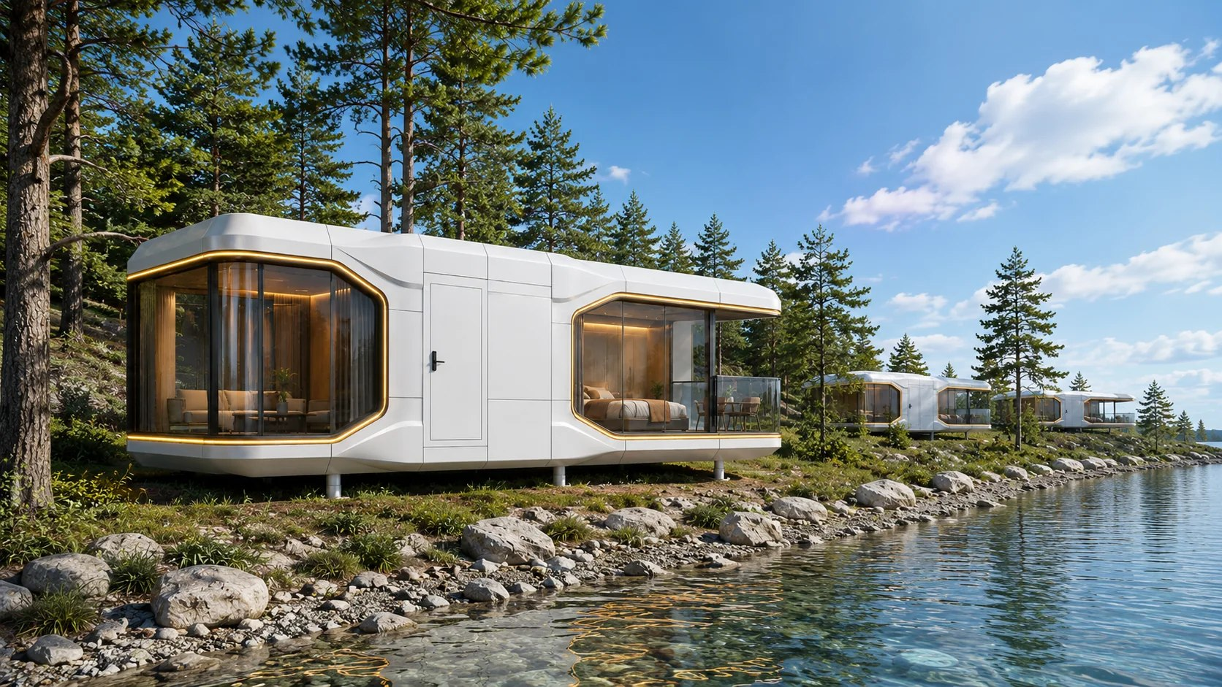
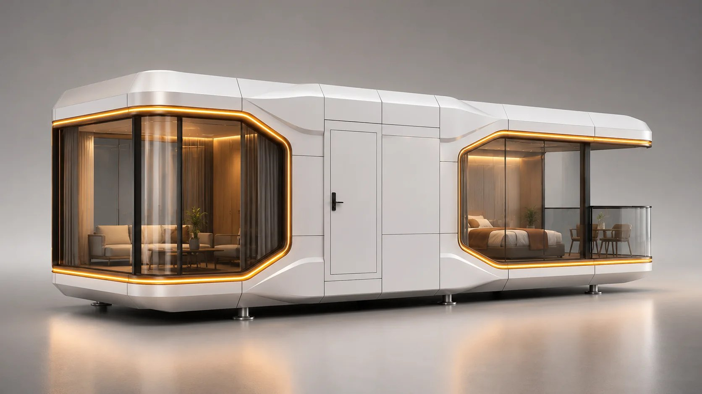
ZK05 Terrace Capsule
Smart Capsule Series
Applications: Terrace accommodation, resort camps and scenic guest rooms
A smart capsule with a terrace for tourism accommodation and scenic resort projects.
ZK05 Terrace Capsule Exterior
ZK05 Terrace Capsule View

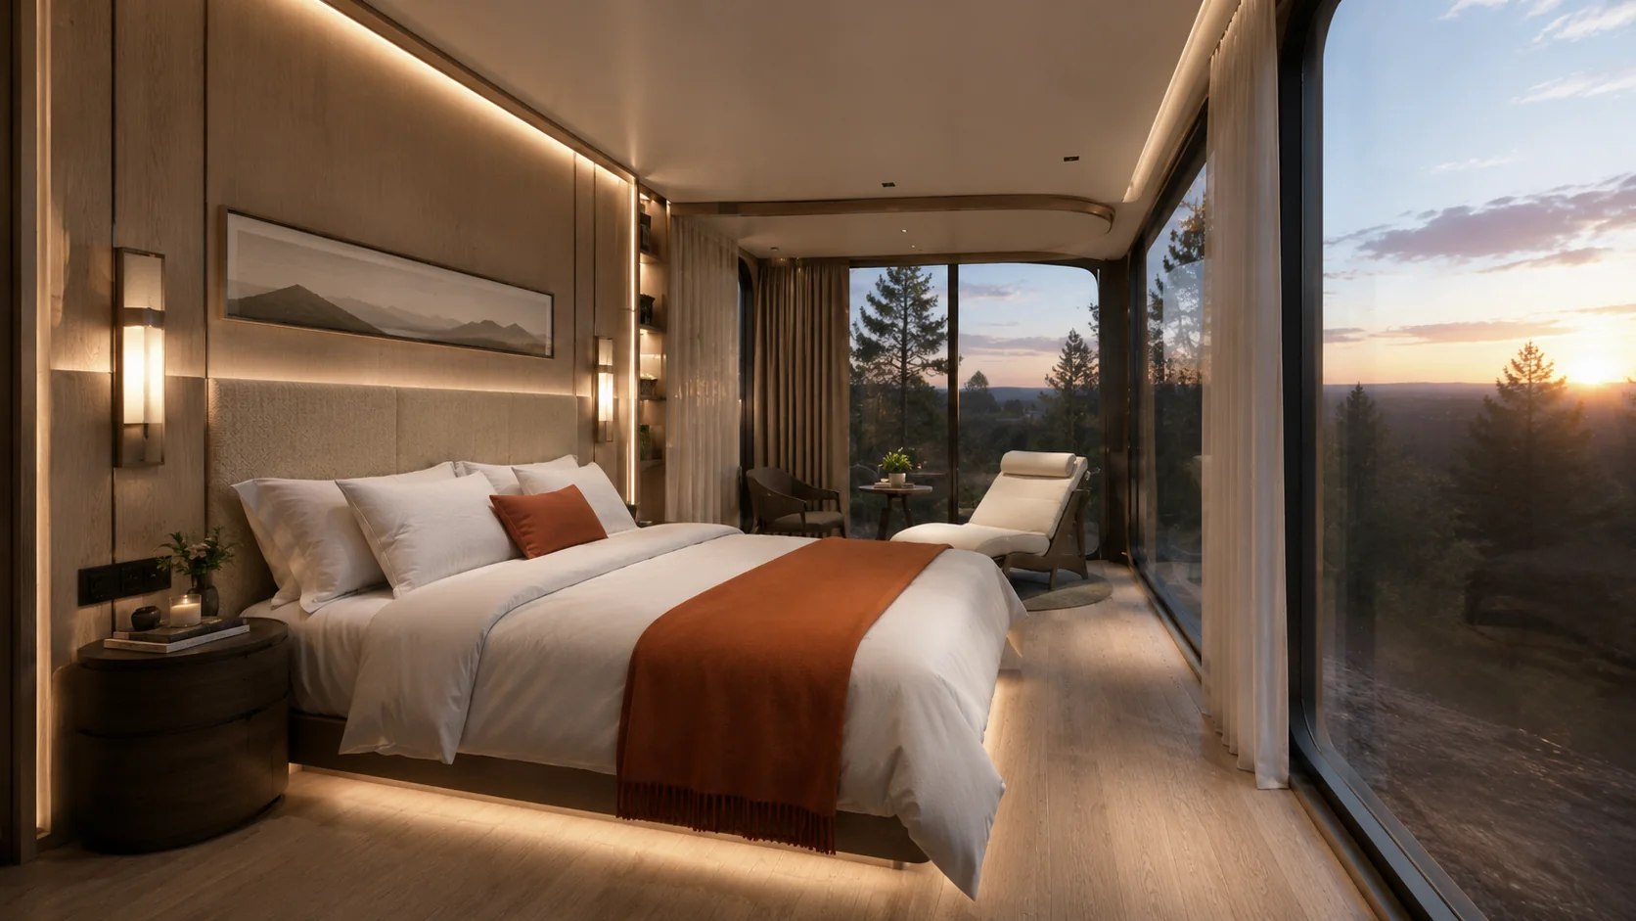
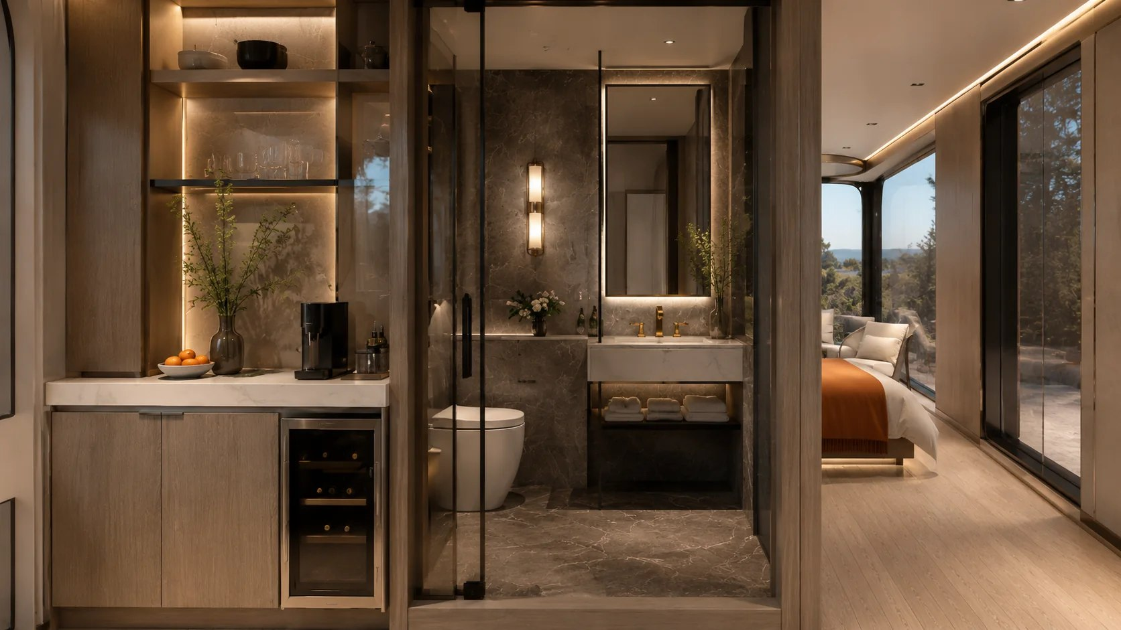
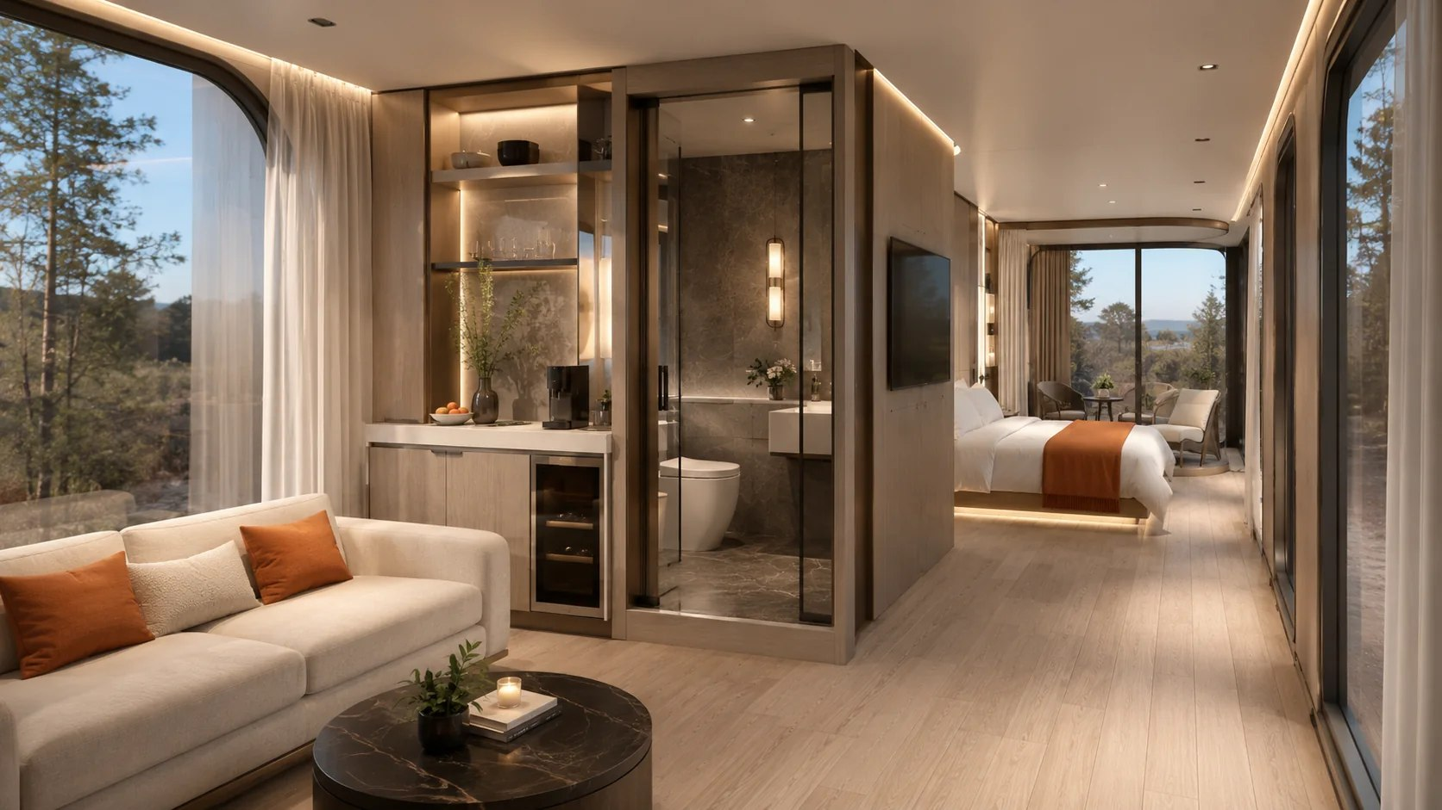
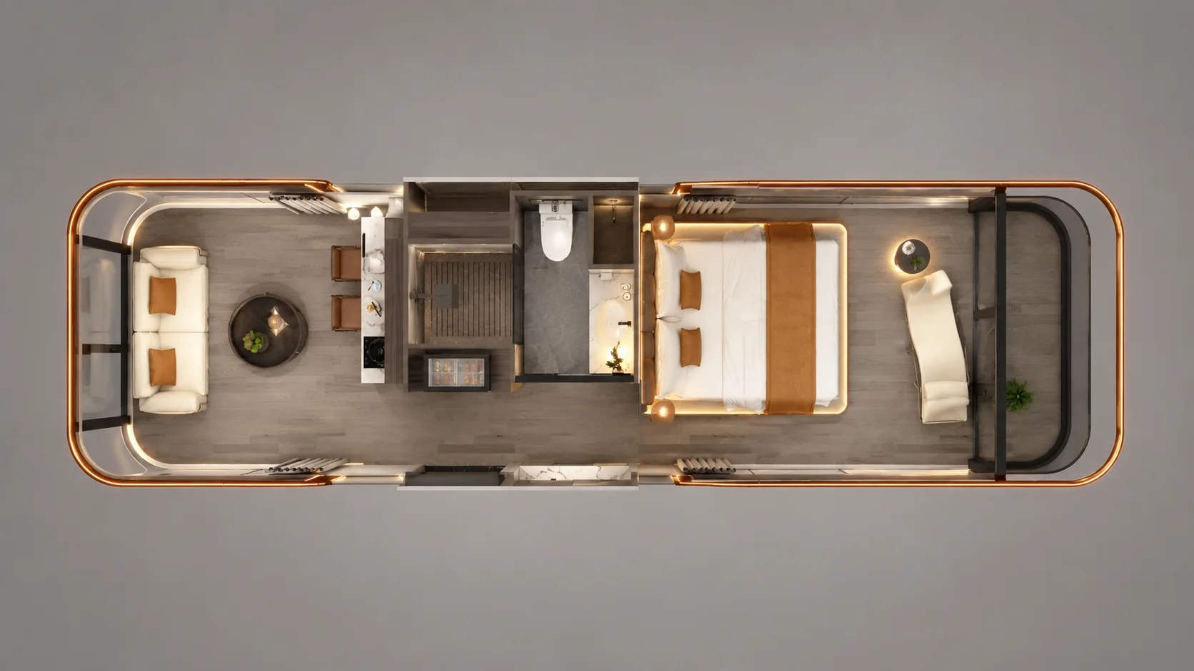
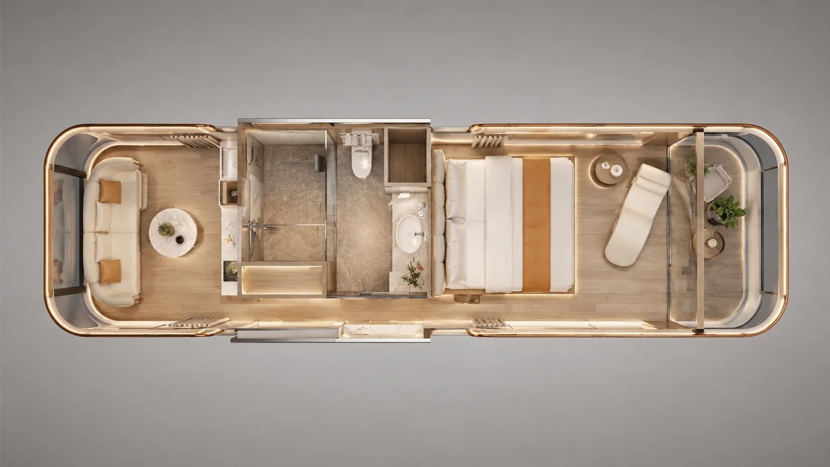
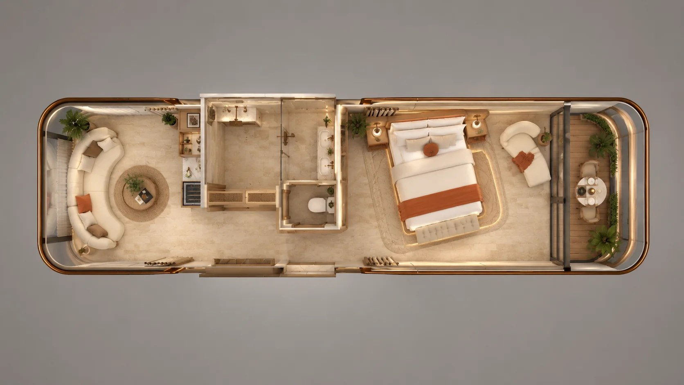
ZK05 Interiors & Floor Plans
Terrace Capsule INTERIORS & FLOOR PLANS
ZK05 Bedroom Interior
ZK05 Suite Interior
ZK05 Living Room Interior
ZK05 Interior Layout 01
ZK05 Interior Layout 02
ZK05 Interior Layout 03

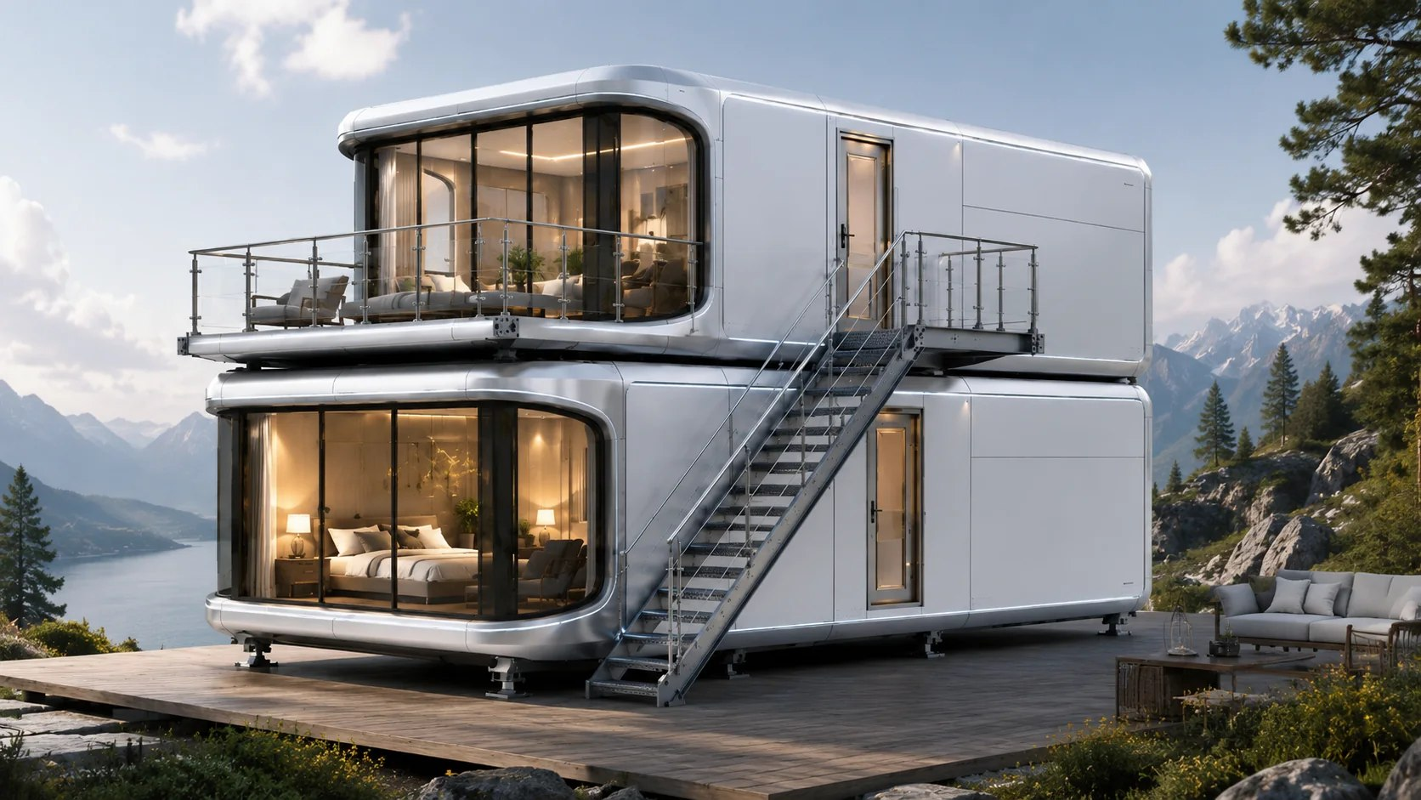
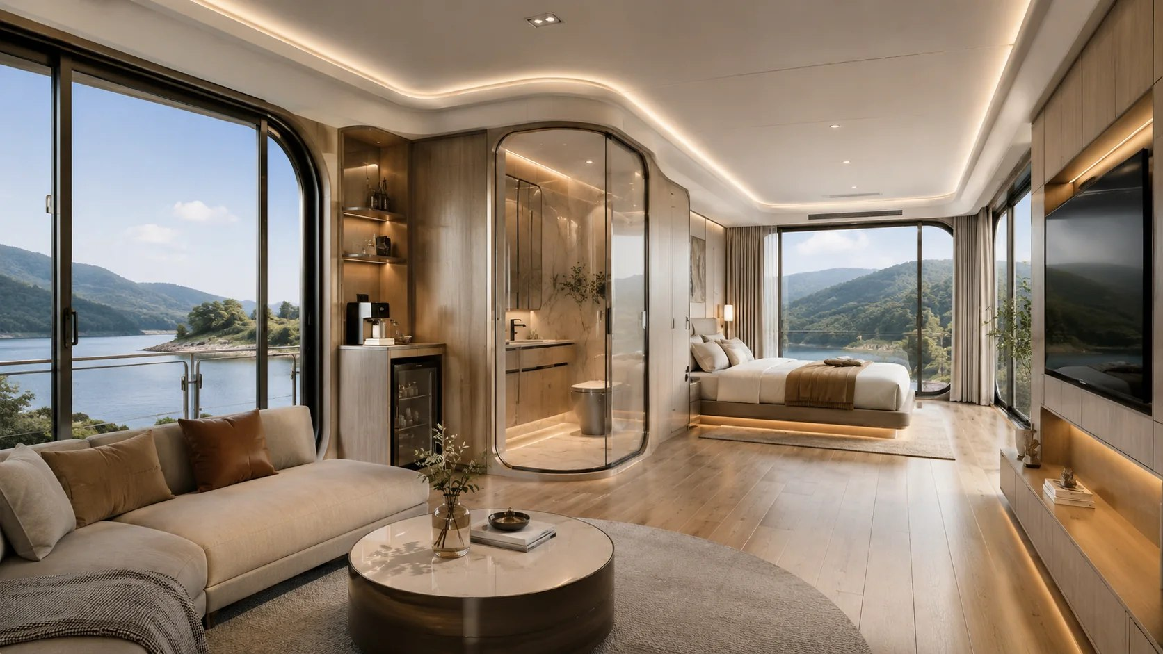
ZK06 Stacked Resort Suite Capsule
Smart Capsule Series Reference area: Approx. 32 m² per capsule; 64 m² in two levels
Applications: Stacked scenic accommodation and boutique hospitality clusters
A stacked accommodation capsule for scenic destinations and boutique resort projects.
ZK06 Two-Level Configuration Exterior
ZK06 Suite Living Room Interior

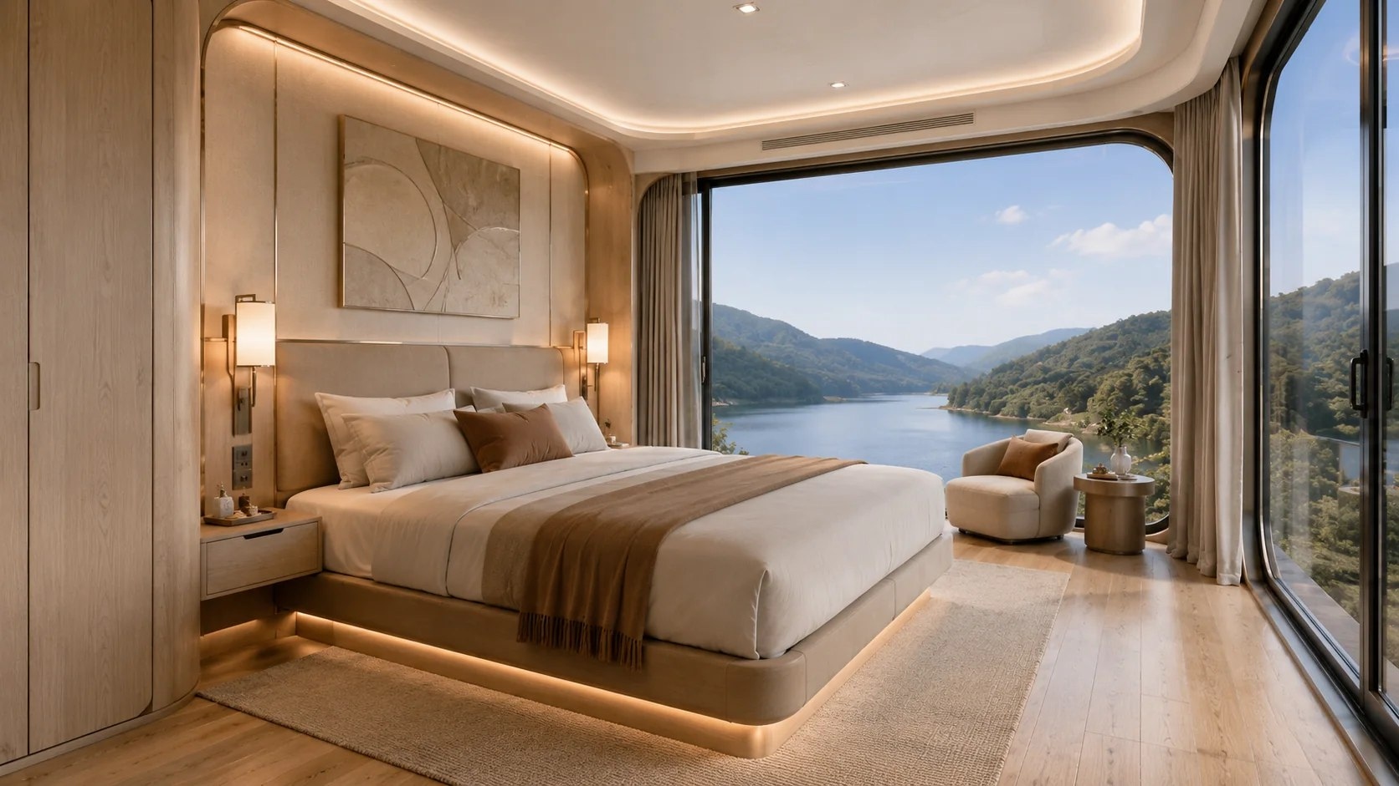
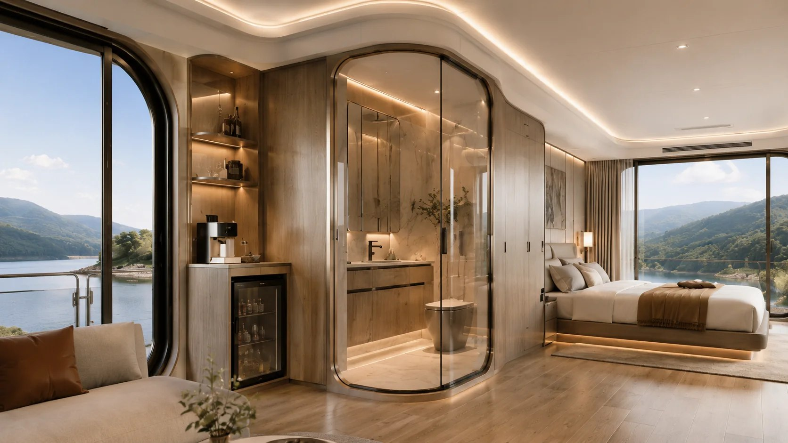
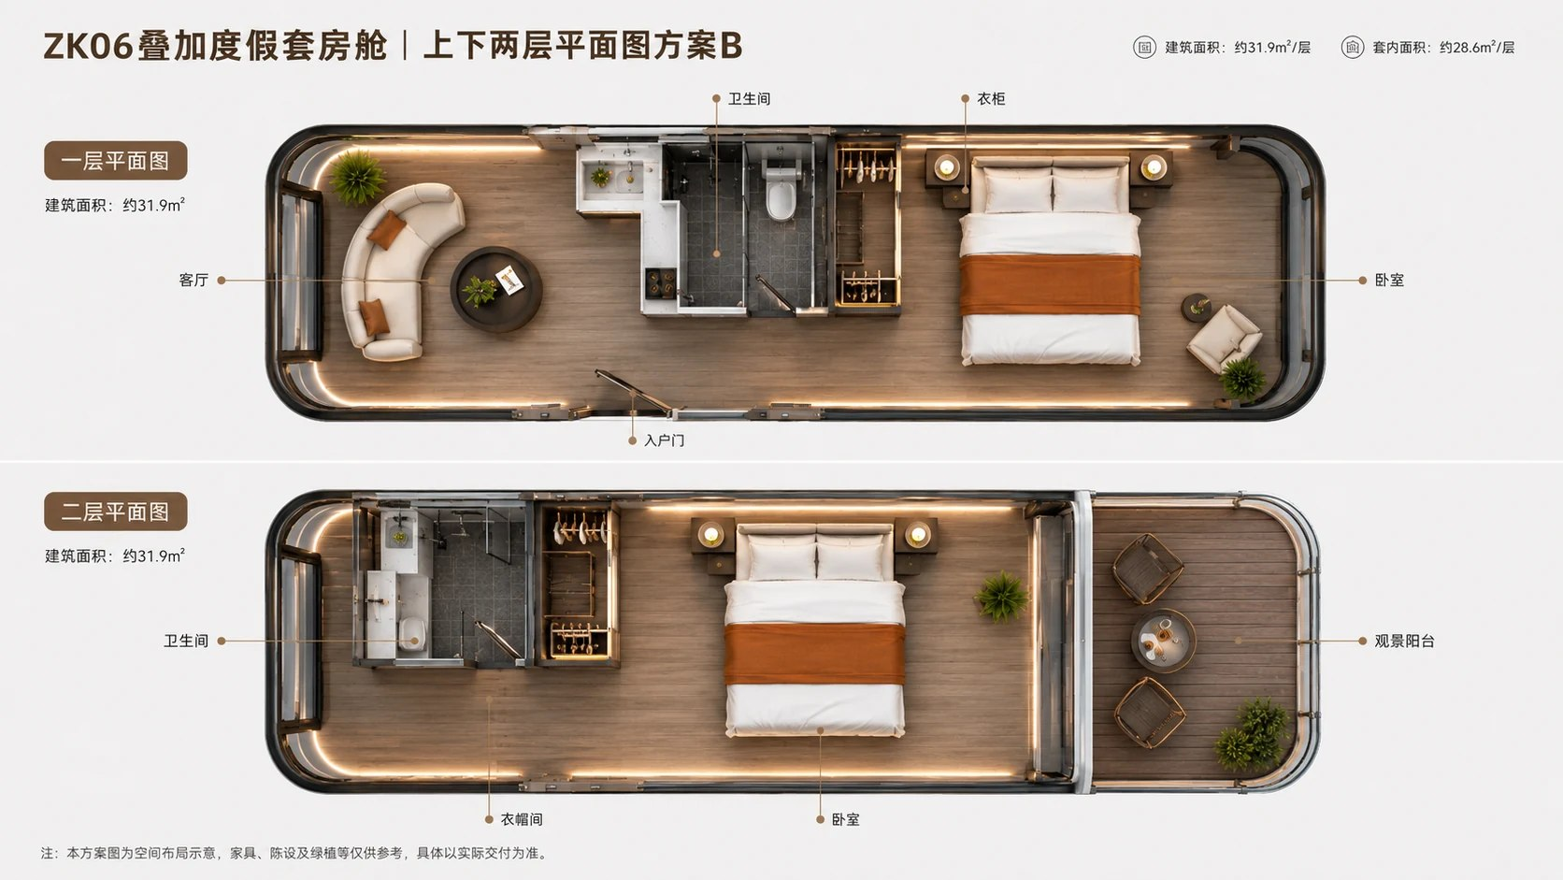
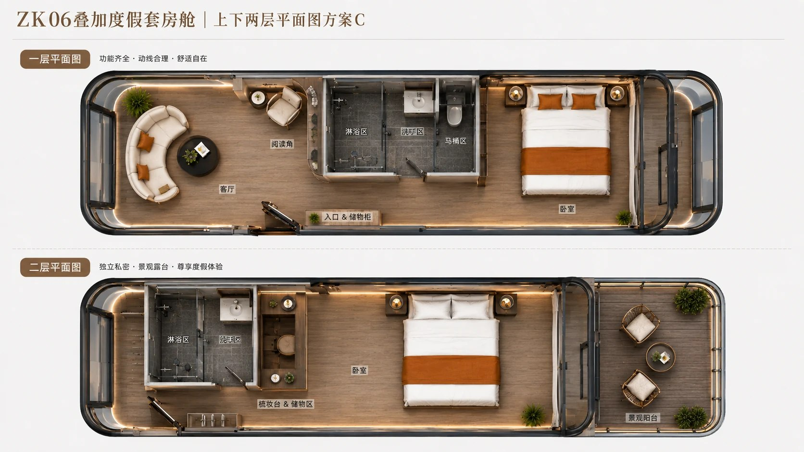
ZK06 Interiors & Floor Plans
Stacked Resort Suite Capsule INTERIORS & FLOOR PLANS
ZK06 Scenic Bedroom Interior
ZK06 Suite Interior
ZK06 Two-Level Floor Plan - Option B
ZK06 Two-Level Floor Plan - Option C
B: Ground / upper floor plans; approx. gross area 31.9 m² and internal area 28.6 m² per level. Ground: living room, bathroom, wardrobe, bedroom and entrance. Upper: bathroom, dressing room, bedroom and scenic balcony. Furniture, fittings and planting illustrate the layout; delivery follows the agreed specification. C: Ground: living room, reading nook, shower, washbasin, toilet, bedroom, entrance and storage; complete functions, efficient circulation and comfort. Upper: shower, washbasin, bedroom, dressing / storage area and scenic balcony; privacy, scenic terrace and a premium resort experience.

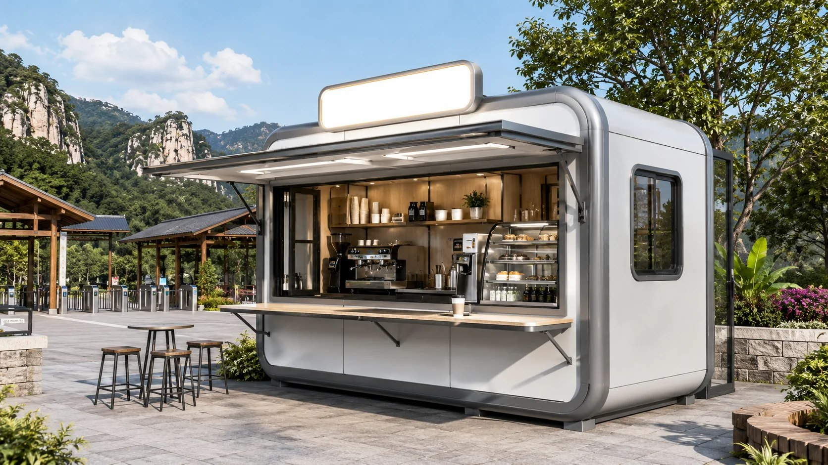
ZK07 Commercial Service Capsule
Smart Capsule Series Reference area: Approx. 18-30 m²
Applications: Cafés, retail, ticketing, customer service and pop-up operations
A compact unit for rapid deployment of commercial operations and service counters.
ZK07 Commercial Service Capsule Exterior

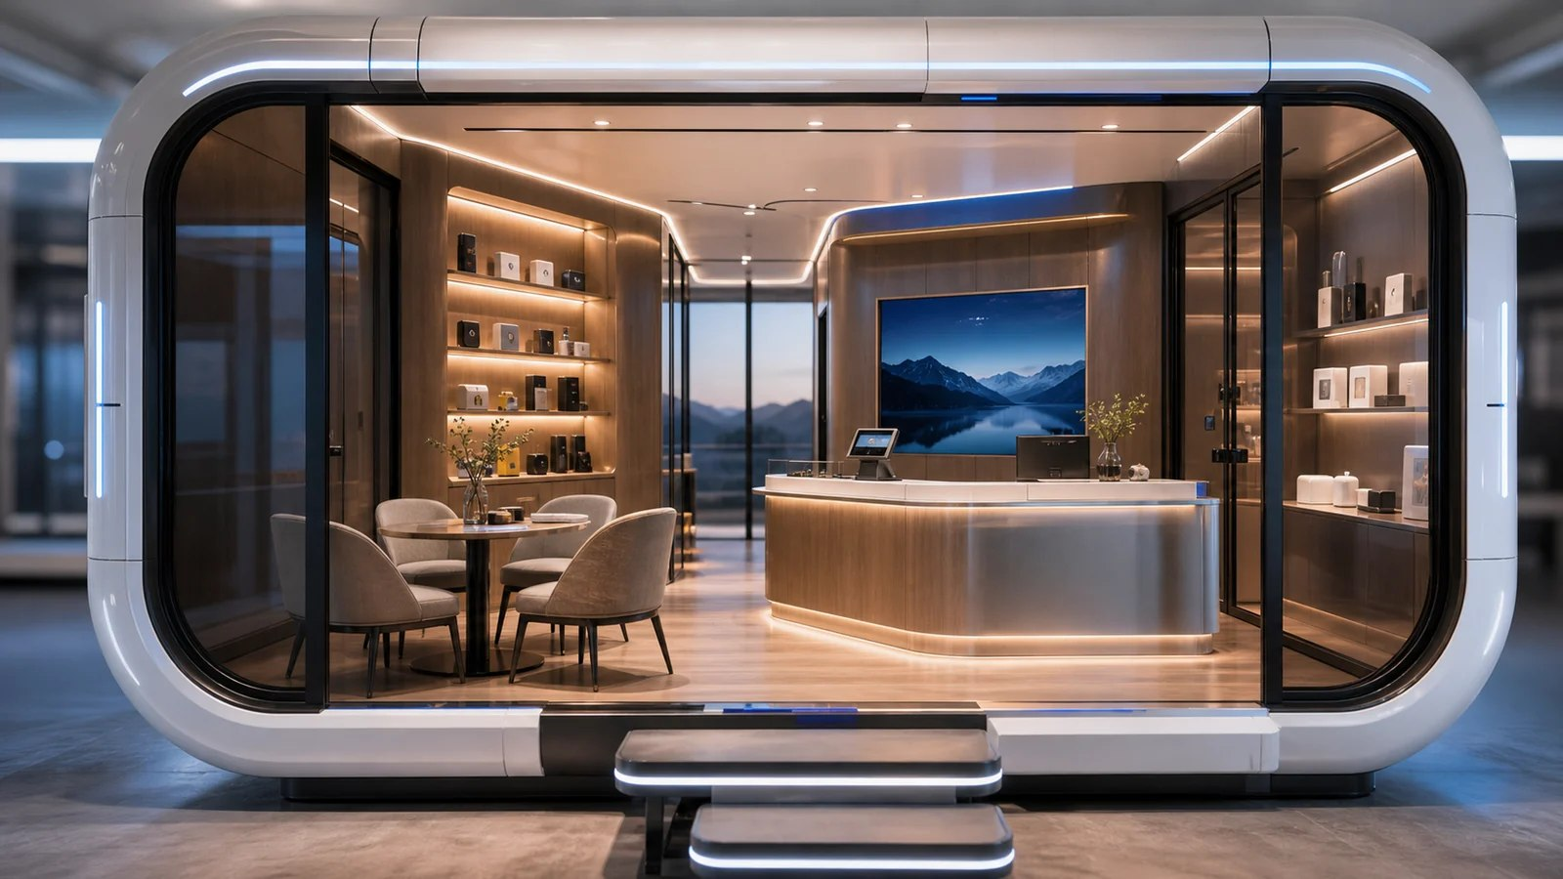
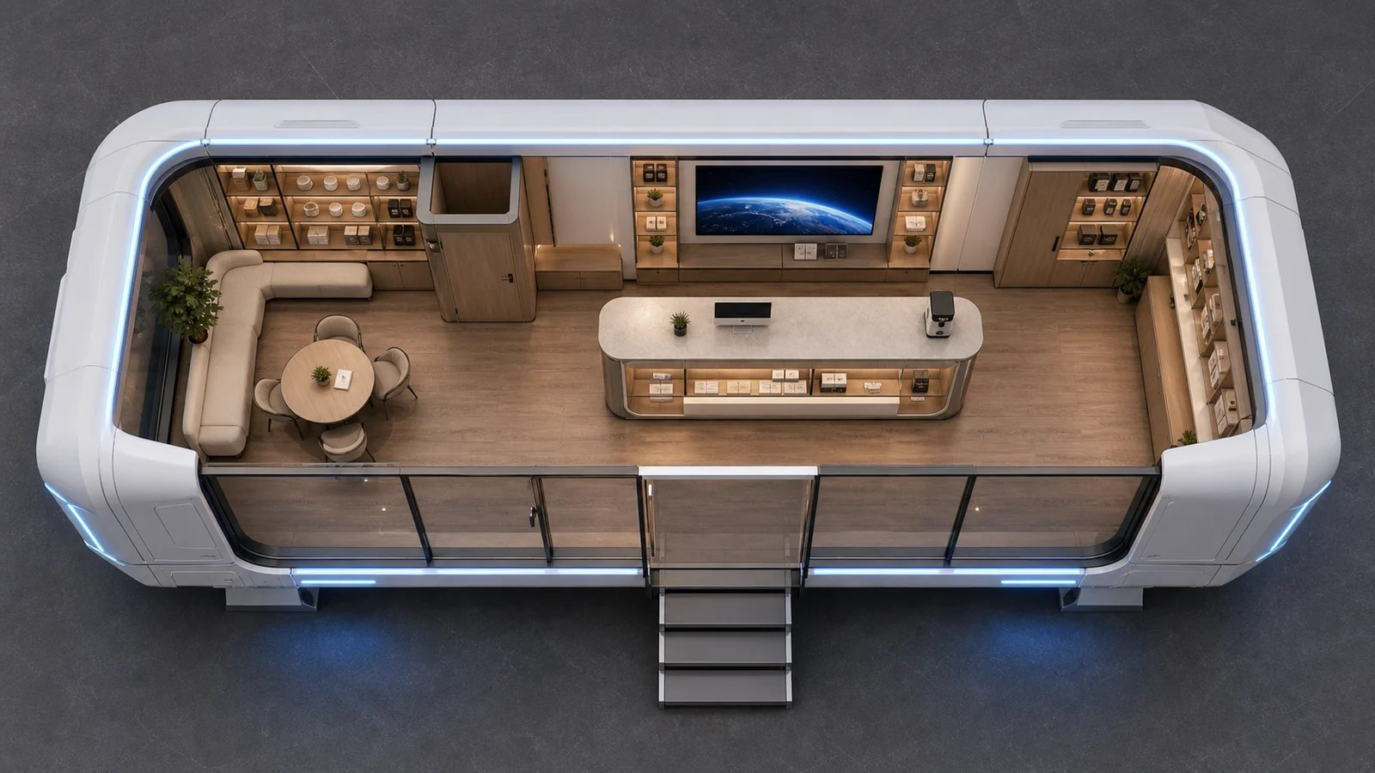
ZK07 Interiors & Floor Plans
Commercial Service Capsule INTERIORS & FLOOR PLANS
ZK07 Interior 3D Illustration
ZK07 Floor Plan 3D Illustration

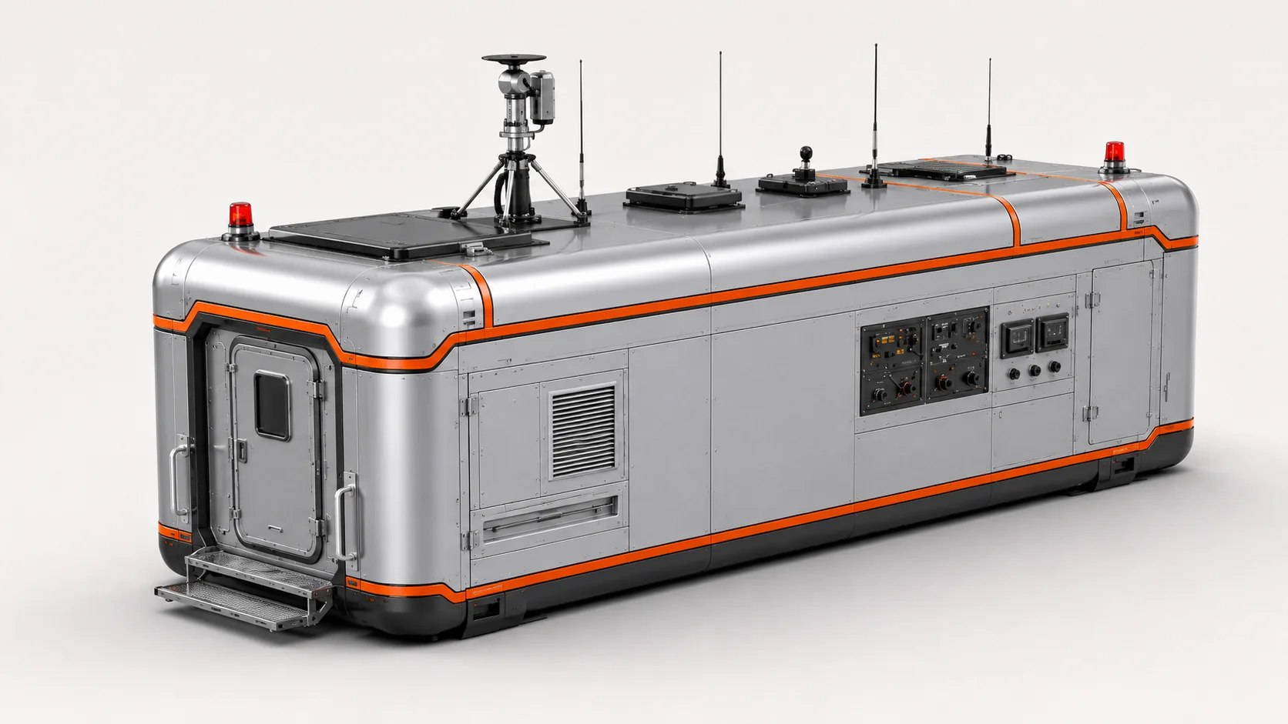
ZK08 Emergency Command Capsule
Smart Capsule Series Reference area: Approx. 28-40 m²
Applications: Rescue command, communications hubs and emergency support
A functional support space for rescue operations, communications and on-site coordination.
ZK08 Emergency Command Capsule Exterior

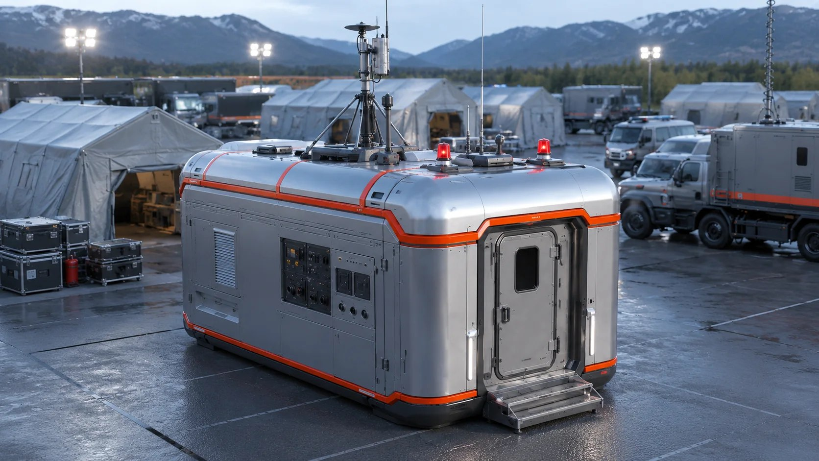
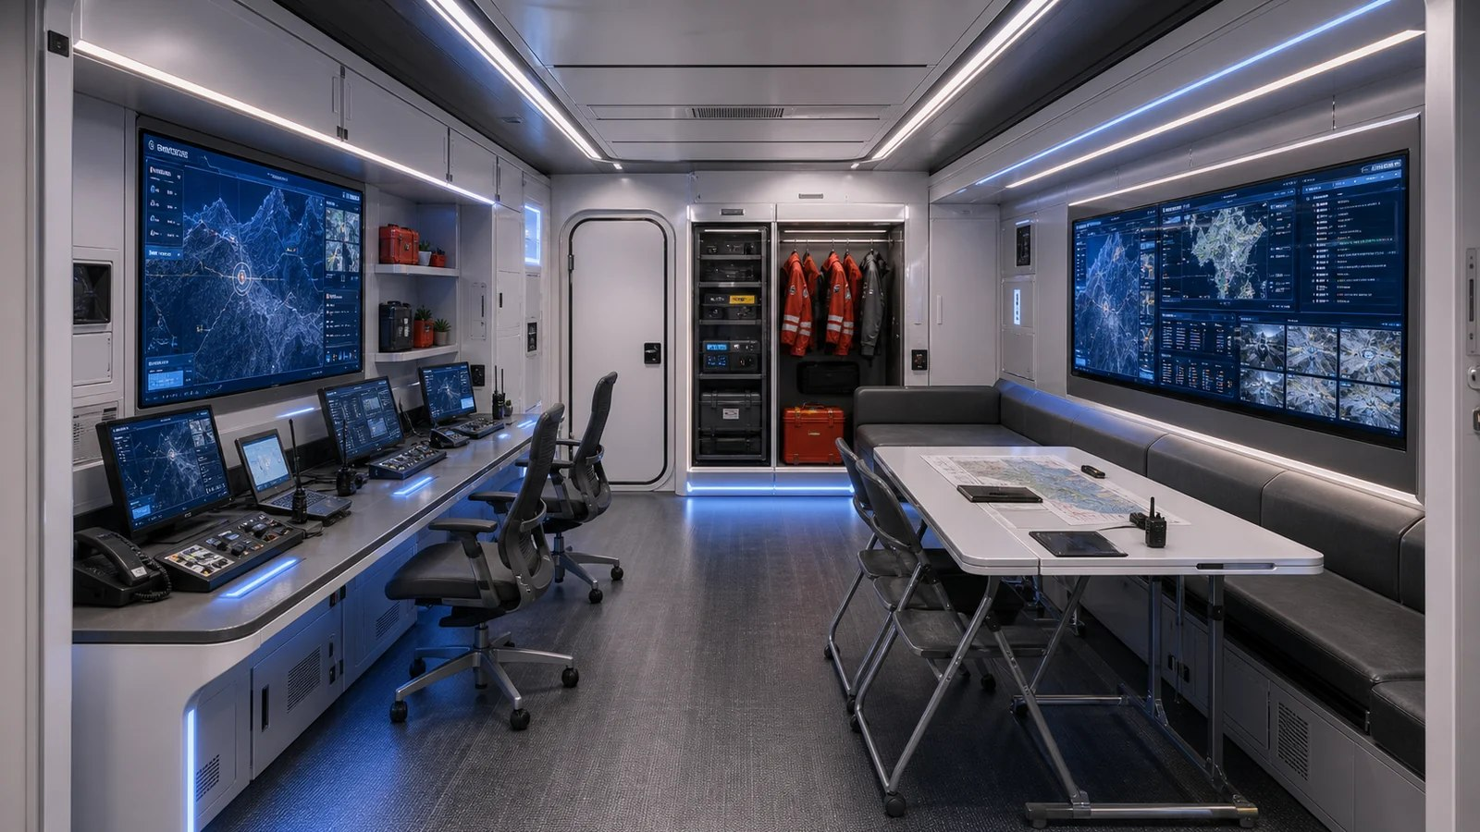
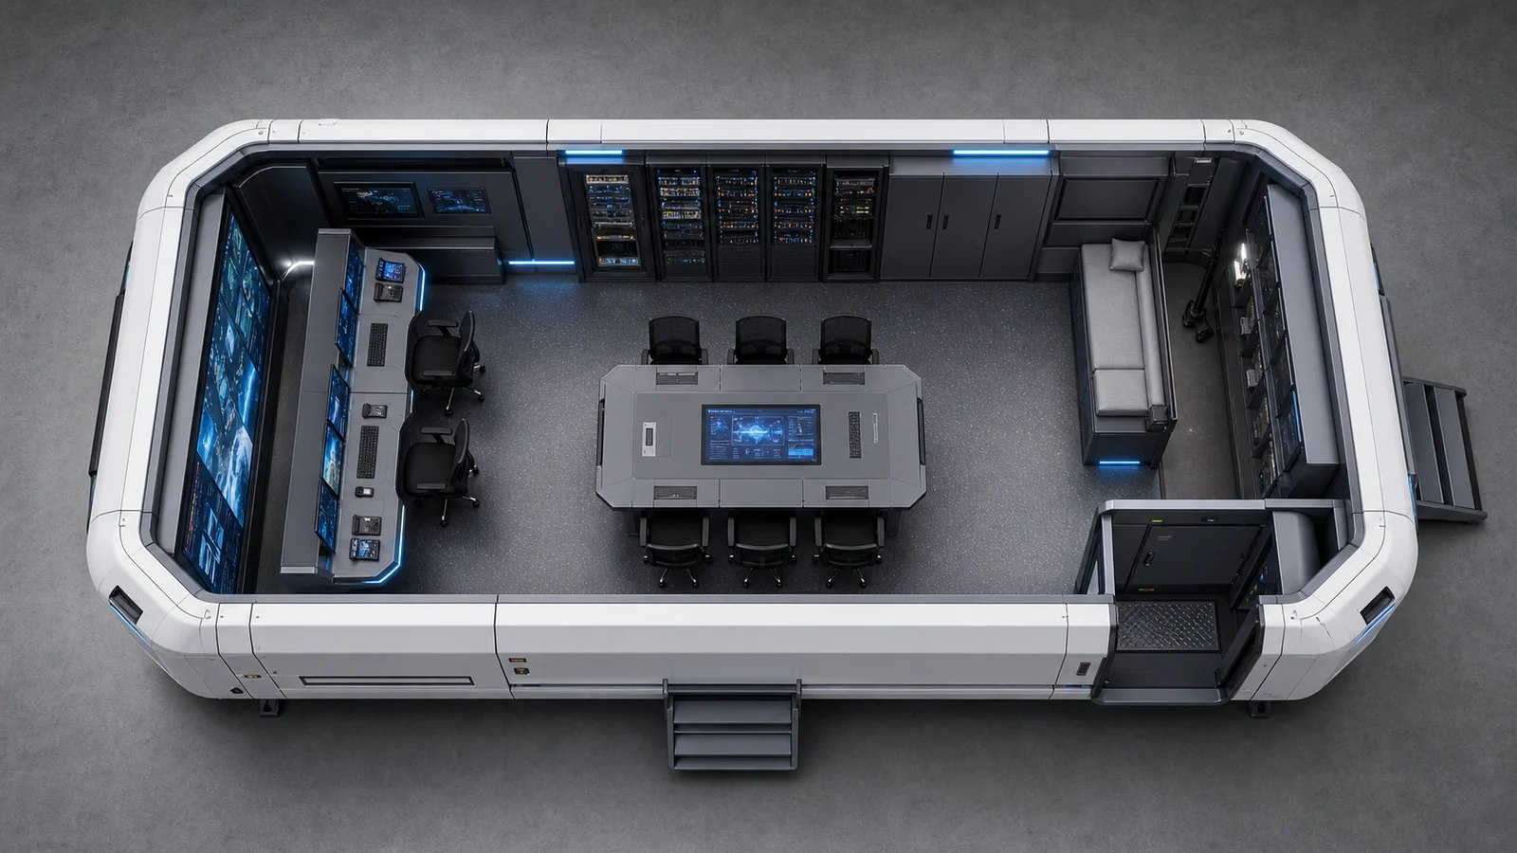
ZK08 Interiors & Floor Plans
Emergency Command Capsule INTERIORS & FLOOR PLANS
ZK08 Rescue Support Application
ZK08 Interior 3D Illustration
ZK08 Floor Plan 3D Illustration

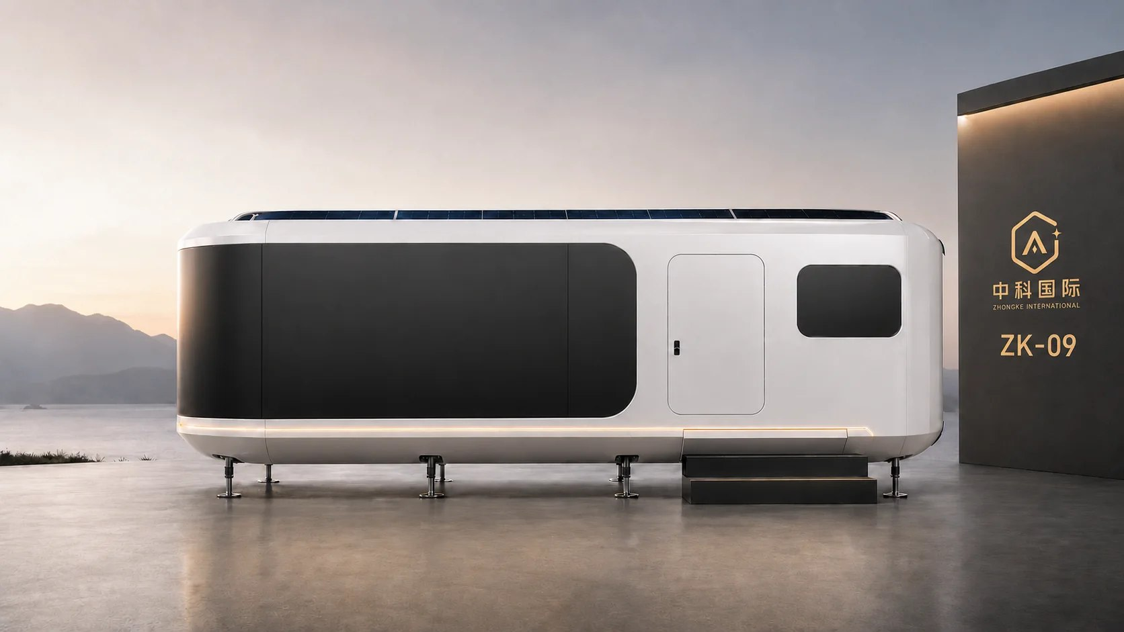
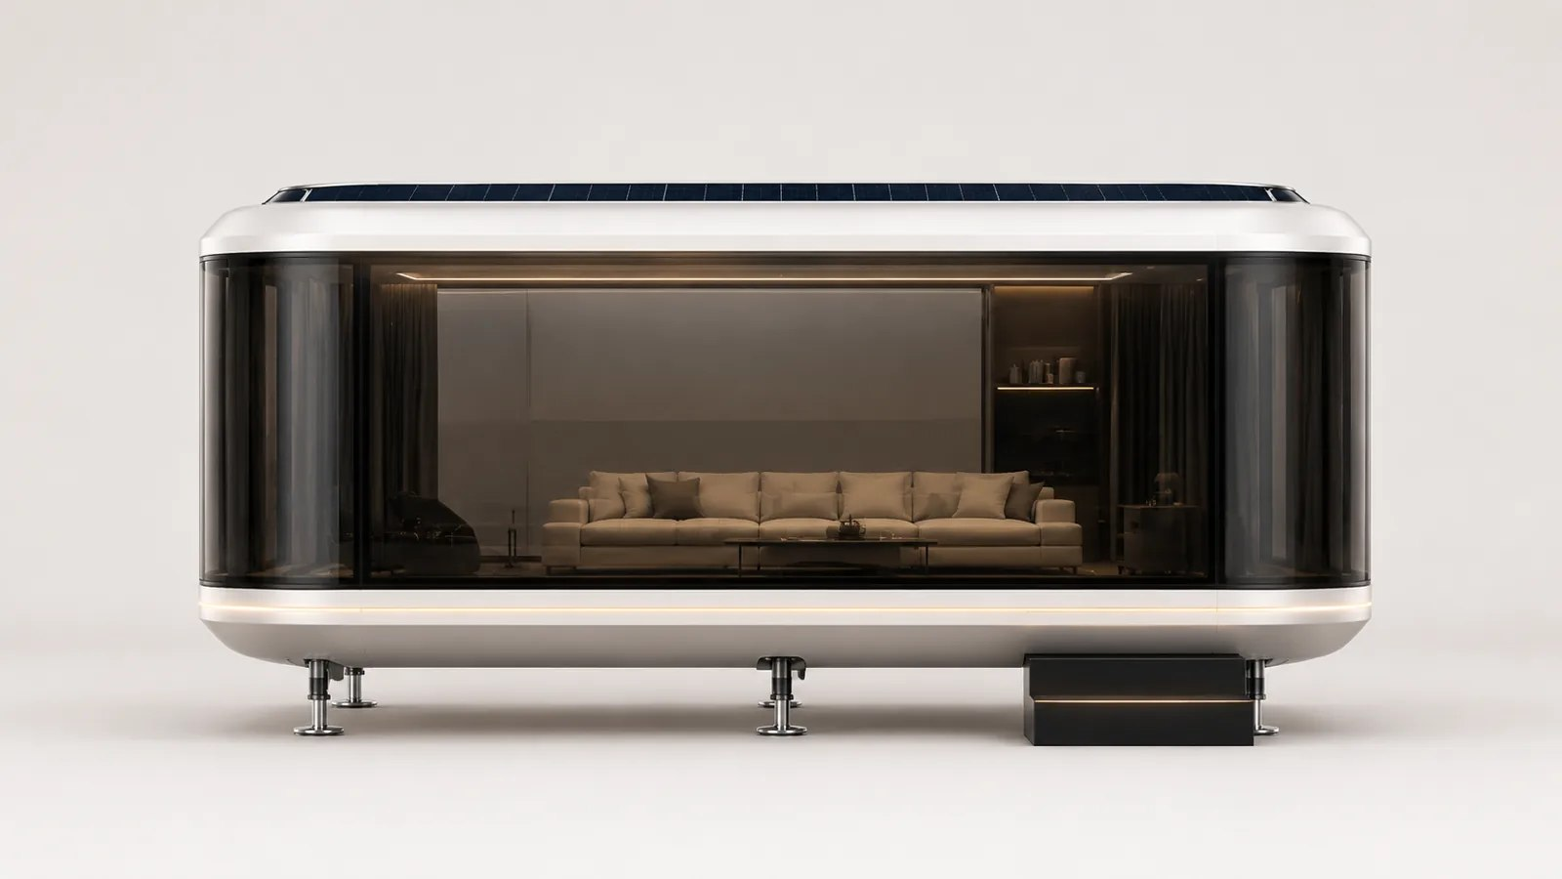
ZK09 Flagship Custom Capsule
Smart Capsule Series Reference area: 38-44 m²
Applications: VIP reception, brand showrooms and multifunctional flagship spaces
A flagship customized space for premium reception and brand presentation.
ZK09 Main Product View
ZK09 Exterior View 02

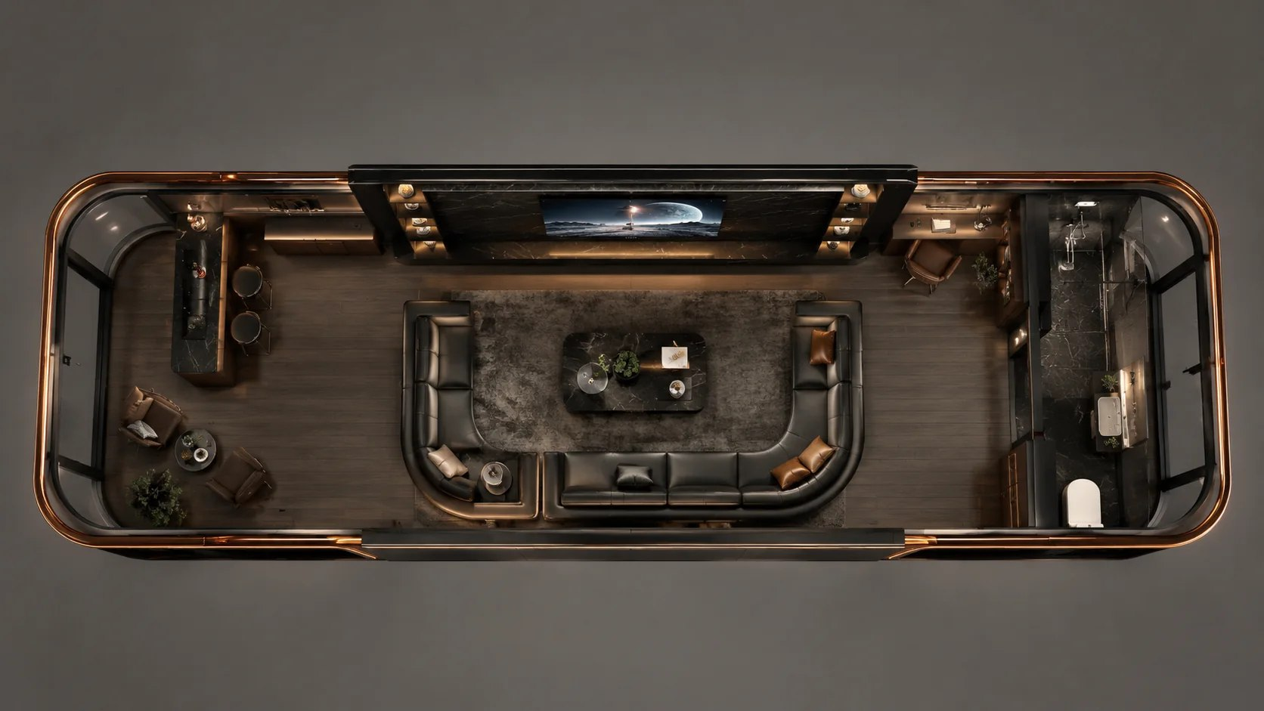
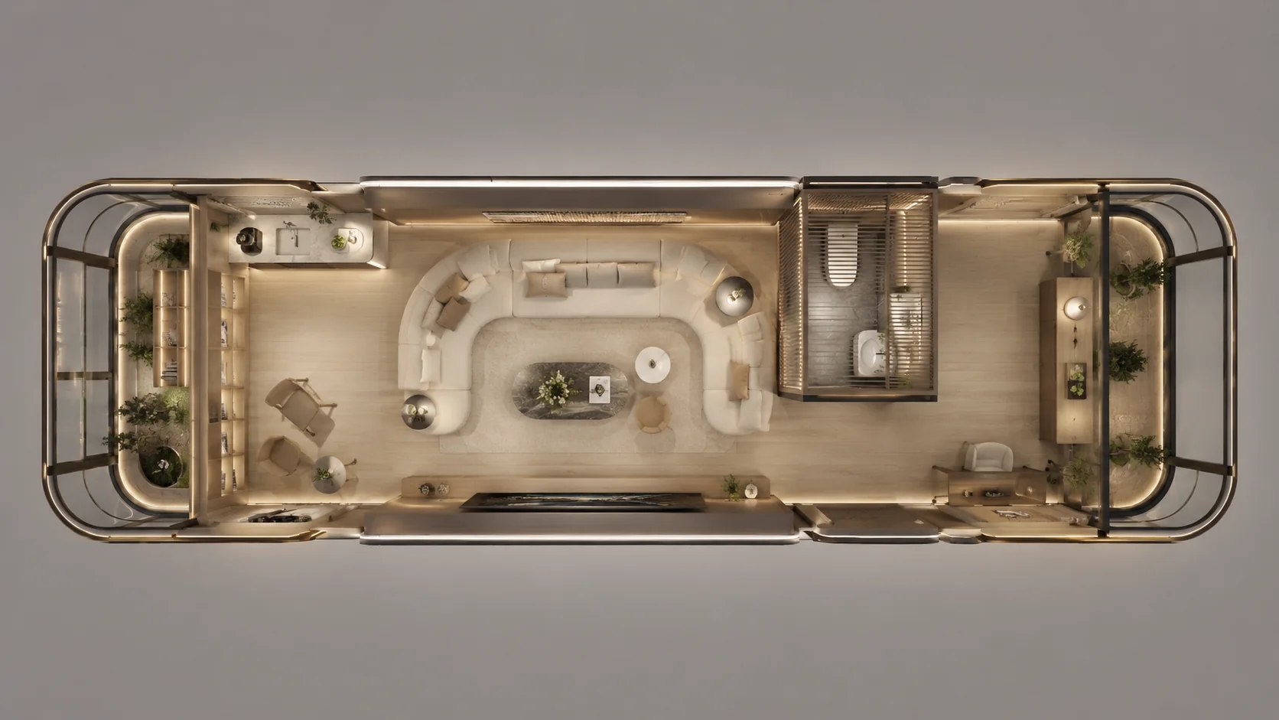
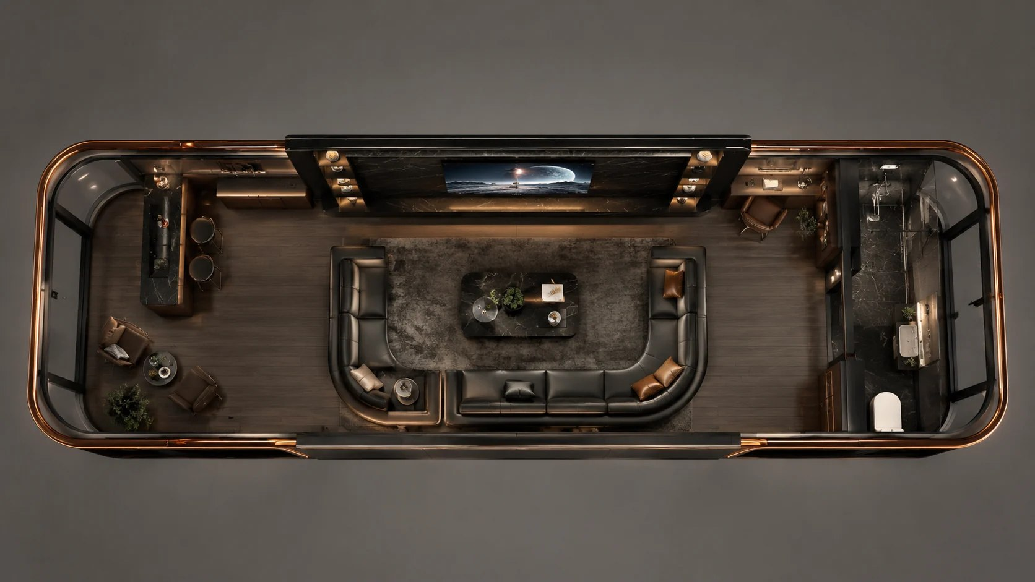
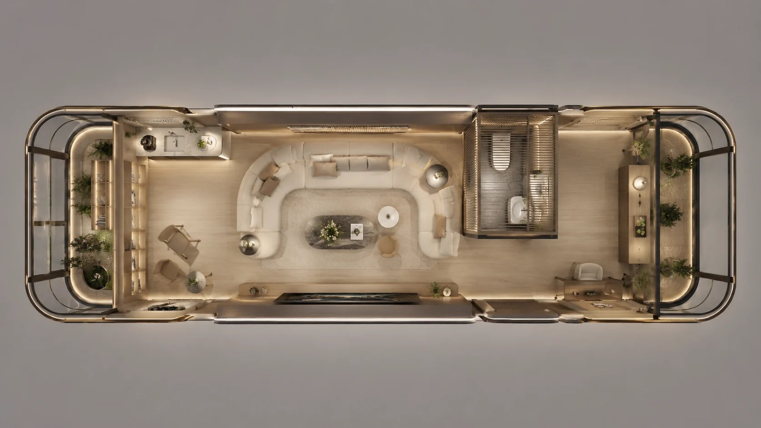
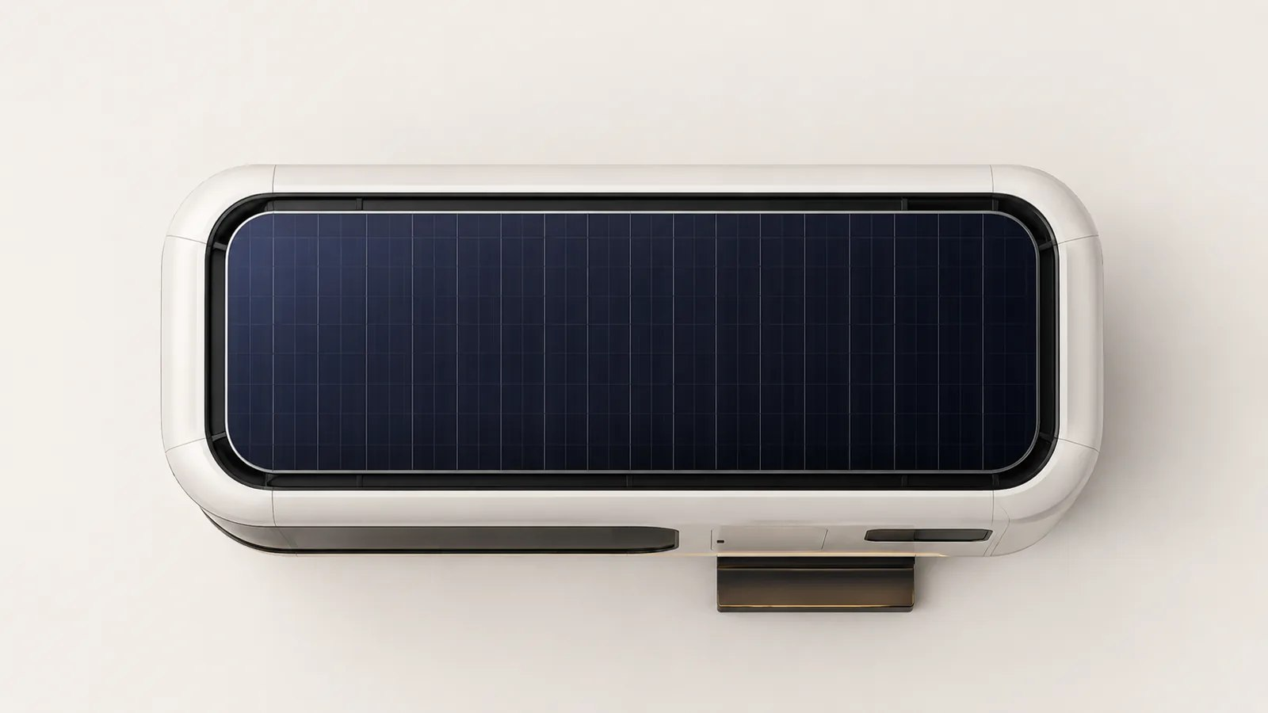
ZK09 Interiors & Floor Plans
Flagship Custom Capsule INTERIORS & FLOOR PLANS
ZK09 Floor Plan View 01
ZK09 Floor Plan View 02
ZK09 Space Layout 01
ZK09 Space Layout 02
ZK09 Exterior View 01

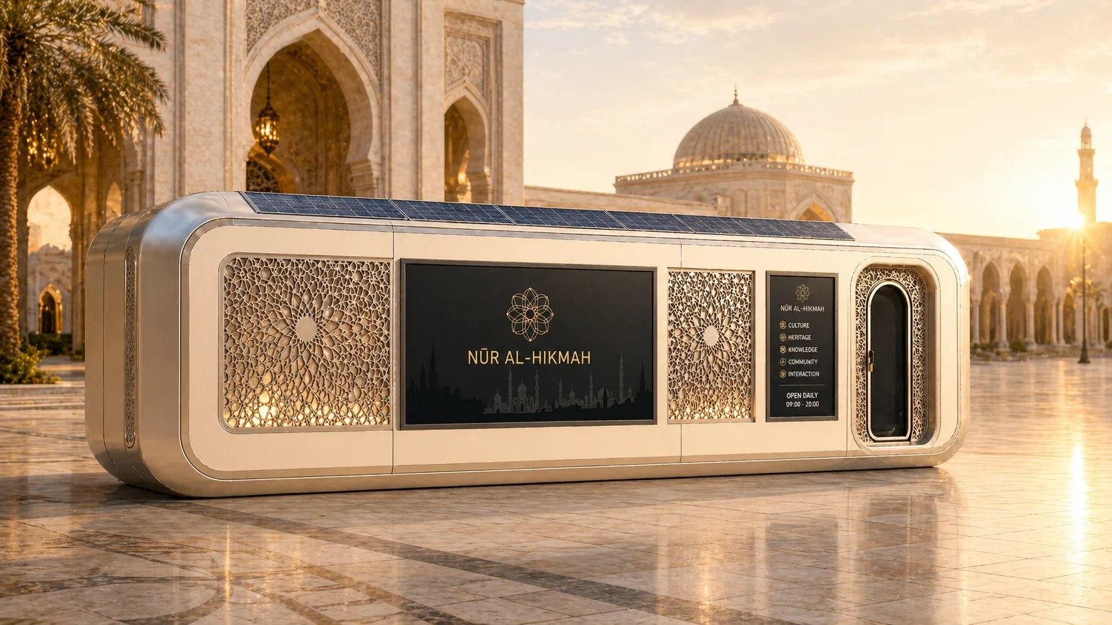
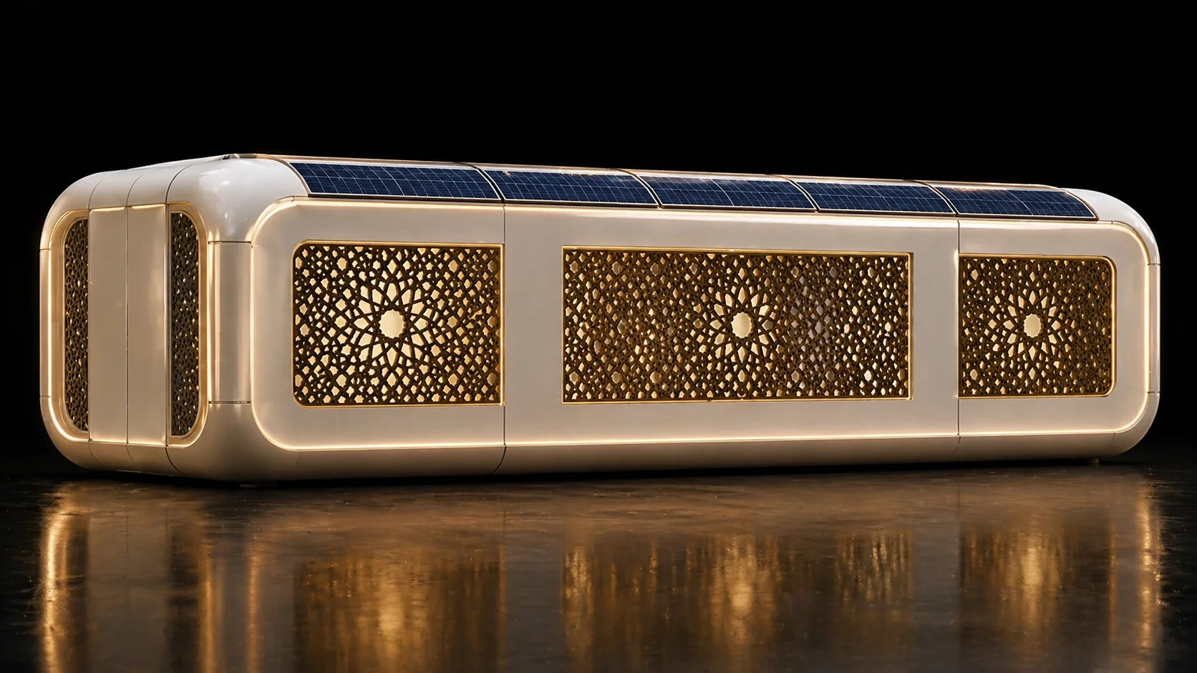
ABADI Premium Customized Smart Capsule
Smart Capsule Series
Applications: Premium customization, smart capsules and project-specific uses
A smart capsule designed for premium customized projects.
ABADI Special Custom Exterior
ABADI Custom Product Exterior

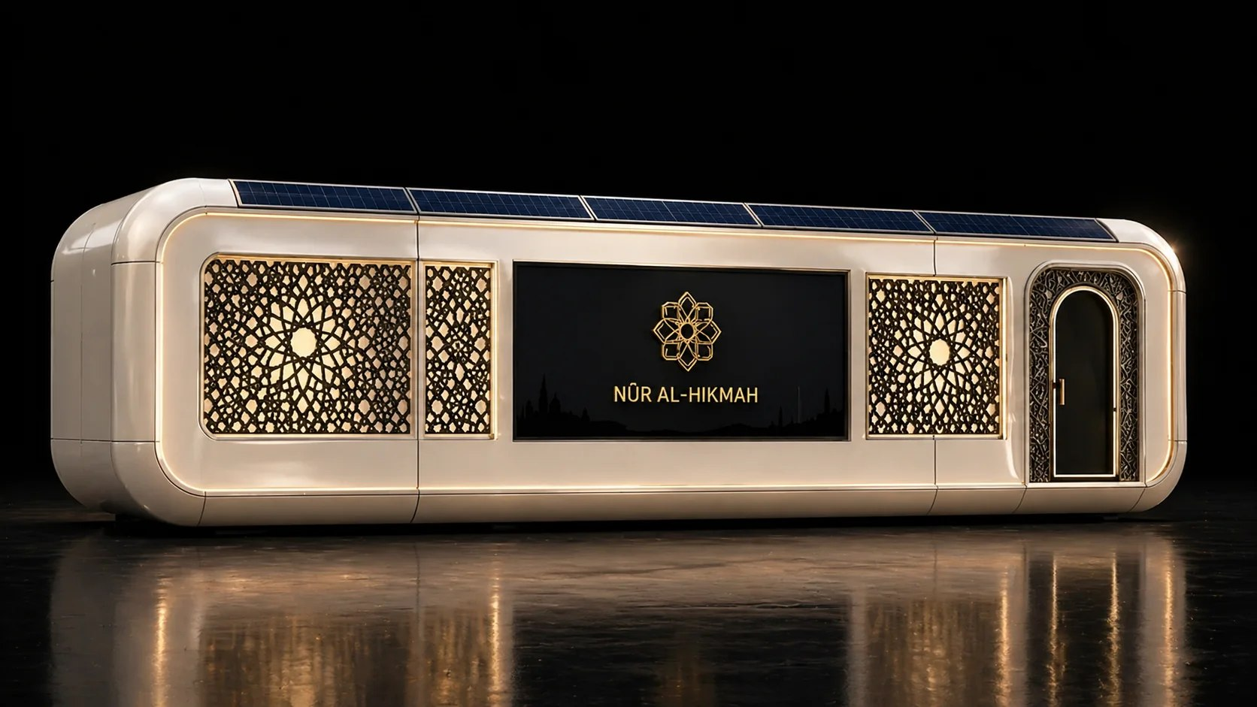
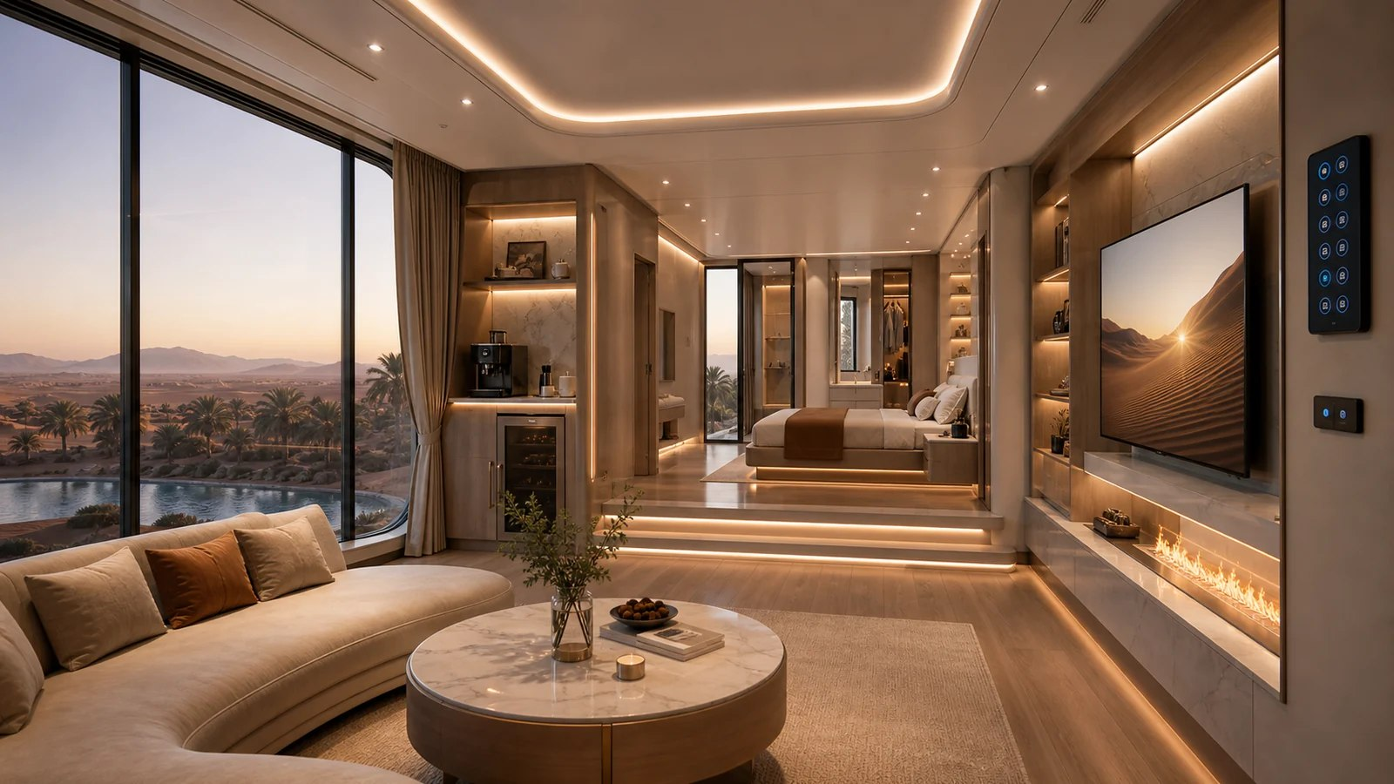
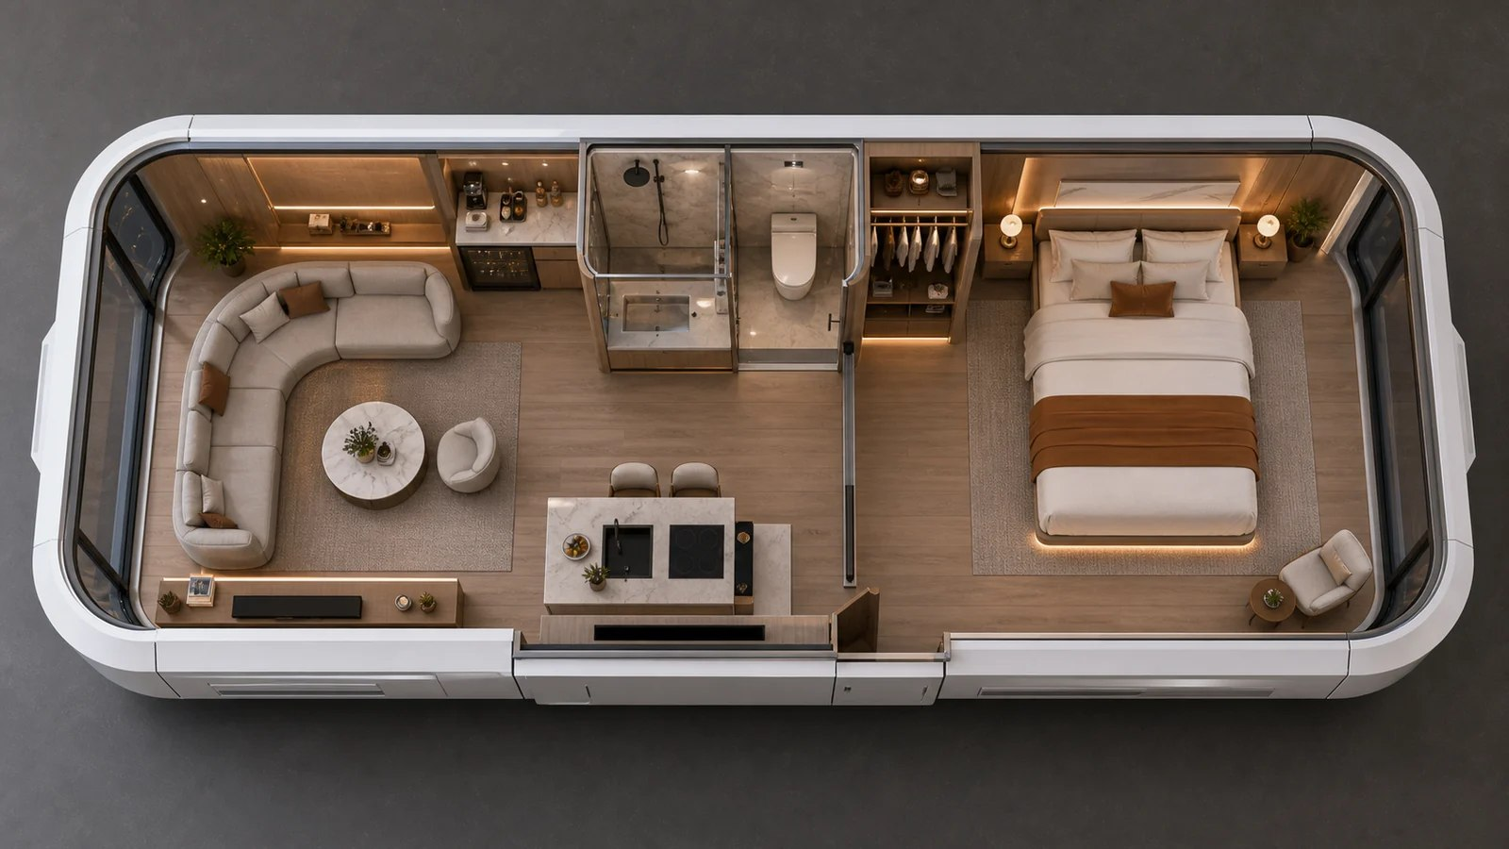
ABADI Interiors & Floor Plans
Premium Customized Smart Capsule INTERIORS & FLOOR PLANS
ABADI Custom Project View
ABADI Interior 3D Illustration
ABADI Floor Plan 3D Illustration

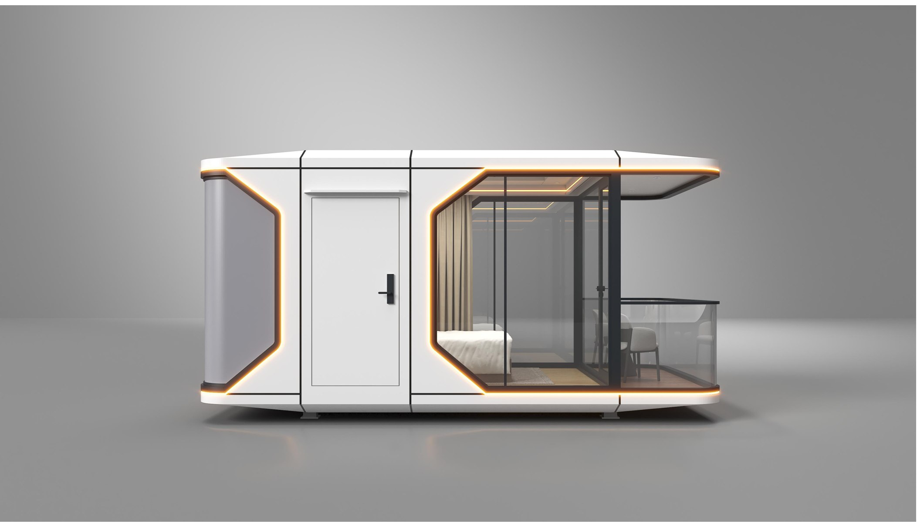
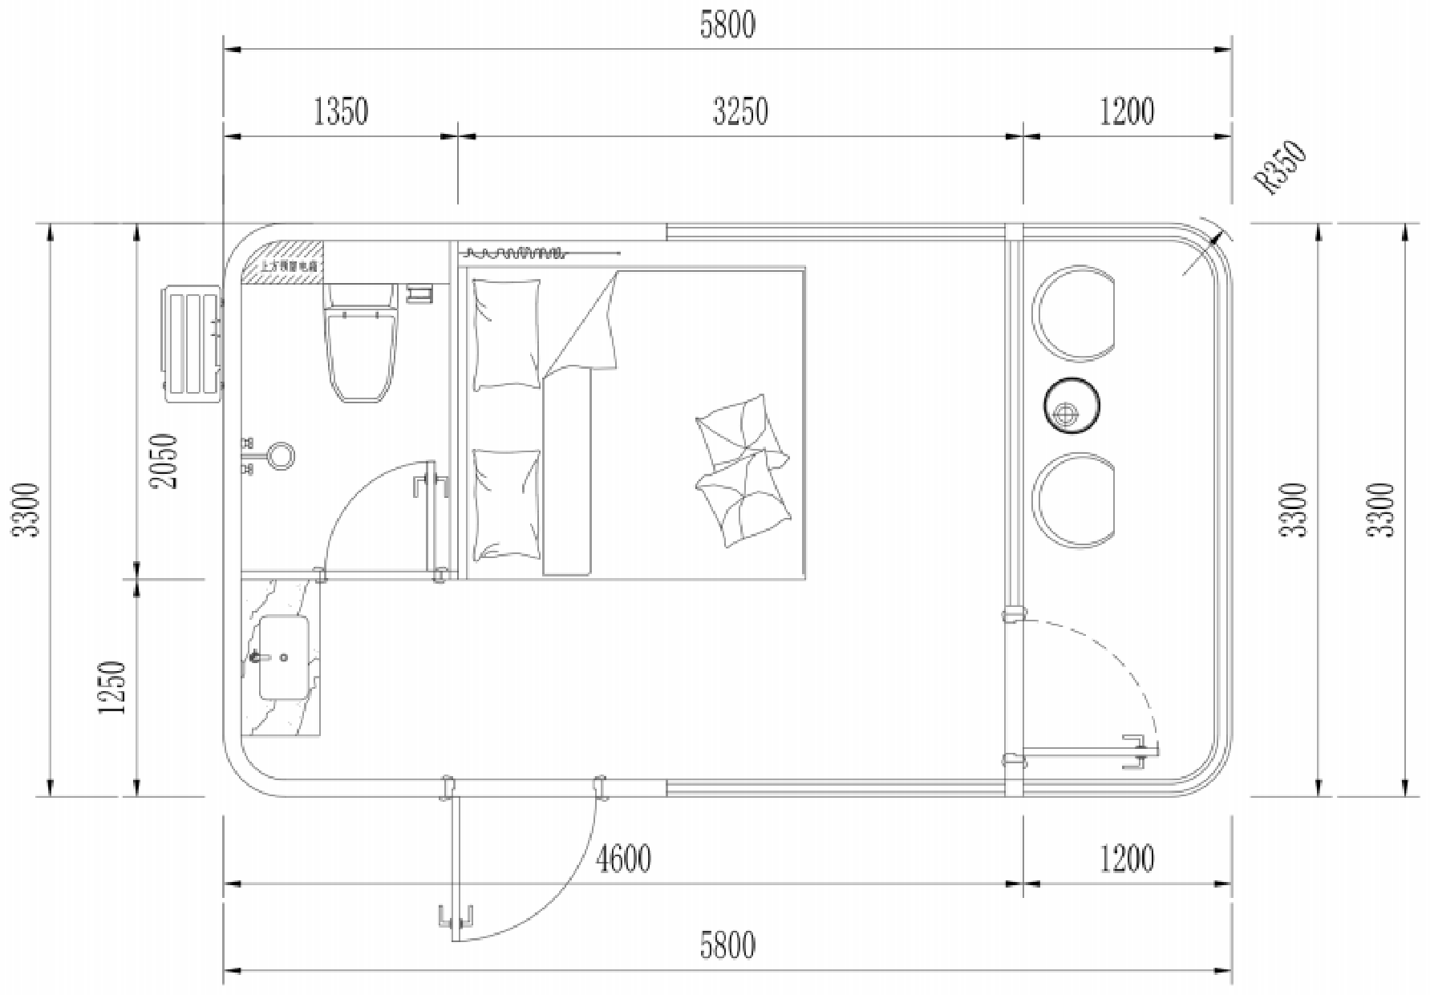
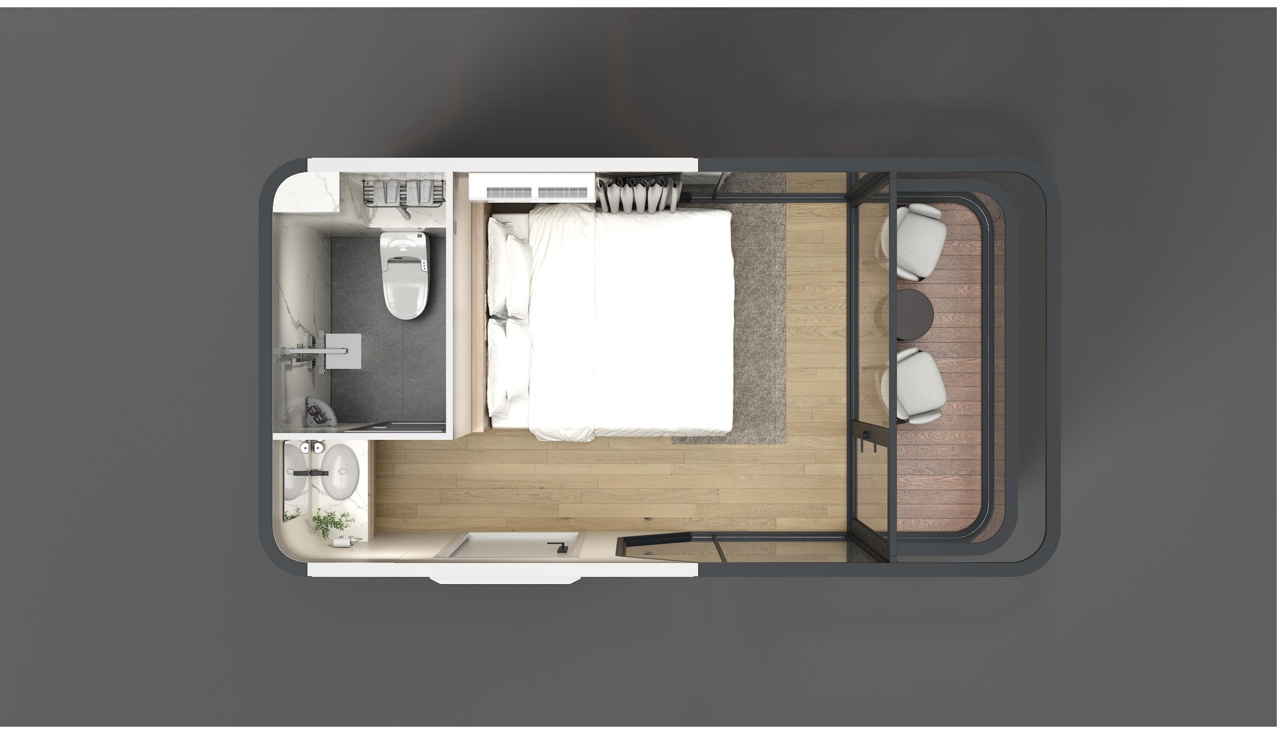
ZK-ME Compact Capsule
COMPACT SPACE | EXTERIOR & LAYOUT | Drawing legend: overhead storage compartment above the bathroom.

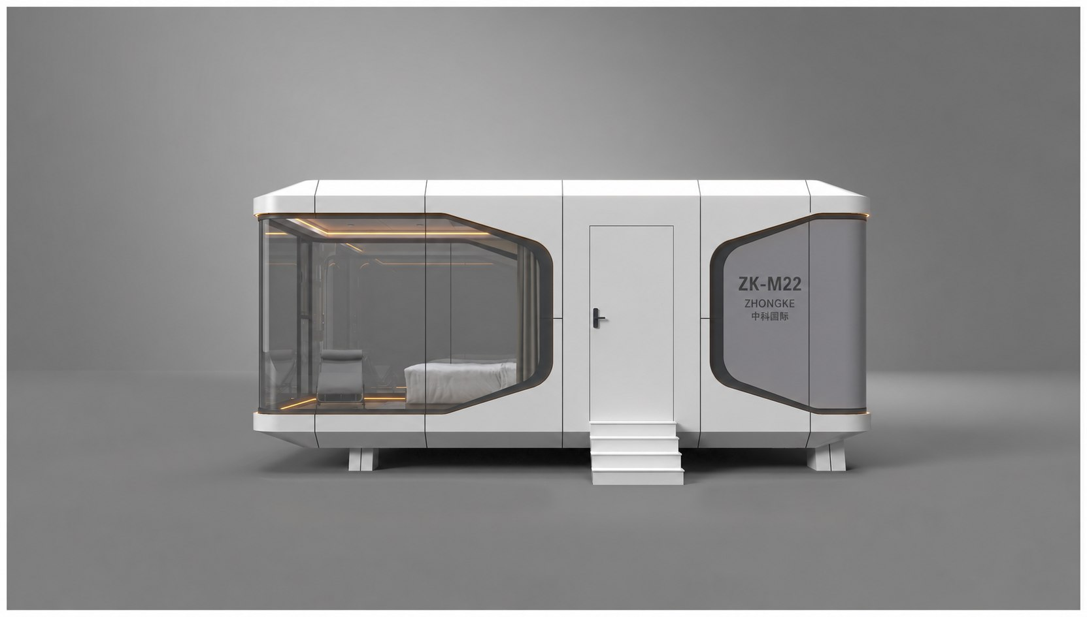
ZK-M22 Classic View Capsule
22.44 m² | 6800 × 3300 × 3200 mm | Approx. 5 tonnes

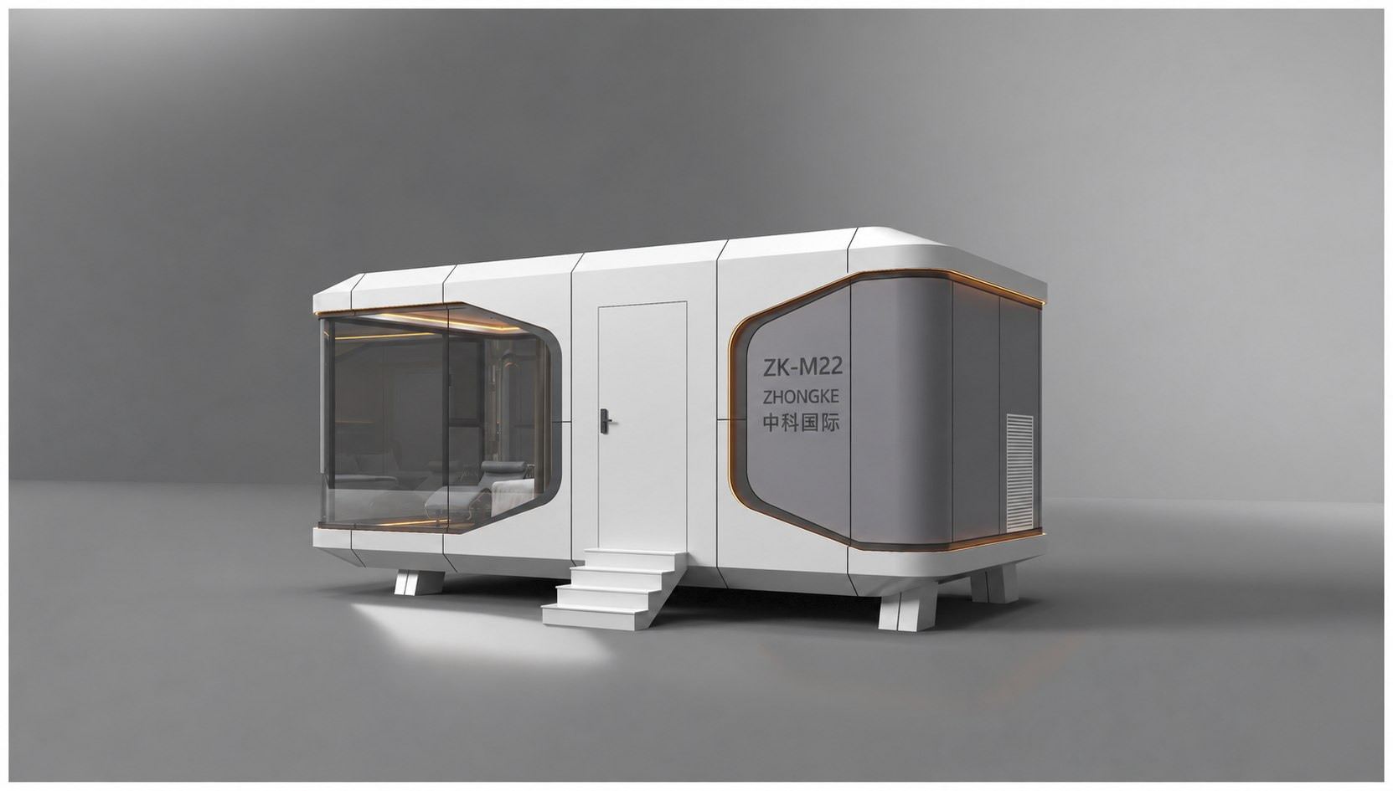
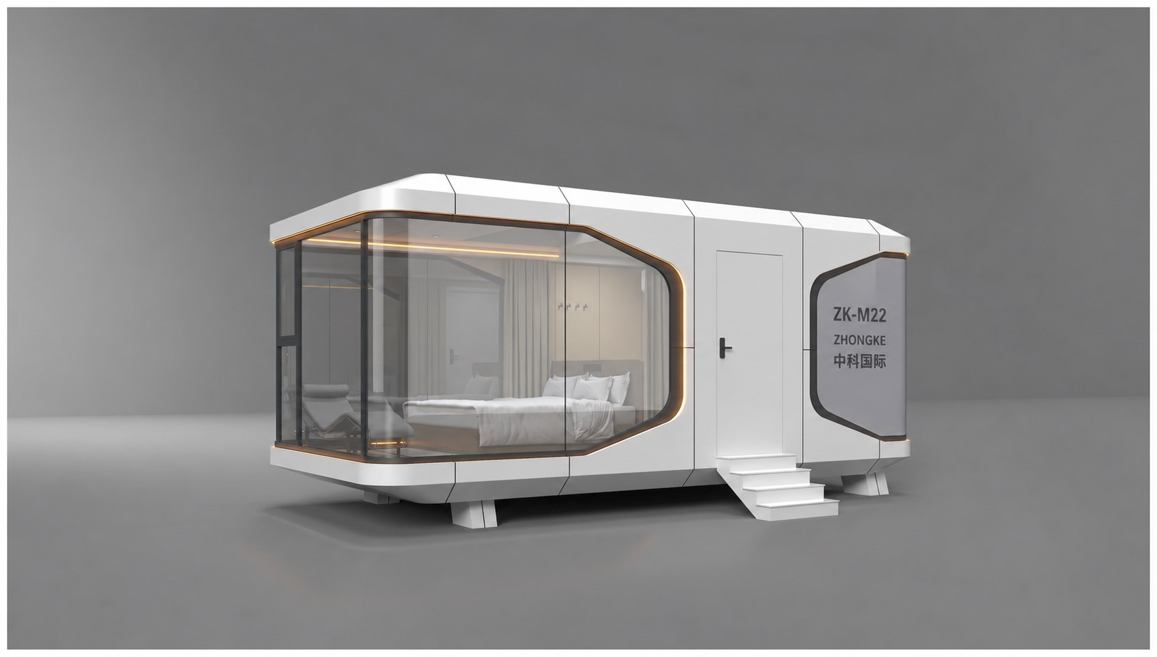
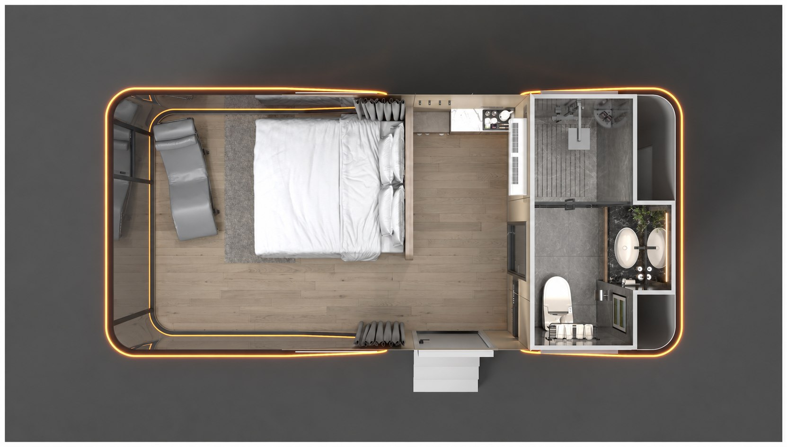
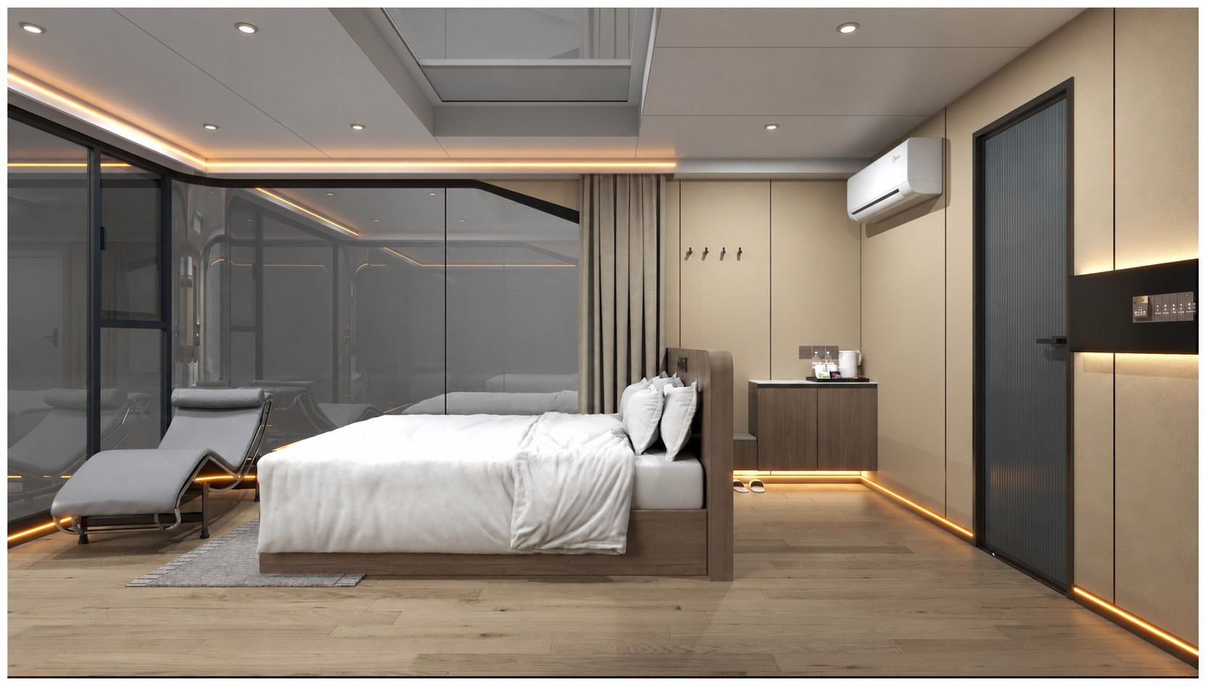
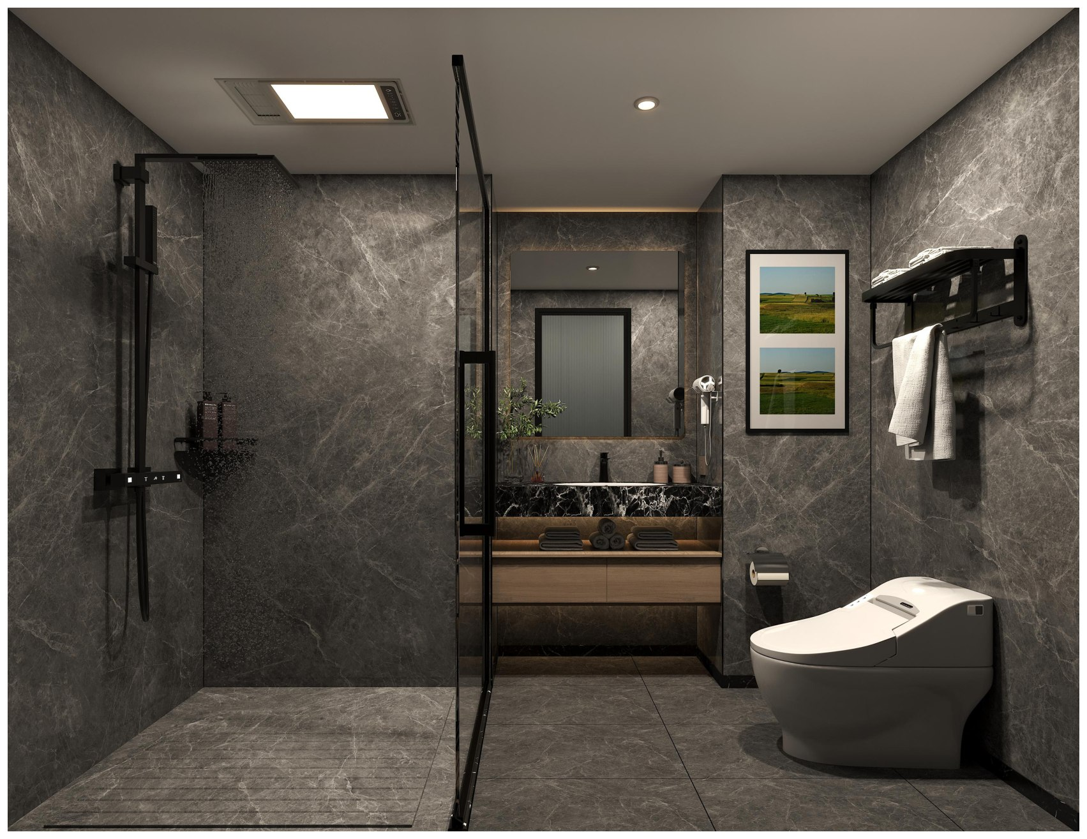
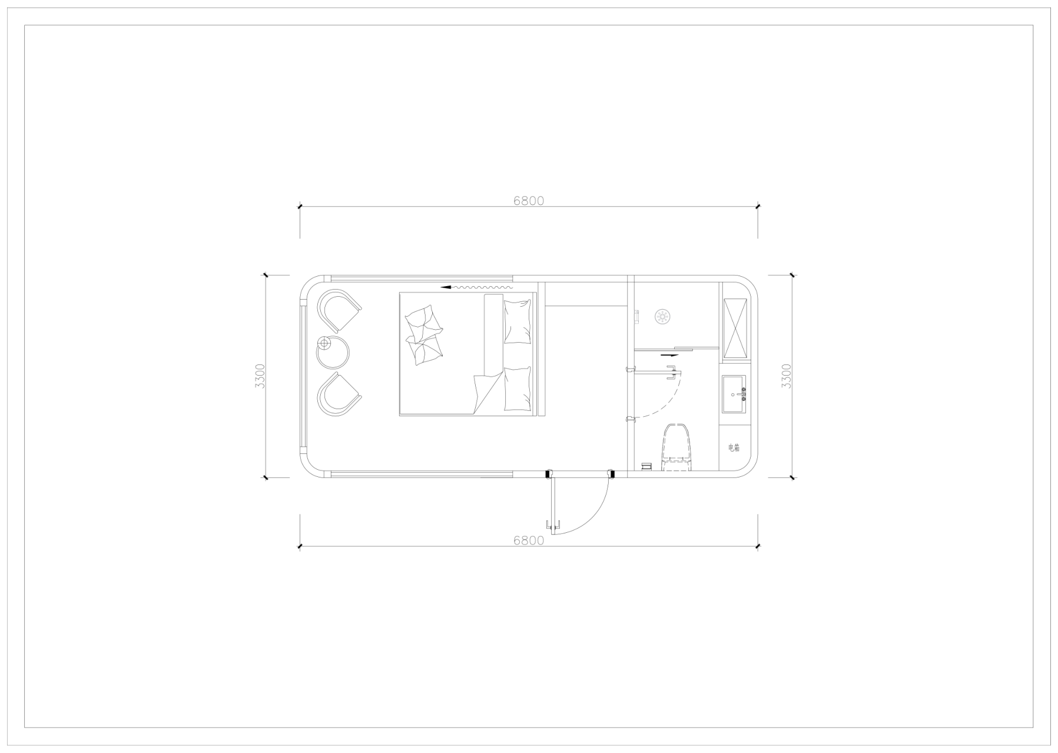
ZK-M22 Exterior & Interior Details
EXTERIOR | TOP VIEW | INTERIOR & BATHROOM | DIMENSIONS | Drawing legend: electrical distribution box.

ZK-M28 Panoramic King Bed Capsule
Approx. 28 m² | 8500 × 3300 × 3200 mm | Approx. 7 tonnes

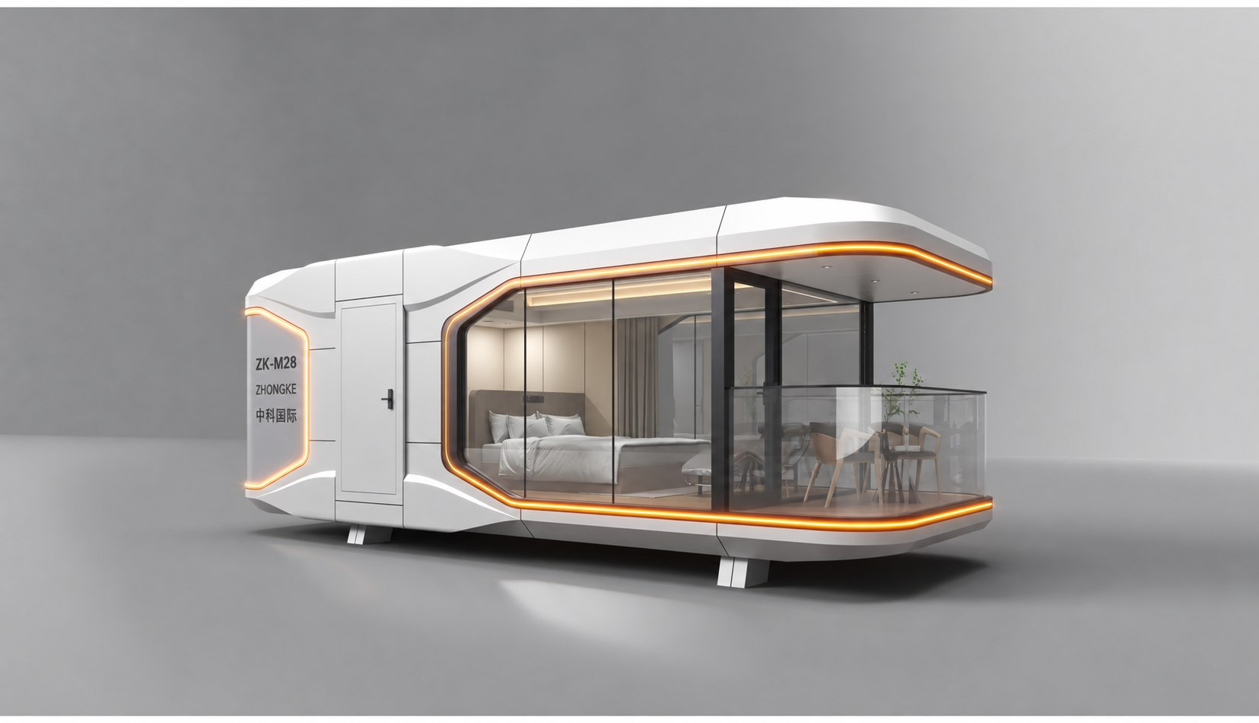
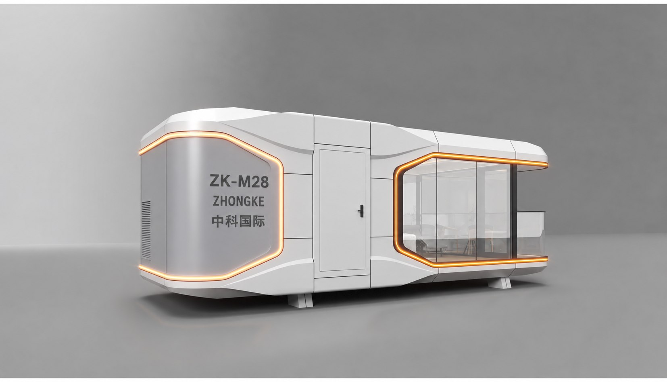
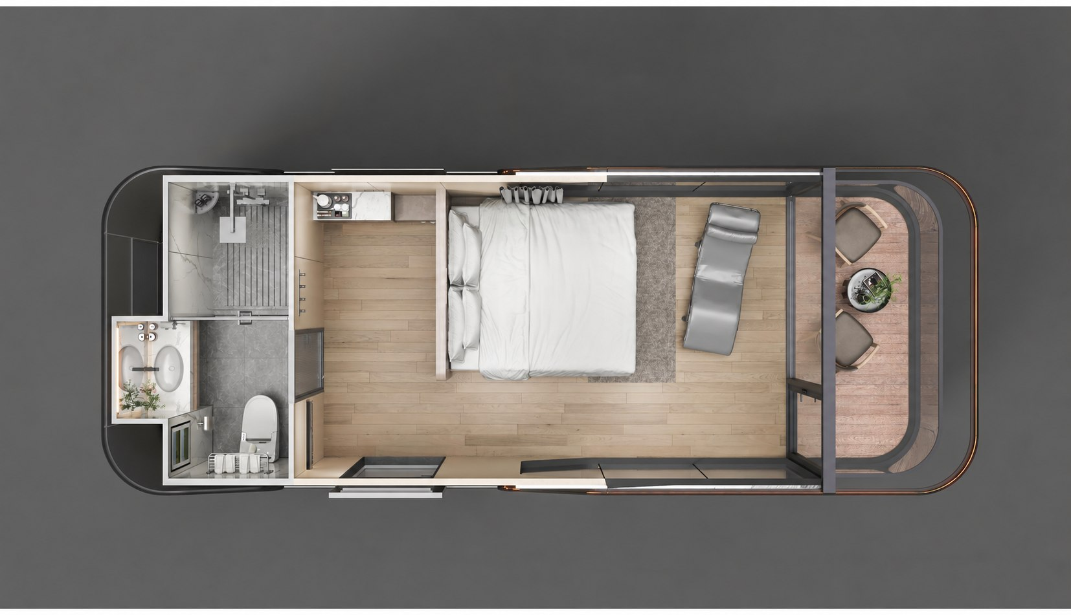
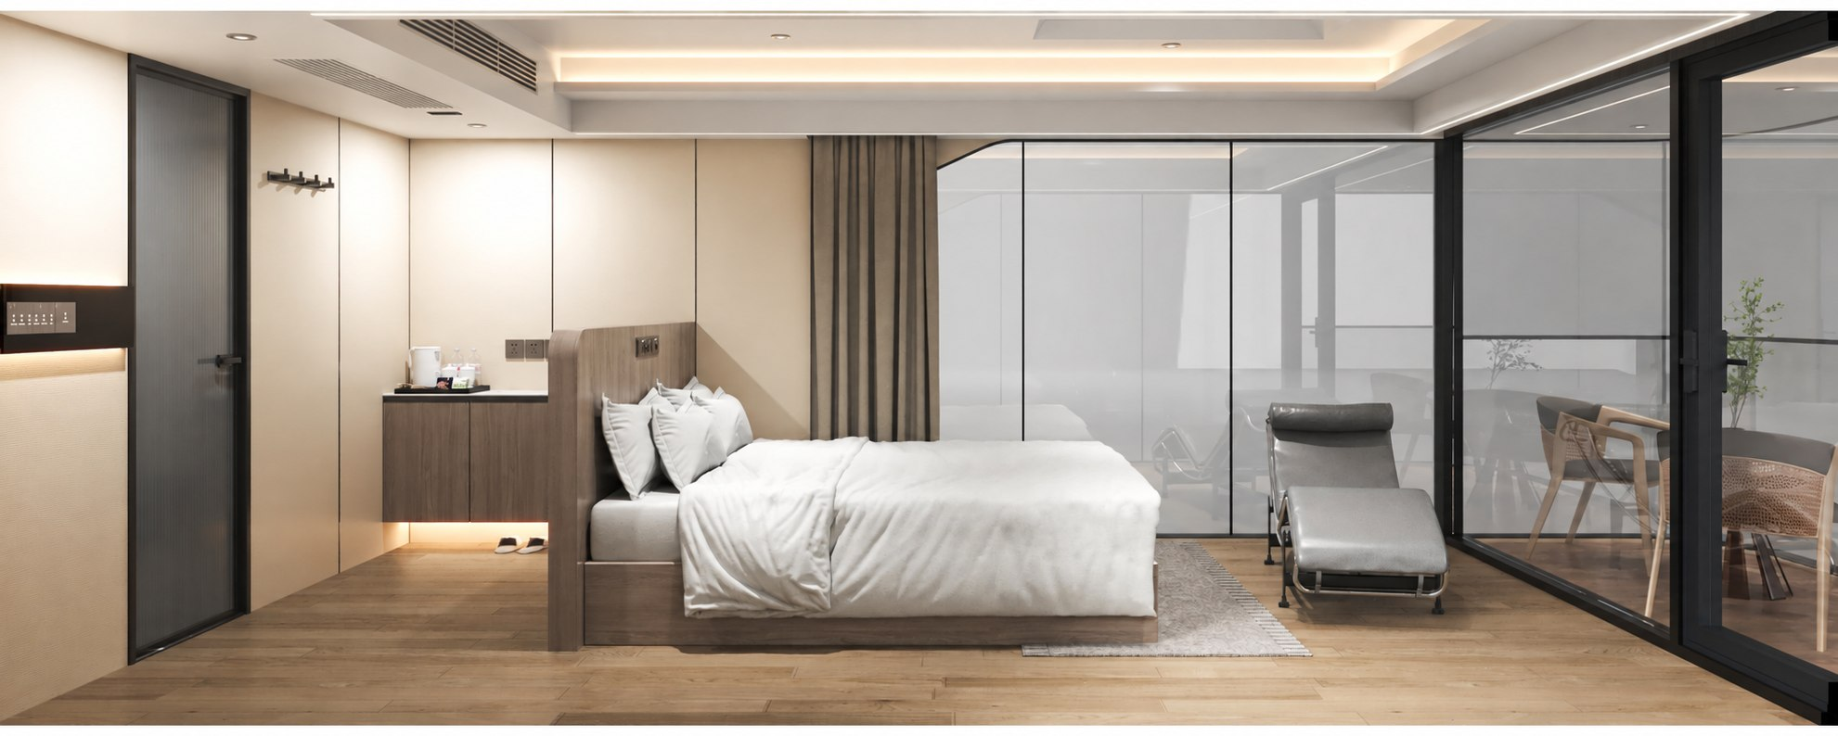
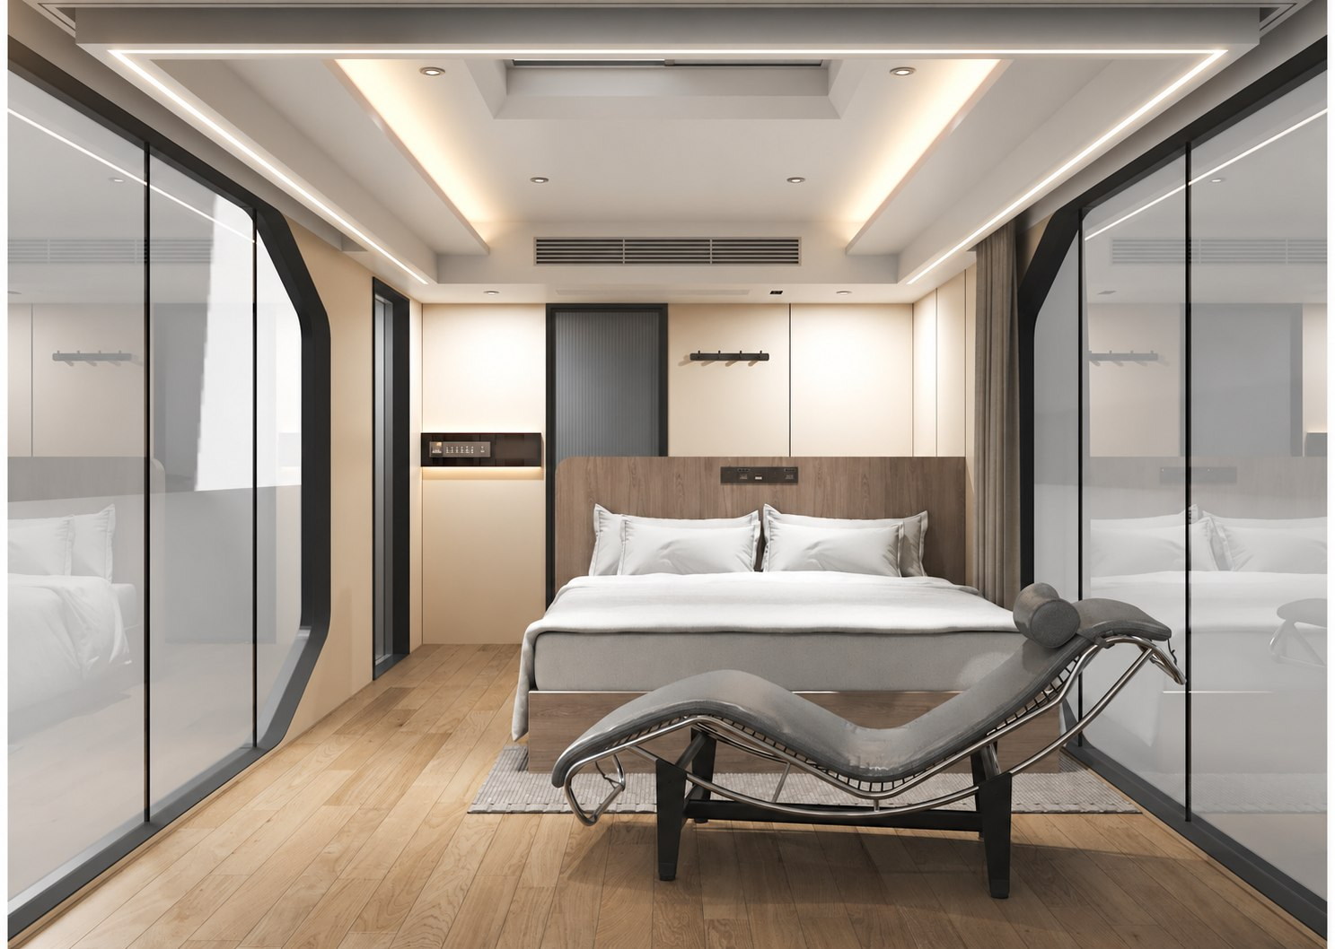
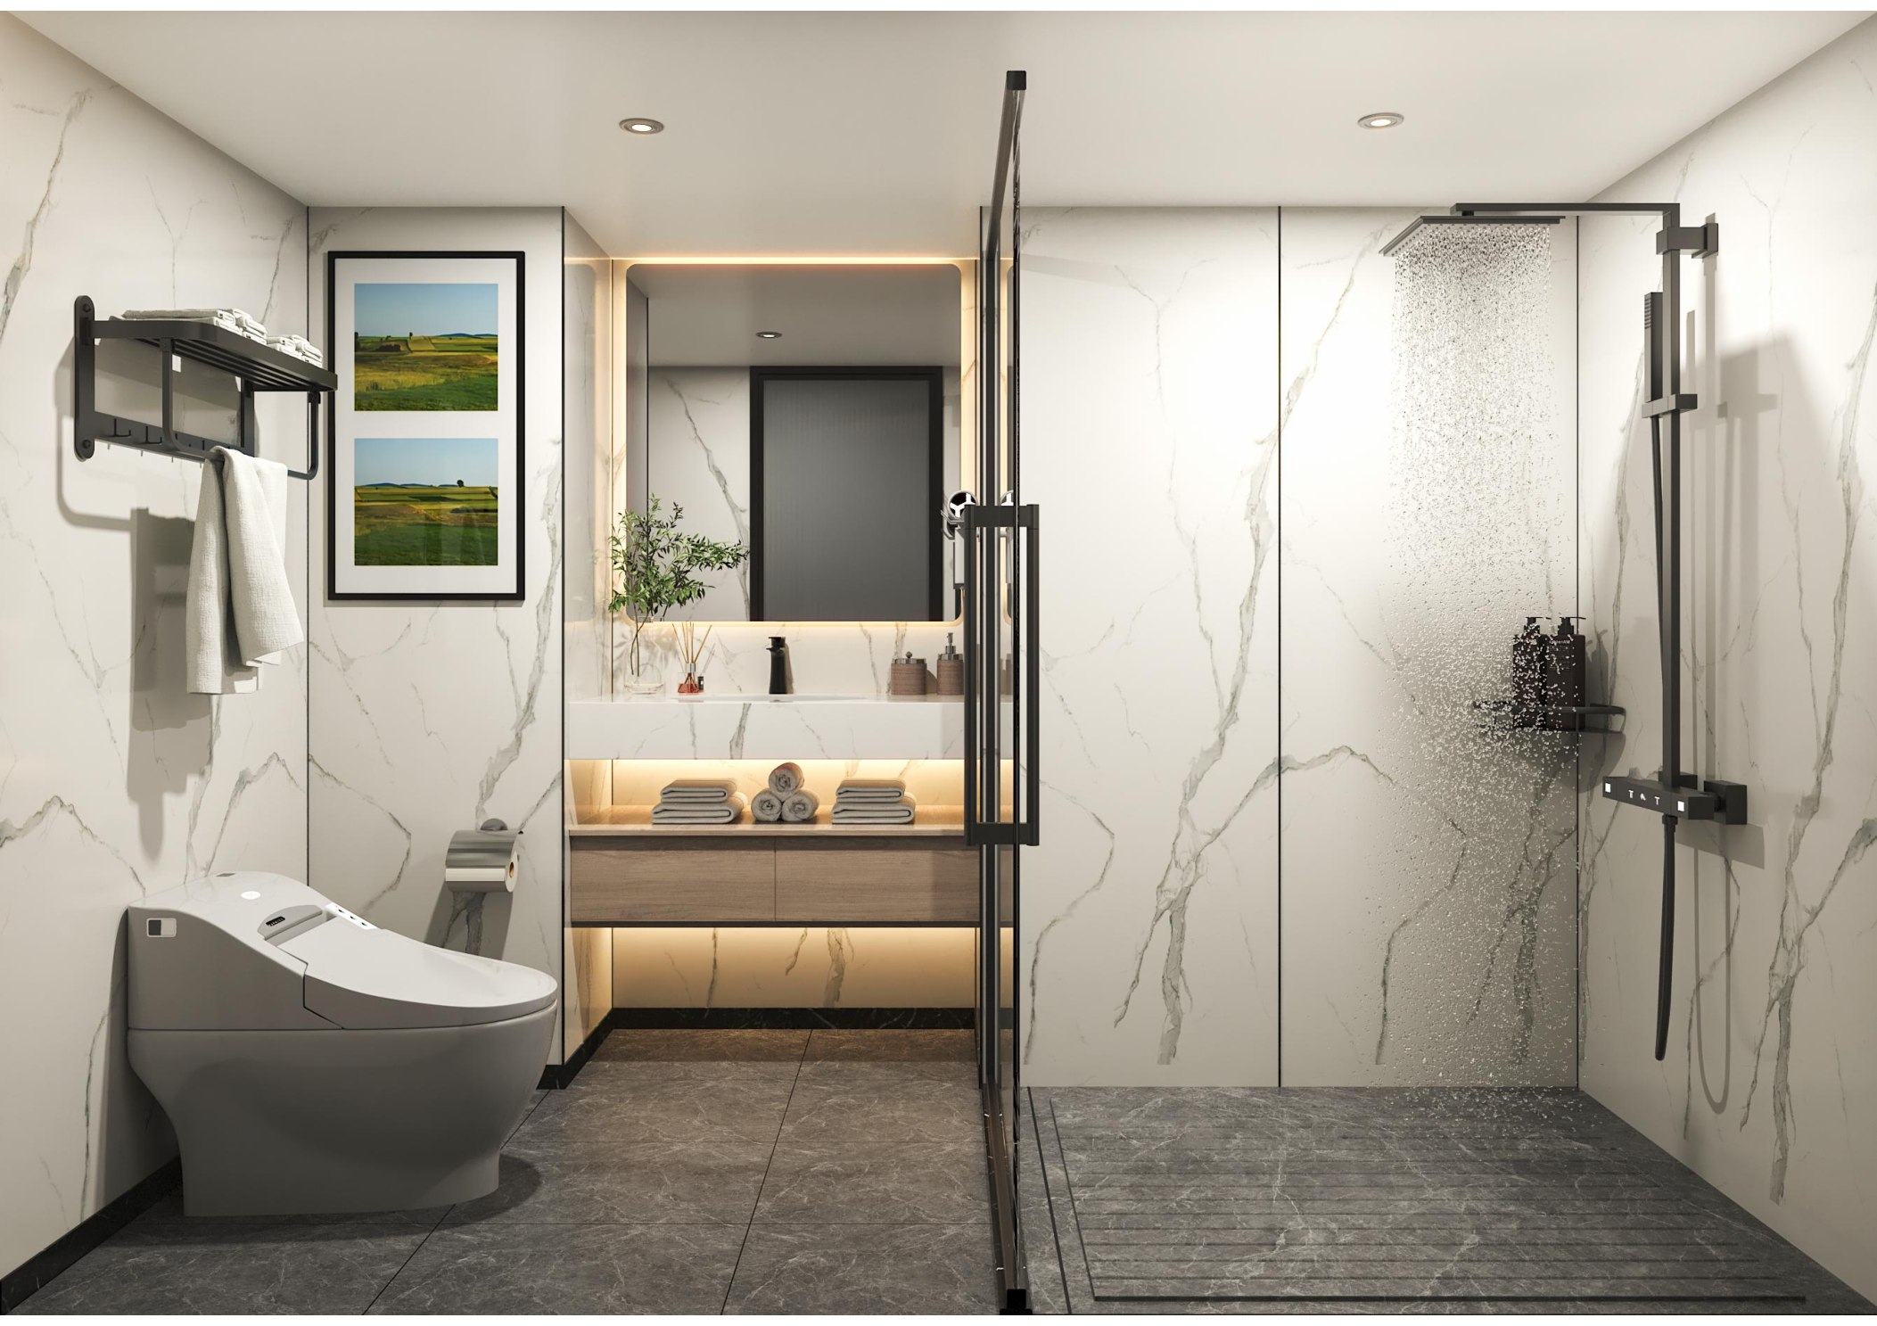
ZK-M28 Exterior & Interior Details
EXTERIOR | TOP VIEW | BEDROOM & BATHROOM

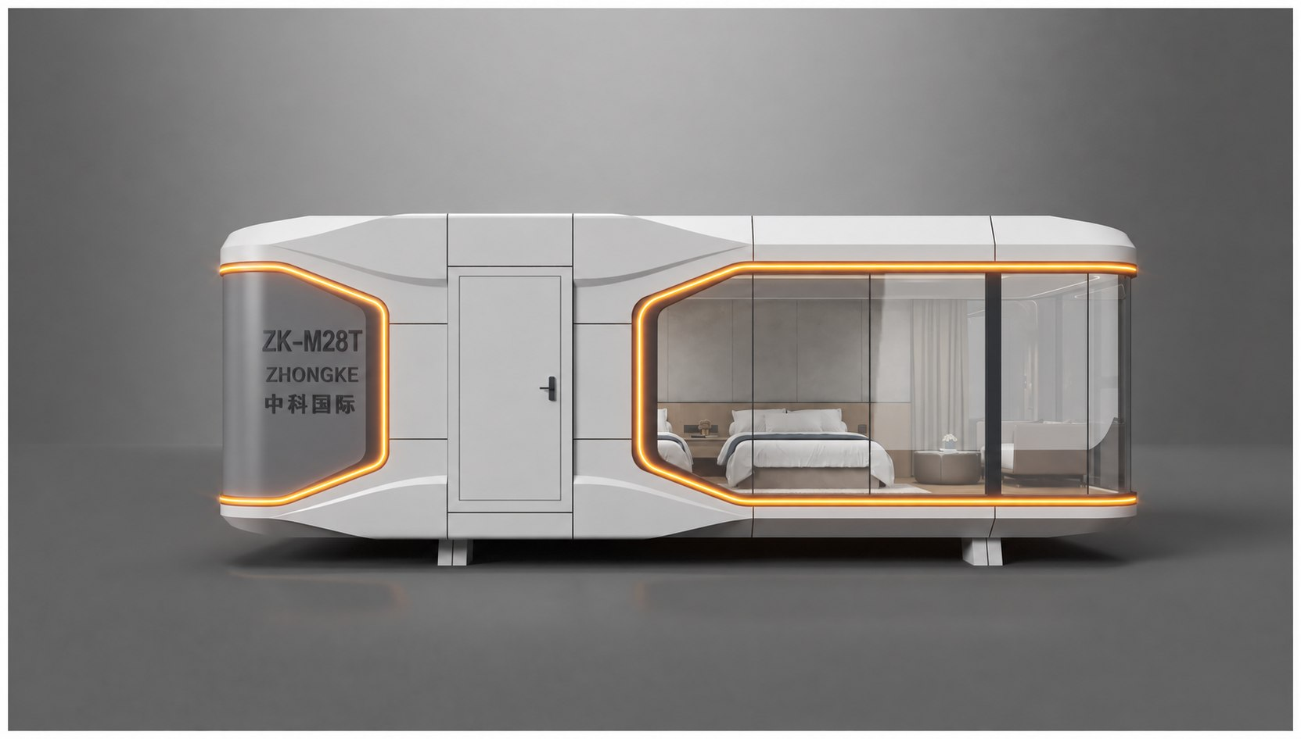
ZK-M28T Panoramic Twin Bed Capsule
TWIN BED LAYOUT | PANORAMIC VIEWS

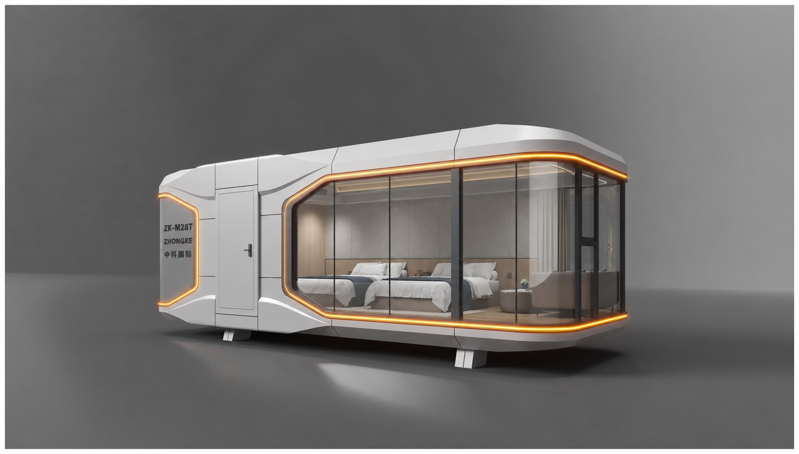
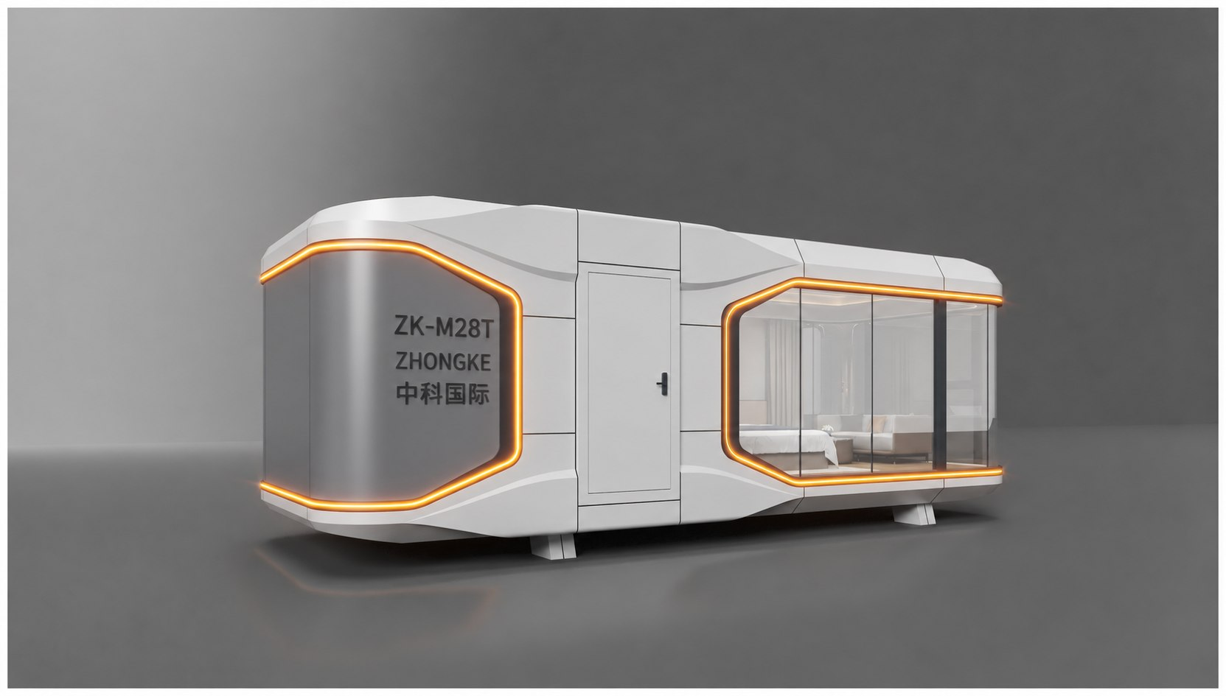
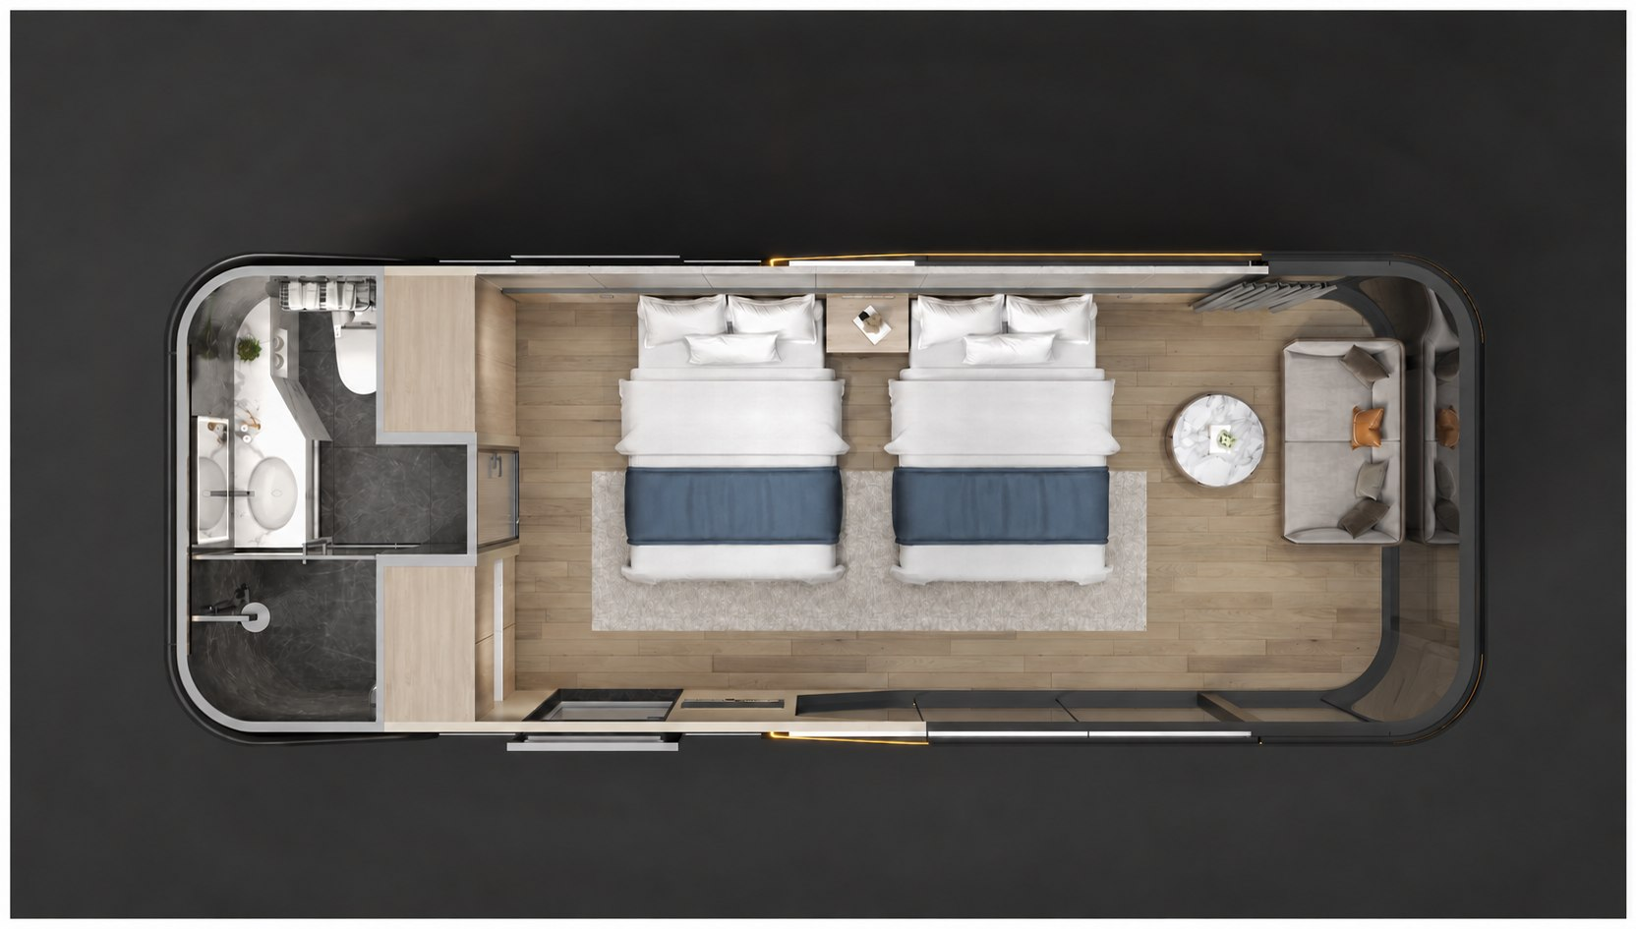
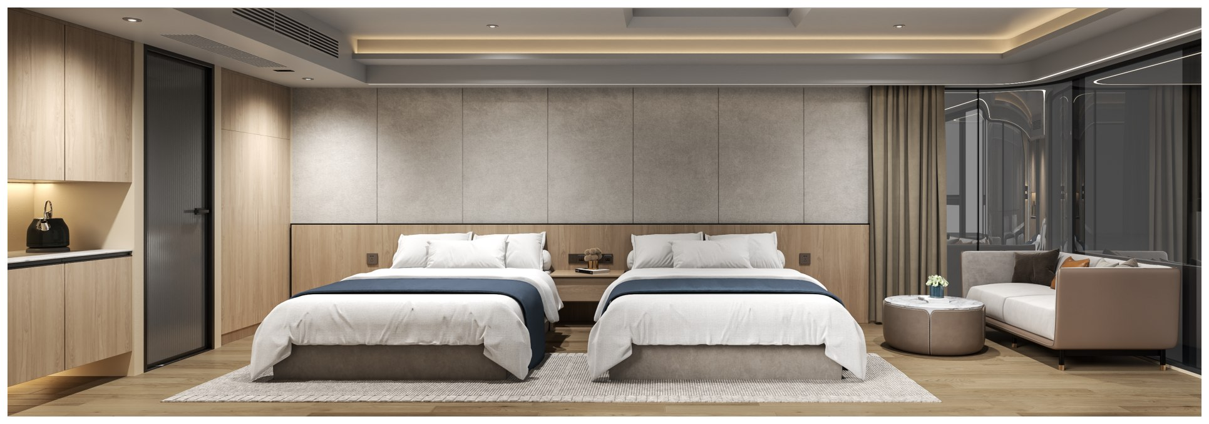
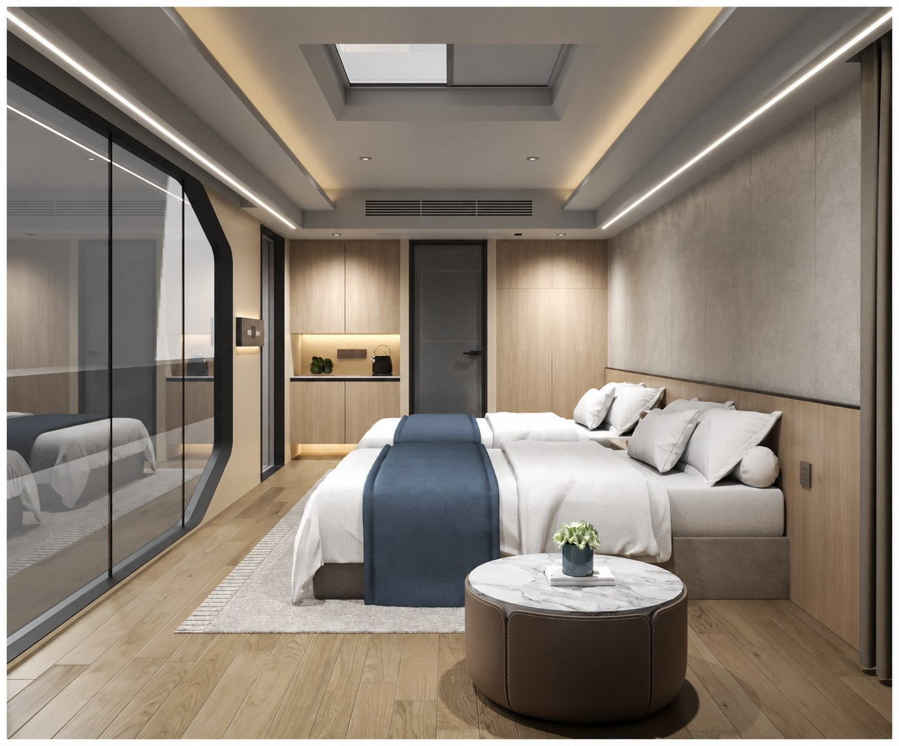
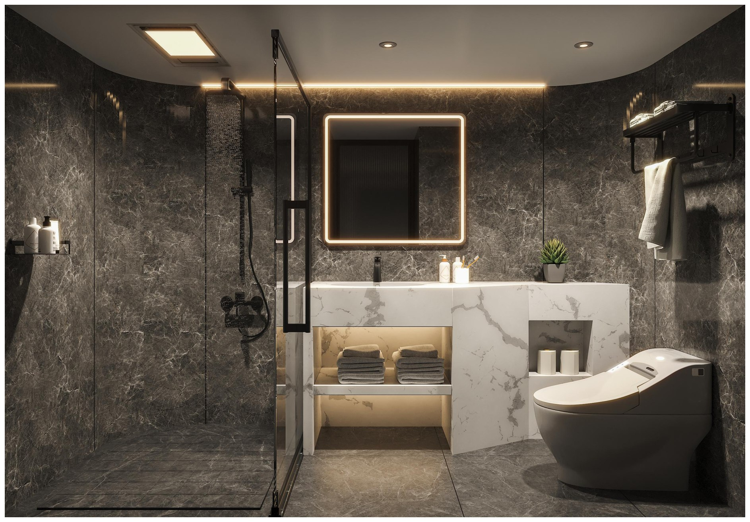
ZK-M28T Exterior & Interior Details
EXTERIOR | TOP VIEW | BEDROOM & BATHROOM

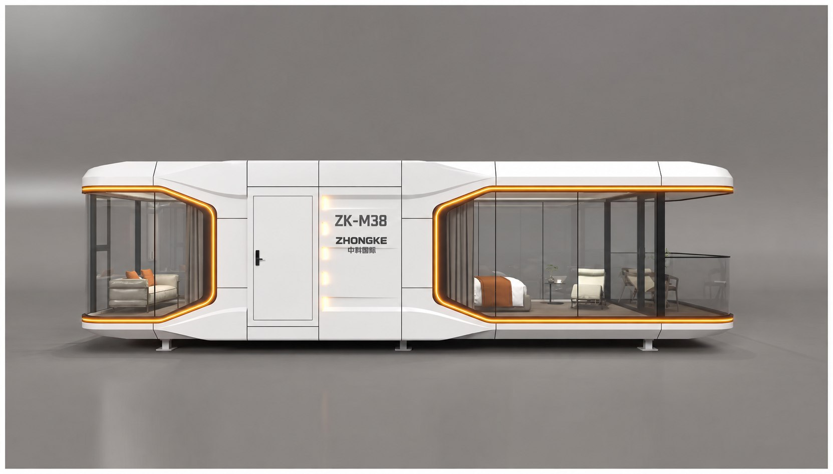
ZK-M38 Family View Capsule
Approx. 38 m² | 11500 × 3300 × 3200 mm | Approx. 9.5 tonnes

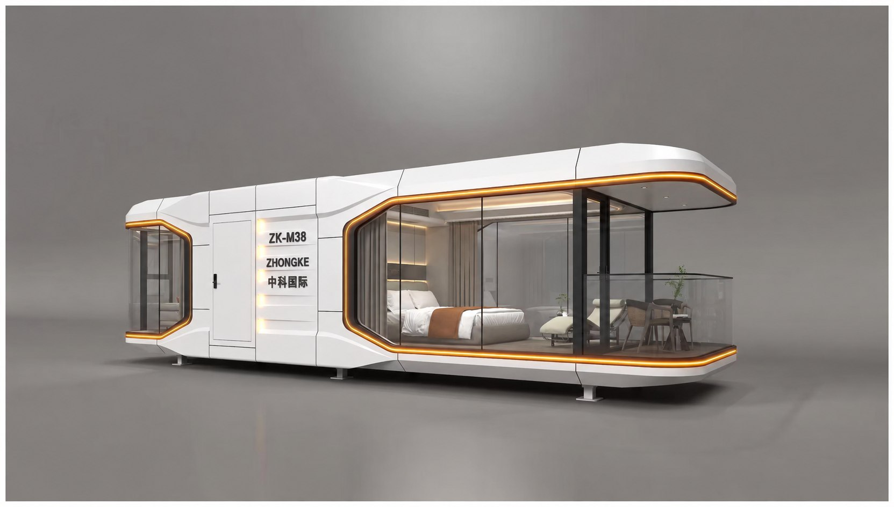
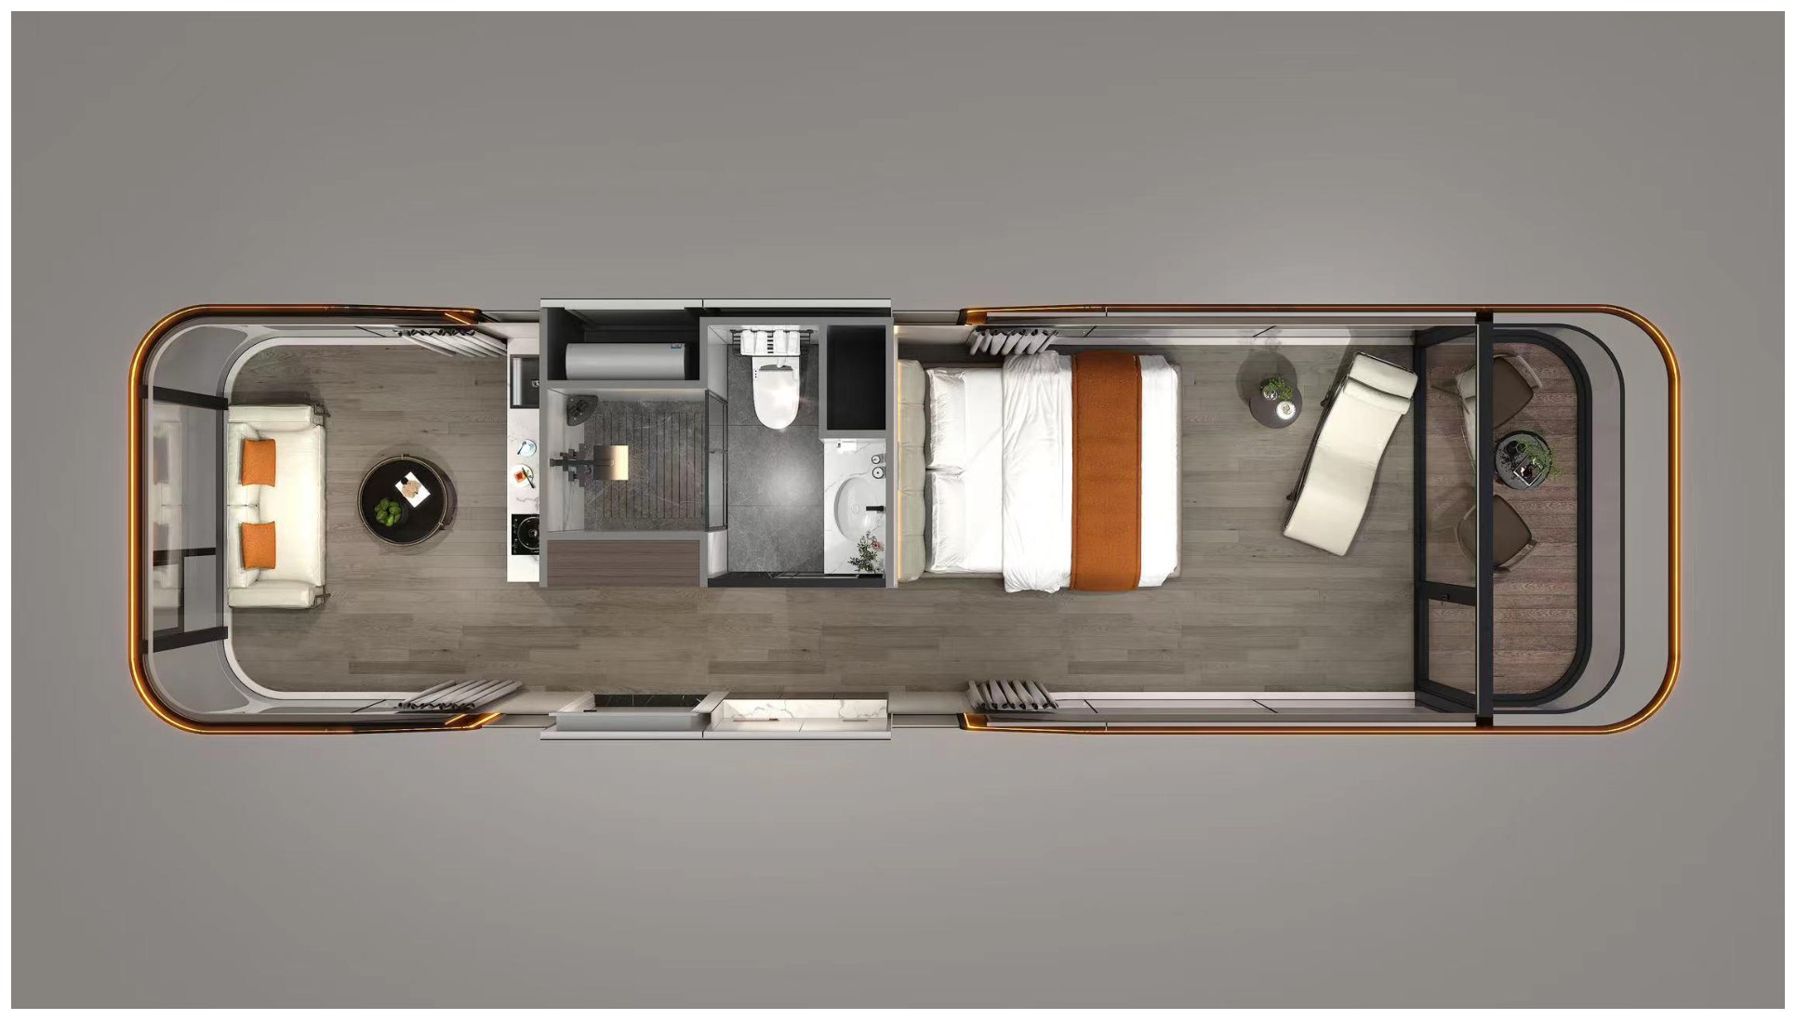
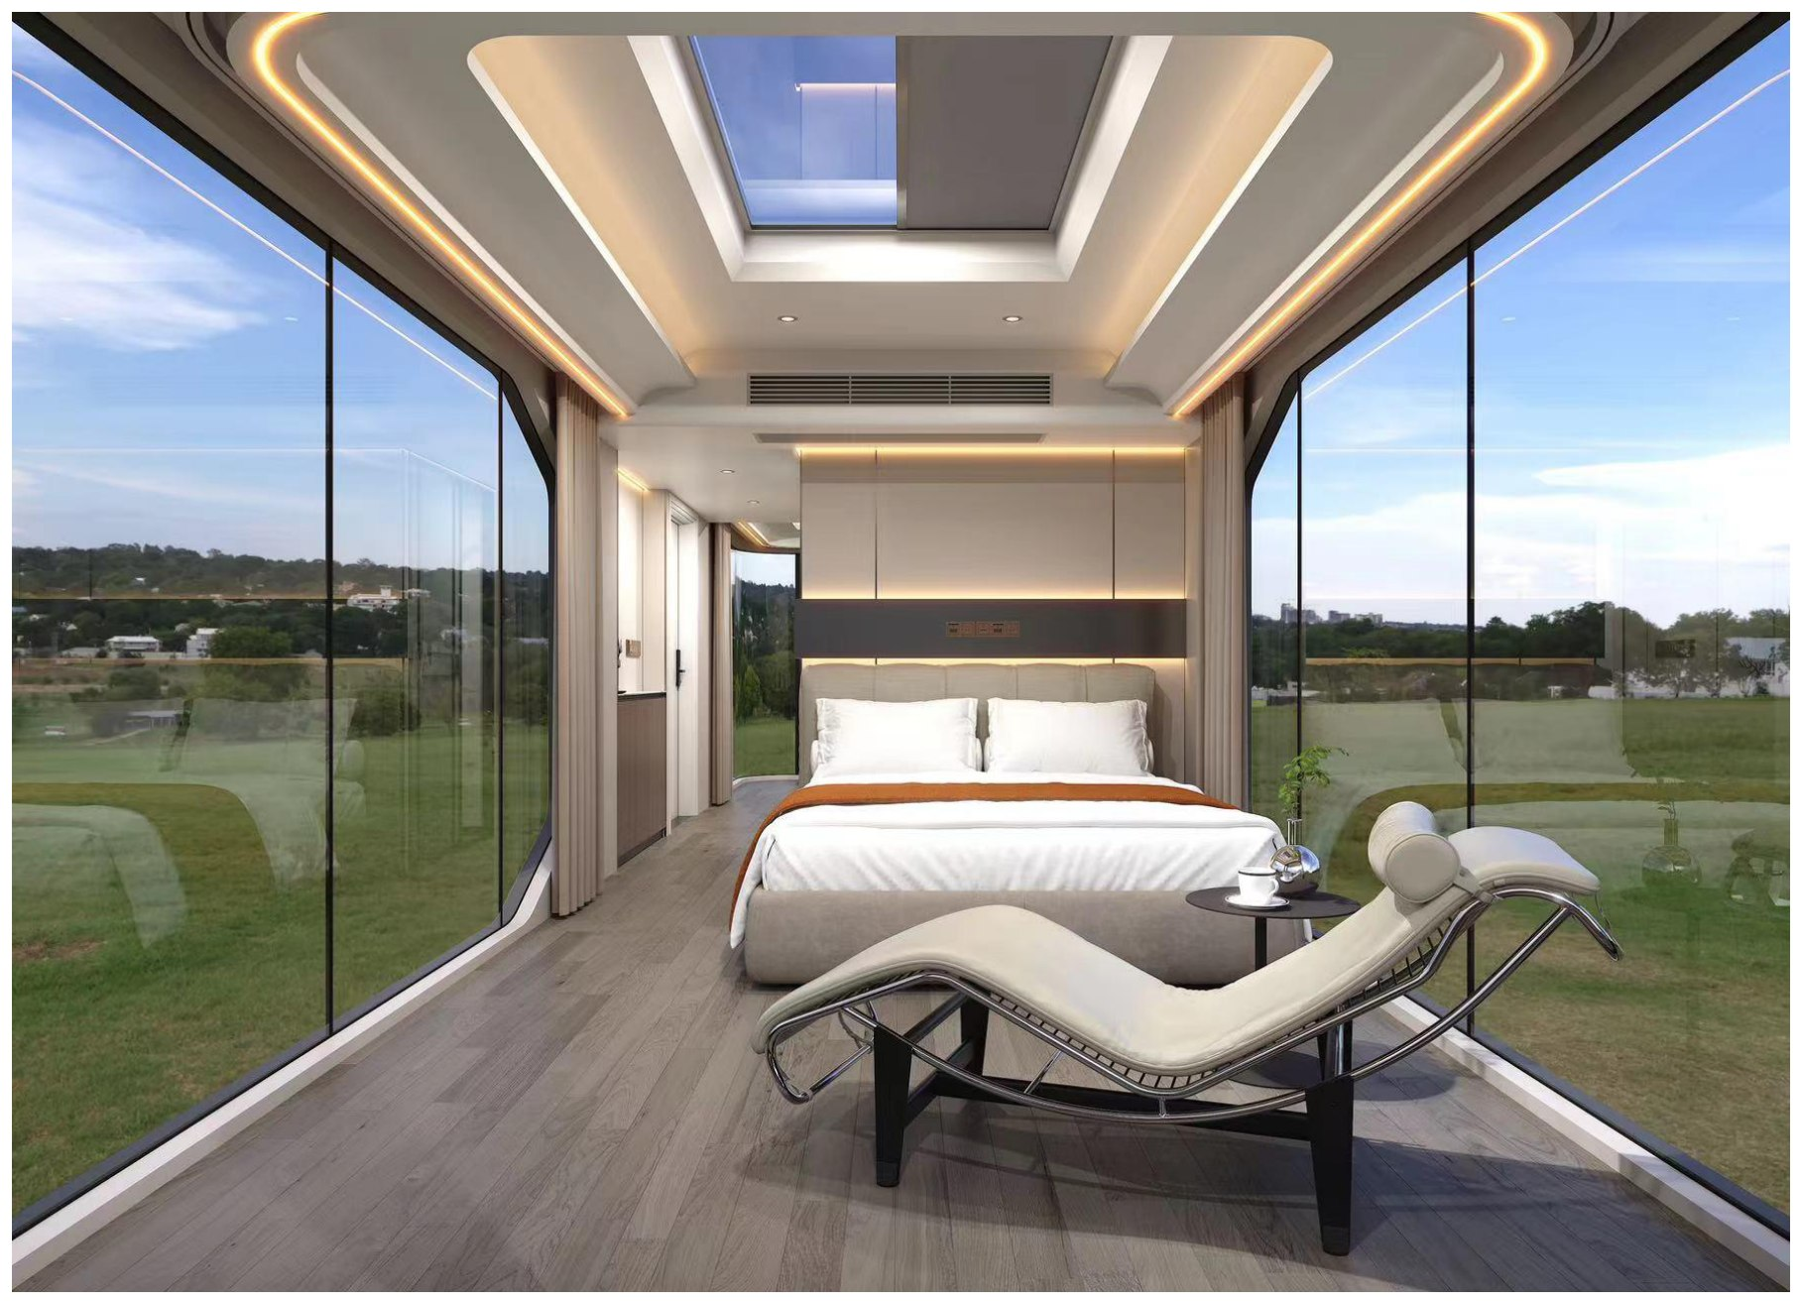
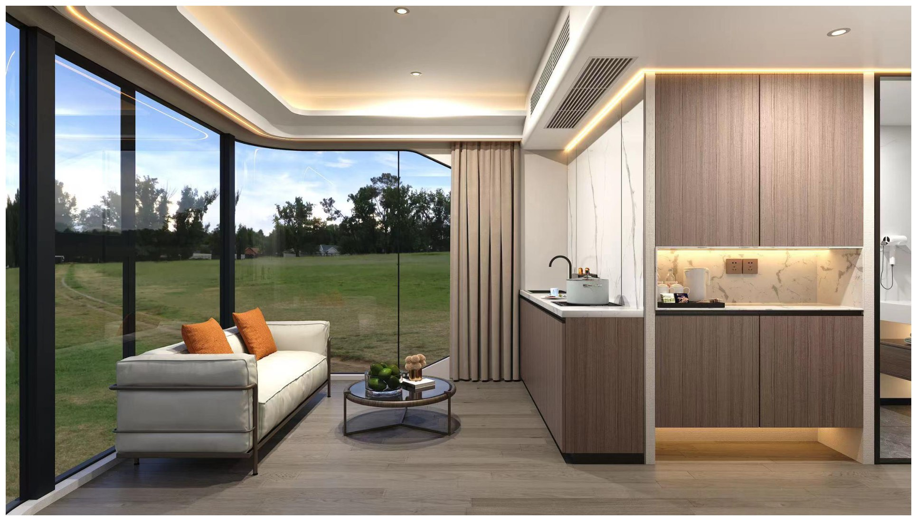
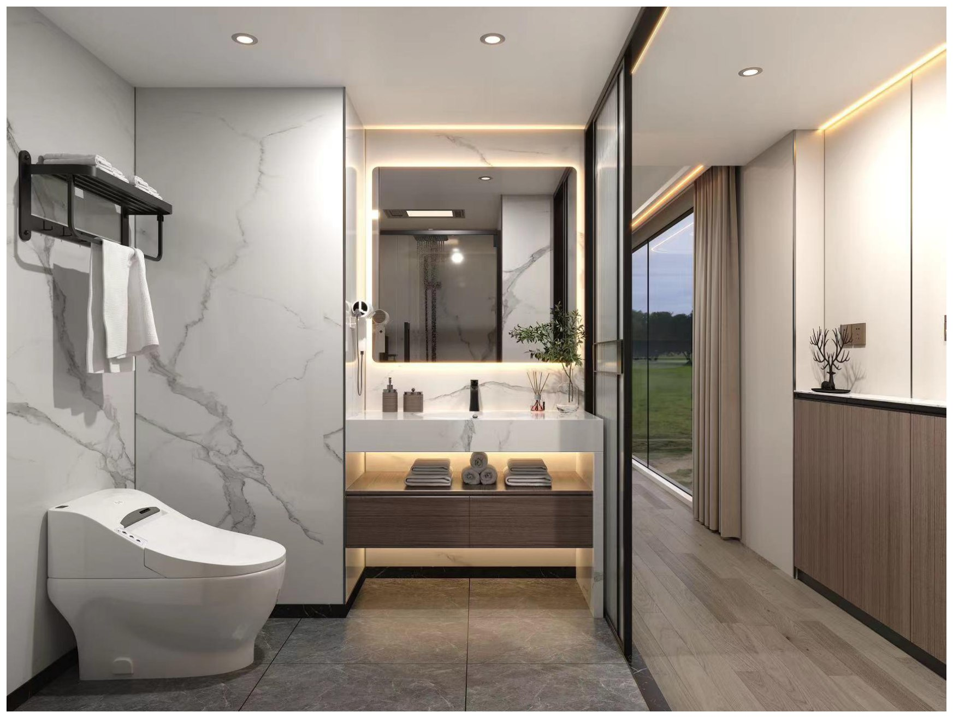
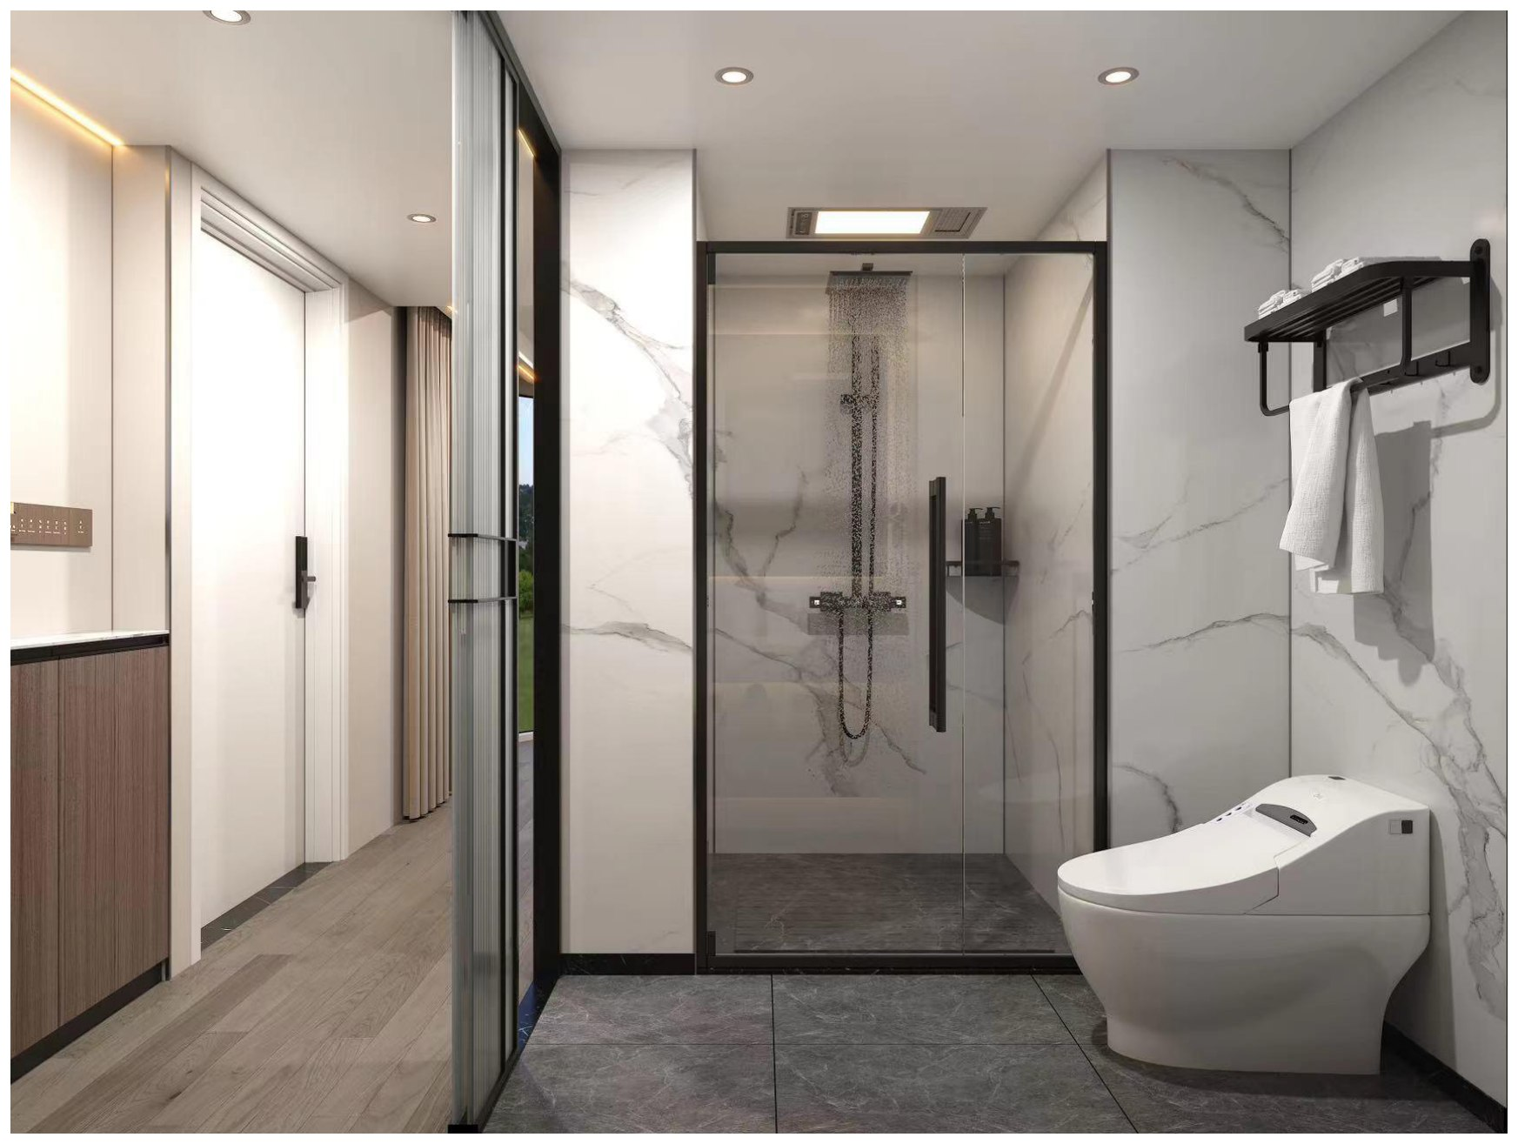
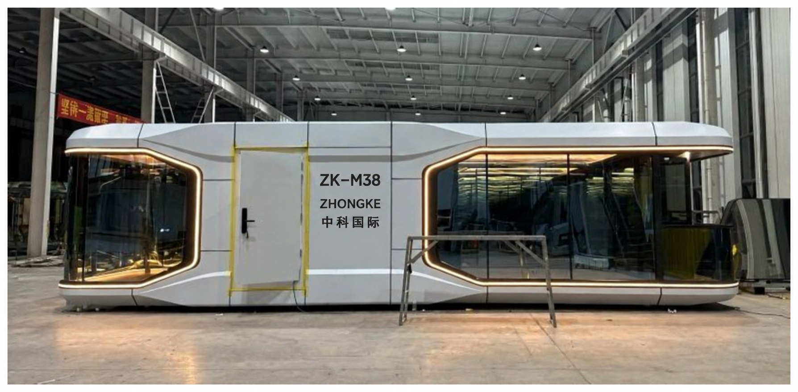
ZK-M38 Exterior & Interior Details
EXTERIOR | TOP VIEW | BEDROOM & BATHROOM | EXTERIOR PHOTOGRAPHS

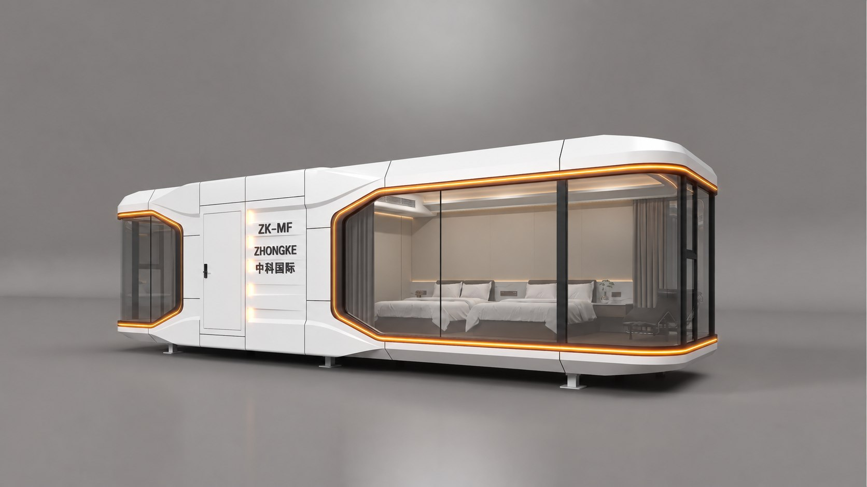
ZK-MF Panoramic Flagship Capsule
PANORAMIC WINDOWS | BEDROOM & LIVING SPACE

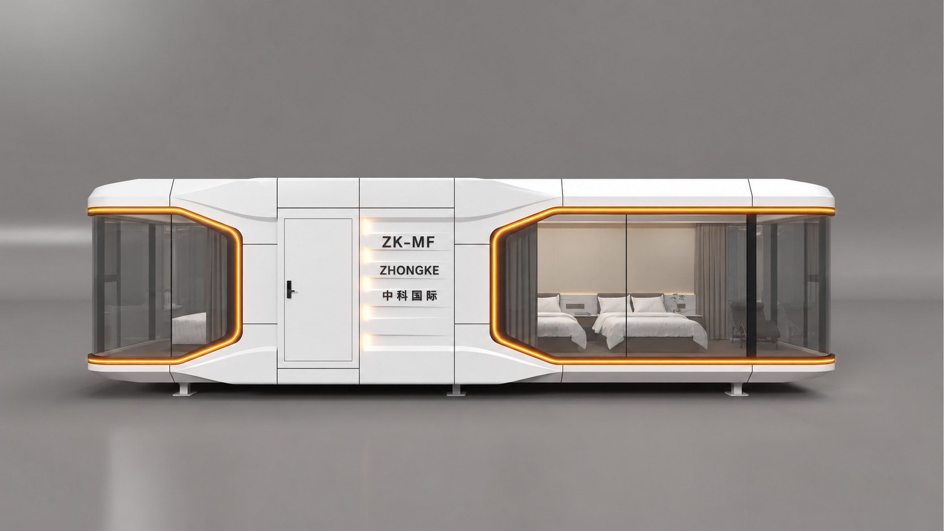
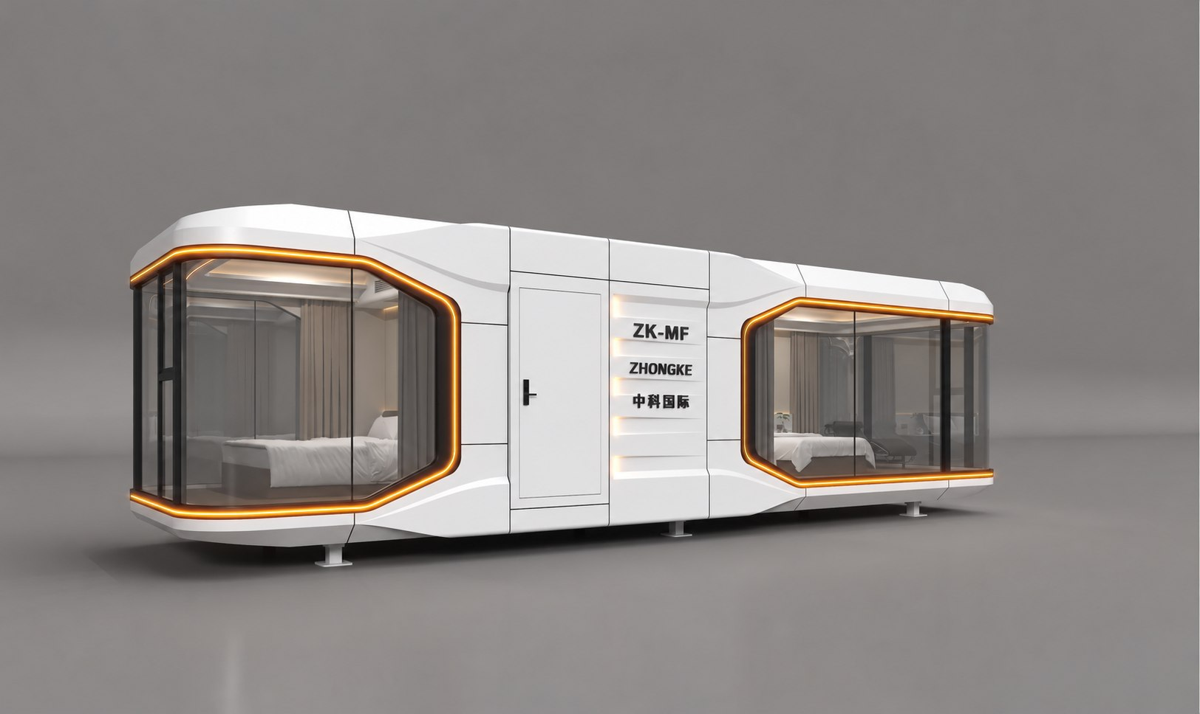
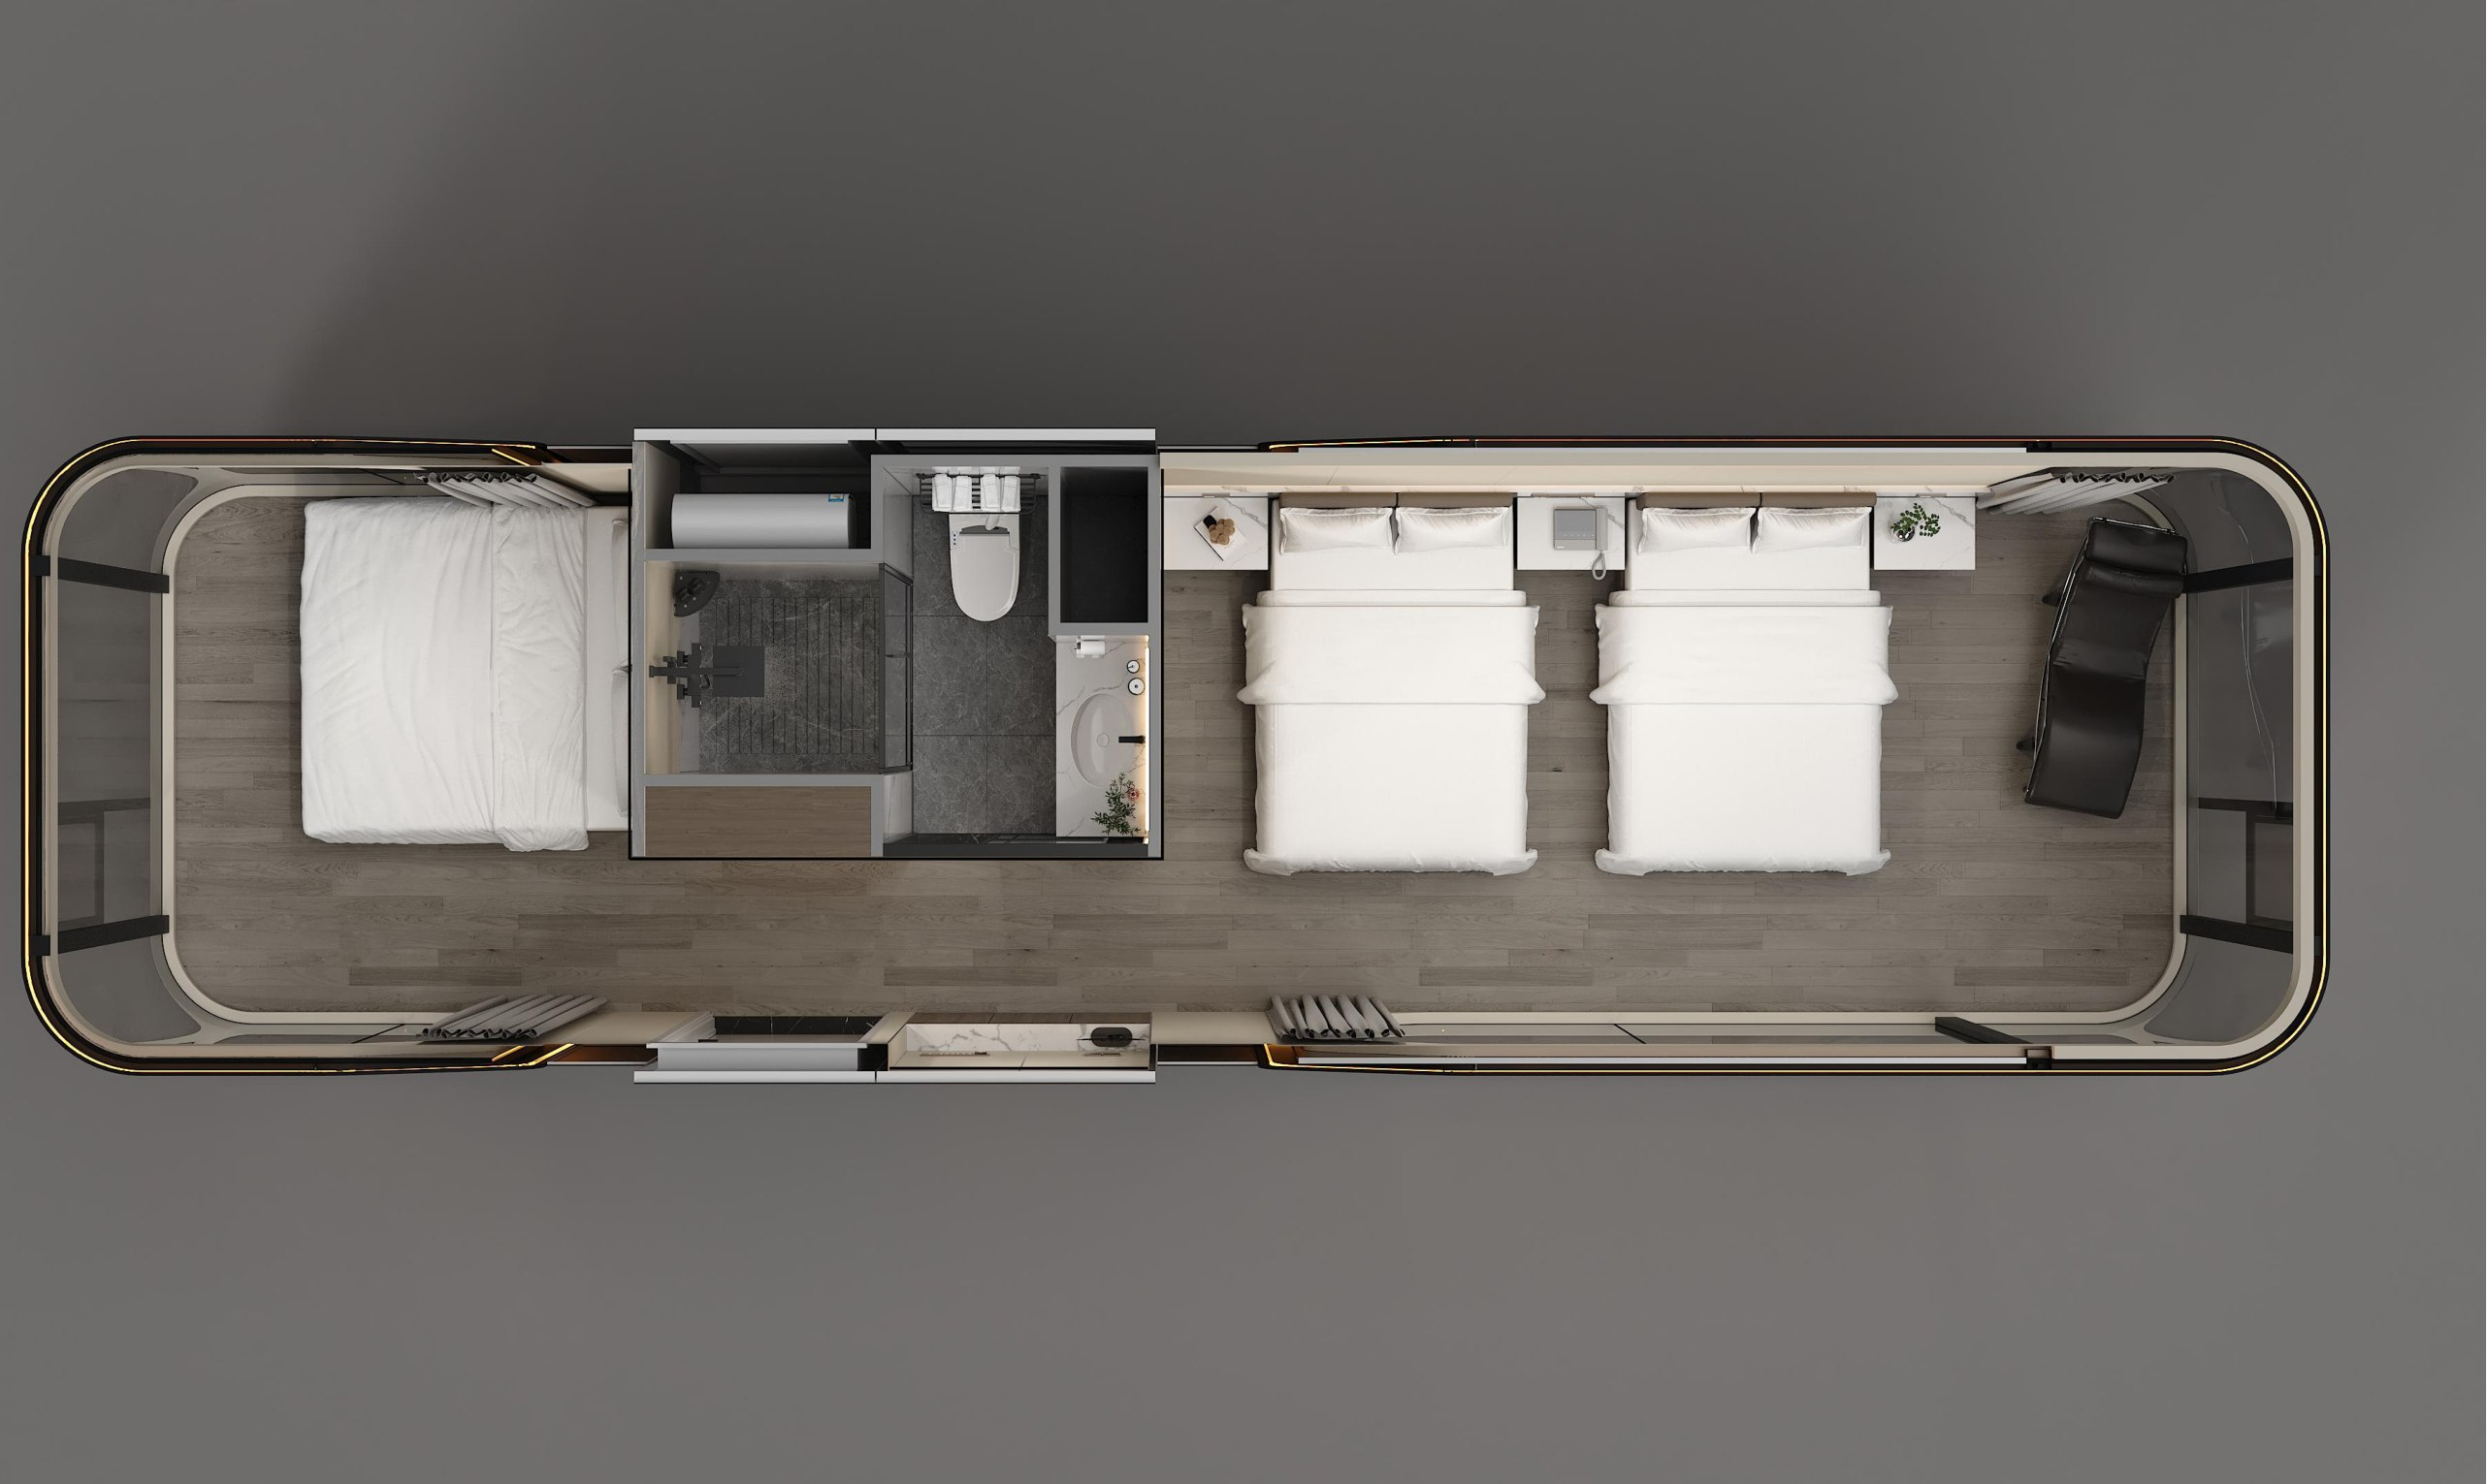
ZK-MF Exterior & Top View Layouts
EXTERIOR | SPACE LAYOUT

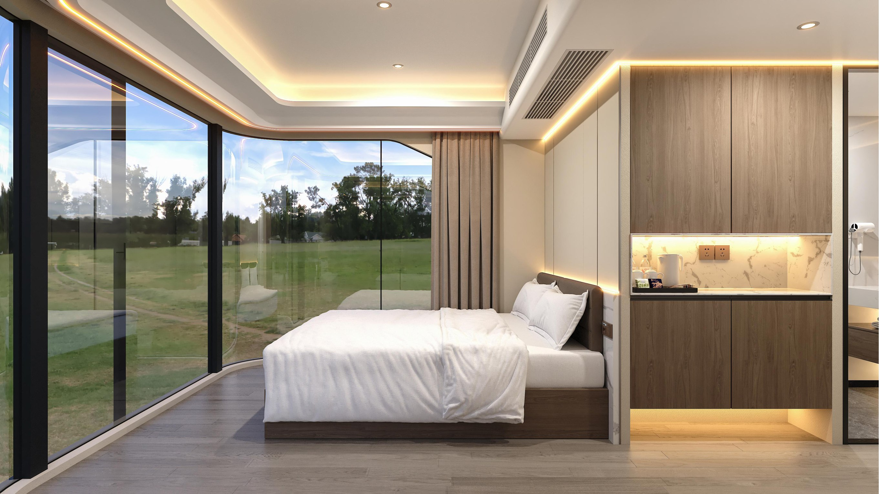
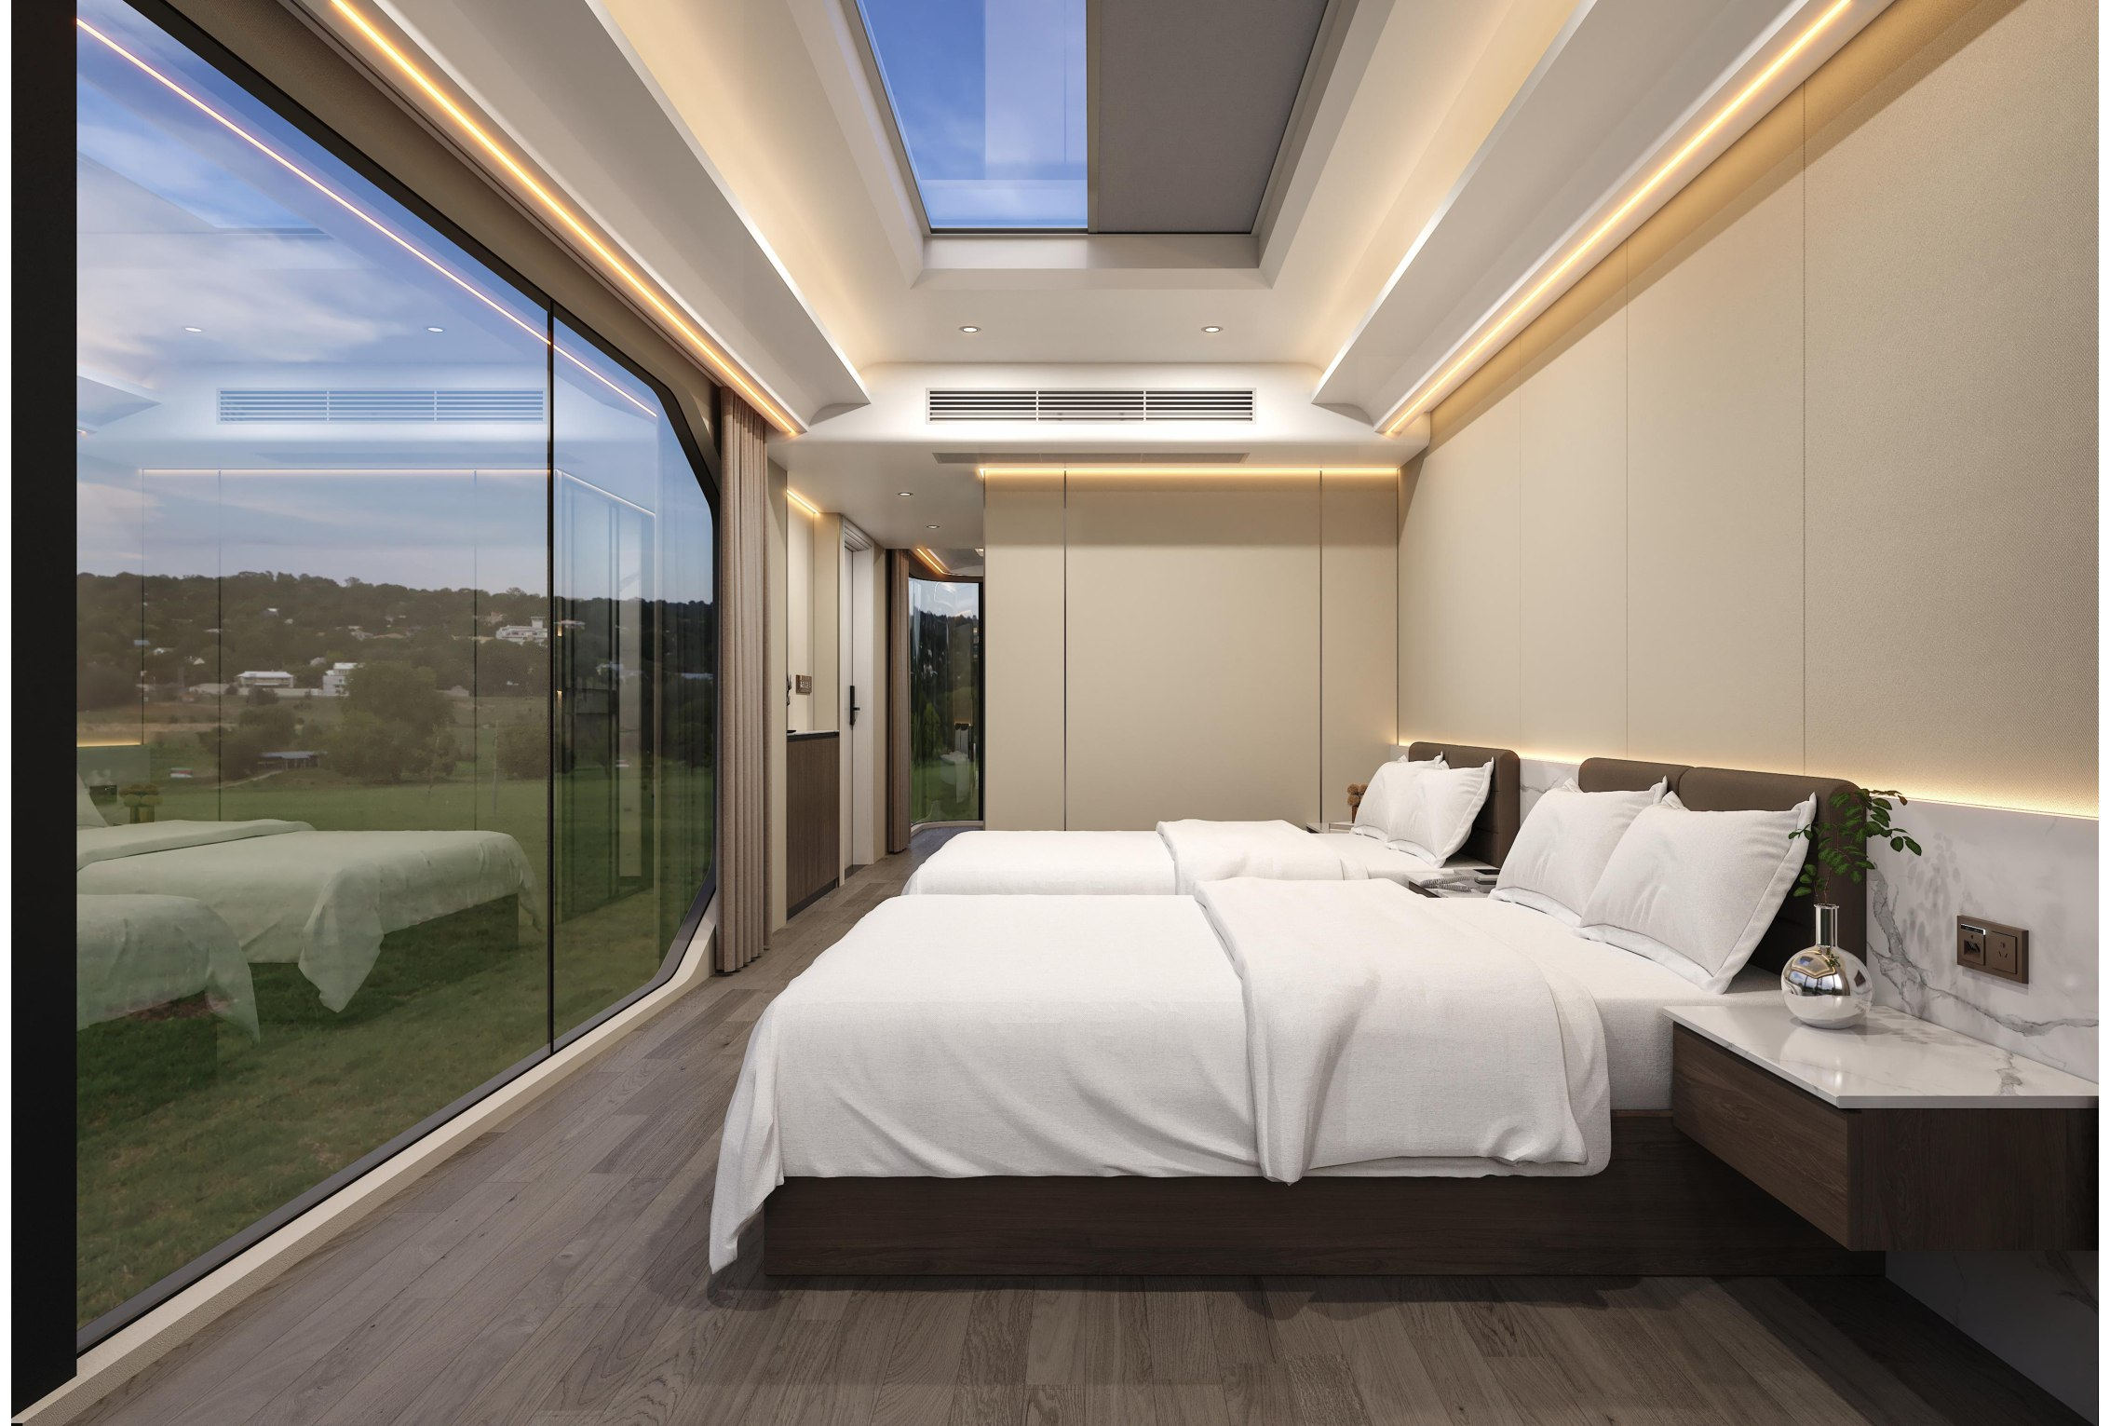
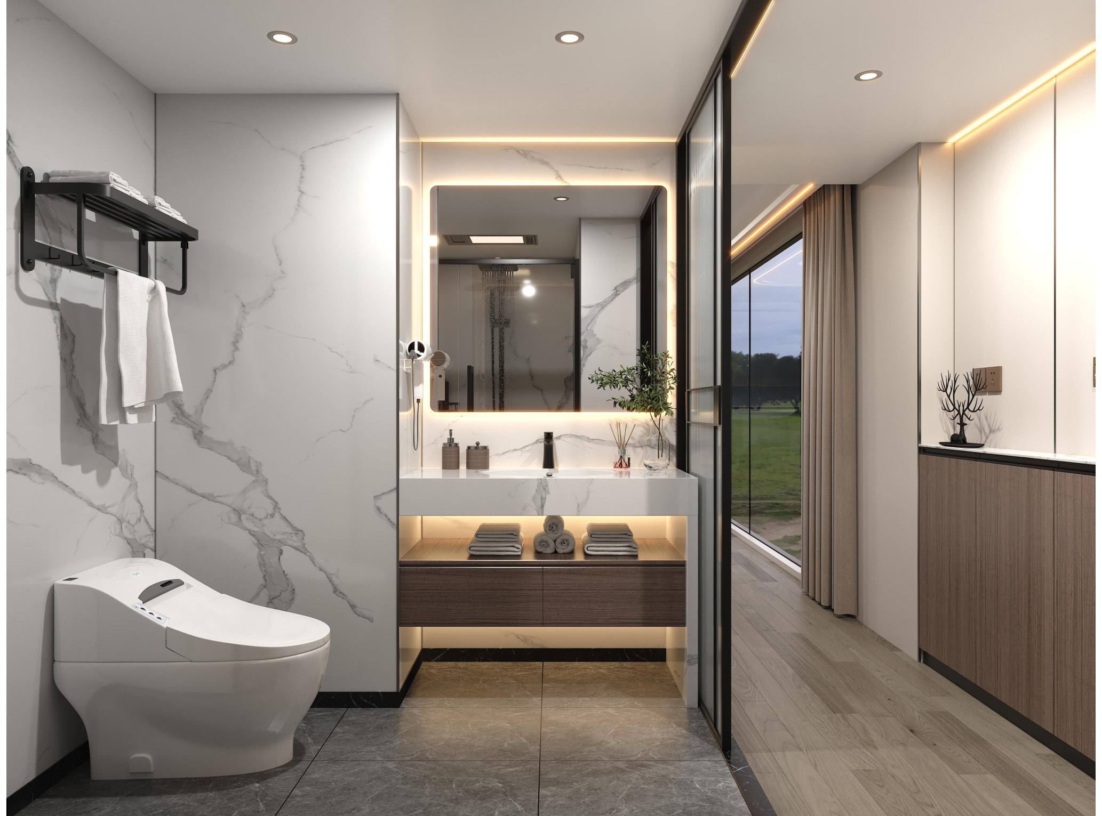
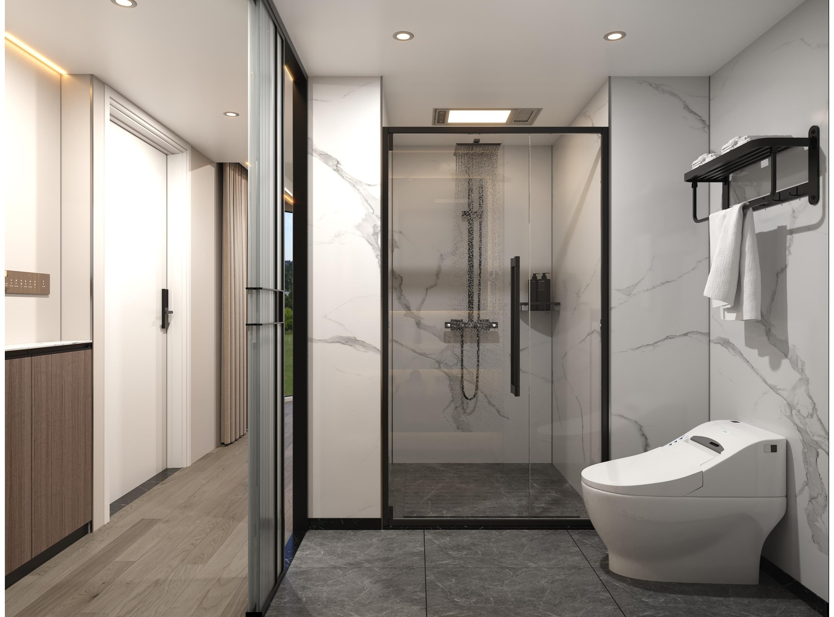
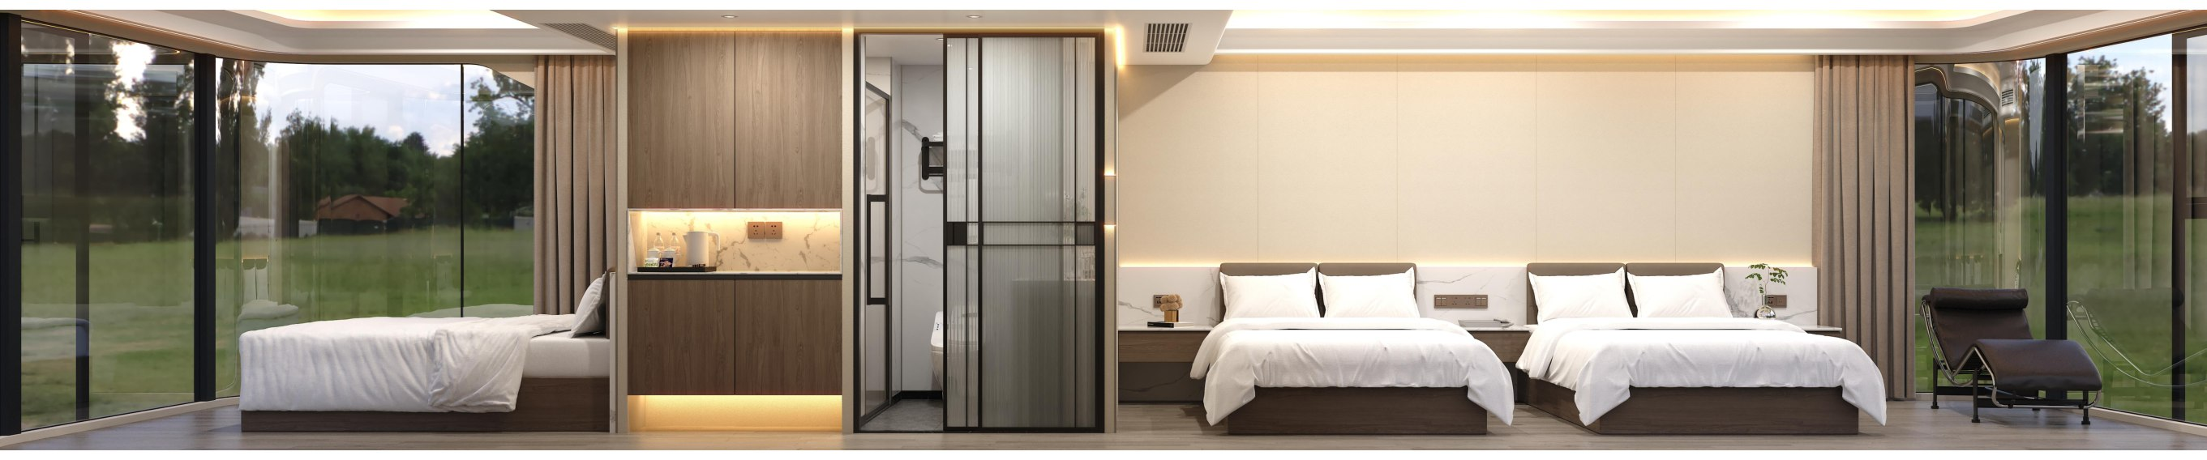
ZK-MF Bedroom & Bathroom Details
BEDROOM INTERIOR | BATHROOM

ZHONGKE
INTERNATIONAL
CAPSULE PRODUCTS & CONFIGURATION SERVICES
Zhongke International Consultants (Hong Kong) Limited

Contact: Yang Taofeng | Tel: 13319274381
Unit 703, 7/F, Tower 2, South Seas Centre, 75 Mody Road, Tsim Sha Tsui, Hong Kong
MODEL SELECTION | CONFIGURATION | PROCUREMENT & DELIVERY COORDINATION
Furniture, soft furnishings, solar PV, energy storage and water purification are optional extras.

