Zero: The section number starting from 0. If it has a subsection it uses dot point for example 0.1, 0.2…. At the end of each section it has many exercises the format is section number dot the number of question. Problems are after the exercises part and the count number continues. Whenever the book has figure, example, or theorem, it adds one to the number. The format is also section number dot count number.

First: La = { n | n = 00…0111…1., 111…100…00,000…0, 11….1}

Lb = { n | n = 0….0, 1….1 }

Two:

a: La length of 3 can be 100, 110, 111, 011, 001, 000 and B is { 0, 1 }

So the Product is {(0, 100), (0, 110), (0, 111), (0, 011), (0, 001), (0, 000), (1, 100), (1, 110), (1, 111), (1, 011), (1, 001), (1, 000) }

b: Power set of B { empty, {0} , {1}, { 0, 1}}

c: The cardinality is 2^3 = 8

f: {}

g: {ε}

Three:

Base: When n =0, Structural and Recursive are the same

We assume n = k is true

Then to prove n = k + 1

structural :

When n =k the longest path is k, so when n = k + 1, the longest path is k + 1

Recursive

Since we only add one level. One rooted sub-tree of height n, Zero or more additional rooted sub-trees of height n, and For each sub-tree there is one edge between the root of the subtree and the root of the tree. All sub-trees are disjoint from each other.

Four:

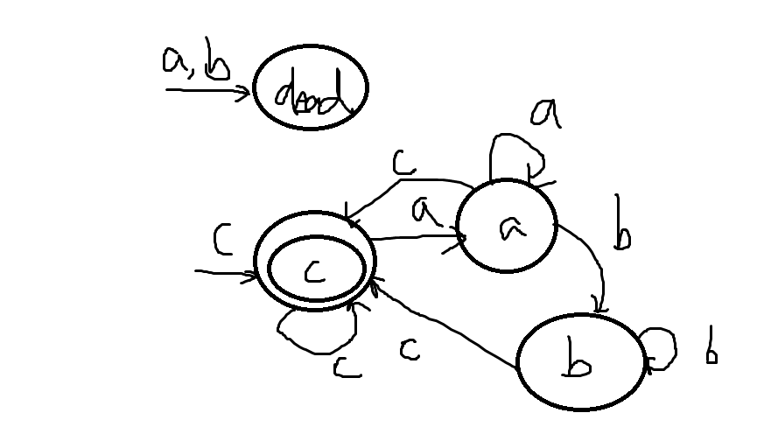

Five:

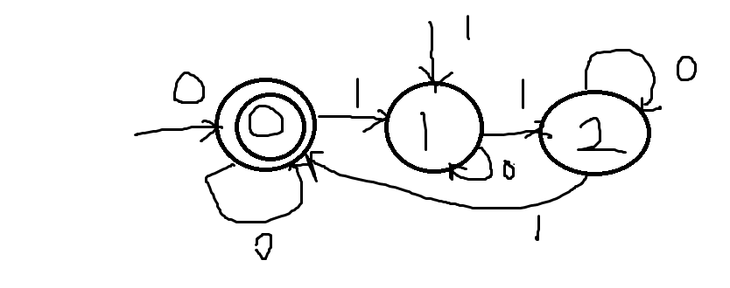

Six:

LSix = { w ∈ Σ\* | (w end with even number of b or odd number of a ) and b can’t follow an even number of a, a can’t follow by odd number of b}