W01 — FleetLink Service Design Document
- Component Diagram
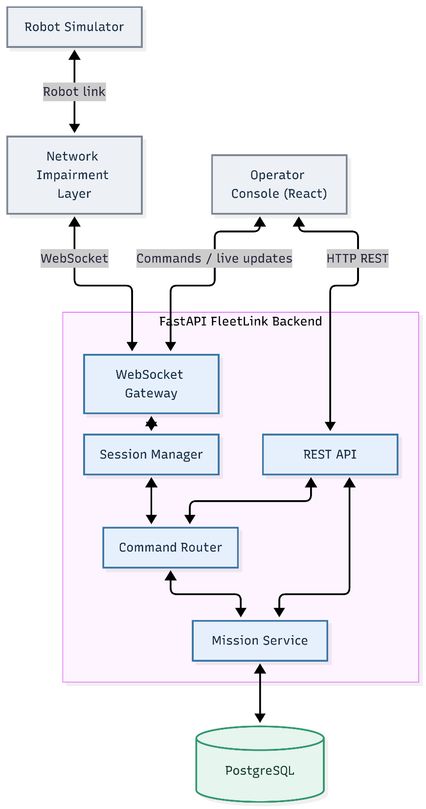
Figure 1. Proposed FleetLink System Architecture
The Robot Simulator communicates with the FastAPI backend through a network impairment layer and WebSocket Gateway. The Session Manager maintains robot connectivity, while the Command Router manages command delivery and the Mission Service handles mission operations. PostgreSQL provides persistent storage. The Operator Console interacts with the backend through REST APIs and real-time WebSocket communication.
The diagram represents the proposed system architecture. In Week 1, only the FastAPI service skeleton, database readiness checking, structured logging, and automated testing have been implemented. The remaining components will be developed in subsequent weeks.

2. Component Responsibilities and Boundaries
The FleetLink system follows a layered architecture that separates communication, connection management, command processing, mission logic, and data persistence. Each component has a clearly defined responsibility.
2.1 Robot Simulator
Simulates robot movement, telemetry, battery status, and command execution. It handles robot-side safety checks, including command expiration and duplicate prevention, but does not manage backend missions or operator permissions.
2.2 Network Impairment Layer
Simulates network latency, jitter, packet loss, and temporary disconnections using Toxiproxy. It modifies network conditions without changing application-level message content.
2.3 WebSocket Gateway
Manages bidirectional communication between robots and the backend. It handles connections, validates incoming protocol messages, and forwards telemetry and commands. It does not implement mission logic.
2.4 Session Manager
Maintains robot session information, heartbeat status, connection states, and reconnection handling. It tracks whether robots are online, degraded, or offline but does not execute commands.
2.5 Command Router
Validates command requests, manages delivery and retries, and tracks command status. It enforces server-side authorization and expiration policies, while final command expiration checks and deduplication are performed by the robot.
2.6 Mission Service
Manages missions, waypoints, robot assignments, and mission progress. It handles mission-related business logic but delegates network communication and persistent storage to other components.
2.7 REST API
Provides versioned HTTP endpoints for robot information, telemetry, commands, and mission management. It validates requests and responses while delegating business logic to the corresponding services.
2.8 PostgreSQL Database
Stores robot information, missions, assignments, command history, audit records, and telemetry data. It provides reliable persistence and transactional consistency but does not handle robot communication or mission decisions.
2.9 Operator Console
Provides an interface for operators to monitor robot status, view missions, and issue commands. It communicates with the backend through REST APIs and WebSockets but does not directly control robot hardware or independently authorize commands.
2.10 Design Principles
Separation of Concerns: Communication, business logic, and persistence are separated to improve maintainability and testing.
Robot-Side Safety: Command expiration, duplicate prevention, and emergency stopping must be enforced locally to prevent unsafe behavior during network failures.
Reliable State Management: The backend must maintain consistent robot and command states, identify outdated telemetry, and recover safely from temporary disconnections.
3. Failure Mode Analysis
The FleetLink backend must handle network interruptions, command delivery failures, and service outages without compromising robot safety or data consistency. The following failure-handling strategies define the intended system behavior.
3.1 Robot Disconnects Mid-Command
If a robot disconnects while executing a command, the Session Manager marks its connection as OFFLINE. The robot activates its local deadman mechanism and enters a safe state when the configured timeout expires. The backend keeps unconfirmed commands in an unresolved state until reconnection, when the robot reports its actual execution status. Expired commands must not be executed.
3.2 Operator Disconnects While Holding Control
If an operator disconnects while holding a control lease, the lease remains valid only until its expiration time. Once expired, the backend releases control and rejects further commands from that operator. If the robot is moving, it must enter SAFE_HOLD when control authority is lost.
3.3 Duplicate Command Delivery
Network retries may cause the same command to be delivered multiple times. Each command includes a unique idempotency key. The robot records previously processed keys and returns the existing result for duplicates without executing the command again.
3.4 Out-of-Order Telemetry
Network delays and buffered message replay may cause older telemetry to arrive after newer updates. Each telemetry message includes a sequence number and timestamp. The backend detects out-of-order messages and prevents older data from overwriting the robot's latest known state. Historical telemetry may still be stored with its original timestamp.
3.5 Robot Clock Skew
Robot and server clocks may differ, affecting timestamp validation and command expiration. During connection establishment, the server provides its current time to help estimate clock offset. The protocol applies a documented tolerance for clock differences. Commands must be rejected when their validity cannot be established safely.
3.6 Database Unavailable
If PostgreSQL becomes unavailable, the /readyz endpoint returns HTTP 503 to indicate that the service is not ready. Database-dependent operations must fail safely rather than report false success. Existing robot-side safety functions continue independently, and the backend resumes normal operations after database connectivity is restored.
3.7 Gateway Restart
A gateway restart interrupts active WebSocket connections. Robots reconnect using exponential backoff and resume their sessions when supported. The backend reconciles command states with robot-reported status and processes buffered telemetry without overwriting newer information. Commands that have expired during the interruption are rejected.
3.8 Summary
The failure-handling design prioritizes three principles: robot-side safety, consistent command and telemetry states, and reliable recovery from network or service interruptions.
These behaviors are proposed design requirements for future implementation and testing.

4. Initial REST API and Protocol Message Inventory
The FleetLink backend uses versioned REST APIs for fleet management and WebSocket messages for real-time robot communication.
4.1 REST API Endpoints
- GET /healthz: Checks whether the backend service is running.
- GET /readyz: Checks database connectivity and service readiness.
- GET /v1/robots: Lists registered robots.
- GET /v1/robots/{robot_id}: Retrieves robot information and connection status.
- GET /v1/robots/{robot_id}/telemetry/latest: Returns the latest robot telemetry.
- POST /v1/robots/{robot_id}/commands: Submits a robot command.
- GET /v1/missions: Lists missions.
- POST /v1/missions: Creates a new mission.
- POST /v1/robots/{robot_id}/lease: Requests exclusive robot control.
4.2 WebSocket Message Types
- HELLO: Robot initiates a connection.
- WELCOME: Server confirms the session.
- HEARTBEAT / HEARTBEAT_ACK: Monitors connection health.
- TELEMETRY: Reports robot position, battery, and status.
- COMMAND: Delivers a command to the robot.
- COMMAND_ACK: Confirms command receipt.
- COMMAND_RESULT: Reports command execution results.
- ERROR: Reports protocol or communication errors.
4.3 Message Envelope
All WebSocket messages use a consistent envelope containing:
protocol_version, msg_type, robot_id, session_id, seq, sent_at, and payload.
These fields provide protocol versioning, message identification, ordering, timestamps, and structured message content.
4.4 Implementation Scope
Week 1 implements /healthz and /readyz. The remaining REST endpoints and WebSocket protocol will be developed in Week 2, with command safety and mission management added in subsequent weeks.

5. Non-Functional Requirements
The FleetLink backend must meet the following performance, reliability, and safety requirements.
5.1 Command Latency
Under clean network conditions, the 95th percentile (p95) command round-trip time from gateway to acknowledgment should remain below 150 ms.
5.2 Connection Monitoring
The backend must detect robot disconnections within 3 seconds of link loss and maintain accurate ONLINE, DEGRADED, and OFFLINE connection states.
5.3 Robot Safety
The robot must enter a safe-stop state within 500 ms after its local deadman timeout. Commands received after their expiration time must never execute, including during network recovery.
5.4 Command Reliability
The system uses at-least-once delivery with idempotent deduplication to prevent duplicate execution. Only one operator may hold an active control lease for a robot at any time, and STOP commands must take priority.
5.5 Recovery and Data Consistency
After reconnection, the system must resume sessions, reconcile command states, and replay buffered telemetry without replacing newer data with outdated information.
5.6 Security and Observability
The backend must use environment-based configuration, avoid hardcoded credentials, and maintain structured JSON logs with request and connection identifiers. All development data must be synthetic.
5.7 Validation
Performance and safety targets will be tested under simulated network impairments in subsequent weeks. Any unmet target must be documented with supporting measurements and technical explanations.

