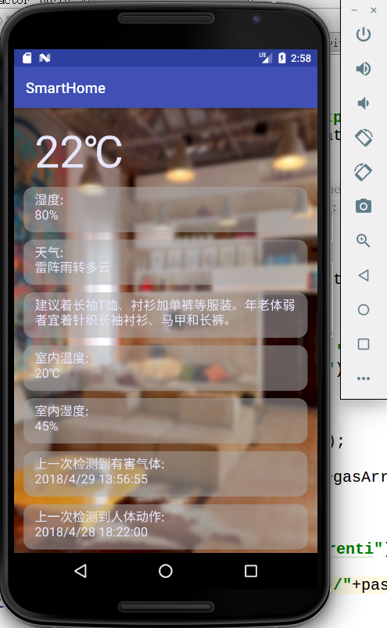安卓手机客户端以及服务器后端脚本的实现

图1 安卓客户端

手机客户端功能介绍：

实时获取家中的情况

对异常数据进行报警

对用户的家庭生活提供各方面智能的建议

接入聚合数据天气API接口，提供实时气候情况、穿着的建议等

附：

服务器端脚本API使用文档

**返回所有温度数据**

<http://47.96.162.8/stitp/getWendu.jsp>

例：

21-2018-3-1-8-55-32#20-2018-3-1-9-18-18#24-2018-3-1-9-41-4#24-2018-3-1-10-3-50#24-2018-3-1-10-26-36#24-2018-3-1-10-49-22#21-2018-3-1-11-12-8#20-2018-3-1-11-34-54#20-2018-3-1-11-57-40#23-2018-3-1-12-20-26#21-2018-3-1-12-43-12#21-2018-3-1-13-5-58#24-2018-3-1-13-28-44#23-2018-3-1-13-51-30#

**返回所有湿度数据**

<http://47.96.162.8/stitp/getShidu.jsp>

例：

46-2018-3-1-8-55-32#46-2018-3-1-9-18-18#43-2018-3-1-10-26-36#43-2018-3-1-10-49-22#43-2018-3-1-11-12-8#

**返回所有人体热释电数据**

<http://47.96.162.8/stitp/getRenti.jsp>

例：

2018-3-1-8-26-00#2018-3-1-18-48-00#2018-3-2-8-35-00#2018-3-2-18-29-00#2018-3-3-8-24-00#2018-3-3-18-24-00#2018-3-5-8-35-00#2018-3-5-18-29-00#2018-3-6-8-38-00#2018-3-6-18-25-00#2018-3-7-8-24-00#2018-3-7-18-59-00#2018-3-8-8-20-00#2018-3-8-18-35-00#2018-3-9-8-37-00#2018-3-9-18-36-00#2018-3-10-8-29-00#2018-3-10-18-39-00#2018-3-12-8-15-00#2018-3-12-19-24-00#

**返回所有气体数据**

<http://47.96.162.8/stitp/getQiti.jsp>

例：

2018-4-10-18-32-41#2018-4-19-8-2-3#2018-4-25-19-2-16#2018-4-29-13-40-55#2018-4-29-13-56-55#

**返回算法得出的用户行为模式**

<http://47.96.162.8/stitp/getOutput.jsp>

例：

{

"foiluserdata": [{

"Type": "leave",

"Time": "7",

"isWeekday": "true",

"isSat": "true",

"isSun": "false",

"isHoliday": "false",

"wCondition": "true"

}, {

"Type": "back",

"Time": "24",

"isWeekday": "true",

"isSat": "true",

"isSun": "false",

"isHoliday": "false",

"wCondition": "true"

}]

}

**返回所有数据的最近一次记录**

<http://47.96.162.8/stitp/getAll.jsp>

例：

{

"wendu": "20-2018-3-3-17-27-46",

"shidu": "45-2018-3-3-17-27-46",

"qiti": "2018-4-29-13-56-55",

"renti": "2018-4-28-18-22-00"

}

**返回是否需要针对气体进行报警**

<http://47.96.162.8/stitp/getQitiReturn.jsp>

例：

{

"ret": "false"

}

**返回是否需要针对人体进行报警**

<http://47.96.162.8/stitp/getRentiReturn.jsp>

例：

{

"ret": "true"

}

**返回聚合数据网提供的天气信息**

<http://v.juhe.cn/weather/index?format=2&cityname=%E5%8D%97%E4%BA%AC&key=66022d283653094507dc70f68872f0a3>

例：

{  
"resultcode": "200",  
"reason": "successed!",  
"result": {  
"sk": {  
"temp": "27",  
"wind_direction": "西南风",  
"wind_strength": "4级",  
"humidity": "55%",  
"time": "12:45"  
},  
"today": {  
"temperature": "19℃~27℃",  
"weather": "雷阵雨转阴",  
"weather_id": {  
"fa": "04",  
"fb": "02"  
},  
"wind": "南风3-5级",  
"week": "星期日",  
"city": "南京",  
"date_y": "2018年04月29日",  
"dressing_index": "舒适",  
"dressing_advice": "建议着长袖T恤、衬衫加单裤等服装。年老体弱者宜着针织长袖衬衫、马甲和长裤。",  
"uv_index": "弱",  
"comfort_index": "",  
"wash_index": "不宜",  
"travel_index": "较不宜",  
"exercise_index": "较不宜",  
"drying_index": ""  
},  
"future": [{  
"temperature": "19℃~27℃",  
"weather": "雷阵雨转阴",  
"weather_id": {  
"fa": "04",  
"fb": "02"  
},  
"wind": "南风3-5级",  
"week": "星期日",  
"date": "20180429"  
}, {  
"temperature": "20℃~29℃",  
"weather": "阴",  
"weather_id": {  
"fa": "02",  
"fb": "02"  
},  
"wind": "西南风3-5级",  
"week": "星期一",  
"date": "20180430"  
}, {  
"temperature": "19℃~27℃",  
"weather": "雷阵雨",  
"weather_id": {  
"fa": "04",  
"fb": "04"  
},  
"wind": "东南风3-5级",  
"week": "星期二",  
"date": "20180501"  
}, {  
"temperature": "13℃~25℃",  
"weather": "阵雨转多云",  
"weather_id": {  
"fa": "03",  
"fb": "01"  
},  
"wind": "北风4-5级",  
"week": "星期三",  
"date": "20180502"  
}, {  
"temperature": "13℃~24℃",  
"weather": "晴转多云",  
"weather_id": {  
"fa": "00",  
"fb": "01"  
},  
"wind": "南风3-5级",  
"week": "星期四",  
"date": "20180503"  
}, {  
"temperature": "19℃~27℃",  
"weather": "雷阵雨",  
"weather_id": {  
"fa": "04",  
"fb": "04"  
},  
"wind": "东南风3-5级",  
"week": "星期五",  
"date": "20180504"  
}, {  
"temperature": "20℃~29℃",  
"weather": "阴",  
"weather_id": {  
"fa": "02",  
"fb": "02"  
},  
"wind": "西南风3-5级",  
"week": "星期六",  
"date": "20180505"  
}]  
},  
"error_code": 0  
}