Personal Investment Assistant Application

1. Background and Motivation

1.1 Background
The efficient-market hypothesis posits that stock prices are a function of information and rational expectations, and that newly revealed information about a company's prospects is almost immediately reflected in the current stock price. This would imply that all publicly known information about a company, which obviously includes its price history, would already be reflected in the current price of the stock. Accordingly, changes in the stock price reflect release of new information, changes in the market generally, or random movements around the value that reflects the existing information set. Burton Malkiel, in his influential 1973 work A Random Walk Down Wall Street, claimed that stock prices could therefore not be accurately predicted by looking at price history. As a result, Malkiel argued, stock prices are best described by a statistical process called a "random walk" meaning each day's deviations from the central value are random and unpredictable. This led Malkiel to conclude that paying financial services persons to predict the market actually hurt, rather than helped, net portfolio return. A number of empirical tests support the notion that the theory applies generally, as most portfolios managed by professional stock predictors do not outperform the market average return after accounting for the managers' fees.
While the efficient-market hypothesis finds favor among financial academics, but its critics point to instances in which actual market experience differs from the prediction-of-unpredictability the hypothesis implies. A large industry has grown up around the implication proposition that some analysts can predict stocks better than others; ironically that would be impossible under the Efficient Markets Hypothesis if the stock prediction industry did not offer something its customers believed to be of value.

1.2 Prediction Methods

1.2.1 Fundamental Analysis
Fundamental analysis is built on the belief that human society needs capital to make progress and if a company operates well, it should be rewarded with additional capital and result in a surge in stock price. Fundamental analysis is widely used by fund managers as it is the most reasonable, objective and made from publicly available information like financial statement analysis.
Another meaning of fundamental analysis is beyond bottom-up company analysis, it refers to top-down analysis from first analyzing the global economy, followed by country analysis and then sector analysis, and finally the company level analysis.

1.2.2 Technical Analysis
Principles
Technical analysis focuses on identifiable trends and conditions, based on the belief that price action tends to repeat itself due to investors collectively tending toward patterned behavior. And here is the principle of the technical analysis. First, market action discount everything. Accordingly, in technical analysis one need only look at price movements, and not at other factors such as the balance sheet. Second, prices move in trends. The series of "lower highs" and "lower lows" is a tell tale sign of a stock in a down trend. In other words, each time the stock moved lower, it fell below its previous relative low price. Each time the stock moved higher, it could not reach the level of its previous relative high price. Third, History tends to repeat itself. Recognition of these patterns can allow the technician to select trades that have a higher probability of success.
Comparison with Fundamental Analysis
Fundamental analysis maintains that markets may misprice a security in the short run but that the "correct" price will eventually be reached. Profits can be made by purchasing the mispriced security and then waiting for the market to recognize its "mistake" and reprice the security.
Technical analysis maintains that all information is reflected already in the price of a security. Technical analysts analyze trends and believe that sentiment changes predate and predict trend changes. Investors' emotional responses to price movements lead to recognizable price chart patterns. Technical analysts also analyze historical trends to predict future price movement.
Computerized Support Using Technical Analysis
Technical analysts believe that market prices exhibit identifiable regularities (or patterns or indicators) that are bound to be repeated. Using technical analysis, various trends could be “unearthed” from the historical prices of a particular stock and potentially those could be “projected into future” to have some estimation around where that stock price is heading. Technical analysts believe that graphs give them the ability to form an opinion about any security without following it in real time.
Furthermore, we should clearly state the user's goal. We need to know whether our trader has a long-term or short-term outlook to investment. After that, we should choose proper patterns and indicators to create system. In next section, head and shoulder pattern would be explained in detail.

1.3 Motivation
Our goal is to create a system allow users to:
- Get stock information of the specific companies
- Get short-term and long-term prediction for price and volume
- Get recommendation for buying/holding/selling
- Record trading record
- Calculate the earning of specific stocks

2. User Cases
User cases | Description
Login | Allow users to access their account and view information for their tracked stocks.
History Time Data | Allow users to find 1-year price,volume and other information of the specific stock.
Real Time Data | Allow users to find daily price,volume and other information of the specific stock.
K-chart | Allow users to view the K-chart of specific stocks
Query | Allow users to access the required queries for specific stock
Prediction | Allow users to get long-term and short-term predicted price of the specific stock
Recommendation | Allow users to get recommendation by analyzing indicators of the stock
Trading Recording | Allow users to access the trading record of the stocks and get current earnings for each stock
Search | Allow users to search for information of the specific stocks

3. System Design

3.1 System Requirement
Operating System: Windows, Linux, Mac OS
XAMPP/MAMPP: Deploying local server
PHP: v7.0 or newer
MySQL: supporting database operations
Python: using SVM and Bayesian Curve Fitting
v2.7
sklearn
pandas
stockstats
Java: using ANN
java-bridge

3.2 System Diagrams
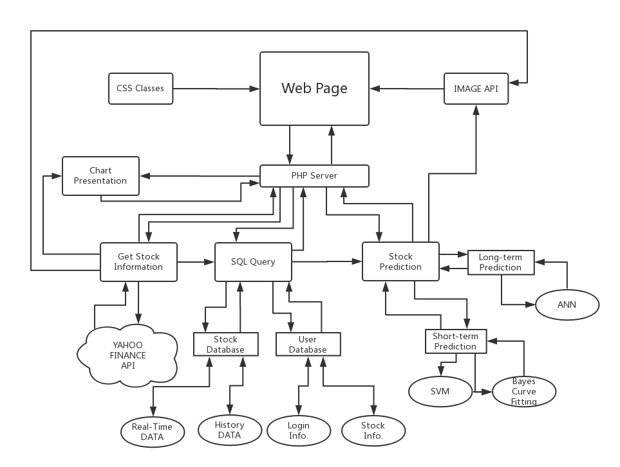

Our back-end system consists of three main modules: Getting information, SQL Query and Stock Prediction. We will describe the three modules in detail in the following sections. After that, we will introduce AJAX to imply how we connect the client and server side.

3.3 Get Stock Information
Data collection is the first process in our project. First of all, we used two PHP programs to download stock price csv files using Yahoo Finance API. Then we parse those csv files to get the corresponding stock information we need and store them in the database as well as display them in our web page.

3.3.1 Download stock .csv files
In this part, we used “getHistory.php” and “getReal.php” to obtain the stock information from Yahoo Finance. The former program is used to get the historical information of each stock while the latter program is used to get the real-time information of each stock. In each program, we mainly rely on a downfile function to achieve our goal. Since Yahoo Finance provides a convenient API, by which we can only modify the stock symbol and time period according to its URL link format then Yahoo Finance would automatically generate a certain csv file for us to download. The main difference between our two programs is the URL link format.

3.3.3.1 Historical data
For the historical data, the URL we use to call the data is:
http://ichart.yahoo.com/table.csv?s=\$stock&a=\$a&b=\$b&c=\$c&d=\$d&e=\$e&f=$f&g=d&ignore=.csv
For this URL format, some parameters need to be replaced according to the following chart.
Symbols | Meanings
a | start month
b | start day
c | start year
d | end month
e | end day
f | end year
After running this program, the cvs file like “FB-hist-04-24-2017.csv” will be downloaded, where “FB” is the stock name and “04-24-2017” is the date. This cvs file stores the date, open price, high price, low price, close price volume and adj close price of this stock in the previous year until Apr 4, 2017. The following screenshot shows the content of a part of this file.
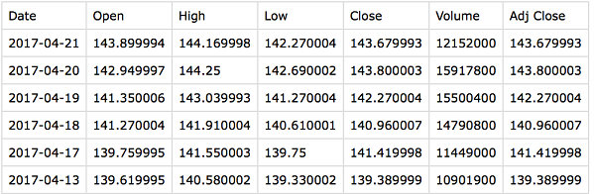

3.3.1.2 Real-time data
For the real-time data, the URL we use is:
http://chartapi.finance.yahoo.com/instrument/1.0/$stock/chartdata;type=quote; range=1d/csv
In this link, the only parameter we need to specify is the “stock”. Because we only need to download the stock information of a certain stock in the previous 24 hours from when we implement this program. So we specify the range as “1d” in this URL. After running the “getReal.php”, the data will be stored in the file like “AAPL-04-24-2017.txt”.
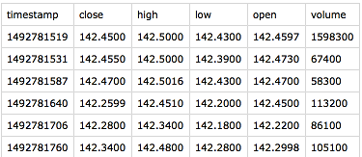

3.3.2 Display Stock Information In the Web Page
Based on the csv files downloaded in the previous step, we designed a “chart.html” to display the stock price into a table. This display method is mainly implemented by using JQuery. Below is a screenshot of this chart html page.
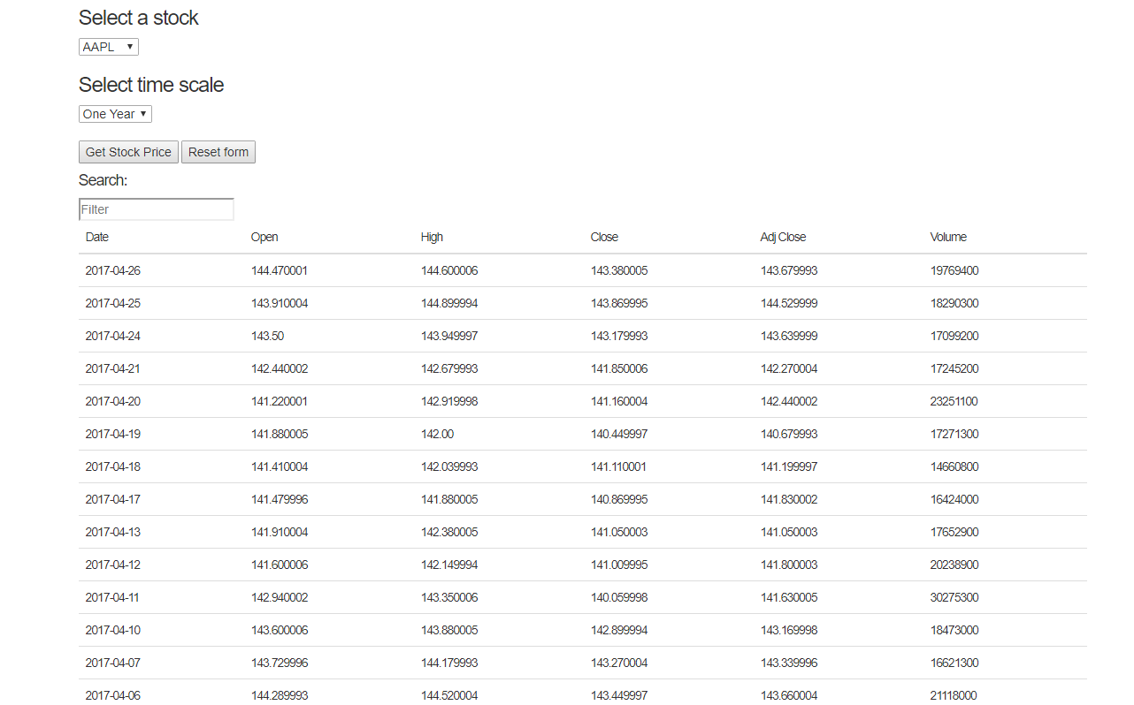

In this page, we can select the stock name and then the time scale, which has two options, one year or one day. After selecting the stock name and time scale. We can press the “Get Stock Price” button. Then the whole price table will be displayed.

3.3.3 Display the Stock Graph
In this part, we used “GetHistoryStock.php” and “GetRealStock.php” to read the stock price from the csv files to the “candlestick-sh-2015.html” and then display them in this html page in a candlestick chart format.
A candlestick chart (also called Japanese candlestick chart) is a style of financial chart used to describe price movements of a security, derivative, or currency. Each "candlestick" typically shows one day; so for example a one-month chart may show the 20 trading days as 20 “candlesticks”.
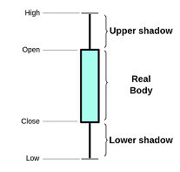

It is like a combination of line-chart and a bar-chart: each bar represents all four important pieces of information for that day: the open, the close, the high and the low. Being densely packed with information, they tend to represent trading patterns over short periods of time, often a few days or a few trading sessions.[1]
Not only Using candlestick chart to display the stock price, we also used a pop-up window to display the price. When users point the mouse arrow to each candlestick in a particular date or time, the window will pop up to show the detailed price information.[2]
This graph shows the history stock price of Facebook within one year. The pop-up windows shows the detailed price information of a particular date “2016/09/09”. In a word, with this graph, we can have a good understanding of the trend of a stock price within one year or within one day for real-time data as well as the detailed price in a particular date or time.
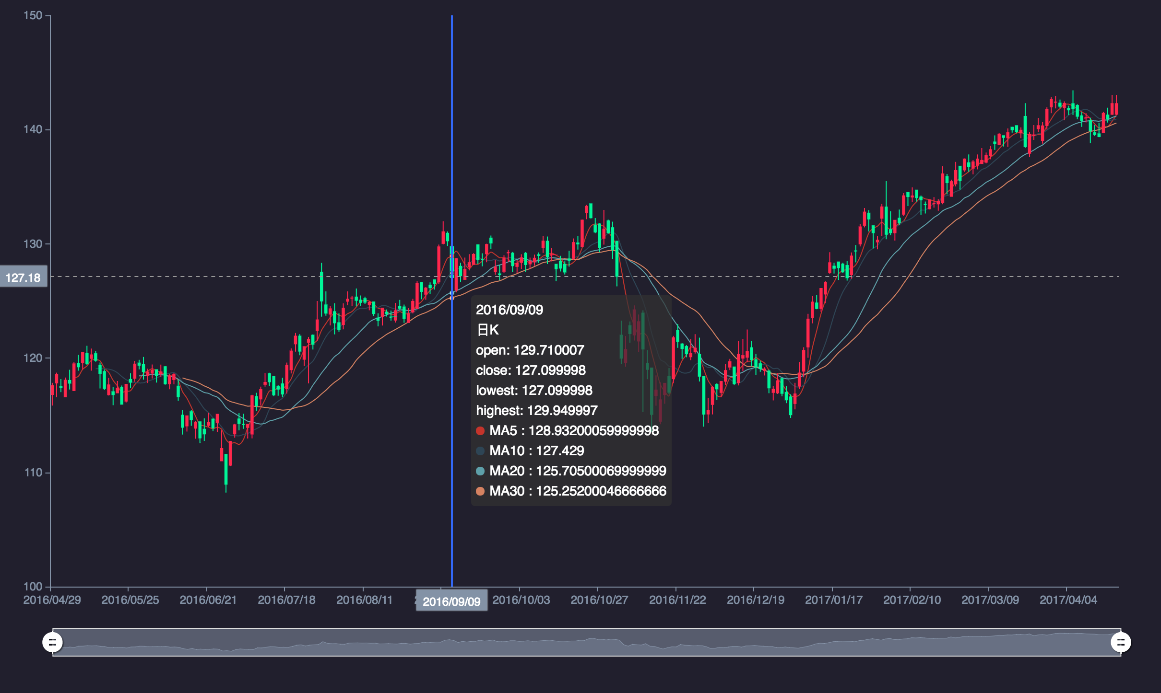

3.4 Database Design

3.4.1 Stock Database
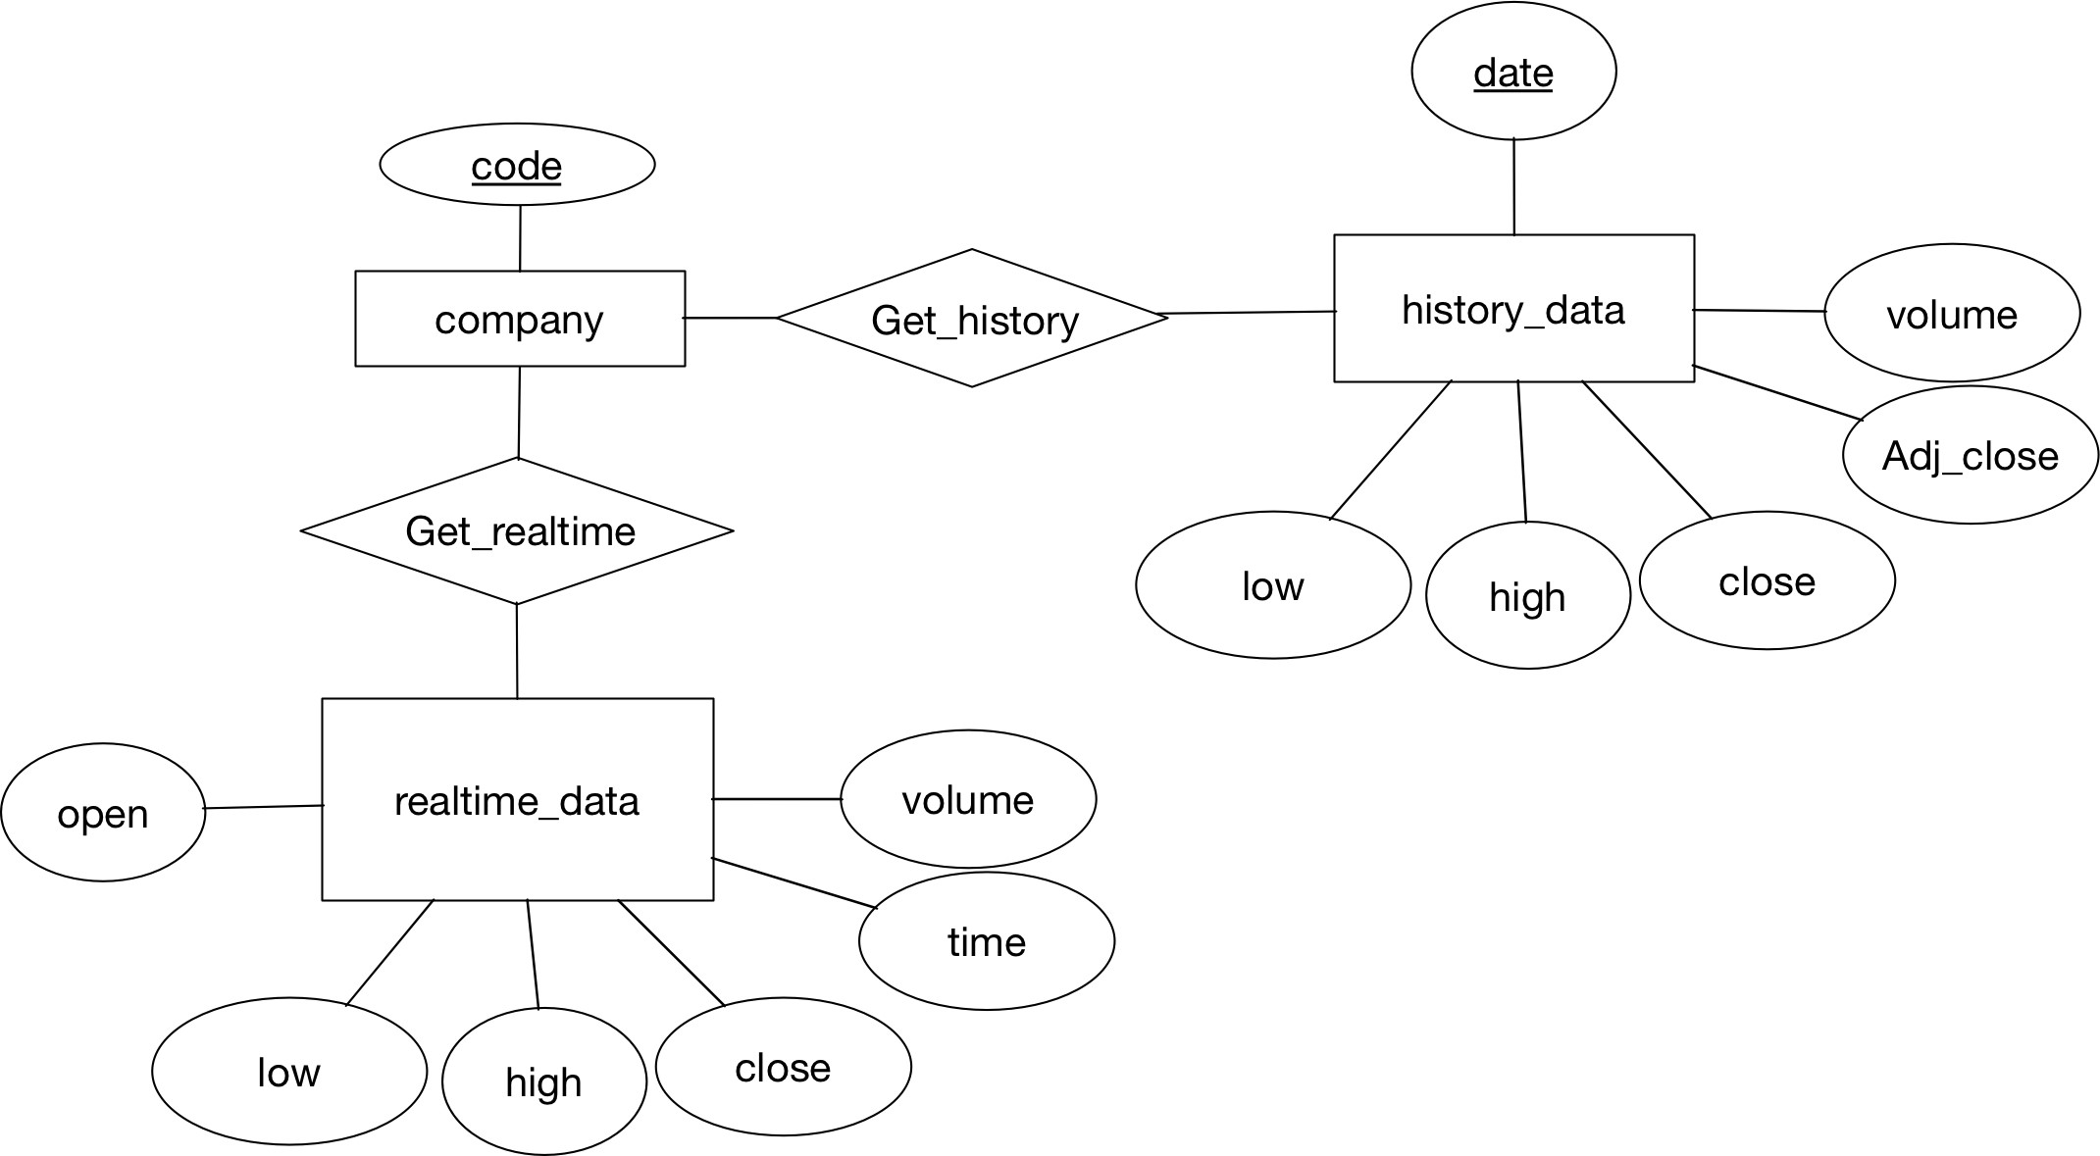

Here is our ER model. We have 3 entities whose name are company, realtime_data and history_data. Company has only one attribute which is code and has two relationship with realtime_data and history_data. Realtime_data has a 6 attributes which are open, low, high, close, time, and volume.History has 6 attributes which are date , volume , Adj_close, close, high, and low and date is the primary key for history_data.
For the stock prediction system, we do not need to save data in real time which means not dynamically querying database. Instead, when a single execution of the system happen, we may transform the functions. The data will be stored using a relational database, and we select MySQL. MySQL was chosen for the job due to its open source nature and has all the functions required for the job.
The data collected from Yahoo Finance is stored in [Company Code]-[Download Date].csv file. Based on the usage of information from different companies, we decided to store historical data and real time data separately in two databases. And both of them contain some tables. We firstly created two databases History_Data and Real_Data. The stock information of a specific stock will be stored in a table in both databases. And we have stored totally 10 companies. I.e. array("AAPL","AMZN","COKE","INTC","ORCL","YHOO", "GOOG", "MSFT", "FB", "CCF");

3.4.1.1 Historical data
Here is a sample table of a company historical data.
CREATE TABLE $tmp (
His_Date DATE,
Open_Price DECIMAL(10, 6) NOT NULL,
High_Price DECIMAL(10, 6) NOT NULL,
Low_Price DECIMAL(10, 6) NOT NULL,
Close_Price DECIMAL(10, 6) NOT NULL,
Volume DECIMAL(20, 0) NOT NULL,
Adj_Close DECIMAL(10, 6) NOT NULL
);
When we import historical data into database, we insert the stock data row by row into corresponding table.
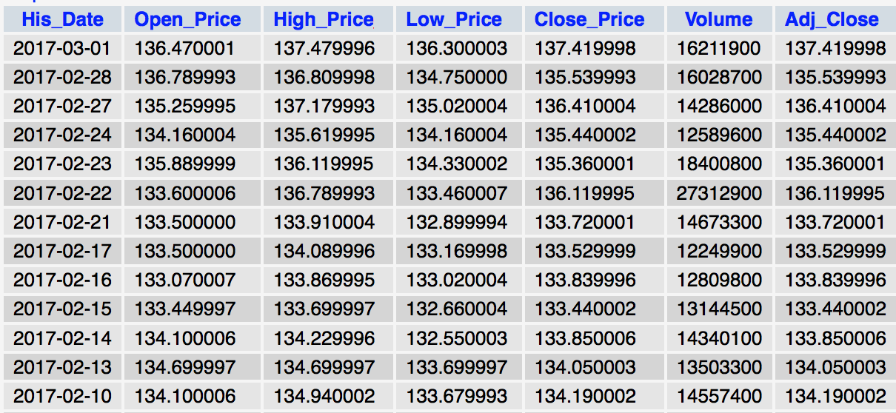

3.4.1.2 Real Time Data
Here is a sample table of a company real time data.
CREATE TABLE $tmp (
Rea_Date DECIMAL(20,0) NOT NULL,
Close_Price DECIMAL(10, 6) NOT NULL,
High_Price DECIMAL(10, 6) NOT NULL,
Low_Price DECIMAL(10, 6) NOT NULL,
Open_Price DECIMAL(10, 6) NOT NULL,
Volume DECIMAL(20, 0) NOT NULL
);
After we collected a time period of data and save in csv file, we load the file into real time database.
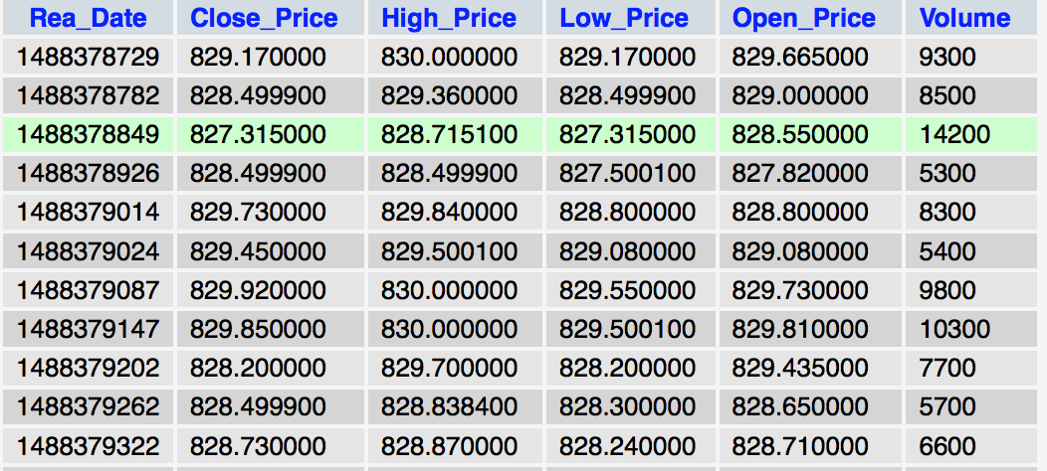

3.4.1.3 Database Query
1) Show the list of all companies in the database along with their latest stock price (real time latest stock price. We use the following SQL query, and we simply go to the table to get the latest record.
SELECT *
FROM $tmp
ORDER BY Rea_Date DESC
LIMIT 1
2) Get the highest stock price of any company in the last ten days. We firstly select the date of previous ten days. And find the max stock price using following query.
SELECT *
FROM $tmp
WHERE High_Price=
(SELECT MAX(High_Price)
FROM $tmp
WHERE His_Date>='$cdate'
)
AND His_Date>='$cdate'
3) Average stock price of any company in the latest one year. In our historical database, we store the latest one year ‘s data. So we find average price in each company ‘s History_Data.
SELECT AVG(Close_Price)
FROM $tmp
4) Lowest stock price for any company in the latest one year. Similar with query (3), we can access the lowest price in a company's table.
SELECT *
FROM $tmp
WHERE Low_Price=
(SELECT MIN(Low_Price)
FROM $tmp
)
5) List the ids of companies along with their name who have the average stock price lesser than the lowest of any of the Selected Company in the latest one year. We first use query (3) and (4) to get average price and lowest price in the latest one year, and use a function to compare average price of each company with lowest price of all other companies.

3.4.1.4 Implementation
We use PHP to create databases, tables, and query Mysql. We store the output of each function in a txt file. For showing on website, we echo the result and used by AJAX.
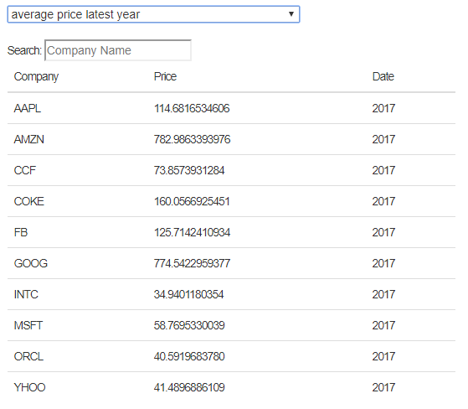

3.4.2 User Database
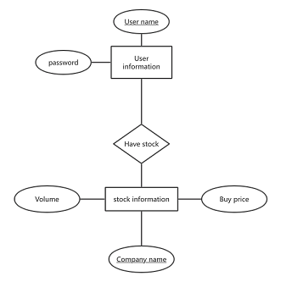

This is the ER diagram of user database. This database has two entities : User information and stock information. User information has two attributes : User name and user’s password. User name is its primary key. Stock information has three attributes which are company name, buy price and volume. Company name is the primary key of stock information. These two entities has one relationship have stock.

3.4.2.1 Create Table
The code of this part is in Table.php. User database has two tables. The first table is user information table. It contains the user’s personal information, like user name and this user’s password. The code to create this table is :
CREATE TABLE User (
Username VARCHAR(20) NOT NULL,
Password VARCHAR(20) NOT NULL)
The second table is the stock information table. It contains every user’s stock information. In this table, it has ten stock information every user bought. The stock information is the company’s name, the buy price of each stock. The code to create this stock information is :
CREATE TABLE Info (
Username VARCHAR(20) NOT NULL,
Company VARCHAR(10) NOT NULL,
BuyPrice DECIMAL(10, 6) NOT NULL,
Volume DECIMAL(20, 0) NOT NULL
)

3.4.2.2 User Register
The code of this part is in Register.php.
This part is used to let user to register in the user table. The register information contains user name and user’s password. Only after registering, user can log into the system then do some operations. The code that let user to register is :
$check="SELECT *
FROM User
WHERE Username='$user'
";
$result = $conn->query($check);
if ($result->num_rows>0){
while($row = $result->fetch_assoc()){
echo "Error User already exists!\n";
} }
else{
$sql=" INSERT INTO User (Username,Password)
VALUES('$user','$pasw')
“;
This user database doesn’t allow same username to exist. If some user registers a name which is already exist in the database, it will show “Error User already exists!” and let user choose a different user name.

3.4.2.3 User Login
The code of this part is in Getpwd.php. After registering, the user can use the user name and password of register to log into the user database in the website. This part is to verify if the user has entered the right password. If the password is right, user can log into the user database. If the user name entered doesn’t exist, it will show “User Not Exist”. The code of this part is :
SELECT *
FROM User
WHERE Username='$user'
LIMIT 1

3.4.2.4 Add Stock Information
The code of this part is in Addinfo.php. When user buy or sell stock, the information of this operation will be added to the stock database of this user. The information contains company name, buy price and volume. The code of this part is :
INSERT INTO Info (Username, Company, BuyPrice,Volume)
VALUES('$user','$company','$price','$vol')

3.4.2.5 Get Holding Stock Information
The code of this part is in Getinfo.php. This part is a search operation. It allows user to give a company name and get the holding stock information of this company. The information contains bought price and volume. The code of this part is :
SELECT *
FROM Info
WHERE Username='$user'
AND Company='$company'

3.4.2.6 User Database Result
This figure example is one user’s stock database. User can go into this user’s profile after logging in.From the figure we can see that this database can store 10 stock companies each user. At the top of this page, there is a search button which can let user search the stock information user has.
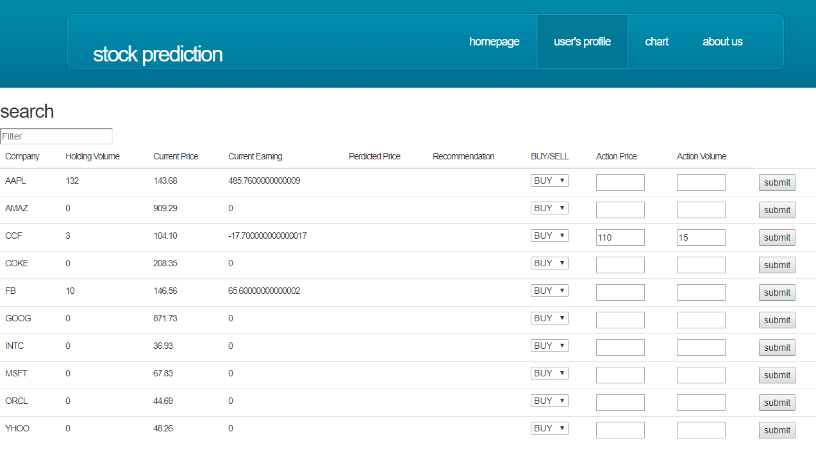

3.5 Stock Prediction

3.5.1 Long-term Prediction
The purpose of long-term prediction is to help investor to make a assumptions about future risk and return, and actually our prediction does not includes much financial analysis but technical analysis, more based on statistics of history data. In this case, we use 1-year historical data to calculate and predict possible stocks price in the coming 7 days, and the indicators that we choose are: high price, low price, open price, close price and volume.
For high price and low price, we think they are relatively non-convictive, so they act as a range of possible prices, and the close price is the most important indicator which is our main indicator used to judge trends of stocks. Thus for these four kinds of prices, we use Bayesian curve-fitting to predict, and for volume, we use ANN to predict.

3.5.1.1 Prediction Strategy
As mentioned above, we use Bayesian curve-fitting to predict stocks price. There are couple of reasons why we choose this method to predict; The one is, Bayesian curve-fitting is able to predict trends of price, it is a good property. As shown by following figure, we can clearly find out that though two curve does not overlap totally but the trend of them are roughly same, and another detail is when there is a big increase or a big fall, the Bayesian curve tend to be flatter than the actual price curve, which is another reason we choose Bayesian, because this property tells us results of prediction is not too sensitive, and when there is a fall, we will know the actual price is likely to be even lower, and then we will notify investor to be prudent, to hold or sell their stocks, and when there is a increasing, we will know the actual price is likely to be higher, we will tell investors it is a good chance to buy more.
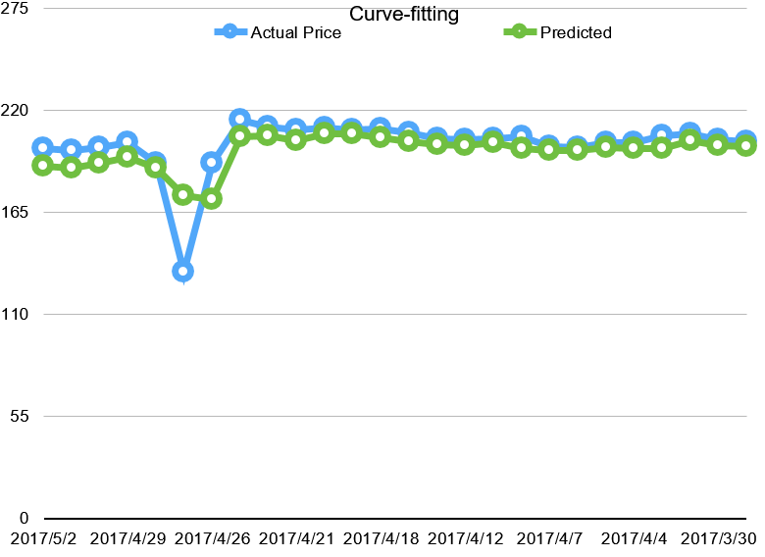

For volume, an another important indicator for prediction. We know that volume is always associate with price. Thus we can not to predict it directly use historical volume data, but with prices. That’s why we choose ANN to predict volume. ANN opposed to the traditional model based methods and it learns from examples and capture subtle functional relationships among the data even if the underlying relationships are unknown or hard to describe. It gives the ability to learn from experience and provides a practical feasible way to solve real world problems.
we input high price and low price to train neural network to find a relationship between price and volume, and then we input high price and low price to predict volume.

3.5.1.2 Prediction Accuracy
The accuracy is what we care most. For testing purpose, we use our program to predict 10 stocks and 10 times each, and record average error. There are two time scale we choose, one week and one month in future, from below figures, we can see that the accuracy one-week prediction is satisfactory, the highest error is below 15 percent, and the most approximate result is below 5 percent, it is accurate enough to guide investor to sell or buy this stocks. However, it is not easy to make one-month prediction.
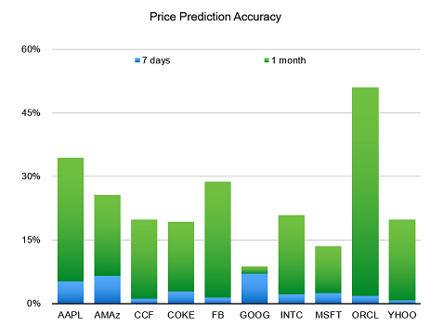
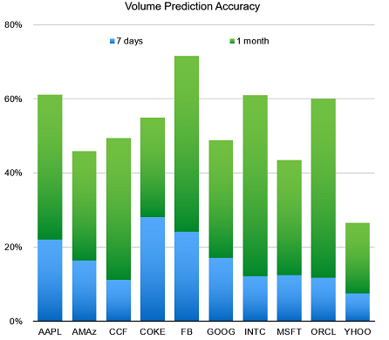

Actually it is not necessary to make a such long-term prediction, because many factors will influent the result. Since we don’t include any relevant information about company’s valuation.we can predict it week by week, in practice it is acceptable to make decision for investor.

3.5.1.3 Implementation
We implement these two predictions program by Java language. The program have three main classes; Readin.java, Bayesian.java and ANN.java. Readin.java is static method class, which used to read in historical data and includes copy function, etc. Bayesian.java and ANN.java is main two classes. Bayesian.java uses input data to make a curve-fitting and return four estimated prices and pass the price value to ANN.java which will use inputted parameter to predict volume.
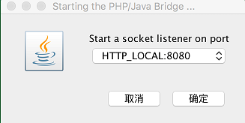

And we use PHP/JAVA bridge toconnect front end and back end. we run javaBridge first and start a socketlistener, then connect PHP program with it. By doing that, we are able to call java method by PHP.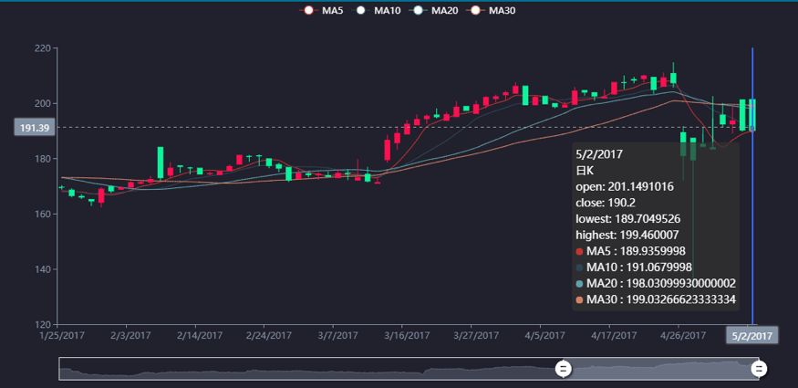
And whenever user ask for a prediction, PHP program will directly return the prediction results and show it on the website.
The default Candlestick chart shows the stock’s historical information within last one year, and after user asking for prediction, it will show the future 7 days. As above screen shot shows, this chart created on 4/26, and the chart between 4/26/2017 and 5/2/2017 are result of long-term prediction.

3.5.2 Short-term Prediction
In our project, we uses SVM and Bayesian Curve Fitting to support short-term stock prediction. The maximum prediction scale is 12 hours.

3.5.2.1 Using SVM to Predict Volume
The exact code is in: svm.py.
In machine learning, support vector machines (SVMs, also support vector networks) are supervised learning models with associated learning algorithms that analyze data used for classification and regression analysis. Given a set of training examples, each marked as belonging to one or the other of two categories, an SVM training algorithm builds a model that assigns new examples to one category or the other, making it a non-probabilistic binary linear classifier.
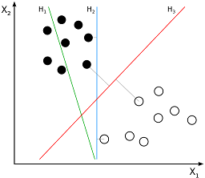

In this case, we directly uses scikit learn tools to predict volumes using SVM. The inputs are the open price and close price of the stock. The support vector machines in scikit-learn support both dense (numpy.ndarray and convertible to that by numpy.asarray) and sparse (any scipy.sparse) sample vectors as input. However, to use an SVM to make predictions for sparse data, it must have been fit on such data. For optimal performance, use C-ordered numpy.ndarray (dense) orscipy.sparse.csr_matrix (sparse) with dtype=float64.
The core code is shown below:
# normalization matrix
x = np.array(x)
y = np.array(y)
scalerx = preprocessing.RobustScaler()
x_scaled = scalerx.fit_transform(x)
scalery = preprocessing.RobustScaler()
y_scaled = scalery.fit_transform(y)
# initialize predictor
svr = svm.SVR()
# training data
svr.fit(x_scaled,y_scaled)
# predict
result = svr.predict(scalerx.transform(np.array(price_index)))
The script running result:
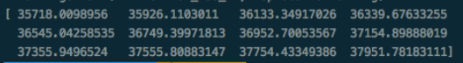

3.5.3.2 Using Bayesian Curve Fitting to Predict Price
As described in class, in the curve fitting problem, we are given the training data x' and t, along with a new test point x, and to predict the value of t. So, we need to evaluate the predictive distribution. In this project,we use and , which comes from the smallest error one. Therefore, we use the predicted volume as the input to predict for the new price.
Because of using Ajax to communicate with the HTML, we used a simple php script tp call the python script:
<?php
system("python bayes.py");
?>
The script running result:
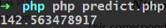

3.5.3 Recommendations
In our project, we uses MACD(Moving Average Convergence/Divergence Oscillator) to provide users recommendation of whether to buy or sell their stock.
The MACD turns two trend-following indicators, moving averages, into a momentum oscillator by subtracting the longer moving average from the shorter moving average. As a result, the MACD offers the best of both worlds: trend following and momentum. The MACD fluctuates above and below the zero line as the moving averages converge, cross and diverge. Traders can look for signal line crossovers, centerline crossovers and divergences to generate signals.
In our project, we directly uses 'stockstats' tool to complete MACD. The code could be found in macd.py:
stock = Sdf.retype(pd.read_csv(filename_r))
macd = stock.get('macd')
Also, we need to get DIF as another indicator to decide the recommendation. DIF can be calculated as EMA(12) - EMA(16).
After we get the MACD and DIF, we can provide recommendation based on the following chart:
Condition | Recommendation
DIF>0 and , MACD>0 and | Buy or Hold
DIF<0 and , MACD<0 and | Sell or Wait
DIF>0 and , MACD>0 and | Sell or Wait
DIF<0 and , MACD<0 and | Buy or Hold
After that, we displayed the recommendation on webpage:
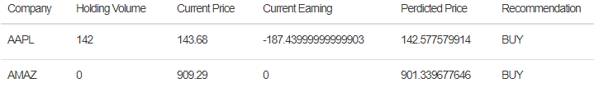

3.6 Connection Between Front-end and Back-end

3.6.1 AJAX
AJAX means Asynchronous JavaScript And XML. AJAX allows web pages to be updated synchronously by exchanging data with a web server behind the scenes. This means that it is possible to update parts of a web page, without reloading the whole page. AJAX just uses a combination of:
- A browser built-in XMLHttpRequest object (to request data from a web server)
- JavaScript and HTML DOM (to display or use the data)
The following figure shows the working principle of AJAX.
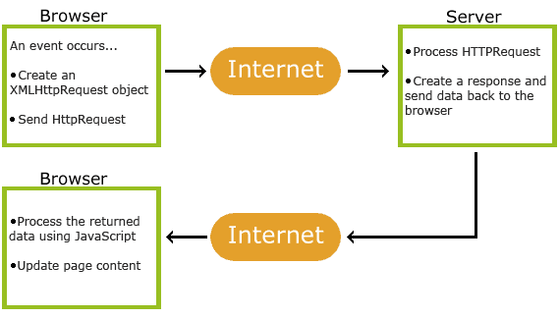

- An event occurs in a web page(for example, a page is reloaded or a button is clicked)
- An XMLHttpRequest object is created by JavaScript
- The XMLHttpRequest object sends a request to a web server
- The server processes the request(PHP + JAVA + Python)
- The server sends a response back to the web page
- The response is read by JavaScript
- Update DOM elements by JavaScript
Here presents the function to complete the AJAX request:
function postRequest(strURL, sql_op, iteration) {
var xmlHttp;
if (window.XMLHttpRequest) { // Mozilla, Safari, ...
var xmlHttp = new XMLHttpRequest();
}else if (window.ActiveXObject) { // IE
var xmlHttp = new ActiveXObject("Microsoft.XMLHTTP");
}
// false means Synchronize
xmlHttp.open('POST', strURL, false);
xmlHttp.setRequestHeader('Content-Type', 'application/x-www-form-urlencoded');
xmlHttp.onreadystatechange = function()
{
if (xmlHttp.readyState == 4) {
updatepage(xmlHttp.responseText, sql_op, iteration);
}
}
xmlHttp.send(strURL);
}

3.6.2 Interaction Diagrams

User Case 1: Login
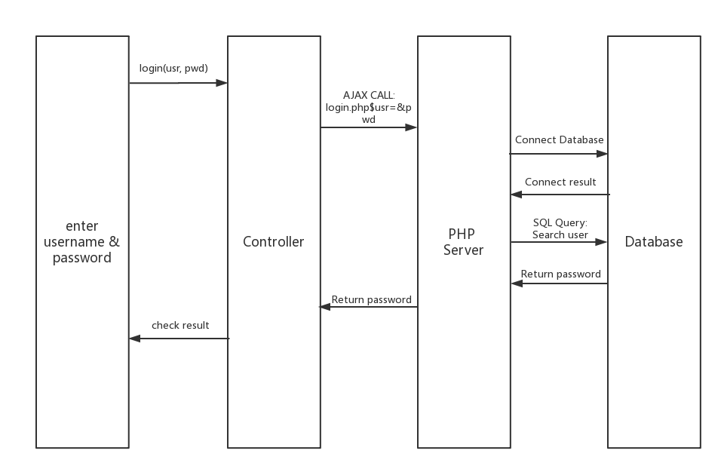

The figure shows the design sequence diagram for login. Once a user inputs user name and password, JavaScript sends a AJAX request to PHP server to query for the user information. If the user exists, the database would return its password and the JavaScript controller would check whether the password is correct. Otherwise, database would return "user not exists" and the controller would show the message on the web page.

User case2: Trading Recording
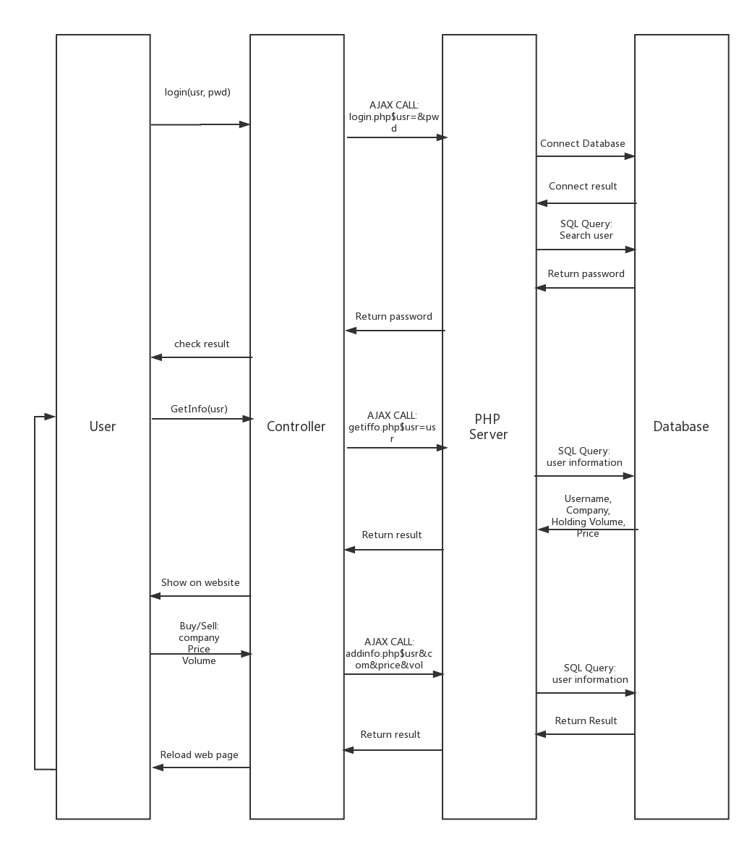

The figure shows the sequence for fetching user trading records. Firstly, a user needs to inputs his/her user name and password to login in the system. After the process we discussed in the last user case, the website will direct to the "User Profile" page. While the page is loading, it sends requests to PHP server to achieve the user trading records. Then the server sends several query messages to the database, and return the results after the database replies. Finally, the user's profile will be presented on the web page.
Furthermore, users can save their trading recordings. Once the user inputs the operation, company, price and volume, the JavaScript controller sends AJAX request, to call the database to insert the new record. After that, the database also returns the insertion status. Finally, once the website receive the status message, it reloads the page and retrieve the user data again.

User Case3: Get Stock Information
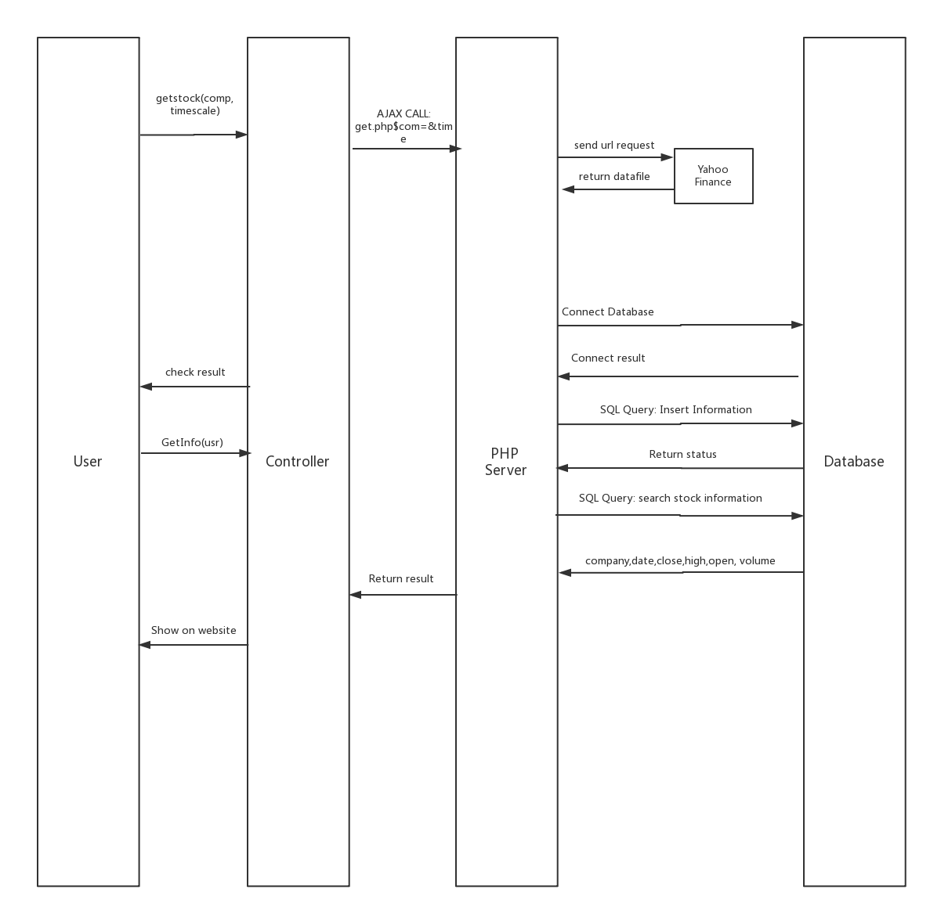

Figures shows the sequence for fetching stock information. Firstly, once the user select the company and time scale in the selecting form, the website sends an AJAX request to PHP server. The PHP server sends an URL request to the YAHOO FINANCE API, thus it would get the corresponding file containing the stock information. After that, we insert the data into the database for further query requirements. Also, the PHP server would return the result to website, and thus shows the image, chart and query result to the users.

User Case4: Get Stock Prediction
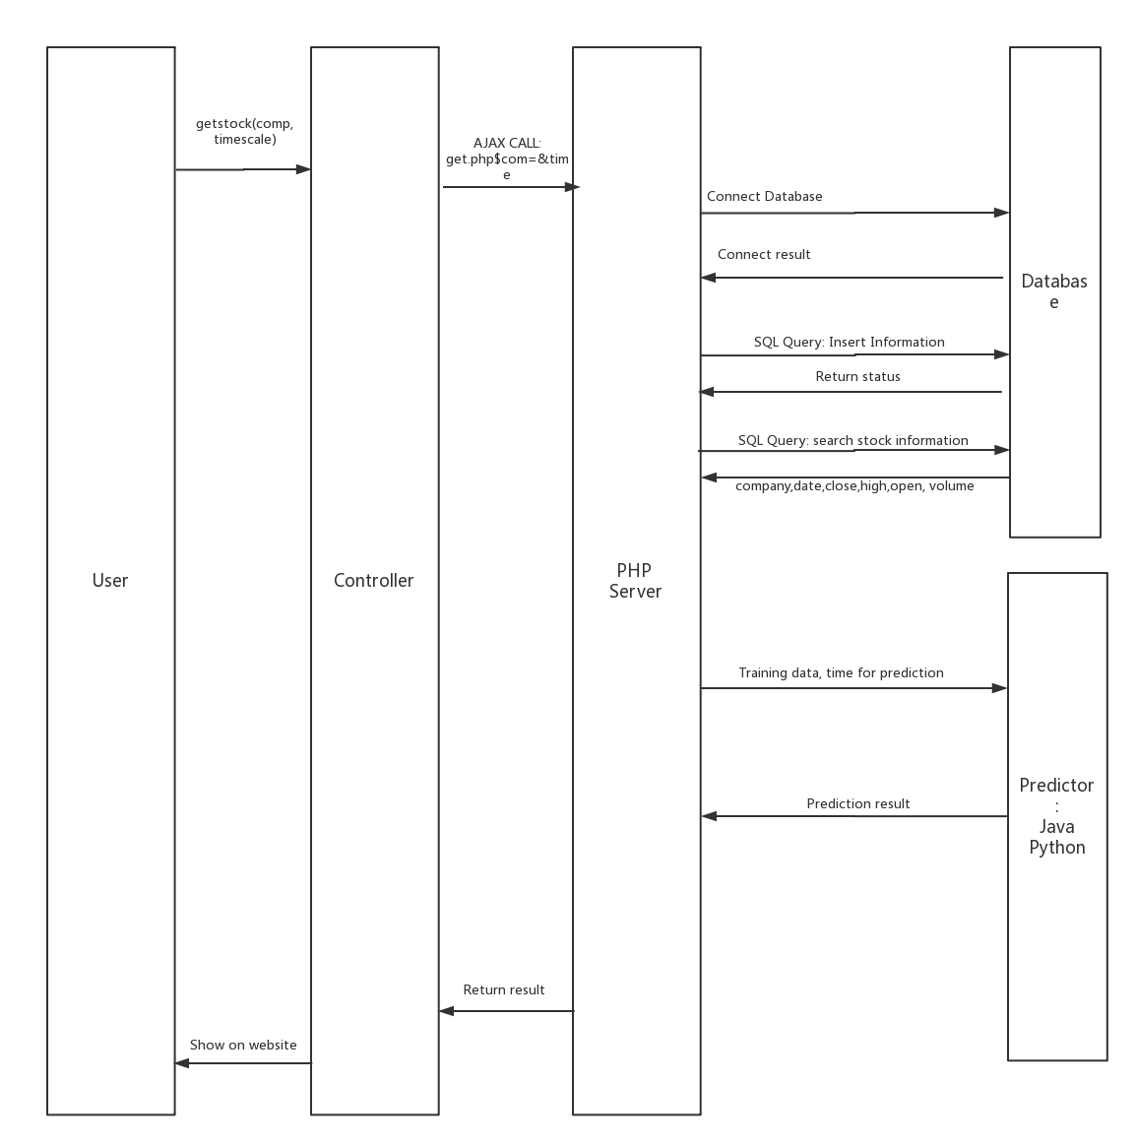

The figure shows the sequence to get the prediction price. Firstly, the user need to point out the company and the timescale to prediction. The website sends an AJAX request to the PHP server. After that, PHP server would retrieve data from the database, and then send the stock information to the predictors to get the predicted price. After completing the prediction, the PHP server shows the result on the image and chart.

4. User Interface Design
We use javascript and html to design our User interface, which including Homepage, user’s profile, chart and about us, four section in total.
Homepage will show user the k line for specific stock that user choose. By login in system user can manage their own operation or without login in user can also choose one stock to research from menu provided by homepage.
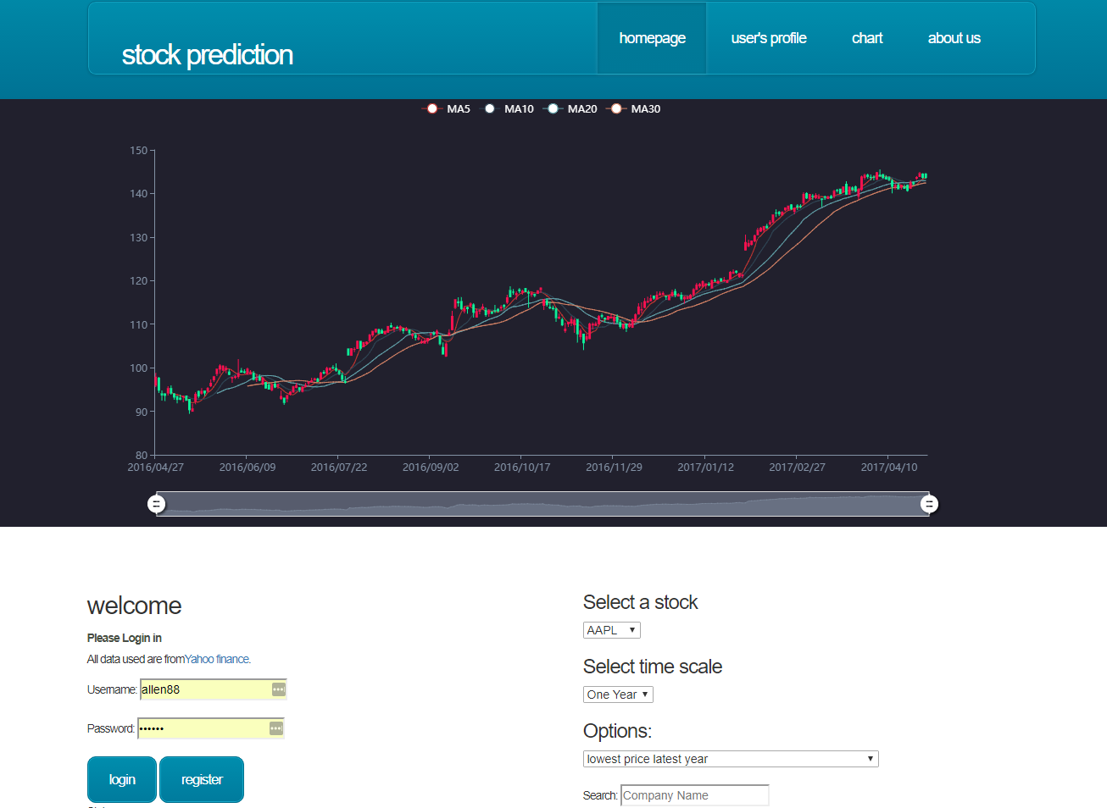

K line chart also has many functions to help analysis. User can see MA5 – MA30 besides some other basic information. Also user can turn on/off those auxiliary line.
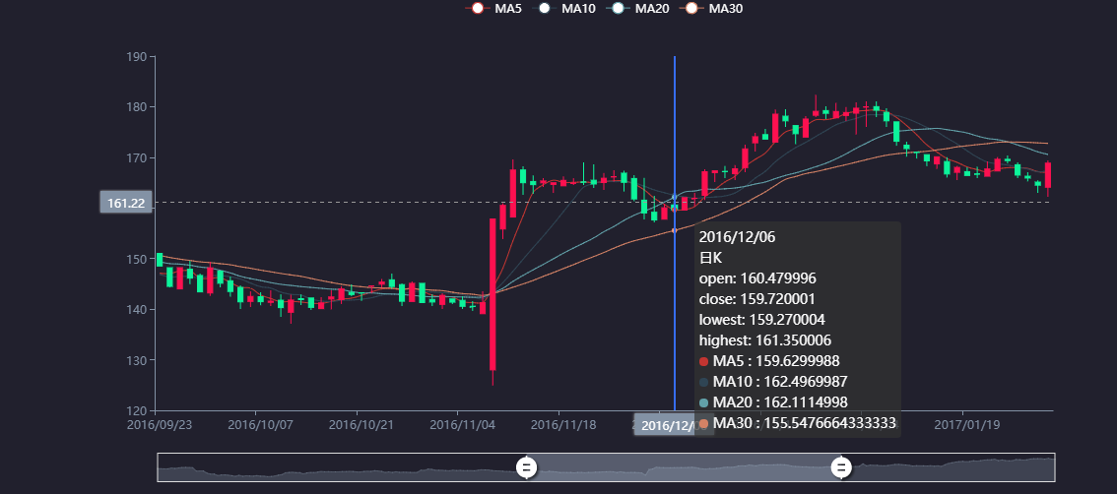

User can also search for a stock information in any time interval and this are also some other function to help analysis.
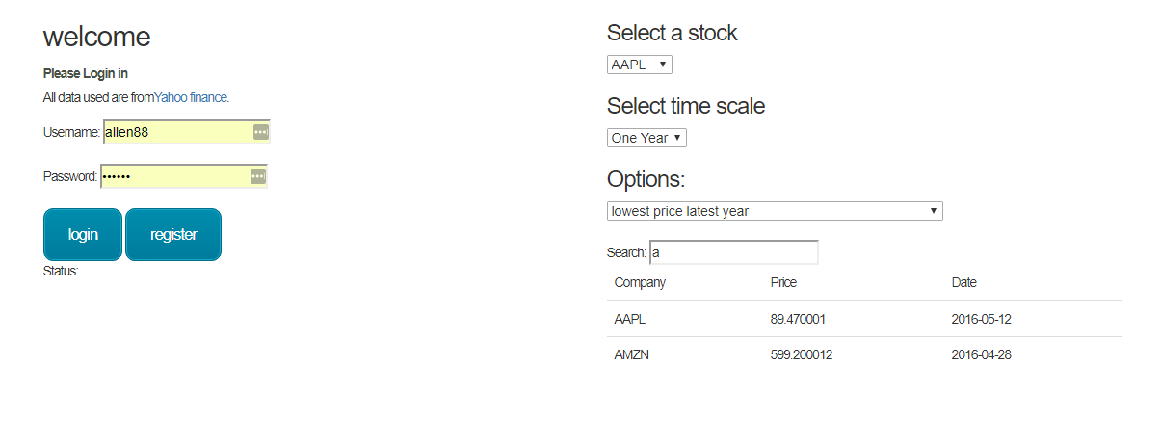

user profile will show a table which record operation for every user. As figure below shows, The table has name of company, holding volume ,current price predicted Price, recommendation for specific stock. And also we allow user to buy/sell stock the operation will be stored in our database.
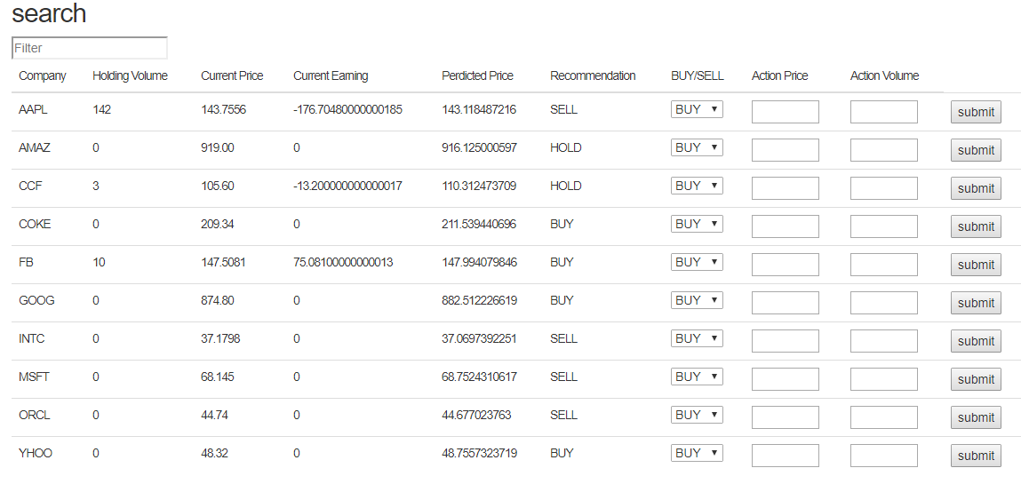

Chart will show more information for a stock to help user analysis stock. User can select one stock and one time scale. This page will automatically present a table which shows all information about this stock in specific time interval. User can also filter information as they want. For example, if user want to see how one stock performance on 04/26/2017 he just need type in this date. The table will be filtered as he want.
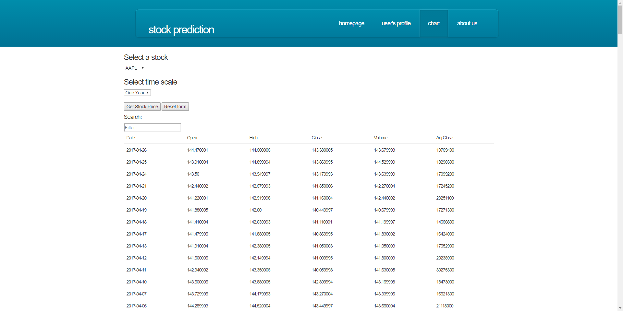

About us , this page shows some basic information about us! user can also log this page but hit the link at bottom of every other pages in this website.
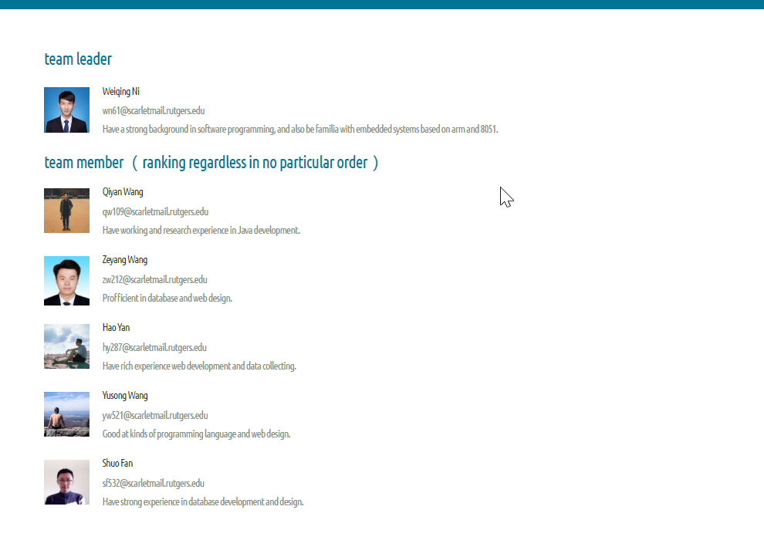

5. Future Work
In the future, we plan on adding further models to our trading records system to provides more stock information to users. Also, we would optimize the website performance and stability and make the website more user-friendly. Moreover, we would like to add pattern recognization as we could not implemented due to the time limitation. Furthermore, small other details can be added such as social networking, FAQ pages, or even we can connect the user profile with the stock trading API.

References
[1] https://en.wikipedia.org/wiki/Candlestick
[2] http://echarts.baidu.com/demo.html#candlestick-sh-2015
[3] https://en.wikipedia.org/wiki/MACD
[4] https://en.wikipedia.org/wiki/Moving_average#Exponential_moving_average
[5] https://en.wikipedia.org/wiki/Technical_analysis
[6] https://www.w3schools.com/xml/ajax_intro.asp
[7] http://scikit-learn.org/stable/
[8] http://www.ece.rutgers.edu/~marsic/books/SE/
[9] http://users.isr.ist.utl.pt/~wurmd/Livros/school/Bishop%20-%20Pattern%20Recognition%20And%20Machine%20Learning%20-%20Springer%20%202006.pdf
[10] http://www.investopedia.com
[11] https://pypi.python.org/pypi/stockstats
[12] https://pypi.python.org/pypi/yahoo-finance

