Z5379852

Qiyao Zhou

UNSW Learning and Growing Platform

**Project Purpose**

This project is aim to create a platform for career development, study groups and knowledge sharing to help students in UNSW to seek dream jobs.

**WBS**

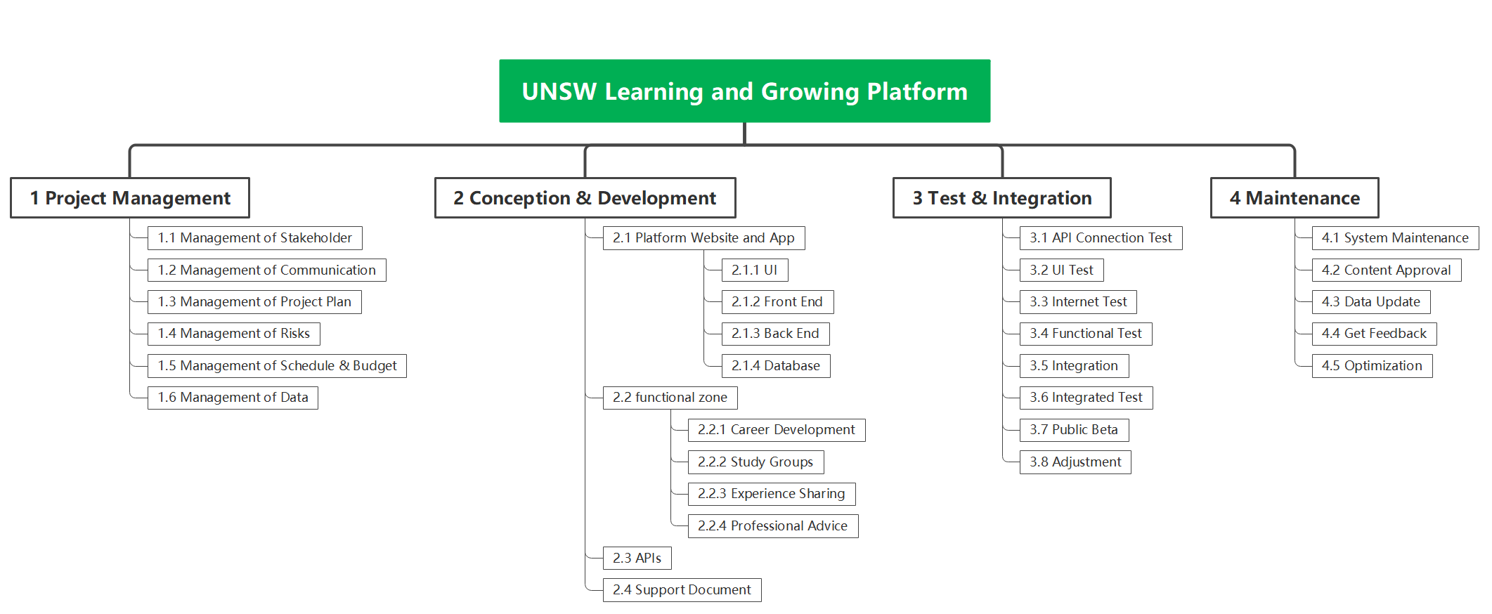

**Scope Statement**

This project is to create a platform which can help students in UNSW to seek dream jobs. The budget is no more than 250,000AUD and this project shall be done within 6 months. To do this, the platform should include career development, study groups and experience sharing about employment knowledge. Besides, stakeholder engagement and feedback during this process engagement and feedback during this process shall be taken into account. The same goes to any further work required to commission and consideration of how to facilitate its integration with other existing UNSW platforms.