# 1. Scope Statement

This project is to build the UNSW Learning and Growing Platform under 350,000 AUD within 4 months. It will deliver a website and an application to fulfill the purpose whose functions include career development, study groups and experience sharing about employment knowledge., in addition to the supporting PM activities. It will also deliver end-user and admins training. This project will not include the convening of company recruitment information. Finally, this project help UNSW students who are looking for professional skills help.

## 1.1 Description of Project Rationality

Although UNSW has the world's top employment rate and employer reputation, there are still some graduates who cannot find suitable jobs. In order to help these students to find their dream jobs to a greater extent, this project plans to build a learning platform.

## 1.2 Deliverables

The main deliverable of the project is a fully functional learning platform, including website, software and UI. Specifically, the main deliverables fall into the following three categories.

In addition, this project fits with UNSW 2025 Strategy, in the first place in our school under the cultivation of a batch of and a group of outstanding graduates enter the society, made huge contribution to social development, enjoy good reputation in all walks of life, to help graduates to find your dream job is the responsibility of the school, also help to continue to improve and maintain the reputation of the school. Secondly, due to the extensive and profound cooperation between the university and all walks of life, it is convenient for the project to find a third party.

### 1.2.1 Program

Application software installation program and software and website source code

### 1.2.2 Plug-ins and library files

Third party plug-ins, development kits, and library files necessary to execute administrative tools

### 1.2.3 Documents

Description of the software itself, including interface description, main function realization and code description

## 1.3 Acceptance Criteria

The project will be considered complete when all testing of the platform is completed and the official first version of the website and software is released.

The specific acceptance requirements are as follows:

1)Acceptance materials are complete

2)All functions required by the project can be realized

3)Friendly interface, easy to interact

4)The platform itself and its functions are stable without gross error

5)All errors found during testing are corrected

In addition, the way of acceptance is network acceptance

## 1.4 Constraints

This project, UNSW Learning and Growing Platform, will cost no more than 350,000AUD within 4 months. The fund of project is provided by Tong Ju, who is the sponsor of this project.

## 1.5 Assumptions

The UNSW learning and growing platform building project will be launched on the premise of providing hardware such as computers and offices. In addition, all required materials will be delivered on time, and school officials and students will be happy to participate in the platform construction process, especially in the private beta.

In case of unexpected events such as inclement weather or large-scale power failure during the construction period, it can be postponed appropriately, but not more than one week.

# 2.WBS

## 2.1 Deliverables Breakdown

|  |  |
| --- | --- |
| Work Package | Activity |
| 1.1.1 UNSW approval documents | 1.1.1.1 Project sponsor signoff |
| 1.1.1.2 Internal UNSW compliance signoff |
| 1.1.2 Project risk, time & cost management | 1.1.2.1 Project risk management document |
| 1.1.2.2 Project time & cost management document |
| 1.2.1 Stakeholder survey | 1.2.1.1 Make a Stakeholder survey |
| 1.2.1.2 Make market research |
| 1.2.2 Final requirement specification document | 1.2.2.1 Make a requirement survey |
| 1.2.2.2 Write final requirement specification document |
| 1.3.1 App & Web Front-end UI system design | 1.3.1.1 App Front-end UI system design |
| 1.3.1.2 Web Front-end UI system design |
| 1.3.2 App & Web Back-end system design | 1.3.2.1 Back-end interface design |
| 1.3.2.2 Back-end database design |
| 1.3.2.3 Back-end infrastructure design |
| 1.4.1 Database and server environment setup | 1.4.1.1 Database server setup |
| 1.4.1.2 Back-end server setup |
| 1.4.2 App Front-end UI implementation | 1.4.2.1 App Front-end coding |
| 1.4.3 Web Front-end implementation | 1.4.3.1 Web Front-end coding |
| 1.4.4 APP and Web Back-end implementation | 1.4.4.1 Back-end coding |
| 1.4.5 Code integration | 1.4.5.2 Front-end and Back-end Code integration |
| 1.4.6 Code review and optimization | 1.4.6.1 Code review |
| 1.4.6.2 Code optimization |
| 1.5.1 Back-end interface tests | 1.5.1.1 Back-end interface test |
| 1.5.1.2 Back-end interface test report |
| 1.5.2 UI tests | 1.5.2.1 UI test |
| 1.5.2.2 UI test report |
| 1.5.3 Integration tests | 1.5.3.1 Front-end and Back-end integration test |
| 1.5.3.2 Front-end and Back-end integration test report |
| 1.6.1 User Training Document | 1.6.1.1 Write User manual |
| 1.6.1.2 User training |
| 1.6.2 System admins Training Document | 1.6.2.1 System admin manual |
| 1.6.2.2 System admin training |
| 1.6.3 System publication Document | 1.6.3.1 System publication manual |
| 1.6.3.2 System publication training |
| 1.7.1 Final Project Report | 1.7.1.1 Write final project report |
| 1.7.2 Project documentation | 1.7.2.1 Save project documents |
| 1.7.2.2 Save project codes |

# 3. Stakeholder Management

## 3.1 Overview

Stakeholder management is a crucial part of the project management plan. It mainly focuses on identifying project stakeholders and promoting the communication between project and stakeholders, so as to meet the requirements of project stakeholders and facilitate the timely solution of possible problems.

## 3.2 Management Method

According to Power Influence Grid in data representation methods [1], we can identify the type of relationship the project needs to establish with each stakeholder to distinguish the various stakeholders of this project. In addition, we manage stakeholder participation through Stakeholder Engagement Assessment Matrix [2]. And with the guidance of the grid, we can generate a reasonable communication plan with all of the stakeholders.

## 3.3 Stakeholders Identification

Based on the principle of power influence grid, all of the stakeholders can be divided into four categories called ‘A B C D’ which represent different kind of relationships that need to be built. These relationships are as followed:

A: satisfaction

Stakeholders in A are characterized by "great power and low attention to project results", so it is crucial to win the support of relevant parties in A for the success of the project

B: The key management

They have a high level of authority over the project and are concerned about the results of the project. The project manager should "focus on management, timely report, and take forceful actions to satisfy the relevant parties in B.

C: Keep inform

Despite the low power of the relevant parties in C, they pay attention to the results of the project. So, the project manager is "keep inform" of the status of the project. To maintain the satisfaction of the parties concerned in C. Underestimating the interests of the parties involved in C can have dangerous consequences and may lead to opposition from the parties involved in C.

D: Supervision

Properly address the needs of interested parties in D. Related parties in D are characterized by "low power and low attention to project results", so the project manager can mainly "supervise them with the least effort".

Figure 3.1 Power Influence Grid

Table 3.1 Identified Stakeholders

|  |  |  |
| --- | --- | --- |
| Category | Stakeholders | Interest |
| A | External implementation team | Complete the design of the platform as required to implement specific functions |
| B | Sponsor | Aims to obtain the required network platform through the project, and can provide constructive guidance and suggestions for the project |
| B | UNSW student development managers | To find future directions for more graduates |
| C | UNSW publicity managers | Promote the school through better employment data advantages |
| C | UNSW students | Allow UNSW students have better chance to find their dream job after graduation |
| D | Business enterprise | Have better chance of hiring the right graduates |

## 3.4 Stakeholders Engagement

Stakeholder Engagement Assessment Matrix is used to compare the current level of stakeholder participation with the expected level of participation. Stakeholder Engagement Assessment Matrix divide stakeholders into five positions: Unaware, Resistant, Neutral, Supportive and Leading.

Table 3.2 The Engagement Level Of Stakeholders

|  |  |  |  |  |  |
| --- | --- | --- | --- | --- | --- |
| Stakeholders | Unaware | Resistant | Neutral | Supportive | Leading |
| External implementation team |  |  | C |  | D |
| Sponsor |  |  |  | CD |  |
| UNSW student development managers |  |  | C |  | D |
| UNSW publicity managers |  |  | C |  | D |
| UNSW students |  |  | C |  | D |
| Business enterprise | C |  | D |  |  |

C = Current D = Desired

In Table 3.2, C represents the current level of participation of each interested party, while D is the level of participation (expected) assessed by the project team as necessary to ensure the success of the project.

# 4. Communication Plan

## 4.1 Overview

Project communication plan is a part of the overall project plan, which is very important and often overlooked. Understanding the organizational structure and doing stakeholder analysis are the most important aspects of developing a project communication plan. There are many forms of communication in the project, usually divided into written and oral forms.

## 4.2 Communications Tools and Skills

Communication tools:

Conferences, face-to-face conversation, online meeting, telephone, Email, websites and other technologies.

Communication skills [3]:

1. Listen actively.

2. Understand cultural and personal differences.

3. Identify, set and manage stakeholder expectations.

4. Involve interested parties in project meetings.

TABLE 4.1 COMMUNICATIONS PLAN

|  |  |  |  |  |
| --- | --- | --- | --- | --- |
| Communication Type | Receive | Owner | Medium | Content |
| Daily Report | Team Leaders | External implementation team | Email, websites | The process of a particular project |
| Weekly Report | Sponsor, UNSW student development managers | Team Leaders | Face-to-face/online meeting | The process of the whole project |
| Monthly Report | Sponsor, UNSW student development managers | Team Leaders | Email | The process of the whole project |
| Public Report | UNSW Students | Sponsor, UNSW student development managers | social media, website | The process of the whole project |
| Emergency | Sponsor, UNSW student development managers | Incident Leader | Telephone, face-to-face/online meeting | possible problems and solutions |
| Milestone Event | The public | UNSW publicity managers | Social media, website | The phased progress of the project |

# Cost Estimate

The management of cost and time plays an important role in a project. For this project, we estimated cost and time

to make sure the project will be finished in time and within $350,000. After the estimation, the total cost of this

project should be $298,966 excluding $49,548 risk reserve budget. The detail of overall cost shows in

Table 1. The volunteer in Table 1 means our group members, so the cost of volunteer is 0. The distribution of

budget shows below. The salary of each employee get from UNSW Human Resources.

## The Detail of Total Cost

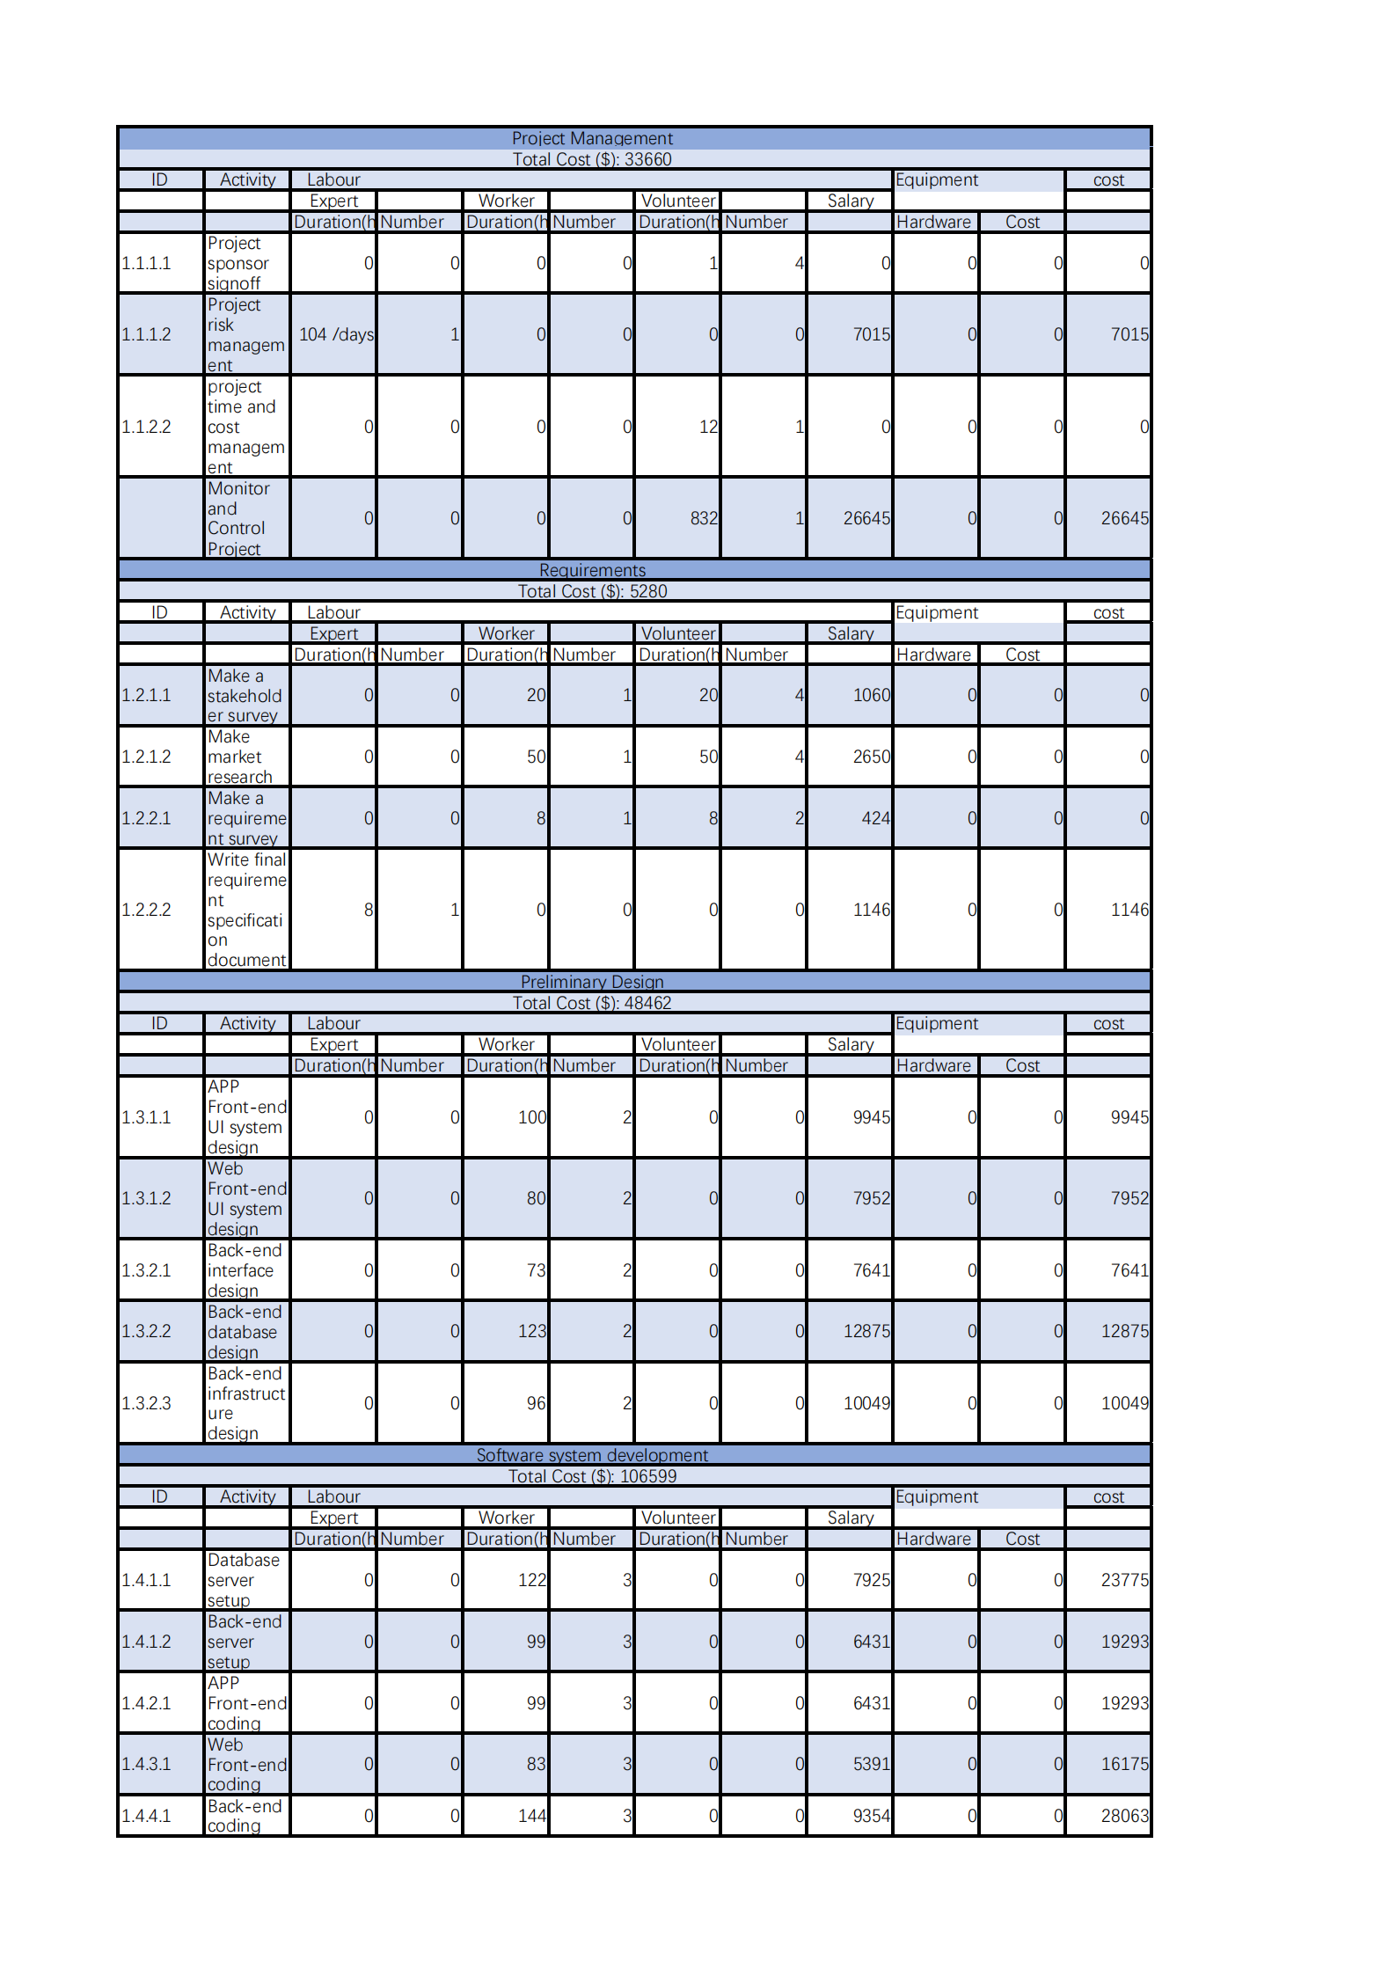

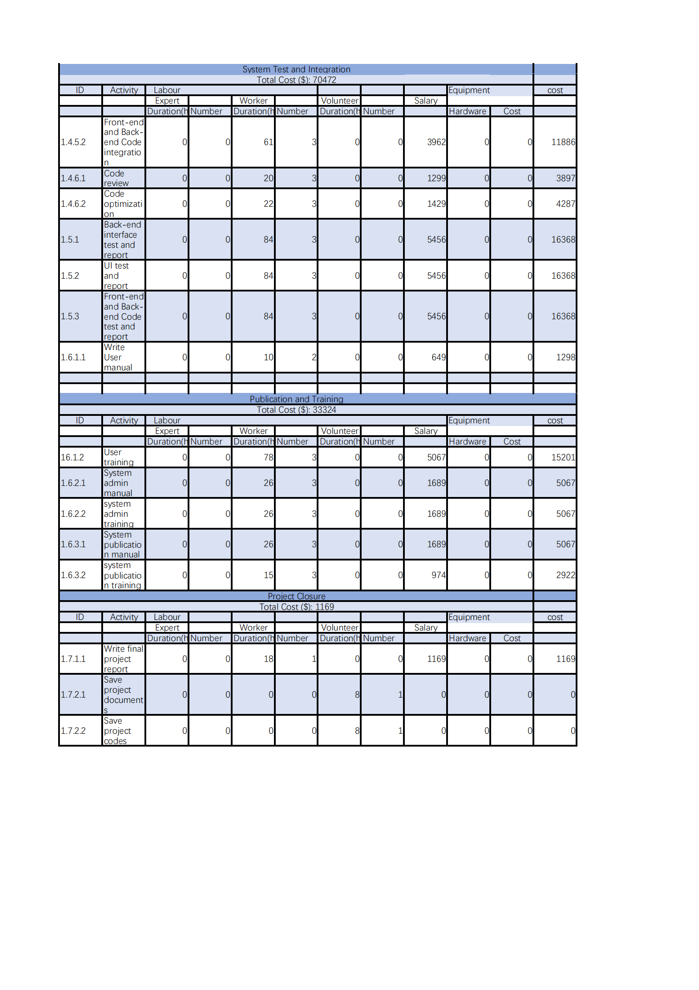

## 5.2 Budget Distribution

## 5.3 Budget In terms of Time

# 6.Schedule

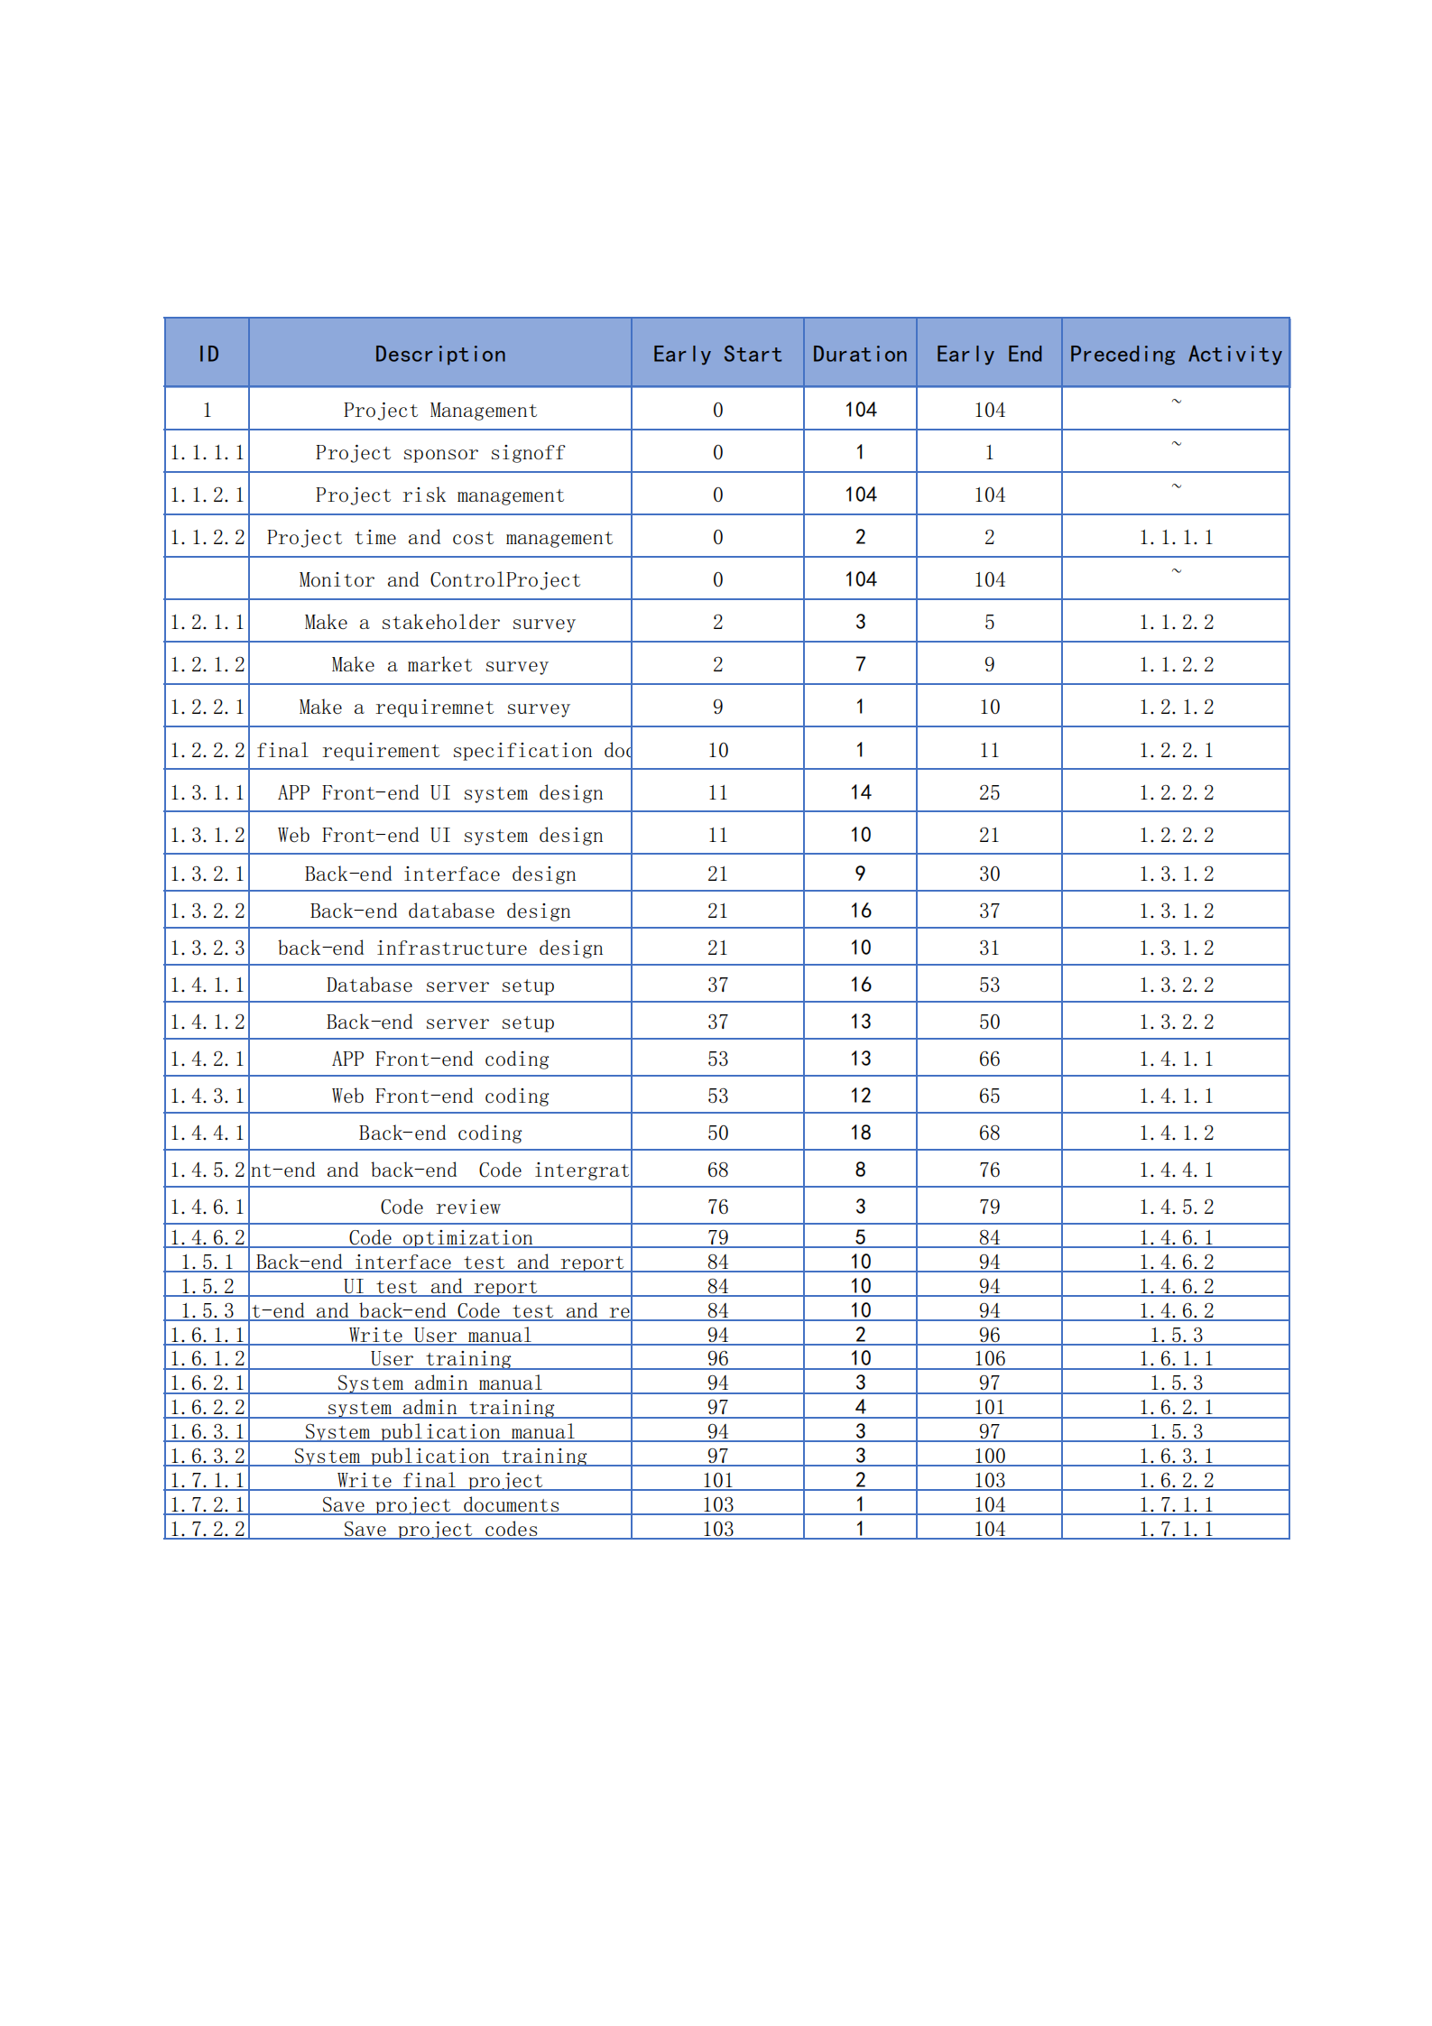

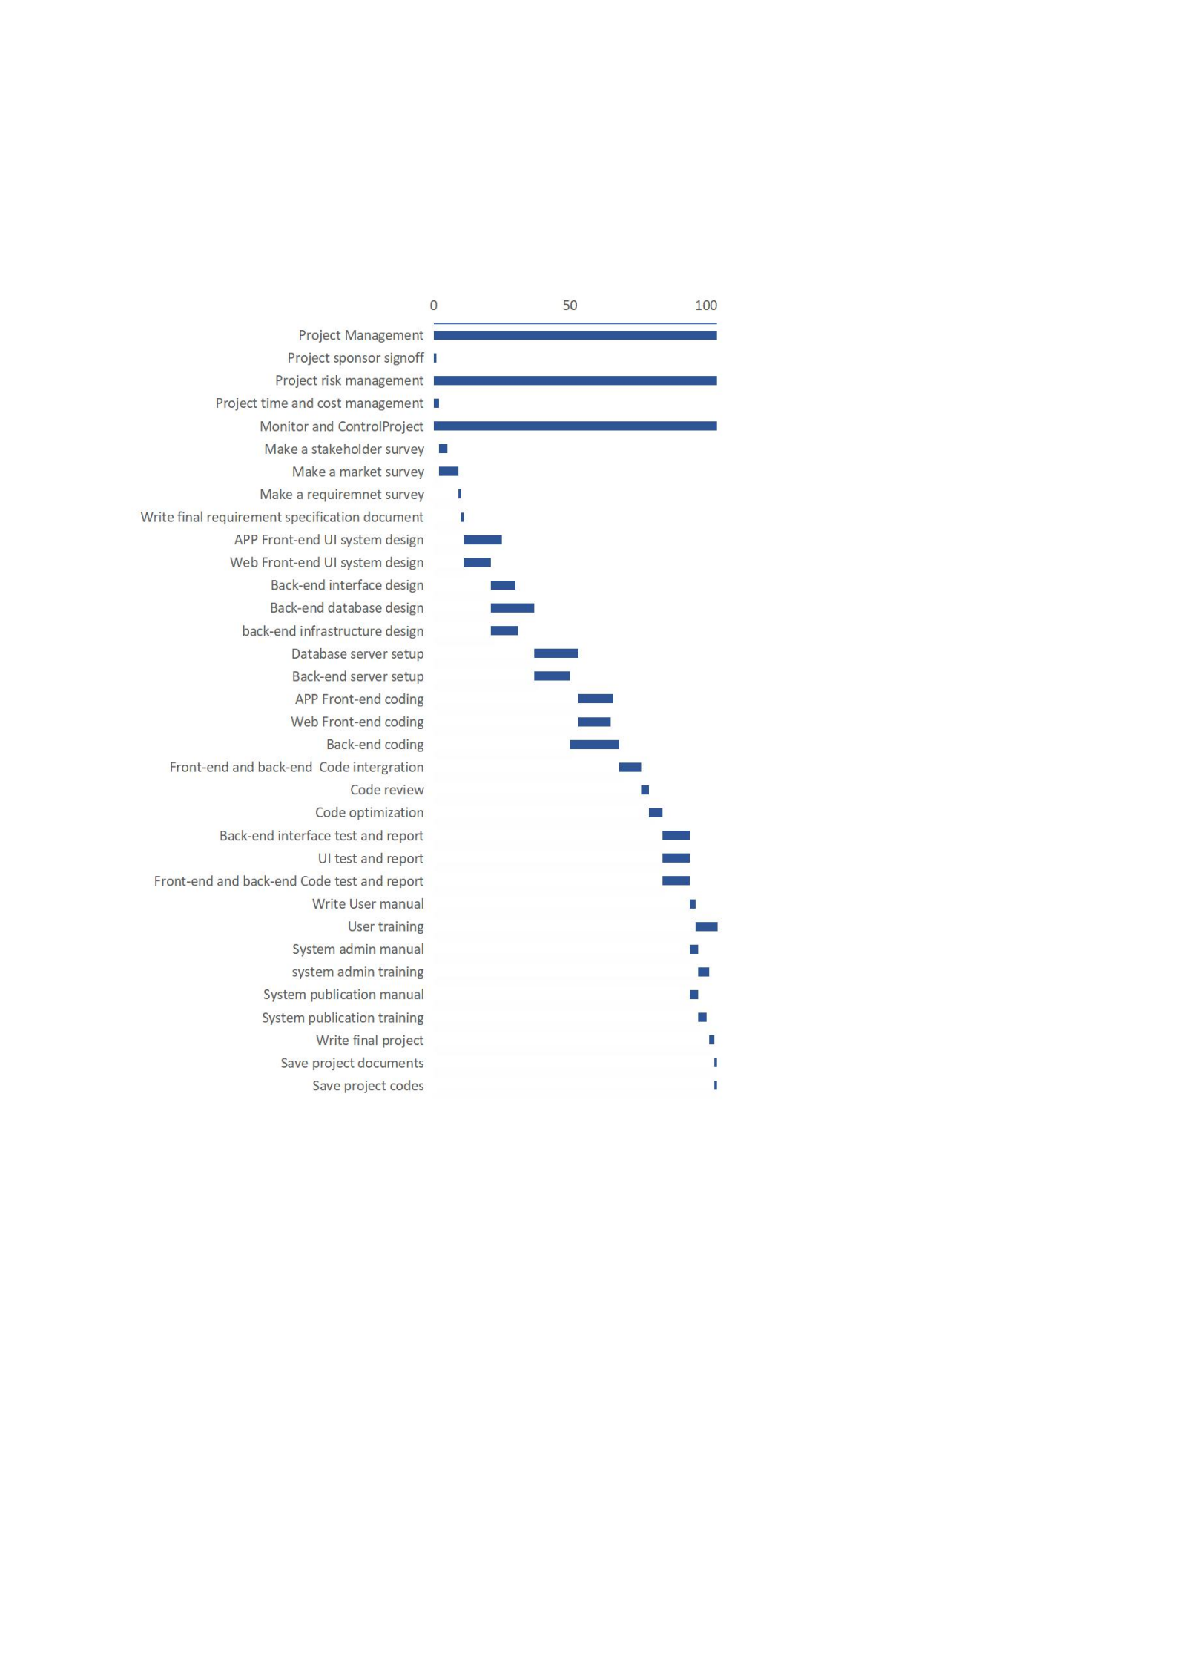

# 7.1 Human Resource Plan

## 7.1.1 Overview

In this project, we will acquiring our human resources in two ways. First is hiring staff online, the second is hiring staff from UNSW. For online hiring, we need some experienced engineers to complete the project efficiently. For hiring in UNSW, we need some volunteers and they will benefit from this project.

**

**1.1.3 Role and Responsibilities (RACI)**

|  |  |  |  |  |  |  |  |  |  |  |
| --- | --- | --- | --- | --- | --- | --- | --- | --- | --- | --- |
| **Work Package** | **Project Manager** | **Front-end Developer** | **Back-end**  **Developer** | **App**  **Developer** | **Database**  **Developer** | **System**  **Tester** | **Operations Engineer** | **Hardware**  **Engineer** | **Support**  **Staff** | **Volunteers** |
| 1.1.1 UNSW approval documents | A,C |  |  |  |  |  |  |  |  | R |
| 1.1.2 Project risk, time&cost management | A,C |  |  |  |  |  |  |  |  | R |
| 1.2.1 Stakeholder survey | A,C |  |  |  |  |  |  |  |  | R |
| 1.2.2 Final requirement specification document | A,C |  |  |  |  |  |  |  |  | R |
| 1.3.1 App&Web Front-end UI system design | I | R |  | R |  |  |  |  |  |  |
| 1.3.2 App&Web Back-end system design | I |  | R |  | R |  | R |  |  |  |
| 1.4.1 Database and server environment setup | I |  |  |  | R |  | R | R |  |  |
| 1.4.2 App Front-end UI implementation | I |  |  | R |  |  |  |  |  |  |
| 1.4.3 Web Front-end implementation | I | R |  |  |  |  |  |  |  |  |
| 1.4.4 APP and Web Back-end implementation | I |  | R |  | R |  | R | R |  |  |
| 1.4.5 Code integration | I | R | R | R | R |  |  |  |  |  |
| 1.4.6 Code review and optimization | I | R | R | R | R | R |  |  |  |  |
| 1.5.1 Back-end interface tests | I |  |  |  |  | R |  |  |  |  |
| 1.5.2 UI tests | I |  |  |  |  | R |  |  |  |  |
| 1.5.3 Integration tests | I |  |  |  |  | R |  |  |  |  |
| 1.6.1 User Training Document | I |  |  |  |  |  |  |  | R | R |
| 1.6.2 System admins Training Document | I |  |  |  |  |  |  |  | R | R |
| 1.6.3 System publication Document | I |  |  |  |  |  |  |  | R | R |
| 1.7.1 Final Project Report | A,C |  |  |  |  |  |  |  |  | R |
| 1.7.2 Project documentation | I |  |  |  |  |  |  |  |  | R |

### 7.1.4 Position Descriptions

#### Project Manager:

Responsibilities: Defining project scope, roles & responsibilities, defining resource requirements and managing resource. Preparing a detailed project management plan to schedule key project time. Managing delivery of the project. Tracking project, managing, and adjusting for changes in project scope, schedule, and budget. Ensuring the project is delivered to their satisfaction.

Experience: Have at least 1 previous experience in project management.

Duration: Full project, 6 months, Full-Time.

#### Front-end Developer:

Responsibilities: The design of the Web front-end, communicate with other parts of the project.

Experience: 3 years of front-end development experience required.

Duration: Full project, 6 months, Full-Time.

#### Back-end Developer:

Responsibilities: The design of back-end functions, interfaces. Communicate with other parts of the project

Experience: 3 years of back-end development experience required.

Duration: Full project, 6 months, Full-Time.

#### App Developer:

Responsibilities: The design of App-front end, communicate with other parts of the project.

Experience: 3 years of App development experience required.

Duration: Full project, 6 months, Full-Time.

#### Database Developer

Responsibilities: Design of system database.

Experience: 3 years of Database development experience required.

Duration: Full project, 6 months, Full-Time.

#### System Tester:

Responsibilities: System front-end and back-end testing.

Experience: 3 years of software test experience required.

Duration: Full project, 6 months, Full-Time.

#### Operations Engineer:

Responsibilities: The operations engineer is responsible for maintaining and ensuring the high availability of the whole service, continuously optimizing the system architecture, improving deployment efficiency, optimizing resource utilization and improving the overall ROI.

Experience: 3 years of operations experience required.

Duration: Full project, 6 months, Full-Time.

#### Hardware Engineer:

Responsibilities: Set up and operation of the whole system server.

Experience: 3 years of hardware experience required.

Duration: Full project, 6 months, Full-Time.

#### Support Staff:

Responsibilities: Project support, preparation of project documents and customer service

Experience: 1 years of support experience required.

Duration: Full project, 6 months, Full-Time.

#### Volunteers:

Responsibilities: Project preparation, make some survey and make advertisement.

Experience: No experience required.

Duration: Full project, 6 months, Part-Time.

### 7.1.5 Training

There are some training programs for project staff.

|  |  |
| --- | --- |
| **Training Program** | **Recommended recipients** |
| Basic project knowledge, project requirements and design specifications, code style writing specifications, document writing specifications. | All |
| Learn the machine learning algorithms required for some projects from some online courses. | Specific |
| Some online courses on effective teamwork. | All |
| Customer service training for this project. | Specific |
| Some course from UNSW lectures related to this project | Specific |

# 8. Risk Management

## 8.1 Overview

For most projects, there are too many situations that can directly threaten the project's existence beyond the planned time and budget. In fact, there is no project without any risk. This is because each project is a unique enterprise with varying degrees of complexity. At the same time, any project has its purpose, including profitability or the benefit of the target population. In this way, the identification, analysis, processing and monitoring of potential risks are particularly important. This risk management plan will follow the procedures recommended in the PMBOK and analyze how to assess and manage the risks of the UNSW Learning and Growing Platform project.

## 8.2 Risk Management Planning

Combining the project life cycle time plan and budget plan management risk activities, we have carefully identified potential risks for the UNSW Learning and Growing Platform project and listed all estimated risks in detail. At the same time, according to the matrix assessment risk method, after fully considering the possible impact on the stakeholder, the corresponding possibility and potential consequences of the impact level are classified. Finally, in order to reduce the potential impact of risks and even avoid some risks from appearing, a series of solutions and contingency plans are proposed for potential risks to seek and budget estimates for these methods.

## 8.3 Risk Identification

According to the method mentioned in PMBOK (PMI, 2017) [4], project team members can collect risk data with reference significance through risk identification activities such as brainstorming, cross-checking and visiting professionals. In risk identification activities, project managers, project team members, project sponsors, and users are all participants. In each different operating phase of the project, the number and level of risks may change accordingly. Under such circumstances, formulating a risk management plan is particularly important for dealing with risks in a positive and effective manner. Therefore, the members of this group compiled the detailed information of the risk registration.

## 8.4 Risk Assessment

According to the risk analysis chapter in PMBOK (PMI, 2017)[5], the project team members, referring to the characteristics of the project, carried out the risk tolerance of related parties on the probability of occurrence of a single potential risk, potential impact, and affected groups. Evaluate. Among them, high-level risks and catastrophe-level risks received special attention. Based on this, a risk matrix was further developed based on the probability and degree of impact of the risk. The purpose is to purposefully formulate risk response measures.

## 8.5 Risk Likelihood

The following list levels are based on the possibility of risk occurrence:

|  |  |  |
| --- | --- | --- |
| **Rare** | **Possibility Description** | Level |
| Insignificant | The chance of occurrence is almost negligible. | 1 |
| Unlikely | it will happen under rare special circumstances. | 2 |
| Possible | The probability of a certain risk occurring is a probability that cannot be ignored, although this value is not high. | 3 |
| Likely | The probability of occurrence exceeds 50%. | 4 |
| Almost Certain | It will happen almost absolutely, with extremely high probability. | 5 |

## 8.6 Risk Severity

The following list levels are based on the influence when risk occurrence:

|  |  |  |
| --- | --- | --- |
| **Severity** | **Severity Description** | Level |
| Insignificant | very insignificant risk, almost negligible impact. | 1 |
| Minor | The impact is slight, and it can be completely resolved with very little time and passive response. | 2 |
| Moderate | The impact on the project schedule and overall budget cannot be ignored and requires proactive response. | 3 |
| Major | It will have a more serious impact, and the loss will be greater if it is not actively handled. | 4 |
| Catastrophic | Significant impact and loss caused the project to fail to proceed smoothly. | 5 |

## 8.7 Risk Matrix

The following matrix is based on the product of the intersection of the likelihood of the known risk and the magnitude of the potential hazard. There are 4 levels: low risk (0-4), intermediate (5-9), high risk (10-14) and extreme (15-25).

|  |  |  |  |  |  |  |  |  |
| --- | --- | --- | --- | --- | --- | --- | --- | --- |
| Low | | 0~4 | | Severity | | | | |
| Moderate | | 5~9 | |
| High | | 10~14 | | Insignificant | Minor | Moderate | Major | Catastrophic |
| Extremely High | | 15~25 | | 1 | 2 | 3 | 4 | 5 |
| Likelihood | Almost Certain | | 5 | 5 | 10 | 15 | 20 | 25 |
| Likely | | 4 | 4 | 8 | 12 | 16 | 20 |
| Possible | | 3 | 3 | 6 | 9 | 12 | 15 |
| Unlikely | | 2 | 2 | 4 | 6 | 8 | 10 |
| Rare | | 1 | 1 | 2 | 3 | 4 | 5 |

## 8.8 Risk response strategy

The teammate in charge of risk has formulated effective and appropriate risk response measures for each risk obtained from the analysis, and proposed the following four strategies:

Avoidance: The project team needs to take action to eliminate the impact of the risk before it appears, in order to avoid being affected by it.

Transformation: Reasonable evasion by transferring the risk responsibility to a third party.

Mitigation: Take proactive measures to reduce the possibility of risks, or minimize negative effects.

Acceptance: adopt an attitude of accepting the existence of risks in a passive way.

(Referring to the planning risk response in PMBOK (PMI, 2017) [6].)

## 8.9 Risk Response Control

By implementing the risk response strategies that have been formulated, monitoring and reporting risks, initiating emergency plans and allocating emergency funds and timetables, monitoring project changes and preventing new risks, and formulating risk response control plans.

|  |  |  |  |  |  |  |  |  |  |
| --- | --- | --- | --- | --- | --- | --- | --- | --- | --- |
| **Risk Register** | | | | | | | | | |
| **Work Package ID** | **Risk** **Description** | **Owner** | **Impact** | **Likelihood** | **Severity** | **Risk Level** | **Description of Response Strategy** | **Risk** **Response** | **Contingency** |
| 1.1.1  1.1.2 | The project proposal get rejected, the communication between the project team or the University of New South Wales was not smooth and there was even a conflict of cooperation. | Project Team | Project completion delays, project quality degradation | 3 | 2 | 6 | The project manager harmonizes the relationship between the members and strengthens the bond; to ensure the exchange of information with UNSW lecturers. | Accept | Convene an emergency meeting to urgently change the project plan matching requirements |
| 1.2.1 1.2.2 | Project requirements or project conditions have changed significantly. | Project Sponsor | Project completion delays, rising costs, increased spending, and budget re-engineering | 3 | 3 | 9 | Extend special emergency funds for time buffering and start extending time buffers. | Avoid | Convene an emergency meeting to urgently change the project plan matching requirements |
| 1.4.1 1.4.2 1.4.3 1.4.4 1.4.5 | The source code is lost due to reasons including but not limited to human factors and environmental factors during the implementation process. | Project Team | Project completion delay | 2 | 5 | 10 | Supervise developers to back up code files in time and use the code files that were backed up last time. | Transfer | Make backups with security, at the same time retrieve or rewrite the code, you can consider the automatic code saving function |
| 1.4.1 1.4.2 1.4.3 1.4.4 1.4.5 | Platform-based software cannot be deployed on all platforms | Project Team | Project completion delays, rising costs, increased spending, and budget re-engineering | 3 | 4 | 6 | It does not adopt the idea of App design, and the use of the web-side platform has guaranteed it. | Avoid | Timely add responsive features and deploy tests |
| System crashes caused by software running errors and lost unstored files at the same time。 | Project Team | Project delays and impact on project quality | 3 | 4 | 12 | Extend a time buffer, re-run the software and locate the problem code for maintenance. | Mitigate | Shorten the software test cycle, increase the number of test cycles and regularly maintain code optimization, |
| 1.4.1 | Problems such as system disconnection, inability to log in, etc. caused by hardware quality problems or other reasons | Project Team | Project completion delays, rising costs, increased spending, and budget re-engineering | 3 | 5 | 17 | Extend time buffer hardware maintenance | Transfer | Activate emergency funds to purchase equipment in time |
| 1.5.1 | Lack or shortage of hardware conditions, such as insufficient storage space. | Project Team | Project completion delays, rising costs, increased spending, and budget re-engineering | 2 | 5 | 10 | Extend time buffer | Transfer | Report to the project sponsor |
| 1.5.1 | Hardware damage or abnormality caused by installation problems or transportation problems. | Project Team | Project completion delays, rising costs, increased spending, and budget re-engineering | 2 | 4 | 8 | Extend time buffer hardware maintenance | Transfer | Convene project sponsors to meet to discuss and discuss increasing the quantity and quality of hardware |
| Encountered bad or extreme weather during installation. | Project Team | Project completion delays, rising costs, increased spending, and budget re-engineering | 3 | 3 | 6 | Extend time buffers | Accept | Quickly organize personnel to connect to the server and restore the system to go online as soon as possible |
| 1.5.1 1.5.2 1.5.3 | Bugs found in the test such as connection problems between systems, data transmission errors, data loss, poor hardware contact, and interface display errors. | Project Team | Project completion delay | 3 | 5 | 16 | Extend time buffer to optimize software and hardware and increase test time | Mitigate | Strengthen communication with the testing department, regularly maintain and upgrade system functions, and improve user satisfaction. |
| 1.6.1 1.6.2 1.6.3 | Users are very unfamiliar or even unable to understand the operation of the platform. | Project Team | Project completion delays threaten the overall quality of the project | 4 | 3 | 12 | Reader documents are as detailed and straightforward as possible, and can achieve 100% satisfaction of checking software and user self-test. | Accept | Strengthen communication with the testing department, regularly maintain and upgrade system functions, and improve user satisfaction. |
| 1.6.3 | User information leakage | Project Sponsor | Project completion delays, damage to individual reputation rights | 3 | 4 | 12 | Use the Microfost login port that UNSW has always used, and stay vigilant to find similar traces | Avoid | Cooperate with intern companies to adopt commercial-level confidentiality measures to improve the protection level of sensitive information |

|  |  |  |  |  |  |
| --- | --- | --- | --- | --- | --- |
|  | **Contingency** **Reserve** **Budget** | | | | |
| **Activity** **ID** | **Baseline($)** | **Contingency** **Reserve** **($)** | **Proportion （%）** | **Overall** **Cost** **($)** | **Description** |
| 1.1.2.2 | 0 | 1200 | 2.4% | 1500 | The project is delayed due to changes in requirements, or the budget needs to be increased due to the need to change and plan the project plan. |
| 1.3.1.1 | 9945 | 1492 | 3.0% | 11437 | Due to changes in requirements, projects may be delayed since the design needs to be modified. |
| 1.3.1.2 | 7952 | 1193 | 2.4% | 9145 | Due to changes in requirements, projects may be delayed since the design needs to be modified. |
| 1.3.2.1 | 6909 | 1146 | 2.3% | 8787 | Due to changes in requirements, projects may be delayed since the design needs to be modified. |
| 1.3.2.2 | 9316 | 1931 | 3.9% | 14806 | Due to changes in requirements, projects may be delayed since the design needs to be modified. |
| 1.3.2.3 | 6909 | 1507 | 3.0% | 11556 | Due to changes in requirements, projects may be delayed since the design needs to be modified. |
| 1.4.1.1 | 15904 | 5944 | 12.0% | 29719 | Due to system operation failure or loss of source code, the project may be delayed, and it takes time and money to organize manpower to recheck and rewrite. |
| 1.4.1.2 | 13392 | 4823 | 9.7% | 24116 | Due to system operation failure or loss of source code, the project may be delayed, and it takes time and money to organize manpower to recheck and rewrite. |
| 1.4.2.1 | 12868 | 4823 | 9.7% | 24116 | Due to system operation failure or loss of source code, the project may be delayed, and it takes time and money to organize manpower to recheck and rewrite. |
| 1.4.3.1 | 12136 | 4044 | 8.2% | 20219 | Due to system operation failure or loss of source code, the project may be delayed, and it takes time and money to organize manpower to recheck and rewrite. |
| 1.4.4.1 | 21762 | 7016 | 14.2% | 35079 | Due to system operation failure or loss of source code, the project may be delayed, and it takes time and money to organize manpower to recheck and rewrite. |
| 1.4.5.2 | 5836 | 2972 | 6.0% | 14858 | Due to software failures or data abnormalities, the software system needs to be changed and reorganized to test in order to solve the project as soon as possible. |
| 1.4.6.1 | 1146 | 974 | 2.0% | 4871 | Some of the tasks were backtracked due to problems found in the code review process, which resulted in delays. |
| 1.4.6.2 | 4690 | 1072 | 2.2% | 5359 | Due to software failures or data abnormalities, the software system needs to be changed and reorganized to test in order to solve the project as soon as possible. |
| 1.5.1 | 5755 | 2292 | 4.6% | 18660 | Due to software failures or data abnormalities, the software system needs to be changed and reorganized to test in order to solve the project as soon as possible. |
| 1.5.2 | 3308 | 2292 | 4.6% | 18660 | Due to software failures or data abnormalities, the software system needs to be changed and reorganized to test in order to solve the project as soon as possible. |
| 1.5.3 | 5755 | 2292 | 4.6% | 18660 | Due to software failures or data abnormalities, the software system needs to be changed and reorganized to test in order to solve the project as soon as possible. |
| 1.6.1.2 | 10135 | 2128 | 4.3% | 17329 | Because the user is not familiar with the system interface or the user guide is not detailed enough, the user's use cost increases, and the user manual needs to be rewritten |
| 1.6.3.2 | 1559 | 409 | 0.8% | 3331 | Due to information security issues caused by data collection or data entry, in order to resist viruses and external attacks in order to increase robustness, it is very necessary to conduct regular maintenance inspections and optimization processing of the system. |
| Total Contingency Reserve ($) | | 49548 |  |  | |

Reference

[1] Project Management Institute. (2017). A guide to the Project Management Body of Knowledge (PMBOK guide) (6th ed.). 13.1.2. Project Management Institute.

[2] Project Management Institute. (2017). A guide to the Project Management Body of Knowledge (PMBOK guide) (6th ed.). 13.2.2. Project Management Institute.

[3] Project Management Institute. (2017). A guide to the Project Management Body of Knowledge (PMBOK guide) (6th ed.). 10.2.2. Project Management Institute.

[4]Project Management Institute. (2017). A guide to the Project Management Body of Knowledge (PMBOK guide) (6th ed.). 11.2.2. Project Management Institute.

[5]Project Management Institute. (2017). A guide to the Project Management Body of Knowledge (PMBOK guide) (6th ed.). 11.3.2. Project Management Institute.

[6]Project Management Institute. (2017). A guide to the Project Management Body of Knowledge (PMBOK guide) (6th ed.). 11.5.2. Project Management Institute.