1.如何称呼面试tutor

Hi, It’s XX from CSE, Can I have Your Name

2.没听清问题

pardon, sorry. could you please repeat question slowly?

目录

**1.justifying the project plan** 1

**1.What is your contingency for this risk event?** 1

**2.How did you analyse your stakeholders?** 1

**3.Where is the contingency plan costed in your budget?（在你的预算中，应急计划的成本花费在哪个部分?）** 2

**4.Where are the tasks planned for deliverable X?（x老师指定）** 2

**5.After the change request, what parts of the project did you have to change and how?** 2

**6.How has the change request impacted the risk profile of your project?** 3

**7.What part of the PMP did you work on? Explain this part. Explain what your team member(s) did for a different part.** 3

**2.Questions about project success** 4

**1.What is your definition of success for your project? How does your plan achieve this?** 4

**2.What are the main needs of your stakeholders?** 5

**3.What is the biggest risk in your project plan, and how does it impact on project success? 您的项目计划中最大的风险是什么?它如何影响项目的成功?** 6

**4.What is your minimum viable product? What proportion of the overall project benefit does it deliver? （你的最小可行产品是什么?它在整个项目收益中所占的比例是多少?）** 6

**6.At what checkpoints in your plan could your project be abandoned if was not delivering the expected value to the stakeholders? How would you decide?** 7

**7. Describe how your project furthers the UNSW 2025 strategy** 7

**1.justifying the project plan**

**1.What is your contingency for this risk event?**

（1）解释下contingency是啥

        As we all know, there is a difference between contingency and response. The contingency is the plan when a risky event happens.

（2）评价公式是啥+说本组pmp中评价最高的两个风险事件, 当风险出现时的应急计划

Our team has listed twelve risks and their impacts based on a specific evaluation formula, and ranked them based on risk matrix. The one with the highest risk score is Problems such as system disconnection, inability to log in, etc. caused by hardware quality problems or other reasons. In this regard, we should urgently purchase encrypted cloud servers or purchase additional hardware equipment to restore the system; the problem with the second highest risk score is caused by Bugs found in the test such as connection problems between systems, data transmission errors, data loss, poor, hardware contact, and interface display errors. Contact the relative emergency plan is to seek IT support from the University of New South Wales to help us solve the problem and restore the system to operation. Strengthen communication with the testing department, regularly maintain and upgrade system functions, and improve user satisfaction.

Another more important risk event is that the user's private data may be leaked by computer viruses, which will have a negative impact on the user. For this incident, the emergency measure is to retain necessary user data and establish a data security protection system

**2.How did you analyse your stakeholders?**

This is a good question. First of all, we brainstorm the main stakeholders for the project which are External implementation team, Sponsor, UNSW student development managers, UNSW publicity managers, UNSW students and Business enterprise. Next, based on the principle of Power Influence Grid in data representation methods, we can identify the type of relationship the project needs to establish with each stakeholder to distinguish the various stakeholders of this project. Power influence grid divided all stakeholders into four categories called satisfaction, The key management, Keep inform and Supervision respectively. Finally, after identification of stakeholders, we used Stakeholder Engagement Assessment Matrix to compare the current level of stakeholder participation with the expected level of participation.

This is our analysis of stakeholders, thank you.

**3.Where is the contingency plan costed in your budget?（在你的预算中，应急计划的成本花费在哪个部分?）**

用在了整个PMP流程，especially mainly in two  risk events，

（1）系统崩溃-> testing, development

（2）数据安全-> design, support

（3）用户使用

In fact, emergency plans are used throughout the entire PMP process, especially in risk events.

Our team listed 12 risk events and their emergencies based on a specific evaluation formula, and ranked them based on their scores. The main risk events with the highest scores are system crashes caused by hardware failures and system crashes caused by software operation failures. Regarding hardware issues, we will spend more budget on equipment procurement, installation and debugging. In the event of a system crash, we use our budget for testing and development. In terms of data security, we spend on designing and supporting modules.

**4.Where are the tasks planned for deliverable X?（x老师指定）**

说这个x在被计划在哪个阶段，解释即可

Deliverable 做了啥，确定PMP的位置，在哪个地方讲到

**5.After the change request, what parts of the project did you have to change and how?**

（1）human resource plan，duration随change request 改变而改变

（2）scope statement 关于预算和时间的具体数值都变了

（3）design of system和development的预算扩充，总预算扩充到349000，应急预算也相应的增加了；time schedule缩短，也是design of system和development，因为这两个part扩充了预算，效率提高，所以缩短了时间.

（4）预算增加了，导致contingency 的预算也相应的增加；工期缩短了，导致time buffer 也缩短了；把risk response 改成了contingency；因为change request改变，可能出现新的风险，所以要更新change management的内容和相关的记录（change log）.

提一嘴疫情的影响.

1.     After the change request, the first thing we need to change is the scope statement. The budget constraint and schedule constraint should be changed according to the change request.

2.     The second part that may change is the budget. For example, in our team, when the requirements change, we need to speed up the system design and development budget, and the follow-up test time is also compressed, so we choose to reduce the emergency budget by 3%, and add the remaining increased budget to Project realization and testing.

3.     The schedule has changed. In the change request, the timetable is shortened, so in order to meet this requirement, we must increase efficiency. To this end, we increased the budget for the basic project. On this basis, try to ensure that the original sufficient emergency funds are not greatly compressed, because a shorter timetable may introduce new risks.

什么变了

原先用多久 多少钱 现在是多少 人力资源部门做出反应 为了应对更紧凑的工作节奏招募更多的人 ，

这样就平衡了

哪些 花费 risk 稍微降低了，但是就，怎么实现的

**6.How has the change request impacted the risk profile of your project?**

(1) change request改了预算和工期

(2)改了预算对risk profile 的影响：重新估算contingency budget，钱更多了，团队就有更多的money to implement contingency

(3) 改了工期对risk profile 的影响: 完成项目的时间更短，time buffer to contingency are small.

Due to the change in schedule, the impact is that our project takes less time to complete

For budget changes, the impact of risk status is that when we have more budget, our team needs to re-estimate the emergency budget, because the more funds we invest, the more risk events we can deal with. Therefore, try to ensure the stability of the early platform construction, perform more tests, and ensure that a certain amount of emergency funds is used to deal with risks.

**7.What part of the PMP did you work on? Explain this part. Explain what your team member(s) did for a different part.**

(1) 你做了啥（2）解释你具体做了啥 （3）你的队友做了啥

Well, I am mainly responsible for project scope management, stakeholder management and communication management. Project scope management mainly involves the description of project feasibility and the statement of deliverables, acceptance criteria and constraints. Stakeholder management is a crucial part of the project management plan. It mainly focuses on identifying project stakeholders and promoting the communication between project and stakeholders, so as to meet the requirements of project stakeholders and facilitate the timely solution of possible problems. Communication management, which is tied to stakeholder management, is mainly focus on communication tools and skills. It's worth noting that different stakeholders need different communication plans which should align with their impact and focus on the project.

LJ: For our PMP, my job is to define the scope and develop risk management.

In the scope statement charter, my Risk Identification, Risk Assessment, and Risk response strategy, Risk Response Control, and Contingency Reserve Budget are based on Risk Likelihood, Severity and Matrix.

Li Jun: Mainly engaged in risk management evaluation plan

Qi Yao: Committed to stakeholder management and communication plan

Tian Ru: Engaged in cost and schedule estimation, network diagram and project schedule

Run Sen: Responsible for the project charter, Work Breakdown Structure,  and human resource plan

**2.Questions about project success**

**1.What is your definition of success for your project? How does your plan achieve this?**

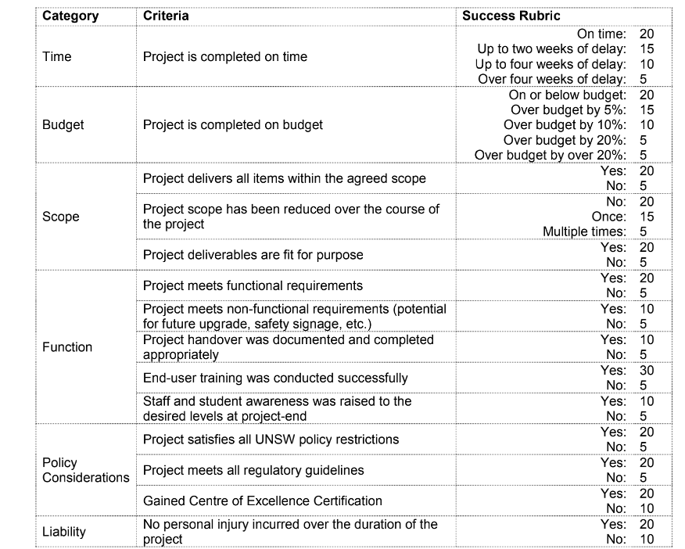

Satisfy UNSW 2025 strategy，stakeholder很满意，

Our team has defined success criteria in 5 areas.

They are: time, budget, scope, University of New South Wales 2025 strategy and stakeholders.

In terms of time, if our project is completed on time, we will succeed in time.

In terms of budget, if our project is completed within budget, we will succeed in budget.

In the scope area, if our project deliverables meet the project goals, we are successful

In the UNSW 2025 strategy, if our project follows the UNSW 2025 strategy, we will succeed

Finally, among stakeholders, if our learning platform has a positive impact on them and they are satisfied, we have succeeded.

Just make sure our team finish every work package on time, always follow the time schedule. Use money carefully. Do everything possible in scope. And do things always follow the UNSW 2025 strategy.

**2.What are the main needs of your stakeholders?**

Based on the stakeholder management of our PMP, there are 6 main stakeholders with different needs. First, the sponsor is aim to obtain the required network platform through the project. The External implementation team is interested in complete the design of the platform as required to implement specific functions and get paid what they deserve. The UNSW student development managers want to find future directions for more graduates and UNSW publicity managers are aim to promote the school through better employment data advantages. As for UNSW students and Business enterprise, they want to have better chance to find their dream job after graduation or to hire the right graduates separately.

**3.What is the biggest risk in your project plan, and how does it impact on project success? 您的项目计划中最大的风险是什么?它如何影响项目的成功?**

the biggest risk in our project plan is “system breakdown”.

When our system breakdown, we must input more budget to provide more IT

support, in this way it influence on our budget plan, it may be delay our project success.

If system break down, we have to spend extra time in fixing it so it has negative influence on our time schedule. This will result in shortening our time buffer and may make us spend more time to finish our project. It will also slow down the success of our project

If our system doesn’t meet the needs of users, it will influence our project success

当系统崩溃时，a.预算花多 b. 工期不够了 c.影响用户体验 d.(如何达不到成功标准)

**4.What is your minimum viable product? What proportion of the overall project benefit does it deliver? （你的最小可行产品是什么?它在整个项目收益中所占的比例是多少?）**

The product includes the basic functions required by the project. That is to realize member registration, form a study group, form a helping relationship, build a speech platform, and access the moodle or myunsw system at the same time.

Our small products account for 70% of our revenue when delivered.

**5.What opportunities have you discovered that you could exploit to enhance your project success? How would this happen? 你发现了哪些可以用来提高项目成功的机会?这是怎么发生的?**

In my opinion, these opportunities mean that we can have a positive impact on our projects.

So I found that if the University of New South Wales can provide an excellent IT support team, it will have a positive impact on our project process. In addition, these opportunities are in line with the University of New South Wales 2025 strategy.

If the cooperative enterprise can provide some development funds for our project, after the project is deployed, students around UNSW will have more opportunities to participate in their work and integrate into society in advance.

**6.At what checkpoints in your plan could your project be abandoned if was not delivering the expected value to the stakeholders? How would you decide?**

有时候我们会遇到突发情况比如COVID，那么就必须舍弃一些功能，比如UI design，保留最重要的功能

（1）项目的某些功能（checkpoints）

（2）如何决定舍弃哪些功能，理由如何

When our project fails to deliver the expected value to stakeholders, our team will give up part of the user interface design and project support. In UI design, we have to spend a lot of money to recruit UI designers and develop UI. However, the UI only plays a small role in the purpose of our project. If we remove a perfect UI design, we can still make our system work. We can still provide services to students and teachers in need, and can still guarantee their communication. Therefore, the UI is a checkpoint that our project can give up.

**7. Describe how your project furthers the UNSW 2025 strategy**

PMP 1.2部分摘抄

**Enabler03** Support Our Services, Systems and Processes

**Enabler04** Enhance Our Campuses.

Our project can advance the strategy of the University of New South Wales in two ways.

For innovation and participation, our project can cooperate with the Student Management Department of the University of New South Wales or CSE Academy

Our projects can promote the employability of students, help future students to participate in project development, and encourage employees and students to innovate.

For social impact,

Our project can enhance UNSW’s reputation and academic influence, thereby attracting more future students and forming a virtuous circle.

In addition, our project will strengthen the connection between students. In the future, UNSW students will have closer ties; companies that cooperate with the project will also directly benefit from the improvement of talents, while other universities need to work harder and work with UNSW. Promote social progress.