Question 1

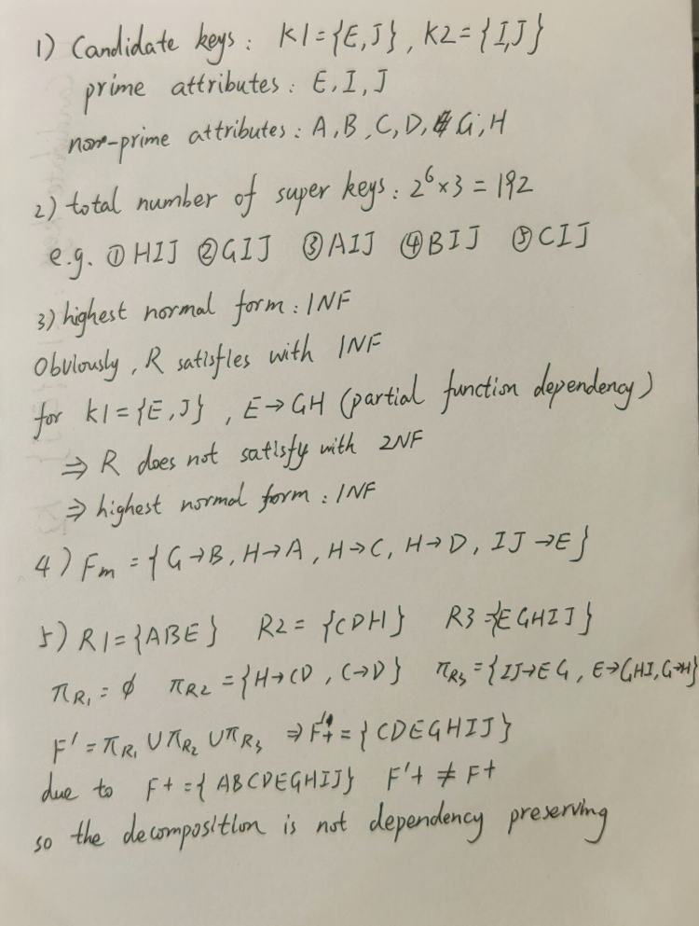

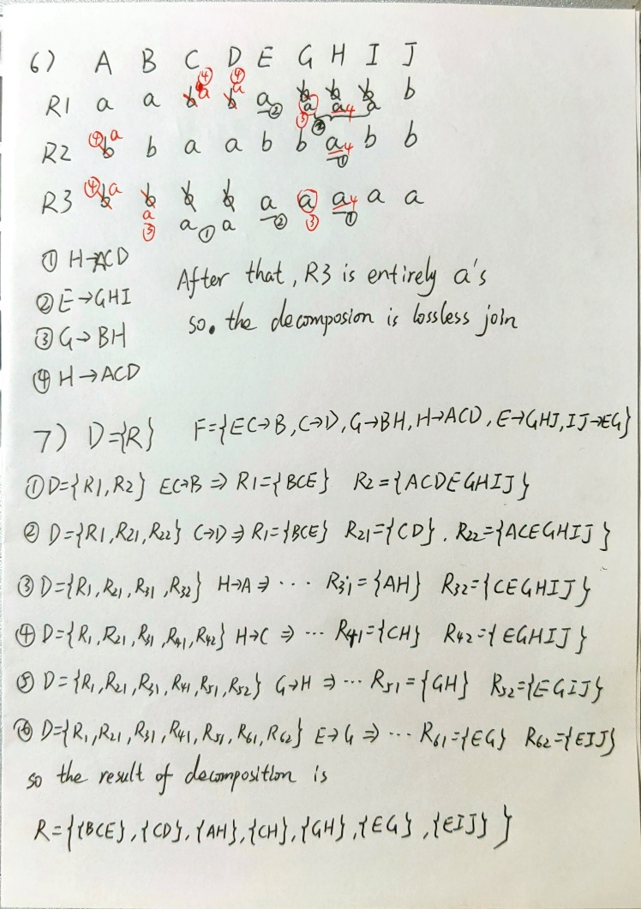

Question 2

1)

redo: T1, T5

undo: T3, T4

2)

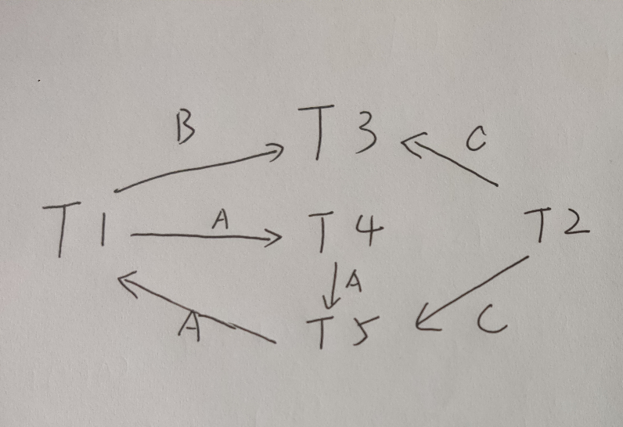

3)

|  |  |  |  |  |  |  |  |  |  |  |  |  |  |  |  |  |  |  |
| --- | --- | --- | --- | --- | --- | --- | --- | --- | --- | --- | --- | --- | --- | --- | --- | --- | --- | --- |
|  | t1 | t2 | t3 | t4 | t5 | t6 | t7 | t8 | t9 | t10 | t11 | t12 | t13 | t14 | t15 | t16 | t17 | t18 |
| T1 |  |  | R(A) |  |  |  | R(B) |  | W(A) |  |  |  |  |  | W(B) |  |  |  |
| T2 | R(C) |  |  |  | W(C) |  |  |  |  |  |  |  |  |  |  |  |  |  |
| T3 |  | R(B) |  |  |  |  |  |  |  | R(C) |  |  |  |  |  | W(B) | W(C) |  |
| T4 |  |  |  | R(D) |  |  |  |  |  |  |  | W(D) | R(A) |  |  |  |  | W(A) |
| T5 |  |  |  |  |  | R(C) |  | R(A) |  |  | W(C) |  |  | W(A) |  |  |  |  |

Lock in red and unlock in blue

Compared with the given schedule, only the order of t10 and T11 operations has been switched

4)

|  |  |  |  |  |  |  |  |  |  |  |  |  |  |  |  |  |  |  |
| --- | --- | --- | --- | --- | --- | --- | --- | --- | --- | --- | --- | --- | --- | --- | --- | --- | --- | --- |
|  | t1 | t2 | t3 | t4 | t5 | t6 | t7 | t8 | t9 | t10 | t11 | t12 | t13 | t14 | t15 | t16 | t17 | t18 |
| T1 |  |  | R(A) |  |  |  | R(B) | W(A) |  |  |  |  |  |  | W(B) |  |  |  |
| T2 | R(C) |  |  |  | W(C) |  |  |  |  |  |  |  |  |  |  |  |  |  |
| T3 |  | R(B) |  |  |  |  |  |  |  |  | R(C) |  |  |  |  | W(B) | W(C) |  |
| T4 |  |  |  | R(D) |  |  |  |  |  |  |  | W(D) | R(A) |  |  |  |  | W(A) |
| T5 |  |  |  |  |  | R(C) |  |  | R(A) | W(C) |  |  |  | W(A) |  |  |  |  |

Lock in red and unlock in blue

Compared with the given schedule, only the order of t8 and t9 operations has been switched