Question 1:

i: Composite attributes can be subdivided into smaller parts while simple attributes themselves are already minimal attributes; Composite attributes search and store data efficiently.

ii: If attributes in R1(R2) contain or intersect on that in another relation, the result will be different; if attributes in R1(R2) disjoint to that in another relation, the result will be the same.

iii: example: A transferred 50 Australian dollars to B, first A’s account -50 then B’s account +50, but the second step error, so the system will rollback(A’s account +50 to the initial state)

counterexample : A transferred 50 Australian dollars to B, first A’s account -50 then B’s account +50, but the second step error, so the system will stop which make 50 Australian dollars missed.

iv: 3NF has no transfer function dependencies. There are no properties in the relationship that depend on non-primary keys. This means that all non-key attributes are completely function dependent on the key which satisfied with 2NF.

v: (b)the latter. Because the former will get not only the maximum value of A but also other values of A, only the first row of the result is needed.

Question2:

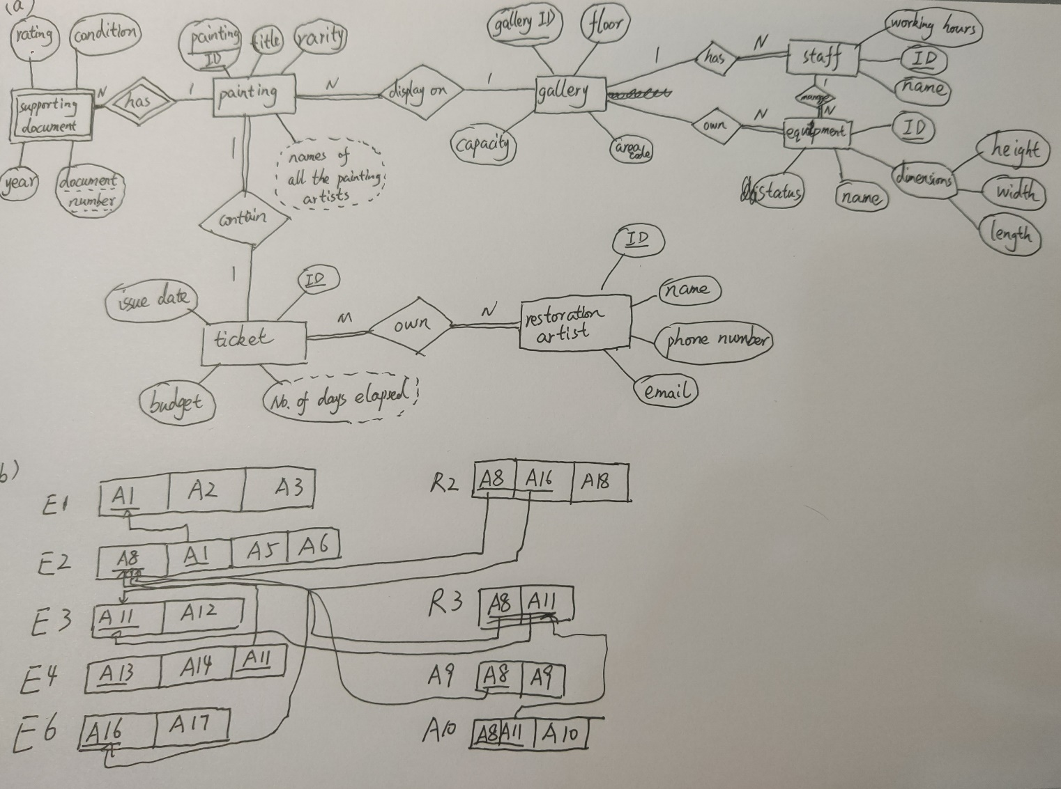

Question3:

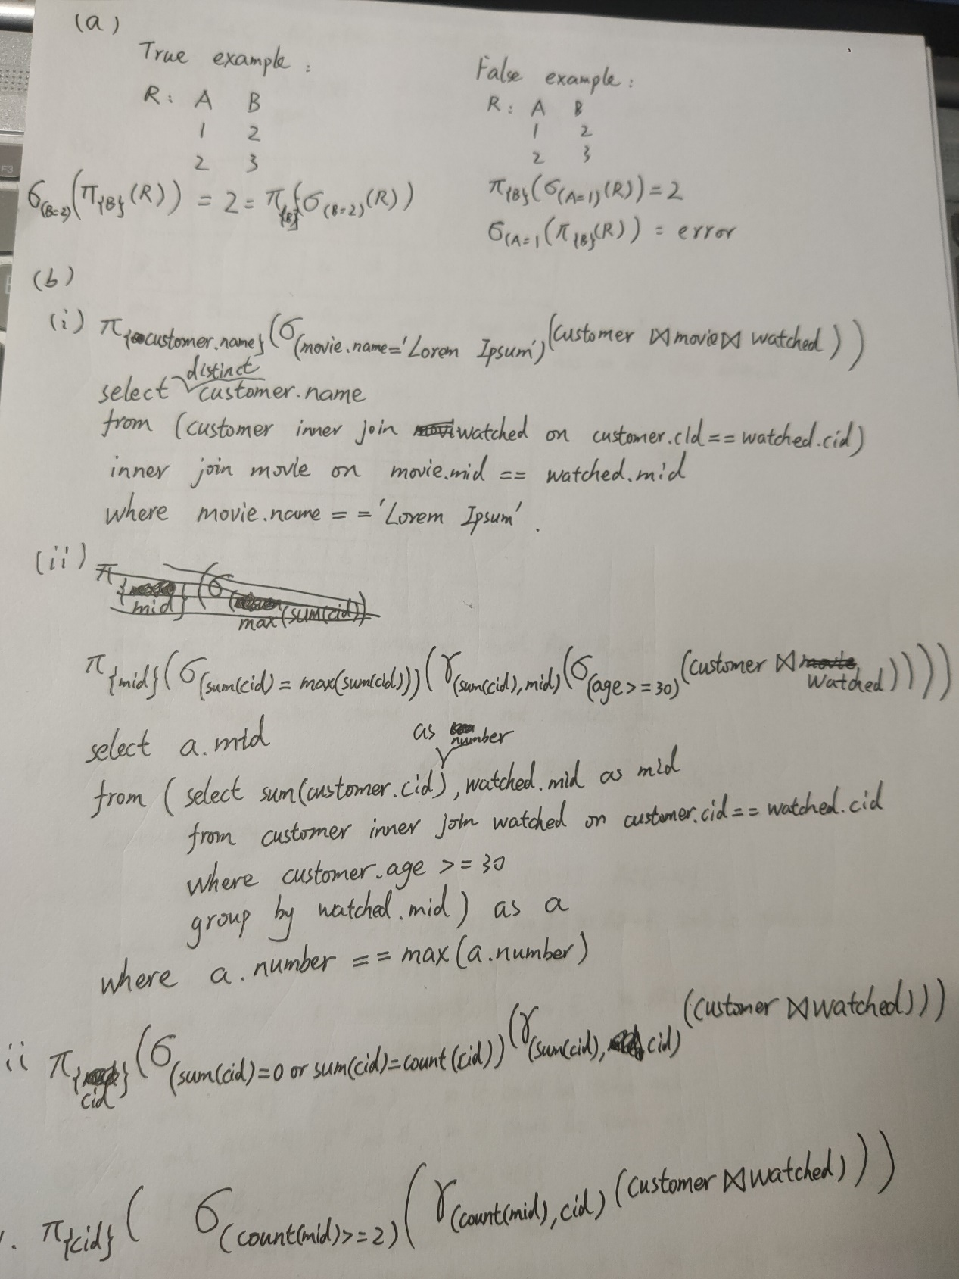

Question 4:

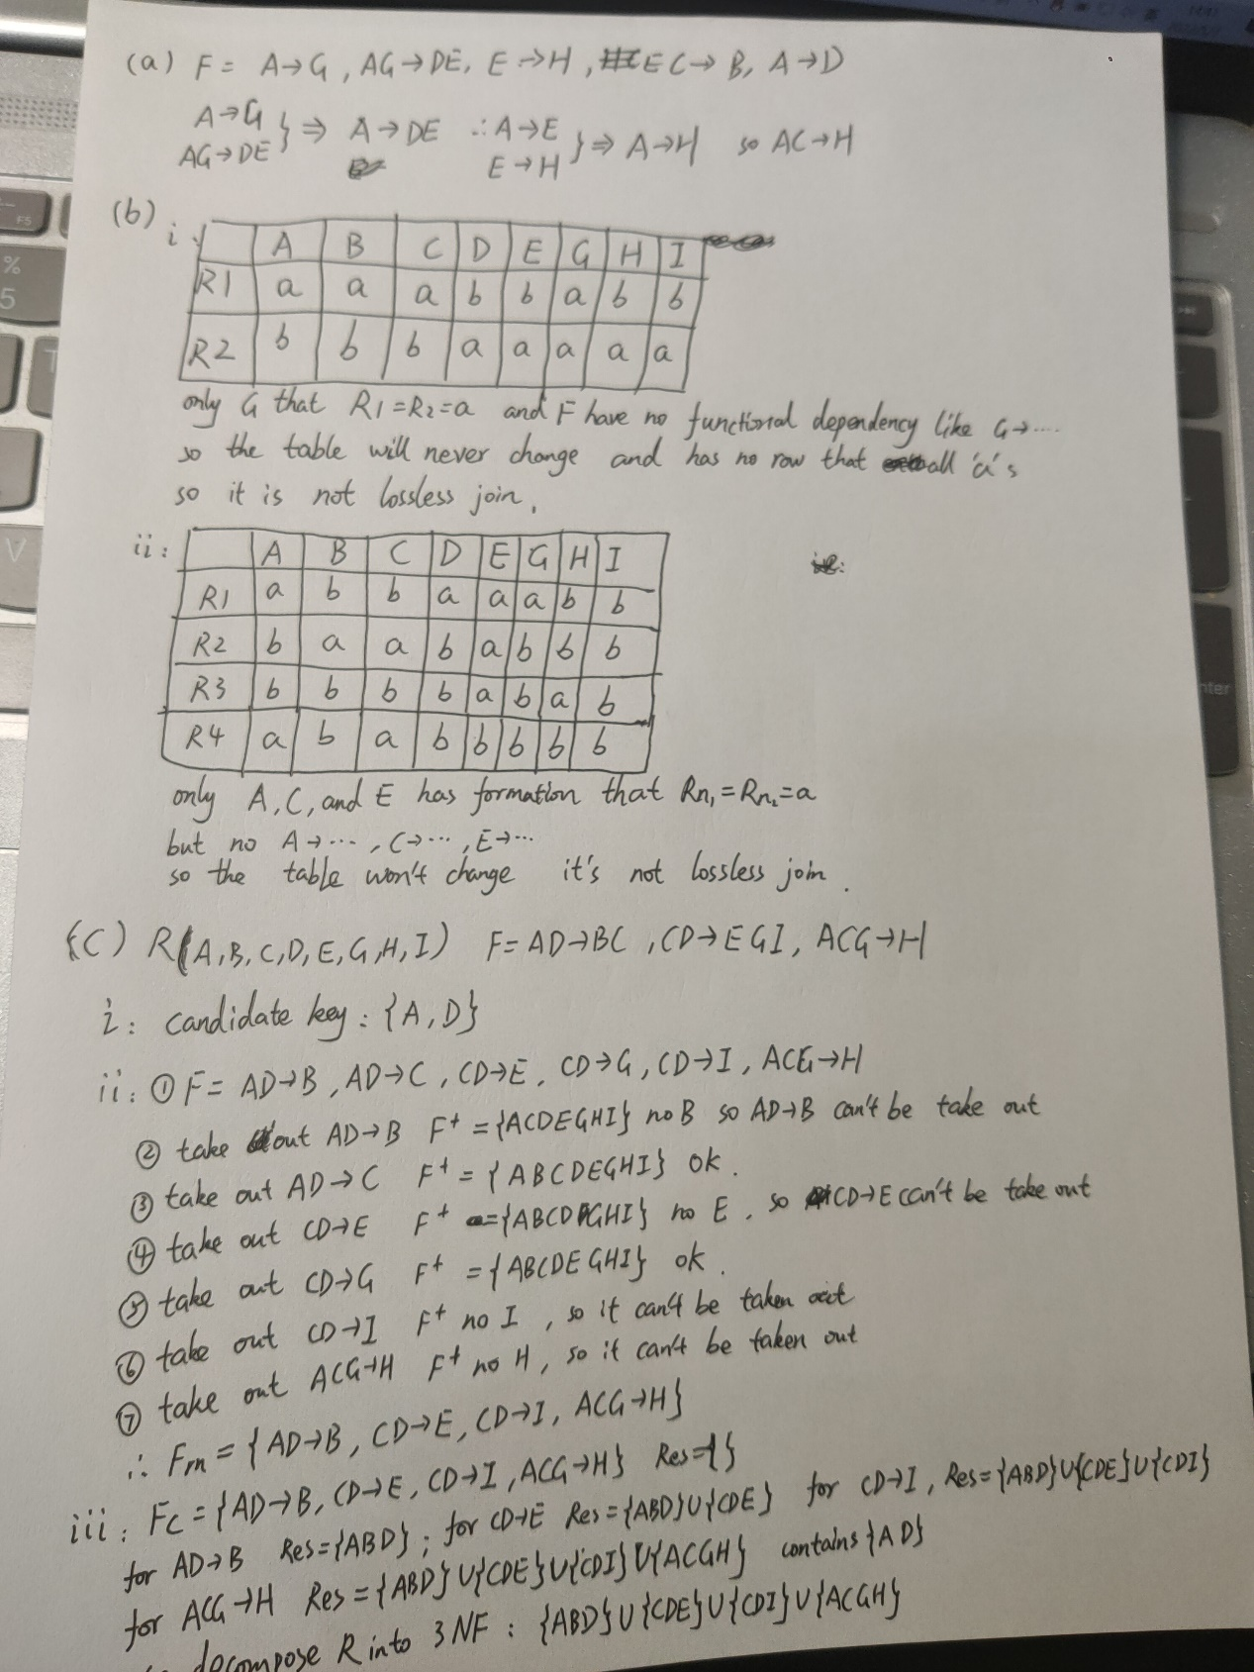

Question 5:

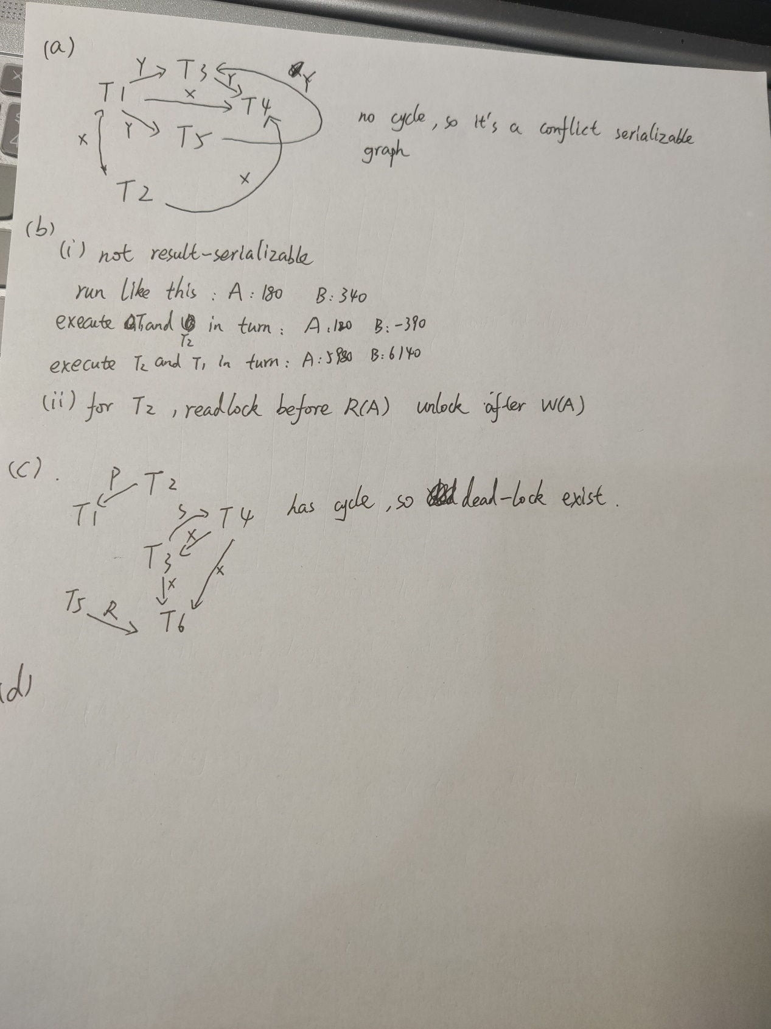

Question 6：

