Exercise 1.

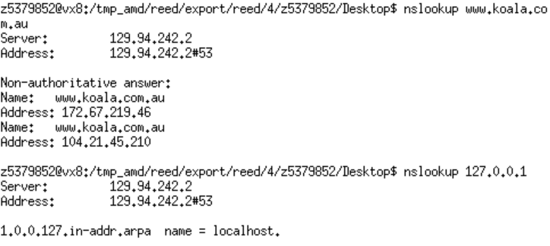

1.IP address：172.67.219.46 and 104.21.45.210

Reason: Easy to check and maintain

2.name: localhost

special as this ip address is not exist

Exercise 2.

（1）[www.unsw.edu.au](http://www.unsw.edu.au)

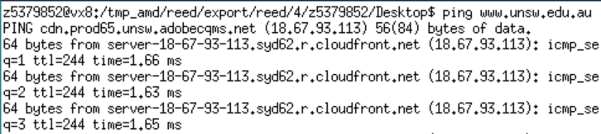

(2) [www.getfittest.com.au](http://www.getfittest.com.au)



(3) [www.mit.edu](http://www.mit.edu)

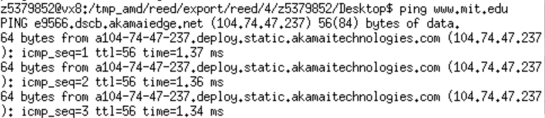

(4) [www.intel.com.au](http://www.intel.com.au/)

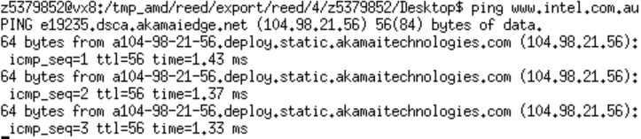

(5)[www.tgp.com.au](http://www.tgp.com.au)

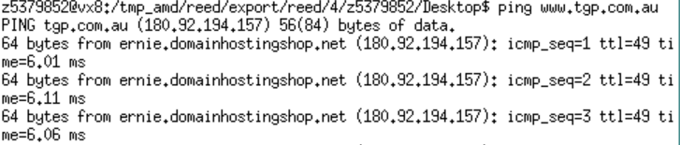

(6)www.hola.hp



(7)[www.amazon.com](http://www.amazon.com)

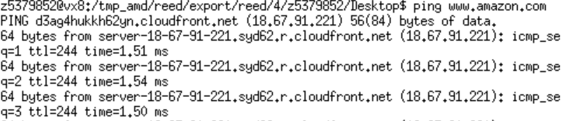

(8)[www.tsinghua.edu.cn](http://www.tsinghua.edu.cn)



(9)[www.krimlin.ru](http://www.krimlin.ru)



(10)8.8.8.8

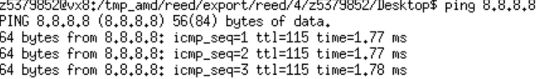

Of the above 10 hosts, hosts 2,6, 8, and 9 are inaccessible. Among them, hosts 2 and 6 are inaccessible through browsers, while hosts 8 and 9 are accessible. This indicates that the former does not exist or has been logged out, and the latter may be inaccessible due to security restrictions.

Exercise 3.

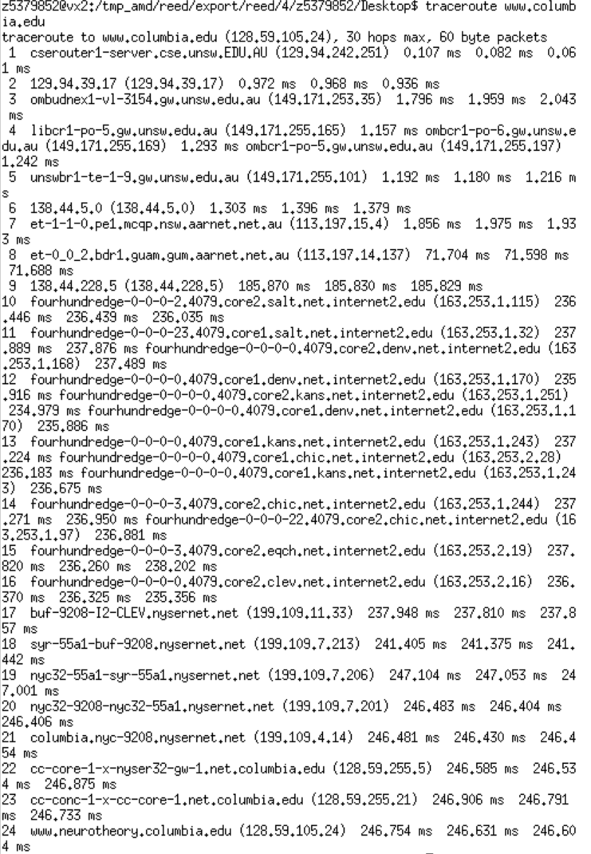

1. 23 routers, part of the UNSW network :5,cross the Pacific Ocean :8-9 routers.

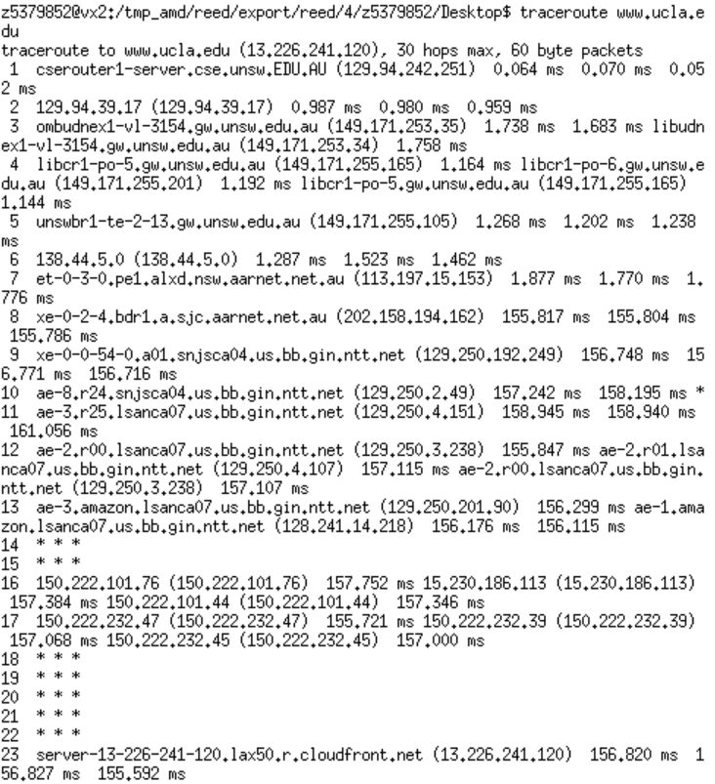

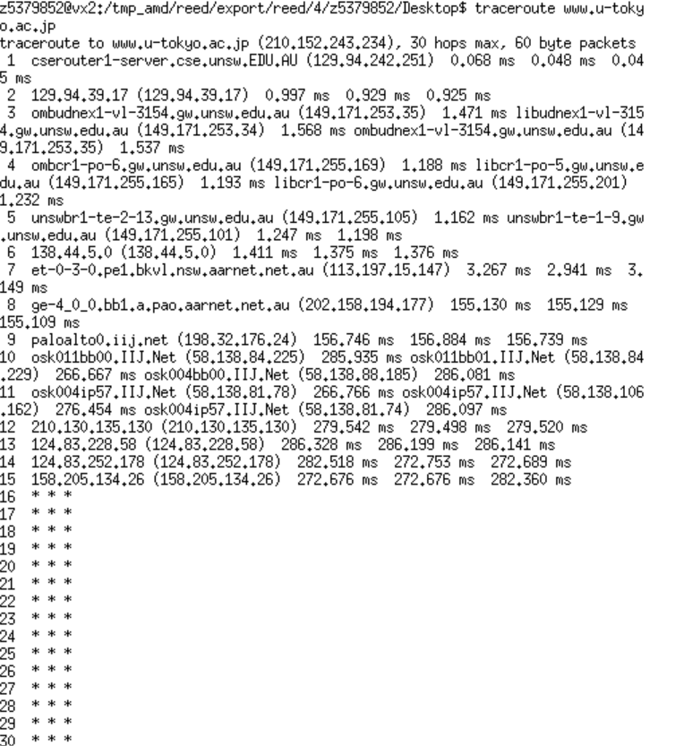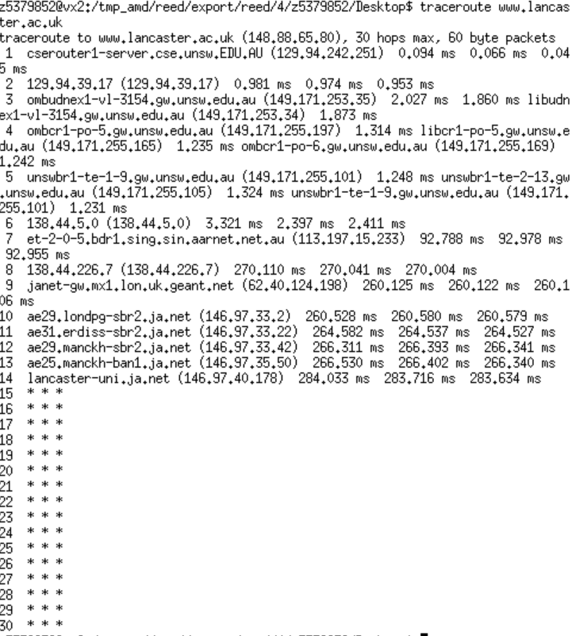

1. diverge router:138.44.5.0,more information as followed, the number of hops on each path is not proportional to the physical distance.

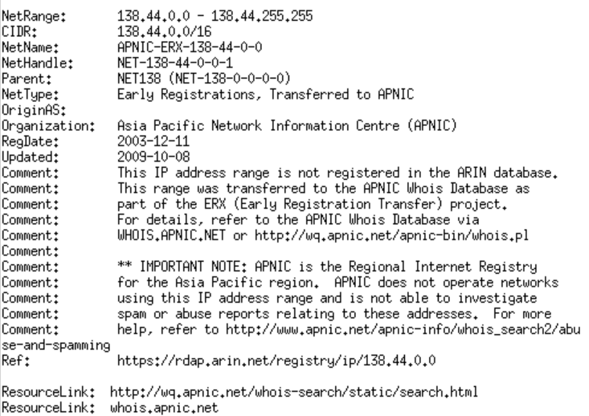

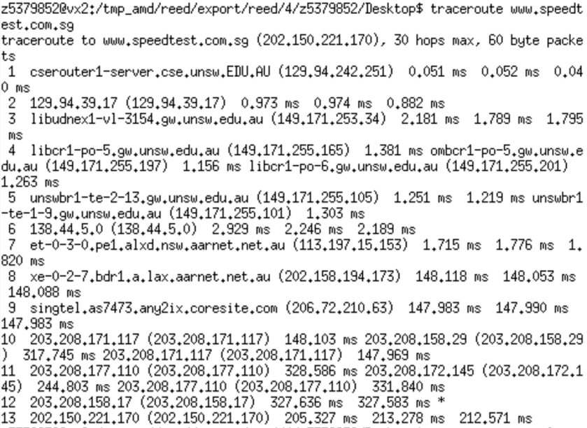 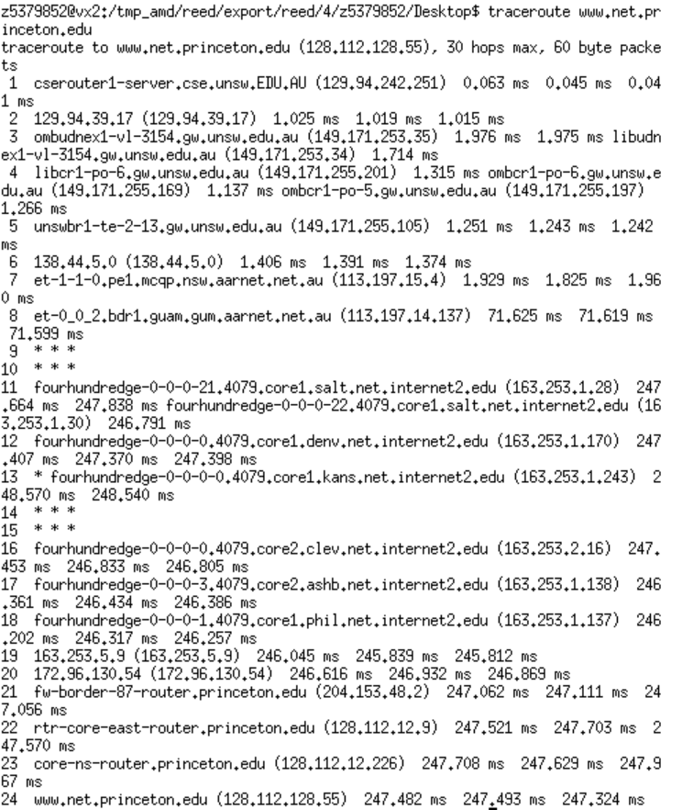

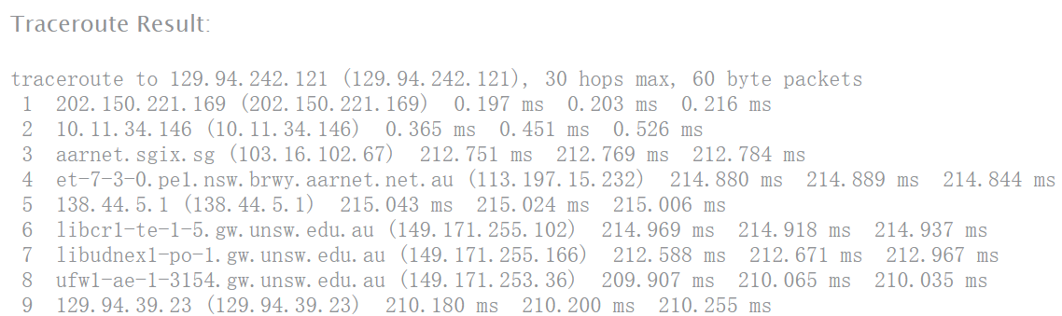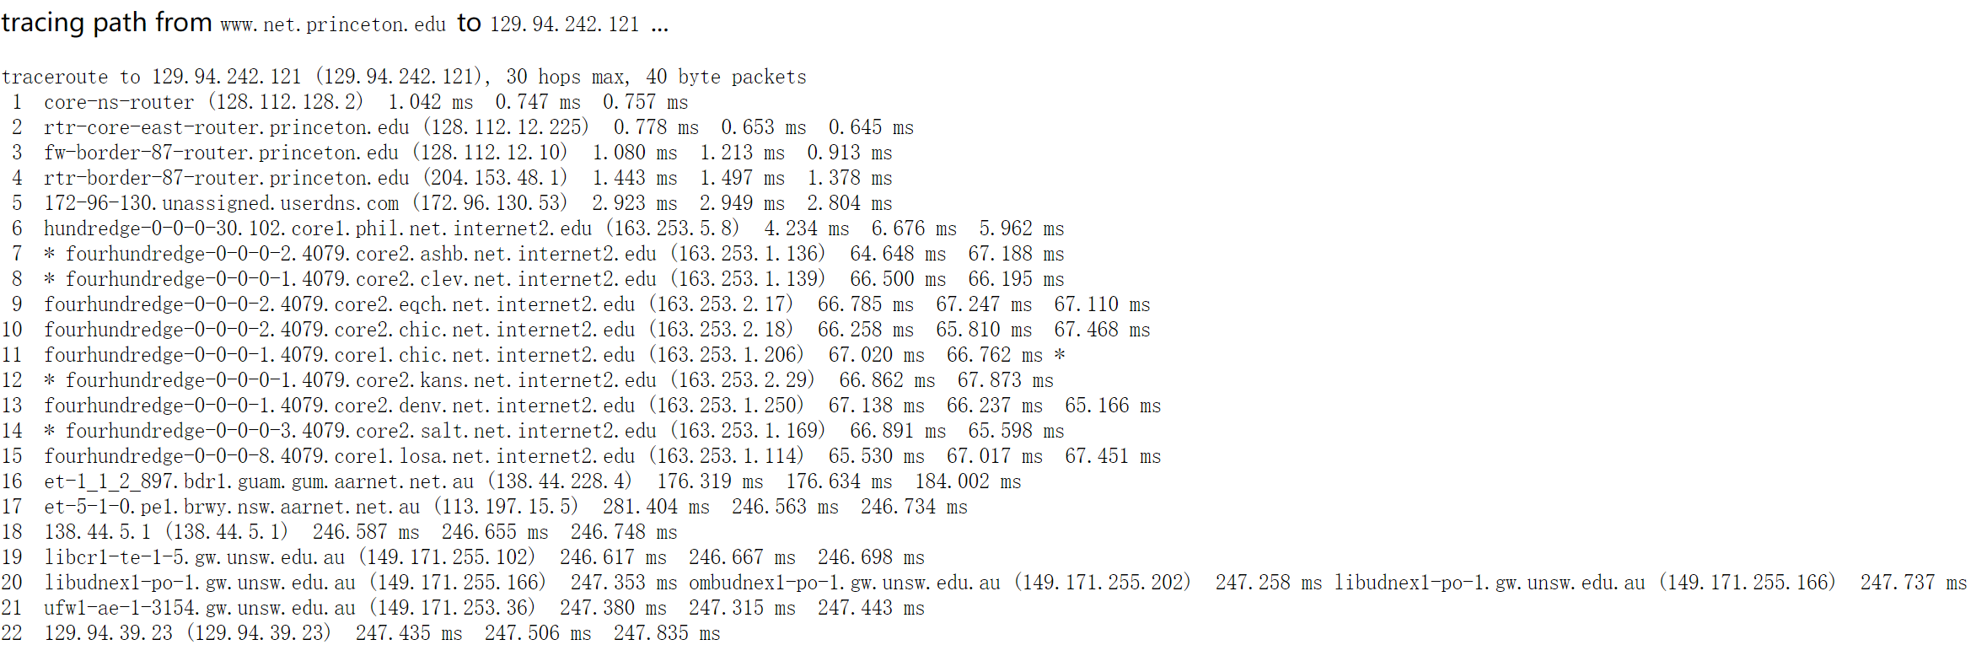

3.IP:202.150.221.170 and 128.112.128.55; the reverse path didn’t go through the same routers as the forward path; the same IP addresses exist. This may be related to the security policy of the route.

Exercise 4.

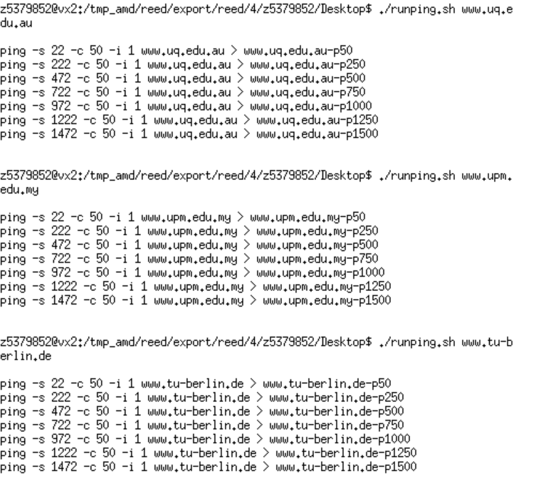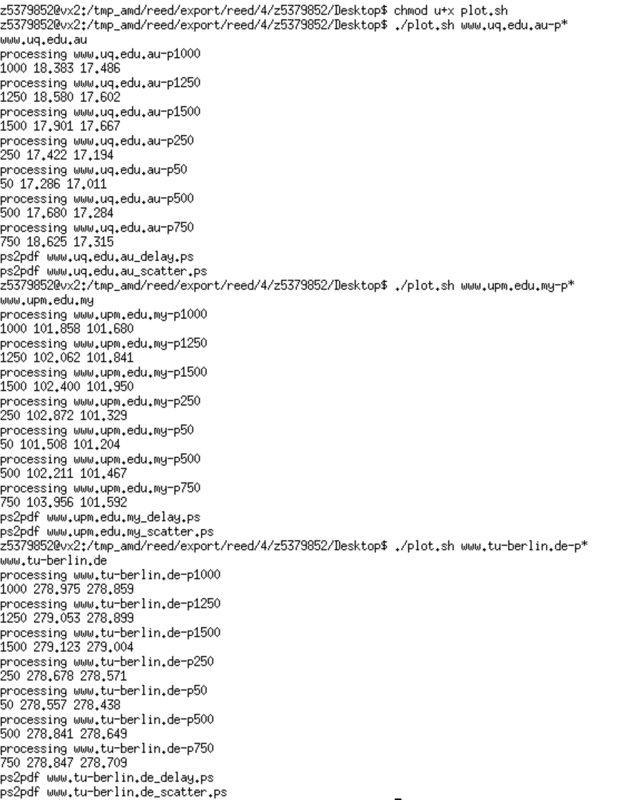

www.uq.edu.au:

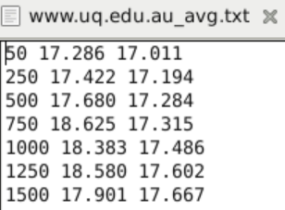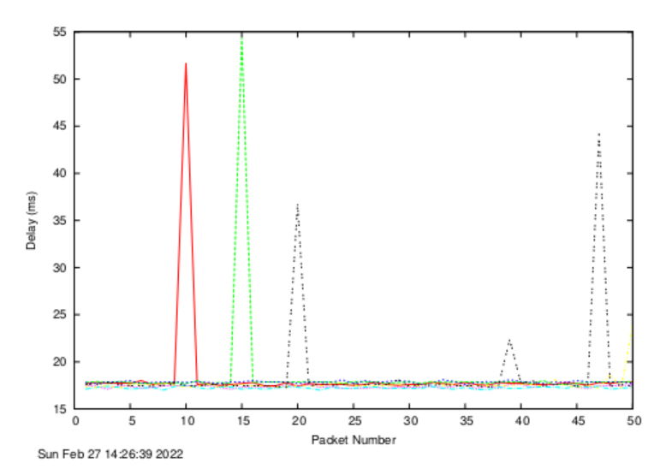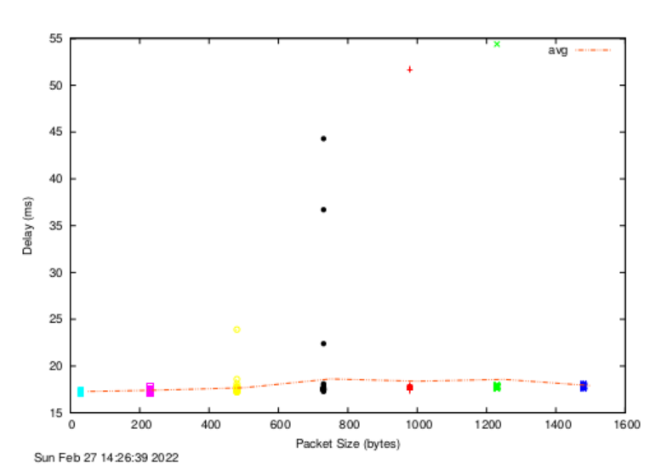

[www.upm.edu.my](http://www.upm.edu.my):

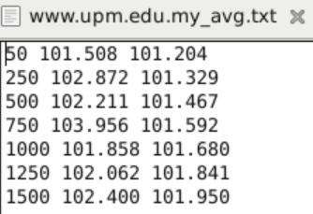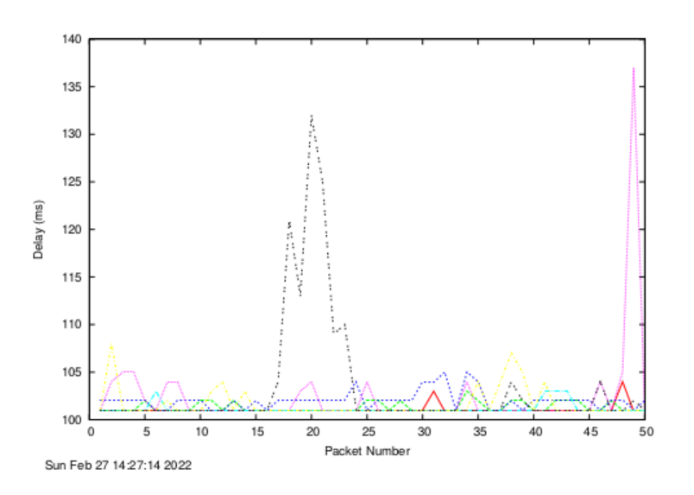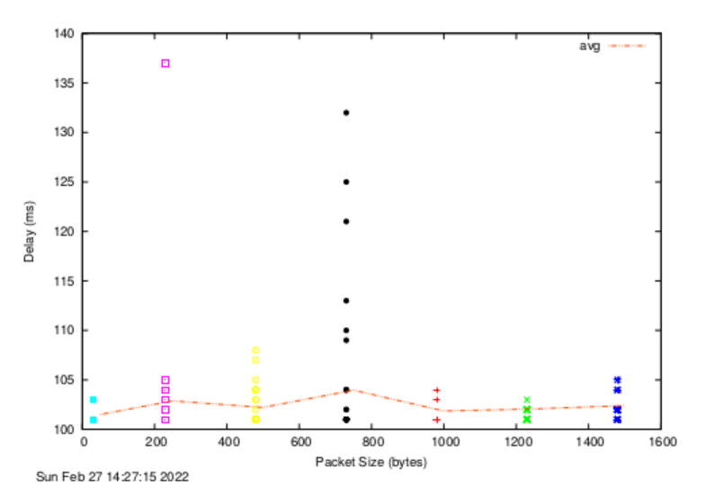

[www.tu-berlin.de](http://www.tu-berlin.de):

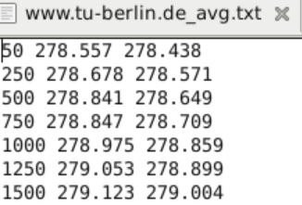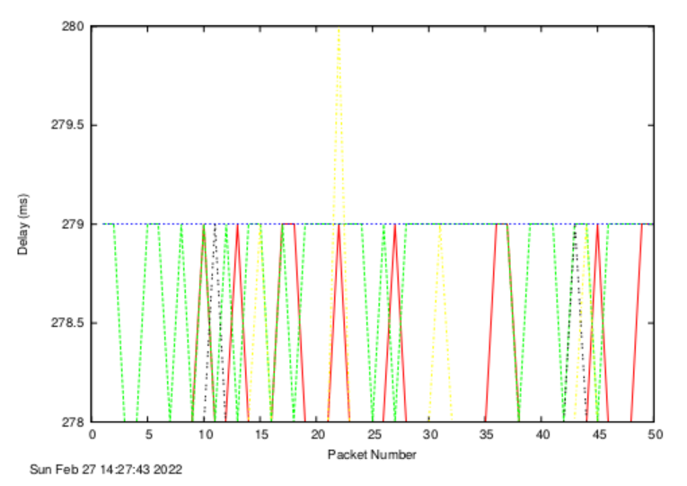

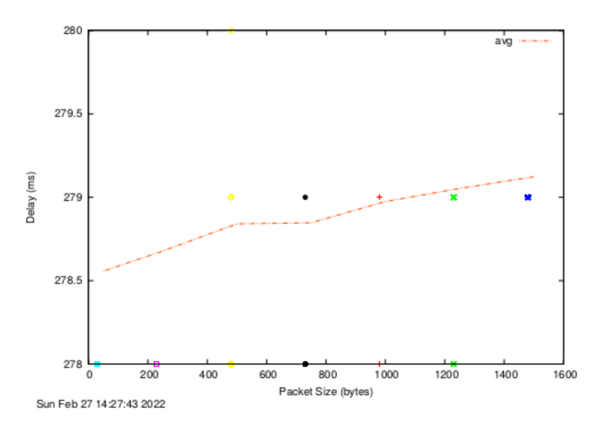

1. 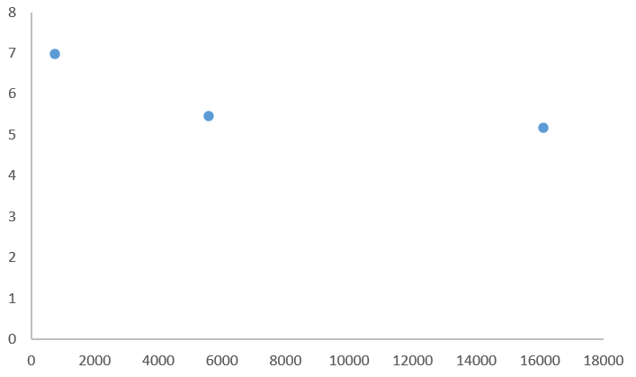
2. The delay vary over time, because the delay is related to the distance traveled and the number of routes traveled.
3. Transmission delay depends on the packet size while propagation delay, processing delay and queuing delay are not.