Exercise 3:

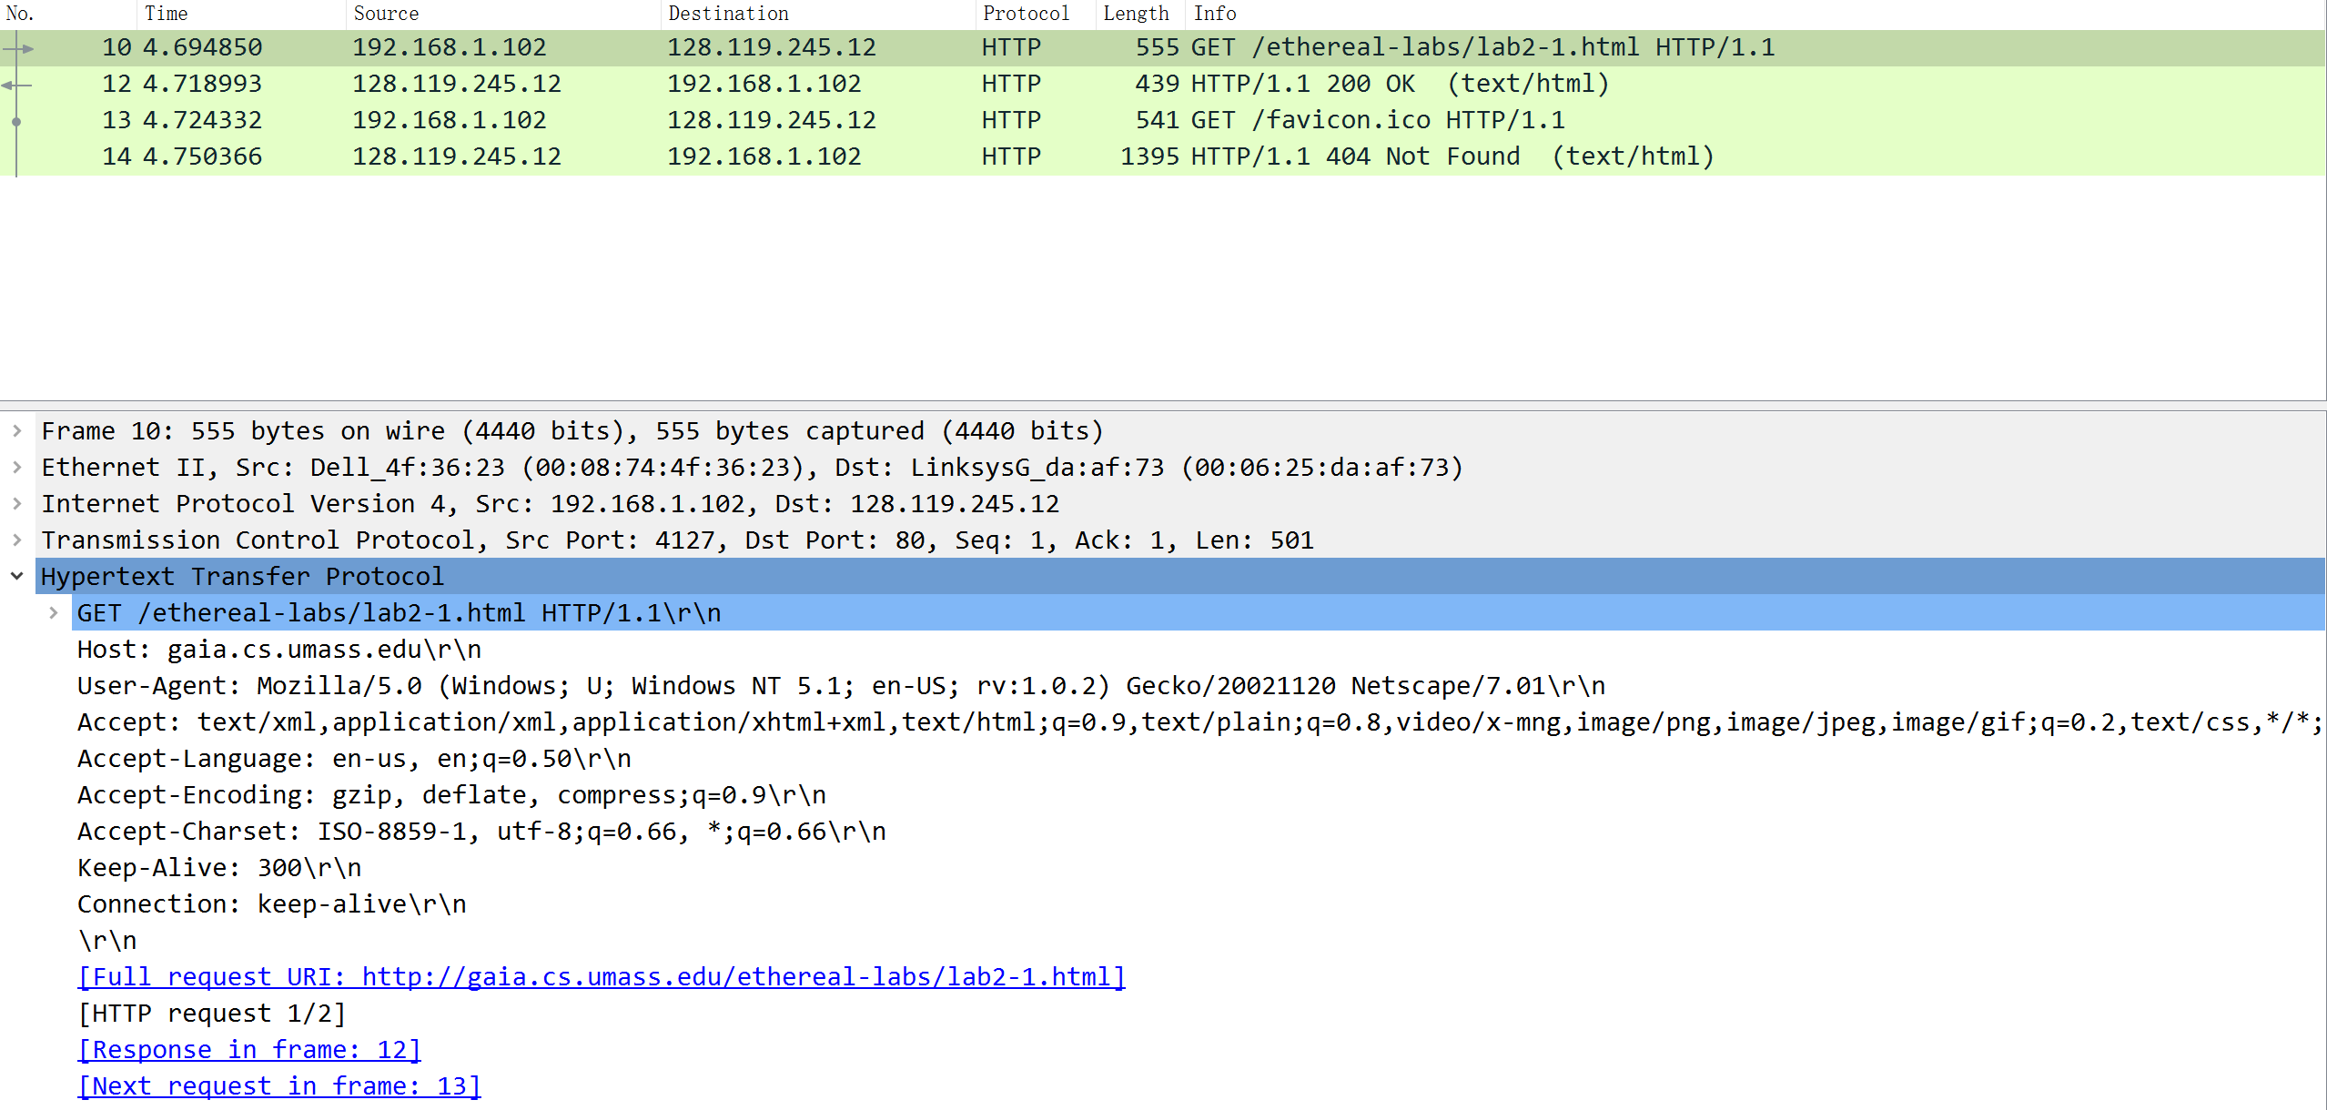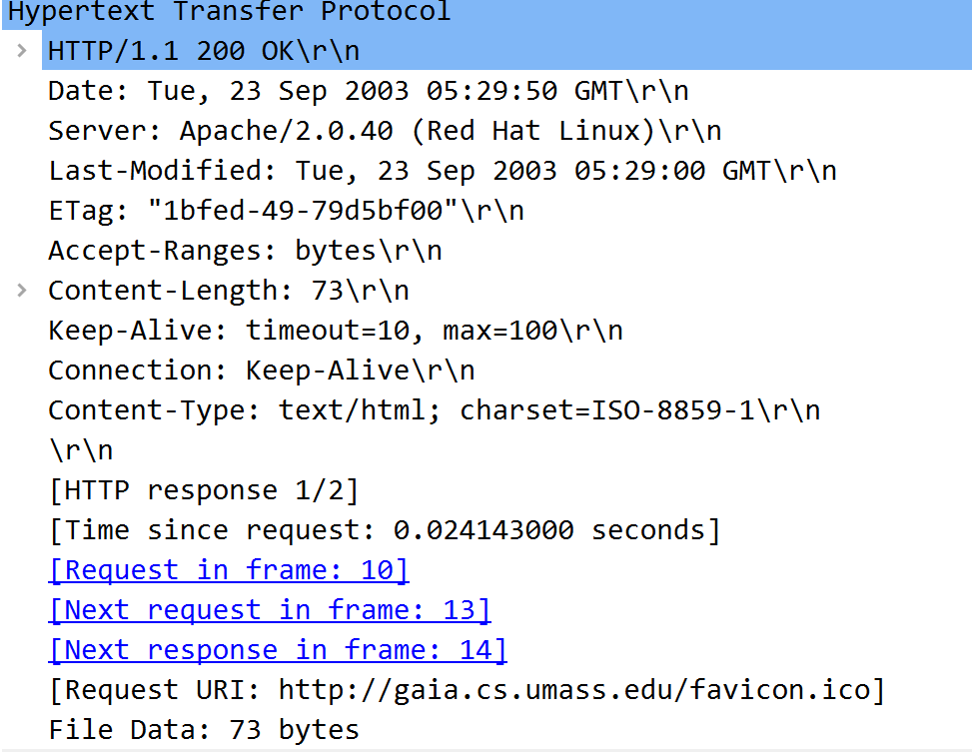

Q1:status code = 200 phrase = OK

Q2: Last modified at the server: Tue, 23 Sep 2003 05:29:00 GMT

No DATE header; DATE header indicates when the server generates and sends response messages

Q3: The connection is persistent because the header line showed that the connection is “Keep-Alive”.

Q4: 73 bytes

Q5: text/html

Exercise 4:

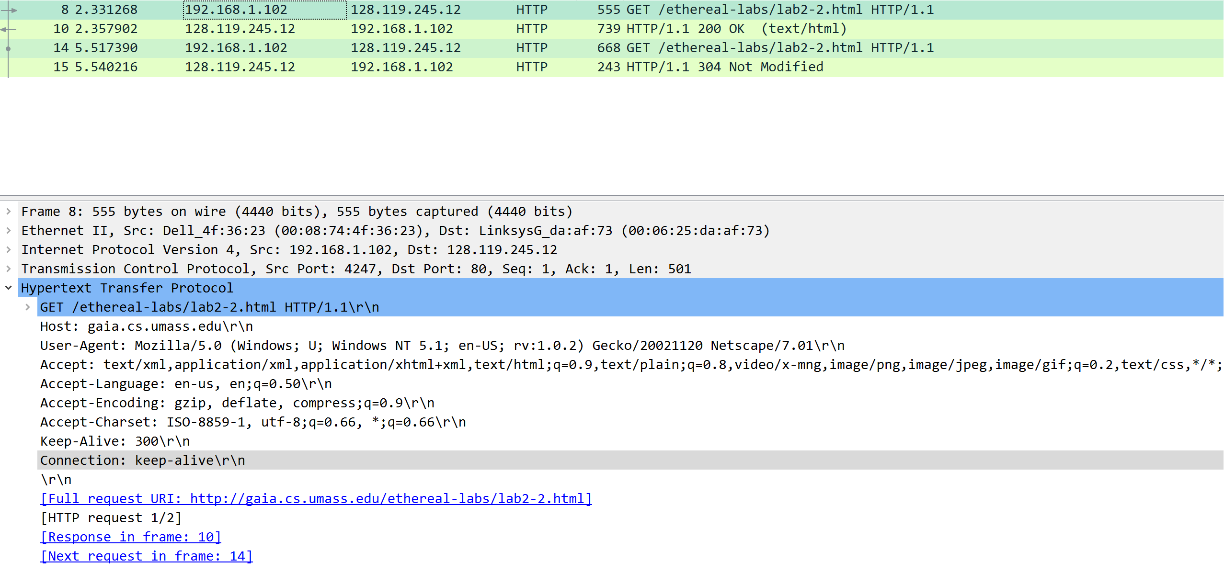 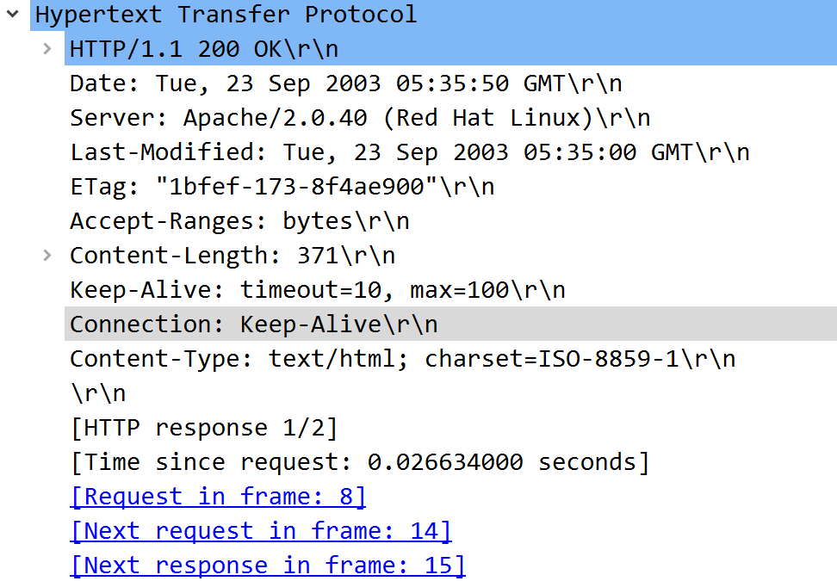 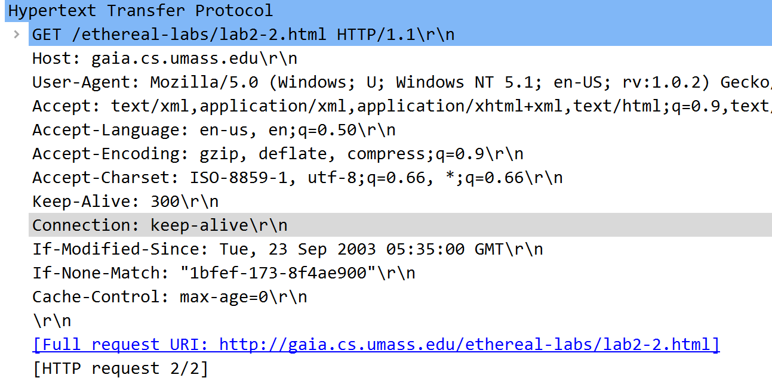 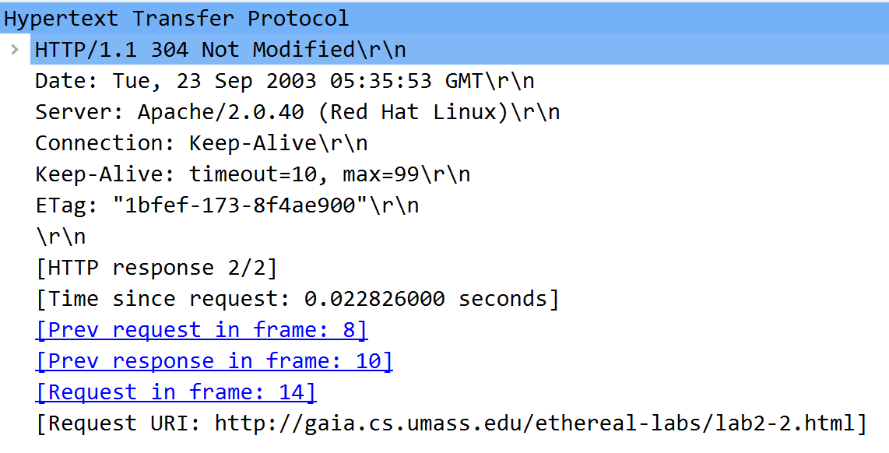

Q1: No.

Q2: Yes.

Q3: Yes.

IF-MODIFIED-SINCE: Tue, 23 Sep 2003 05:35:00 GMT

IF-NONE-MATCH: “1bfef-173-8f4ae900”

Q4: 304 Not Modified.

The server didn’t return the contents of the file explicitly because the server determines that the resources cached by the client are up to date.

Q5: “1bfef-173-8f4ae900” It acts as a cached copy of the original object. It hasn’t changed.

Exercise 5:

