Exercise 3:

1)IP:23.185.0.1 Type: A

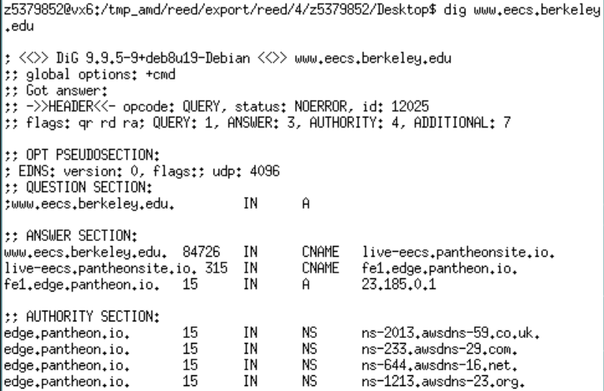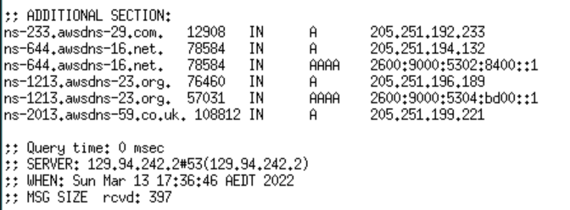

2) canonical name: live-eecs.pantheonsite.io.

Reason: much easier to remember for user

3)To provide information and IP address of name servers

4)129.94.242.2

5) adns2.berkeley.edu 128.32.136.14

adns1.berkeley.edu 128.32.136.3

adns3.berkeley.edu 192.107.102.142

ns.eecs.berkeley.edu 129.229.60.153

ns. cs.berkeley.edu 129.229.60.61

NS

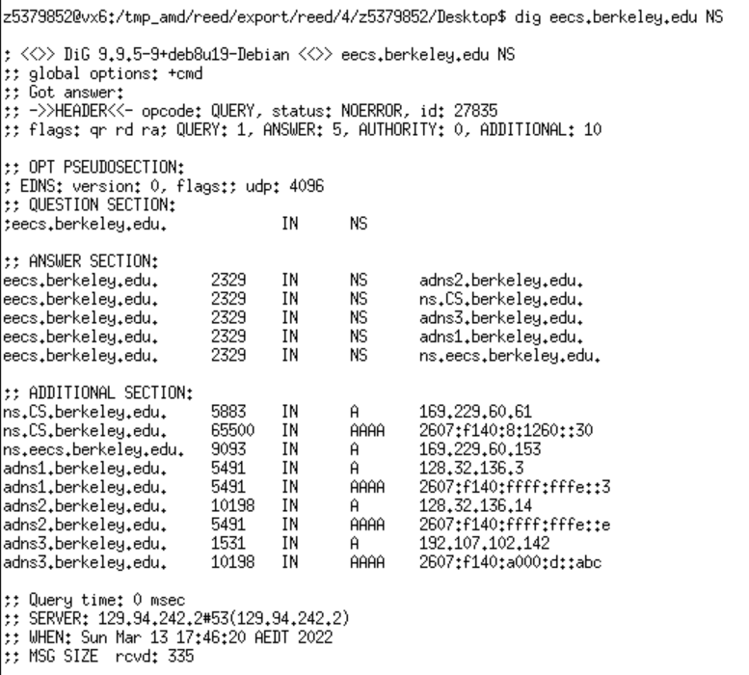

6) SOA

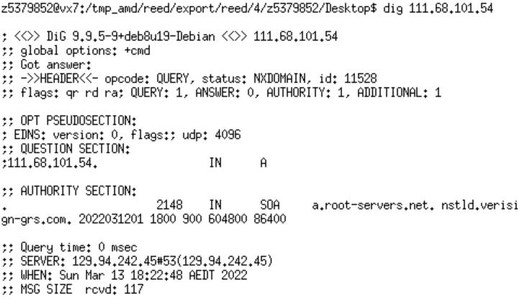

7) No.Because “AA” is not in flags.

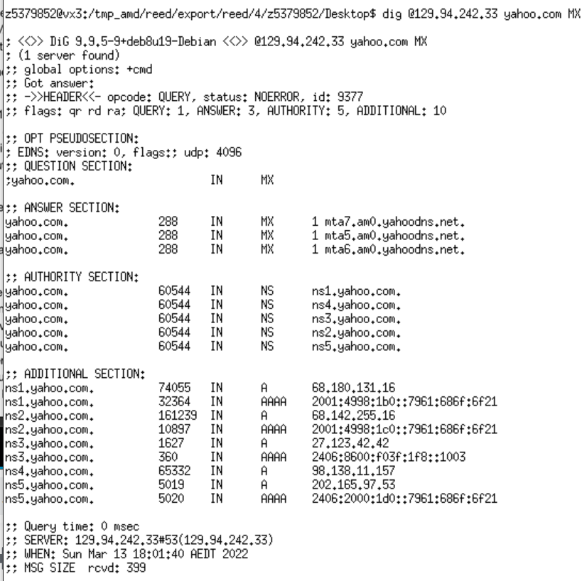

8)Query refused

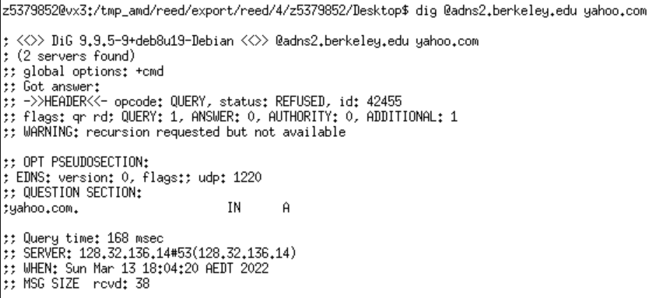

9) “A” and “MX”

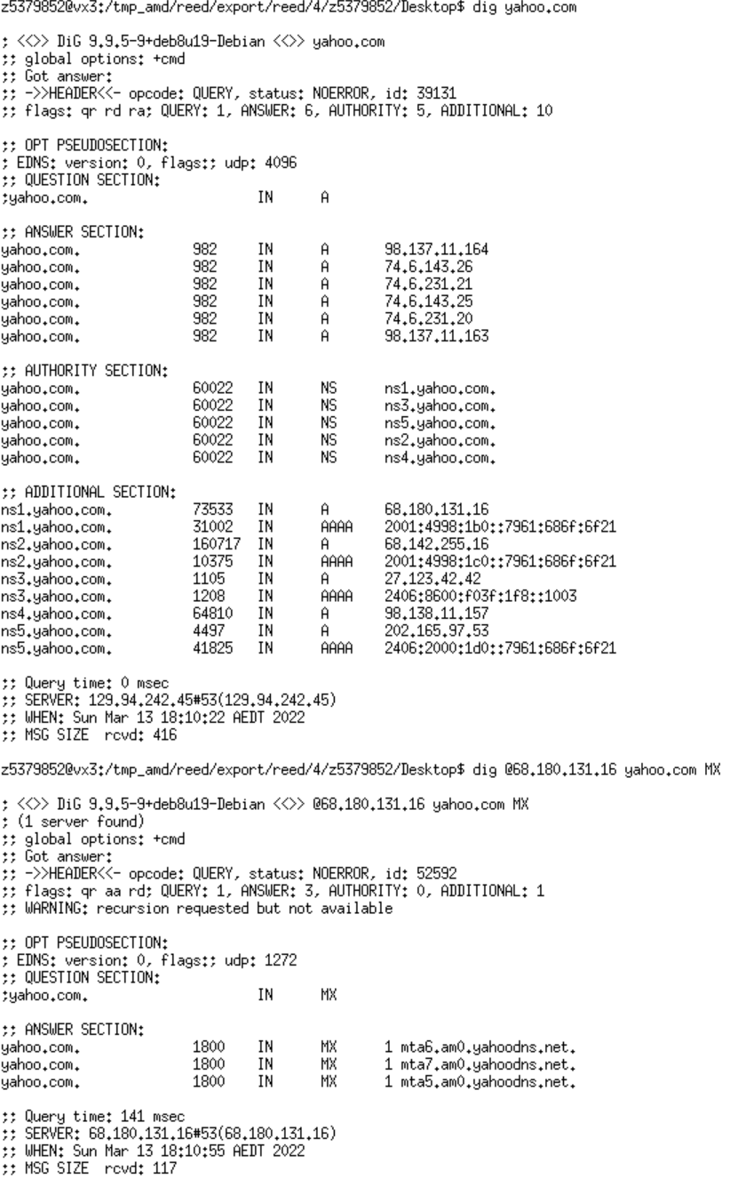

10)5

11)Yes.

Exercise 4:

