Exercise1:

Q1.the IP address of gaia.cs.umass.edu:128.119.245.12

port number:80

the IP address and TCP port numbers used by the client computer (source):192.168.1.102;1161

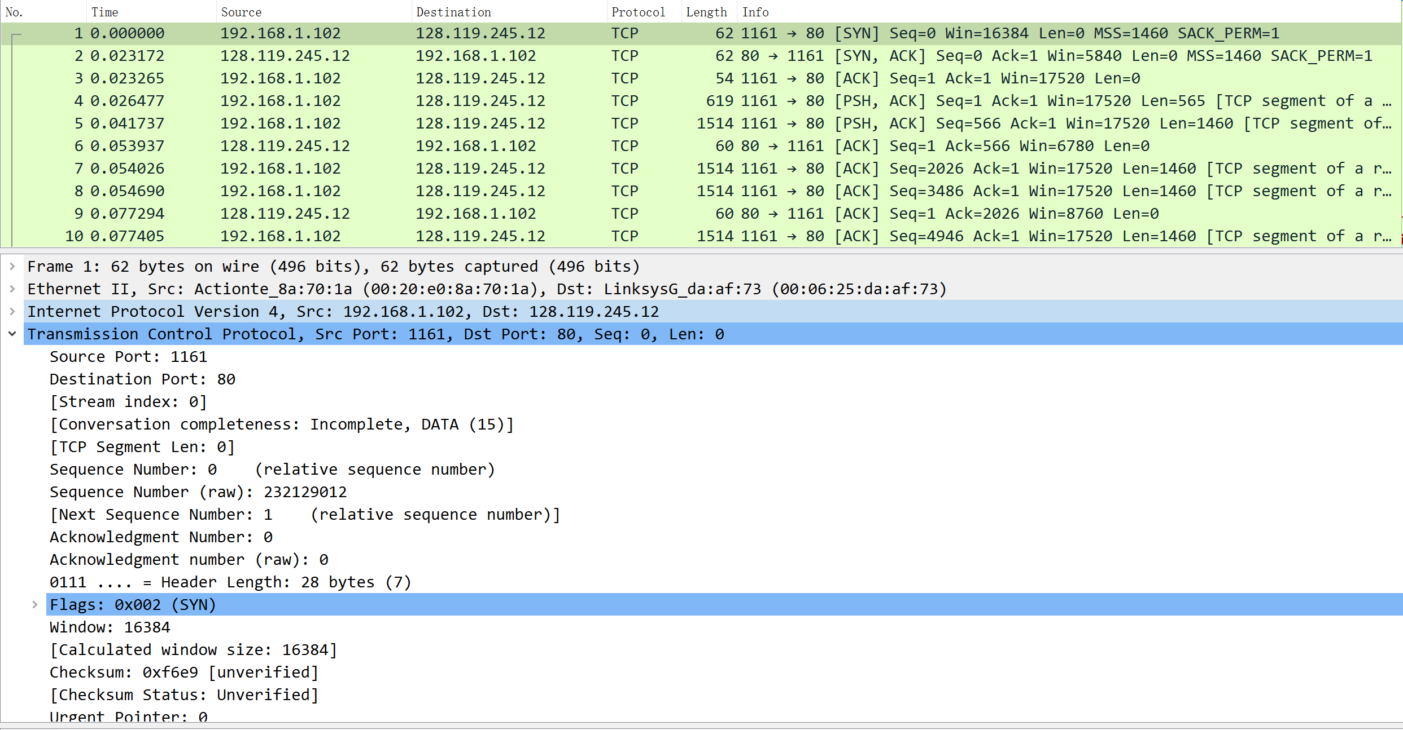

Q2.  sequence number:232129013

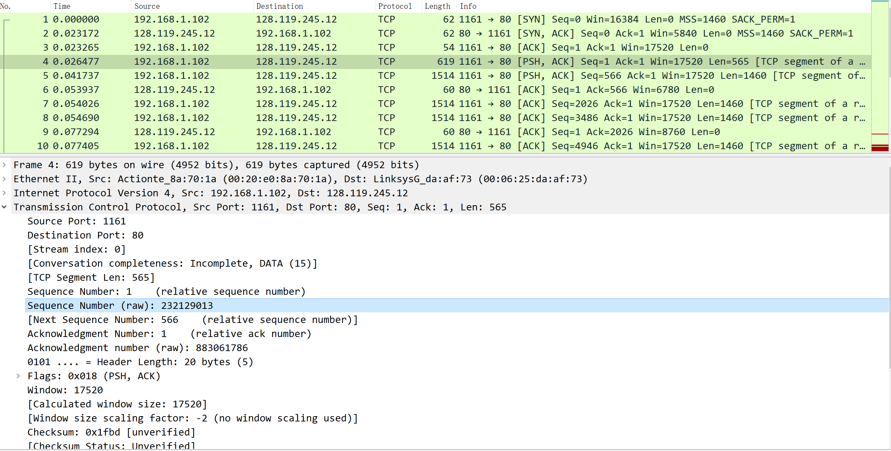

Q3.

|  |  |  |  |  |  |
| --- | --- | --- | --- | --- | --- |
| No | sequence number | sent time | received time | RTT | EstimatedRTT |
| 1 | 232129013 | 0.026477 | 0.053937 | 0.027460 | 0.027460 |
| 2 | 232129578 | 0.041737 | 0.077294 | 0.035557 | 0.028472 |
| 3 | 232131038 | 0.054026 | 0.124085 | 0.070059 | 0.033670 |
| 4 | 232132498 | 0.054690 | 0.169118 | 0.114428 | 0.043765 |
| 5 | 232133958 | 0.077405 | 0.217299 | 0.139894 | 0.055781 |
| 6 | 232135418 | 0.078157 | 0.267802 | 0.189645 | 0.072514 |

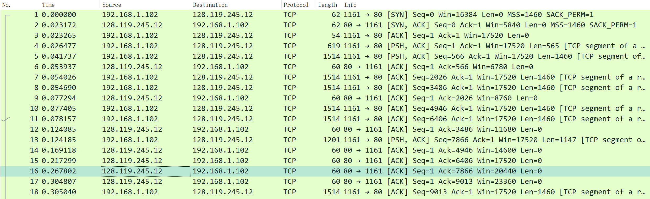

Q4. 565,1460,1460,1460,1460,1460

Q5. 5840;No,5840>1460.

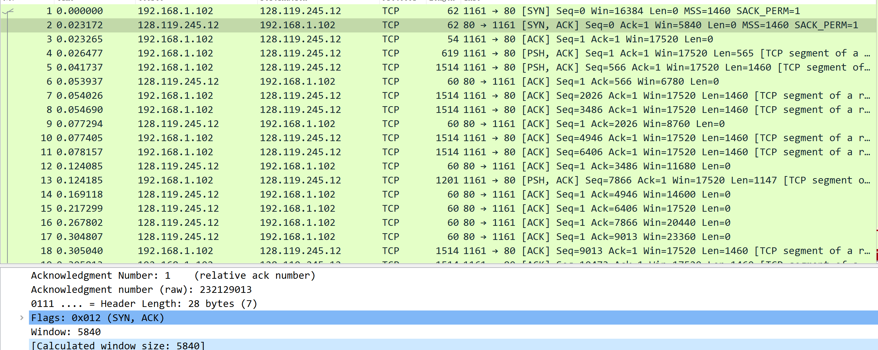

Q6.No, the sequence number never repeated.

Q7.1460, the server waits for a short time after receiving a packet. If consecutive new packets are received within this period of time, the server directly sends the ACK of the latter and ignores the ACK of the former.

Q8.Throughput=Total data transmission/The total time

=(232293103-232129013)/(5.461175-0.026477)=164090/5.434698=30193.03

Eexrcise2:

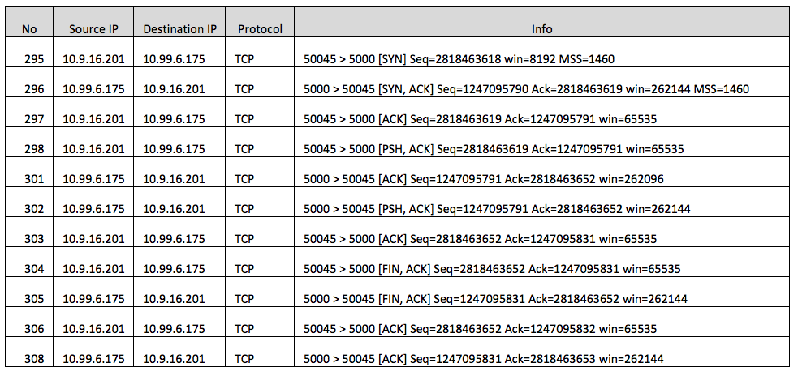

Q1.2818463618

Q2.1247095790, 2818463619, seq+1

Q3. 2818463619, 1247095791,no

Q4. Client which first sent FIN in No.305; simultaneous close

Q5. client to server:2818463653-2818463618-2=33

server to client:1247095831-1247095790-2=39

data=final ACK-Initial Sequence Number-2