Exercise1:

Q1. The maximum size of the congestion window is about 68. When the congestion window reaches this value, it went down to 1 and then to slow start because of timeout.

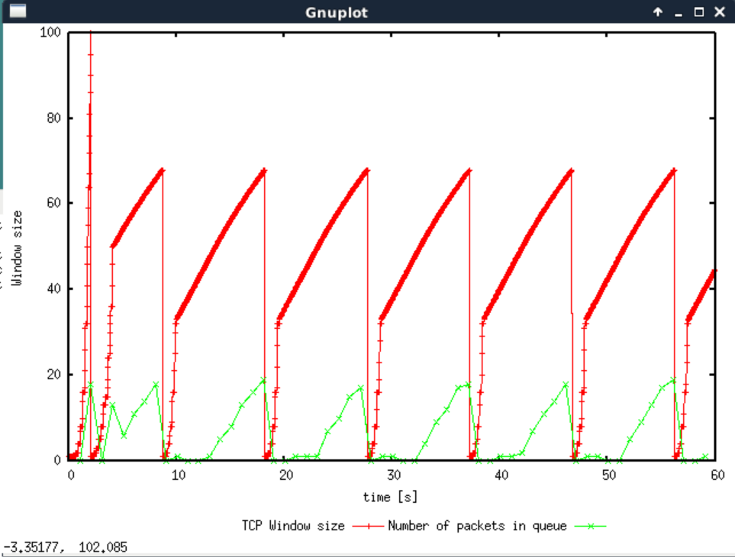

Q2. average throughput=18.5 packets per second=8880bps

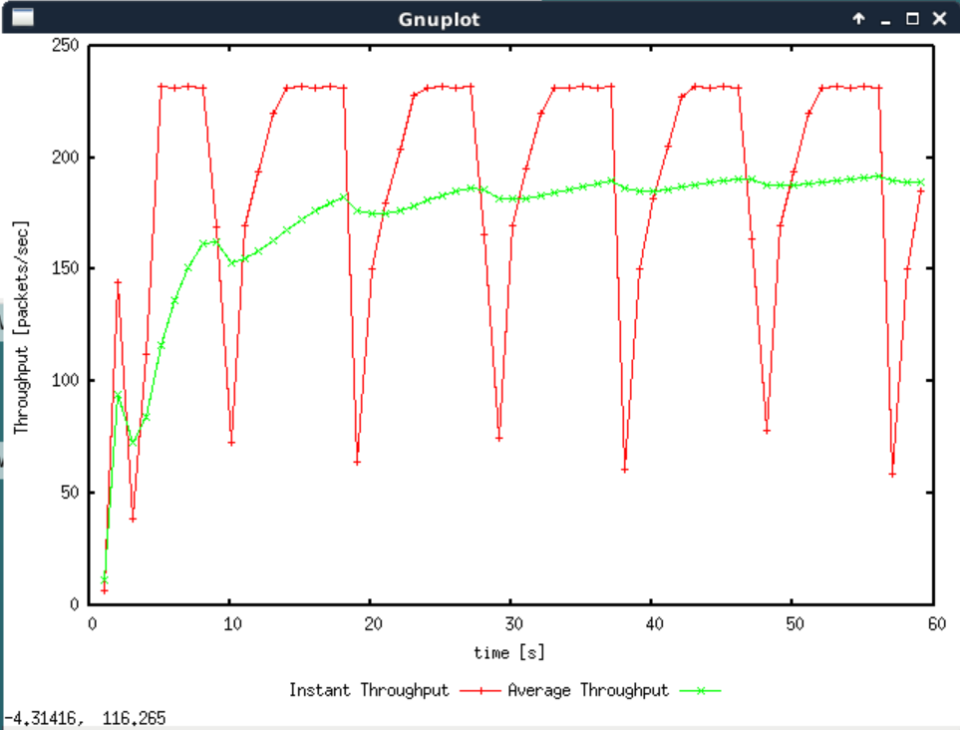

Q3. The peak window size decreases with the increase of the maximum congestion window size, and the TCP response period also decreases, and vice versa.

65,average throughput=220 packets per second=105600bps=0.1056Mbps<1Mbps

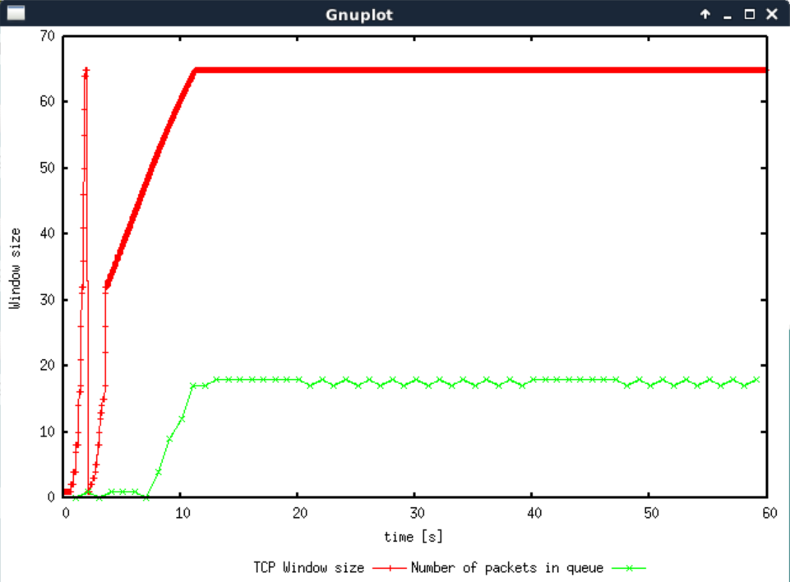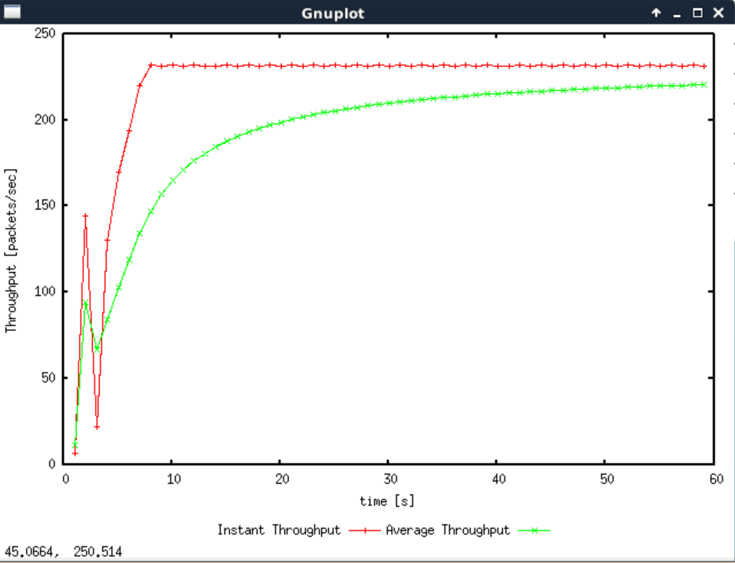

Q4. TCP slow start in TCP Reno occurs only twice at the start of a transmission while TCP slow start in TCP Tahoe always occurs in transmission period.

The average throughput in TCP Reno is significantly higher than TCP Tahoe.

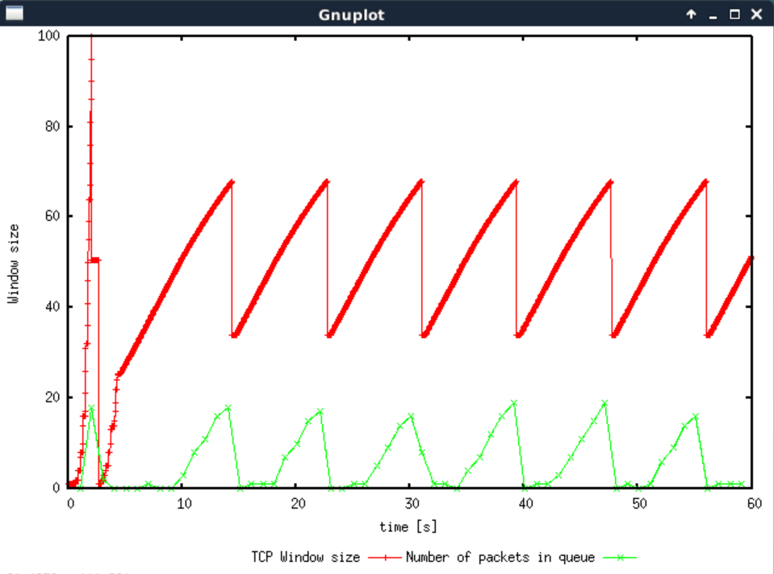 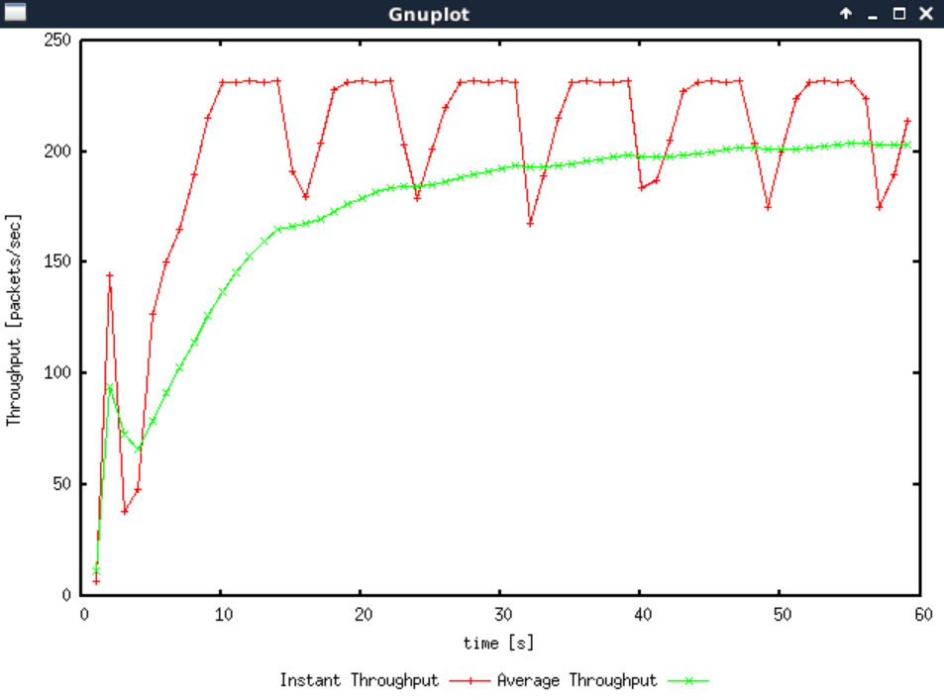

Exercise2:

Q1.Yes, when different streams use a common network connection in the same time period, their throughput fluctuates around a similar value, and the overall throughput is similar.

Q2. The average throughput of existing TCP streams is reduced accordingly.

In TCP connection, TCP always runs according to AIMD when slow start is ignored. When packet loss occurs, each stream will reduce its window by half. Finally, the loan of each stream will fluctuate along the equal bandwidth sharing curve.

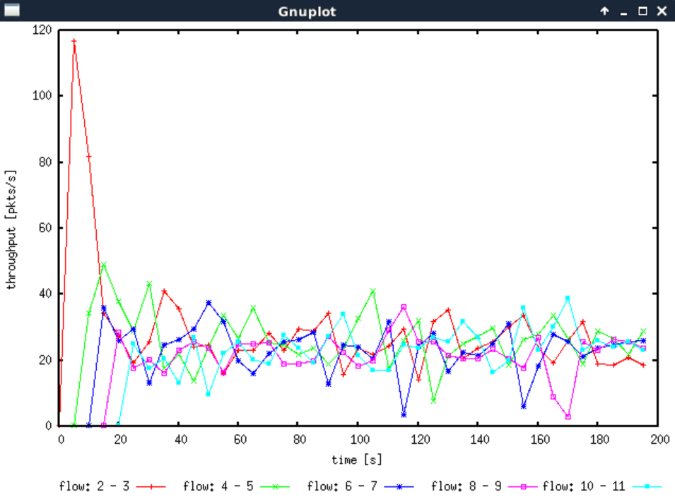

Exercise3:

Q1. TCP throughput will be significantly less than UDP

blue:TCP;red:UDP

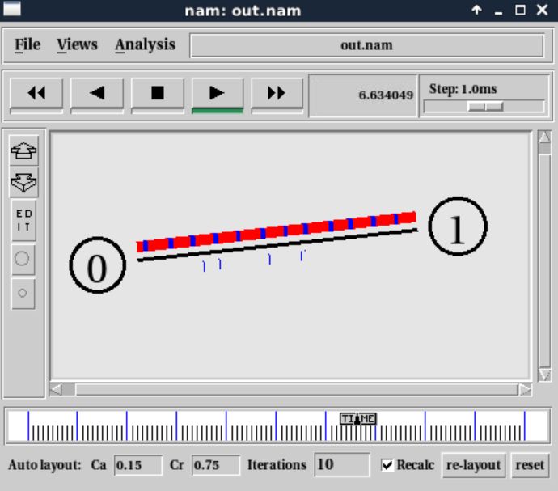

Q2. UDP has no congestion control, and streams running on UDP can be transmitted at a constant rate and allow packet loss, whereas TCP will slow down its transmission rate in the face of increased congestion.

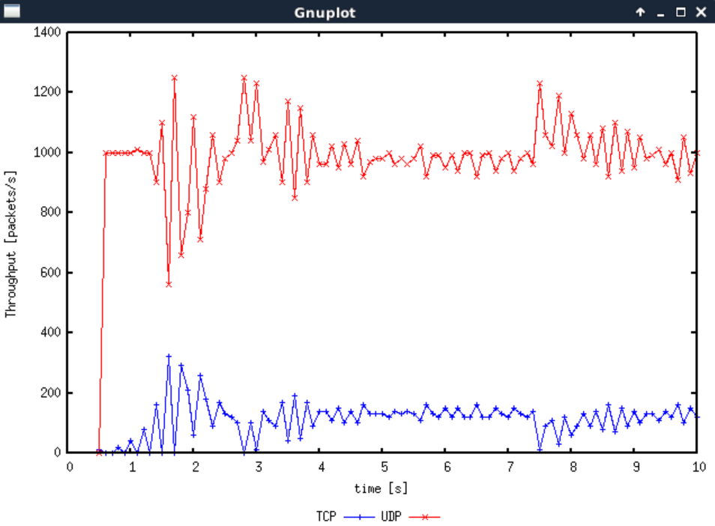

Q3.  Advantages : Fast transmission rate and safe

Disadvantages: Unreliable and unstable

The network quality may be poor, and the packet loss rate increases greatly.