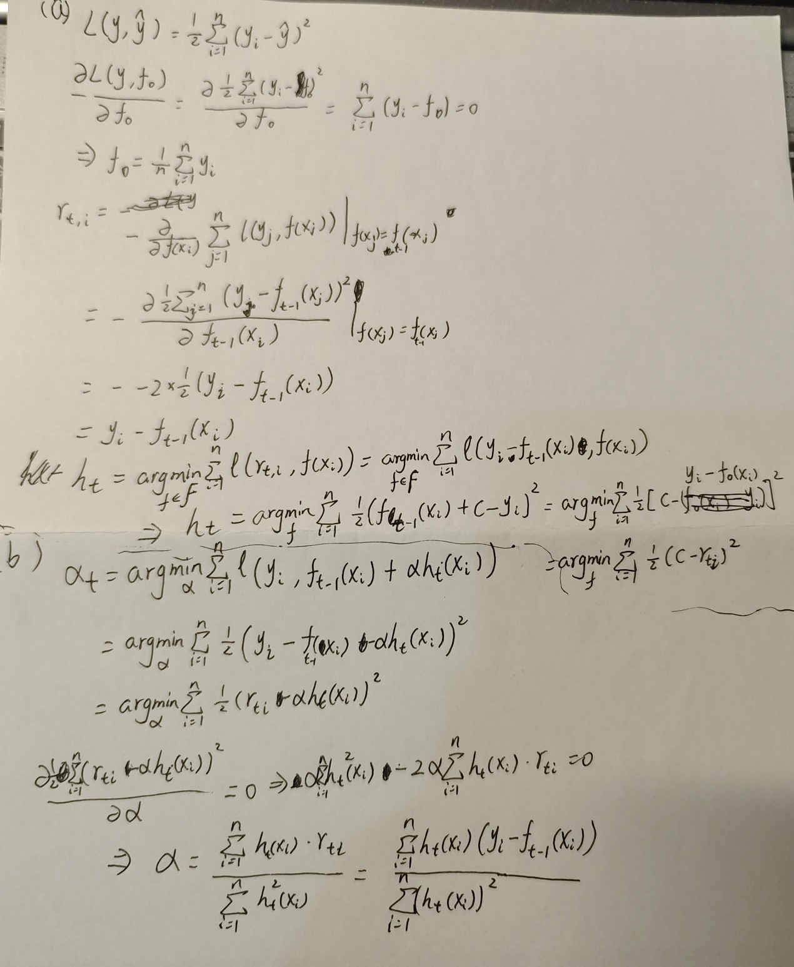

(c)

Learning rate = 0.1:

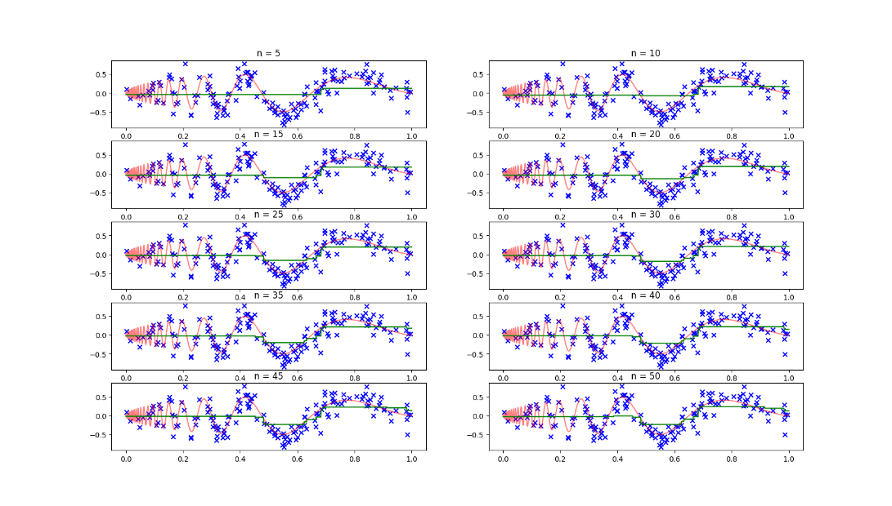

Learning rate =adaptive step size:

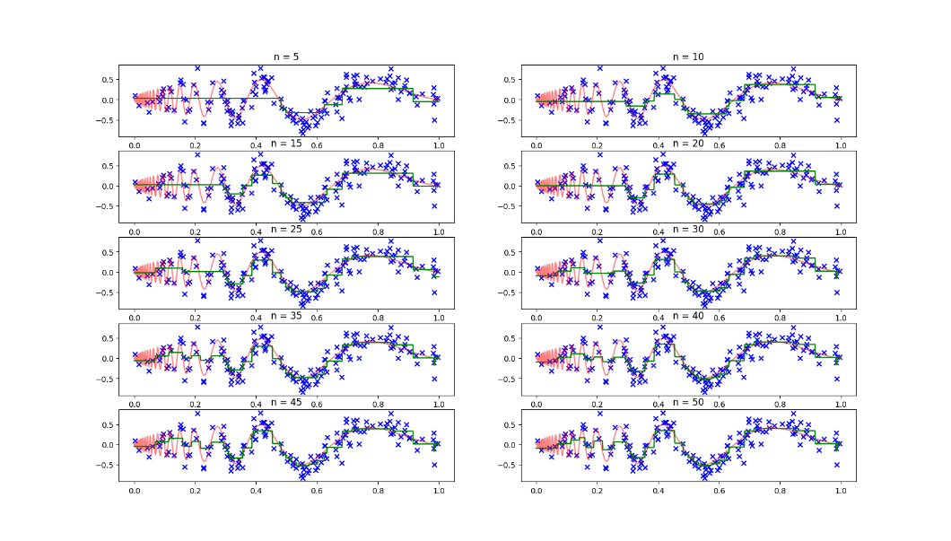

The model obtained from the adaptive step is a better fit to the data set.

The model struggles to achieve true function levels in the faster oscillating left-hand side of the data segment, but the fit is excellent in the slower oscillating right-hand side.

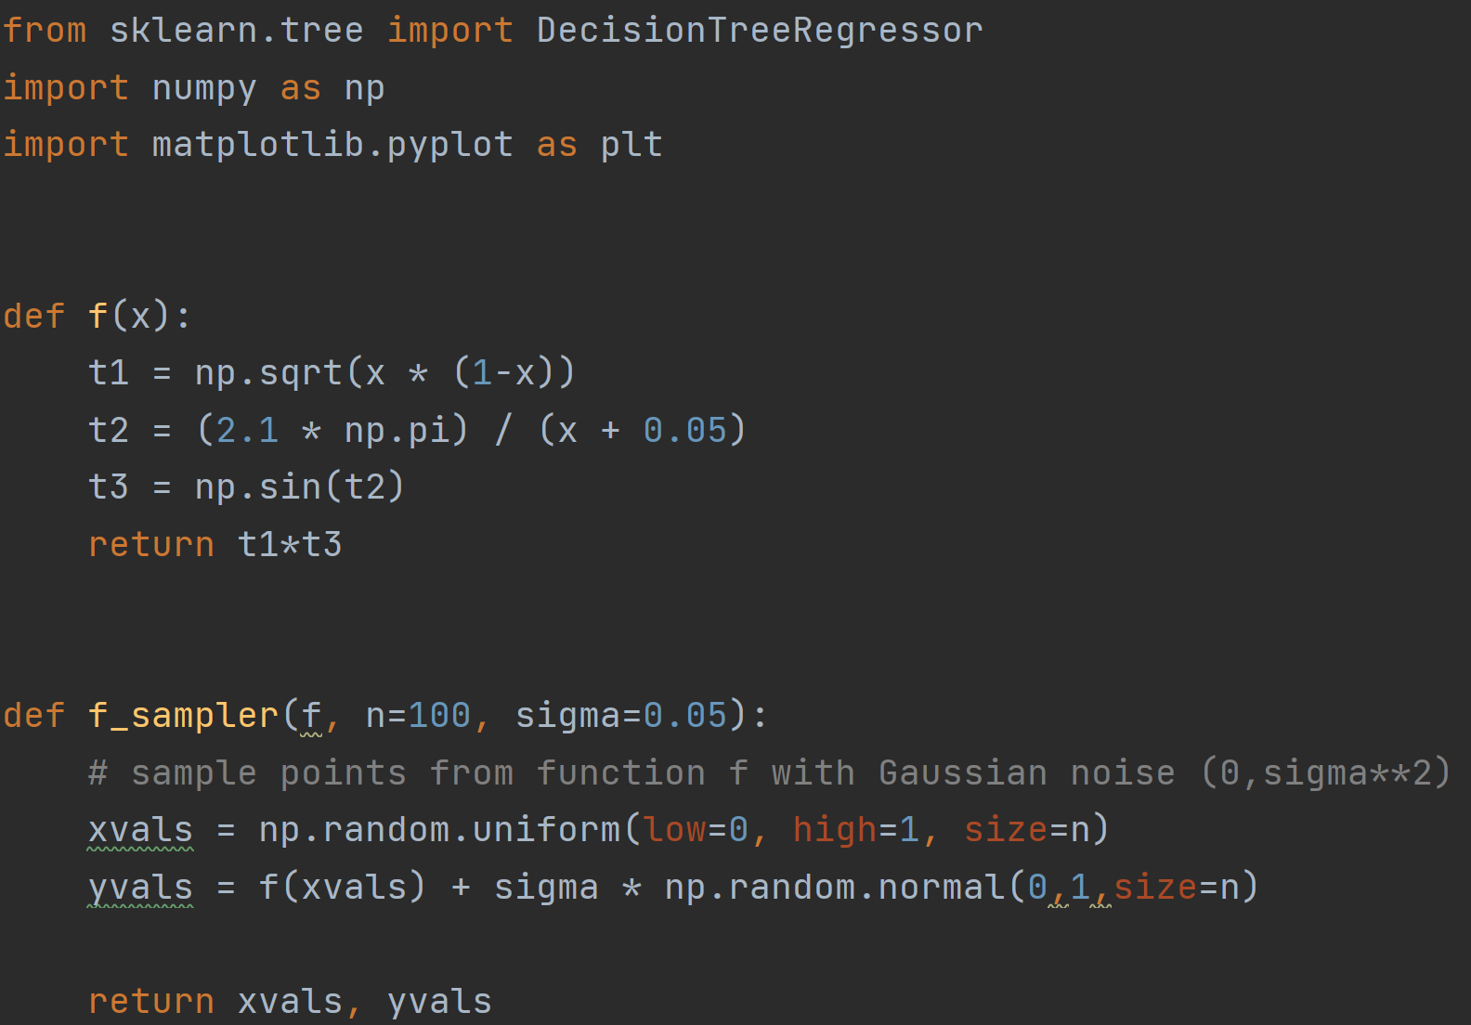

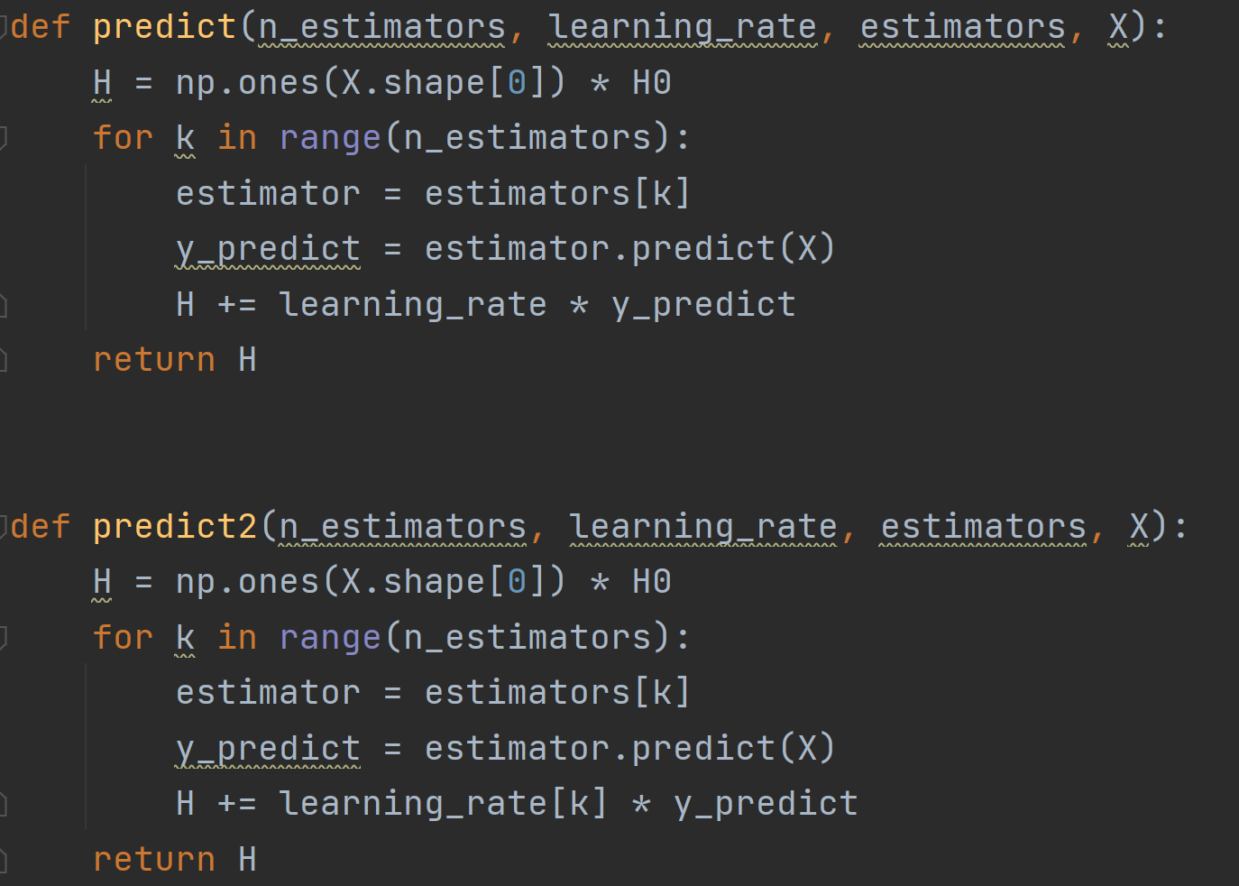 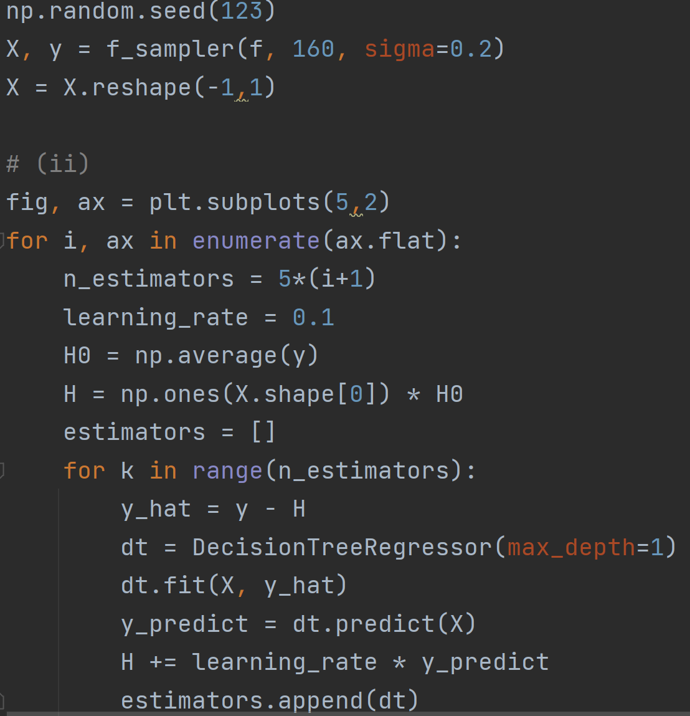 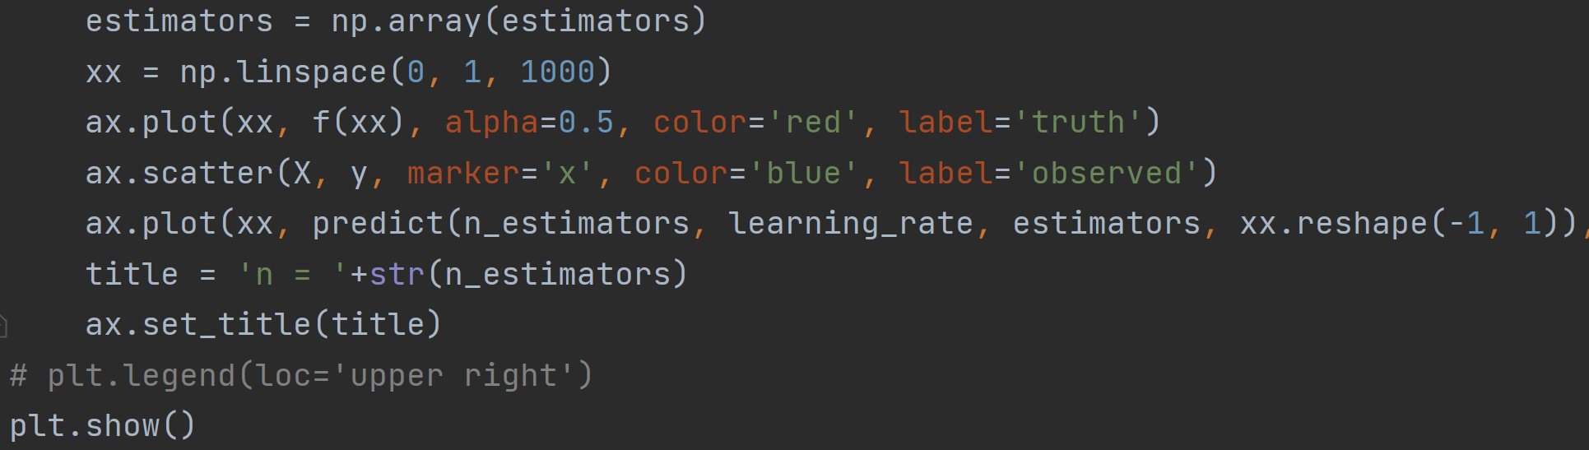 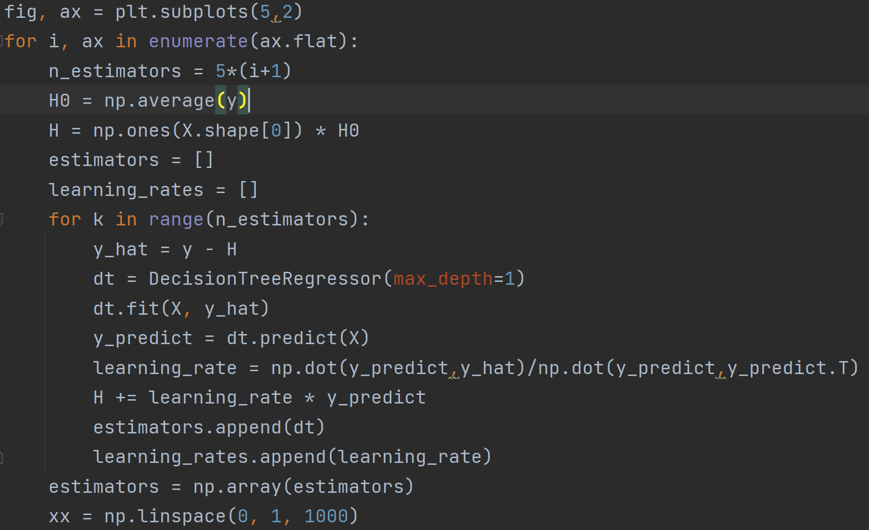 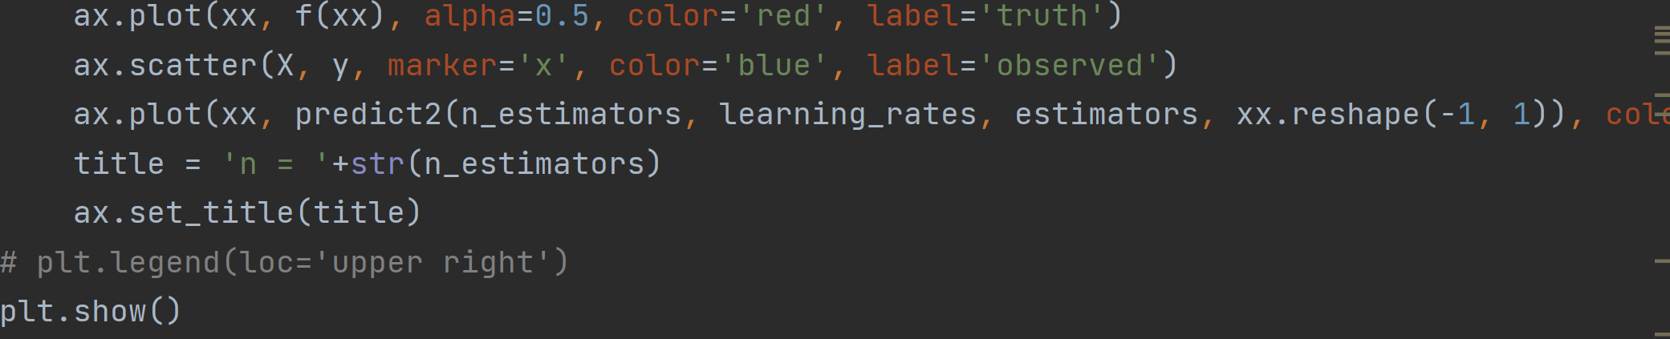

(d)

Learning rate = 0.1:

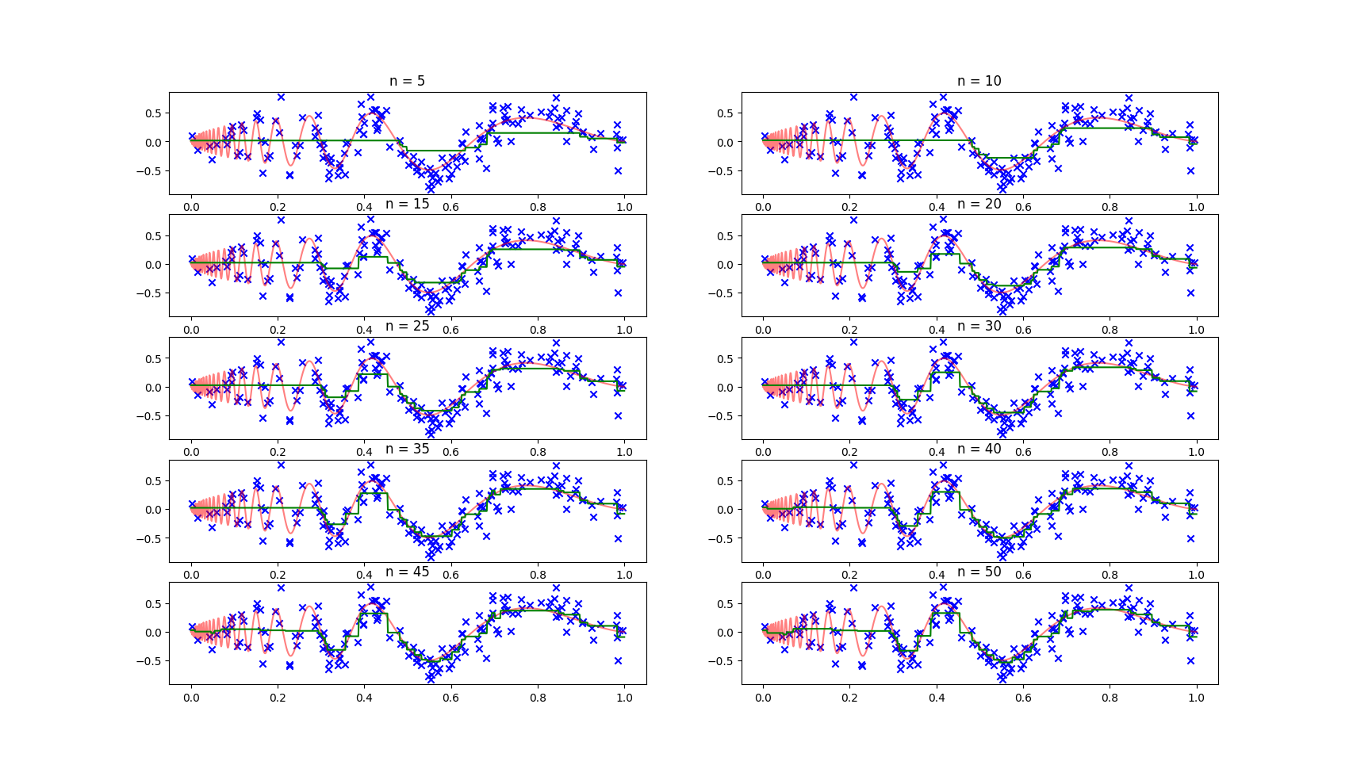

Learning rate =adaptive step size:

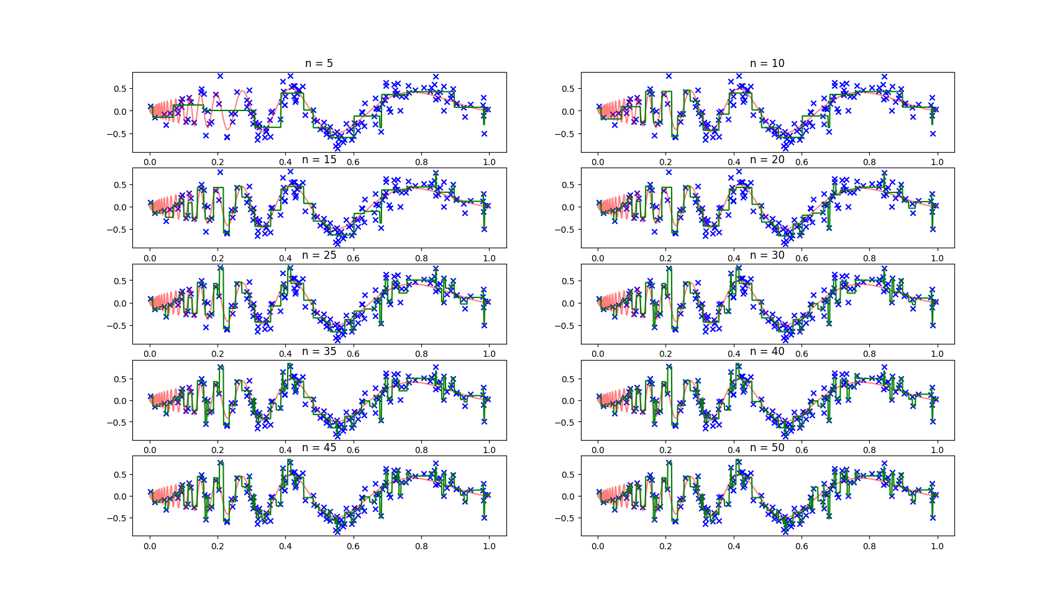

Overfitting occurs in models with adaptive step sizes, while models with fixed step sizes are relatively more consistent with the true function.

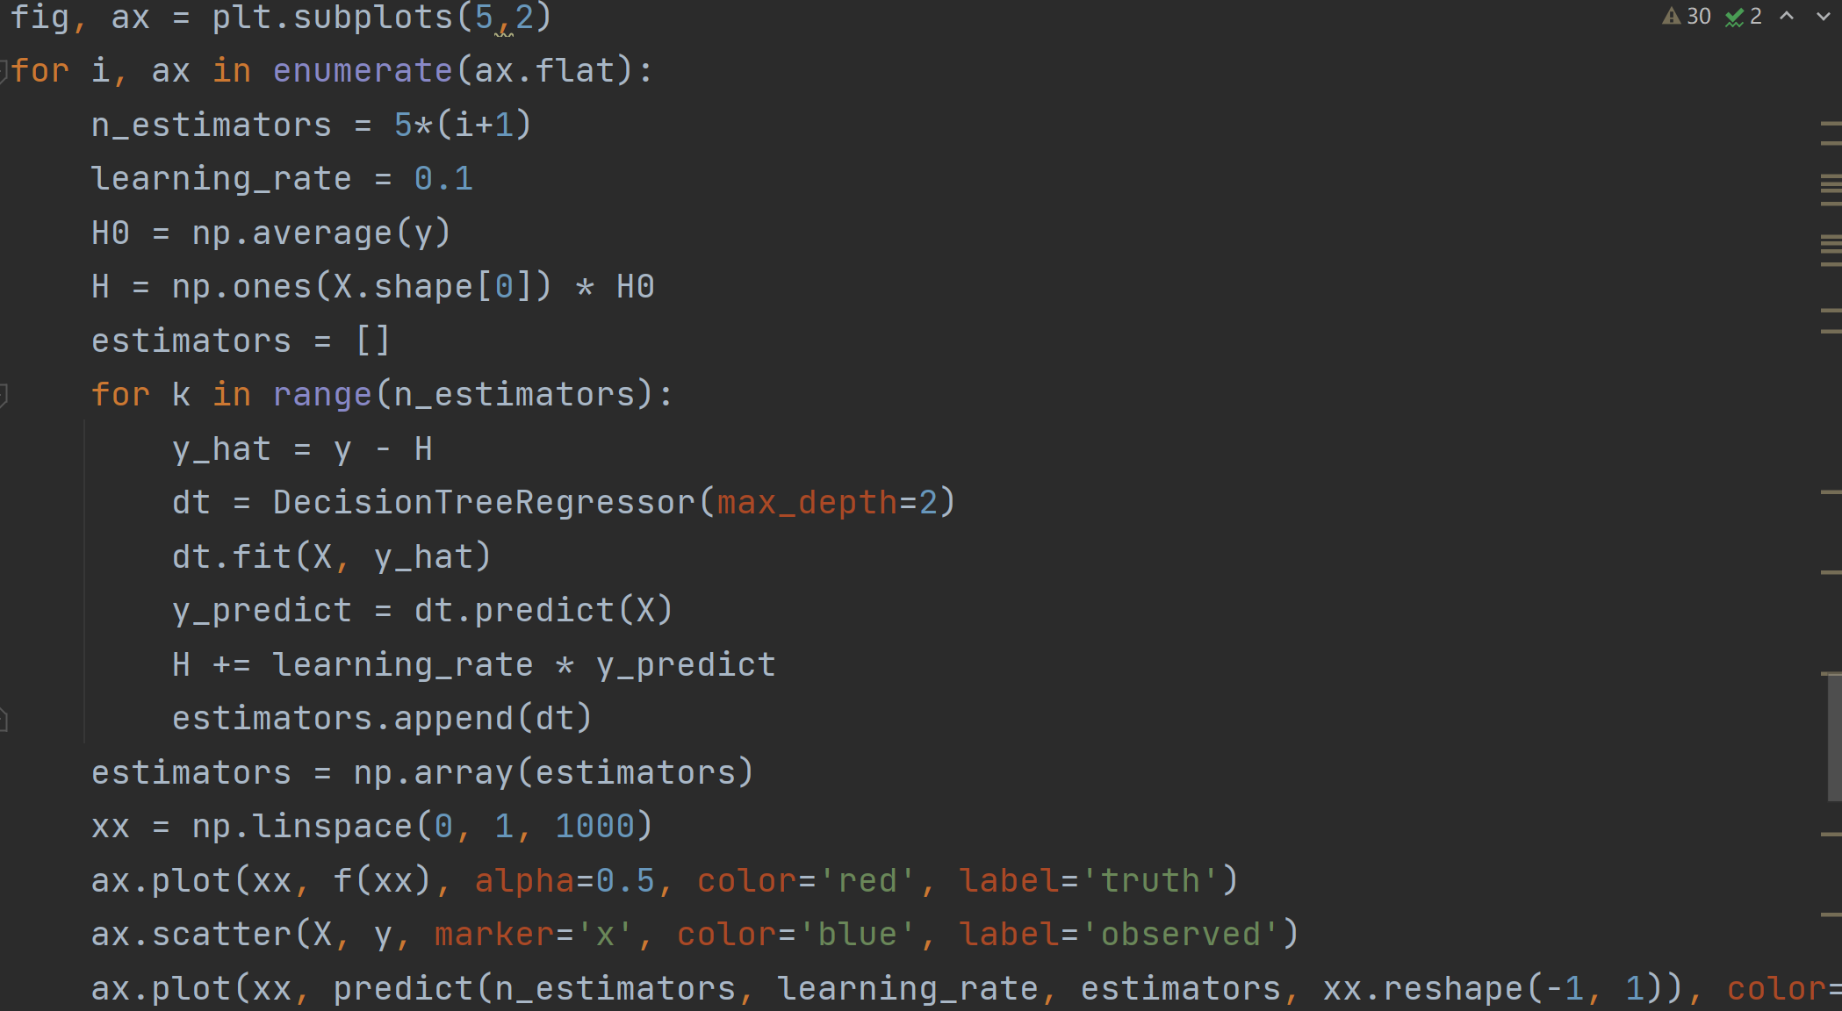 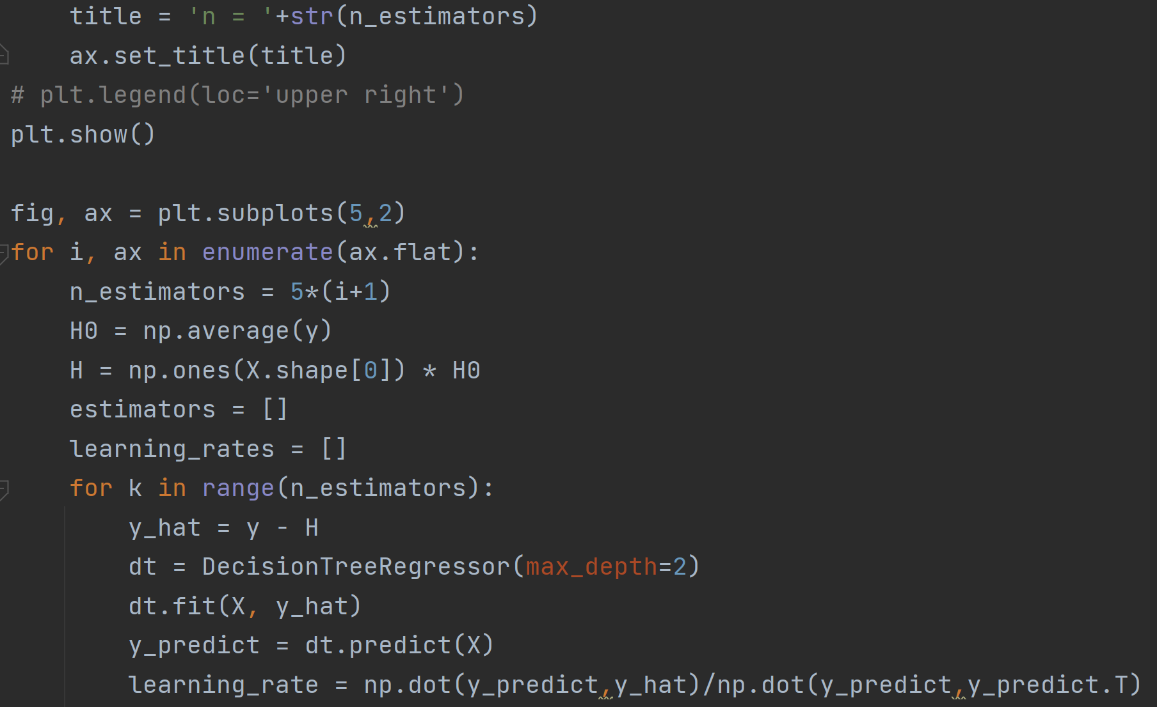 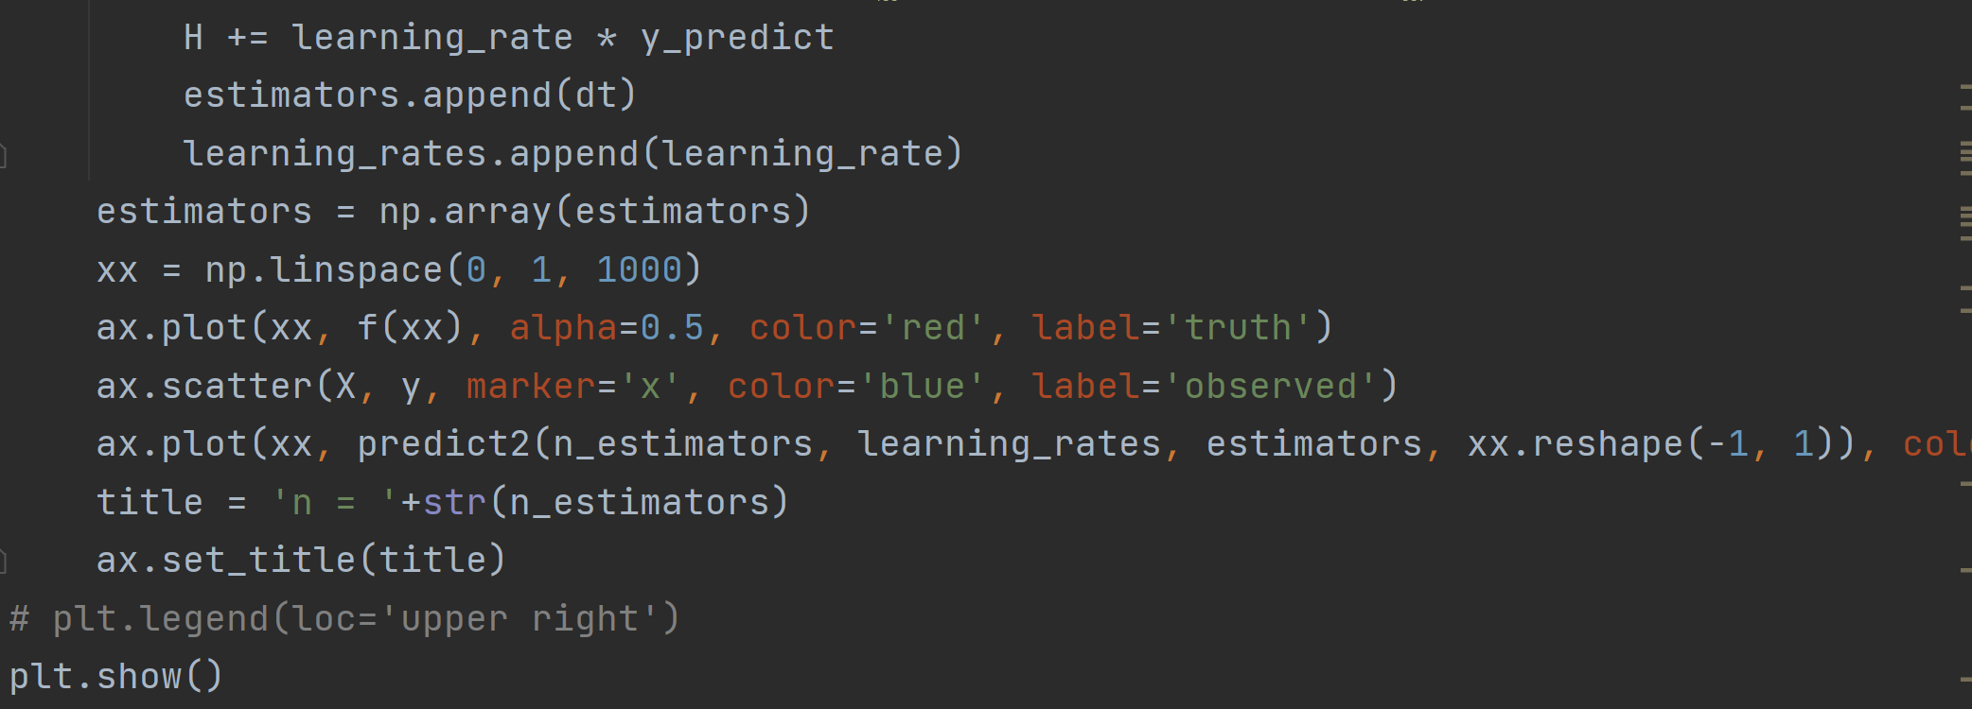

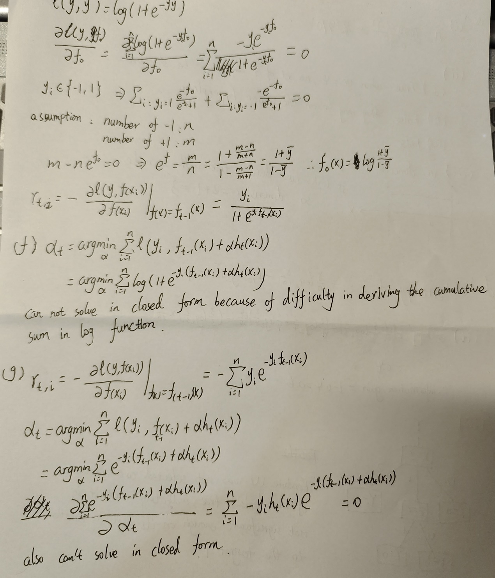

(h)

Set an initial step size and then calculate the loss function for each iteration, using the product of the step size and the difference between the loss functions between the two iterations as the new step size.

Additional calculations include the calculation of the loss function and the multiplicative iterations of the step size.