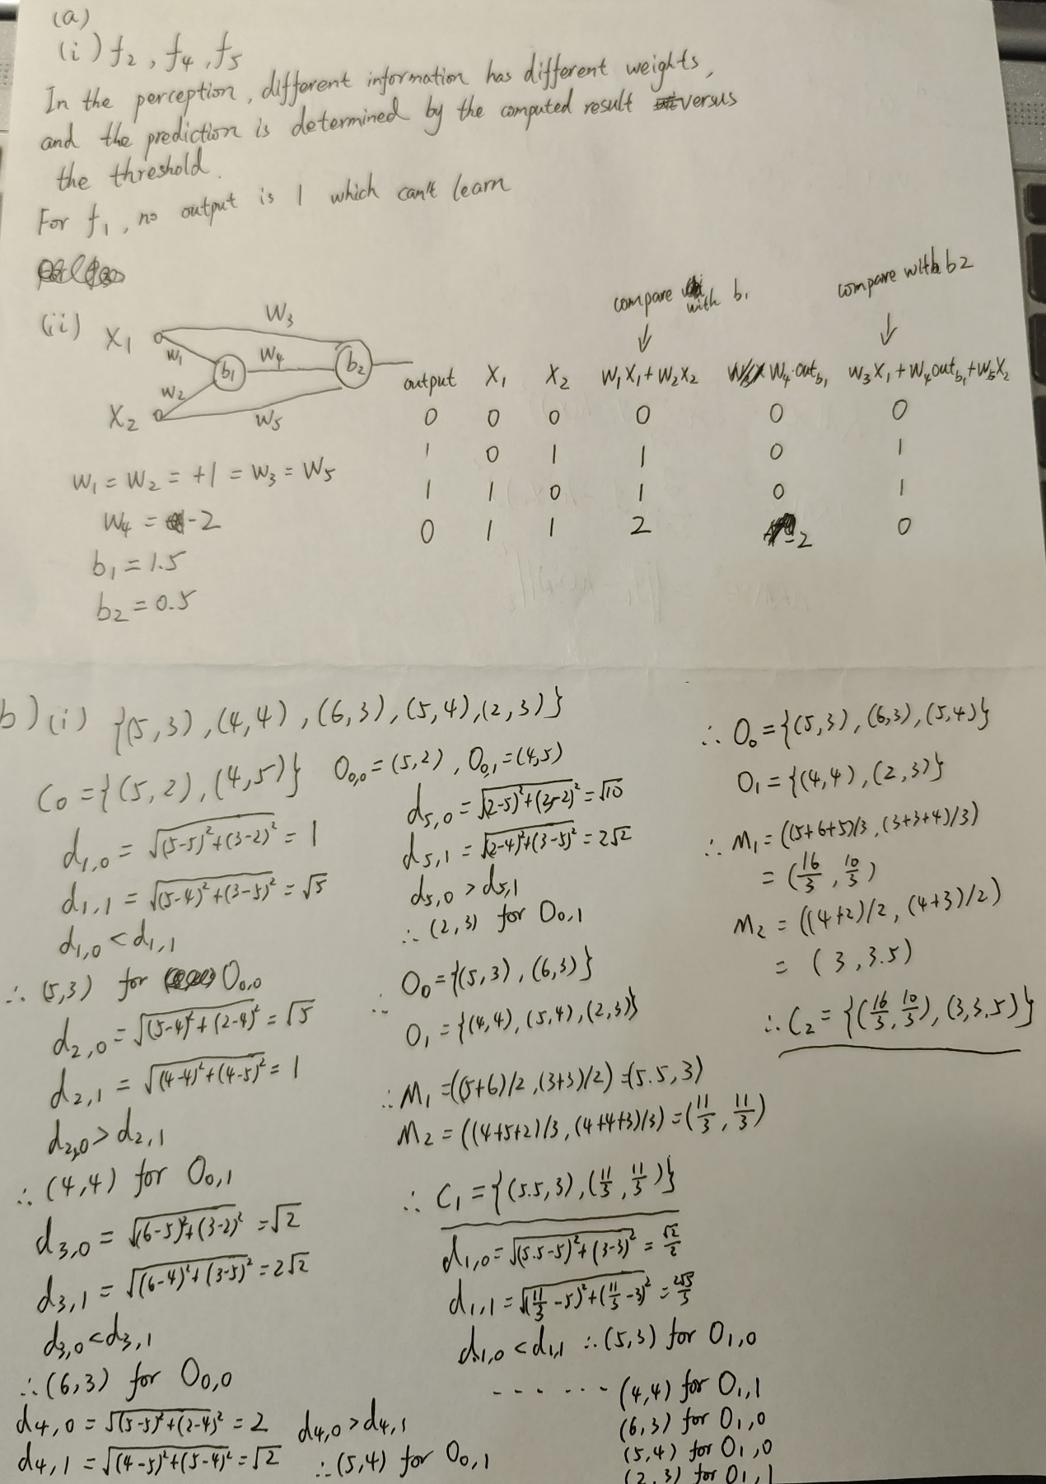

（ii）Firstly, the large number of features requires significant computational resources to calculate the Euclidean distance, and secondly, the large K values chosen make it difficult to converge the data.

