Name: Qiyao Zhou ZID: Z5379852

**Mission1: Background Estimation**

First of all, the input image I is copied as image A, and the minimum filtering is carried out in image A, then the filtered image A is copied as image B, and the maximum filtering is carried out in image B, and the obtained image B is the result of background estimation。

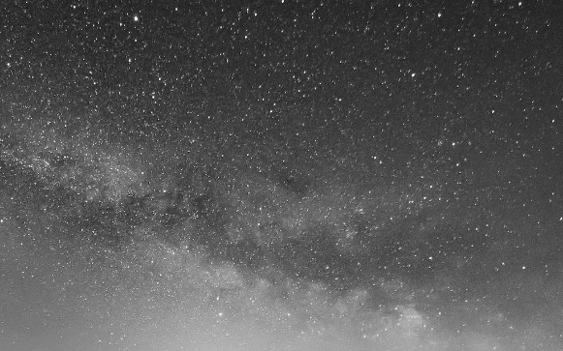sample input

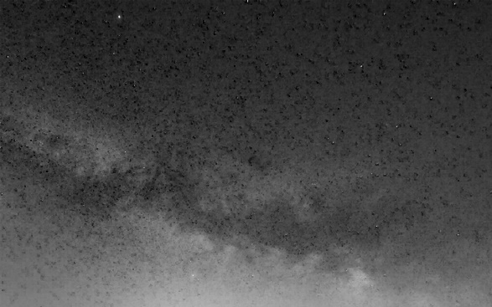image A when N =3

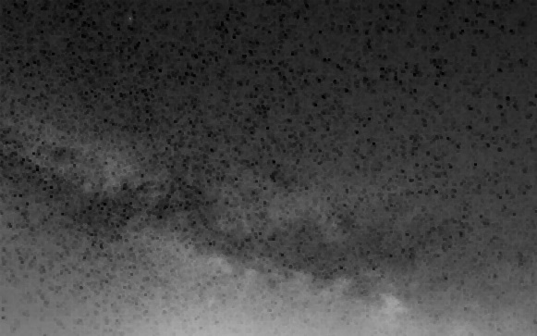 image A when N =5

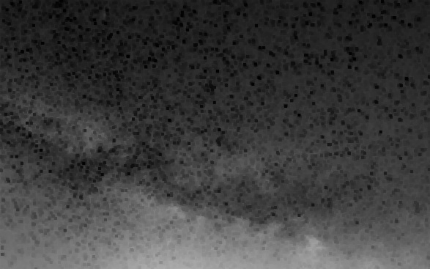 image A when N =7

When N is 3 or 5, almost no stars can be seen in image A except for the stars in the upper left corner. When N is 7, no stars can be seen at all in image A, so the minimum value of N is 7, which is related to the pixel size of A single star. When N is larger than this, the pixels that do not belong to stars may acquire small values, causing haze to appear again in image processing

**Mission2: Background Subtraction**

This task is relatively simple. You only need to subtract the gray value of the corresponding position in the image B processed in Task 1 pixel by pixel from the original image I, which can be solved by cv2.Subtract.

Here are the result of image B and output image O when N = 3,5,7 [respectively](javascript:;):

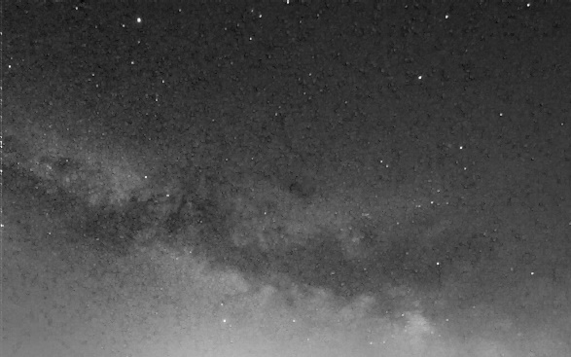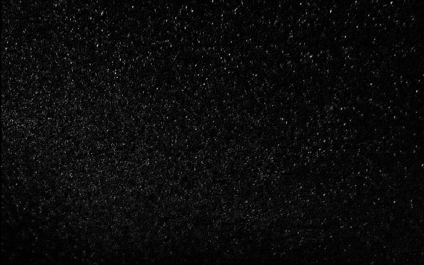

N = 3

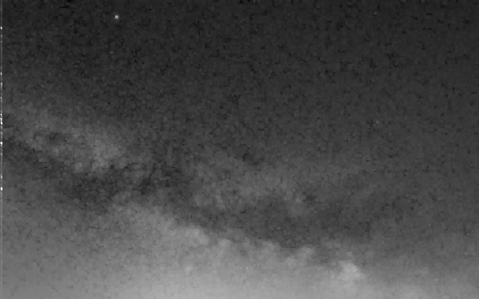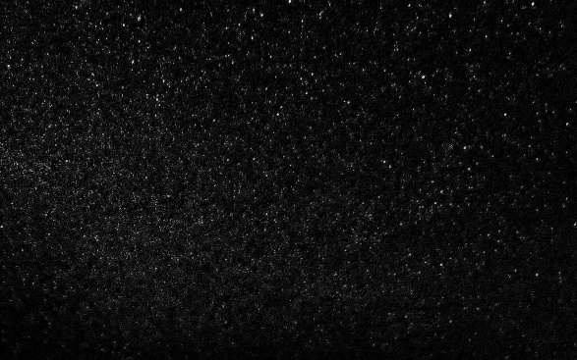

N = 5

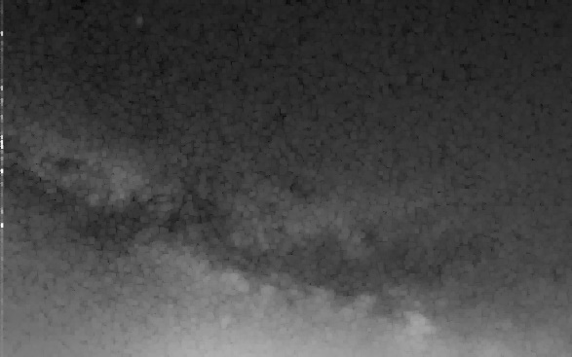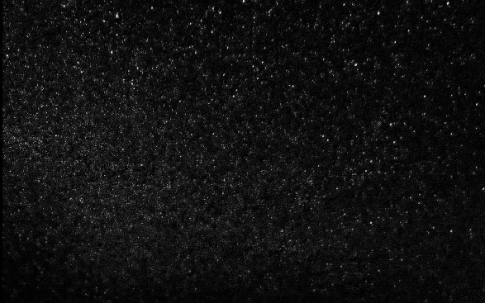

N =7

**Mission3: Algorithm Extensions**

This step is based on the above two tasks. Considering that the image background used in the previous processing is dark and the feature to be recognized is bright, while the Cells. PNG used in the extended algorithm is opposite and the feature color to be recognized is dark, some adjustments need to be made in the background estimation method. After the first largest filtering for bright color image background, minimum filtering in after background subtraction steps, because of the background for the bright color (mean gray value is extremely low near zero), if simply using corresponding grey value of the original image and the background subtraction, the result of the will and the original image difference is not big, can't achieve recognition characteristics of the function, Therefore, a brightness adjustment value of 255 should be added on the basis of subtracting the corresponding gray value of the original image and background. For any size of the input image, the maximum (minimum) filtering function is still effective, because the function is to retrieve rows and columns of the input image processing, the code in the process of generalization, users only need to modify the code at the beginning of the neighborhood size parameter N and maximum minimum filter order mode parameters M background estimation can be realized and the background subtraction, Specific to the code section is a simple condition change according to M judgment, only need an 'IF' statement to achieve.



Cells.png Output (N = 3)

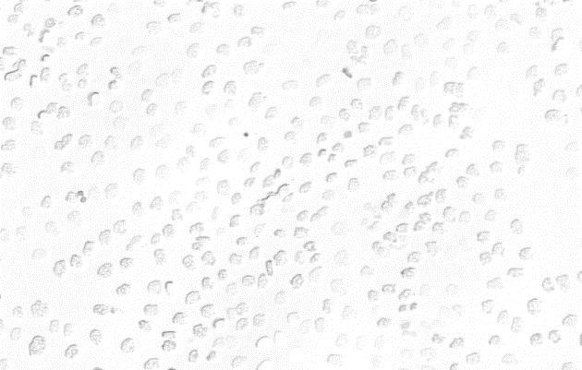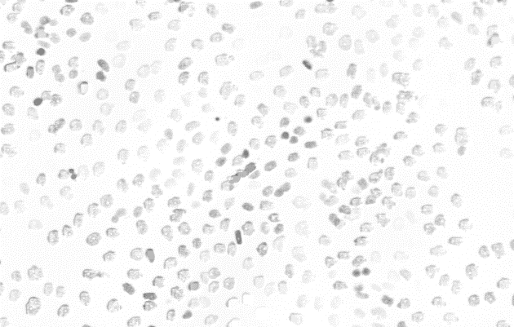

Output (N = 9) Output (N = 15)

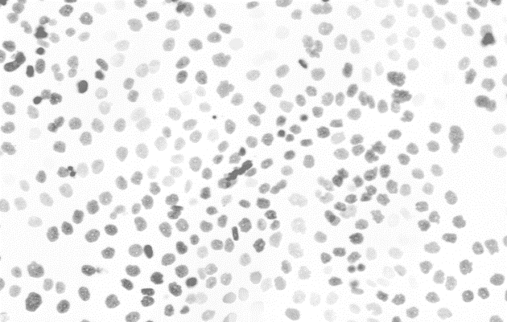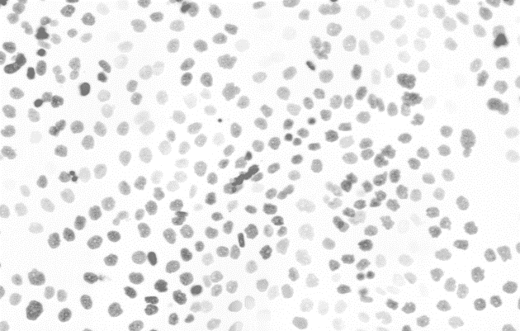

Output (N = 31) Output (N = 35)

It can be seen from the output result that the cells in the image are clear enough when N = 31 and there is almost no difference between the image at N = 35, so 31 is a good N value.

**Maximum (minimum) filtering algorithm**

Maximum (minimum) filtering algorithm in the code in the form of a function, the function of the input is bounded domain, the size of the input image and symbol (symbol of 0 represents the largest filtering model, mark 1 represents the minimum filtering mode), function first copy the input image is stored as the result image, and then for input image, function per-pixel to deal with, Firstly, all the values in the neighborhood are obtained and stored in a temporary array, and then the maximum (minimum) values in the temporary array are found and assigned to corresponding pixels in the resulting image. And the resulting image is returned as output.

**More explanation**

Explanation of why for M = 1 the subtraction requires adding 255 is in mission3. As for why M = 0 or M = 1 for the two different images, the maximum filter is sensitive to the bright spot while the minimum filter is sensitive to the dark spot. The first maximum filter will obtain the dark background, and the subsequent minimum filter can deal with the salt and pepper noise of the bright spot, which is suitable for the image processing of the dark background, and vice versa.