Name: Qiyao Zhou

Zid: z5379852

1.1

center vertex: vertex(d)

edges included in the spanning spider:

edge (a, d).

edge (b, d).

edge (c, d).

edge (d, e).

edge (e, x).

edge (x, z).

edge (y, z).

1.2

edge (X, Y): -edge (Y, X).

degree (X, Y): - vertex(X), Y= #count {Z: edge (X, Z)}.

center_acc(X): -A=#max {N: degree (M, N)}, A>=3, degree (X, Y), Y>=3.

center_acc(X): -A=#max {N: degree (M, N)}, A<3, vertex(X).

1 {center(X): center_acc(X)} 1.

1.3

leg (X, Y): - edge (X, Y), center(X).

leg (X, Y): - leg (Z, X), edge (X, Y).

1.4

reachable(X): -center(X).

reachable(X): -leg (Y, X).

: - vertex(X), not reachable(X).

1.5

degree_leg (X, Y): - vertex(X), Y= #count {Z: leg_guess (X, Z)}.

: - vertex(X), degree_leg(X, Y),Y>2, not center(X).

1.6

See file spider.lp.

Use command like: clingo –models 0 sample.lp spider.lp

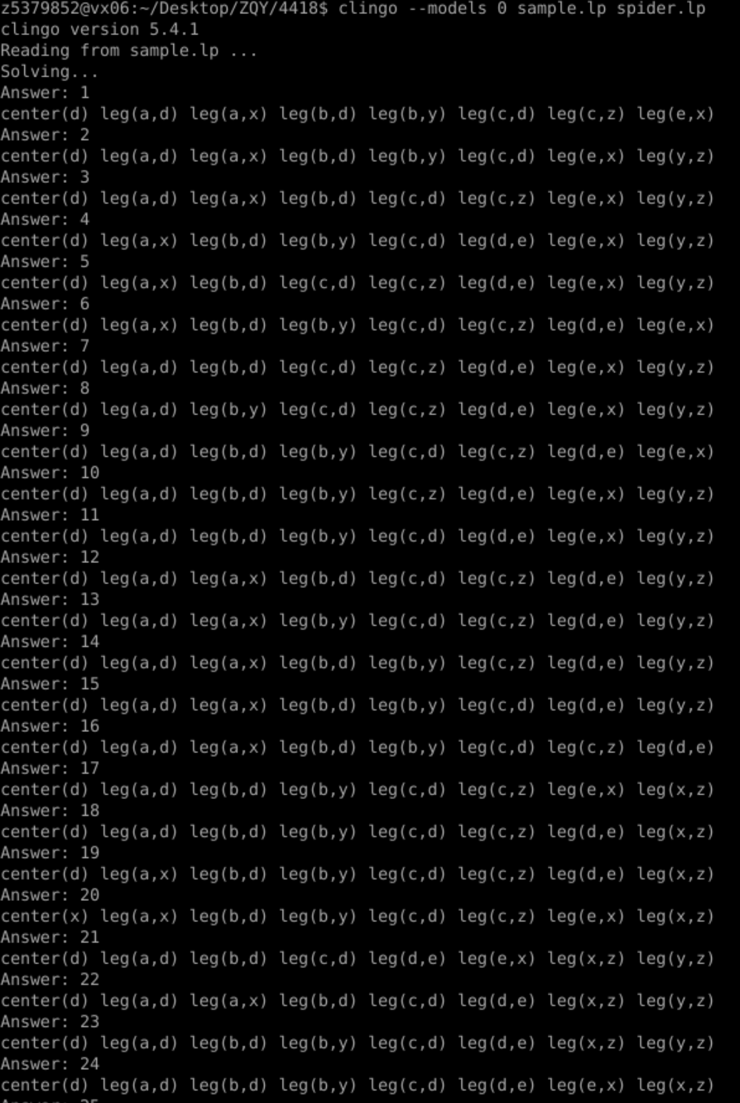 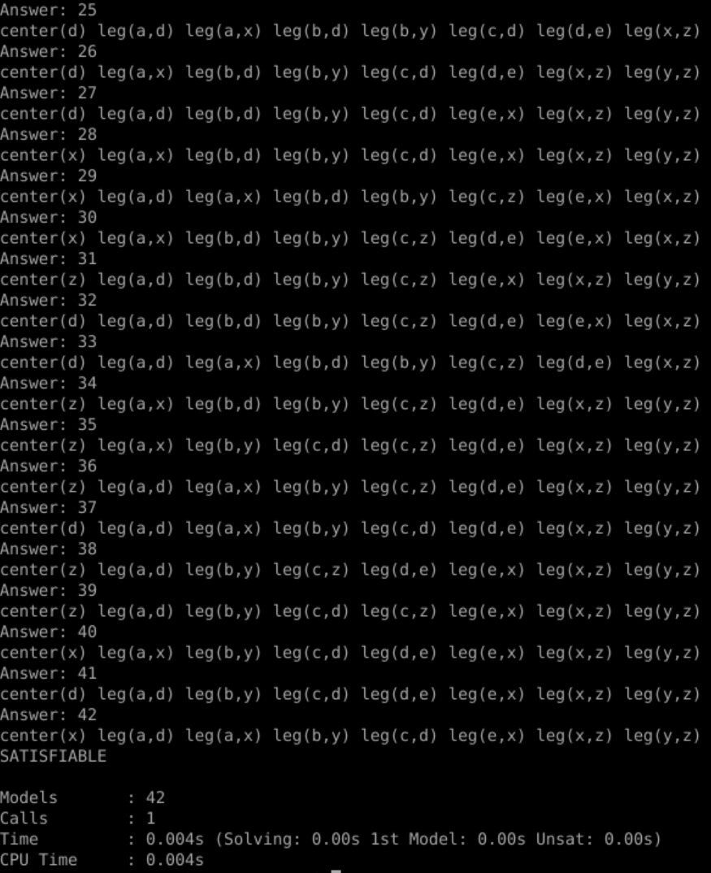

It can be seen that there are 42 distinct spanning spiders in Figure 1.

1.7

See file spidershortlegs.lp

Use command like :clingo --models 0 sample.lp spidershortlegs.lp

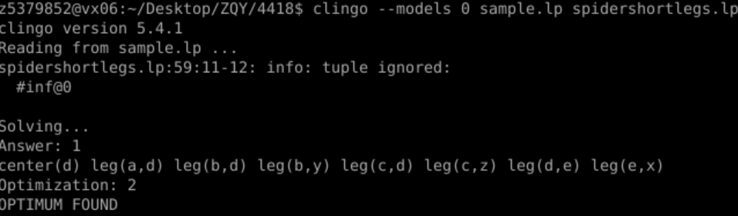

Here is the result of sample.