**Qiyao Zhou**

**Z5379852**

**Question 1**

We begin by constructing a flow network using the input data. The network is showed in the diagram below:

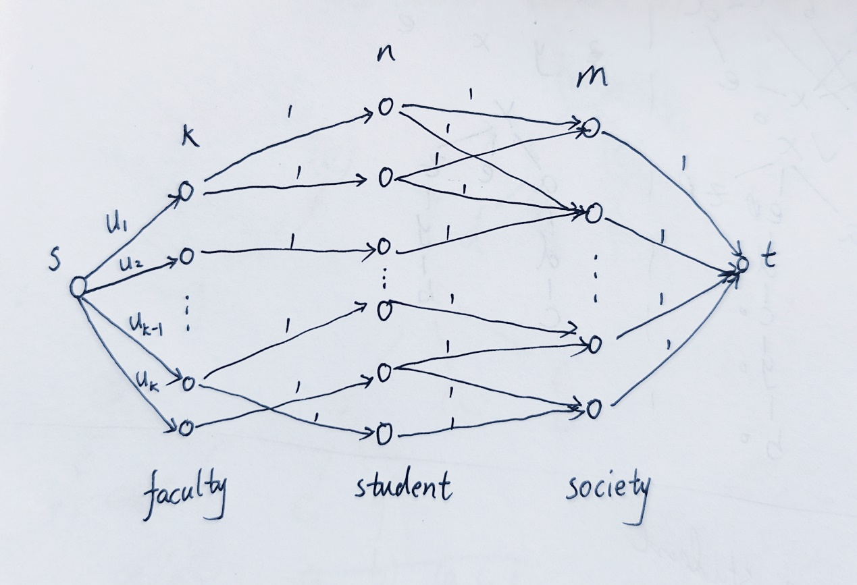

* source s and sink t,
* The combinations of vertices from left to right represent faculty, students and societies in that order,
* connect s to each faculty vertex(i) with capacity equal to $u_{i}$,
* The student vertices are connected to the corresponding faculties and societies according to the input, with a capacity of 1 for all connections,
* connect each society vertex to t with capacity equal to 1.

From this flow network construction, we run Ford-Fulkerson to find the maximum flow. If the maximum flow is less than m, then we output “no solution”. Otherwise, a selection is possible. We can deduce a selection of students by examining which of the student vertices are in the max flow. If student vertex i is in the max flow, then the student i is selected to attend the event.

The time complexity is O(|V||F|) where V= k+m+n+2 and F <= 3m+k <= 3m+n, so the algorithm runs in O(nm).