**Qiyao Zhou**

**Z5379852**

**Question 2**

2.1 We begin by constructing a flow network using the input data. The network is showed in the diagram below:

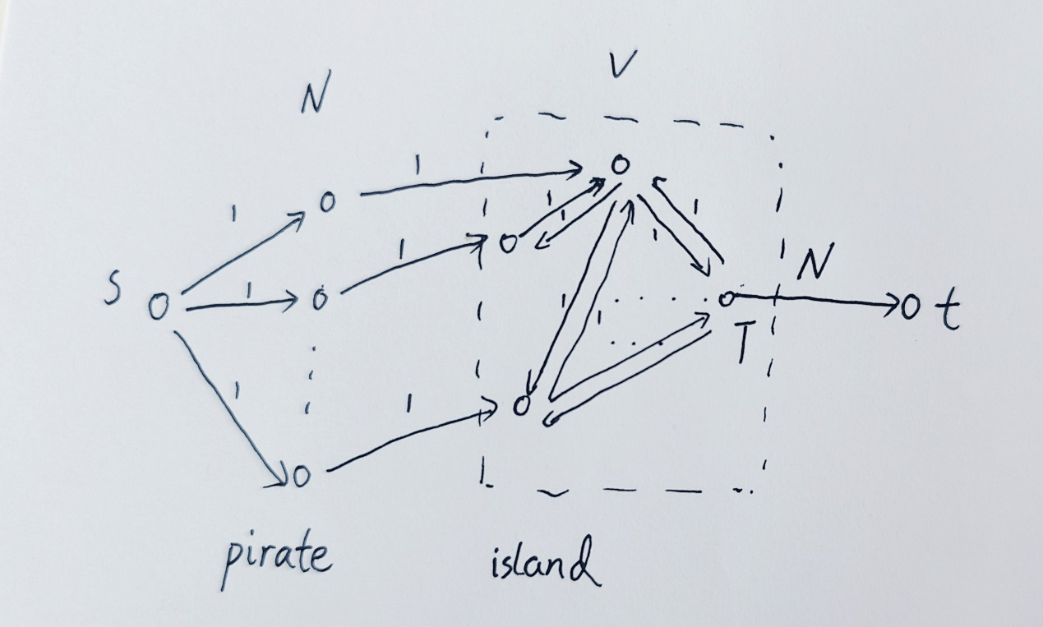

* source s and sink t,
* the combinations of vertices from left to right represent pirate and islands,
* connect s to each pirate vertex with capacity equal to 1,
* connect each pirate to their initial island vertex with capacity equal to 1,
* for each route ($u_{i},v_{i}$), connect $u_{i}$ to $v_{i}$ and $v_{i} to u_{i}$ with capacity equal to 1,
* connect the designated island T to t with capacity equal to N.

From this flow network construction, we run Ford-Fulkerson to find the maximum flow. If the maximum flow is less than N, then we output “no solution”. Otherwise, it is possible for every pirate to reach the designated island.

The time complexity is O(|Vertex||F|) where Vertex=V+N+2 and F <=2N+2E+1, so the algorithm meets the time requirement.

2.2 According to the maximum flow obtained in 2.1, each island vertice can be traversed and its out-degree counted, if there exists an island i with out-degree ${OD}_{i}$ greater than $S_{i}$,then it is not possible for every pirate to reach the designated island now.

In terms of time complexity, the time complexity of 2.1 is considered as O(NE), while the time complexity of the traversal comparison is less than O(VE), which generally meets the time complexity requirement.

2.3 Similarly, the same method as in 2.1 and 2.2 can be used as required by the question, with the slight difference that here the solution for V times the maximum flow needs to be performed, i.e. each time a different island vertice is set in the original graph connected to t with capacity set to N. Then if the maximum flow obtained - is N and has out degree ${OD}_{i}$ <= $S_{i}$ for all vertices i, then the set of islands chosen for the term is valid, otherwise it is not.

The time complexity is VO(NE)= O(VNE), meet the time requirement.