

**COMP9900 Information**

**Technology Project Car Space Renting System Group Report**

**9900-F17A-Let’s quit**

|  |  |  |  |
| --- | --- | --- | --- |
| Name | zID | Email | Role |
| Qiyao Zhou | z5379852 | z5379852@ad.unsw.edu.au | Back-end Developer |
| Yuanwei Zhao | z5355526 | z5355526@ad.unsw.edu.au | Back-end Developer |
| Chengxuan Han | z5334537 | z5334537@ad.unsw.edu.au | Front-end Developer |
| Buwei Sun | z5334540 | z5334540@ad.unsw.edu.au | Front-end Developer |
| Hanbo Jiang | z5353088 | Z5353088@ad.unsw.edu.au | Back-end Developer |

Submission Date: 04/08/2023

Table of Contents

1. Overview..................................................................................................... 3

1.1. Background...................................................................................... 3

1.2. Software Architechture.....................................................................4

2. Functionality…………................................................................................ 5

2.1. User authentication…..:.............................................................. 5

2.2. Personal profile........................................................................... 7

2.3. Find a Spot……………………………………………………….…..7

2.4.My spots………………………………………………………….…..10

2.5. My bookings………………………………………………………...10

2.6. My wallet…………………………………………………………….11

2.7.Invite Friends……………………………………………………...…11

3. Third Party Function…………………………………………………………...12

3.1. Front End.………………………………..………………………….12

3.1.1 React JS………………………………………….……….12

3.1.2 Material UI.………………………………….…………….13

3.1.3 The libraries and dependencies we used……...……..15

3.2 Back End……………………………………….……………….……13

3.2.1 Spring Boot…………………………………………..…...13

3.2.2 Mybatis…………………………………………..….…….16

3.2.3 Tools related to Java development………………….…16

3.3 Database Enumerate.…………………………………..……..……17

3.3.1 mySQL database.………………………………….…….17

3.3.2 Caching Database………………………………….……18

4.Challenges.…………………………………………………………….….…….19

4.1 Team collaboration………………………………………….………19

4.2 Front-end Challenges..……………………………..……….………20

4.3 Back-end Challenges………………………………………..………20

4.3.1 Pre-construction of project.………………………………20

4.3.2 Application of the redis..…………………………………20

4.3.3 Backend debugging.…………………………………….20

5.User documentation …………………………………………………..………..21

**1.Overview**

**1.1 Background**

As urban populations continue to surge at an unprecedented rate, the pressing issue of inadequate parking spaces has become a pervasive problem in society. This growing demand for parking spots has led to a significant disparity between supply and demand, posing challenges for both car owners and parking lot providers alike. Consequently, the current parking situation in urban areas presents several critical challenges that require immediate attention and effective solutions.

To tackle this burgeoning issue, one viable and innovative solution is to implement a web-based car space renting system, designed to maximize the utilization of underutilized parking spaces. By creating an efficient and user-friendly online platform, parking lot providers can list their available spaces for rent and manage them more effectively. Simultaneously, this system empowers consumers to easily search for and book their desired parking spaces conveniently through the web.

Our car space renting system allows easy registration, login, and logout. Administrators can manage all parking space information for quality control. Consumers can search and book parking spaces based on their preferences, with transparent pricing and a flexible cancellation policy.

Additionally, the Car Parking Space Web introduces two novel features. Existing users have the option to invite new users to the platform. Upon a successful invitation, both the new and existing accounts will receive a cash reward, promoting user engagement and community growth. Furthermore, after completing an order, consumers can provide valuable feedback and rate the parking space they used. This feature encourages transparency and accountability among parking space providers and helps future consumers make well-informed decisions.

**1.2 Software Architechture**

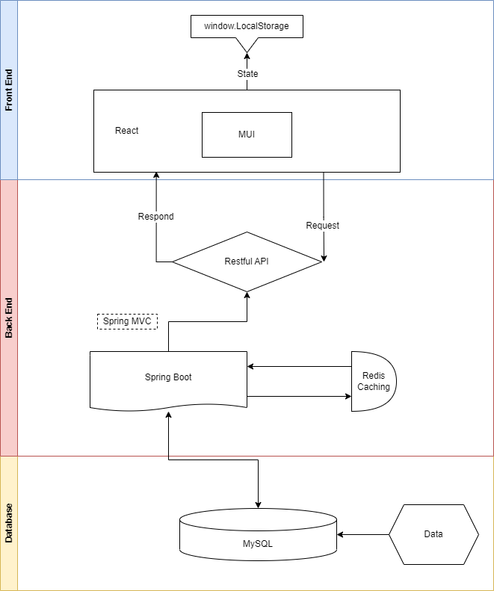

**2. Functionality**

The website we made allows users to release their own parking spaces to earn money, rent other people's parking spaces, and evaluate orders after registration.

**2.1 User Authentication**

For all users, they need to sign up first and sing in to use our website. They need to provide their name, email, password, birthday and the friend who invited them which is optional. And after create account successfully user can log in using their name and password they will be able to access all the features of the system:

1. Users can go to their profile page to view their profile.
2. Users can change their profile and password.
3. Users can release their car spaces to earn money.
4. Users can view all the car spaces they released and edit or delete them.
5. Users can find all the car spaces using the filter we provided and rent them.
6. Users can go to the wallet page to check their balance and top up their account.
7. Users can go to their booking page to check their order and cancel their order.



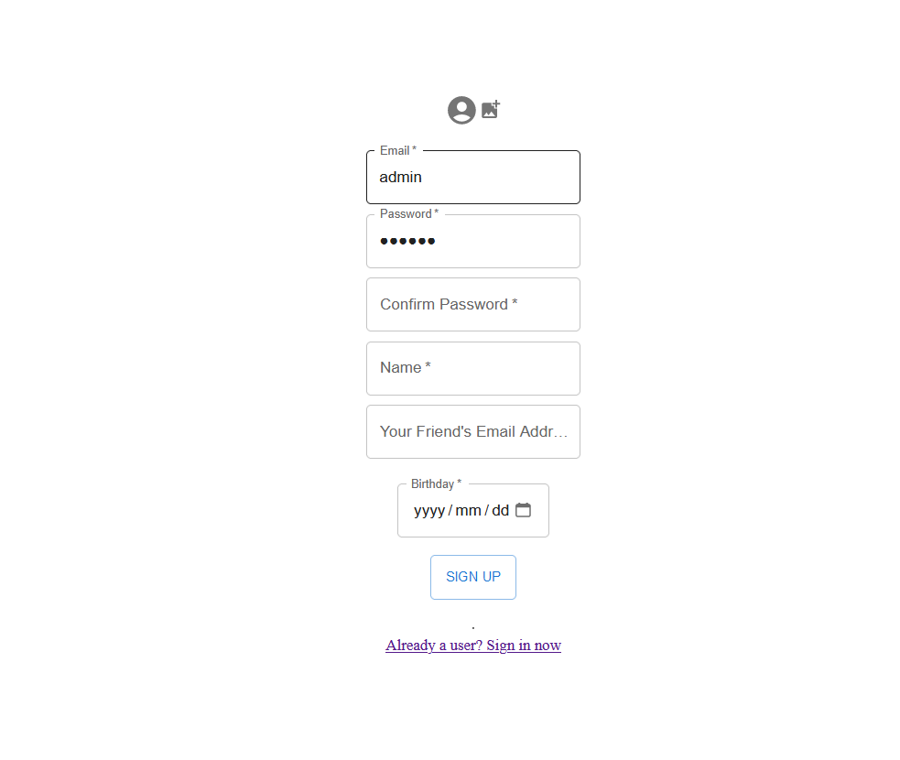

**2.2 Personal profile page**

On this page, users can view their account information, including passwords, which are hidden at first and will be displayed after clicking the 'eye' button. And you can edit and modify your personal information on this page

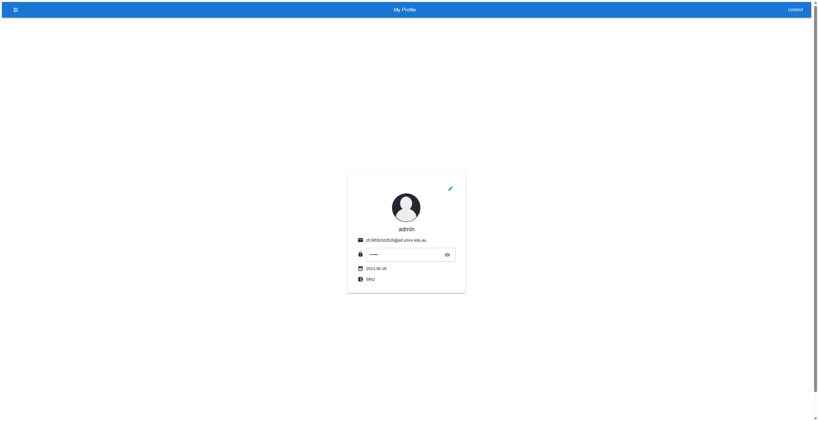

**2.3 Find a spot page**

Users can view all released car spaces through this page, and can search through the search box on the upper left, and sort all parking spaces by distance or price. And if the address of all parking spaces is correct (not scribbled by yourself), the parking spaces will be displayed on the Google map on the right. At the same time, the map will also show your location. Users can click to view the detailed information and comments of the parking space and rent this parking space. Users can choose the time period for renting a car space, and the start date of the car rental space cannot be selected later than the end date.

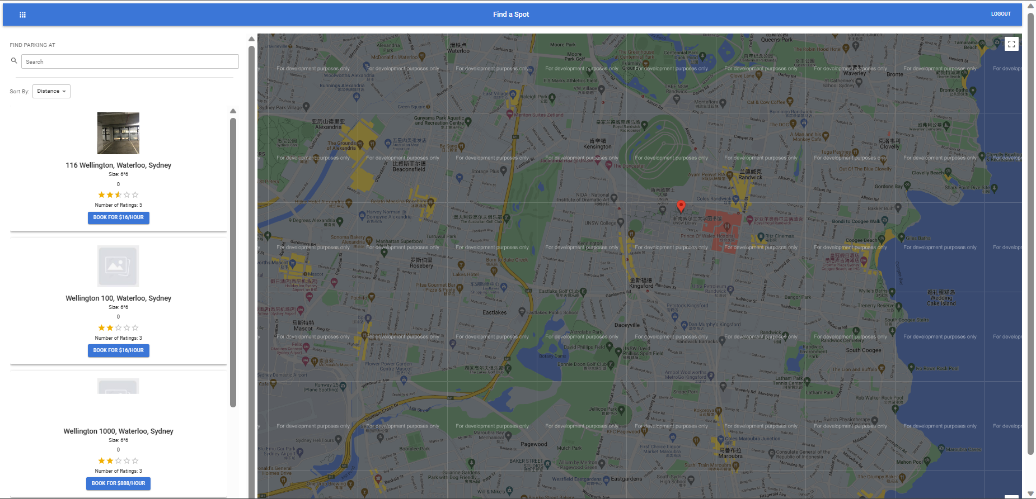

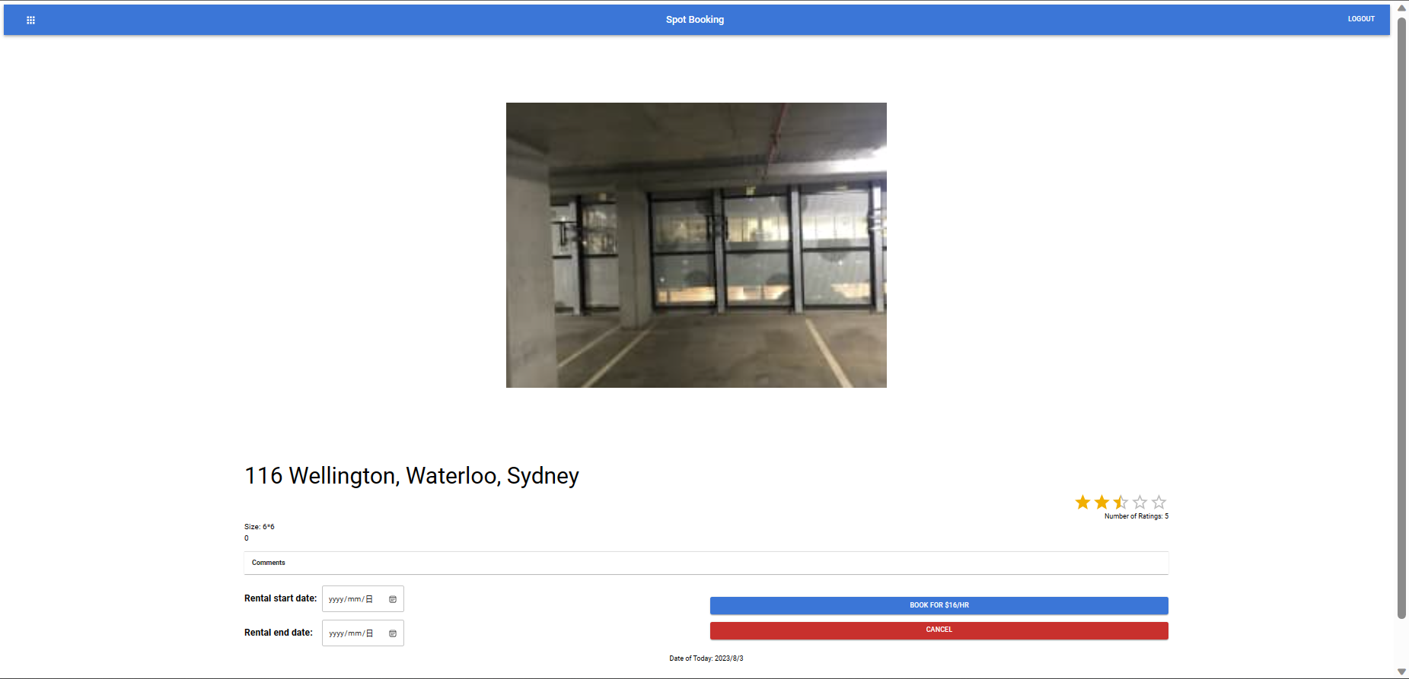

**2.4 My spots page**

Users can view all their released parking spaces on this page. And you can edit and modify the information of the parking space, or delete the parking space. And on this page, you can click the + icon at the bottom right to release a new parking space.

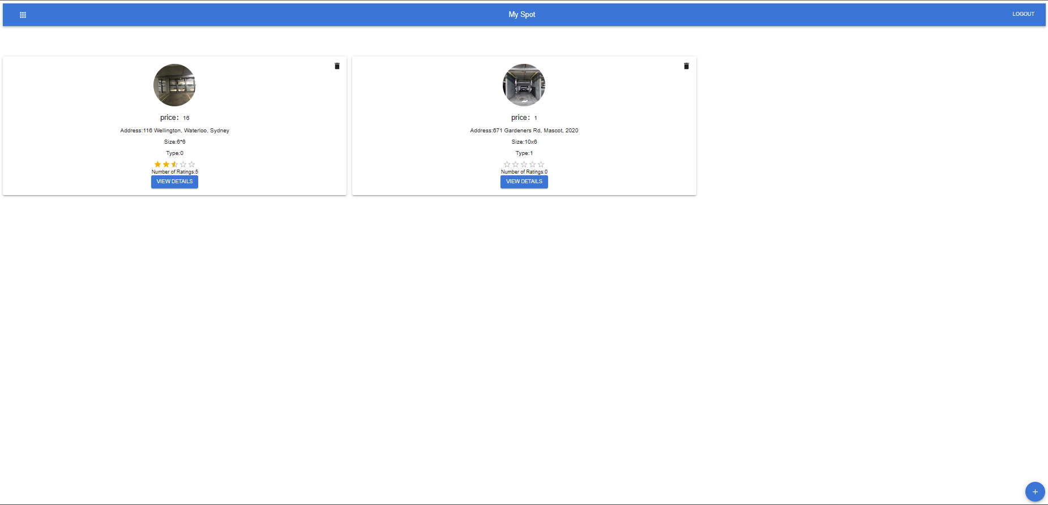

**2.5 My bookings page**

Users can view all their order information on this page, and can delete orders that are more than 7 days away from the start of the order. At the same time, you can also jump to the order details page on this page, and leave comments and ratings. When the order end date is reached, the order ends and can no longer be viewed.

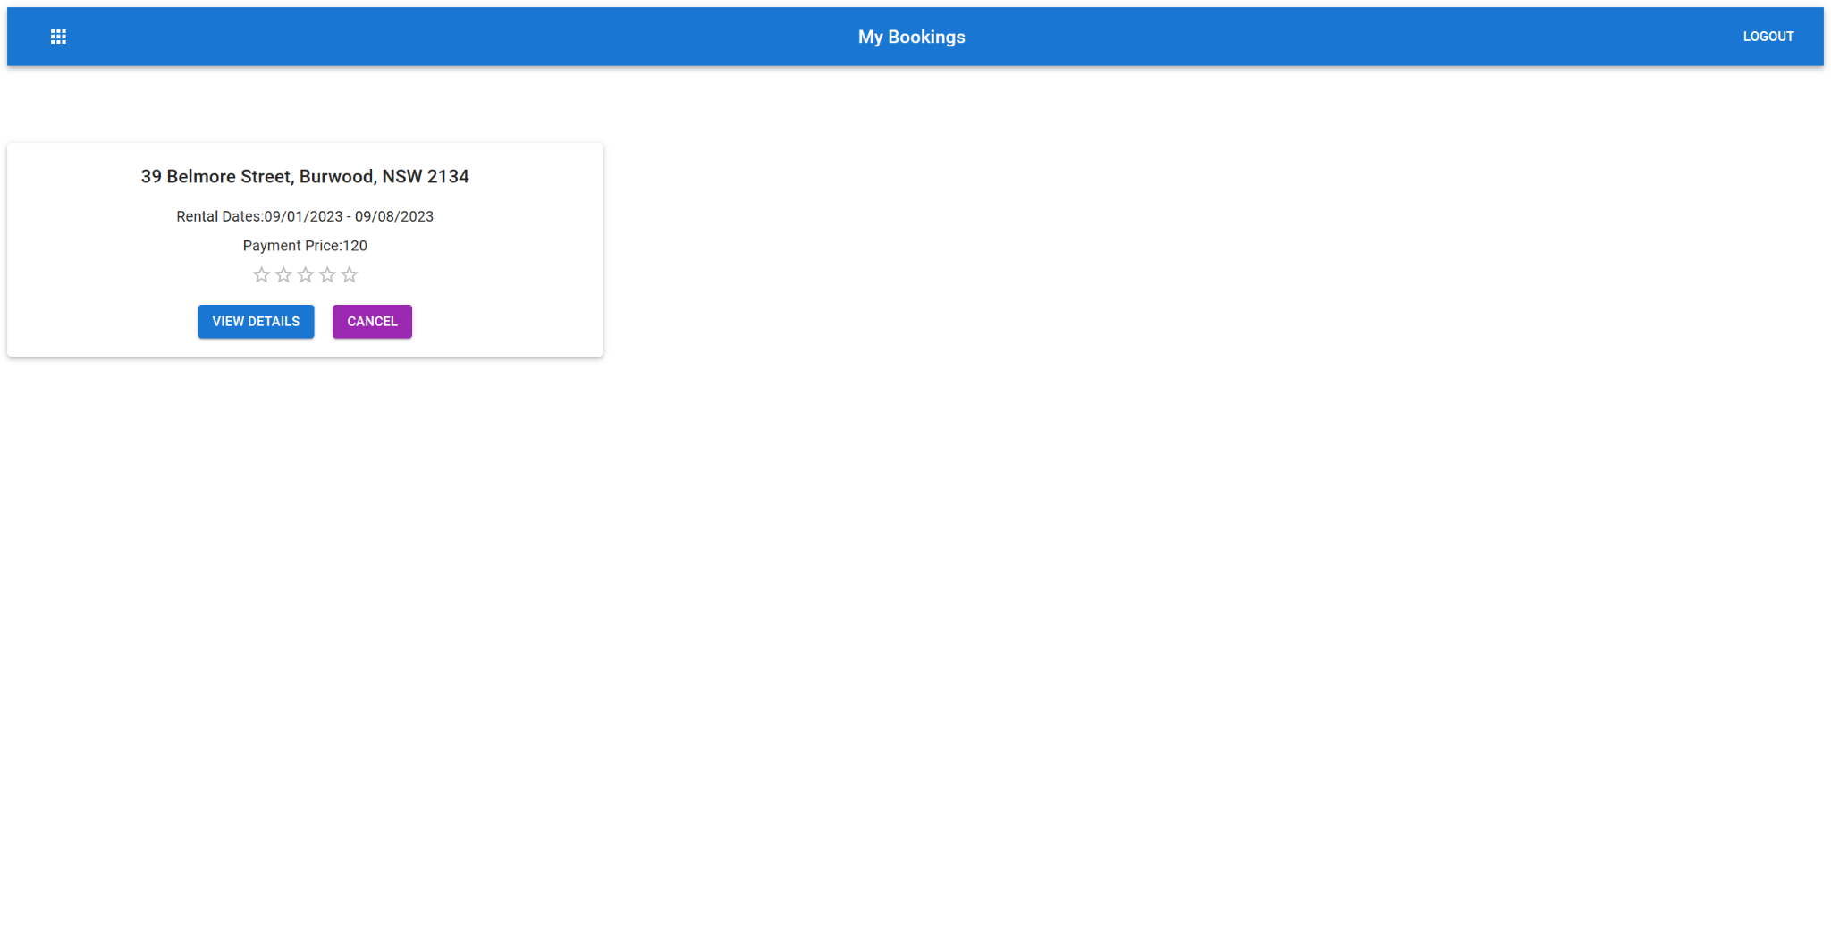

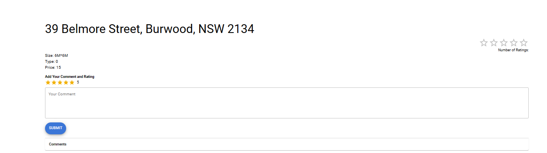

**2.6 My wallet page**

On this page, users can check their wallet balance and recharge. To recharge their wallet, users need to provide their card details.

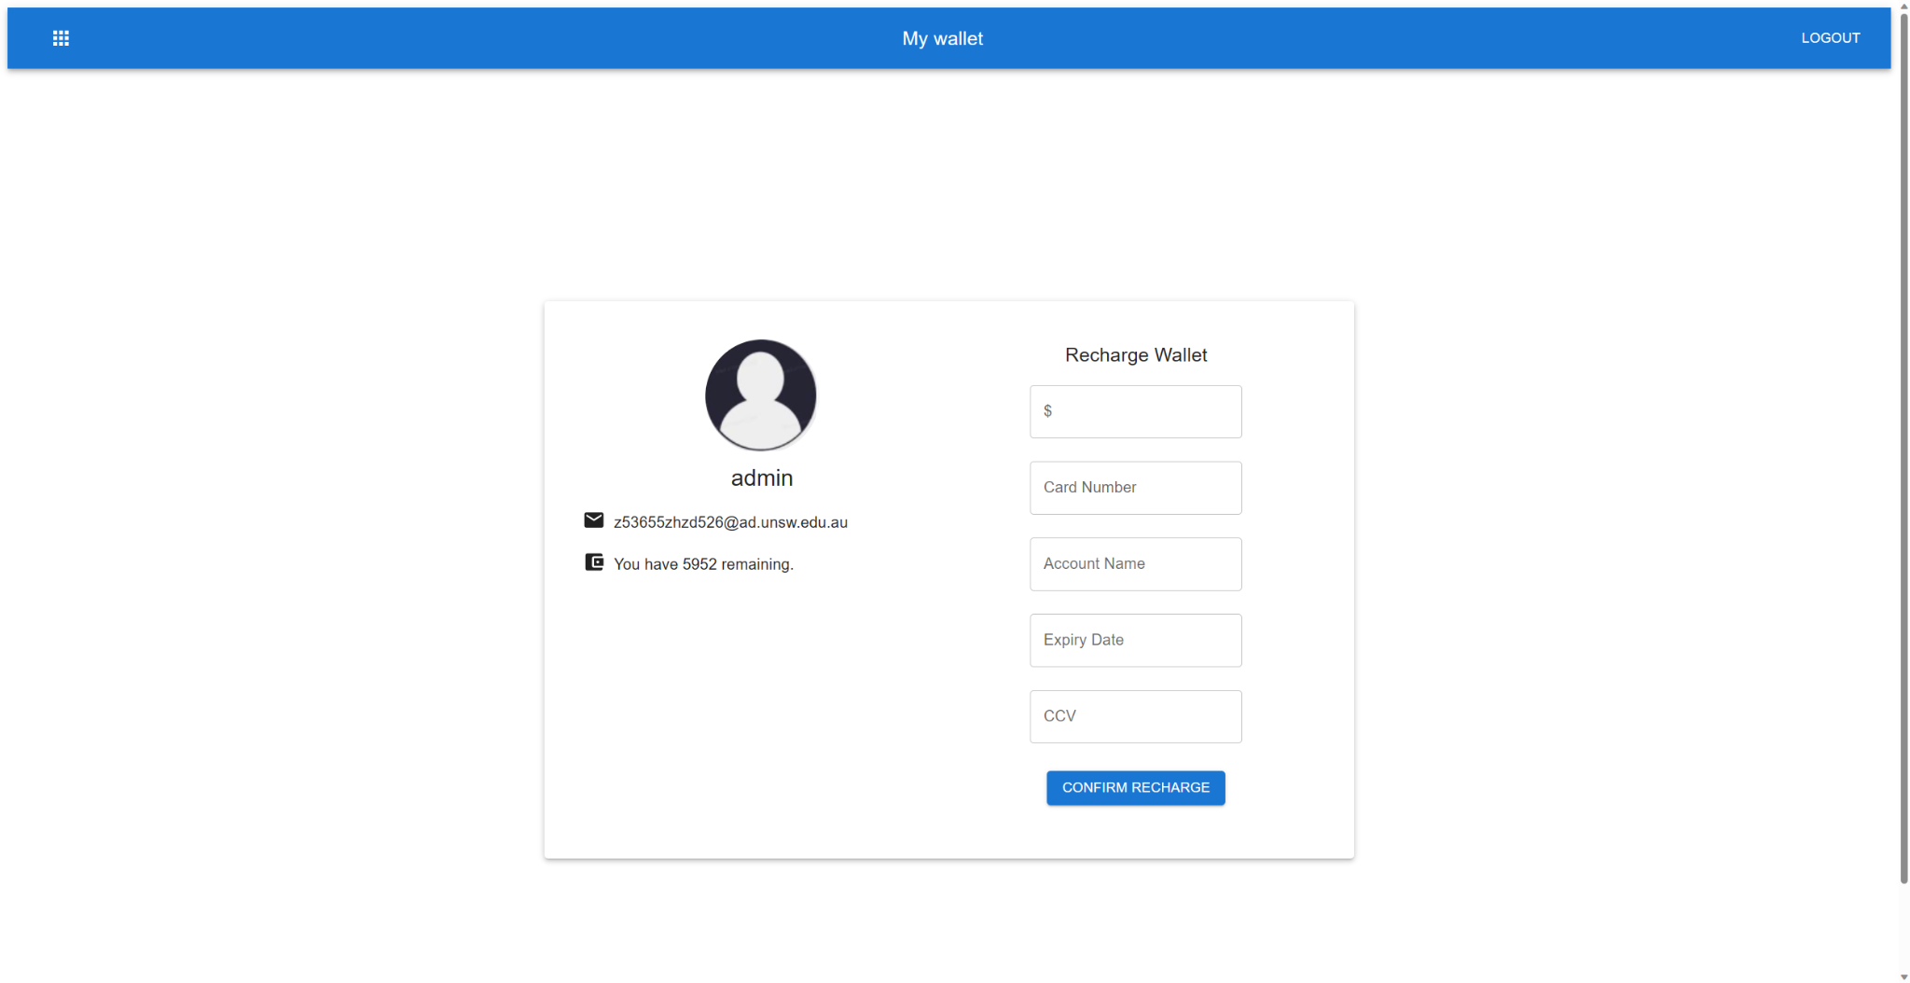

**2.7 Invite Friends**

This part is a little different from our proposal. For more convenient use, our function of inviting friends does not use a separate page, but during registration, users can choose to fill in the email address of an inviter. And when he/she completes the first order, the wallets of him and the friend who invited him will be automatically recharged with 5 dollars.

**3. Thrid part function**

**3.1 Front End**

**3.1.1 ReactJS**

React is a free and open-source front-end JavaScript library for building user interfaces based on components. It is maintained by Meta and a community of individual developers and companies. React can be used to develop single-page, mobile, or server-rendered applications with frameworks like Next.js. According to the previous knowledge and experience we had for front-end design, we found that ReactJS is perfect for this project.

By using ReactJS, we can achieve these advantages:

1. It is easy to learn and apply for the project. It comes with a good supply of documentation, tutorials, and training resources.
2. React is an SEO-friendly and performance-focused library that addresses common challenges with JavaScript-based websites. The virtual DOM and server-side rendering have revolutionized content rendering, eliminating the need for search engines like Google to directly interpret JavaScript for indexing. As a result, long loading times and potential website issues are effectively mitigated. Thanks to these advancements, React offers an optimized solution for seamless user experiences and improved search engine visibility.
3. The ReactJS web application is made of different components and each of the components can be exported and imported so that the components can interact with each other, making the application more usable.

ReactJS also comes with this disadvantage:

1. The syntax of ReactJS is similar to JavaScript but not the same, when we tried to use the APIs such as Google map API, the documents only support JavaScript but not ReactJS, which slowed us down during development.

**3.1.2 Material UI**

Material UI is beautiful by design and features a suite of customization options that make it easy to implement your own custom design system.

By using Material UI, we can achieve these advantages:

1. Material UI is a great tool for creating user interfaces. It is easy to use and has a wide range of components that can be used to create an interface. It is also responsive and can be used on a variety of devices.
2. Since we chose ReactJS for our application, and to enhance our development process, we adopted Material-UI, a powerful React-based UI library. It provides ready-made components and styles, ensuring compatibility and reliability. Being open-source, Material-UI benefits from an active community, making it an excellent fit for our project. With Material-UI, we can focus on building robust features, saving time on design details.

Material UI also comes with this disadvantage:

1. A disadvantage of using Material-UI is that it can be slow and buggy. The module size is huge and it will sometimes decrease the proformance of the application.

**3.1.3 The libraries and dependencies we used**

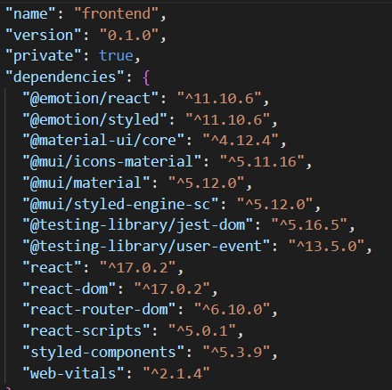

**3.2 Back End**

**3.2.1 Sprint Boot**

The decision of our group was made to adopt Spring Boot 2.0 for our backend development. Spring Boot is a solution of Spring's convention over configuration, which is used to create production-grade Spring applications with minimal configuration. It can make it easier for developers to write business codes without configuring and logically transforming their thinking. The Spring Boot framework improves and optimizes the Spring framework by starting dependency and automatic configuration. Starting dependency is to package the dependent coordinates with a certain function and provide the corresponding function. Automatic configuration means that Springboot can register some beans of configuration classes into IOC container and use them in the form of annotations, so we only need to introduce the functional packages we want to use, and Springboot can automatically inject beans for our direct use. Most applications can be pre configured using the Spring team's "self-righteous view", which is the best configuration and use of the Spring platform and third-party libraries. Spring Boot applications can be written in a variety of programming languages, including Java and Kotlin.

The following are some core features and brief introduction of the Spring Boot framework:

1. Embedded Tomcat, Jetty or UnderTow Web application server.

2. Provide a fixed "getting started" project object model (POM) for building tools. The only supported build tools are Maven and Gradle.

3. Automatic configuration of Spring application

4. Provide production-ready functions, such as indicators, health check and external configuration.

5. No code generation is required.

6. XML configuration is not required.

**3.2.2 Mybatis**

MyBatis is an excellent persistence framework, and it is one of the frameworks for accessing databases in web project engineering. The main goal of MyBatis is to simplify the database interaction, and make it easier for developers to access the database by providing concise API and flexible configuration.

The following are some core features and brief introduction of the MyBatis framework:

1. Separation of SQL and Java codes: MyBatis separates SQL statements from Java codes and configures them by using XML or annotations, so that SQL and Java codes can not interfere with each other and are easier to maintain and read.

2. Flexible mapping method: MyBatis supports user-defined object mapping, which can map query results into Java objects or nested data structures, thus reducing manual data transformation.

3. Dynamic SQL：MyBatis allows dynamic SQL to be used in SQL statements, and can dynamically splice SQL fragments according to conditions, making SQL queries more flexible and reusable.

4. Cache support: MyBatis provides first-level cache and second-level cache support, which can reduce database access times and improve system performance. The secondary caching mechanism in Mybatis is not very effective when actually caching in the project, so we use the third-party tool redis to cache specific businesses.

5. Transaction management: MyBatis can be seamlessly integrated with frameworks such as Spring to support transaction management and ensure the consistency and reliability of database operations. Plug-in extension: MyBatis allows developers to write custom plug-ins to extend their functions to meet specific needs.

6. Support multiple databases: MyBatis supports mainstream relational databases, such as MySQL, Oracle, SQL Server, etc., and also supports some non-relational databases.

**3.2.3 Tools related to Java development**

In addition to the above-mentioned framework selection in the project, we also applied some tools that can help us to develop the code simply to facilitate our business processing, reduce the coding and improve efficiency.

1. Lombok

Lombok is a Java library, which simplifies the writing of Java code by annotation. By providing annotations, we can apply annotations to the object classes in pojo layer, and then we can automatically generate object classes, helping developers to automatically generate some template codes such as getter, setter, constructor, equals, hashCode, etc., thus reducing the repetitive and tedious codes. Lombok belongs to the Java enhancement library.

2. Mybatis-generator

MyBatis Generator is a tool for automatically generating Java code, especially for interacting with databases. Based on the MyBatis framework, it simplifies the development of data access layers by parsing database table structure and configuration files to generate corresponding Java model classes, DAO(Data Access Object) classes and Mapper interfaces. MyBatis Generator is a Java code generation tool.

3. Restful Api

RESTful API is a design style of Web service interface based on HTTP protocol, which is used for data exchange and communication between client and server. It is a lightweight, flexible and easy-to-understand way to build a distributed system. RESTful API is not a specific tool or technology, but an architectural style or design concept.

**3.3 Database enumerate**

**3.3.1 Mysql Database**

We use the Mysql database as our main storage database. When there is no data we need in the cache, we will enter Mysql data for data query and execute. MySQL is a popular open source relational database management system (RDBMS), which is one of the most commonly used databases in Web applications and many other types of software. Because of its free open source, strong expansibility, rapid and efficient deployment on various operating systems, strong security and following the SQL(Structured Query Language) standard, it can help us to develop projects more conveniently. In the actual operation business, we created the car_space_renting_database database, and divided it into several tables according to the actual business, namely: car_space table, comment_for_car_space table, order table and user table.

**3.3.2 Caching Database**

We use redis (Remote Dictionary Server) as our caching technology. Every time we need to access the data in the database, we will not directly enter the database for operation, but enter the redis cache for query. This reduces the consumption of resources, because every time you visit the database, you will establish a connection and release resources, which will consume too many resources and waste time. Using redis cache can avoid these situations and improve our business efficiency. Redis is mainly used to cache and access data quickly, and it is a high-performance and non-relational cache database.

The advantages of redis for our project can be summarized as follows:

1. Memory storage: Redis stores data in memory, so the reading and writing speed is very fast, which is suitable for scenes that need high-speed reading and writing.

2. Persistence: Although Redis is mainly an in-memory database, it supports persistence of data to disk to prevent data loss.

3. Client support: Redis provides clients in multiple programming languages, which can be easily integrated into different applications.

4. High concurrency: Redis uses a single-threaded model to process requests, and can support high concurrency read and write operations through non-blocking I/O and event-driven.

**4. Challenges**

**4.1 Team collaboration**

Version control and team collaboration: This is also the biggest challenge we have encountered. Inefficient team communication can make the code development process extremely slow. There will be many bugs in the code due to many non-technical problems. Because our front-end and back-end division of labor is completed, not only the data communication format between the front-end and the back-end needs to be coordinated, but also the partners who work with the front-end and the front-end also need to control the version and communicate with the code to ensure that the code can run normally. It also taught us that with team development, effective version control and team collaboration tools are essential to ensure code consistency and coordination.

**4.2 Front-end challenges**

Since we are using the Google Maps API first, we need to learn how to use it from scratch. When we successfully implemented it, a serious problem occurred, that is, the Google Maps API is not free, and every call will be automatically deducted without prompting, resulting in us being charged 700 Australian dollars. In the end, we disabled the API for using Google Maps, but kept the code, that is, if you want to enable Google Maps again, just need to recharge the google wallet.

**4.3 Back-end challenges**

**4.3.1 Pre-construction of project**

As we haven't been exposed to the construction of this kind of entity project before, we are not familiar with this kind of project, and all the work is done in the process of querying information while actually operating. In the pre-project preparation process, we need to query a lot of information to choose the most suitable framework for the project, which will consume a lot of time. After the frame selection is completed, it is also necessary for us to consider whether the frames are suitable and the version number is selected. After the construction, we need to classify all the functions of the project in a unified way, so that it can be divided into several modules to facilitate our unified management, which will inevitably take a lot of time to organize meetings to discuss. After the module is established, we still need to fix various bugs in the project construction process.

**4.3.2 Application of the redis**

In the process of building redis, we need to selectively cache specific business functions. This is because although building a redis cache can help us to reduce the times of querying the database, due to the characteristics of business functions, the concurrent operation of some functions will not be too much. At this time, it is a bit wasteful to build a Redis cache if it is true. So we organized a meeting to discuss whether to build Redis cache for each business and finally determined which businesses to do Redis cache for. In the actual construction process, because we have not done the experience of building cache before, we have encountered many difficulties in the construction process. After inquiring a lot of data and modifying various bugs in the actual construction process, the cache of Redis is completed.

**4.3.3 Back-end debugging**

In the process of front-end and back-end joint debugging, we don't know whether the data returned by the back-end project is acceptable to the front-end because we have developed the front-end separately. In addition, in the process of front-end and back-end debugging, the preparation of interface project documents also consumes a lot of time and energy. It is very important to choose a suitable tool to help us check whether the results returned by the back end conform to the format of the front end in the actual debugging process, but we have no experience in this field. After consulting a lot of information, we chose a suitable tool: Postman to help us test whether the results returned by the back-end project meet the requirements of the interface document.

**5. User documentation**

The project was run and tested on a Lubuntu 20.4.1 LTS virtual machine as project requirements. The following are all the commands required to run the project. You need to run the first ten steps of commands when you use them for the first time. If you want to use them later, you only need to start from the ninth step and ignore the tenth step.

1.Update apt

(1)sudo apt-get update

2.Install curl

(1)sudo snap install curl # version 8.1.2

3.Install nodejs

(1)curl -fsSL https://deb.nodesource.com/setup_16.x | sudo -E bash -

(2)sudo apt-get install -y nodejs

4.Install java 11

(1)sudo apt-get install openjdk-11-jdk

5. Install Redis server

(1) sudo apt-get install redis-server

6.Install MySQL

(1)sudo apt install mysql-server

7.Install npm

(1)sudo apt install npm

8.Install the react and MUI package necessary for the frontend

(1)Go to “./frontend” folder

(2)npm install react react-dom

(3)npm install react react-router-dom

(4)npm install @mui/material @emotion/react @emotion/styled

9.Start Redis server and MySQL server

(1)sudo systemctl start redis-server

(2)sudo systemctl start mysql

10.Set up database

(1)CREATE DATABASE car_space_renting_database;

(2)CREATE USER 'letsquit'@'localhost' IDENTIFIED BY '9900letsquit';

(3)GRANT ALL PRIVILEGES ON car_space_renting_database.* TO 'letsquit'@'localhost';

(4)FLUSH PRIVILEGES;

(5)exit;

11.Import sql file

(1)Navigate to the root

(2)sudo mysql -u root

(3)USE car_space_renting_database;

(4)source car_space_renting_database.sql;

(5)exit;

12.Start the backend

(1)Navigate to the root

(2)java -jar back_end.jar

13.Start the frontend

(1)Navigate to the“./frontend” folder

(2)npm start

14.Open firefox and go to http://localhost:3000, then you can enjoy this project.