中美个人所得税调查报告
作为全球GDP前二的两个超级大国，中国和美国都有着其他国家难以匹敌的经济实力，但是他们的经济组成结构却有着很大的差别。仅在个人所得税方面，中美的政策就有着很大的不同。在美国，个人所得税是总税收的大头、根据一般统计，美国个人所得税占总税收收入的50%以上，且美国低收入者人个税税率最少为10%，对高收入者个人税最高为35%；在中国，个人所得税占总税收的比例在8%左右，中国对低收入者不收税，对高收入者收税最高为45%。因为我国的贫富差距远远比美国更大，所以为了缩小贫富差距，我国对高收入群体的税收较重。我们通过程序来对比一下，不同收入的人群在美国和中国税款差别。
- 收入在5000元（折合约725美元）以下的人群
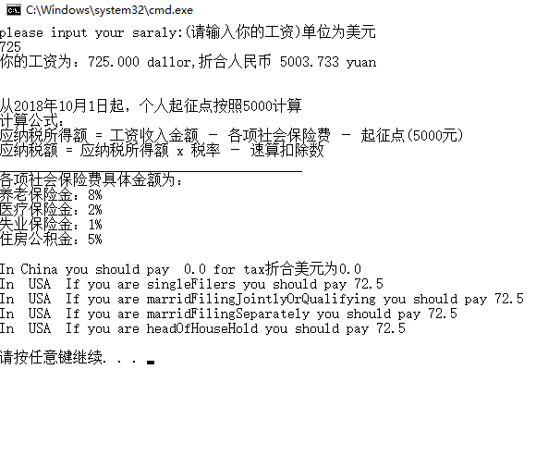
在中国不需要交税，在美国需要交72.5美元的税
- 收入为15000元（折合约2174美元）的中收入人群。
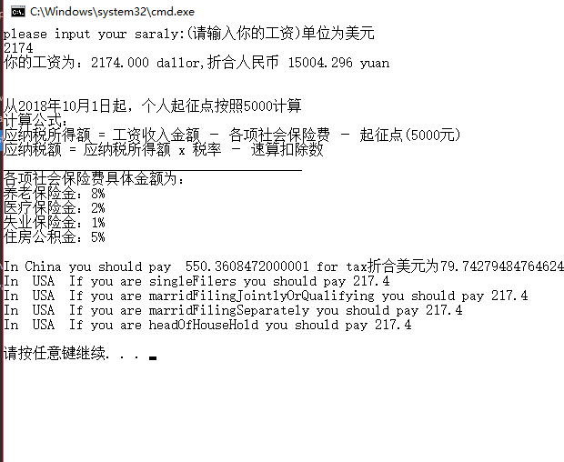
在中国需要缴纳79美元的税，在美国则需要缴纳217美元的税。
- 收入30000人民币（折合约4248美元）的人群
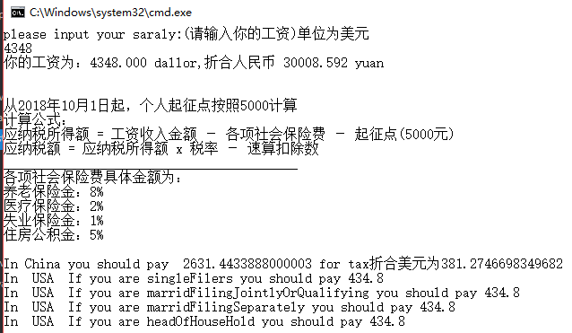
在中国需要缴纳381美元的税，在美国则需要缴纳434.8美元的税。发现差距貌似变小了，没有之前低收入人群的那么大了。
- 收入100000人民币（折合约14493美元）的人群
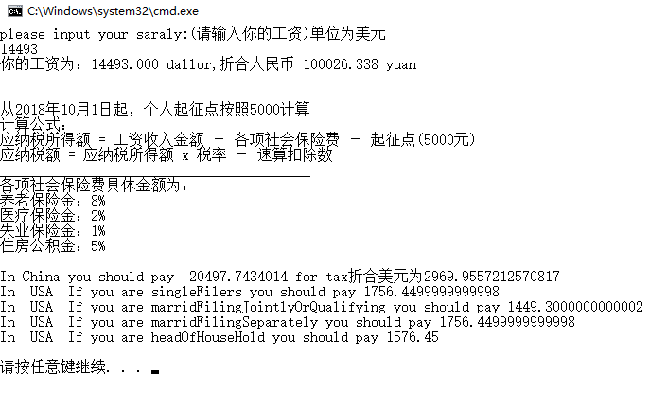
在中国需要缴纳2970美元的税，在美国则需要缴纳1576-1756美元的税。
因此可以得出结论：
在中国对于正常收入和较低收入的人群所收税率较低，而对于高收入人群的税却十分重，美国整体税收比较平均，对高收入人群最高税率没有中国高，且在美国针对不同的人群，应需缴纳的税款也不同，针对高收入人群，单身的人比有孩子的人需要缴纳更多的税款。

程序源代码如下：
//中国税率算法
import java.util.Scanner;

class ChineseIndividualIncomeTax
{
private double gongzi;
private double shuihougongzi;

public ChineseIndividualIncomeTax(double a)
{

gongzi = a;
shuihougongzi = 0;
Count();
printRE();

}
public void printRE()
{
System.out.println("从2018年10月1日起，个人起征点按照5000计算");
System.out.println("计算公式：");
System.out.println("应纳税所得额 = 工资收入金额 － 各项社会保险费 － 起征点(5000元)");
System.out.println("应纳税额 = 应纳税所得额 x 税率 － 速算扣除数");
System.out.println("_________________________________________");
System.out.println("各项社会保险费具体金额为：");
System.out.println("养老保险金：8%");
System.out.println("医疗保险金：2%");
System.out.println("失业保险金：1%");
System.out.println("住房公积金：5%");
System.out.println();
}

double getGongzi()
{
return gongzi;
}
double getshuihougongzi()
{
return shuihougongzi;
}

public double Count()
{
double one = gongzi-gongzi*0.16-5000;
double tax = 0;
double k = 0;
if(one>0&&one<=3000)
{
tax = one*0.03;
}else if(one>0&&one<=12000)
{
tax = (one-3000)*0.10-210+3000*0.03;
k+=210;
}else if(one>0&&one<=25000)
{
tax = (one-12000)*0.2-1410+(12000-3000)*0.1-210+3000*0.03-0;
k+=1410+210;
}else if(one>0&&one<=35000)
{
tax = (one-25000)*0.25-2660+13000*0.2-1410+9000*0.1-210+3000*0.03-0;
k+=2660+1410+210;
}else if(one>0&&one<=55000)
{
tax = (one-35000)*0.3-4410+10000*0.25-2660+13000*0.2-1410+9000*0.1-210+3000*0.03-0;
k+=4410+2660+1410+210;

}else if(one>0&&one<=80000)
{
tax = (one-55000)*0.35-7160+20000*0.3-4410+10000*0.25-2660+13000*0.2-1410+9000*0.1-210+3000*0.03-0;
k+=7160+4410+2660+1410+210;
}else if(one>80000)
{
tax = (one-80000)*0.45-15160+25000*0.35-7160+20000*0.3-4410+10000*0.25-2660+13000*0.2-1410+9000*0.1-210+3000*0.03-0;
k+=15160+7160+4410+2660+1410+210;
}
shuihougongzi = gongzi-tax-gongzi*0.16-k;
return tax+k;
}

}
//美国税率算法
class ComputerTax {
//danshenshuishou
private double singleFilersTax = 0;
//yihungongtonghuogongtongzhengshiguangashuishou
private double marridFilingJointlyOrQualifyingTax = 0;
//yihundandushuishou
private double marridFilingSeparatelyTax = 0;
//jiatinghuzhunashui
private double headOfHouseHoldTax = 0;
//shouru
private double income = 0;
public ComputerTax(double income){
this.income = income;
}
//dedaodanshenshuishou
public double getsingleFilersTax(){
if(income <= 8350)
singleFilersTax = income * 0.1;
else if(income <= 33950)
singleFilersTax = 8350 * 0.1 + (income - 8350) * 0.15;
else if(income <= 52250)
singleFilersTax = 8350 * 0.1 + (33950 - 8350) * 0.15
+ (income -33950) * 0.25;
else if(income <= 171550)
singleFilersTax = 8350 * 0.1 + (33950 - 8355) * 0.15
+ (52250 -33950) * 0.25 + (income -52250) * 0.28;
else if(income <= 372950)
singleFilersTax = 8350 * 0.1 + (33950 - 8355) * 0.15
+ (52250 -33950) * 0.25 + (171550 -52250) * 0.28
+ (income - 171550) * 0.33;
else
singleFilersTax = 8350 * 0.1 + (33950 - 8355) * 0.15
+ (52250 -33950) * 0.25 + (171550 -52250) * 0.28
+ (327950 - 171550) * 0.33 + (income - 372950) * 0.35;
return singleFilersTax;
}
//dedaoyihungongtonghuogongtongzhengshiguangashuishou
public double getmarridFilingJointlyOrQualifyingTax(){
if(income <= 16700)
marridFilingJointlyOrQualifyingTax = income * 0.1;
else if(income <= 67900)
marridFilingJointlyOrQualifyingTax = 16700 * 0.1
+ (income - 16700) * 0.15;
else if(income <= 137050)
marridFilingJointlyOrQualifyingTax = 16700 * 0.1
+ (67900 - 16700) * 0.15 + (income - 67900) * 0.25;
else if(income <= 208850)
marridFilingJointlyOrQualifyingTax = 16700 * 0.1
+ (67900 - 16700) * 0.15 + (137050 - 37900) * 0.25
+ (income - 137050) * 0.28;
else if(income <= 372950 )
marridFilingJointlyOrQualifyingTax = 16700 * 0.1
+ (67900 - 16700) * 0.15+ (137050 - 37900) * 0.25
+ (208850 - 137050) * 0.28 + (income - 208850) * 0.33;
else
marridFilingJointlyOrQualifyingTax = 16700 * 0.1
+ (67900 - 16700) * 0.15 + (137050 - 37900) * 0.25
+ (208850 - 137050) * 0.28 + (372950 - 208850) * 0.33
+ (income - 372950) * 0.35;
return marridFilingJointlyOrQualifyingTax;
}
//dedaoyihundandushuishou
public double getmarridFilingSeparatelyTax(){
if(income <= 8350)
marridFilingSeparatelyTax = income * 0.1;
else if(income <= 33950)
marridFilingSeparatelyTax = 8350 * 0.1 + (income - 8350) * 0.15;
else if(income <= 68525)
marridFilingSeparatelyTax = 8350 * 0.1 + (33950 - 8350) * 0.15
+ (income - 33950) * 0.25;
else if(income <= 104425)
marridFilingSeparatelyTax = 8350 * 0.1 + (33950 - 8350) * 0.15
+ (68525 - 33950) * 0.25 + (income - 68525) * 0.28;
else if(income <= 186475 )
marridFilingSeparatelyTax = 8350 * 0.1 + (33950 - 8350) * 0.15
+ (68525 - 33950) * 0.25 + (104425 - 68525) * 0.28
+ (income - 104425) * 0.33;
else
marridFilingSeparatelyTax = 8350 * 0.1 + (33950 - 8350) * 0.15
+ (68525 - 33950) * 0.25 + (104425 - 68525) * 0.28
+ (186475 - 104425) * 0.33 + (income - 186475);
return marridFilingSeparatelyTax;
}
//dedao
public double getheadOfHouseHoldTax(){
if(income <= 11950)
headOfHouseHoldTax = income * 0.1;
else if(income <= 45500)
headOfHouseHoldTax = 11950 * 0.1 + (income - 11950) * 0.15;
else if(income <= 117450)
headOfHouseHoldTax = 11950 * 0.1 + (45500 - 11950) * 0.15
+ (income - 45500) * 0.25;
else if(income <= 190200)
headOfHouseHoldTax = 11950 * 0.1 + (45500 - 11950) * 0.15
+ (117450 - 33950) * 0.25 + (income - 117450) * 0.28;
else if(income <= 372950)
headOfHouseHoldTax = 11950 * 0.1 + (45500 - 11950) * 0.15
+ (117450 - 33950) * 0.25 + (190200 - 117450) * 0.28
+ (income - 190200) * 0.33;
else
headOfHouseHoldTax = 11950 * 0.1 + (45500 - 11950) * 0.15
+ (117450 - 33950) * 0.25 + (190200 - 117450) * 0.28
+ (372950 - 190200) * 0.33 + (income - 372950) * 0.35;
return headOfHouseHoldTax;
}
}

//测试比较

public class ComputerTaxTest {

/**
* @param args the command line arguments
*/
public static void main(String[] args) {

Scanner input = new Scanner(System.in);
System.out.println("please input your saraly:(请输入你的工资)单位为美元");
double salary = input.nextInt();
System.out.print("你的工资为：");
System.out.printf("%.3f dallor,折合人民币 %.3f yuan\n\n\n",salary,salary*6.9017);
ComputerTax USA = new ComputerTax(salary);
ChineseIndividualIncomeTax China = new ChineseIndividualIncomeTax(salary*6.9017);
System.out.println("In China you should pay " + China.Count()
+ " for tax"+"折合美元为"+China.Count()/6.9017);
System.out.println("In USA If you are singleFilers you should pay "
+ USA.getsingleFilersTax());
System.out.println("In USA If you are marridFilingJointlyOrQualifying"
+ " you should pay " + USA.getmarridFilingJointlyOrQualifyingTax());
System.out.println("In USA If you are marridFilingSeparately you"
+ " should pay " + USA.getmarridFilingSeparatelyTax());
System.out.println("In USA If you are headOfHouseHold you should pay "
+ USA.getheadOfHouseHoldTax());
}

}

