IJC437 Coursework 2025-26 (Reassessment)

Uneven Recovery of UK Rail Passenger Usage After COVID-19:
A Regional Data Science Analysis

Module: IJC437 Introduction to Data Science
Registration number: 250124790
GitHub repository: https://github.com/Qjins/IJC437-UK-Rail-Recovery
Word count: 3,096

1. Introduction and Aims
The COVID-19 pandemic caused the most severe disruption to public transport demand in modern history. Expert surveys anticipated lasting changes in travel behaviour from lockdowns and remote working (Zhang et al., 2021), reviews documented unprecedented ridership losses across major networks (Gkiotsalitis & Cats, 2021), and early household studies confirmed a steep fall in commuting alongside rapid adoption of working from home (Beck & Hensher, 2020).
Great Britain's railway illustrates this clearly. Official statistics from the Office of Rail and Road (ORR) show 1,739 million passenger journeys in the rail year ending March 2020, a collapse to roughly one fifth of that level in the first pandemic year, and a return to 1,730 million by the year ending March 2025 (ORR, 2025a). The headline recovery, however, conceals a structural change in how the railway is used: the share of journeys made with season tickets, the ticket type most associated with five-day commuting, fell from 34% in 2019-20 to 13% in 2024-25 (ORR, 2025a). Pre-pandemic rail commuters have reduced commuting from an average of 4.3 to 2.0 days per week, mainly because of homeworking (Magrico et al., 2023), and hybrid working remains concentrated in London and professional occupations (Office for National Statistics [ONS], 2025). UK-focused analyses accordingly argue that a simple return to the status quo is unlikely (Vickerman, 2021).
These behavioural changes have a strong geographical dimension. Regions differ in economic structure, occupational mix and dependence on commuting, so reliance on aggregate national indicators risks overlooking persistent regional disparities in rail demand. Although the ORR publishes regional usage levels (ORR, 2025b), published analysis rarely compares regions against a common pre-pandemic baseline, and rarely against the demand trajectory each region was on before the pandemic. This matters for transport planning: decisions based on national averages may misallocate resources if recovery is spatially uneven.
This study addresses that gap using ORR statistics on passenger journeys for the eleven regions of Great Britain over 1996-2025, complemented by station-level usage estimates for 2,554 stations. By indexing demand to a 2019 baseline, projecting pre-pandemic trends forward as a counterfactual, clustering regional recovery trajectories and examining within-region variation at station level, it quantifies how evenly Britain's rail recovery has been distributed.

1.1 Research aim
The aim of this study is to quantify the extent to which the post-pandemic recovery of rail passenger usage in Great Britain has been uneven across regions, and to assess what regional and station-level recovery patterns imply for the interpretation of national recovery figures.

1.2 Research questions
The study is guided by three research questions:
- RQ1: How did national rail passenger usage in Great Britain change before, during and after the COVID-19 pandemic?
- RQ2: To what extent has the recovery of rail passenger usage been uneven across regions and stations?
- RQ3: How do regional recovery patterns compare with the overall national recovery trend?
RQ1 establishes the national context, RQ2 measures unevenness at two spatial scales, and RQ3 tests whether the national trend represents regional experience. The same questions are stated in the GitHub repository so the report and published code remain consistent.

2. Methodology
The project follows a structured data science process comprising data collection, cleaning and validation, exploratory data analysis (EDA), recovery indexing, modelling and interpretation. Figure 1 summarises the workflow; each stage is described below, together with the reasoning behind the methodological choices.
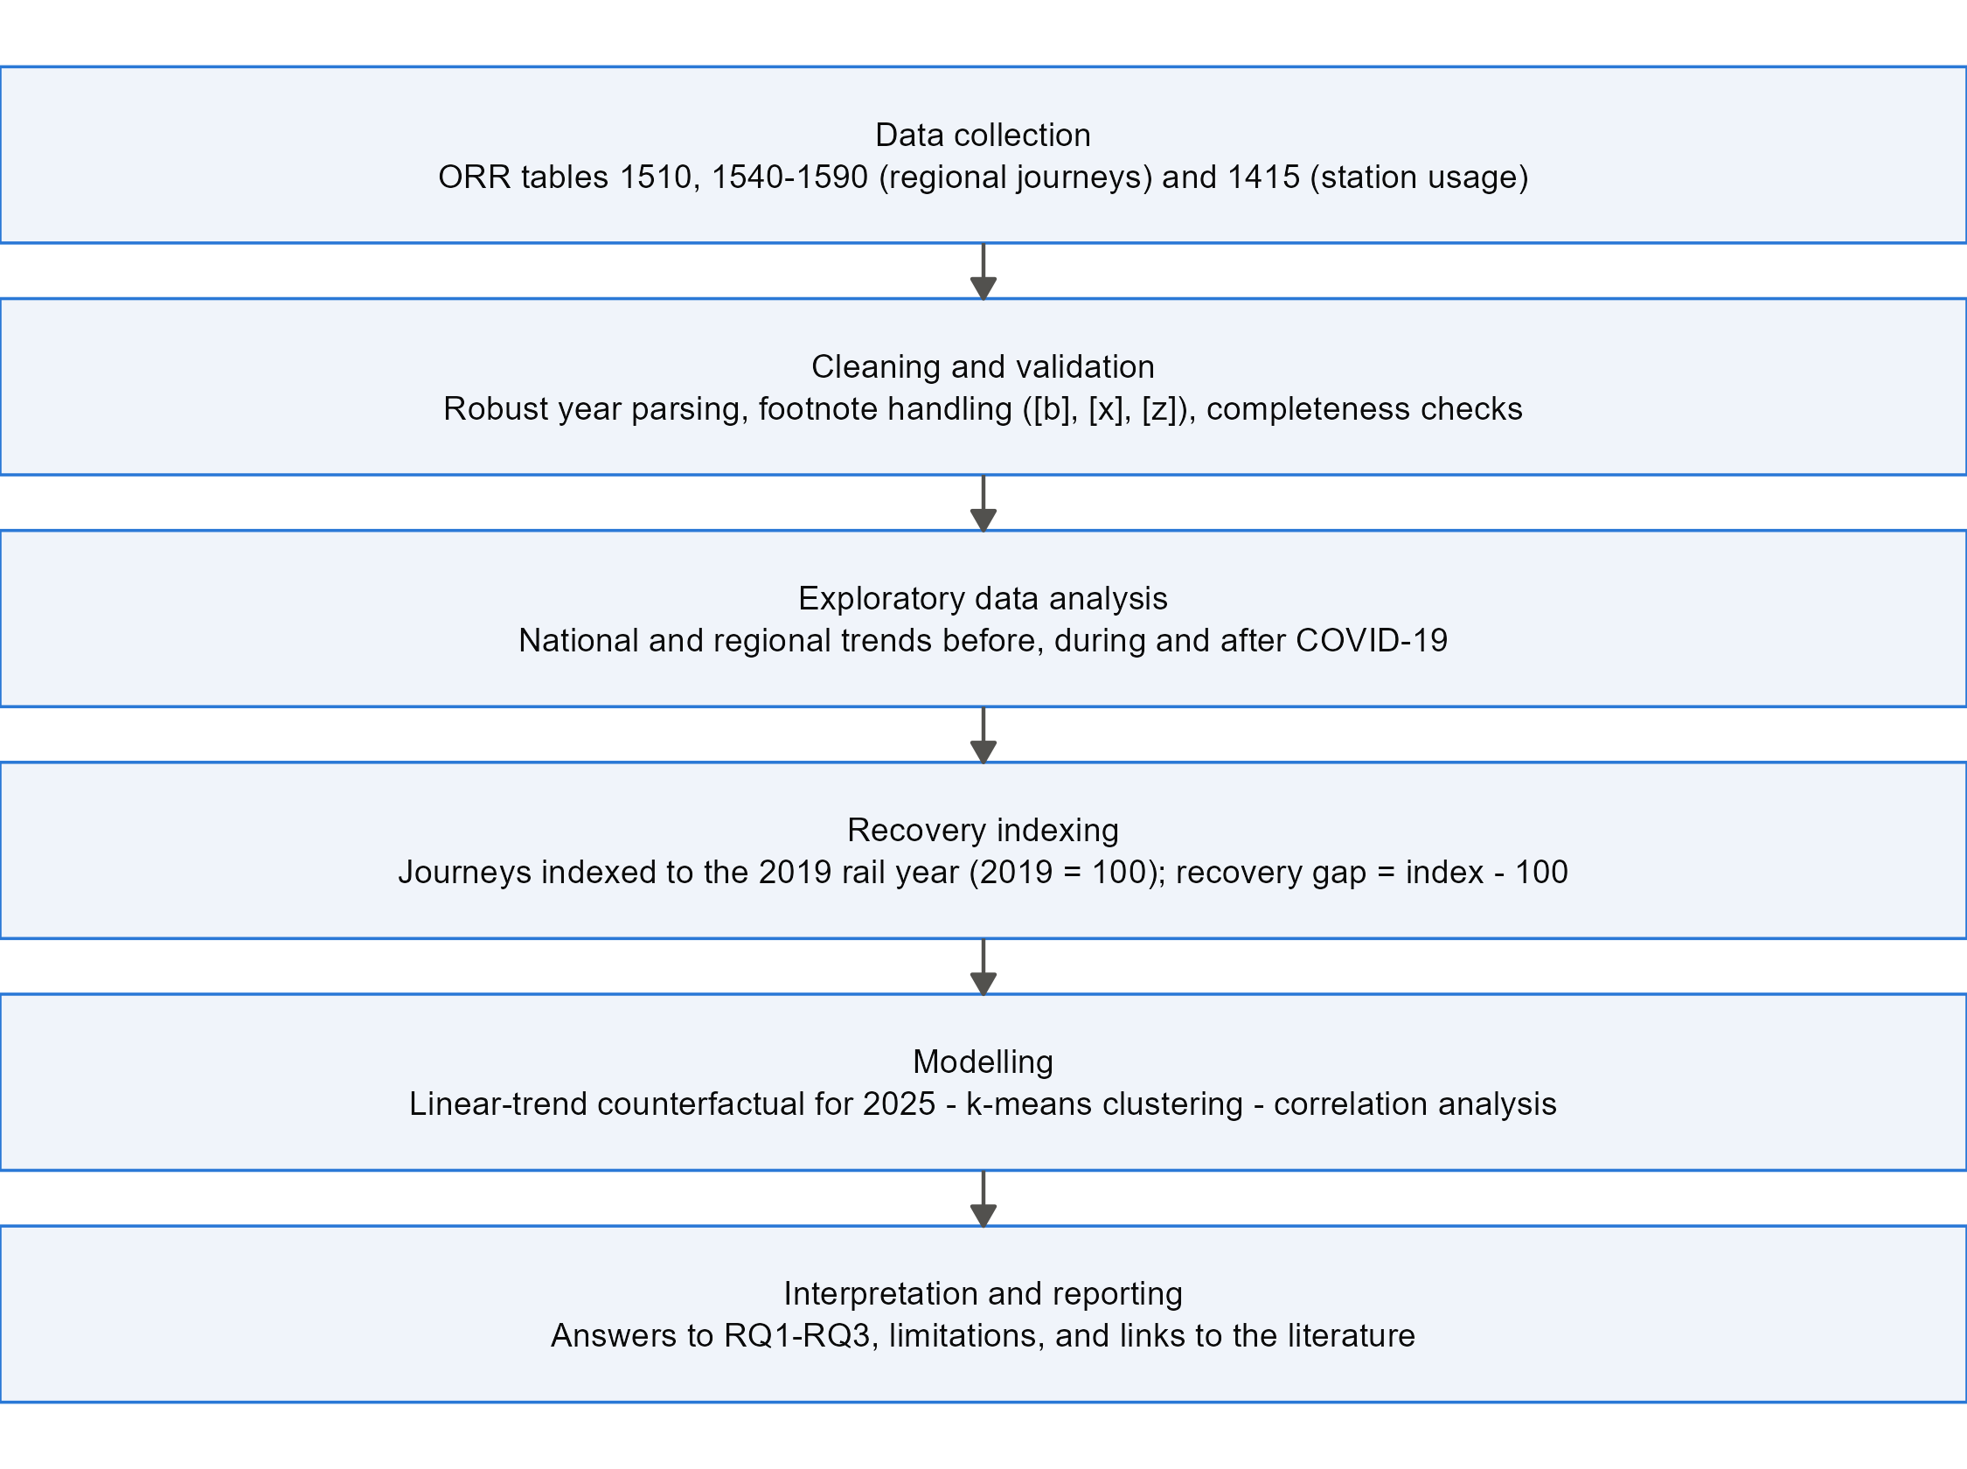
Figure 1. Workflow of the data science process used in this study.

2.1 Data
Three sets of official ORR statistics were used (Table 1). All are published as OpenDocument spreadsheets on the ORR data portal under the Open Government Licence, and the raw files are preserved unmodified in the project repository. Throughout this report, years refer to rail years running from April to March and are labelled by their end year: 2019 denotes April 2018 to March 2019 and 2025 denotes April 2024 to March 2025.
Table 1. Datasets used in the analysis (source: ORR data portal).
Dataset | Content | Coverage | Size after cleaning
ORR Table 1510 | National passenger journeys between and within England, Scotland and Wales | 1996-2025 rail years | 30 annual observations
ORR Tables 1540-1590 | Passenger journeys to, from and within each region (total, within-region and inter-regional journeys) | 1996-2025 rail years, 11 regions | 330 region-year observations
ORR Table 1415a | Estimated entries and exits by station | 2019 and 2025 rail years | 2,554 stations

Two properties of these data shape the analysis. First, regional totals count journeys made to, from or within each region, so a journey between two regions contributes to both totals, while the national series counts each journey once. Second, 2019 was chosen as the pre-pandemic baseline because it is the last complete rail year unaffected by COVID-19: the 2020 rail year already includes the collapse of travel in March 2020.

2.2 Data quality and cleaning
The raw ODS tables embed presentational features that complicate machine reading: ORR marks breaks in the time series by appending “[b]” to the time-period label (for example “Apr 2022 to Mar 2023 [b]”) and uses “[x]” and “[z]” codes inside data cells. The first version of this pipeline extracted the year with a regular expression anchored to the end of the label; this silently failed for every flagged row and dropped it, removing the 2019 and 2020 values for the North West and the 2023 values for all regions. The rebuilt pipeline anchors the year pattern on the month-year token, converts shorthand codes to explicit missing values, retains the break flags as a variable, and validates completeness programmatically: after cleaning, all 11 regions have complete series for all 30 years. The defect and its correction illustrate why automated validation checks are essential when ingesting statistical spreadsheets.
Two limitations are carried through as caveats rather than corrected: ORR series breaks affecting all regions in 2009 and 2023, and journey estimates derived mainly from ticket sales, which ORR notes may overstate recent journeys, and hence the apparent recovery, because of the growth of split ticketing (ORR, 2025a).

2.3 Analytical methods
EDA (Tukey, 1977) was used first to profile national and regional trends and to expose the scale differences that motivate indexing: London records roughly sixty times more journeys than the North East, so raw counts cannot be compared directly. Each region's journeys were therefore expressed as a recovery index, 100 times journeys in year t divided by journeys in 2019. The recovery gap is the 2025 index minus 100, with a direct interpretation: a gap of -10 means 2025 usage is 10% below that region's 2019 level.
Three methods extend the analysis beyond description. First, a linear-trend counterfactual was estimated for each region by regressing journeys on year over 2010-2019 (a period inside a consistent ORR series) and extrapolating to 2025. The shortfall, the percentage difference between actual 2025 journeys and this projection, measures recovery against where demand was heading rather than where it stood in 2019, which matters because pre-pandemic growth rates differed widely. The fits are strong (R-squared 0.93-0.99), but extrapolation assumes pre-pandemic growth would have continued, so it is treated as a benchmark rather than a forecast. Second, k-means clustering, a standard interpretable partitioning method (Jain, 2010), was applied to the standardised 2021-2025 index trajectories, with the number of clusters selected by average silhouette width over k = 2 to 4 (Rousseeuw, 1987) and a fixed random seed for reproducibility. Third, Pearson and Spearman correlations were computed between the recovery gap and three candidate characteristics: pre-pandemic growth (compound annual growth rate, 2010-2019), market size (log journeys, 2019) and the 2019 share of inter-regional journeys, a proxy for dependence on longer-distance commuting. With eleven regions these tests are indicative only, so coefficients and p-values are reported and interpreted cautiously.
Finally, the same recovery index was computed for every station with usable 2019 and 2025 entries-and-exits values (n = 2,554), allowing within-region variation to be examined directly.

2.4 Implementation and reproducibility
All analysis was implemented in R 4.5.1 (R Core Team, 2025) using the tidyverse (Wickham et al., 2019), readODS and cluster packages, organised as three numbered scripts covering cleaning, analysis and figures. Every figure and table in this report is regenerated by them from the raw ORR files; the full code is in Appendix A and in the GitHub repository together with package requirements and execution instructions.

3. Results and Discussion

3.1 National recovery (RQ1)
Figure 2 shows national passenger journeys from 1996 to 2025. Before the pandemic the railway was on a long expansion, from 589 million journeys in 1996 to 1,520 million in 2019 (+158%). The pandemic removed most of this demand almost instantly: journeys in 2021 (April 2020 to March 2021) fell to 344 million, only 22.6% of the 2019 baseline. By 2025 the national index reached 100.8, marginally above the 2019 level.
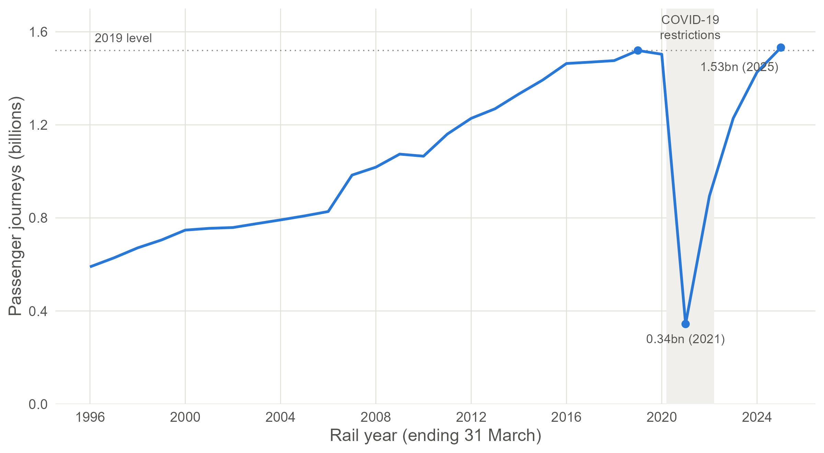
Figure 2. National rail passenger journeys in Great Britain, 1996-2025 (ORR Table 1510). The shaded band marks the rail years most affected by COVID-19 restrictions.
Two qualifications matter for RQ1. First, the composition of demand has changed: within-region journeys in 2025 were 6.0% above 2019, while inter-regional journeys remained 9.8% below (ORR Table 1510), consistent with the collapse of season-ticket commuting noted above. Second, recovery of the level is not recovery of the trajectory: against a linear projection of the 2010-2019 trend, national demand in 2025 is 17.5% lower than it would have been had pre-pandemic growth continued (trend R-squared = 0.954). The railway has regained its 2019 passengers, but not the passengers it was on course to gain.

3.2 Regional recovery gaps (RQ2)
Regional trajectories (Figure 3) show that every region followed the same qualitative pattern of collapse and rebound, but at clearly different speeds. The recovery gap (Figure 4, Table 2) quantifies where each region stood in 2025: only three of eleven regions were at or above their 2019 level. The North East leads with +17.4, followed by the South West (+6.7) and London (+5.1); East Midlands, Yorkshire and the Humber, Wales and the North West lie within four points of full recovery, while the East of England (-10.5), South East (-11.1), Scotland (-12.3) and West Midlands (-15.7) remain far below baseline. Concretely, the West Midlands' gap means about 16 million fewer journeys in 2025 than in 2019.
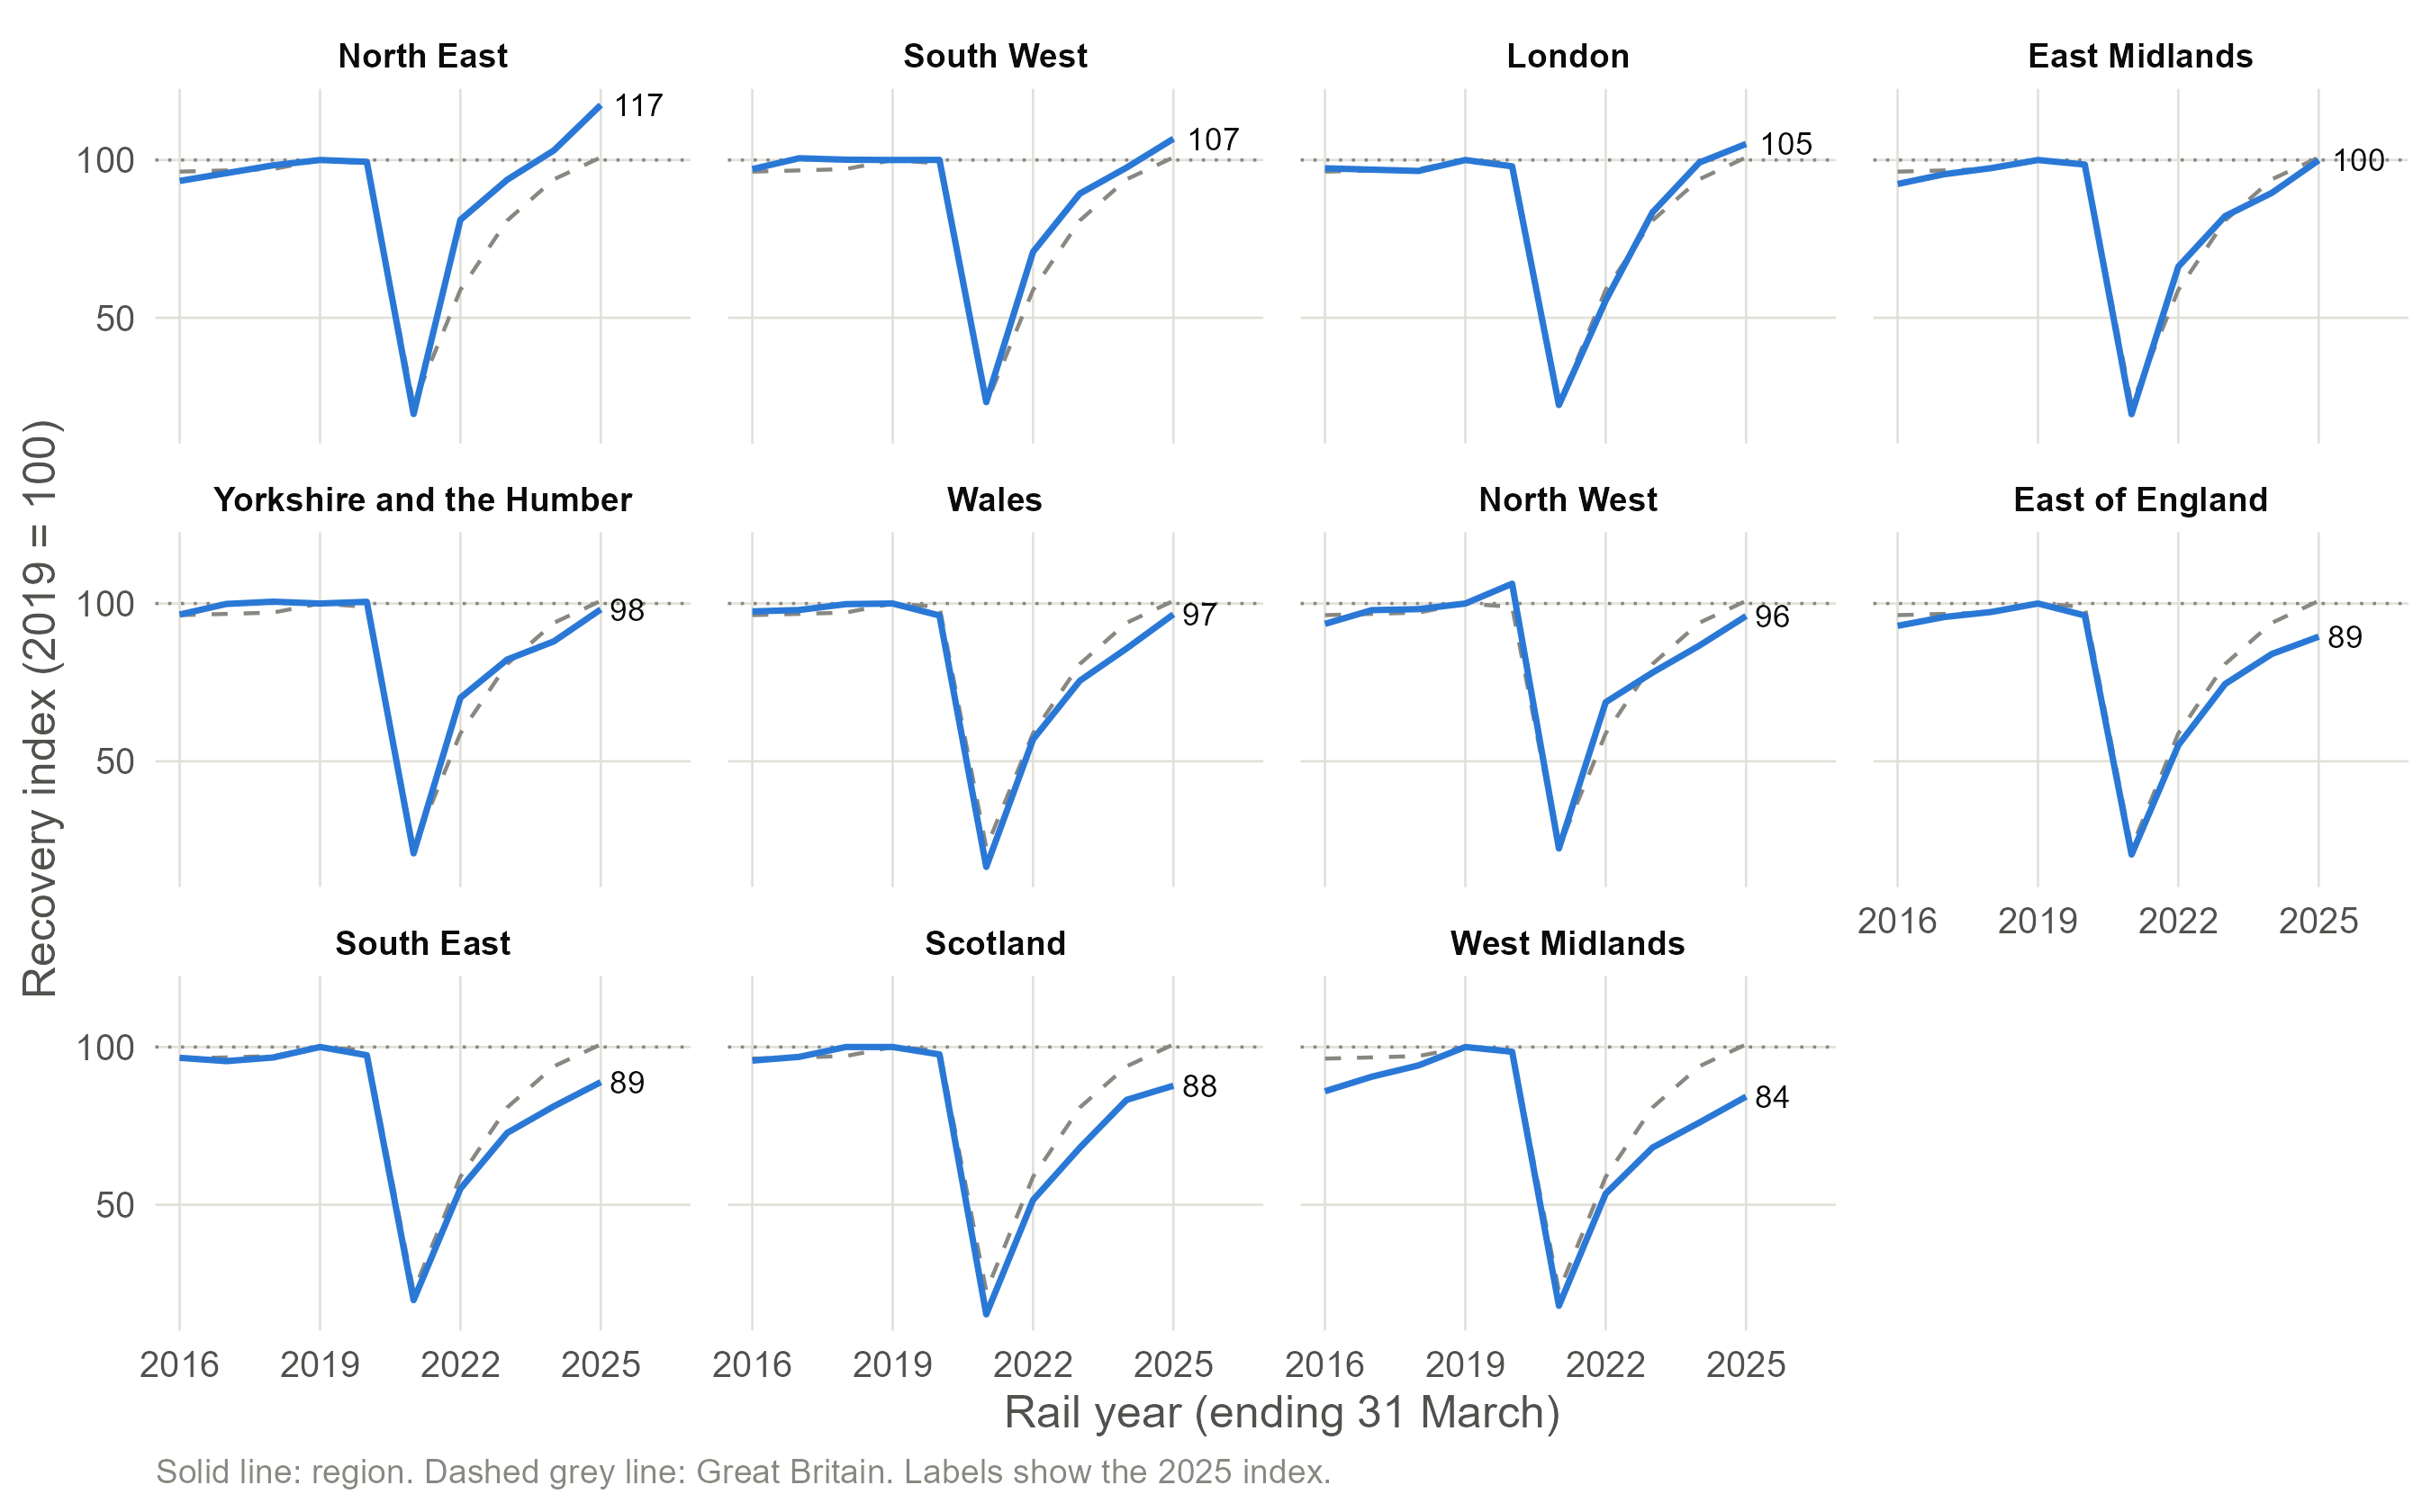
Figure 3. Regional recovery trajectories, 2016-2025, indexed to 2019 = 100 (solid lines), with the national trajectory overlaid (dashed). Panels ordered by 2025 index.
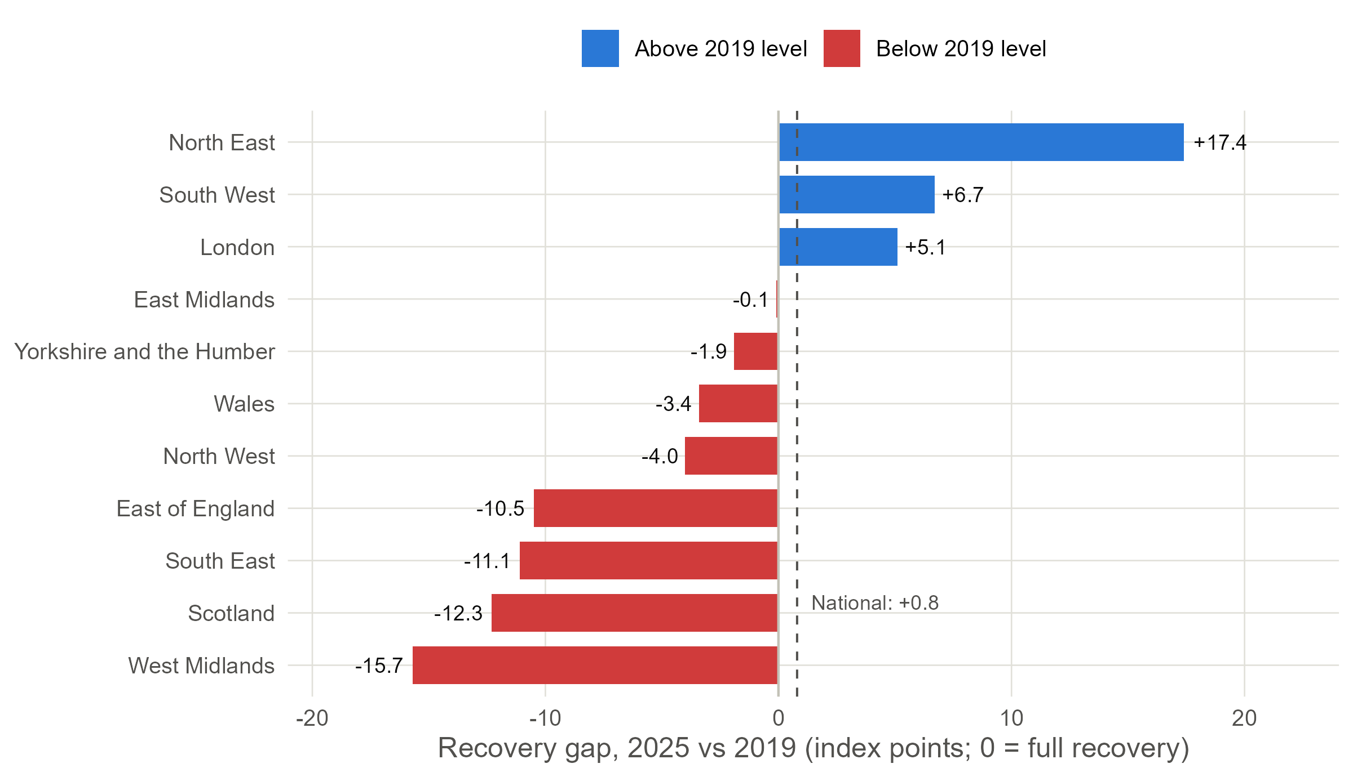
Figure 4. Recovery gap by region, 2025 versus the 2019 baseline (index points). Blue regions exceed their 2019 level; red regions remain below it. The dashed line marks the national gap (+0.8).
Table 2. Regional recovery metrics, 2025. Index and gap are relative to 2019 = 100; the trend shortfall compares actual 2025 journeys with a linear projection of the region's 2010-2019 trend; clusters from k-means (k = 2) on standardised 2021-2025 indices.
Region | Journeys 2025 (m) | Index 2025 | Recovery gap | Vs 2010-2019 trend (%) | Cluster
North East | 19.1 | 117.4 | +17.4 | +4.8 | Stronger recovery
South West | 55.7 | 106.7 | +6.7 | -10.0 | Stronger recovery
London | 1008.7 | 105.1 | +5.1 | -16.5 | Stronger recovery
East Midlands | 36.4 | 99.9 | -0.1 | -13.5 | Stronger recovery
Yorkshire and the Humber | 72.0 | 98.1 | -1.9 | -17.8 | Stronger recovery
Wales | 30.0 | 96.6 | -3.4 | -13.7 | Weaker recovery
North West | 131.4 | 96.0 | -4.0 | -17.5 | Stronger recovery
East of England | 173.4 | 89.5 | -10.5 | -25.4 | Weaker recovery
South East | 279.3 | 88.9 | -11.1 | -20.8 | Weaker recovery
Scotland | 89.4 | 87.7 | -12.3 | -25.0 | Weaker recovery
West Midlands | 85.1 | 84.3 | -15.7 | -32.3 | Weaker recovery

K-means clustering of the 2021-2025 trajectories separates the regions into two groups (average silhouette width 0.43 for k = 2, against 0.37 for k = 3), shown in Figure 5: a stronger-recovery cluster (North East, South West, London, East Midlands, Yorkshire and the Humber, North West) and a weaker-recovery cluster (Wales, East of England, South East, Scotland, West Midlands). The clustering is informative beyond the 2025 endpoint: the North West (gap -4.0) joins the stronger cluster on its steeper post-2022 momentum, while Wales, with a smaller gap (-3.4) but a flatter recent path, falls in the weaker cluster. Recovery is a trajectory, not a single number.
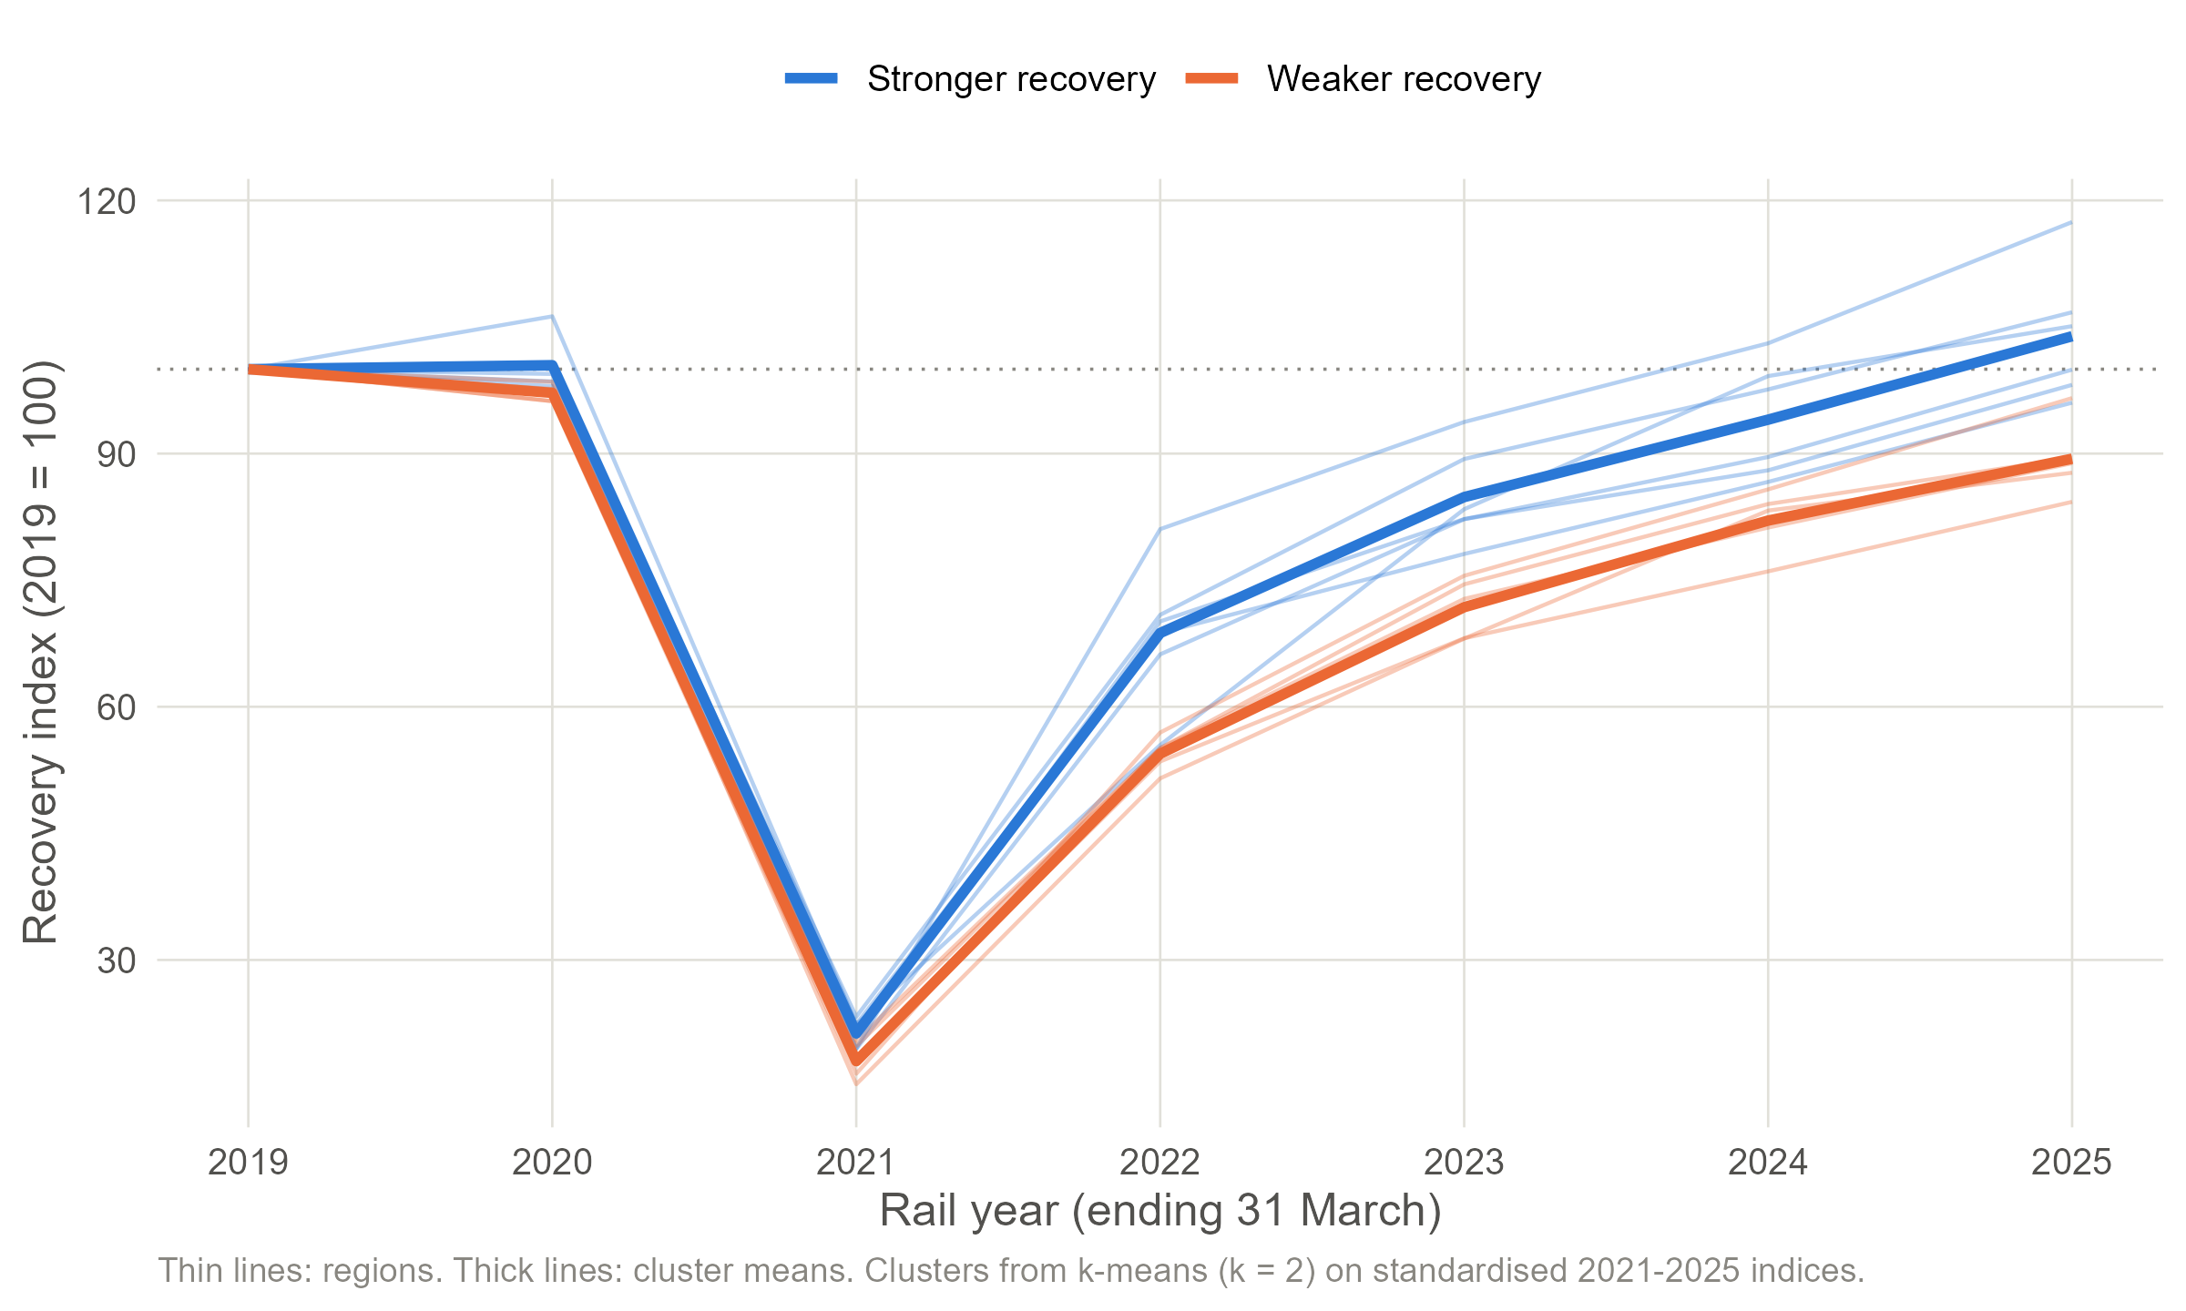
Figure 5. K-means clusters of regional recovery trajectories (k = 2). Thin lines are regions; thick lines are cluster means.

3.3 Regional patterns versus the national trend (RQ3)
The national recovery figure is not representative of the typical region: the national gap of +0.8 sits above eight of the eleven regional gaps. The explanation is compositional. London accounted for 50.9% of all regional journey legs in 2025, so its +5.1 gap, worth about 49 million additional journeys relative to 2019, mechanically pulls the national index above 100 while most regions remain below baseline; the South East alone lost 35 million journeys. National recovery is, in large part, London's recovery.
The counterfactual comparison strengthens this conclusion (Figure 6, Table 2). Measured against their own 2010-2019 trends, every region except the North East (+4.8%) remains below projection, including all three regions above their 2019 levels: even London is 16.5% short of its pre-pandemic trajectory, and the West Midlands, which grew fastest before the pandemic (5.7% per year), shows the largest shortfall at -32.3%. Judged against trend rather than level, no broad-based recovery has yet occurred outside the North East.
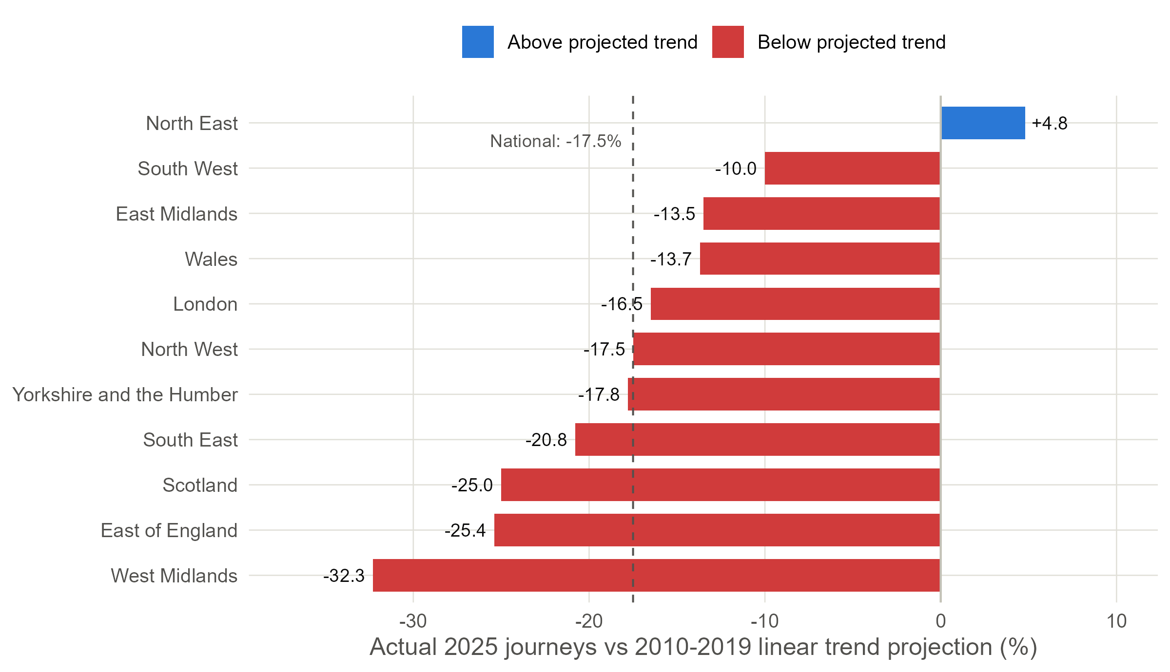
Figure 6. Actual 2025 journeys versus a linear projection of each region's 2010-2019 trend. The dashed line marks the national shortfall (-17.5%).

3.4 Station-level recovery: inside the regional averages (RQ2)
Station-level indices reveal substantial heterogeneity within regions (Figure 7). Across 2,554 stations, only 43.1% had returned to their 2019 usage by 2025. The contrast with regional aggregates is starkest in London: total journeys are 5.1% above baseline, yet the median London station stands at 88.5 and fewer than a third of London stations (31.6%) have recovered. Aggregate recovery there is concentrated in a few very large stations, consistent with the May 2022 opening of the Elizabeth line's central section, which ORR notes substantially uplifted recorded journeys at stations such as Liverpool Street, Paddington and Farringdon (ORR, 2025a, 2025c). The North East shows the opposite pattern: broad-based recovery (84.9% of stations at or above baseline, median 126), reinforced by the Northumberland Line reopening between Newcastle and Ashington from December 2024 (Northumberland County Council, 2024).
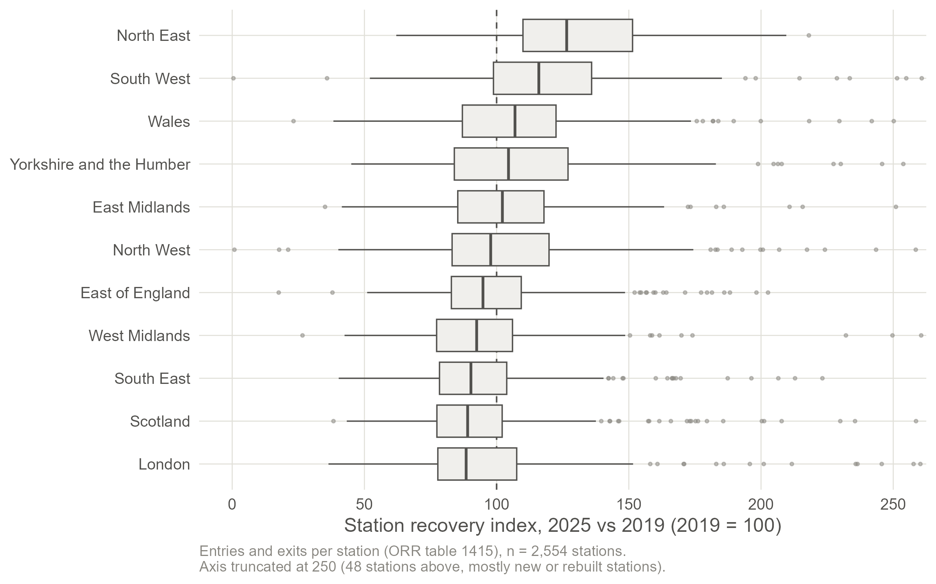
Figure 7. Distribution of station-level recovery indices by region, 2025 versus 2019 (ORR Table 1415a). The dashed line marks full recovery (100).

3.5 Interpretation and relation to existing research
The geography of the recovery gap is consistent with what is known about post-pandemic working patterns. The regions furthest below baseline, the South East and East of England, are those whose pre-pandemic demand depended most on radial commuting into London, the segment most exposed to hybrid working: rail commuters cut office attendance by more than half (Magrico et al., 2023), season tickets fell from 34% to 13% of journeys (ORR, 2025a), and access to hybrid work is highest in London and professional occupations (ONS, 2025). Conversely, the strongest performers, the North East and South West, have demand weighted towards leisure and regional travel. This matches Vickerman's (2021) argument that the post-COVID railway would serve a different mix of purposes rather than simply less of the same.
The correlation analysis adds a cautionary nuance: none of the three regional characteristics tested correlates significantly with the recovery gap at n = 11 (all p > 0.16; Table 3). Together with the wide within-region dispersion in Figure 7, this suggests recovery is shaped at a finer spatial scale than the region, by specific flows, station catchments and line-level service changes, so regional aggregates can describe uneven recovery but not explain it. The policy implications are direct: national demand figures should not guide regional service or investment decisions; revenue remains below pre-pandemic levels in real terms even as journeys recover (ORR, 2025a); and the concentration of recovery in leisure markets and a few large hubs argues for regionally differentiated planning targeted at the weaker-recovery cluster identified here.
Table 3. Correlations between regional characteristics and the 2025 recovery gap (n = 11 regions).
Characteristic | Pearson r | p | Spearman rho | p
Pre-pandemic growth (CAGR 2010-2019, %) | -0.29 | 0.380 | -0.15 | 0.650
Market size (log10 journeys, 2019) | -0.38 | 0.249 | -0.45 | 0.170
Inter-regional journey share, 2019 (%) | 0.22 | 0.525 | 0.28 | 0.401

3.6 Answers to the research questions
RQ1: National usage grew steadily for two decades, collapsed to 22.6% of the 2019 baseline in 2021, and by 2025 stood 0.8% above the 2019 level (Figure 2). The recovery is structurally partial: inter-regional travel remains 9.8% below 2019, season tickets fell from 34% to 13% of journeys, and demand is 17.5% below the pre-pandemic trend projection.
RQ2: Recovery is markedly uneven. Regional gaps span 33 index points, from +17.4 (North East) to -15.7 (West Midlands), with only three regions above baseline (Figures 3 and 4, Table 2); clustering separates stronger and weaker trajectory groups (Figure 5). Unevenness is at least as large within regions: fewer than half of stations have recovered, and London's above-baseline aggregate coexists with a median station at 88.5 (Figure 7).
RQ3: The national trend does not represent regional experience. The national gap (+0.8) exceeds eight of eleven regional gaps and is driven by London's 50.9% share of journey legs; against pre-pandemic trends, every region except the North East remains in shortfall (Figure 6). Aggregate indicators therefore overstate the breadth of Britain's rail recovery.

4. R Code and GitHub Pages
All materials are published at https://github.com/Qjins/IJC437-UK-Rail-Recovery. The repository preserves the raw ORR tables (01_data/raw), cleaned datasets (01_data/processed), the three numbered analysis scripts (02_scripts), all figures (03_figures) and this report (05_report). The README states the research questions exactly as in Section 1.2, summarises the key findings, lists required R packages and gives step-by-step instructions for reproducing every result from the raw data. The code follows a consistent style with meaningful variable names and comments explaining intent rather than mechanics; full listings are in Appendix A. A companion repository for the IJC445 Data Visualisation module, which uses the same source data for a visualisation-focused brief, is linked from the README.

5. Conclusions
This project used official ORR statistics to quantify how unevenly rail demand in Great Britain has recovered from COVID-19. Nationally, the railway regained its pre-pandemic passenger numbers by 2025, but the recovery is narrow: concentrated in London and a minority of regions, driven by within-region and leisure travel rather than commuting, visible at fewer than half of stations, and 17.5% below the pre-pandemic trajectory. National indicators systematically overstate the breadth of recovery.

5.1 Reflections

Key findings
- Only three of eleven regions (North East, South West, London) exceeded their 2019 passenger levels in 2025; the recovery gap spans +17.4 to -15.7 index points (Section 3.2).
- The national figure (+0.8) is composition-driven: London supplies half of regional journey legs, and against 2010-2019 trends every region except the North East remains in shortfall (Section 3.3).
- Recovery is even more uneven within regions: 43.1% of stations have recovered, and London combines an above-baseline aggregate with a below-baseline typical station (Section 3.4).

Limitations, assumptions and weaknesses
- Regional totals double-count inter-regional journeys and aggregate heterogeneous markets; annual data hide seasonal and weekday/weekend patterns.
- ORR series breaks (2009, 2023, and 2019-2020 for the North West) and the growth of split ticketing mean levels are not perfectly comparable over time, and recovery may be slightly overstated (ORR, 2025a).
- The linear counterfactual assumes pre-pandemic growth would have continued; it is a benchmark, not a forecast.
- With eleven regions, correlation tests have little power, and the analysis is descriptive: no causal claims are made about why particular regions lag.
- Station entries and exits are estimates and measure a different quantity from journey counts.

Lessons learned
The most valuable lesson was methodological humility about data quality: a single fragile regular expression silently deleted an entire region's baseline from the first version of this analysis, and only systematic completeness checks exposed it. Rebuilding the pipeline with explicit validation and a fixed seed made every number in this report reproducible from the raw files. A second lesson is that a single metric can mislead: level recovery, trend recovery and within-region distributions tell materially different stories, and reporting them together is what makes the analysis useful.

5.2 Engagement
Three engagement activities during the module directly shaped this project. First, the Week 8 session on scoping data science projects, held alongside Industry Week, examined why data-driven projects fail and placed data quality and reproducibility among the leading causes. That framing changed how I treated the silent data-loss defect found in my own pipeline: rather than a bug to patch quietly, I documented it in the methodology as evidence of why validation belongs in the workflow. Second, the Week 10 guest lecture by Paul Clough, a principal data science and AI consultant, on how organisations become data-driven, emphasised that analysis only creates value when a decision-maker can act on it; this influenced the choice of an interpretable index (a planner can read a gap of -10 directly as 10% below pre-pandemic demand) and the decision to report honest null correlation results instead of overclaiming. Third, employability and alumni sessions stressed that a public, well-documented GitHub repository is itself a professional artefact, which motivated its structure and README. Collectively these sessions also sharpened the social dimension of the analysis: uneven rail recovery is an equity question about which communities the post-pandemic railway serves.

References
Beck, M. J., & Hensher, D. A. (2020). Insights into the impact of COVID-19 on household travel and activities in Australia: The early days of easing restrictions. Transport Policy, 99, 95-119. https://doi.org/10.1016/j.tranpol.2020.08.004
Gkiotsalitis, K., & Cats, O. (2021). Public transport planning adaption under the COVID-19 pandemic crisis: Literature review of research needs and directions. Transport Reviews, 41(3), 374-392. https://doi.org/10.1080/01441647.2020.1857886
Jain, A. K. (2010). Data clustering: 50 years beyond K-means. Pattern Recognition Letters, 31(8), 651-666. https://doi.org/10.1016/j.patrec.2009.09.011
Magrico, D., Sheehy, C., Siraut, J., & Fuller, T. (2023). Survey evidence on COVID-19 and its impact on rail commuting patterns in Great Britain. Case Studies on Transport Policy, 11, 100965. https://doi.org/10.1016/j.cstp.2023.100965
Northumberland County Council. (2024, December 15). A new dawn for travel - as Northumberland Line opens to passengers. https://www.northumberland.gov.uk/news/new-dawn-travel-northumberland-line-opens-passengers
Office for National Statistics. (2025, June 11). Who has access to hybrid work in Great Britain? https://www.ons.gov.uk/employmentandlabourmarket/peopleinwork/employmentandemployeetypes/articles/whohasaccesstohybridworkingreatbritain/2025-06-11
Office of Rail and Road. (2025a). Passenger rail usage: January to March 2025 [Statistical release]. https://dataportal.orr.gov.uk/statistics/usage/passenger-rail-usage/
Office of Rail and Road. (2025b). Regional rail usage: April 2024 to March 2025 [Statistical release]. https://dataportal.orr.gov.uk/statistics/usage/regional-rail-usage/
Office of Rail and Road. (2025c). Estimates of station usage: April 2024 to March 2025 [Statistical release]. https://dataportal.orr.gov.uk/statistics/usage/estimates-of-station-usage/
R Core Team. (2025). R: A language and environment for statistical computing (Version 4.5.1) [Computer software]. R Foundation for Statistical Computing. https://www.R-project.org/
Rousseeuw, P. J. (1987). Silhouettes: A graphical aid to the interpretation and validation of cluster analysis. Journal of Computational and Applied Mathematics, 20, 53-65. https://doi.org/10.1016/0377-0427(87)90125-7
Tukey, J. W. (1977). Exploratory data analysis. Addison-Wesley.
Vickerman, R. (2021). Will Covid-19 put the public back in public transport? A UK perspective. Transport Policy, 103, 95-102. https://doi.org/10.1016/j.tranpol.2021.01.005
Wickham, H., Averick, M., Bryan, J., Chang, W., McGowan, L. D., Francois, R., Grolemund, G., Hayes, A., Henry, L., Hester, J., Kuhn, M., Pedersen, T. L., Miller, E., Bache, S. M., Muller, K., Ooms, J., Robinson, D., Seidel, D. P., Spinu, V., ... Yutani, H. (2019). Welcome to the tidyverse. Journal of Open Source Software, 4(43), 1686. https://doi.org/10.21105/joss.01686
Zhang, J., Hayashi, Y., & Frank, L. D. (2021). COVID-19 and transport: Findings from a world-wide expert survey. Transport Policy, 103, 68-85. https://doi.org/10.1016/j.tranpol.2021.01.011

Appendix A: R code
The three scripts below reproduce every result in this report when run in order from the repository root. They are also available at https://github.com/Qjins/IJC437-UK-Rail-Recovery.

A.1 01_data_cleaning.R
# ============================================================
# IJC437 - Script 01: Data cleaning
#
# Builds tidy datasets from the raw ORR ODS tables.
#
# Input (raw ORR tables, Open Government Licence):
# 01_data/raw/national/table-1510-... .ods (GB total journeys)
# 01_data/raw/regional/table-15XX-... .ods (10 regional tables)
# 01_data/raw/station/table-1415-... .ods (station entries & exits)
#
# Output:
# 01_data/processed/national_time_series.csv
# 01_data/processed/regional_time_series.csv
# 01_data/processed/station_recovery.csv
#
# Notes on the raw format:
# - Each regional file holds the data in the sheet named
# "15XX_journeys_<region>"; the first table (columns A-D) gives
# journeys to/from other regions, within the region, and the total.
# - Years are rail years running April to March. Throughout this
# project a year label refers to the END of the rail year, so
# 2019 = April 2018 to March 2019.
# - ORR marks breaks in the time series with "[b]" appended to the
# time-period label (e.g. "Apr 2022 to Mar 2023 [b]"). The first
# version of this pipeline extracted the year with the regex
# "\\d{4}$", which silently failed on those rows and dropped
# them. The regex below anchors on "Mar <year>" instead, so
# flagged rows are retained and the break is kept as a variable.
#
# Working directory must be the project root: IJC437-UK-Rail-Recovery
# ============================================================
library(tidyverse)
library(readODS)
# ------------------------------------------------------------
# 0. Locate project root
# ------------------------------------------------------------
if (basename(getwd()) == "02_scripts") setwd(dirname(getwd()))
if (!dir.exists("01_data")) {
stop("Project root not detected. Set the working directory to IJC437-UK-Rail-Recovery.")
}
dir.create("01_data/processed", showWarnings = FALSE, recursive = TRUE)
# ------------------------------------------------------------
# 1. Helper functions shared by all ORR tables
# ------------------------------------------------------------
# Rail years are labelled by their end year: "Apr 2018 to Mar 2019" -> 2019.
# Anchoring on "Mar " keeps rows whose label carries a footnote such as "[b]".
extract_end_year <- function(time_period) {
as.integer(str_extract(time_period, "(?<=Mar )\\d{4}"))
}
# ORR uses shorthand codes ([x] not available, [z] not applicable,
# [b] break in series) inside data cells; coerce those to NA quietly.
to_numeric <- function(x) {
suppressWarnings(as.numeric(gsub(",", "", as.character(x))))
}
# The data sheet is the one whose name contains "journeys"
# (e.g. "1560_journeys_north_west", "1510_journeys_great_britain").
data_sheet <- function(file_path) {
sheets <- list_ods_sheets(file_path)
sheets[str_detect(sheets, "journeys")][1]
}
# Consistent region names across the regional and station tables
# (the raw files disagree on capitalisation, e.g. "East of England"
# in table 1415 vs the file name "east-of-england" in table 1545).
tidy_region_name <- function(x) {
str_to_title(x) |>
str_replace_all(c(" Of " = " of ", " And The " = " and the "))
}
region_label <- function(file_path) {
tools::file_path_sans_ext(basename(file_path)) |>
str_replace("^table-\\d+-regional-passenger-journeys-", "") |>
str_replace_all("-", " ") |>
tidy_region_name()
}
# ------------------------------------------------------------
# 2. Regional tables (1540-1590): one tidy panel
# ------------------------------------------------------------
regional_files <- list.files("01_data/raw/regional", full.names = TRUE, pattern = "\\.ods$")
regional_files <- regional_files[!str_detect(regional_files, "~\\$")] # drop editor lock files
stopifnot(length(regional_files) == 11)
clean_regional <- function(file_path) {
read_ods(file_path, sheet = data_sheet(file_path), skip = 5, col_names = TRUE) |>
select(1:4) |>
set_names(c("time_period", "interregional_thousands", "within_thousands", "total_thousands")) |>
mutate(
year = extract_end_year(time_period),
series_break = str_detect(time_period, fixed("[b]")),
region = region_label(file_path),
journeys_interregional = round(to_numeric(interregional_thousands) * 1000),
journeys_within = round(to_numeric(within_thousands) * 1000),
journeys_total = round(to_numeric(total_thousands) * 1000)
) |>
filter(!is.na(year)) |>
select(year, region, journeys_total, journeys_within, journeys_interregional, series_break)
}
regional <- map(regional_files, clean_regional) |>
list_rbind() |>
arrange(region, year)
# Completeness check: every region should now cover 1996-2025 with no gaps
completeness <- regional |>
summarise(n_years = n_distinct(year), missing_values = sum(is.na(journeys_total)), .by = region)
print(completeness)
stopifnot(all(completeness$n_years == 30), all(completeness$missing_values == 0))
write_csv(regional, "01_data/processed/regional_time_series.csv")
# ------------------------------------------------------------
# 3. National table (1510): GB total journeys
# ------------------------------------------------------------
national_file <- list.files("01_data/raw/national", full.names = TRUE, pattern = "\\.ods$")[1]
national <- read_ods(national_file, sheet = data_sheet(national_file), skip = 4, col_names = TRUE) |>
select(1:4) |>
set_names(c("time_period", "between_thousands", "within_thousands", "total_thousands")) |>
mutate(
year = extract_end_year(time_period),
series_break = str_detect(time_period, fixed("[b]")),
journeys_total = round(to_numeric(total_thousands) * 1000)
) |>
filter(!is.na(year)) |>
select(year, journeys_total, series_break)
stopifnot(nrow(national) == 30, !any(is.na(national$journeys_total)))
write_csv(national, "01_data/processed/national_time_series.csv")
# ------------------------------------------------------------
# 4. Station table (1415a): entries & exits, wide -> long
# Kept only for the 2019 baseline and 2025 comparison years,
# which is all the station-level analysis needs.
# ------------------------------------------------------------
station_file <- list.files("01_data/raw/station", full.names = TRUE, pattern = "\\.ods$")[1]
station_raw <- read_ods(station_file, sheet = "1415a_Entries_and_Exits", skip = 3, col_names = TRUE)
station <- station_raw |>
rename(station = `Station name`, region = Region) |>
mutate(region = tidy_region_name(region)) |>
select(station, region,
entries_exits_2019 = matches("Apr 2018 to Mar 2019"),
entries_exits_2025 = matches("Apr 2024 to Mar 2025")) |>
mutate(across(starts_with("entries_exits"), to_numeric)) |>
filter(!is.na(entries_exits_2019), !is.na(entries_exits_2025),
entries_exits_2019 > 0, region %in% unique(regional$region)) |>
mutate(recovery_index = entries_exits_2025 / entries_exits_2019 * 100)
cat("Stations with usable 2019 and 2025 values:", nrow(station), "\n")
write_csv(station, "01_data/processed/station_recovery.csv")
cat("Data cleaning complete.\n")

A.2 02_analysis_recovery.R
# ============================================================
# IJC437 - Script 02: Analysis
#
# Quantifies post-pandemic recovery of UK rail passenger usage:
# 1. 2019-baseline recovery index and recovery gap by region
# 2. Regional vs national comparison (RQ3)
# 3. Linear-trend counterfactual: where would demand be in 2025
# had the 2010-2019 trend continued? (regression/prediction)
# 4. Correlates of recovery (pre-pandemic growth, market size,
# inter-regional journey share)
# 5. K-means clustering of recovery trajectories 2021-2025
# 6. Station-level recovery summary (within-region variation)
#
# Input: 01_data/processed/*.csv (from 01_data_cleaning.R)
# Output: 01_data/processed/rail_indexed_2019.csv
# 01_data/processed/recovery_gap_2019_2025.csv
# 01_data/processed/counterfactual_2025.csv
# 01_data/processed/recovery_correlates.csv
# 01_data/processed/recovery_clusters.csv
# 01_data/processed/station_summary_by_region.csv
#
# Baseline definition: 2019 = rail year April 2018 to March 2019,
# the last complete rail year unaffected by the pandemic (the
# 2019-20 rail year already includes the March 2020 lockdown).
# ============================================================
library(tidyverse)
library(cluster) # silhouette widths for choosing k
if (basename(getwd()) == "02_scripts") setwd(dirname(getwd()))
if (!dir.exists("01_data")) stop("Set the working directory to the project root.")
set.seed(437) # reproducible k-means
baseline_year <- 2019
comparison_year <- 2025
trend_years <- 2010:2019 # consistent post-2009-break, pre-pandemic decade
regional <- read_csv("01_data/processed/regional_time_series.csv", show_col_types = FALSE)
national <- read_csv("01_data/processed/national_time_series.csv", show_col_types = FALSE)
station <- read_csv("01_data/processed/station_recovery.csv", show_col_types = FALSE)
# ------------------------------------------------------------
# 1. Recovery index (2019 = 100) and recovery gap by region
# ------------------------------------------------------------
baseline <- regional |>
filter(year == baseline_year) |>
select(region, baseline_journeys = journeys_total)
regional_indexed <- regional |>
left_join(baseline, by = "region") |>
mutate(index_2019 = journeys_total / baseline_journeys * 100)
write_csv(regional_indexed, "01_data/processed/rail_indexed_2019.csv")
national_indexed <- national |>
mutate(index_2019 = journeys_total / journeys_total[year == baseline_year] * 100)
recovery_gap <- regional_indexed |>
filter(year == comparison_year) |>
transmute(region,
journeys_2019_m = round(baseline_journeys / 1e6, 1),
journeys_2025_m = round(journeys_total / 1e6, 1),
index_2025 = round(index_2019, 1),
recovery_gap = round(index_2019 - 100, 1)) |>
arrange(desc(recovery_gap))
national_index_2025 <- national_indexed$index_2019[national_indexed$year == comparison_year]
cat(sprintf("National recovery index 2025 (2019 = 100): %.1f\n", national_index_2025))
cat(sprintf("Regions at or above the 2019 baseline: %d of %d\n\n",
sum(recovery_gap$recovery_gap >= 0), nrow(recovery_gap)))
print(recovery_gap)
write_csv(recovery_gap, "01_data/processed/recovery_gap_2019_2025.csv")
# ------------------------------------------------------------
# 2. Linear-trend counterfactual for 2025
# A separate OLS regression of journeys on year is fitted for
# each region over 2010-2019, then extrapolated to 2025. The
# shortfall compares actual 2025 demand with that projection,
# i.e. recovery measured against where demand was heading
# rather than where it stood in 2019.
# ------------------------------------------------------------
fit_counterfactual <- function(df) {
model <- lm(journeys_total ~ year, data = filter(df, year %in% trend_years))
predicted_2025 <- predict(model, newdata = tibble(year = comparison_year))
tibble(
predicted_2025 = predicted_2025,
r_squared = summary(model)$r.squared,
annual_growth_m = round(coef(model)["year"] / 1e6, 2)
)
}
counterfactual <- regional |>
group_by(region) |>
group_modify(~ fit_counterfactual(.x)) |>
ungroup() |>
left_join(filter(regional, year == comparison_year) |> select(region, actual_2025 = journeys_total),
by = "region") |>
mutate(shortfall_pct = round((actual_2025 - predicted_2025) / predicted_2025 * 100, 1),
predicted_2025_m = round(predicted_2025 / 1e6, 1),
actual_2025_m = round(actual_2025 / 1e6, 1)) |>
select(region, actual_2025_m, predicted_2025_m, shortfall_pct, r_squared, annual_growth_m) |>
arrange(shortfall_pct)
national_model <- lm(journeys_total ~ year, data = filter(national, year %in% trend_years))
national_pred <- predict(national_model, newdata = tibble(year = comparison_year))
national_actual <- national$journeys_total[national$year == comparison_year]
cat(sprintf("\nNational 2025 vs 2010-2019 trend: %.1f%% (trend R^2 = %.3f)\n",
(national_actual - national_pred) / national_pred * 100,
summary(national_model)$r.squared))
print(counterfactual)
write_csv(counterfactual, "01_data/processed/counterfactual_2025.csv")
# ------------------------------------------------------------
# 3. Correlates of the recovery gap
# Small sample (n = 11 regions), so Pearson and Spearman are
# both reported and results are treated as indicative only.
# ------------------------------------------------------------
correlates_data <- regional |>
filter(year == baseline_year) |>
transmute(region,
log_journeys_2019 = log10(journeys_total),
interregional_share_2019 = journeys_interregional / journeys_total * 100) |>
left_join(
regional |>
filter(year %in% range(trend_years)) |>
select(region, year, journeys_total) |>
pivot_wider(names_from = year, values_from = journeys_total, names_prefix = "y") |>
mutate(cagr_2010_2019 = ((y2019 / y2010)^(1 / 9) - 1) * 100) |>
select(region, cagr_2010_2019),
by = "region") |>
left_join(select(recovery_gap, region, recovery_gap), by = "region")
test_correlate <- function(x_name) {
p <- cor.test(correlates_data[[x_name]], correlates_data$recovery_gap, method = "pearson")
s <- cor.test(correlates_data[[x_name]], correlates_data$recovery_gap, method = "spearman", exact = FALSE)
tibble(variable = x_name,
pearson_r = round(p$estimate, 2), pearson_p = round(p$p.value, 3),
spearman_rho = round(s$estimate, 2), spearman_p = round(s$p.value, 3))
}
correlations <- map(c("cagr_2010_2019", "log_journeys_2019", "interregional_share_2019"),
test_correlate) |> list_rbind()
cat("\nCorrelates of the 2025 recovery gap (n = 11 regions):\n")
print(correlations)
write_csv(correlates_data, "01_data/processed/recovery_correlates_data.csv")
write_csv(correlations, "01_data/processed/recovery_correlates.csv")
# ------------------------------------------------------------
# 4. K-means clustering of recovery trajectories
# Features: recovery index in each pandemic/recovery year
# (2021-2025), standardised. k chosen by average silhouette
# width over k = 2..4.
# ------------------------------------------------------------
trajectory_features <- regional_indexed |>
filter(year >= 2021) |>
select(region, year, index_2019) |>
pivot_wider(names_from = year, values_from = index_2019, names_prefix = "index_") |>
column_to_rownames("region")
scaled_features <- scale(trajectory_features)
silhouette_width <- function(k) {
km <- kmeans(scaled_features, centers = k, nstart = 50)
mean(silhouette(km$cluster, dist(scaled_features))[, "sil_width"])
}
sil <- tibble(k = 2:4, avg_silhouette = map_dbl(k, silhouette_width))
cat("\nAverage silhouette width by k:\n"); print(sil)
best_k <- sil$k[which.max(sil$avg_silhouette)]
km_final <- kmeans(scaled_features, centers = best_k, nstart = 50)
clusters <- tibble(region = rownames(trajectory_features),
cluster = km_final$cluster) |>
left_join(select(recovery_gap, region, recovery_gap), by = "region") |>
arrange(cluster, desc(recovery_gap))
# Label clusters by their mean recovery gap so the labels are data-driven
label_sets <- list(
`2` = c("Stronger recovery", "Weaker recovery"),
`3` = c("Recovered / above baseline", "Near baseline", "Lagging recovery"),
`4` = c("Recovered / above baseline", "Near baseline", "Lagging recovery", "Weakest recovery")
)
cluster_labels <- clusters |>
summarise(mean_gap = mean(recovery_gap), .by = cluster) |>
arrange(desc(mean_gap)) |>
mutate(cluster_label = label_sets[[as.character(best_k)]][seq_len(n())])
clusters <- left_join(clusters, cluster_labels, by = "cluster")
cat(sprintf("\nK-means clusters (k = %d):\n", best_k))
print(clusters)
write_csv(clusters, "01_data/processed/recovery_clusters.csv")
# ------------------------------------------------------------
# 5. Station-level recovery: variation within regions
# ------------------------------------------------------------
station_summary <- station |>
summarise(n_stations = n(),
median_index = round(median(recovery_index), 1),
q1 = round(quantile(recovery_index, 0.25), 1),
q3 = round(quantile(recovery_index, 0.75), 1),
share_recovered_pct = round(mean(recovery_index >= 100) * 100, 1),
.by = region) |>
arrange(desc(median_index))
cat("\nStation-level recovery by region (index, 2019 = 100):\n")
print(station_summary)
cat(sprintf("\nGB stations at or above their 2019 usage: %.1f%% of %d stations\n",
mean(station$recovery_index >= 100) * 100, nrow(station)))
write_csv(station_summary, "01_data/processed/station_summary_by_region.csv")
cat("\nAnalysis complete.\n")

A.3 03_figures.R
# ============================================================
# IJC437 - Script 03: Report figures
#
# Produces every figure used in the report:
# fig1_methodology_workflow.png - data science process diagram
# fig2_national_trend.png - GB journeys 1996-2025 (RQ1)
# fig3_regional_trajectories.png - indexed regional paths vs national (RQ2, RQ3)
# fig4_recovery_gap.png - recovery gap by region, 2025 vs 2019 (RQ2)
# fig5_counterfactual.png - 2025 vs 2010-2019 trend projection (RQ3)
# fig6_clusters.png - k-means recovery trajectory clusters (RQ2)
# fig7_station_recovery.png - station-level recovery by region (RQ2)
#
# Input: 01_data/processed/*.csv (from scripts 01 and 02)
# Output: 03_figures/*.png (300 dpi)
# ============================================================
library(tidyverse)
if (basename(getwd()) == "02_scripts") setwd(dirname(getwd()))
if (!dir.exists("03_figures")) dir.create("03_figures")
# ---- shared style ------------------------------------------------
col_blue <- "#2a78d6" # primary series / above baseline
col_red <- "#d03b3b" # below baseline
col_orange <- "#eb6834" # second categorical series (cluster 2)
col_ink <- "#0b0b0b"
col_ink2 <- "#52514e"
col_muted <- "#898781"
col_grid <- "#e1e0d9"
col_axis <- "#c3c2b7"
theme_report <- function(base_size = 12) {
theme_minimal(base_size = base_size) +
theme(
panel.grid.minor = element_blank(),
panel.grid.major = element_line(colour = col_grid, linewidth = 0.3),
axis.text = element_text(colour = col_ink2),
axis.title = element_text(colour = col_ink2),
plot.title = element_text(face = "bold", colour = col_ink, size = base_size + 2),
plot.subtitle = element_text(colour = col_ink2, margin = margin(b = 8)),
plot.caption = element_text(colour = col_muted, size = base_size - 3, hjust = 0),
plot.title.position = "plot",
legend.position = "top"
)
}
save_fig <- function(name, plot, width, height) {
ggsave(file.path("03_figures", name), plot,
width = width, height = height, dpi = 300, bg = "white")
cat("Saved", name, "\n")
}
regional_indexed <- read_csv("01_data/processed/rail_indexed_2019.csv", show_col_types = FALSE)
national <- read_csv("01_data/processed/national_time_series.csv", show_col_types = FALSE)
recovery_gap <- read_csv("01_data/processed/recovery_gap_2019_2025.csv",show_col_types = FALSE)
counterfactual <- read_csv("01_data/processed/counterfactual_2025.csv", show_col_types = FALSE)
clusters <- read_csv("01_data/processed/recovery_clusters.csv", show_col_types = FALSE)
station <- read_csv("01_data/processed/station_recovery.csv", show_col_types = FALSE)
national_indexed <- national |>
mutate(index_2019 = journeys_total / journeys_total[year == 2019] * 100)
national_index_2025 <- round(national_indexed$index_2019[national_indexed$year == 2025] - 100, 1)
# ------------------------------------------------------------------
# Figure 1: methodology workflow
# ------------------------------------------------------------------
stages <- tribble(
~step, ~label,
1, "Data collection\nORR tables 1510, 1540-1590 (regional journeys) and 1415 (station usage)",
2, "Cleaning and validation\nRobust year parsing, footnote handling ([b], [x], [z]), completeness checks",
3, "Exploratory data analysis\nNational and regional trends before, during and after COVID-19",
4, "Recovery indexing\nJourneys indexed to the 2019 rail year (2019 = 100); recovery gap = index - 100",
5, "Modelling\nLinear-trend counterfactual for 2025 - k-means clustering - correlation analysis",
6, "Interpretation and reporting\nAnswers to RQ1-RQ3, limitations, and links to the literature"
) |>
mutate(y = rev(step))
fig1 <- ggplot(stages) +
geom_rect(aes(xmin = 0, xmax = 10, ymin = y - 0.38, ymax = y + 0.38),
fill = "#f0f4fa", colour = col_blue, linewidth = 0.4) +
geom_text(aes(x = 5, y = y, label = label),
size = 3.2, colour = col_ink, lineheight = 1.05) +
geom_segment(data = filter(stages, step < 6),
aes(x = 5, xend = 5, y = y - 0.38, yend = y - 0.62),
arrow = arrow(length = unit(2.2, "mm"), type = "closed"),
colour = col_ink2, linewidth = 0.5) +
scale_x_continuous(limits = c(0, 10), expand = c(0, 0)) +
theme_void()
save_fig("fig1_methodology_workflow.png", fig1, width = 7.5, height = 5.6)
# ------------------------------------------------------------------
# Figure 2: national trend 1996-2025 (RQ1)
# ------------------------------------------------------------------
pandemic_band <- tibble(xmin = 2020.2, xmax = 2022.2) # rail years ending 2021-2022
fig2 <- ggplot(national, aes(year, journeys_total / 1e9)) +
annotate("rect", xmin = pandemic_band$xmin, xmax = pandemic_band$xmax,
ymin = -Inf, ymax = Inf, fill = "#f0efec") +
annotate("text", x = 2021.2, y = 1.62, label = "COVID-19\nrestrictions",
size = 3.1, colour = col_ink2, lineheight = 1) +
geom_hline(yintercept = national$journeys_total[national$year == 2019] / 1e9,
linetype = "dotted", colour = col_muted, linewidth = 0.4) +
annotate("text", x = 1996.2, y = 1.575, hjust = 0, size = 3.1, colour = col_ink2,
label = "2019 level") +
geom_line(colour = col_blue, linewidth = 0.9) +
geom_point(data = filter(national, year %in% c(2019, 2021, 2025)),
colour = col_blue, size = 2) +
annotate("text", x = 2021, y = 0.28, label = "0.34bn (2021)",
size = 3.1, colour = col_ink2) +
annotate("text", x = 2024.9, y = 1.45, hjust = 1, size = 3.1, colour = col_ink2,
label = "1.53bn (2025)") +
scale_x_continuous(breaks = seq(1996, 2025, 4)) +
scale_y_continuous(limits = c(0, 1.7), expand = c(0, 0)) +
labs(x = "Rail year (ending 31 March)",
y = "Passenger journeys (billions)") +
theme_report()
save_fig("fig2_national_trend.png", fig2, width = 8, height = 4.4)
# ------------------------------------------------------------------
# Figure 3: regional indexed trajectories vs national (RQ2, RQ3)
# ------------------------------------------------------------------
facet_order <- recovery_gap |> arrange(desc(index_2025)) |> pull(region)
plot_data <- regional_indexed |>
filter(year >= 2016) |>
mutate(region = factor(region, levels = facet_order))
national_overlay <- national_indexed |>
filter(year >= 2016) |>
select(year, index_2019)
end_labels <- plot_data |>
filter(year == 2025) |>
mutate(label = sprintf("%.0f", index_2019))
fig3 <- ggplot(plot_data, aes(year, index_2019)) +
geom_hline(yintercept = 100, linetype = "dotted", colour = col_muted, linewidth = 0.4) +
geom_line(data = national_overlay, aes(year, index_2019),
colour = col_muted, linetype = "dashed", linewidth = 0.5) +
geom_line(colour = col_blue, linewidth = 0.8) +
geom_text(data = end_labels, aes(label = label),
hjust = -0.25, size = 3, colour = col_ink) +
facet_wrap(~region, ncol = 4) +
scale_x_continuous(breaks = c(2016, 2019, 2022, 2025), limits = c(2016, 2026.4)) +
scale_y_continuous(breaks = c(0, 50, 100)) +
labs(x = "Rail year (ending 31 March)",
y = "Recovery index (2019 = 100)",
caption = "Solid line: region. Dashed grey line: Great Britain. Labels show the 2025 index.") +
theme_report() +
theme(strip.text = element_text(colour = col_ink, face = "bold", size = 9),
panel.spacing.x = unit(10, "pt"))
save_fig("fig3_regional_trajectories.png", fig3, width = 9, height = 5.6)
# ------------------------------------------------------------------
# Figure 4: recovery gap by region (RQ2)
# ------------------------------------------------------------------
gap_data <- recovery_gap |>
mutate(region = fct_reorder(region, recovery_gap),
direction = if_else(recovery_gap >= 0, "Above 2019 level", "Below 2019 level"))
fig4 <- ggplot(gap_data, aes(recovery_gap, region, fill = direction)) +
geom_col(width = 0.72) +
geom_vline(xintercept = 0, colour = col_axis, linewidth = 0.5) +
geom_vline(xintercept = national_index_2025, linetype = "dashed",
colour = col_ink2, linewidth = 0.45) +
annotate("text", x = national_index_2025 + 0.6, y = 2.2, hjust = 0, size = 3.1,
colour = col_ink2, label = sprintf("National: %+.1f", national_index_2025)) +
geom_text(aes(label = sprintf("%+.1f", recovery_gap),
hjust = if_else(recovery_gap >= 0, -0.18, 1.18)),
size = 3.2, colour = col_ink) +
scale_fill_manual(values = c("Above 2019 level" = col_blue, "Below 2019 level" = col_red)) +
scale_x_continuous(limits = c(-19, 22)) +
labs(x = "Recovery gap, 2025 vs 2019 (index points; 0 = full recovery)",
y = NULL, fill = NULL) +
theme_report()
save_fig("fig4_recovery_gap.png", fig4, width = 8, height = 4.6)
# ------------------------------------------------------------------
# Figure 5: 2025 demand vs 2010-2019 trend projection (RQ3)
# ------------------------------------------------------------------
national_shortfall <- -17.5 # from script 02 output
cf_data <- counterfactual |>
mutate(region = fct_reorder(region, shortfall_pct),
direction = if_else(shortfall_pct >= 0, "Above projected trend", "Below projected trend"))
fig5 <- ggplot(cf_data, aes(shortfall_pct, region, fill = direction)) +
geom_col(width = 0.72) +
geom_vline(xintercept = 0, colour = col_axis, linewidth = 0.5) +
geom_vline(xintercept = national_shortfall, linetype = "dashed",
colour = col_ink2, linewidth = 0.45) +
annotate("text", x = national_shortfall - 0.6, y = 10.6, hjust = 1, size = 3.1,
colour = col_ink2, label = sprintf("National: %+.1f%%", national_shortfall)) +
geom_text(aes(label = sprintf("%+.1f", shortfall_pct),
hjust = if_else(shortfall_pct >= 0, -0.18, 1.18)),
size = 3.2, colour = col_ink) +
scale_fill_manual(values = c("Above projected trend" = col_blue,
"Below projected trend" = col_red)) +
scale_x_continuous(limits = c(-37, 10)) +
labs(x = "Actual 2025 journeys vs 2010-2019 linear trend projection (%)",
y = NULL, fill = NULL) +
theme_report()
save_fig("fig5_counterfactual.png", fig5, width = 8, height = 4.6)
# ------------------------------------------------------------------
# Figure 6: k-means clusters of recovery trajectories (RQ2)
# ------------------------------------------------------------------
cluster_data <- regional_indexed |>
filter(year >= 2019) |>
left_join(select(clusters, region, cluster_label), by = "region")
cluster_means <- cluster_data |>
summarise(index_2019 = mean(index_2019), .by = c(year, cluster_label))
fig6 <- ggplot(cluster_data, aes(year, index_2019, colour = cluster_label)) +
geom_hline(yintercept = 100, linetype = "dotted", colour = col_muted, linewidth = 0.4) +
geom_line(aes(group = region), alpha = 0.35, linewidth = 0.5) +
geom_line(data = cluster_means, linewidth = 1.3) +
scale_colour_manual(values = c("Stronger recovery" = col_blue,
"Weaker recovery" = col_orange)) +
scale_x_continuous(breaks = 2019:2025) +
labs(x = "Rail year (ending 31 March)",
y = "Recovery index (2019 = 100)",
colour = NULL,
caption = "Thin lines: regions. Thick lines: cluster means. Clusters from k-means (k = 2) on standardised 2021-2025 indices.") +
theme_report()
save_fig("fig6_clusters.png", fig6, width = 8, height = 4.8)
# ------------------------------------------------------------------
# Figure 7: station-level recovery by region (RQ2, granularity)
# ------------------------------------------------------------------
station_order <- station |>
summarise(median_index = median(recovery_index), .by = region) |>
arrange(median_index) |>
pull(region)
n_truncated <- sum(station$recovery_index > 250)
fig7 <- ggplot(station, aes(recovery_index, factor(region, levels = station_order))) +
geom_vline(xintercept = 100, linetype = "dashed", colour = col_ink2, linewidth = 0.45) +
geom_boxplot(fill = "#f0efec", colour = col_ink2, linewidth = 0.4,
outlier.size = 0.7, outlier.colour = col_muted, outlier.alpha = 0.5) +
coord_cartesian(xlim = c(0, 250)) +
labs(x = "Station recovery index, 2025 vs 2019 (2019 = 100)",
y = NULL,
caption = sprintf(
"Entries and exits per station (ORR table 1415), n = %s stations.\nAxis truncated at 250 (%d stations above, mostly new or rebuilt stations).",
format(nrow(station), big.mark = ","), n_truncated)) +
theme_report()
save_fig("fig7_station_recovery.png", fig7, width = 8, height = 5)
cat("All figures saved.\n")

