Lab Activity 6

Objectives
- To design a dashboard and redesign the layout pages.
- To implement and utilize the MUI Component Library
- To revise the code relatively
Materials Needed:
- A computer with Node.js and React JS installed.
- IDE: VS Code, Github Codespaces, or Code Sandbox

Instructions:
Replicate the code snippet.
Follow and implement the enhancement instructions.

Web App Initialization:
Sample design pattern [component based]
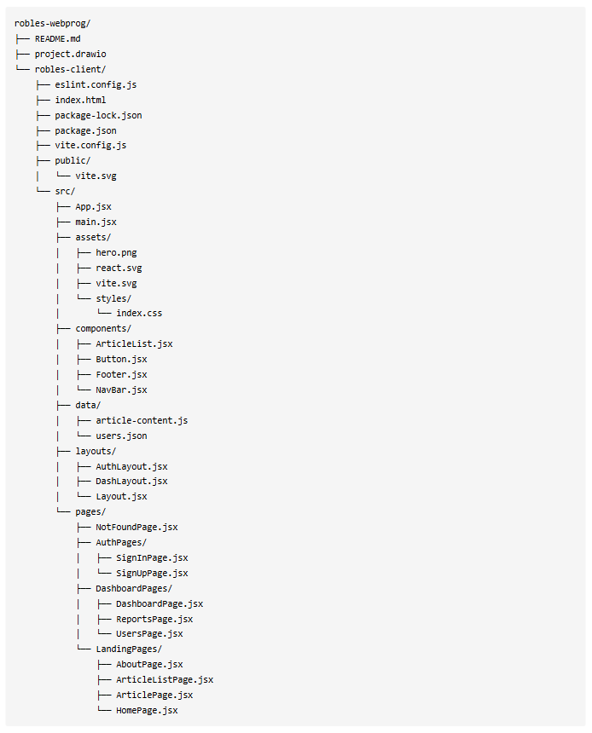

Code Snippets
pages/DashboardPages
ReportsPage.jsx [sample implementation of useRef]
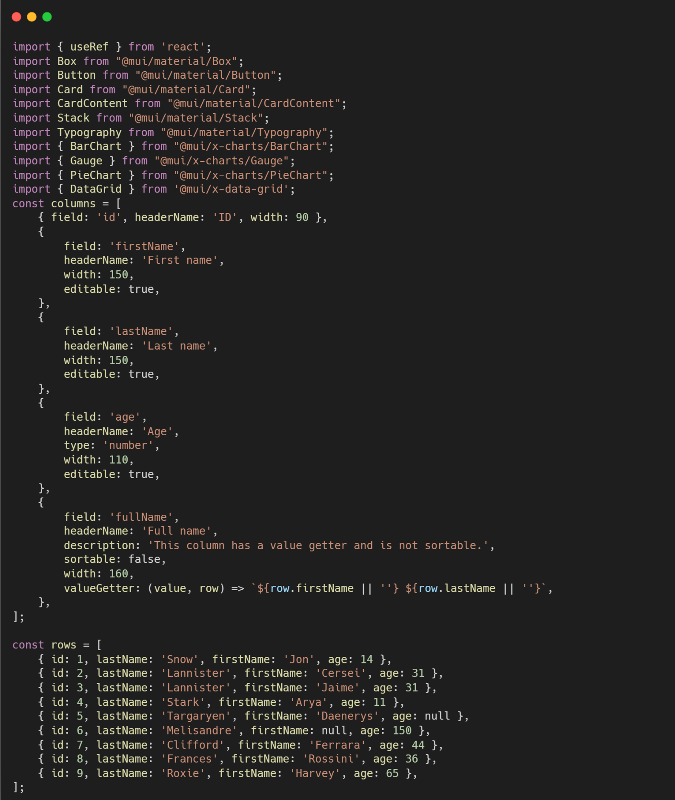

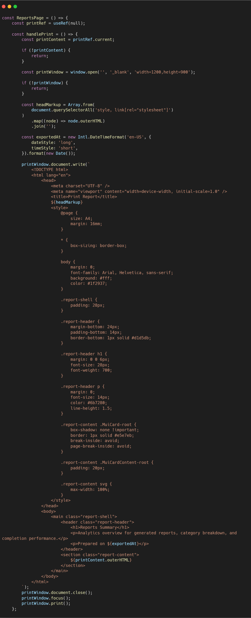
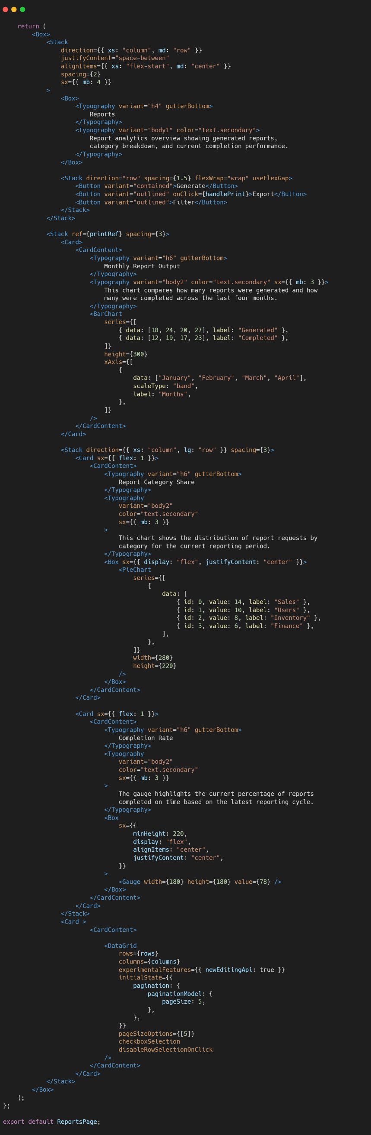
UsersPage.jsx
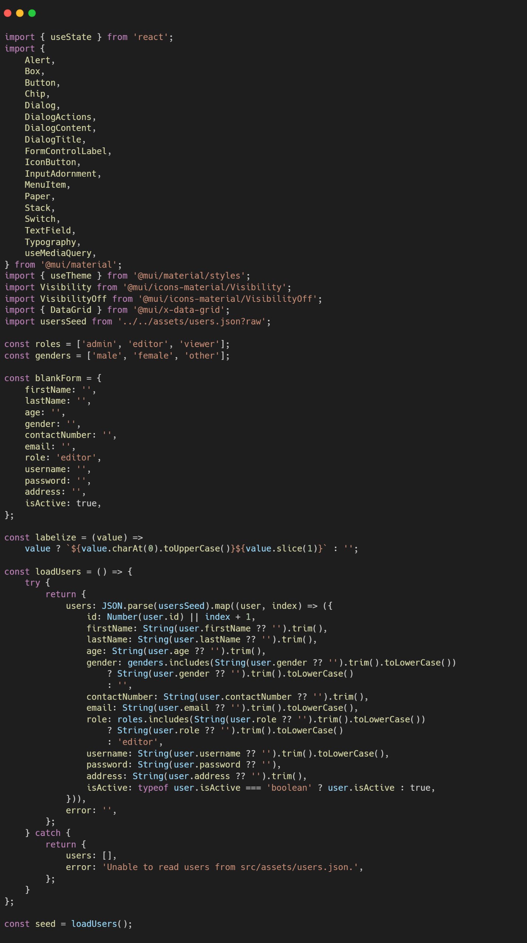
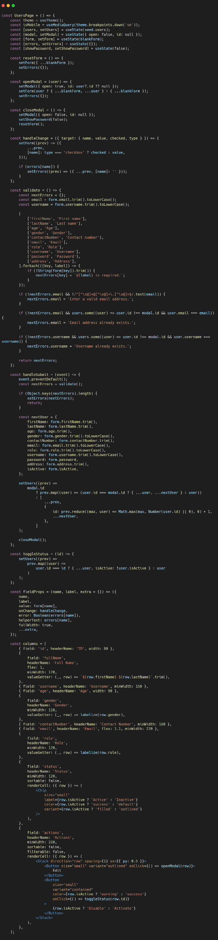
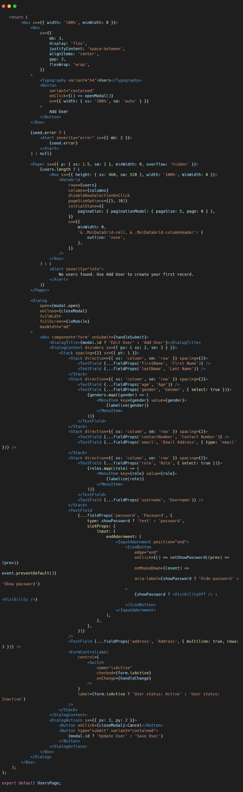
users.json

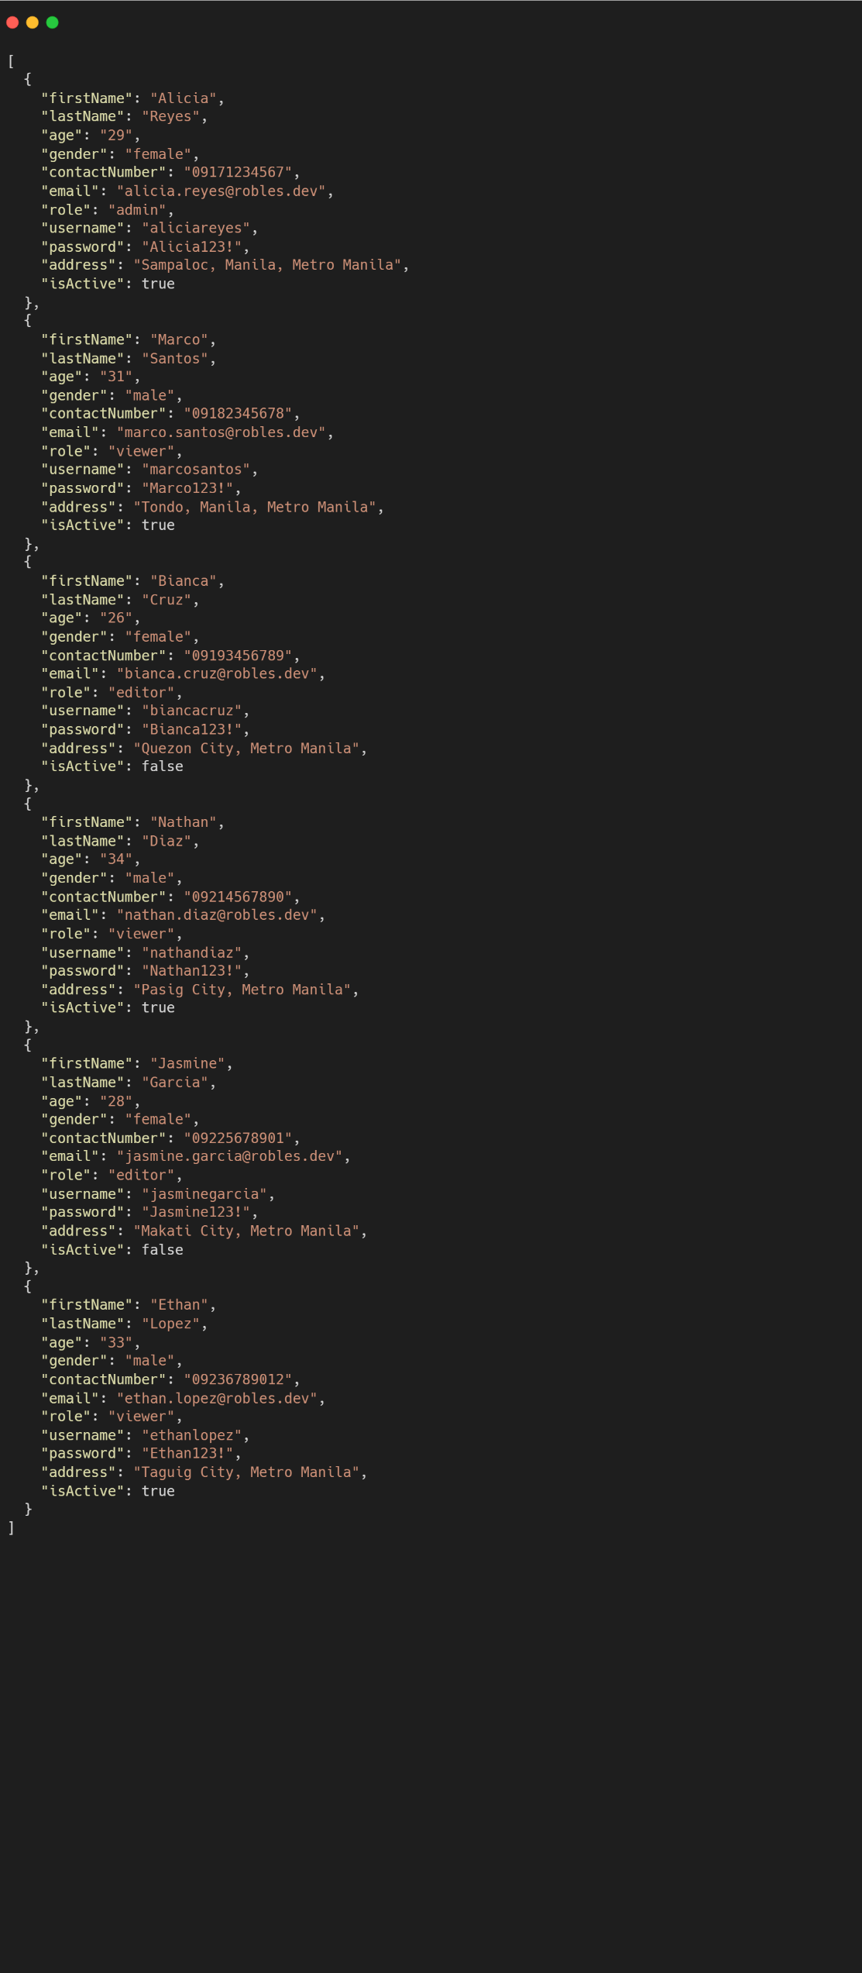

Sample Output | Enhancement Instructions:
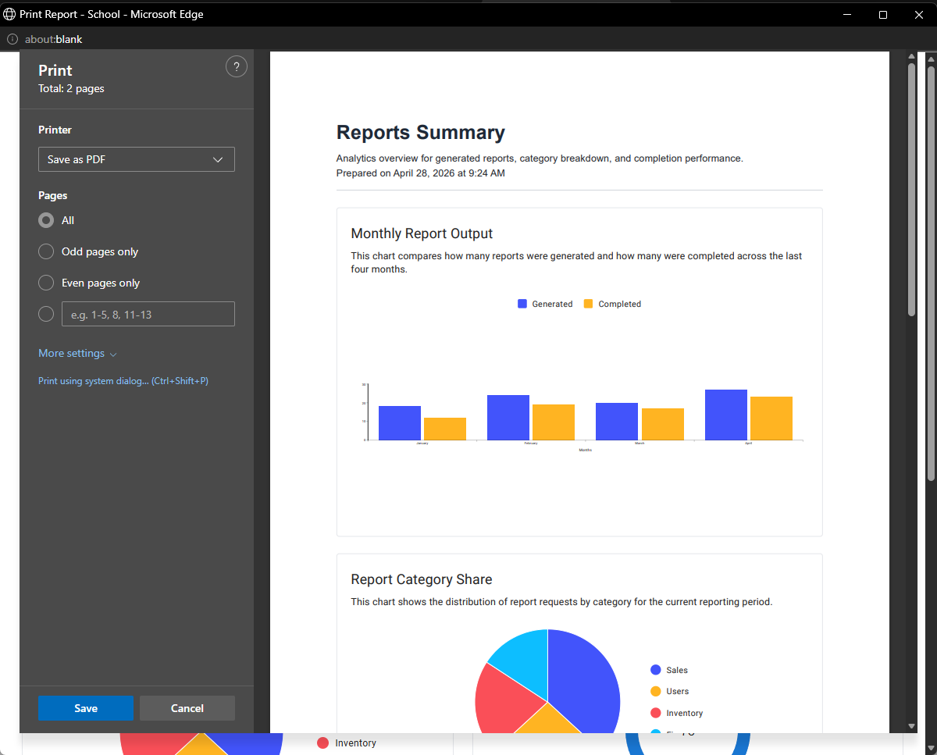
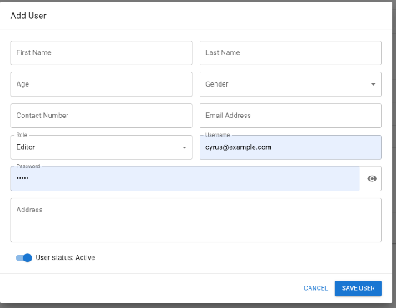
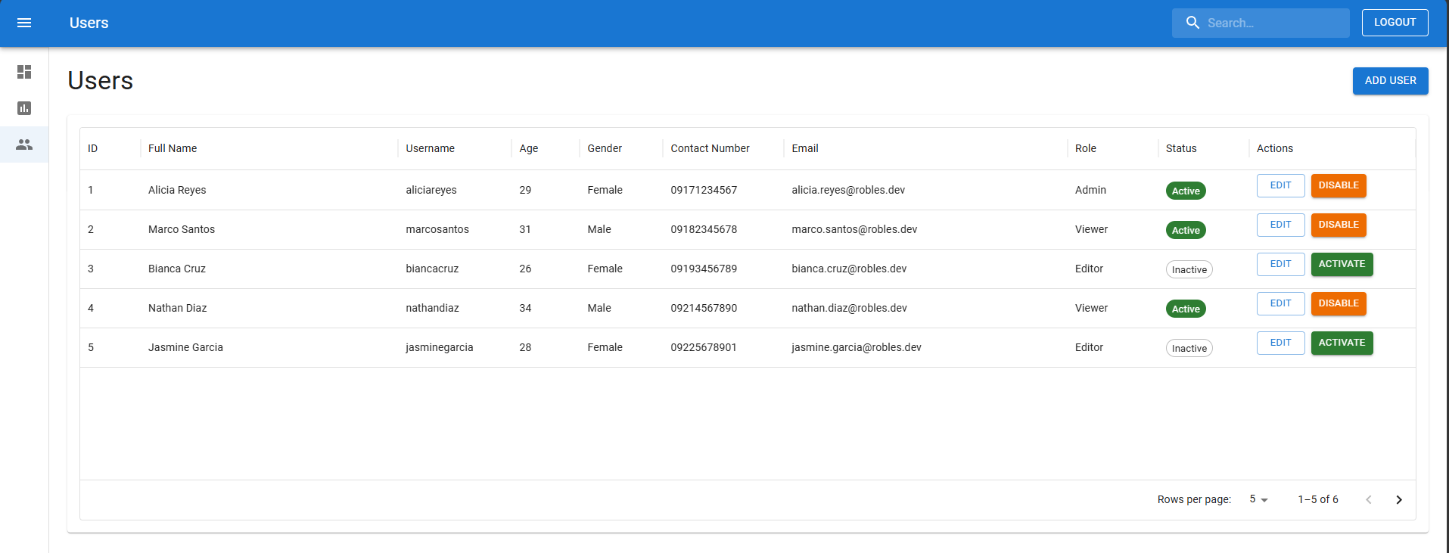

In using MUI:
Enhancement 1: Create and design a your printing pdf based on you Laboratory 5 ReportsPage design.
Enhancement 2: Create and design a search and filter.
- Add a simple search bar - Let users search by firstName, lastName, email, or username.
- Add basic dropdown filters - Create simple filters for role, gender, and status (active/inactive)
Enhancement 3: Improve form validation with beginner-friendly rules
Add easy validations such as:
  - password must be at least 8 characters
  - contact number must be 11 digits
  - age must be a number only
  - username must not contain spaces

Git Instructions
after the enhancement (must be on root folder surname-webprog)

- git checkout -b lab-act6
- git add .
- git commit -m “lab-act6”
- git push origin lab-act6

Lab Activity Rubric

Criteria | Excellent (4 pts) | Good (3 pts) | Fair (2 pts) | Poor (1 pt) | Points
Project Setup & Environment | Project is set up correctly with all dependencies installed. The environment is well-configured and ready for development. | Project is set up with minor issues that do not impact core functionality. | Project setup is attempted but has errors affecting development. | Project setup is incomplete or non-functional.
Navigation & Routing | Navigation is well-structured, intuitive, and includes a responsive design. Routing is properly implemented with dynamic paths if applicable. | Navigation works correctly but may lack responsiveness or design refinements. | Navigation is functional but may have broken links or a confusing structure. | Navigation is missing or not working.
Component Structure & Reusability | Components are well-structured, reusable, and follow best practices (e.g., props, state, hooks). Code is modular and scalable. | Components are properly used but may lack optimization or modularity. | Components are used but with poor structure, making the code difficult to scale. | Components are poorly implemented, leading to excessive redundancy or poor organization.
Styling & UI Design | UI is visually appealing, well-structured, and fully responsive. Consistent styling is applied across the project. | UI is functional and mostly styled well but may have minor inconsistencies or responsiveness issues. | UI is present but lacks proper styling, consistency, or responsiveness. | UI is missing or poorly designed, making navigation difficult.
Content & Functionality | The app displays dynamic content effectively, and all functionalities work as expected without bugs. | Most functionalities work well, but minor issues exist. Content is displayed correctly. | Some functionalities are incomplete, and content may not load properly. | Major functionalities are missing or broken.
Code Quality & Best Practices | Code follows best practices, is clean, well-commented, and easy to maintain. Proper use of hooks, state, and props is evident. | Code is well-written but may have minor inefficiencies or inconsistent formatting. | Code runs but is cluttered, inefficient, or difficult to read. | Code is disorganized, hard to understand, and does not follow best practices.
 | Other Comments/ Observations: |  |  | Total Score
 |  |  |  | Rating: (Total Score/24) * 100

