Lab Activity 5

Objectives
- To design a dashboard and redesign the layout pages.
- To implement and utilize the MUI Component Library
- To revise the code relatively
Materials Needed:
- A computer with Node.js and React JS installed.
- IDE: VS Code, Github Codespaces, or Code Sandbox

Instructions:
Replicate the code snippet.
Follow and implement the enhancement instructions.

Web App Initialization:
Sample design pattern [component based]
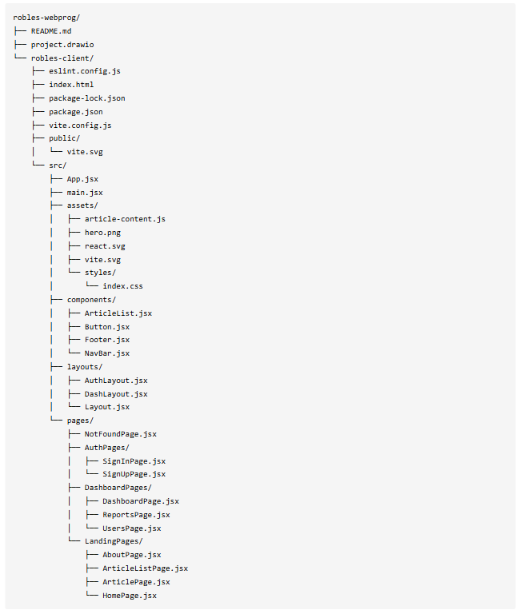

Code Snippets
App.jsx [just add routes to locate the new pages]
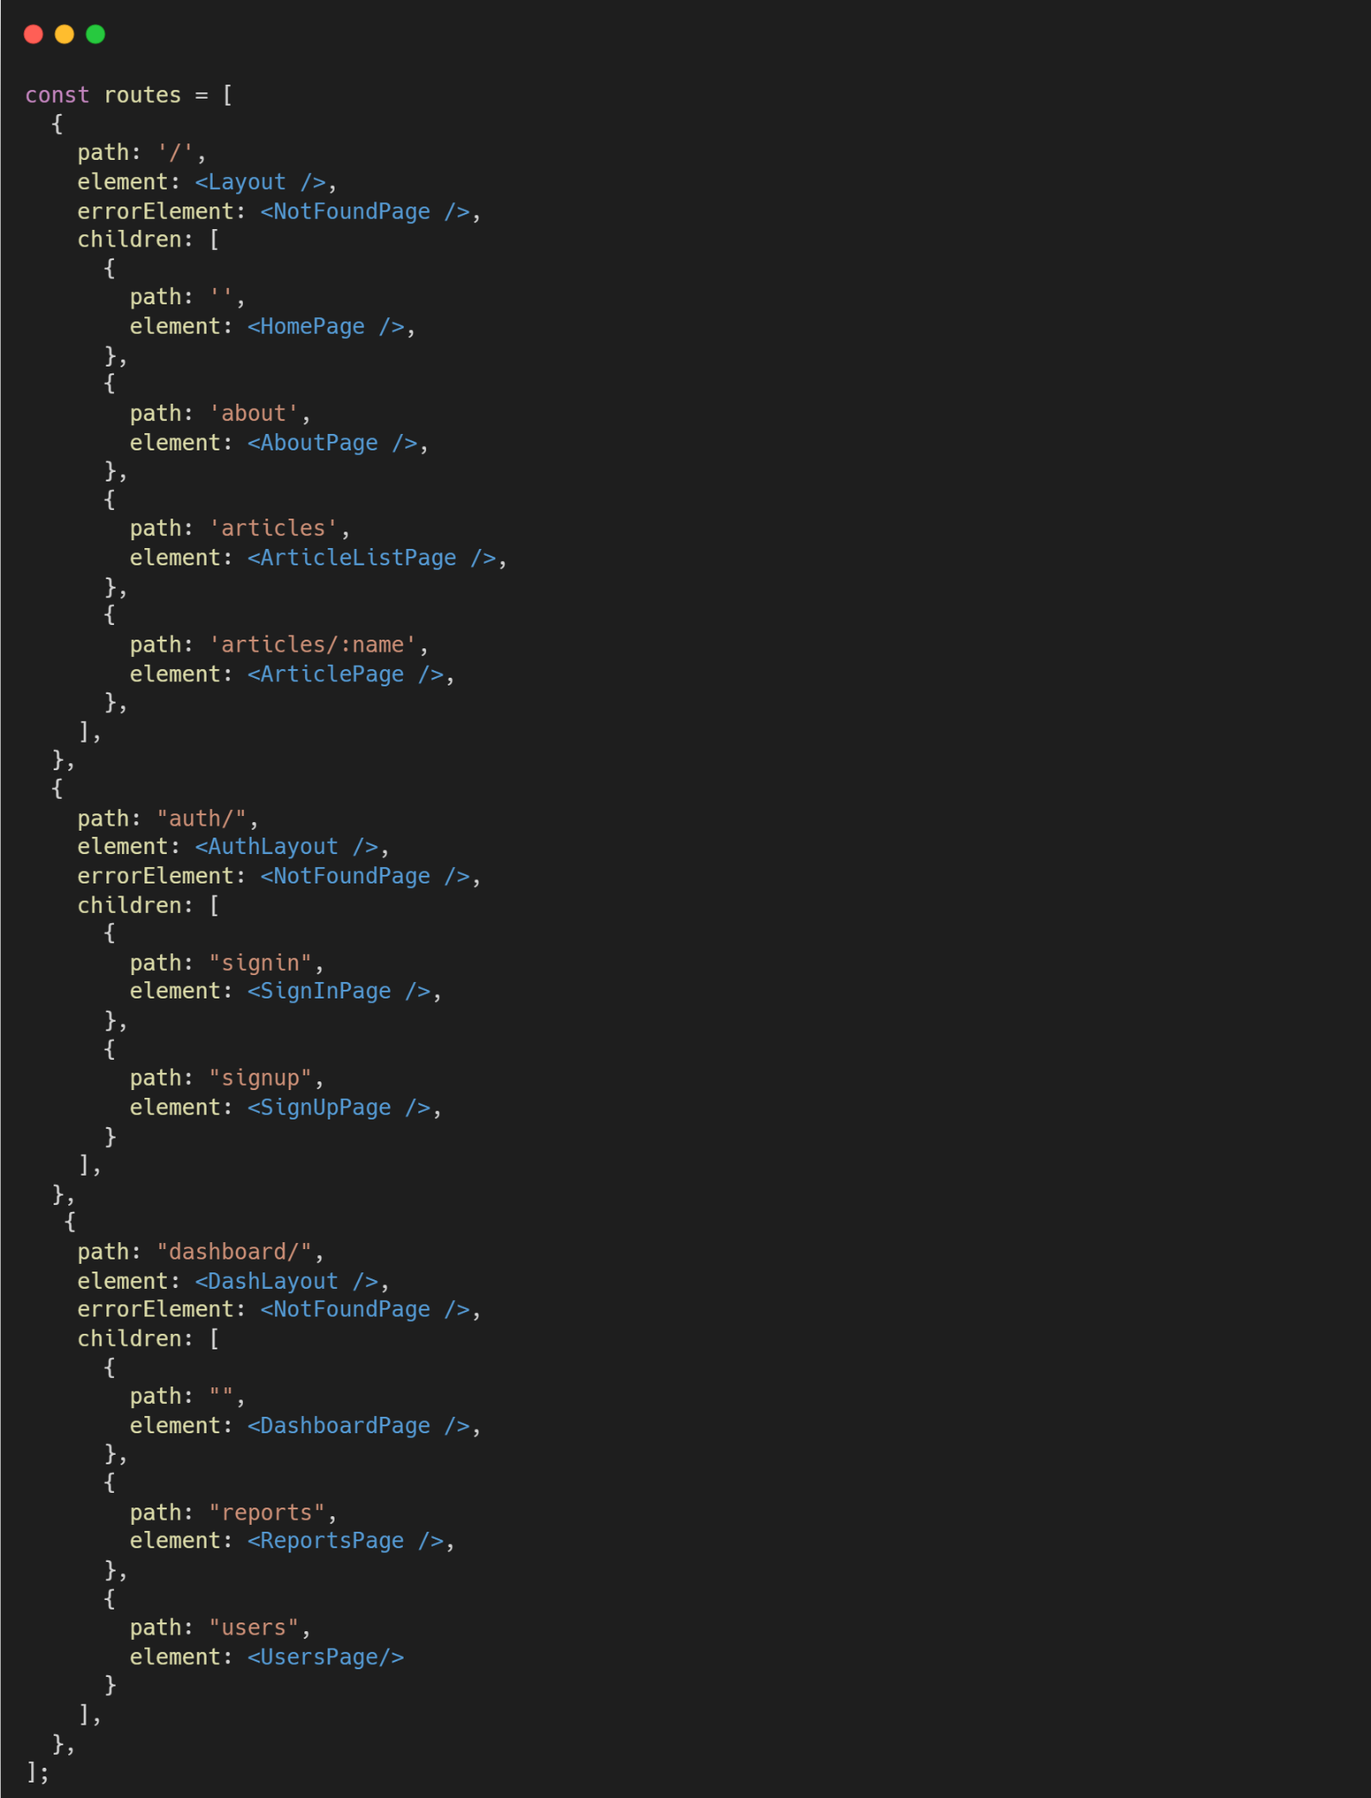

layouts/
DashLayout.jsx
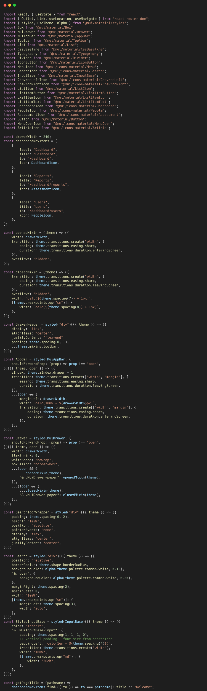
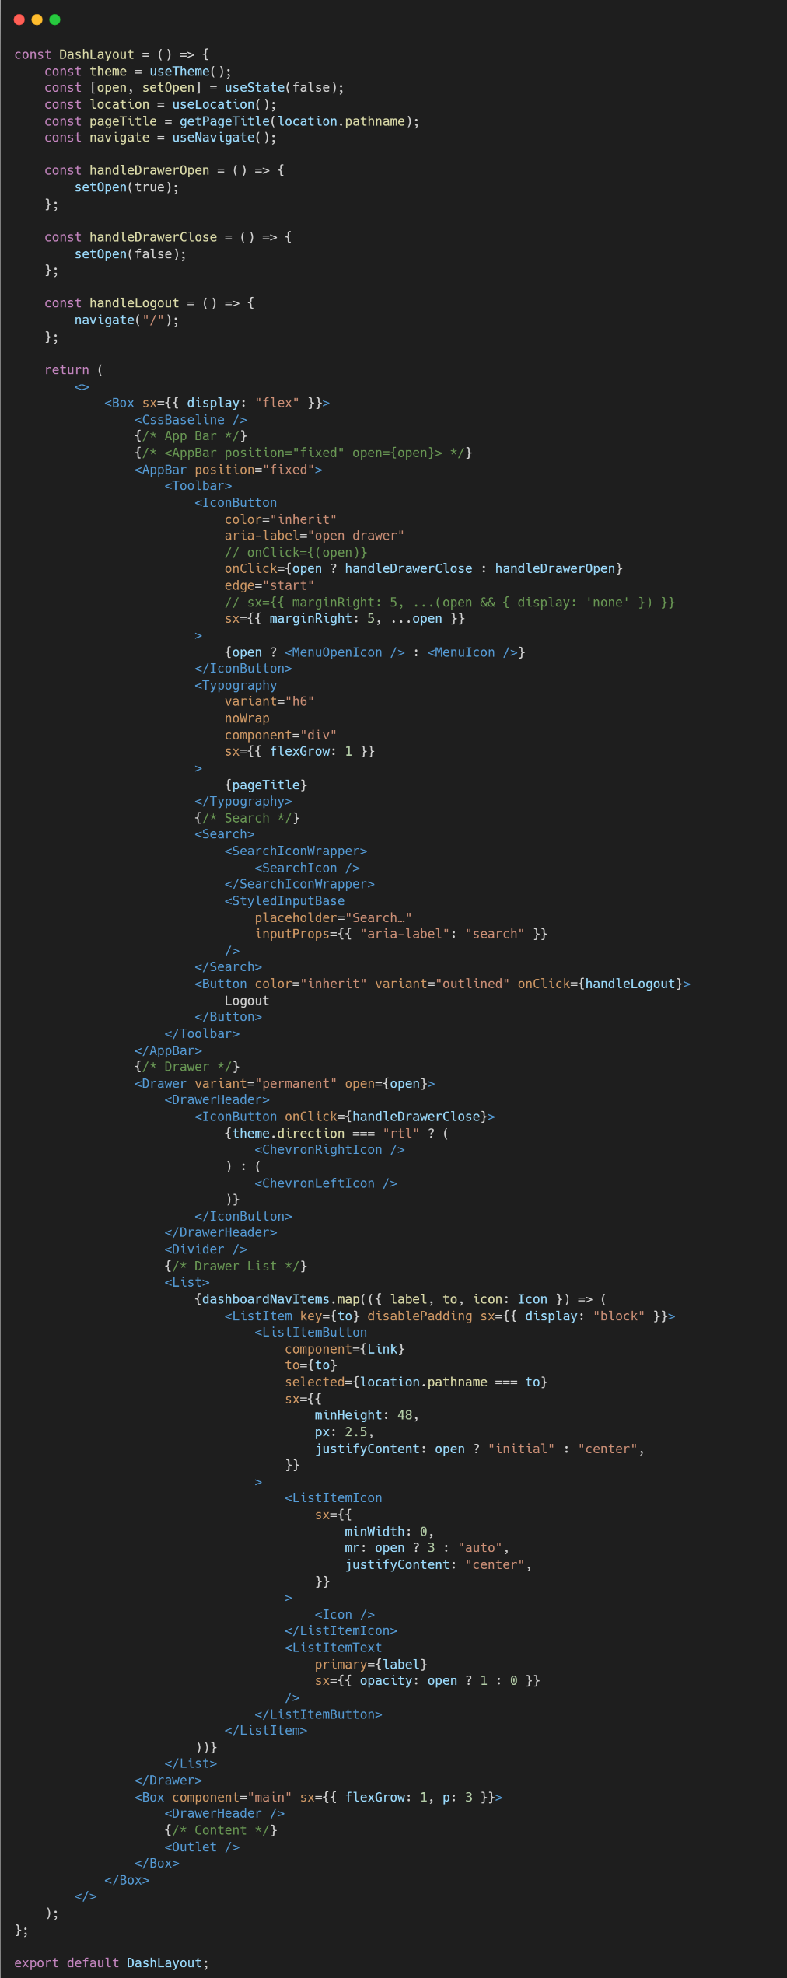

pages/DashboardPages
DashboardPage.jsx
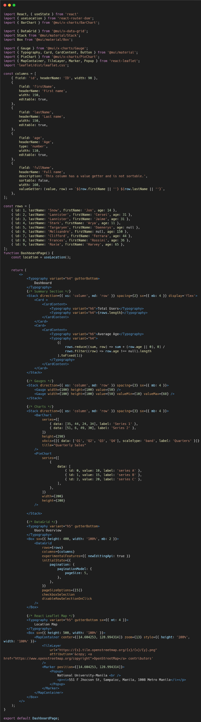
General MUI Implementation Instructions:
- In installation go to Installation - Material UI
- Integrate the Drawer Component at the DashLayout or create a component for the navigation to the children of the DashboardPages. Each item list must be linked to the routes e.g.:
- In using Charts Components at MUI visit React Charts – MUI X
- In using Data Grid [Table] Components at MUI visit React Data Grid component – MUI X

Sample Output | Enhancement Instructions:

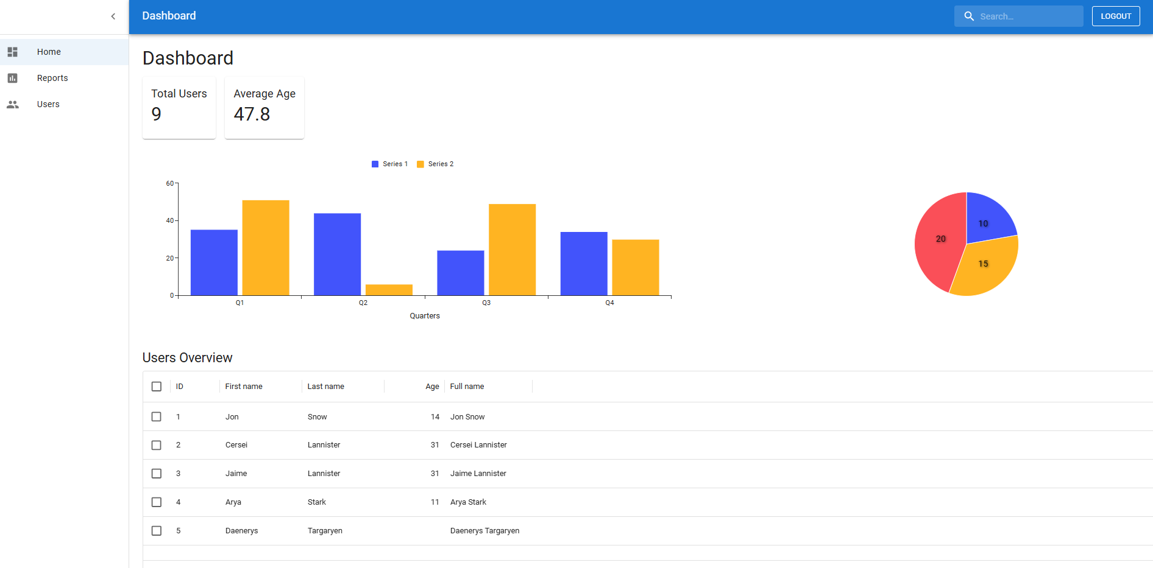

In using MUI:
Enhancement 1: Create and design a DashboardPage for [Overview or Summary].
Enhancement 2: Create and design a ReportsPage for [Charts or Data Visualization].
Enhancement 3: Create for the UsersPage for [User List or Table for Users details].

NOTE: For now, just copy and paste the data included at the MUI Samples for output in preparation for the next activity.

Git Instructions
after the enhancement (must be on root folder surname-webprog)

- git checkout -b lab-act5
- git add .
- git commit -m “lab-act5”
- git push origin lab-act5

Lab Activity Rubric

Criteria | Excellent (4 pts) | Good (3 pts) | Fair (2 pts) | Poor (1 pt) | Points
Project Setup & Environment | Project is set up correctly with all dependencies installed. The environment is well-configured and ready for development. | Project is set up with minor issues that do not impact core functionality. | Project setup is attempted but has errors affecting development. | Project setup is incomplete or non-functional.
Navigation & Routing | Navigation is well-structured, intuitive, and includes a responsive design. Routing is properly implemented with dynamic paths if applicable. | Navigation works correctly but may lack responsiveness or design refinements. | Navigation is functional but may have broken links or a confusing structure. | Navigation is missing or not working.
Component Structure & Reusability | Components are well-structured, reusable, and follow best practices (e.g., props, state, hooks). Code is modular and scalable. | Components are properly used but may lack optimization or modularity. | Components are used but with poor structure, making the code difficult to scale. | Components are poorly implemented, leading to excessive redundancy or poor organization.
Styling & UI Design | UI is visually appealing, well-structured, and fully responsive. Consistent styling is applied across the project. | UI is functional and mostly styled well but may have minor inconsistencies or responsiveness issues. | UI is present but lacks proper styling, consistency, or responsiveness. | UI is missing or poorly designed, making navigation difficult.
Content & Functionality | The app displays dynamic content effectively, and all functionalities work as expected without bugs. | Most functionalities work well, but minor issues exist. Content is displayed correctly. | Some functionalities are incomplete, and content may not load properly. | Major functionalities are missing or broken.
Code Quality & Best Practices | Code follows best practices, is clean, well-commented, and easy to maintain. Proper use of hooks, state, and props is evident. | Code is well-written but may have minor inefficiencies or inconsistent formatting. | Code runs but is cluttered, inefficient, or difficult to read. | Code is disorganized, hard to understand, and does not follow best practices.
 | Other Comments/ Observations: |  |  | Total Score
 |  |  |  | Rating: (Total Score/24) * 100

