**ERD**

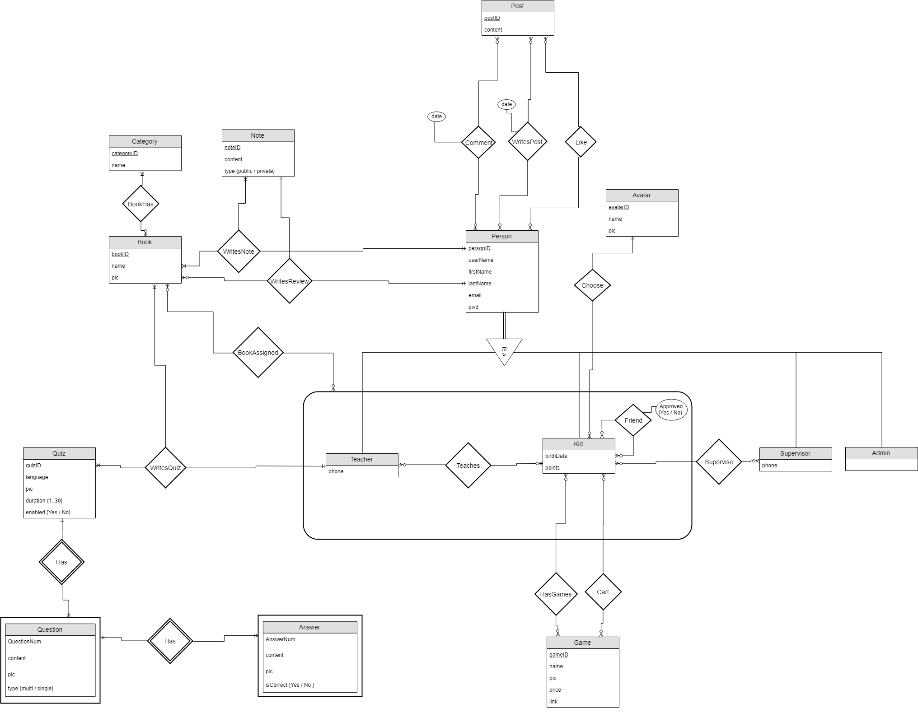

**טבלאות מנורמולות NF/BC**

|  |  |
| --- | --- |
| **שם הטבלה** | **שדות הטבלה** |
| Person | personID, userName, firstName, lastName, email, pwd |
| Admin | adminID (F.K Person) |
| Kid | kidID (F.K Person), birthDate, points, avatarID (F.K Avatar) |
| Teacher | teacherID (F.K Person), phone |
| Supervisor | supervisorID (F.K Person), phone |
| Avatar | avatarID, name, pic |
| Post | postID, content |
| Note | NoteID, content, type |
| Category | categoryID, name |
| Book | bookID, name, pic |
| Game | gameID, name, pic, price, link |
| Quiz | quizID, language, pic, duration, enabled {Y / N} |
| Question | quizID (F.K Quiz), questionNum, content, pic, type {multi / single} |
| Answer | quizID + questionNum (F.K Question), answerNum, content, pic, isCorrect {Y / N} |
| Friend | personA + friendOfA (F.K Person), approved {Y / N} |
| Teaches | teacherID (F.K Teacher), kidID (F.K Kid), groupName |
| Supervise | supervisorID (F.K Supervisor), kidID (F.K Kid) |
| Cart | kidID (F.K Kid), gameID (F.K Game) |
| HasGames | kidID (F.K Kid), gameID (F.K Game) |
| WritesPost | personID (F.K Person), postID (F.K Post), postDate |
| WritesComment | personID (F.K Person), postID (F.K Post), commentDate |
| Likes | personID (F.K Person), postID (F.K Post) |
| WritesNote | bookID (F.K Book), NoteID (F.K Note), personID (F.K Person) |
| BookHas | bookID (F.K Book), categoryID (F.K Category) |
| WritesQuiz | bookID (F.K Book), quizID (F.K Quiz), personID (F.K Person) |
| BookAssigned | bookID (F.K Book), teacherID + kidID (F.K Teaches) |
| KidBook | kidID (F.K Kid), bookID (F.K Book), status {intrested / reading / finished}, review, rating {1..5} |
|  |  |
|  |  |
|  |  |
|  |  |