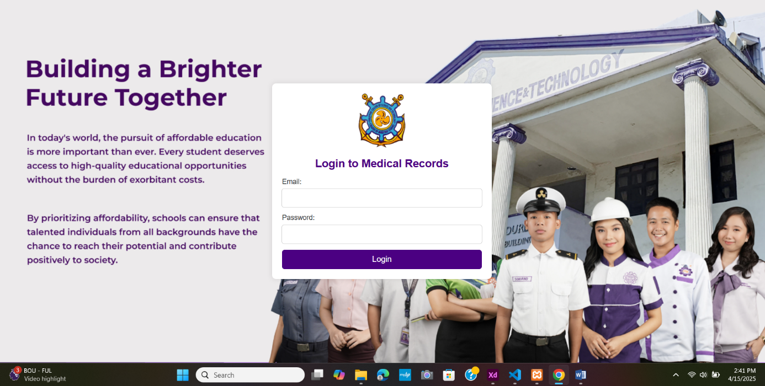
1
3
2

Figure 2
Log In Page

No. | Icons / Buttons | Functions and Descriptions
1 | Username | The user will enter his/her username.
2 | Password | The user will enter his/her password.
3 | Login | The user will click the button and it will directly go to the homepage.(Dean/Physician)

Table 2
Login Page
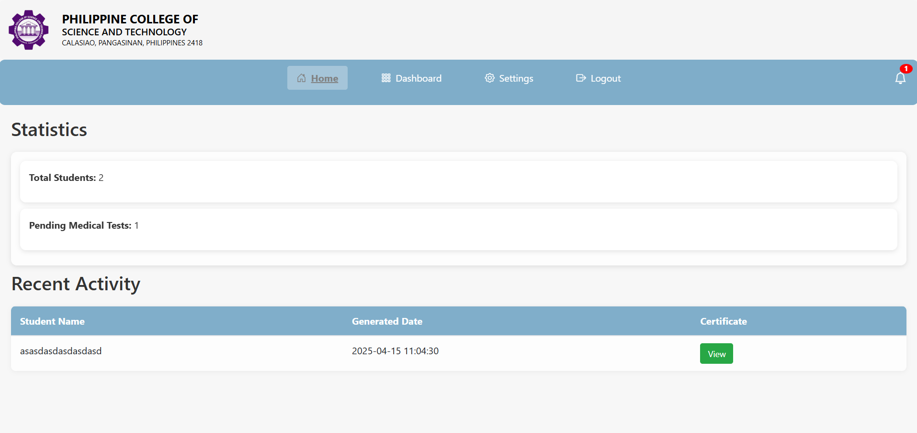
6
5
7
4

7

No. | Icons / Buttons | Functions and Descriptions
4 | Home | This is the homepage where the overview of the system’s functionality is here.
5 | Dashboard | The user will click the button and it will directly go to the Dashboard Page.
6 | Settings | The user will click the button and it will directly open the Settings Form.
7 | Logout | The user will click the button and it will log out the user.
8 | View | The user will click the button to view the uploaded medical certificate.
Figure 3
Physician Homepage
Table 3
Physician Homepage

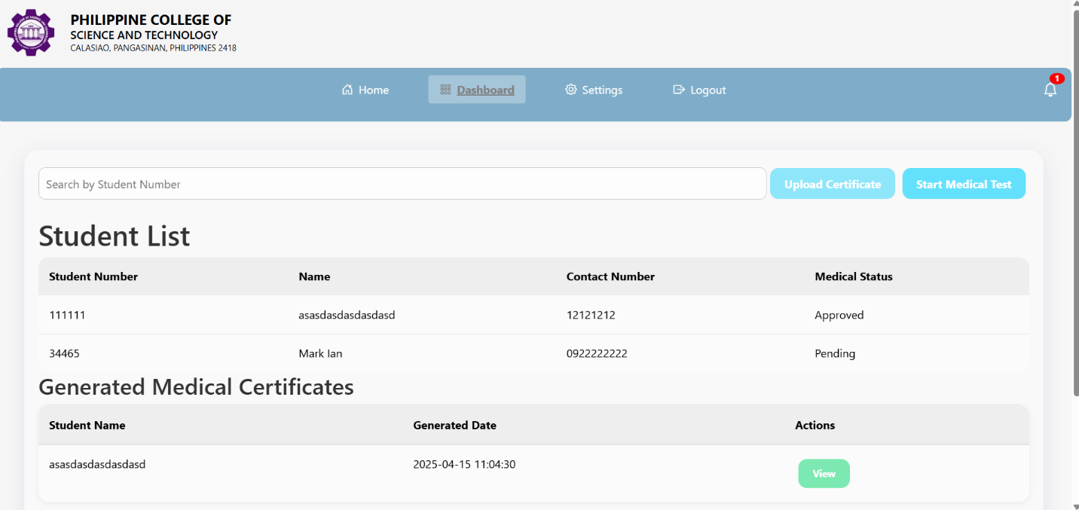
Figure 4
Physician Dashboard
12
11
10
9

No. | Icons / Buttons | Functions and Descriptions
9 | Search by Student Number | The user will type the student number to search for the student easily.
10 | Upload Certificate | The user will click the button and he/she can upload a certificate for a student.
11 | Start Medical Test | The user will click the button and it will open a new tab for the medical certificate docx.
12 | View | The user will click the button to view the generated certificate.
Table 4
Physician Dashboard

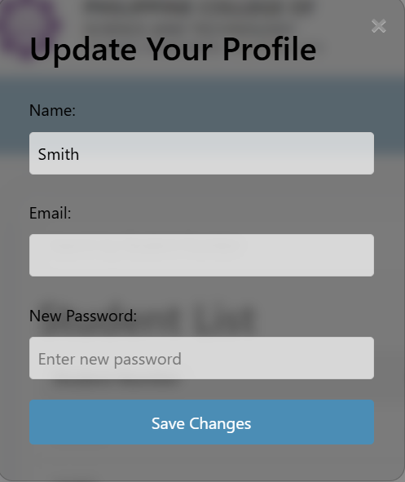
Figure 5
Physician Settings Form
16
15
14
13
No. | Icons / Buttons | Functions and Descriptions
13 | Name | The user will enter his/her Name.
14 | Email | The user will enter his/her email.
15 | Password | The user will enter new password.
16 | Save Changes | The user will click the button and it will Save the changes.

Table 5
Physician Settings Form

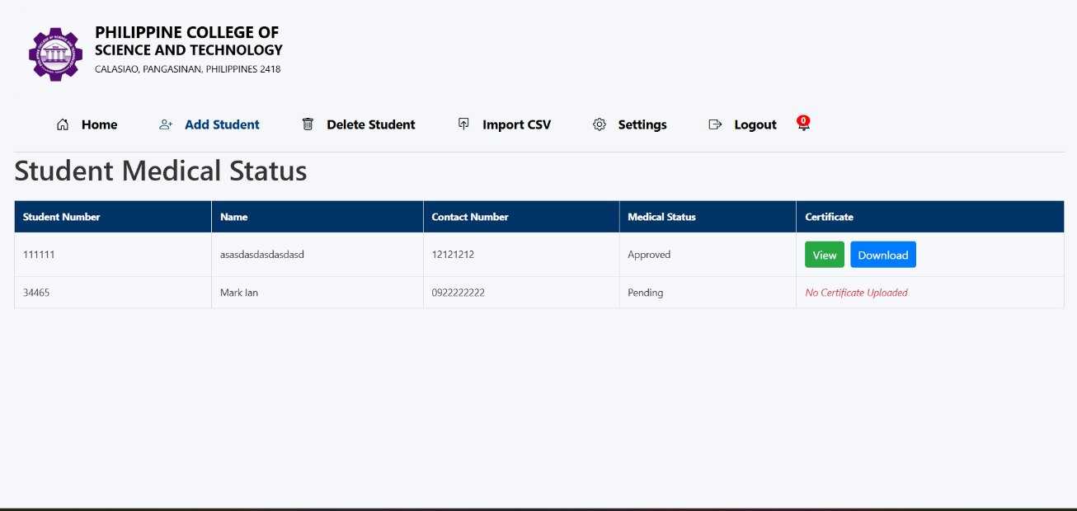
Figure 6
24
23
22
21
20
19
18
17
Dean Homepage

No. | Icons / Buttons | Functions and Descriptions
17 | Home | This is the homepage where the overview of the system’s functionality is here.
18 | Add Student | The user will click the button and it will open the add student form.
19 | Delete Student | The user will click the button and it will open the delete student form.
20 | Import Csv | The user will click the button and it will open the import CSV form.
21 | Settings | The user will click the button and it will open the settings form.
22 | Logout | The user will click the button and it will log out the user.
23 | View | The user will click the button and it will open the uploaded certificate.
24 | Download | The user will click the button and it will download the certificate.

Table 6
Dean Homepage

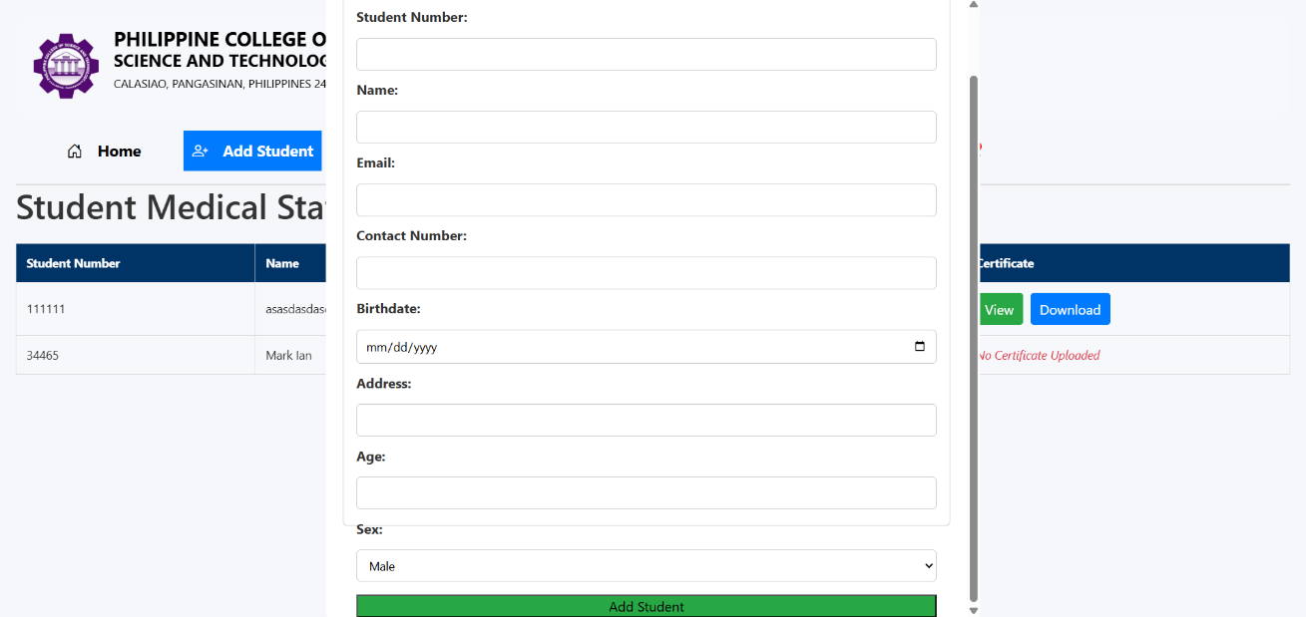
Figure 7
31
33
32
30
29
28
27
26
25
Add Student Form

No. | Icons / Buttons | Functions and Descriptions
25 | Student Number | The user will enter the student number.
26 | Name | The user will enter the Name of the student.
27 | Email | The user will enter the Email of the student.
28 | Contact Number | The user will enter the Contact Number of the student.
29 | Birthdate | The user will enter the Birthdate of the student.
30 | Address | The user will enter the Address of the student.
31 | Age | The user will enter the Age of the student.
32 | Sex | The user will select the gender of the student.
33 | Add Student | The user will click the button and it will add the student.

Table 7
Add Student Form

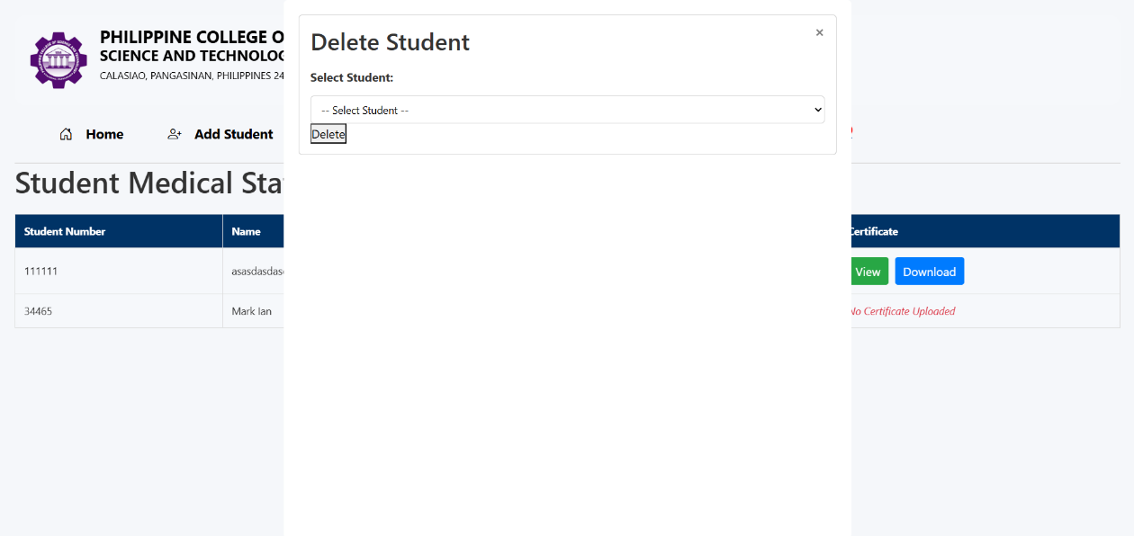
Figure 8
35
34
Delete Student Form

No. | Icons / Buttons | Functions and Descriptions
34 | Select Student | The user will select which student will be deleted.
35 | Delete | The user will click the button and it will remove the student.

Table 8
Delete Student Form

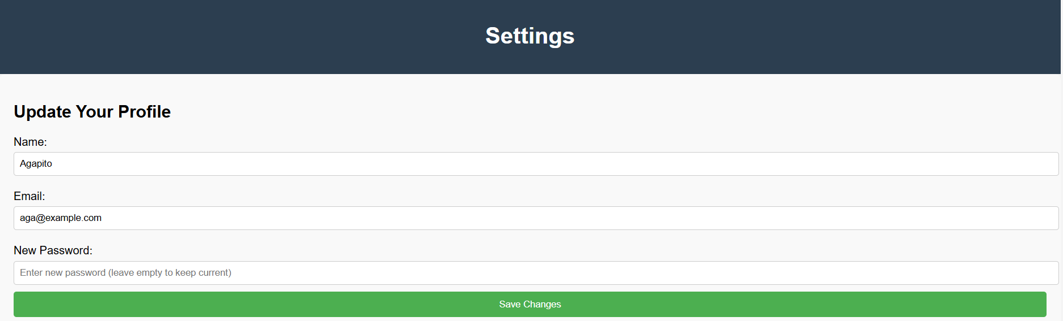
Figure 9
39
38
37
36
Dean’s Settings Form

No. | Icons / Buttons | Functions and Descriptions
36 | Name | The user will enter his/her name.
37 | Email | The user will enter his/her email.
38 | New Password | The user will enter his/her new password.
39 | Save Changes | The user will click this button and it will save the changes made.

Table 9
Dean’s Settings Form


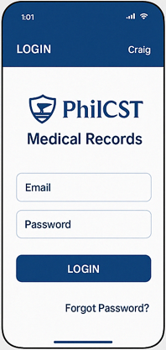
Figure 10
43
42
41
40
Student Login Screen
No. | Icons / Buttons | Functions and Descriptions
40 | Email | The user will enter his/her name.
41 | Password | The user will enter his/her password.
42 | Login | The user will click the button and it will be directed to the student dashboard.
43 | Forgot Password | The student will click the button and he/she will be directed to a page where he/she can recover his/her account.

Table 10
Student Login Screen


43
44

Figure 11
Student Dashboard Screen

No. | Icons / Buttons | Functions and Descriptions
44 | View Medical Certificate | The user will click the button and he/she will be directed to the medical certificate view screen.
45 | View Medical Test Schedule | The user will click the button and he/she will be directed to the view medical test schedule screen.

Table 11
Student Dashboard Screen
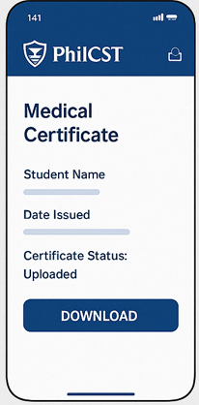
46
Figure 12
Medical Certificate View Screen
No. | Icons / Buttons | Functions and Descriptions
46 | Download | The user will click the button and he/she can download his/her medical certificate.

Table 12
Medical Certificate View Screen

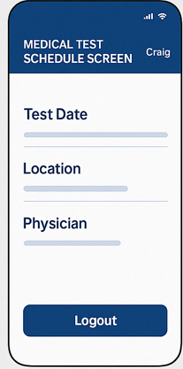
47

Figure 13
Medical Test Schedule Screen
No. | Icons / Buttons | Functions and Descriptions
47 | Logout | The user will click the button and he/she will be directed to the student login screen.

Table 13
Medical Test Schedule Screen

