High Level Design
This document encapsulates the architectural decisions, data flow, security controls, and component interactions that define the production-ready system we have built.

1. Executive Summary
The QLaws Backend is a SOC 2 Compliant, High-Assurance Multi-Tenant IAM System. It serves as a centralized API Gateway for managing tenants, users, authentication, and authorization.
Key Architectural Principles:
- Zero-Trust Database: Security is enforced at the database kernel level via Row-Level Security (RLS). Even if the application layer is compromised, cross-tenant data leakage is mathematically impossible at the SQL execution layer.
- No-ORM Performance: We utilize asyncpg for raw, high-performance SQL execution, bypassing the overhead of ORMs like SQLAlchemy while maintaining strict type safety via Pydantic.
- Stateless Scalability: Authentication is primarily stateless (JWT), allowing horizontal scaling of API nodes. State (Revocations/Rate Limits) is offloaded to high-speed Redis stores.

2. System Architecture Overview
The system follows a Layered Clean Architecture pattern, ensuring separation of concerns between the external world, the API interface, business logic, and data persistence.

2.1. Component Diagram
- API Gateway (FastAPI): The entry point for all traffic. Handles routing, validation, and response formatting.
- Security Middleware Layer: A chain of dependencies that run before any business logic:
  - Rate Limiter (slowapi): DDoS protection using Redis counters.
  - Authentication (OAuth2): Validates JWT signatures (HS256/RS256).
  - Revocation Check (AuthRepo): Checks token_blacklist for logout events.
  - Context Injection (RLS): Sets app.current_tenant_id in the DB session.
  - Authorization (Permission Guard): Verifies granular permissions (RBAC).
- Service Layer: Contains business logic (e.g., "Send email after user creation", "Calculate redirect URL"). It orchestrates the Repository and External Integrations.
- Repository Layer: Pure Data Access Objects (DAOs). Executes raw SQL queries. It does not contain business logic.
- Data Layer:
  - PostgreSQL: Primary store. Uses RLS policies (CREATE POLICY) to isolate data.
  - Redis: Hot store for Rate Limiting counters and User Context caching.

3. Data Architecture & Isolation Strategy
We employ a Shared Database, Shared Schema strategy, which offers the highest operational efficiency while maintaining strict logical isolation.

3.1. Row-Level Security (RLS) Mechanics
Instead of adding WHERE tenant_id = X to every query (which is error-prone), we rely on PostgreSQL policies.
- Connection: The API acquires a generic connection from the pool.
- Context: The API executes SET app.current_tenant_id = 'uuid';.
- Enforcement:
  - Write: INSERT operations are blocked if they attempt to write data for a different tenant.
  - Read: SELECT operations automatically filter rows. A SELECT * FROM users only returns rows where tenant_id matches the session variable.

3.2. Encryption Strategy
- Data in Transit: TLS 1.3 for all API traffic.
- Data at Rest: AES-256 (AWS RDS / Disk Level).
- Field-Level Encryption: Sensitive configuration secrets (e.g., client_secret for SSO providers) are encrypted using Fernet (AES-128-CBC) at the application layer before insertion.

4. Core Workflows

4.1. The "Protected Request" Lifecycle
This flow represents 90% of system traffic (e.g., Creating a User, Listing Audits).

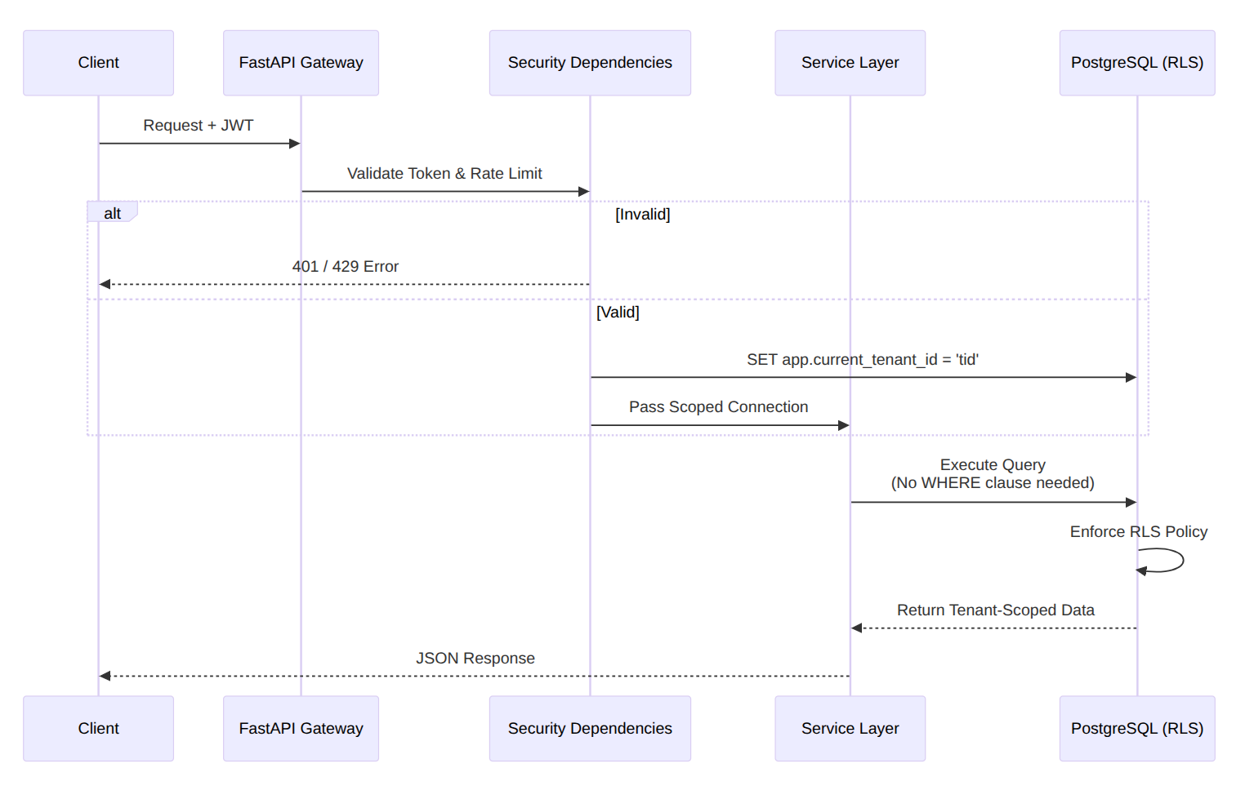

4.2. Authentication & Token Rotation
To balance security and usability, we implement a dual-token system.
- Access Token (JWT): Short-lived (15-30 mins). Contains user_id, tenant_id, and jti. Used for API access.
- Refresh Token (Opaque): Long-lived (7 days). Stored as a hash in the DB. Used to get new Access Tokens.
- Revocation: The /logout endpoint adds the Access Token's jti to a blacklist table and marks the Refresh Token as revoked.

5. Operational Excellence

5.1. Observability
- Audit Logs: Every write operation is recorded in the audit_logs table, partitioned by month for performance.
- Health Checks: A /health endpoint checks DB and Redis connectivity, enabling zero-downtime deployments on Kubernetes.

5.2. Compliance (GDPR/SOC 2)
- Right to Erasure: The "System Cleanup" module allows hard-deletion of data based on retention policies.
- Access Control: The /me endpoint provides transparency into exactly what permissions a user holds.

5.3. Scalability
- Database: Connection pooling (asyncpg) allows handling thousands of concurrent requests with a small number of DB connections.
- Caching: The User Context (/me) is cached in Redis to offload expensive join operations during high-traffic login bursts.

6. Tech Stack Summary
Component | Technology | Justification
Language | Python 3.11+ | Strong typing support, async ecosystem.
Framework | FastAPI | High performance, auto-generated Swagger docs.
Database | PostgreSQL 15+ | RLS support, JSONB support, robust partitioning.
Driver | AsyncPG | Fastest Python Postgres driver (3x speed of  others).
Cache | Redis | Low-latency store for rate limiting and auth  context.
Auth | JWT (Jose) | Stateless authentication standard.
Migrations | Yoyo | Raw SQL migrations for full control over  RLS/Triggers.

7. Deployment View
- Containerization: The application is stateless and dockerized.
- Orchestration: Kubernetes or AWS ECS.
- Secrets: Injected via Environment Variables (12-Factor App).
- Database: Managed RDS (PostgreSQL) with automatic backups enabled.
This design ensures the system is Secure by Design, Performant by Default, and Ready for Scale.

