Multi-Tenant Flow
Flow Diagram for Multi-tenant
Here is the complete flow diagram for the QLaws Multi-Tenant IAM System. We have broken this down into the System Architecture (Components) and the Request Lifecycle (Data Flow).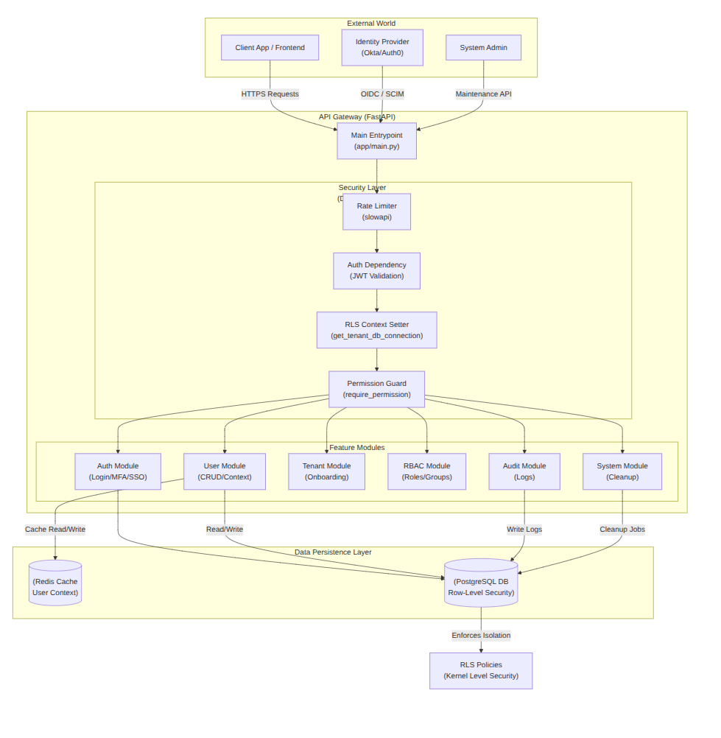

Detailed Request Flow Explanation
Here is the step-by-step lifecycle of a typical Protected Request (e.g., POST /api/v1/users/ to create a new user).

Step 1: Entry & Protection Flow
This diagram shows the interaction between the Client, the API Gateway, the internal Rate Limiter middleware, and the Redis cache used for tracking request counts.
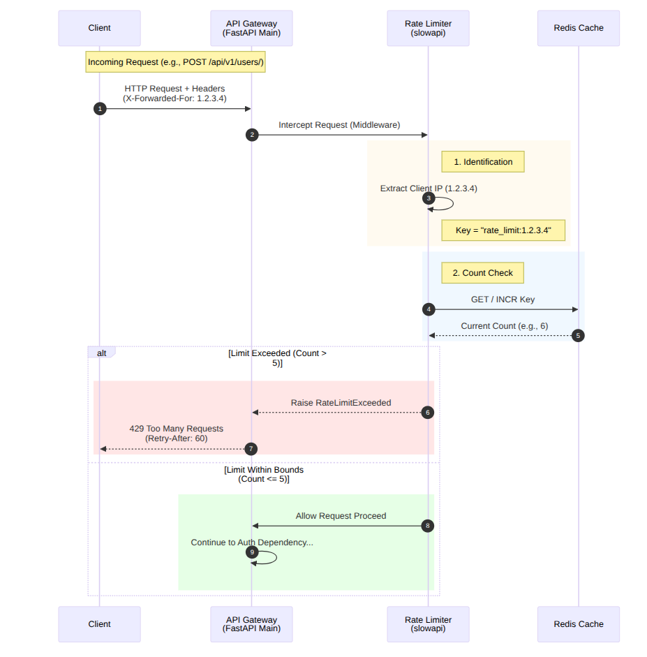

Step 2: Authentication & Context (The "Security Guard")
- JWT Validation (app/dependencies/rls.py):
  - Decodes the Bearer Token using HS256 or RS256.
  - Verifies the signature and expiry (exp).
- Token Check:
  - Extracts the jti (Unique Token ID).
  - Queries token_blacklist table to ensure the user hasn't logged out.
- RLS Context Setting:
  - Extracts tid (Tenant ID) from the token.
  - Executes SQL: SET app.current_tenant_id = 'uuid...'; on the database connection.
  - Outcome: This specific database connection is now "locked" to that tenant.

Flow diagram in next page ....

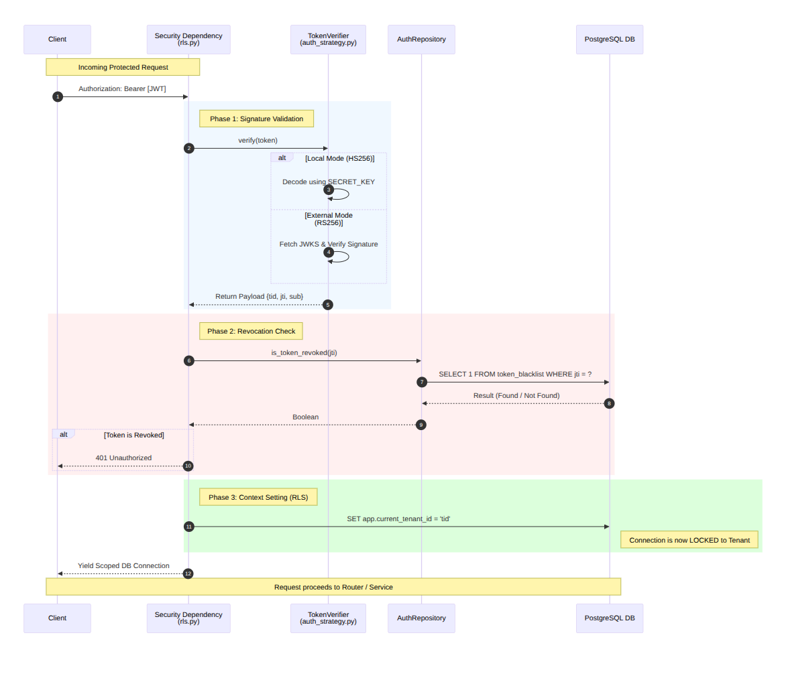

Step 3: Authorization (The "Key Check")
- Permission Guard (app/dependencies/permissions.py):
  - Checks the route requirement: require_permission("user.create").
  - Fetches the user's roles and group memberships.
  - Merges them into a flat list of permissions.
  - Outcome: Returns 403 Forbidden if the user lacks the specific permission.

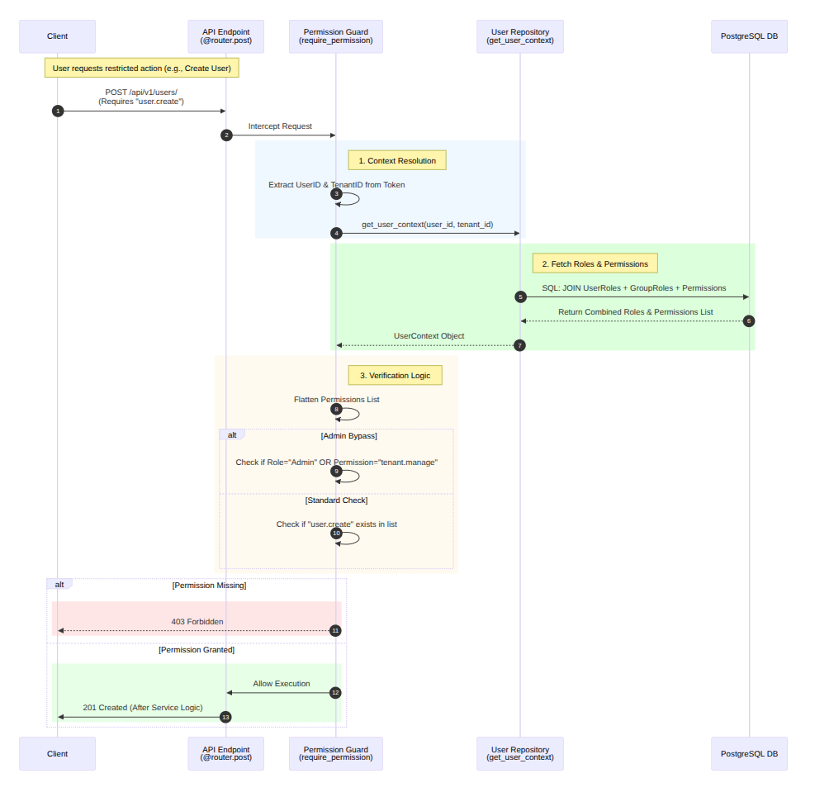

Step 4: Business Logic
- Service Layer (UserService.on_board_user):
  - Validates input data (Pydantic schemas).
  - Calls Repository to perform the insert.
- Repository Layer (UserRepository):
  - Executes INSERT INTO users ....
  - Crucial Security Note: The developer does not need to add WHERE tenant_id = .... The PostgreSQL RLS policy automatically attaches the tenant_id from Step 5 to the row being inserted (or validates it matches).
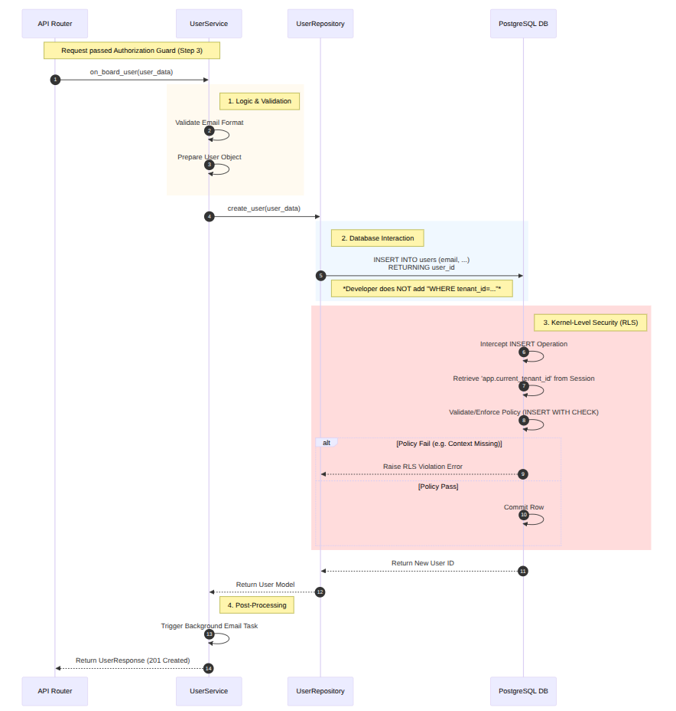

Step 5: Side Effects & Response
- Audit Logging:
  - Service calls AuditRepository to record: "User X created User Y at Time T".
- Background Tasks:
  - FastAPI queues a background task (send_email) to welcome the new user. This runs after the response is sent to keep the API fast.
- Response:
  - Returns 201 Created JSON to the client.
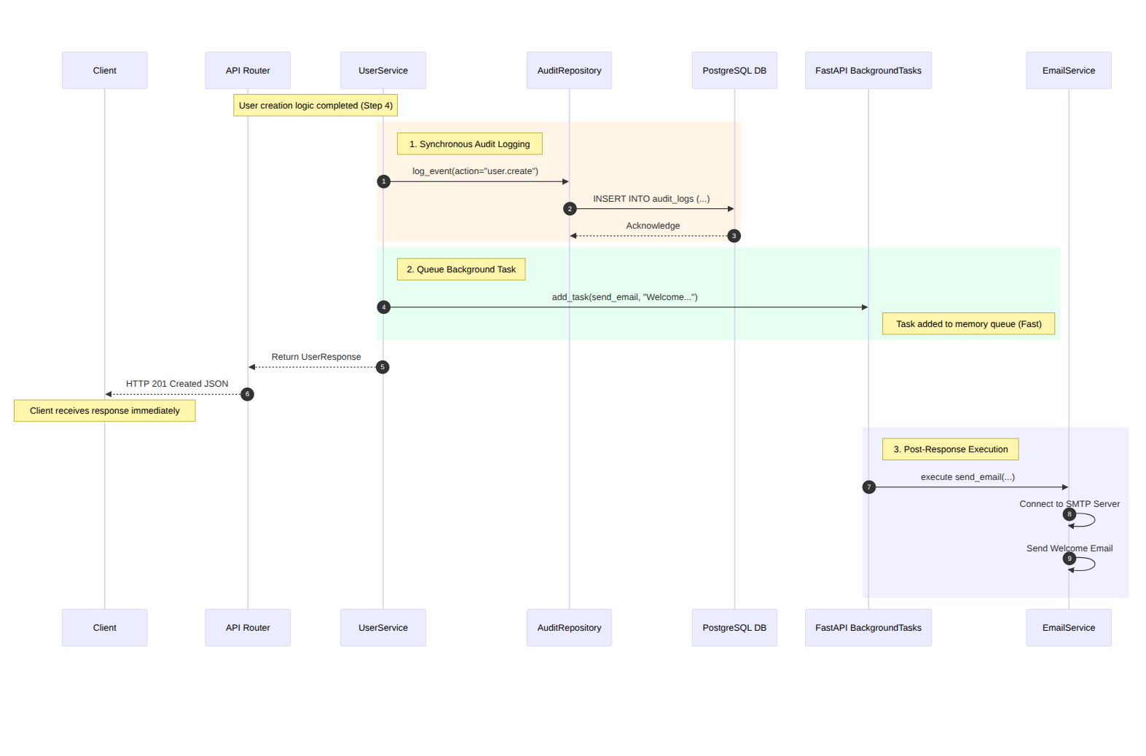

Data Flow Diagram (RLS in Action)
This diagram shows exactly how data leakage is prevented at the database level.
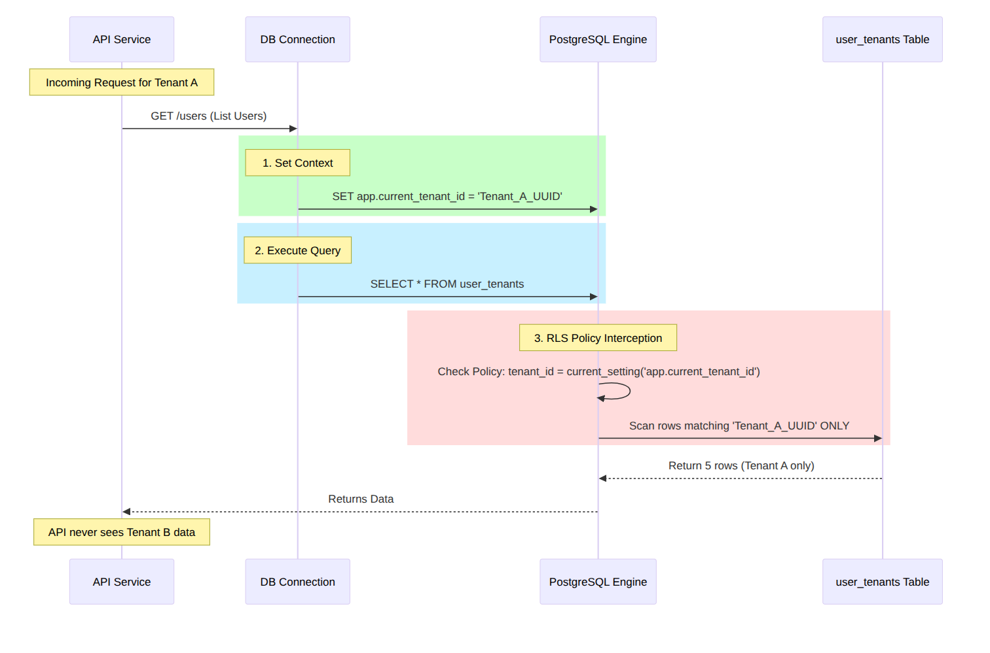

Summary of Architected Solution
- Foundation: You have a solid asyncpg foundation that is performant and type-safe.
- Security: The system follows "Defense in Depth". Even if the API layer has a bug, the Database layer (RLS) prevents data breaches.
- Compliance: The inclusion of Audit Logs, Encryption, and Cleanup Jobs makes this architecture ready for SOC 2 / GDPR audits.
- Scalability: The stateless JWT design combined with Redis caching for user context allows horizontal scaling of the API servers.

