

Overview for Extracting Data from SAP™ BW/BI with the SQL Connector

2012-06-25
QlikView Version: 11.xx English

Contents
1 Introduction 3
1.1 Within SAP 4
2 Content of File 5
3 Extraction Process 6
3.1 Background 6
3.2 Extract all of the metadata from SAP BW/BI 6
3.3 Extract Fact Tables 7
3.4 Extract Master Data 8
3.5 Reload Analysis Application 9
3.6 Script Overview 10
3.6.1 Fact and Dimensions 10
3.6.2 Master Data 12
4 Example Filter on Fact Table Extract 15
5 Delta Loading with the F Fact Table 17
5.1 Background 17
5.2 Script Overview 17

Introduction

The purpose of this overview is to demonstrate the process involved in extracting data from SAP BW/BI with the SQL Connector for usage with larger cubes (>15 million rows) not suitable for the OLAP connector

DataTarget (InfoCube)

The central objects upon which reports and analyses in BW are based, are called InfoCubes
effectively a multidimensional data structure containing a set of relational tables.

An InfoCube consists of a Fact Table and a set of n Dimension Tables that define the axes of
its multiple dimensions in a snowflake schema.

An InfoCube consists of the following structures (other entities can also exist)
- 1 fact table
- n dimension tables
- n surrogate ID (SID) tables
- n text tables
- n master data tables

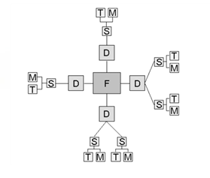

The process covers recreating and simplifying the schema to produce the following structure within QlikView:
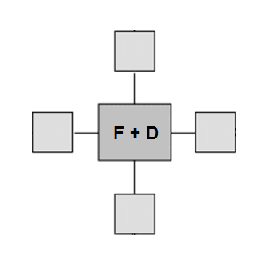
S + T + M Tables

Within SAP
A sample transaction exists within SAP to display the underlying schema of a cube:

LISTSCHEMA

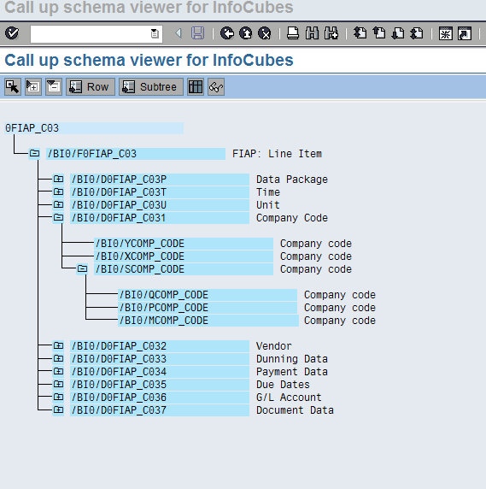

The output displays a list of all of the tables within the cube schema, in the example above we can see the Fact table:

Dimension tables:

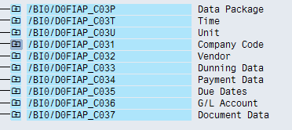

And ths associated S and M tables:

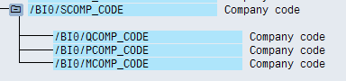

For simplicity the applications provided only extract the S,M and T tables for the master data.

Content of File

The zip file contains the following files and folders

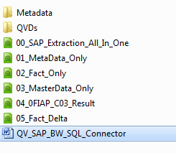

- 00_SAP_Extraction_All_In_One – sample application containing
  - BW Metadata extraction and sample analysis
  - List box selections to export fact and master data to qvd files
- 01_MetaData_Only – separate application to extract the BW metadata only
- 02_Fact_Only – separate application to extract the BW (F) Fact table to a qvd file
- 03_MasterData_Only – separate application to extract the BW master data to qvd file(s)
- 04_0FIAP_C03_Result – resultant analysis application with sample reports on the extracted cube
- 05_Fact_Delta – sample for Fact table delta load
- Metadata folder containing sample qvd files
- QVDs containing named folder for the fact data qvd’s and master data qvd’s

Extraction Process

Background

The following diagram shows the process followed by the applications contained with the zip file (note 00-SAP_Extraction_All_In_One.qvw follows the same process and is designed for point and click extractions via the front end and is not suitable for scheduling reloads)

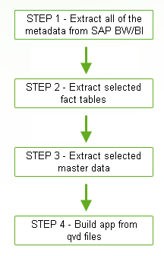

Extract all of the metadata from SAP BW/BI
Application: 01_MetaData_Only.qvw

This application is designed to extract all of the relevant metadata tables and fields for subsequent use in the build applications, it also provides some basic analysis of the InfoObjects/cubes/InfoAreas and dimensions

To populate the application:

- Add a connection string to the script using the SQL Connector
- Reload the application and the following qvd files are created in the location specified from the vDirMeta variable:

Qvd | Description | Source
Dimensions | A list of dimensions | RSDDIME
DimtoInfoLink | Linking table between dimension and InfoObject | RSDDIMEIOBJ
DimensionDescriptions | A list of dimension descriptions | RSDDIMET
InfoObjects | A list of infoObjects with fieldnames and descriptions | RSDIOBJT  RSDIOBJ
Cubes | A list of cubes/ cube types and infoAreas | RSDCUBE  RSDAREAT
Multicubes | A list of the multicubes and their descriptions | RSDCUBEMULTI  RSDCUBET

The qvd files created will be used for InfoObject renaming in subsequent steps

Extract Fact Tables

Application: 02_Fact_Only.qvw

The next step in the process extracts the F fact table from the cube name entered in the script and links the relevant dimension tables to produce a single qvd output file:

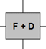
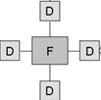
FCube_Name.qvd

To produce the Fact table(s) qvd file(s):

- Add a connection string to the script using the SQL Connector
- Add in the appropriate cube names to the Fact tab:
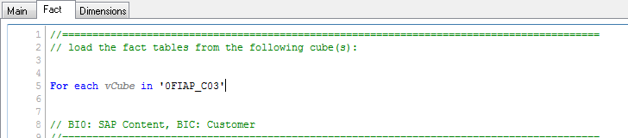
- Reload the application, this will create a new folder and qvd file for each fact table available to be loaded in the analysis application

Extract Master Data

Application: 03_MasterData_Only.qvw

The next step in the process extracts the S (SID), M(master data) and T (text data) tables from the master data names entered in the script, joins them together with keys to link back to the fact/dimension. This produces a single qvd file per master data element:

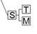
S+M+T
Tables Joined
\Masterdata\Masterdata.qvd

To produce the master data table(s) qvd file(s):

- Add a connection string to the script using the SQL Connector
- Set the language - line 21 of the script (Main tab)
- Add in the appropriate master data names to the relevant script section within the master Data/BIC/BI0 tab:
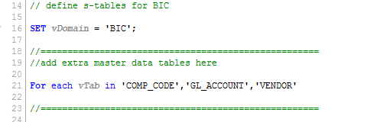

Master data entries will need to be added for both BI0 and BIC sections of the script
SAP Info:

The BI0 prefix denotes standard Infocube tables
The BIC prefix denotes custom Infocube tables

Cubes can have a mixture of both types so the extraction application runs the full script for both prefixes, in a deployment you can modify the script to specify the exact prefixes for your cube master data.

- Reload the application which will create a new folder and qvd file for each master data table available to be loaded in the analysis application

Reload Analysis Application

Application: 04_0FIAP_C03

A sample application is provided for an accounts payable cube found in most BI/BW systems. The application takes the fact/dim and master data qvd files to produce the following schema:

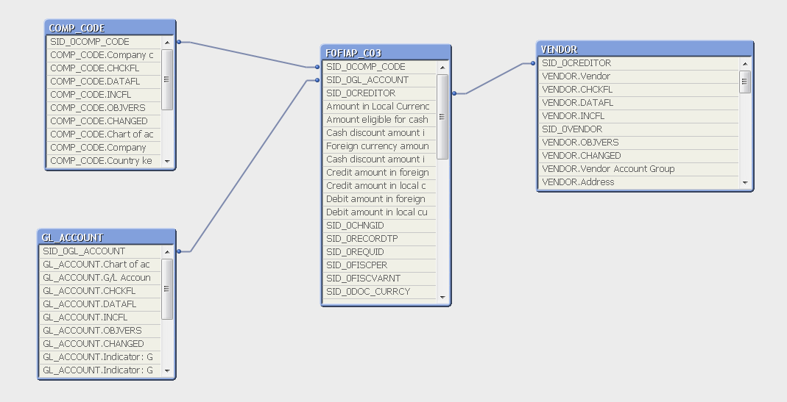

The keys to link the Fact and associated dimension tables are

SID_(0)_Dimname the 0 denotes BI0 cubes e.g. SID_0COMP_CODE and SID_Dimname for BIC cubes.

SAP Info:

The extraction scripts assume the dimension table names match the master data table names this may not always be the case, in our example the VENDOR master data key is renamed in the analysis load script to link to the dimension name CREDITOR

Script Overview

Fact and Dimensions
The fact and dimension application contains the required script to:

- Extract the F – Fact table
- Extract the associated D – dimension tables
- Join the F and associated D tables into a single table for export to qvd

Step 1

Determine cube type by analyzing the cube name and specify if the cube is BIC – custom or BI0 – standard as this will dictate the table names to be extracted:

If left('$(vCube)',1)='Z' Then
SET vDomain = 'BIC';
Else
SET vDomain = 'BI0';
Endif

Step 2

Load in descriptions of the infoObjects for later translation from the qvd file extracted during the metadata application reload:

//Create mapping load for later renaming of columns in the fact table with infoobject descriptions
Names:
Mapping Load
InfoFieldName,
[InfoObject Description]
FROM
$(vDirMeta)InfoObjects.qvd (qvd);

Step 3

Extract all of the F table fact data and name the table based on the vDomain, vCube and vFact variables

//Name the extract based on the vFact and vCube variables
$(vFact)$(vCube):
select * from /$(vDomain)/$(vFact)$(vCube);
//rename all fields in the fact table with the mapping load infoobject descriptions
RENAME fields using Names;

Step 4

Extract dimension tables and create keys to join back to the fact table.

The first stage creates a variable for the suffix of a dimension table name, each dimension will have a different letter/number as shown in the sample below:

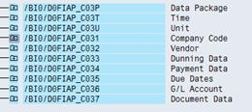
Each cube can have a maximum of 16 dimensions, the dimension routine loops through all of the dimension tables created in the vAnzDim variable and appends the dimension letter P,T,U,1,2,3 etc. to the end of the table name in the select statement:
// build string for variable:
Let vAnzDim = chr(39)&
'P' & chr(39) & ',' & chr(39)&
'T' & chr(39) & ',' & chr(39)&
'U' & chr(39) & ',' & chr(39)&
'1' & chr(39) & ',' & chr(39)&
'2' & chr(39) & ',' & chr(39)&
'3' & chr(39) & ',' & chr(39)&
'4' & chr(39) & ',' & chr(39)&
'5' & chr(39) & ',' & chr(39)&
'6' & chr(39) & ',' & chr(39)&
'7' & chr(39) & ',' & chr(39)&
'8' & chr(39) & ',' & chr(39)&
'9' & chr(39) & ',' & chr(39)&
'A' & chr(39) & ',' & chr(39)&
'B' & chr(39) & ',' & chr(39)&
'C' & chr(39) & ',' & chr(39)&
'D' & chr(39) ;

//=======================================================================================
// load dimensions tables:
For each vDim in $(vAnzDim)
//Create temporary table with the dimension name of the vDim variable
D$(vCube)$(vDim):
select * from /$(vDomain)/D$(vCube)$(vDim);
The next stage renames the key field in each dimension table (DIMID) to join to the fact table and removes the unrequired key fields after the join process:
// rename key field, to connect to fact table
Rename Field DIMID to KEY_$(vCube)$(vDim);
// Join the dimension table to the fact
Left Join (F$(vCube))
Load *, DIMID as KEY_$(vCube)$(vDim)
Resident D$(vCube)$(vDim);
//remove unwanted keys and drop temporary dimension table from memory
Drop field DIMID;
Drop field KEY_$(vCube)$(vDim);
Drop Table D$(vCube)$(vDim);
Next vDim

Master Data

The master data application contains the required script to:

- Extract the S – SID table
- Extract the associated M – master tables
- Extract the T – text tables
- Join all three together in a single qvd export with associated keys to link to the fact/dim output qvd.

Step 1

Load in descriptions of the InfoObjects for later translation from the qvd file extracted during the metadata application reload:

//Create mapping load for later renaming of columns in the fact table with infoobject descriptions
Names:
Mapping Load
InfoFieldName,
[InfoObject Description]
FROM
$(vDirMeta)InfoObjects.qvd (qvd);

Step 2

As cubes may contain a mixture of custom and standard master data the extraction routine runs for both BIC and BI0 domains which are set at the start of the extract:

// ======= Define s-tables for BIC ===================
SET vDomain = 'BIC';

Step 3

Extract all of the S (SID) table data based on the master data items specified in the vTab variable and rename the key to join back to the previously exported fact/dimension qvd files:

// Extract S - SID table using vTab for the table name and rename the SID column to match the column name in the dimension table
S$(vTab):
Load *, SID as SID_$(vTab);
select *
from /$(vDomain)/S$(vTab);
Drop Field SID;

Each SID table will contain a column name to link to the M and T tables further down the script based on the InfoObject for example the SID table for company code shown below has a field COMP_CODE which will exist in both M and T tables:

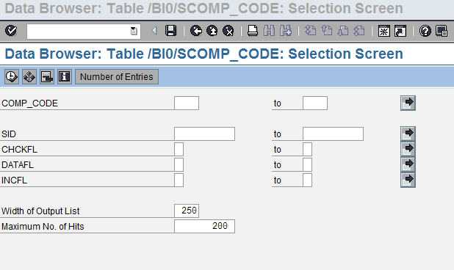

Step 4

Extract the M table data and join to the S (SID) table:

//=============================== MASTER DATA EXTRACT===============================
M$(vTab):
Load *;
Select * from /$(vDomain)/M$(vTab);
// Join all master data items to the S - SID table
Left Join (S$(vTab))
Load * Resident M$(vTab);
//===============================END OF MASTER DATA EXTRACT===========================

Step 5

Extract the T table data and join to the S (SID) table:

//=============================== TEXT DATA EXTRACT================================
T$(vTab):
Load *;
Select * from /$(vDomain)/T$(vTab)
where LANGU = '$(vLanguage)';
// Join all text data items to the M and S tables
Left Join (S$(vTab))
Load * Resident T$(vTab);
//===============================END OF TEXT DATA EXTRACT========================

Step 6

Rename the fields using the mapping load and qualify all columns except for the SID columns to create keys and prevent synthetic loads in preparation for final export to qvd(s):

// Rename info objects from the mapping loaded descriptions
rename fields using Names;
// Qualify all columns in the table to prevent synthetic key joins, only link on SID to the dimension table
Qualify *;
Unqualify 'SID_*';
// Reload S table for final export
$(vTab):
Load *
Resident S$(vTab);

Example Filter on Fact Table Extract

In order to limit data extracted from a Fact table an additional where clause can be added to the F table select statement, for example to limit the 0FIAP_C03 cube to company code ”1000” the relevant key is needed in the where clause.

To find the key using List Schema;

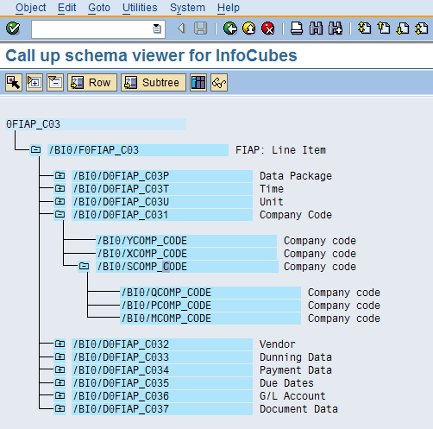

The S table /BI0/SCOMP_CODE can be analysed to find the appropriate SID for the company code to be filtered:

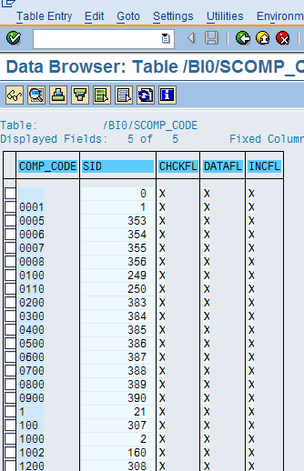

The SID for company code 1000 is 2:

Next the Dimension key corresponding to the SID is required from:

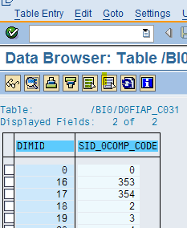

The corresponding DIMIDfor the SID (SID_0COMP_CODE) is 18

This also corresponds to the key within the Fact table for this dimension:

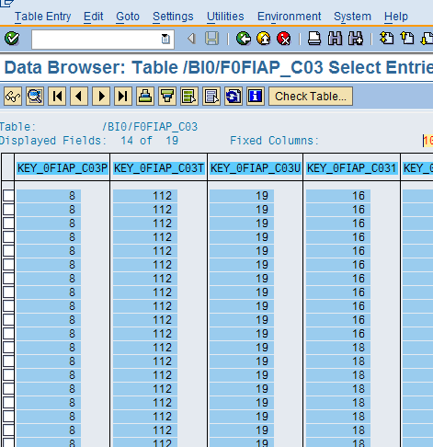

Which can be used in the where clause for the Fact table extract:

$(vFact)$(vCube):
select * from /$(vDomain)/$(vFact)$(vCube)
where KEY_0FIAP_C031 = 18;

Delta Loading with the F Fact Table

Background

Application: 05_Fact_Delta

This method uses the Data Package table to determine the latest data for use in a delta load, in the example below for cube 0SD_C03

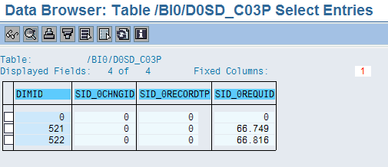

The data package table - /BI0/D0SD_C03P cotains multiple SID_0REQUID’s with associated DIMID’s

The DIMID’s correspond to a key field – KEY_0SD_C03P in the fact table for this cube - /BI0/F0SD_C03 :

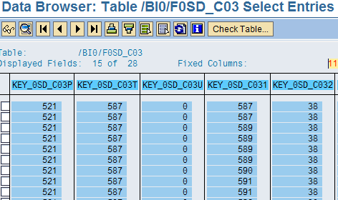

This is the key field which will be added to a where clause on extracting the F – Fact table data.

Script Overview

Step 1

The package variable is setup and a check is made to determine if the reload is full or delta based on the existence of a qvd file containing the maximum DIMID:

//Setup variable for Request ID table name:
LET vPackage = 'KEY_$(vCube)P';
//Check if the Fact tables has already been extracted and set a flag indicating a delta load is possible
LET vListqvdexists=isnull(QvdCreateTime('$(vDir)$(vCube)_Packages.qvd')); // if qvd exists then 0 else -1

Step 2

If the qvd files exists the delta load procedure is invoked and a where clause is constructed to include the maximum DIMID:

If $(vListqvdexists) = 0 then
SET vFact = 'F';
SET vLoadType = 'delta';
//Load the maximum DIMID and build into a where clause string
Packages:
Load LastPackage
from '$(vDir)$(vCube)_Packages'.qvd (qvd);
LET vLastPackageID = num(peek('LastPackage')) ;
Drop Table Packages;
// Where clause string for use in the select statement of the fact table
LET vWhereString = '$(vPackage) > $(vLastPackageID)';

Step 3

The F – Fact table is loaded with the where clause addition:
$(vFact)$(vCube):
select * from /$(vDomain)/$(vFact)$(vCube) WHERE $(vWhereString);

For the 0SD_C03 cube the where clause may look like:

Select * from /BI0/F0D_C03 where KEY_0SD_C03 > 521

Step 4

Dimension tables are joined to the fact as with the previous examples and the concatenated qvd file is created with both historic and new data based on the DIMID:

If vLoadType = 'delta' then
If NoOfRows('$(vFact)$(vCube)') > 0 then
Concatenate($(vFact)$(vCube))
load * from $(vDir)F$(vCube).qvd (qvd);
Store F$(vCube) into $(vDir)F$(vCube).qvd;
Endif

