Wooohoooo your brand-new Version 3.1 Snowflake Usage Analysis QVF file just arrived in the mail. Or email. Or was downloaded from GitHub. Now let's get it running.

If you are using Qlik Sense Enterprise SaaS choose Add New and then select Upload App and then choose the file and upload it.

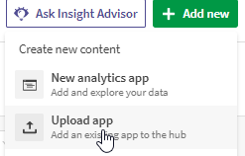

If you are using Qlik Sense Enterprise Windows go to your QMC, select Apps and then choose Import and import it.

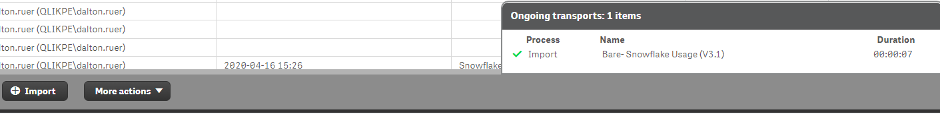

Edit the application name to be whatever you wish

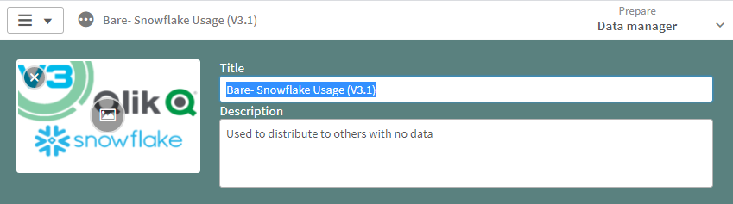

Go to the Load Script and open the Main Variables section of code. Modify the vWindowsOrSaaS variable to either Windows or SaaS.

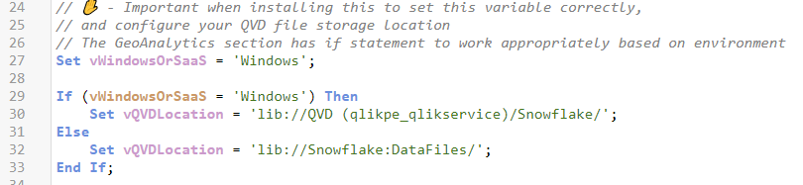

Open the Startup spin through all Snowflake Instances section of code. Edit the SnowflakeInstances that your organization uses as appropriate:

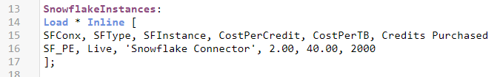

If you are using Qlik Sense Enterprise for Windows and do not have GeoAnalytics installed remove the GeoAnalytics section of code or comment it out. If you are using Qlik Sense Enterprise SaaS edition you have access to the functionality that is needed.

Load your data and have fun analyzing the results.