Changing Flash Programming Timeout in MPT / LIN

Abstract
This document has instructions how to change Flash Programming Timeout for Melexis Programming Tool Software (MPT) when used to reprogram chip via LIN-loader.

History records

Date | Version | Comments
Nov 30, 2011 | 1.0 | Document creation

Table of Contents

1 Introduction 4
1.1 Scope of the document 4
1.2 Glossary of terms 4
2 Changing Flash Programming Timeout in MPT 5
2.1 Save default settings 5
2.2 Change Settings 5
2.3 Activating new settings 6

Introduction

Scope of the document
This document describes how to change Flash Programming Timeout in Melexis Programming Tool (MPT) Software to match the timing used by LIN-loader of the chip.

Glossary of terms
Table 1 explains the abbreviations used in this document.

Table 1: abbreviations used in this document

MPT | Melexis Programming Tool (PC-host software which is used to reprogram chip via LIN bus)

Changing Flash Programming Timeout in MPT
While LIN-loader is erasing/writing flash it uses the compile time setting defined in Flash driver (file \libsrc\LIN\flashfunctions_c_cmp.c). For Software Platform version 3.0.4 the Erase Time is set to 40ms and Write Time is set to 10 ms.

To match this timing the default MPT timeout should be changed.

Save default settings
Start MPT software and by double clicking on LIN (1) in UI Modules list open MLX LIN User Interface window. Select File > Save Settings As .. (2) to save the MPT settings.

Note: Be default the settings will be saved in MLXLIN_default.ini file in Document and Settings directory of the active user. E.g. "D:\Documents and Settings\<user_name>\application data\Melexis\MLXLIN\"

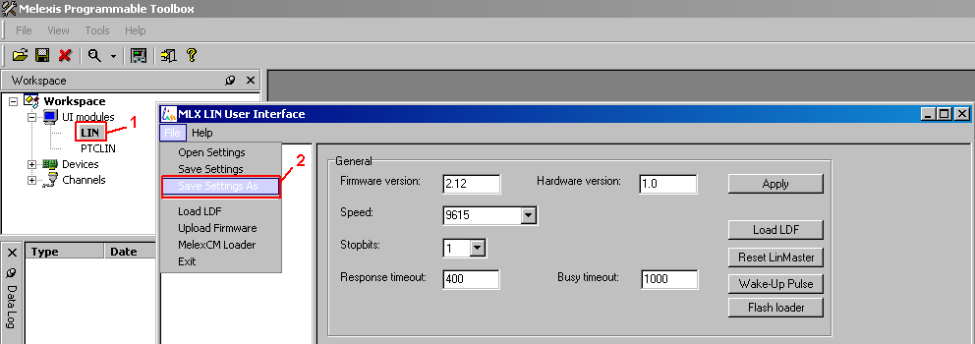

Change Settings
Open file with saved settings (MLXLIN_default.ini) in text editor and change TWriteFlash to 50000 (time is specified in microseconds). Then save the file.

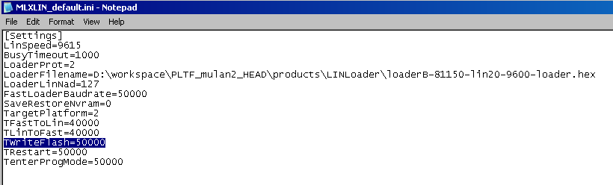

Activating new settings

Open the file with modified settings in MPT (1) or restart the MPT.

