Abstract

This document is a reference manual for programmers to integrate the LIN Module in their application. It presupposes knowledge of the LIN Protocol and the Melexis hardware in which the LIN Module is integrated.
Document History

Revision | Date | Name | Comment
1.0 | May 27th, 2005 | B. Michel | Document creation
1.1 | Sept 5th, 2005 | B. Michel | Commands additions and updates
1.2 | Oct 18th, 2005 | B. Michel | Autoaddressing mode  Configuration updates.
1.3 | Nov 30th, 2005 | B. Michel | Filter code additions  Configuration table descriptions.
1.4 | May 15th, 2006 | B. Michel | Function additions and updates.  Flags
1.5 | May 30th, 2006 | B. Michel | Review
2.0 | Jun 12th, 2006 | B. Michel | Review
2.1 | Dec 18th, 2006 | G. de Jong | Added mlu_ErrorDetected  Updated mlu_LinStateChanged, and Sleep mode
2.2 | Jan 26th, 2007 | G. de Jong | Clarifications on Wakeup
2.3 | Jun 15th, 2007 | G. de Jong | Added DataTransmittedEvent argument to ml_DataReady
2.3.1 | Jul 24th, 2007 | Y. Soloshenko | Corrected ml_Discard to ml_DiscardFrame  Added ml_reasonTimeOutDominant to ml_StateReason  Added ml_erStopBitTX to ml_LinError
2.4 | Oct 5th, 2007 | Y. Soloshenko | Introduction of named slew rate constants to ml_SetOptions  Removed ml_reasonUnknown from ml_StateReason  Added mlu_ApplicationStop notification  Added ml_EnableNextFrameSequence and ml_DisableNextFrameSequence commands  Clarifications
2.5 | Nov 15th, 2007 | Y. Soloshenko | Added clarification to mlu_DataTransmitted event  All interrupts (except LIN) will be automatically disabled by Flash Loader after returning ML_SUCCESS status from mlu_ApplicationStop
2.6 | Mar 11th, 2008 | Y. Soloshenko | Added clarification to mlu_ApplicationStop
2.7 | Jun 13th, 2008 | Y. Soloshenko | Added clarification that LIN API commands can be used only in Protected Mode of CPU  Added clarification to ml_SetBaudRate formula
2.8 | Oct 8th, 2008 | Y. Soloshenko | All reference to "System mode" of MLX16 CPU changed to "Protected mode" as per MLX16 documentation  Added notes on autoaddressing when exiting SLEEP state
2.9 | Feb 18, 2010 | Y. Soloshenko | Removed ml_EnableNextFrameSequence and ml_DisableNextFrameSequence commands (obsolete since SW Platform 1.5.2)
2.10 | May 28, 2010 | Y. Soloshenko  G. de Jong | Added errors description and version references  Updated precondition of ml_InitLinModule  Removal of ml_stINIT
2.11 | Dec 15, 2010 | Y. Soloshenko | Renamed document to Melexis LIN Firmware API (was MelexCM LIN Firmware API)
2.12 | Mar 30, 2011 | O. Sotnikov | Added ml_SetLoaderNAD() and ml_GetLoaderNAD().
2.13 | Nov 24, 2011 | Y. Soloshenko | Added comments to ml_SetBaudRate() command. Since version 3.1.7 of the LIN Module the baudrate can be automatically detected (if the auto-baudrate feature is enabled in the LIN Module).
2.14 | Aug 1, 2012 | Y.Soloshenko | Added restriction for ml_GetState command
2.15 | Jan 23, 2013 | Y. Soloshenko | All reference to "Protected mode" of MLX16 CPU changed to "System mode" as per new MLX16/MLX16-FX documentation.  Added noted on ml_WakeUp function: to generate correct wake-up sequence, an initial baud rate shall be set by ml_SetBaudRate function even if auto-baud rate feature is enabled
2.16 | Sep 25, 2013 | Y. Soloshenko | Marked functions ml_EnableEndOfHeaderEvent , ml_DisableEndOfHeaderEvent, ml_SetNextFrameIDCode, ml_EnableFilter, ml_DisableFilter as deprecated  Functions ml_Receive, ml_Transmit and callback mlu_HeaderReceived are deprecated in ID-filtering mode (can be used only in Frame mode)  Added functions ml_GetBaudRate and ml_SetSlewRate
2.17 | Feb 04, 2014 | Y. Soloshenko | Added function ml_SetAutoBaudRateMode
2.18 | Jan 28, 2015 | P. Sapsay | Changed function ml_SetOptions (ml_SetSlewRate and ml_SetOptions now are separate functions), updated ml_SetAutoBaudRateMode function, updated ml_GetState
2.19 | Oct 18, 2015 | G. Moroz | Updates as switching to MLX4 v4.1.0:  - Frame Mode is NOT supported any more (removed ml_Recieve, ml_Transmit, mlu_HeaderRecieved)  - Removed IDInitTbl config. table  LIN errors changes (ml_erCommand is replaced by ml_erShortDone)  Added ml_erWakeUpInit description  Added ml_reasonWakeupBreak description  Removed ml_erNextFrameIDCode description  Removed ml_FrameIDCode

Table of contents

1. General Description 6
2. Conventions and Types Definitions 9
2.1 Naming conventions 9
2.2 Basic types 9
2.2.1 ml_uint8 9
2.2.2 ml_uint16 9
2.2.3 ml_bool 9
2.2.4 ml_Status 9
2.2.5 ml_AutoAddressingMode 9
2.3 LIN interface types 9
2.3.1 ml_LinError 9
2.3.2 ml_CheckSumType 12
2.3.3 ml_LinState 12
2.3.4 ml_StateReason 12
2.3.5 ml_MessageID 13
2.3.6 ml_FrameID 13
3. LIN API Commands 14
3.1 LIN Module Version 14
3.1.1 ml_LinModuleVersion 14
3.2 Software and Hardware Options 14
3.2.1 ml_SetSlewRate 14
3.2.2 ml_SetOptions 15
3.3 LIN Module State Machine Management 16
3.3.1 ml_Connect 18
3.3.2 ml_Disconnect 18
3.3.3 ml_GetState 19
3.3.4 ml_GotoSleep 19
3.3.5 ml_InitLinModule 20
3.3.6 ml_WakeUp 20
3.4 Bus Timing 21
3.4.1 ml_SetBaudRate 21
3.4.2 ml_GetBaudRate 22
3.4.3 ml_SetAutoBaudRateMode [new] 22
3.5 Set Loader Node Address (NAD) 22
3.5.1 ml_SetLoaderNAD 22
3.5.2 ml_GetLoaderNAD 23
3.6 Message Management 23
3.6.1 ml_AssignFrameToMessageID 23
3.6.2 ml_EnableMessage 25
3.6.3 ml_DisableMessage 25
3.7 Data Transfer 25
3.7.1 ml_DataReady 25
3.7.2 ml_DiscardFrame 26
3.8 Autoaddressing 26
3.8.1 ml_AutoAddressingConfig 26
4. Events raised to the application level 28
4.1.1 mlu_ApplicationStop 28
4.1.2 mlu_AutoAddressingStep 28
4.1.3 mlu_DataRequest 29
4.1.4 mlu_DataTransmitted 30
4.1.5 mlu_ErrorDetected 31
4.1.6 mlu_MessageReceived 31
4.1.7 mlu_LinSleepMode 32
5. Initialization and sleep modes 33
5.1 Starting the LIN Module 33
5.2 Sleep Modes 34
6. Cooling Auto Addressing 35
7. Flash Loading 37
8. Configuration Tables 38
8.1 INDXtbl 38
8.2 PARAMtbl 38
8.3 AUTOADDtbl 38
9. Versions 39
10. References 40

General Description
The LIN Module is specified as a dedicated micro-coded state machine program running on the MLX4 processor controlling a communication bus peripheral, while the user application is running on the MLX16 processor. The communication between the two processors is achieved using interrupts and a shared buffer (LinFrameDataBuffer) from the MLX4 to the MLX16, and by raising events from the MLX16 to the MLX4. The use of events from the MLX16 guarantees that the MLX4 is able to process frames on the LIN bus without being interrupted.

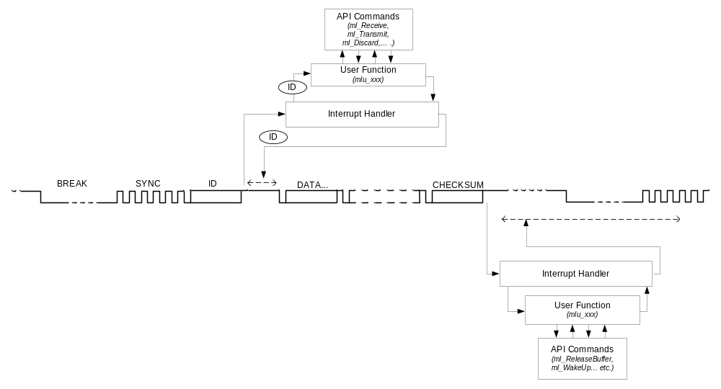
Figure 1 LIN processing overview
The LIN Module is configurable, for example to filter incoming frames and to automatically discard the frames that are not relevant for the application. Relevant frames are transferred to the application. The configuration is by means of a set of offline defined tables.

An interrupt can also be generated to signal other events such as a bus error. The LIN Interrupt Service Routine (ISR) on the MLX16 identifies the source of the interrupt and notify the user application level e.g. by raising a corresponding event, setting a flag or otherwise. The handling of the event can also be done in the ISR by calling user supplied functions. Note that while all other functions of the LIN API are provided by Melexis, these functions (Event Handling Functions) have to be written by the programmer for its particular application but the function signatures are imposed.

Figure 1 gives a general overview of the LIN processing and the above described interaction between the LIN Module monitoring the LIN bus and the application in general terms. Three use cases are described next.

Message reception
The scenario of the reception of a configured master-to-slave message is depicted in Figure 2.

The LIN Module detects the Break/Synch and the protected frame ID. For this case, the frame ID is specified as a master-to-slave message in the configuration tables. The LIN Module then continues to read the frame data bytes, and stores them in a memory buffer called LinFrameDataBuffer. After the checksum byte has been received and validated, the MLX4 generates a interrupt to the MLX16. With the mlu_MessageReceived notification by the Interrupt Handler, the application can retrieve the received data in the LinFrameDataBuffer. The data should be retrieved as soon as possible and the buffer should then be released with the ml_ReleaseBuffer command (is executed internally in API, and not need to execute it from application).

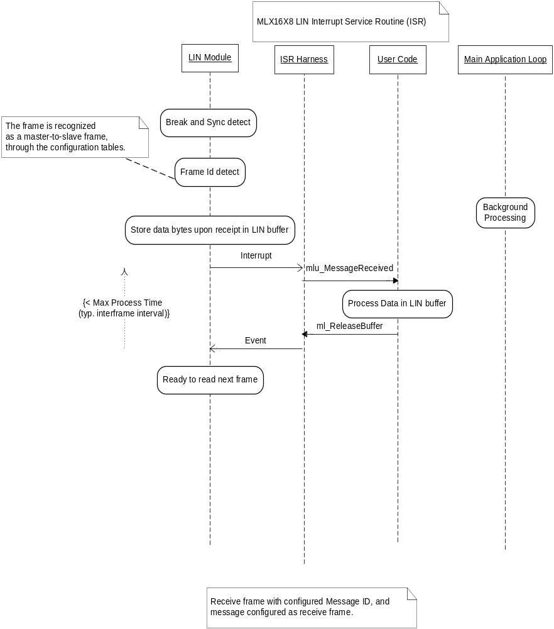
Figure 2 Application scenario receive frame with id-filtering configured
LinFrameDataBuffer is an array of 8 bytes. The checksum is never stored, as it is checked and calculated by the LIN Module. If the LinFrameDataBuffer is not released when the LIN Module needs to fill it with a new frame, an ml_erBufferLocked error will be generated and the new frame content will be lost.

Message Transmission
The scenario of the transmission of a configured slave-to-master message is depicted in Figure 3.

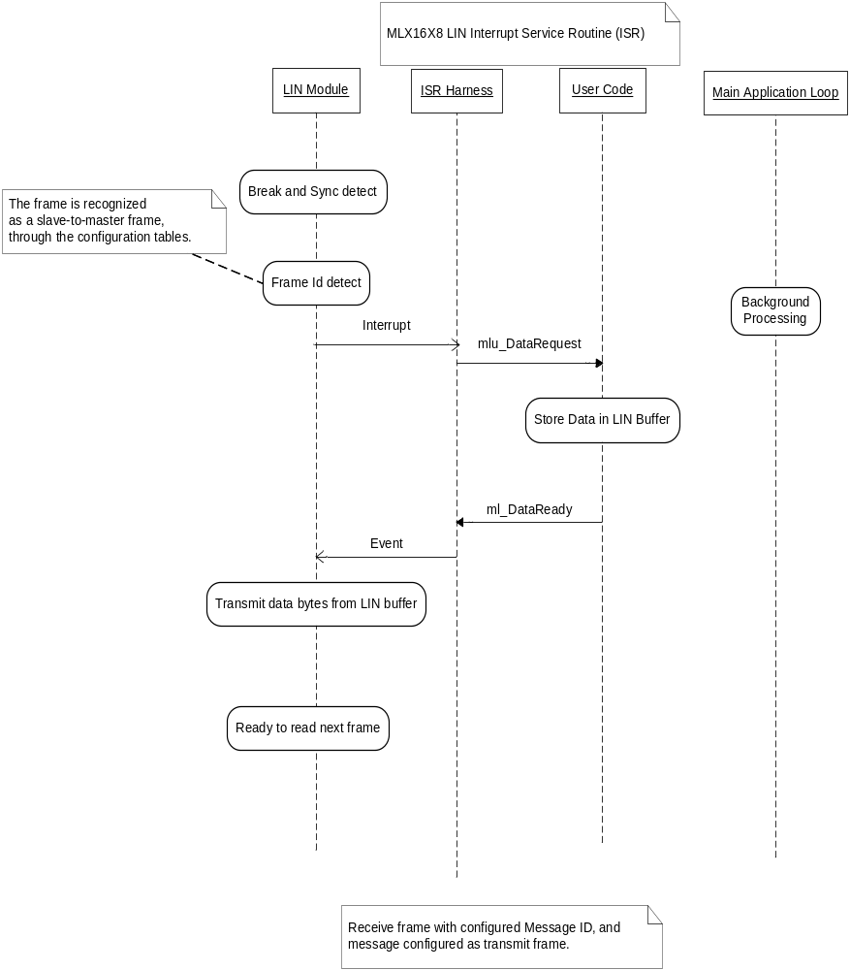
Figure 3 Application scenario transmit frame with id-filtering configured
The LIN Module detects the Break/Synch and the protected frame ID. For this case, the frame ID is specified as a slave-to-master message in the configuration tables. The LIN Module then interrupts the MLX16. With the mlu_DataRequest notification by the Interrupt Handler, the application should store the data to be sent on the LIN bus in LinFrameDataBuffer, and issue the ml_DataReady command. The checksum is automatically calculated in the LIN Module.

Conventions and Types Definitions

Naming conventions
All functions and types of the Melexis LIN API will have the prefix ml_ (lowercase ‘ML’ followed by an ‘underscore’); the LIN Event Handling Functions (called by the LIN ISR) will have the prefix mlu_.

Basic types

ml_uint8
ml_uint8 is an 8-bits unsigned integer type.

ml_uint16
ml_uint16 is a 16-bits unsigned integer type.

ml_bool
ml_bool is a basic integer type sufficient to represent the values: TRUE and FALSE.

Implementation note
ML_FALSE = 0
ML_TRUE (all other values)

ml_Status
ml_Status is a basic integer type sufficient to represent the success status of a command: SUCCESS and FAILURE.

Implementation note
ML_SUCCESS = 0
ML_FAILURE (all other values)

One of the failures case will be a timeout of the LIN module events.

ml_AutoAddressingMode
ml_AutoAddressingMode is a basic integer type sufficient to represent the configuration values for the auto addressing mode: ENABLED, DISABLED, AUTORESET, and FORCE.

Implementation note
ML_ENABLED = 1 (ML_TRUE)
ML_DISABLED = 0 (ML_FALSE)
ML_AUTORESET = 2
ML_FORCE = 3

LIN interface types

ml_LinError
ml_LinError is a basic integer enumeration type to represent the following errors:
ml_erShortDone
A short state has been seen on the bus, but now recovered.

Recommended action: There is no special action required from application.
ml_erWakeUpInit
A valid wakeup pulse has been seen while waiting to enter in sleep state

Recommended action: There is no special action required from application.
ml_erLinModuleReset
A non-recoverable failure has occurred in the LIN Module. The source of this error could be unstable PLL or LIN PHY watchdog timeout.

Recommended action: full LIN Module reset (using MLX4_RESET (); MLX4_START (); sequence [6]) and reinitialization (using API commands ml_InitLinModule, ml_SetBaudRate, ml_SetOptions etc).
ml_erBufferLocked
The LinFrameDataBuffer was not released when needed by the LIN Module due to missing or delayed call to ml_ReleaseBuffer. The buffer is automatically unlocked by LIN Module before signaling this error.

Recommended action: review and profile the code to verify that timing constraints are satisfied for master-to-slave frame processing.
ml_erSynchField
The Synch field edges are not correct: while receiving the Synch field of a frame, the LIN Module detected a timing error. The processing of the frame is then aborted. There is probably a problem with the LIN baudrate or the oscillator frequency of the slave or master node. The possible sources of this error are:
- master’s baudrate is out-of-range (+/-15%)
- duty cycle of the individual bits within Sync field is out of the specification (+/-25%)
- wrong bit pattern (not equal to 0x55)
- sync-break is too long
- bit mismatch during bus sampling

In SAE-J2602 implementation, the slave should report “Data error” in J2602 Status Byte if ml_erSynchField error is detected.

Recommended action: debounce the error and when some critical error rate is achieved -- reset and reinitialize the LIN Module.
ml_erIdParity
Parity error in the Identifier field. The frame will be discarded.

In SAE-J2602 implementation, the slave should report “ID Parity Error” in J2602 Status Byte if ml_erIdParity error is detected.

Recommended action: There is no special action required from application.
ml_erIdFraming
Identifier stop bit not recessive. The frame will be discarded.

Recommended action: There is no special action required from application.
ml_erShort
Short detected on the LIN bus (dominant level present for too long). This error can occur if the baudrate programmed by the application is not consistent with the LIN bus baudrate. Also too long Master’s Sync-Break can be the source of this error.

Recommended action: Review the code to verify that the slave’s baudrate is correctly configured. Check master’s baudrate and Sync-Break field parameters.
ml_erTimeOutResponse
For a master-to-slave frame, if the response part is not fully received within Tframe_Maximum (only for LIN 1.3; for LIN2.0 error in this case is not signaled).

For a slave-to-master frame, the ml_DataReady command is received too late, the LIN Module being unable to transmit the data in time. If the ml_DataReady command is received too late, the transmit will be aborted by the LIN Module.

Recommended action: review and profile the code to verify that timing constraints are satisfied for slave-to-master frame processing.
ml_erBreakDetected
A break is detected while a relevant message is not yet completed (break detected between bytes or overlapping onto a byte). Note that the ml_erBreakDetected error will be associated to another error. The associated error will have been signaled before. It can be a ml_erDataFraming or a ml_erBit error.

Receiving this error does not necessary mean that the break will be followed by a valid message, or by a message relevant to the application.

When a break is detected inside a frame during the auto addressing process, that process can not be successfully completed as it is not possible to know exactly where the break began.

In LIN2.x implementation, the slave should set response_error bit when ml_erBreakDetected error is detected (except for event triggered frame responses).

Recommended action: There is no special action required from application.
ml_erDataFraming
When receiving a frame the stop bit of a data byte is not recessive.

In LIN2.x implementation, the slave should set response_error bit when ml_erDataFraming error is detected (except for event triggered frame responses). If ml_erDataFraming is detected during diagnostic master-request-frame frame, any pending slave responses should be cleared.

In SAE-J2602 implementation, the slave should report “Byte Field Framing Error” in J2602 Status Byte if ml_erDataFraming error is detected.

Recommended action: There is no special action required from application.

ml_erCheckSum
The checksum (regular or enhanced) of an incoming frame is incorrect. In this case the data is discarded.

In LIN2.x implementation, the slave should set response_error bit when ml_erCheckSum error is detected (except for event triggered frame responses). If ml_erCheckSum is detected during diagnostic master-request frame, any pending slave responses should be cleared.

In SAE-J2602 implementation, the slave should report “Checksum Error” in J2602 Status Byte if ml_erCheckSum error is detected.

Recommended action: Review the code to verify that correct checksum model is used.
ml_erBit
For a transmit frame: the LIN bus level read back by the LIN Module differs from the value sent. A ml_erBit is also generated if a start bit is detected between bytes transmitted by the node (including an unexpected start bit detected before the first data byte is transmitted). It is equivalent to a data collision error.

In LIN2.x implementation, the slave should set response_error bit when ml_erBit error is detected (except for event triggered frame responses).

In SAE-J2602 implementation, the slave should report “Data Error” in J2602 Status Byte if ml_erBit error is detected.

Recommended action: There is no special action required from application.
ml_erStopBitTx
For a transmit frame: during transmission of the STOP bit the LIN bus level read back by the LIN Module differs from the value sent. It is similar to a data collision error ml_erBit).

In LIN2.x implementation, the slave should set response_error bit when ml_erStopBitTX error is detected (except for event triggered frame responses).

In SAE-J2602 implementation, the slave should report “Byte Field Framing Error” in J2602 Status Byte if ml_erStopBitTX error is detected.

This is error is needed for SAE-J2602 implementation which should identify collisions at stop bits.

Recommended action: There is no special action required from application.

ml_CheckSumType
ml_CheckSumType is a basic integer enumeration types to represent either the classic checksum: ml_chk13 (specified by the LIN 1.3 specification) or the enhanced one: ml_chk20 (specified by the LIN 2.0 specification, which includes the ID field in its calculation).

ml_LinState
ml_LinState is a basic integer enumeration type to represent the different states of the LIN Module state machine: ml_stDISCONNECTED, ml_stACTIVE, ml_stSLEEP, ml_stACTIVE, ml_stSHORT, ml_stWAKEUP, ml_stINVALID.

ml_StateReason
ml_StateReason is a basic integer enumeration type to represent the following different causes of a LIN state change as reported with the mlu_LinSleepMode event:
ml_reasonCommand
The state transition is due to a command from the application.
Applicable only when entering the SLEEP state.
ml_reasonTimeOut
The state transition is due to a time out, i.e. LIN bus inactivity for more than 4 seconds with LIN bus in recessive state. Applicable only when entering the SLEEP state.
ml_reasonTimeOutDominant
The state transition is due to a time out, i.e. LIN bus inactivity for more than 4 seconds with LIN bus in dominant state. Applicable only when entering the SLEEP state.
ml_reasonMaster
The state transition is due to reception of a go-to-sleep command, sent by the LIN master (ID 0x3C, first data byte 0x00), [1]
Applicable only when entering the SLEEP state.
ml_reasonWakeup
The state transition is due to the detection of a wake-up pulse on the LIN bus.
Applicable only for entering the ACTIVE state from the SLEEP state or from the ACTIVE state. See Section 5.2.
ml_reasonWakeupResponse
The state transition is due to the detection of a wake-up pulse on the LIN bus.
Applicable only for entering the ACTIVE state in response to a ml_Wakeup command. See Section 3.3.6
ml_reasonWakeupBreak
The state transition is due to the detection of a break inside a wakeup pulse sent by the slave.
Applicable only for entering the ACTIVE state in response to a ml_Wakeup command. See Section 3.3.6
ml_reasonWakeupAbort
The state transition is due to no bus activity after initiating the wakeup sequence.
Applicable only for entering the SLEEP state in response to a ml_Wakeup command. See Section 3.3.6

ml_MessageID
ml_MessageID is a basic integer with range 0-63 to identify a message at the application level.

ml_FrameID
ml_FrameID is a basic integer with range 0-63 representing the LIN frame identifier (without the parity bits) as transmitted on the LIN bus.

LIN API Commands
Following are the commands the programmer can use to control and monitor the LIN Module.

Note that the pre-condition “this command can be used in any state”, means after the initialization of the LIN Module with the ml_InitLinModule command. ml_LinInitModule is also the only allowed API command after the ml_erLinModuleReset error and MLX4 reset and restart.

Note that LIN API commands can only be used in System Mode of CPU since they access system register (SLVCMD) which is not accessible in User Mode. In case an LIN API command is called from User Mode, then a Protection Error interrupt may be generated.

LIN Module Version

ml_LinModuleVersion
Syntax
Description
ml_uint16 ml_LinModuleVersion (void);
Returns the version of the LIN Module.
Preconditions
None – this command can be used in any state.
Return Value
Returns the version of the LIN Module. If zero, the version was not successfully obtained.

Software and Hardware Options

ml_SetSlewRate
Syntax
Description
ml_Status ml_SetSlewRate (ml_uint8 SlewRate);
Sets the slew rate value.
SlewRate should be set dependent on the target baudrate of the LIN bus according to the below table. The SlewRate is a hardware register of the (digital) LIN Physical layer cell.

LIN Cell Baudrate | SlewRate Value
10.4 .. 20kbps | ML_SLEWHIGH  (default)
≤ 10.4 kbps | ML_SLEWLOW
> 20kbps  max (reserved for high speed flash loading mode, violates LIN physical requirements) | ML_SLEWFAST

Notes:
- Using ML_SLEWLOW with baud rates higher that 15 kbps might result in unstable communication. Please use ML_SLEWHIGH for baud rates higher than 15 kbps.
- The values of the ML_SLEWHIGH, ML_SLEWLOW and ML_SLEWFAST constants depend on how the MLX4 Phymd register is interpreted by the companion chip. So, might have different defines for different products.
- It is not possible to retrieve the options that have been configured.

Preconditions
This command can be used only from the DISCONNECTED state.
Return Value
Returns ml_Status.
Usage Example
See also
[…]
ml_SetSlewRate(ML_SLEWHIGH);

/* other configurations */

ml_Connect();
ml_SetOptions

ml_SetOptions
Syntax
Description
ml_Status ml_SetOptions (
ml_uint8 IDStopBitLength,
ml_uint8 TXStopBitLength,
ml_bool EnableStateChangeEvent,
ml_uint8 SleepMode);
Sets the configuration options of the LIN Module.

IDStopBitLength is the additional length of the stop bit at the end of the ID field on a slave-to- master frame. By default, the stop bit length is 1 bit.

IDStopBitLength Value | Stop Bit Length
0 (default) | 1 bit
1 | 1.5 bit
2 | 2 bits
3 | 2.5 bits

TXStopBitLength is the additional length of stop bits that are inserted on the LIN bus during a transmission.
TxStopBitLength Value | Stop Bit Length
0 (default) | 1 bit
1 | 2 bit

EnableStateChangeEvent indicates if state changes in the state machine must be signaled to the application or ignored. State changes are signaled by default.

SleepMode indicates if the LIN Module can go into sleep mode after 4 seconds of inactivity on the LIN bus If not enabled, the LIN Module stays in the ACTIVE state even if there is no activity on the LIN bus. SleepMode also indicates the mechanism to use for wake-up detection: monitoring of the bus by the LIN Module firmware, or if triggered by (external) hardware.

SleepMode Value | Wakeup detection | Sleep mode after 4s of bus inactivity
ML_DEEPSLEEP | Hardware | Yes
ML_LIGHTSLEEP | Firmware | Yes

Note that wake-up detection by HW may not be supported on all hardware targets.

Preconditions
This command can be used only in the DISCONNECTED state.
Return Value
Returns ml_Status.

LIN Module State Machine Management
These commands are used to control the LIN Module state machine (see Figure 4).

Upon reset, the LIN Module must receive the ml_InitLinModule command to enter the DISCONNECTED state. In this state, it is possible to set the baudrate, the configuration options and the dynamic LIN identifiers. Once the initialization is done, the ACTIVE state is entered with the ml_Connect command to start communication on the LIN bus.

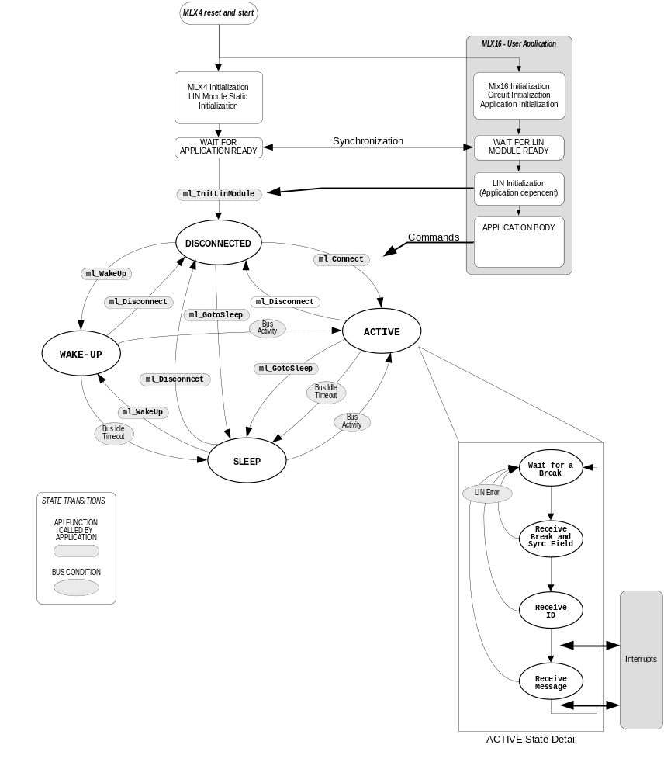
Figure 4 LIN Module State Machine
The LIN Module can enter the SLEEP state after 4 seconds of inactivity on the LIN bus [1] or when the ml_GotoSleep command is issued. Note that the SLEEP state is only a pre-condition for the system and hardware to go into a lower-power mode. When entering the WAKEUP state, the LIN Module will send wake-up pulses on the LIN bus [1]. The LIN Module then automatically goes into the ACTIVE state upon reception of a message sent by the LIN master.

From any state it is possible to go back to the DISCONNECTED state should one need to change the configuration of the LIN Module.

If a command is sent resulting in an invalid state transition, the LIN Module will return an error status

ml_Connect
Syntax
Description
ml_Status ml_Connect (void);
This command causes the LIN Module to switch from the DISCONNECTED state to the ACTIVE state and starts monitoring the LIN bus for activity.
Preconditions
This command can be used only from the DISCONNECTED state.
Return Value
Returns ml_Status.
See also
ml_Disconnect, ml_GotoSleep, ml_WakeUp

ml_Disconnect
Syntax
Description
ml_Status ml_Disconnect (void);
This command causes a transition to the DISCONNECTED state, therefore suspending all message handling.

In case a message is being processed when this command is received, the transition to the DISCONNECTED state will occur after the end of the processing.

This command should be issued first before changing the baudrate and to define new LIN identifiers.
Preconditions
None - This command can be used in any state.

Return Value
Returns ml_Status.
See also
ml_Connect, ml_GotoSleep, ml_WakeUp

ml_GetState
Syntax
Description
ml_LinState ml_GetState(ml_uint8 bits_to_reset);
This command retrieves the current state of the LIN Module and copy current LIN status bits to LinStatus variable

The bits_to_reset value control which LIN status bits will be reset after command execution: ML_NOT_CLEAR – nothing will be cleared, ML_CLR_LIN_BUS_ACTIVITY – only LIN bus activity bit will be cleared, ML_CLR_LIN_CMD_OVERFLOW – reset only overflow occurred bit, ML_CLR_BUS_ACT_AND_OVF – reset overflow occurred bit and LIN bus activity bit.

For reading LIN status bits might be used masks with LinStatus variable: ML_LIN_BUS_ACTIVITY, ML_LIN_BUFFER_NOT_FREE, ML_LIN_CMD_OVERFLOW.

Return Value
ml_GetState(ML_CLR_LIN_BUS_ACTIVITY);
if ((LinStatus & ML_LIN_BUS_ACTIVITY) != 0U)
{
/* bus activity detected */
/* set this bit in status word */
ifcStatus |= ML_IFC_BUS_ACTIVITY;
}
Returns the current state of the LIN module: ml_stDISCONNECTED, ml_stACTIVE, ml_stSLEEP, ml_SHORT, ml_stWAKEUP.

The value ml_stINVALID is returned in case the state of the LIN module can not be retrieved.
See also
ml_LinState type definition

ml_GotoSleep
Syntax
Description
ml_Status ml_GotoSleep (void);
This command causes the LIN Module to switch to the SLEEP state. In this state, the LIN Module will ignore all LIN bus activity except a wake-up pulse.
The wakeup detection mode to exit the SLEEP state is specified with the SleepMode parameter in the ml_SetOptions command.

Note: the switch to the SLEEP state is not instantaneous. (See Section 5.2)
Preconditions
This command can be used only from the DISCONNECTED and ACTIVE states.
Return Value
Returns ml_Status.
See also
Initialization and sleep modes (Chapter 5), ml_Connect, ml_Disconnect, ml_WakeUp, ml_SetOptions.

ml_InitLinModule
Syntax
Description
ml_Status ml_InitLinModule (void);
This command initializes the LIN Module and switches to the DISCONNECTED state. The LIN Module may need to be (re)configured, as no previous configuration data is retained.
Preconditions
This command can be used only after reset of the MLX4 processor, i.e. at power-on of the device or after an explicit reset of the MLX4 by the application with e.g.: [6]
MLX4_RESET ();
NOP ();
NOP ();
NOP ();
MLX4_START ();

Return Value
Returns ml_Status.
See also
Initialization and sleep modes (Chapter 5), ml_SetOptions, ml_SetBaudRate, ml_AssignFrameToMessageID

ml_WakeUp
Syntax
Description
ml_Status ml_WakeUp (void);
This command causes a transition to the WAKEUP state, and subsequently starts the LIN bus wake-up procedure.

A sequence of up to 3 wake-up pulses is sent (if no activity is detected on the LIN bus). When successful, i.e. activity detected on the LIN bus, the LIN Module enters the ACTIVE state.

If there is no activity for 1.5 seconds after the third pulse, the LIN Module enters again the SLEEP state and the mlu_LinSleepMode event is raised, when enabled, with the ml_reasonWakeupAbort cause parameter.
Preconditions
This command can be used only from the DISCONNECTED and SLEEP states.
Return Value
Returns ml_Status.
See also
ml_Connect, ml_Disconnect, ml_GotoSleep

Bus Timing

ml_SetBaudRate
Syntax
Description
ml_Status ml_SetBaudRate (
ml_uint8 caPresc,
ml_uint8 caBaud );
This function sets the target baud rate of the LIN bus. The default baud-rate mode is auto baudrate on the first frame at startup. After execution this command – LIN module will be switched to fixed baud-rate.

The prescaler caPresc and baudrate counter caBaud values are related as follows

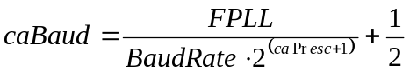

where FPLL is the PLL frequency which is used to clock CPU in Hz, and BaudRate is the desired baudrate of the LIN bus in bit/sec. Both values have to be integers.

If caPresc and caBaud are not set correctly, the LIN Module may be unable to communicate correctly over the LIN bus.
Preconditions
This command has to be used while the LIN Module is in the DISCONNECTED state.
caPresc (value between 0 and 11) must be set so that the caBaud value is between 99 and 200.
Return Value
Returns ml_Status.
See also
ml_GetBaudRate; Initialization and sleep modes (Chapter 5)

ml_GetBaudRate
Syntax
Description
ml_uint16 ml_GetBaudRate (void);
This function returns the LIN baud rate.
Preconditions
To return correct baud rate value, at least one frame should be received by the LIN module.
Return Value
Detected LIN baud rate (in bps) or 0 if baud rate is not detected yet or configured by ml_SetBaudRate.
See also
ml_SetBaudRate, ml_SetAutoBaudRateMode

ml_SetAutoBaudRateMode [new]
Syntax
Description
ml_Status ml_SetAutoBaudRateMode(ml_uint8 Mode);
This command is used to configure baud rate detection mode. Execution of it will switch the LIN module to the auto baudrate mode. Two modes are available:
- baud rate is detected on each LIN frame: ML_ABR_ON_EACH_FRAME
- baud rate is detected only once (default mode): ML_ABR_ON_FIRST_FRAME
Preconditions
This command can be used only in the DISCONNECTED state, i.e. before ml_Connect.
Return Value
Returns ml_Status.
See also
ml_SetBaudRate

Set Loader Node Address (NAD)

ml_SetLoaderNAD
Syntax
Description
ml_Status ml_SetLoaderNAD ( ml_uint8 Nad );
This command sets Node Address (NAD) for loader’s “Enter programming mode” frame. The NAD value is stored in LIN driver and used by the loader until the next power-down. By default loader NAD has special reserved value (equal 0x01).

Return Value
Returns ml_Status.
See also
ml_GetLoaderNAD

ml_GetLoaderNAD
Syntax
Description
ml_uint8 ml_GetLoaderNAD (void);
This command returns current Node Address (NAD) which is used by the loader for “Enter programming mode” frame.
Return Value
Returns NAD value.
See also
ml_SetLoaderNAD

Message Management

ml_AssignFrameToMessageID
Syntax
Description
ml_Status ml_AssignFrameToMessageID (
ml_MessageID MessageIndex,
ml_FrameID FrameID );
This command defines the LIN Identifier of a message with dynamic association.

MessageIndex is the message index that should be used in the application.

FrameID is the LIN Identifier of the concerned frame. It can be entered with or without the two parity bits. (frame ID parity is calculated while the frame is being received).

If a MessageIndex has already been assigned a FrameID using ml_AssigneFrameToMessageID, the new FrameID will overwrite it. Therefore it is possible to update the message FrameID while the application is running, when in the DISCONNECTED state. If a FrameID is associated with more than one MessageIndex, no error will be generated. It is the responsibility of the programmer to make sure that there is only a single association for each Frame ID.

Only 16 message IDs can be dynamically associated; all other message ID have to be assigned a static LIN (frame) identifier (see Section 9.1 INDXtbl).

Each message with dynamic association can be enabled and disabled with ml_EnableMessage and ml_DisableMessage commands. When ml_AssigneFrameToMessageID is used to set the frame identifier of a message, the message is enabled by default. There is no need to enable it with ml_ EnableMessage.

When the LIN Module is initialized, all messages identifiers are cleared. Therefore it is necessary to initialize them after a Power On Reset and a ml_InitLinModule command.
Preconditions
This command can only be used in the DISCONNECTED state.
MessageIndex should be a value in the range 0 to 15 inclusive.
Return Value
Returns ml_Status.
See also
ml_EnableMessage, ml_DisableMessage

ml_EnableMessage
Syntax
Description
ml_status ml_EnableMessage (ml_MessageID MessageIndex);
Enable a message with dynamic association.
Preconditions
This command can only be used in the DISCONNECTED state.
MessageIndex should be a value in the range 0 to 15 inclusive, as only these messages can have a dynamic association.
Return Value
Returns ml_Status.
See also
ml_AssignFrameToMessageID, ml_DisableMessage

ml_DisableMessage
Syntax
Description
ml_status ml_DisableMessage (ml_MessageID MessageIndex);
Disable a message with dynamic association.
Preconditions
This command can only be used in the DISCONNECTED state.
MessageIndex should be a value in the range 0 to 15 inclusive, as only these messages can have a dynamic association.
Return Value
Returns ml_Status.
See also
ml_AssignFrameToMessageID, ml_EnableMessage

Data Transfer

ml_DataReady
Syntax
Description
ml_Status ml_DataReady (ml_bool DataTransmittedEvent);
This command signals to the LIN Module that the data in the LinFrameDataBuffer is ready to be transmitted on the LIN bus.

If DataTransmittedEvent is set, the LIN Module will generate an interrupt after the data has been successfully transmitted, e.g. resulting in raising the mlu_DataTransmitted event.
Preconditions
This command should only be used in response to a mlu_DataRequest Event and to a mlu_MessageReceived event when using the Frame Sequence Option.
Return Value
Returns ml_Status.
See also
mlu_DataRequest, mlu_DataTransmitted

ml_DiscardFrame
Syntax
Description
ml_Status ml_DiscardFrame (void);
This command signals to the LIN module to discard the current frame.
Preconditions
This command should only be called in response to mlu_HeaderReceived or mlu_DataRequest Events.
Return Value
Returns ml_Status.
See also
mlu_HeaderReceived, mlu_DataRequest

Autoaddressing

ml_AutoAddressingConfig
Syntax
Description
ml_Status ml_AutoAddressingConfig (
ml_AutoAddressingMode AutoAddressingMode );
Enable or disable the auto configuration hardware output of the LIN Module to use the bus shunt method for auto addressing. [3] Note that this function depends on hardware support and is intended for applications that require auto addressing.

If AutoAddressingMode is DISABLED, the autoconfiguration output is reset. If AutoAddressingMode is ENABLED, the auto configuration output is set during the break field. It will be reset at the end of the break and automatically set again when the next break starts. If AutoAddressingMode is AUTORESET the autoconfiguration output is set and will be automatically reset at the end of the first break received. If AutoAddressingMode is FORCE the autoconfiguration output is set and will only be reset by sending an explicit ml_AutoAddressingConfig (DISABLED).

If this command is sent while a break is being received, it will take effect on the next break field.

ml_AutoAddressingConfig also enables the generation of auto addressing step events.

Note: If LIN Module enters SLEEP state after activation of autoadressing mode then wake-up pulse should be sent by the master to return LIN Module back to ACTIVE state before starting autoadressing sequence on the next sync break. Otherwise the first sync break will be considered as a wake-up pulse and every transition from dominant to recessive after that pulse will be considered as a possible start of a sync break, so autoaddressing notifications (mlu_AutoAddressingStep) will be incorrectly generated for this first frame.
Preconditions
The LIN Module must have hardware support for the auto addressing bus shunt method. Refer to the circuit specifications for more details.
Return Value
Returns ml_Status.
See also
mlu_AutoAddressingStep

Events raised to the application level
When the LIN Module interrupts the MLX16, the LIN Interrupt Service Routine (ISR) can notify the application on the occurrence of these events. For example, the application can be notified by raising an event or setting a flag, which the programmer then has to test at the application level (normally the main background loop when no RTOS is used), and process these events as applicable, e.g. by calling application event handling functions.

To implement these notifications, the LIN ISR calls the event notification functions specified in the following sections. The programmer is responsible to implement these functions in the application. Function templates are provided for each to codify the various event handling methods.

It is noted that the below notification functions are called by the LIN ISR, and hence the processing in these functions should be kept as short as possible as other interrupts will be disabled or their ISR delayed until the LIN ISR has returned. Another reason is that the LIN timings on the LIN bus must be respected. In summary, any long calculation should be done at the main background loop and often prepare the data for transmission upon request from the master node.

mlu_ApplicationStop
Syntax
Description
ml_Status mlu_ApplicationStop(void);
This notification is called when a diagnostic command to enter Programming mode is received by the Flash Loader firmware [5]. Upon receiving this notification, the user application shall stop execution of background main loop and return ML_SUCCESS status if it is possible to switch to Flash Loader firmware right now. Note that during servicing Flash Loader requests all interrupts except LIN will be disabled. If application decides that it is not possible to stop right now, then ML_FAILURE status shall be returned. In this case the request to enter Programming Mode will be discarded.

ml_Status mlu_ApplicationStop(void) {
return ML_SUCCESS; /* application has stopped */
}

Return Value
Returns ml_Status.

mlu_AutoAddressingStep

Event notification function used for the auto addressing feature with the bus shunt method [3].
Syntax
Description
void mlu_AutoAddressingStep (ml_uint8 StepNumber);
This notification is called when a step is sent by the LIN Module during the auto addressing (enabled with ml_AutoAddressingConfig). StepNumber indicates to the application which step has been received.

If a frame is already being received when the LIN Module receives the ml_AutoAddressConfig (ENABLE) command, the auto addressing step will be sent on the next frame.

If StepNumber is equal to 0, it means that the break stopped before all the Steps were sent and that the auto addressing process was not completed.
Return Value
None.
See also
Cooling Auto Addressing (Chapter 6), ml_AutoAddressingConfig

mlu_DataRequest
Syntax
Description
void mlu_DataRequest (ml_MessageID MessageIndex);
This notification is called when a relevant frame with message index MessageIndex is received for transmit (slave-to-master message).

The application should fill up the LinFrameDataBuffer and then use the ml_DataReady command to start the transmission as in the following example. If no response should be transmitted, the command ml_DiscardFrame should be used.
void mlu_DataRequest (ml_MessageID MessageIndex)
{
/* Check the ID */
switch (MessageIndex)
{
case 3 : /* MessageIndex 3: 4 data bytes */
/* Fill the buffer */
LinFrameDataBuffer[0] = MessageIndex;
LinFrameDataBuffer[1] = LinFrameDataBuffer[1] + 1;
/* Signal that the data is ready */
ml_DataReady(ML_FALSE);
break;

case 15 : /* MessageIndex 15: 2 data bytes */
/* Fill the buffer */
LinFrameDataBuffer[0] = LinFrameDataBuffer[0] + 1;
/* Signal that the data is ready */
ml_DataReady(ML_FALSE);
break;

default : /* Discard any other frame */
ml_DiscardFrame();
}

return;
}
Return Value
None.
See also
ml_DataReady.

mlu_DataTransmitted
Syntax
Description
void mlu_DataTransmitted (void);
This notification is called when the data is successfully transmitted and if requested by the DataTransmittedEvent parameter of the ml_DataReady command.
Return Value
None.
See also
ml_DataReady

mlu_ErrorDetected
Syntax
Description
void mlu_ErrorDetected (ml_LinError Error);
This notification is called when some error has occurred in or detected by the LIN Module.
LIN Module unlocks the LinFrameDataBuffer before signaling this error.
Return Value
None.
See also
ml_LinError type description

mlu_MessageReceived
Syntax
Description
void mlu_MessageReceived (ml_MessageID MessageIndex);
This notification is called when the data of a relevant frame is successfully received. MessageIndex indicates which message has been received.

Return Value
void mlu_MessageReceived (ml_MessageID MessageIndex)
{
/* Get the data (first byte only) */
ml_uint8 MessageRcvd;
MessageRcvd = LinFrameDataBuffer[0];

switch (MessageIndex)
{
case 1 : ApplicationFunction1(MessageRcvd);
break;

case 2 : ApplicationFunction2(MessageRcvd);
break;
}

return;
}
None.
See also
mlu_DataRequest.

mlu_LinSleepMode
Syntax
Description
void mlu_LinSleepMode ( ml_StateReason Reason );
This notification is called when the LIN Module changes state to SLEEP mode. The Reason argument provides the reason of this state change.

This notification will not be called if the EnableStateChangeEvent is disabled by the ml_SetOptions command.

Return Value
None.
See also
ml_StateReason type definition.

Initialization and sleep modes

Starting the LIN Module
Once the system and application has been started, the following commands should be used in order to initialize the LIN Module:
- ml_InitLinModule: After the call, the LIN Module will be in the DISCONNECTED state.
- ml_SetBaudRate: Calculate and program the LIN baud rate.

Once in the DISCONNECTED state, the dynamic identifiers, if any, need to be configured with ml_AssigneFrameToMessageID (see the command description for details on its parameters). After that the ACTIVE state can be entered with the ml_Connect command.

Once the ACTIVE state is entered, the LIN Module is ready to communicate on the LIN bus. Any interaction between the LIN Module and the user application will be done using interrupts and the events.

Before entering the ACTIVE state, the ml_SetOptions command may be used.

A code example to start the LIN Module in the user application main function is given below.
int main (void)
{
/* Enter the DISCONNECTED state */
ml_InitLinModule();

/* Calculate and program the baudrate
- Oscillator Frequency: 30MHz
- LIN Bus Baud rate: 9600 bits/s
*/
ml_SendBaudRate(3, 0xC3);

/* Initialize the LIN Identifiers
In frame processing mode, nothing needs to be done, as the
Identifiers will be handled by the mlu_HeaderReceived event
Identifiers Configuration
*/
ml_AssignFrameToMessageID(0, 0x0B);
ml_AssignFrameToMessageID(1, 0x04);

/* Connect (enter the ACTIVE state) */
ml_Connect();

/* User application (infinite loop) */
do {

/* Do some stuff here... */

} while (1);

return 0;
}

Sleep Modes

There are three ways of entering the SLEEP state:
- upon reception of a go-to-sleep command, sent by the LIN master (ID 0x3C, first data byte 0x00), [1]
- if there is no activity on the LIN bus for more than four seconds, provided this is configured with the ml_SetOptions command,
- if the application requests the LIN Module to enter the sleep state.

The first two ways are done inside the LIN Module and require no involvement from the application.
Once the sleep mode is entered, a mlu_LinSleepMode event is raised to the application, with the cause of the transition as a parameter:
  - ml_reasonMaster upon reception of a go-to-sleep command, sent by the LIN master (ID 0x3C, first data byte 0x00)
  - ml_reasonTimeOut after after a timeout with LIN bus recessive
  - ml_reasonTimeOutDominant after a timeout with LIN bus dominant
  - ml_reasonCommand when requested by a ml_GotoSleep application command.

Two types of wake-up detection to exit the SLEEP state can be configured with the ml_SetOptions command:
- Firmware monitoring, in which the LIN Module monitors the bus, waiting for a wake-up pulse
- Hardware monitoring, in which external hardware to the LIN Module monitors will signal the LIN Module to wake-up from the SLEEP state.

Note: the second type requires hardware support and may not be supported by all hardware targets.

Before raising an event to the application to notify the SLEEP state, there is a 250µs delay during which the LIN bus is monitored. If a dominant state is detected, the 250µs delay is suspended and the delay is measured. If the dominant level is longer than 150µs, it is considered as a wake-up pulse. If the dominant level length is less than 150µs, the LIN Module again starts to wait for the 250µs delay. After the 250µs delay has expired without any dominant level, the LIN Module enters the SLEEP state, and notifies the application by raising the mlu_LinSleepMode event with the appropriate parameter.

The LIN Module exits the SLEEP state when
- receiving a command from the application, or
- detecting a wake-up pulse of at least 150µs in case the firmware monitors the LIN bus, or
- signaled by the external wake-up detection hardware that a wake-up pulse occurred

Cooling Auto Addressing
To support auto addressing with the bus shunt method [3], it is necessary to use the ml_AutoAddressingConfig command. If AutoAddressingMode is set, the auto configuration output (refer to device hardware documentation) will be set as soon as the next break field start. It will stay on until the end of the break field and be set again on the next break field.

During the break, half-bits will be counted and pulses will be generated on the TX output at each step following the AUTOADDtbl table (see chapter 9.3). At the same time, the mlu_AutoAddressingStep function will be called, indicating to the programmer which step was just entered.

If AutoAddressingMode is reset, the auto addressing process will stop. The auto configuration output will be reset and pulses will not be generated.

In AUTORESET mode, the auto addressing process will only occur on the next break field. Once the break field has finished, the AutoAddressingMode will automatically be set to DISABLED.

In case the break field ends before all the steps have been entered, the function mlu_AutoAddressingStep will be called with its argument being 0, indicating an error. In AUTORESET mode, the auto addressing stops. Otherwise it is the responsibility of the application to take the appropriate measures.

If a break begins inside a frame the ml_erBreakDetected error is sent to the application and the auto addressing process, if it was enabled, is automatically disabled.

A code example on how to implement the mlu_AutoAddressingStep function is given below (refer to the Bus Shunt Method specification document [3] for more details).

void mlu_AutoAddressingStep (ml_uint8 StepNumber)
{
switch (StepNumber)
{
case 0 : /* error : the break stopped before all pulses
were sent - abort the autoaddressing */
ml_AutoAddressingConfig( ML_DISABLE );
break;
case 1 : /* step number 1 */
/* Switching off all Pull-Ups and current sources */
break;
case 2 : /* step number 2 */
/* Start offset measurement (I_shunt_1) */
break;
case 3 : /* step number 3 */
/* Switching on current source 1 */
break;
case 4 : /* step number 4 */
/* Start the measurement 1 (I_shunt_2) */
break;
case 5 : /* step number 5 */
[…]
default : /* abort */
ml_AutoAddressConfig ( ML_DISABLE );
break;
}
return;
}

Flash Loading
It is possible to re-program the Flash memory through the LIN bus. The description of this process is beyond the scope of this document. [5]

Implementation note
Diagnostic frames are used for flash loading. They have to be described in the PARAMtbl table. For that, message identifiers 0x10 and 0x11 are reserved.

Configuration Tables
Three tables (defined in the source code file named lin2b_romtbl.S) contain the characteristics of the LIN messages.

INDXtbl
INDXtbl is a table of 64 entries (bytes), which assigns a message identifier number to each LIN frame identifier. The format of this table is as follows:
; xx xxxxxx
; \ \
; \ message identifier
; 00 (0) : ID with static association – message id 10h to 3Fh
; 01 (4) : ID with dynamic association – message id 0 to 0Fh
; 10 (8) : reserved
; 11 (C) : not used
The message identifiers 0x00 to 0x0F are reserved for dynamically programmable identifiers, which should be assigned with the ml_AssignFrameToMessageID command (see Section 3.6.1).

The message identifiers reserved for the diagnostic frames (0x3C and 0x3D) should be assigned to indexes 0x10 and 0x11 by default.

The go-to-sleep command (Identifier 0x3C, first data byte set to 0) [1] is automatically recognized by the LIN Module. The message is not transferred to the application.

PARAMtbl
PARAMtbl table is a table of 64 entries (bytes), which contains for each message identifier the characteristics of the frame: length, checksum, type of message (master-to-slave, slave-to-master). See lin2b_romtbl.S for details on the format used.

AUTOADDtbl
This table is used for auto addressing. It has 16 entries of values between 0 and 15 (coded on 4 bits). The first entry is in the 4 LSBs of the first byte, the second entry on the 4 MSBs, and so on. The AUTOADDtbl contains the number of half-bit times between two steps. A value of 0 indicates that all the steps have been passed. All subsequent entries to an entry with value 0 should be 0.
;Cooling Auto Addressing Step Table
;Store the values in half bit times between two steps

_AUTOADDtbl: ; Pulse Number
.byte 0x62 ; 2, 1
.byte 0x62 ; 4, 3
.byte 0x82 ; 6, 5
.byte 0x00 ; 8, 7
.byte 0x00 ; 10, 9
.byte 0x00 ; 12, 11
.byte 0x00 ; 14, 13
.byte 0x00 ; 16, 15

Versions

This manual applies to following component versions.

Component | Version
MLX4 LIN FW | 4.1.0

References
- LIN Protocol Specification, http://www.lin-subbus.org.
- GCC Documentation. http://gcc.gnu.org
- Cooling Specs 2.1 dated 1.12.2004
- SAE J2602 specifications (Proposal Draft FEB2005. 2005-02). http://www.sae.org
- Melexis LIN Loader
- Melexis Software Peripheral Library – User Manual

