Abstract
This document describes the Flash reprogramming procedure through the LIN bus using the LIN protocol.

History records

Date | Version | Name | Comments
Oct 07, 2015 | 0.7.5 | grm | - Updated MLX4 errors description resp. MLX4 v4.1  - Added conditional option for Reset message  - Changed Loader’s ReadByID scope for application lvl
Aug 13, 2015 | 0.7.4 | grm | - Added Loader protection mechanism with key  - Added support for Set Key message
July 21, 2015 | 0.7.3 | grm | - Added Read by identifier message
June 11, 2015 | 0.7.2 | grm | - Added flexible baud rate setting for Fast Protocol
Feb 17, 2015 | 0.7.1 | grm | - Fixed a few errors in message description
Dec 05, 2014 | 0.7 | grm | - Added LIN Loader ‘Protocol Extension’ command  - Added CRC verification support  - Added ‘Margin Set Offset’ command
Jul 22, 2013 | 0.6.0 | yso | - Added dynamic timeout for Flash Write command  - A reply to Enter Programming mode command contains 4 bytes of the SW Platform version
Apr 15, 2013 | 0.5.1 | yso | Updated info on the reply to Enter Programming mode message
Mar 29, 2013 | 0.5 | yso | Updated to include also MULAN2 LIN loader
Feb 04, 2013 | 0.4 | yso | Added NVRAM address for MULAN2
Aug 29, 2011 | 0.3.8 | yso | Added Erase Flash command (0x55)
Aug 8, 2008 | 0.3.7 | yso | - Added MLX16 error code : “Writing to flash failed”
May 16, 2008 | 0.3.6 | yso | - Added MLX16 error code : “unable to enter fast protocol”
Feb 5, 2008 | 0.3.5 | gdj | - Text updates
Feb 1, 2008 | 0.3.4 | gdj | - Removed wildcards in supplierID and FunctionID of enter programming mode
March 20, 2007 | 0.3.3 | sgr | - Fix a few errors in message description
Oct 13, 2006 | 0.3.2 | sgr | - Fix an error in some message length
Oct 12, 2006 | 0.3.1 | sgr | - Fix an error in description of table exist message
May 22, 2006 | 0.3 | sgr | - Add some clarifications  - Described two protocol versions
May 2, 2006 | 0.2 | sgr, pla, bem, gde | - First review
April 26, 2006 | 0.1 | sgr | - Creation

Table of contents
1. Introduction 5
2. Programming procedure 5
2.1. Programming mode 5
2.2. Loader state 5
2.2.1. Normal mode (state 0) 7
2.2.2. Program Loader B (state 1) 7
2.2.3. Program Melexis code (state 2) 7
2.2.4. Program user code (state 3) 7
2.3. Basic operations 9
2.3.1. Reading 9
2.3.2. Writing 9
3. MLX16 firmware 11
3.1. Loader state 11
3.2. Interrupts 11
3.3. Updating loader state 11
3.4. Code placement and restrictions 11
3.5. Power shortage 12
3.6. Loader protection 12
4. LIN messages 13
4.1. Master to slave messages 13
4.1.1. Enter programming mode 13
4.1.2. Read by identifier 13
4.1.3. Restart 13
4.1.4. Exit 13
4.1.5. Status 13
4.1.6. Set Key 14
4.1.7. Fast protocol 14
4.1.8. Slow protocol 14
4.1.9. Erase Flash 14
4.1.10. Write Flash 14
4.1.11. Read Flash / Read CRC 14
4.1.12. Write Eeprom 16
4.1.13. Read Eeprom 16
4.1.14. Erase Eeprom 16
4.1.15. Erase All Eeprom 17
4.1.16. Restore Eeprom (MelexCM only) 17
4.1.17. Save Eeprom (MelexCM only) 17
4.1.18. Write Ram 17
4.1.19. Read Ram 17
4.1.20. Execute Ram 18
4.1.21. Exist Table 18
4.1.22. Write Table 18
4.1.23. Read Table 18
4.1.24. Data 19
4.2. Slave to master messages 20
4.2.1. Enter programming mode 20
4.2.2. Read by identifier 20
4.2.3. Status 20
4.2.4. Error 21
4.2.5. Exist Table 21
4.2.6. Read Data 21
4.3. Message data 22
4.3.1. PCI 22
4.3.2. Command 22
4.3.3. Status 23
4.3.4. Error 23
4.4. Protocol extension messages 24
4.4.1. Read Flash CRC 24
4.4.2. Read Flash Normal 24
4.4.3. Margin Set Offset 25

Introduction
It is possible to reprogram the whole Flash of the MLX16, including the LIN software using the LIN protocol. Moreover all precautions have been taken at hardware and software level to guarantee that an error during the programming does not leave the device in a dead state.

The loading of the Flash is the most complex operation but the firmware has some additional features like programming the RAM or the EEPROM / NVRAM. These operations use a subset of the Flash functions, available independently of the loader state (see Section 2.2).

A protection mechanism is planned but currently not implemented. Some critical functions (like reading or writing the Flash or the RAM) will be disabled unless a 64 bits secret key is entered. And in order to still allow some tuning of the firmware, reading and writing of predefined areas in the flash, named tables will be allowed without the key.

Programming procedure

Programming mode
A first message must be sent on the LIN bus to enter the programming mode. The device will send a reply and go in programming mode if possible. The application must be stopped before entering this mode, therefore it can decide that it is not possible to do it now and to deny entering the programming mode.

In programming mode, a set of commands is available and all user commands are disabled. Commands available in programming mode are:
- Read and write of Flash
- Read and write of Ram
- Read and write of Table
- Get status
- Reset the device
- Exit from programming mode
All these commands are described in Section 4.

Loader state
The loader state is a number from 0 to 3 corresponding to a particular step in the programming procedure of the Flash. It is not used for writing other kind of memories or reading any memories (including Flash).

The loader firmware is always run from the Flash and the MLX16 is stopped when the write operation is executing. The Flash is divided in two parts. A working copy of the programming software is kept in one part while programming the other part. In order to reprogram the part containing the programming software, a new copy of the programming software will be programmed on the other part. This copy is then used to reprogram the first part.

An overview and description of all the states is presented next.

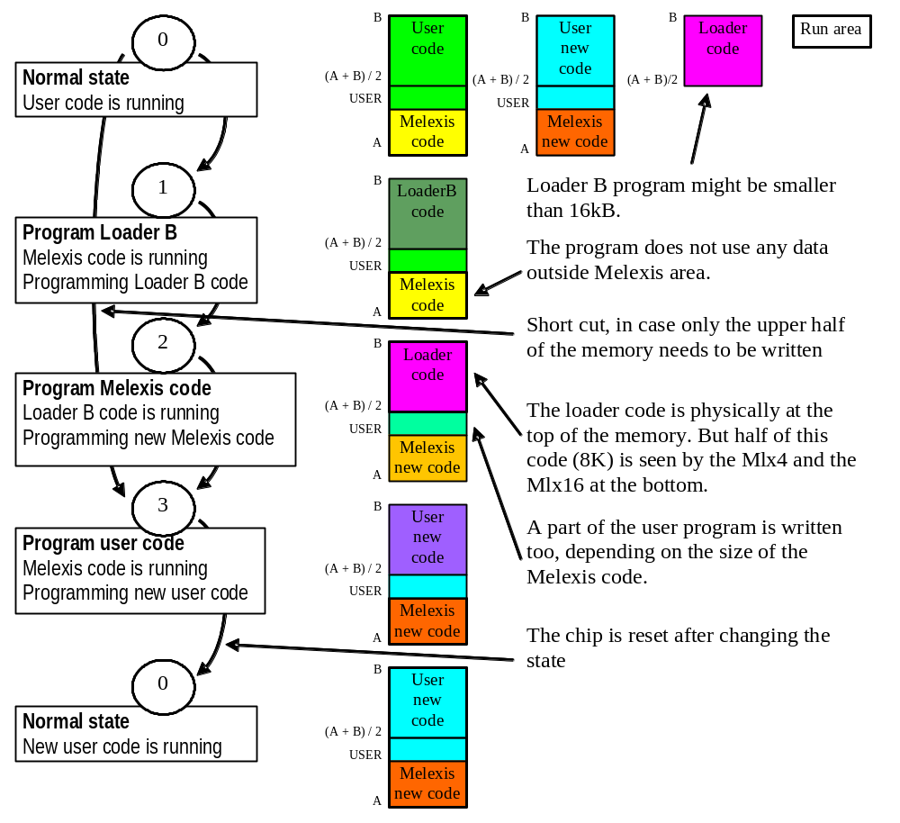
Figure 1: Flash programming steps

Table 1: Start / end address for different MLX16 variants
Name | Symbol | MelexCM | MULAN2
Start of the Flash | A | 0x0000 | 0x4000
Start of User code | USER | depends on SW Platform | depends on SW Platform
Half of the Flash | (A + B) / 2 | 0x4000 | 0x8000
End of the Flash | B | 0x8000 | 0xC000

This loader state is independent of the programming mode. Whatever is the loader state, the device can be in programming mode or not. The device replies to user messages only outside programming mode in loader state 0.

Contrary to the programming mode, the loader state is stored in the Flash, so it is kept after a reset or even an on/off cycle. If during programming, a problem occurs that necessitates a restart of the device, the whole procedure does not have to re-start from the beginning, but can re-enter the programming mode again, read the current loader state and continue from that state.

The switches between programming states must always be done in order. If the device is in state 1, the programmer needs to execute all steps from 1 to 3 before going back to state 0. The only other possibility is to go from state 0 to 3 in case only the upper half of the Flash needs to be written. If the Melexis code or user code in lower half of the memory (0x2800 to 0x4000) is changed (state 2), the programmer needs to execute all steps: writing first the Loader B code, Melexis code and then rewrite the same user code which has been partially overwritten by the loader.

The switch from one state to another is done by writing in the Flash the new state number and the new reset address if necessary. This must be the last thing done, after the new program has been written successfully. There are additional explanations about the consequence in the MLX16 firmware in Section 3.1.

Note: No check is done in the loader firmware to be sure that only the right part of the Flash is programmed in each loader state. It is the responsibility of the programmer software to do so.

Normal mode (state 0)
This is the default state of the device where it has its normal behavior, replying to user LIN messages if not in programming mode. All the flash can be used in this mode. The software needs to include the LIN loader code and other constraints as explained in Section 3.

Program Loader B (state 1)
In this state, the software is running in the lower half of the memory using Melexis code only. If not in programming mode, it will reply only to diagnostic messages handled by Melexis code which include the message to enter in programming mode. In programming mode, it will write the Loader B code in the high part of the Flash. The Loader B code must be smaller than 16kB. The Loader B is project dependent and provided as part of the Software Platform (file loaderB.hex)

Program Melexis code (state 2)
In this state, the Loader B code is running, it includes Melexis code only slightly modified to be able to execute at a different address, so the device will reply only to messages handled by Melexis like in state 1. The Loader B code is physically located at the top half of the memory, but the 8kB block (from 2/4 to 3/4 of the flash size) is mapped to the beginning of the Flash (see Figure 2)
- for both the Mlx4 and the Mlx16 on MelexCM
- and for the MLX4 only on MULAN2
This is necessary for the Mlx4 which can only address the lower 8kB of the Flash. In this state, the lower part of the Flash is programmed, which includes the new Mlx4 program, the new Melexis code and a part of the new user program.

Program user code (state 3)
In this state, the new Melexis program is located in and run from the lower half of the memory and will program the top half of the Flash with the remaining code of the user program. Like in state 1 and 2, only Melexis code is running in this state, so the device will reply to Melexis messages only.

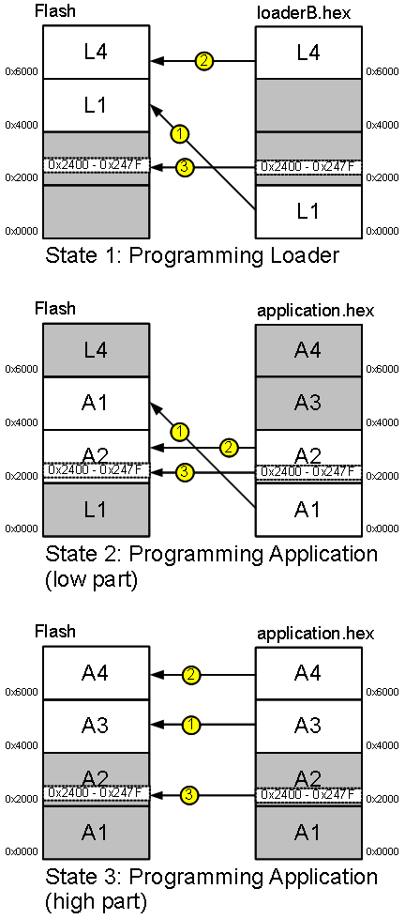 | 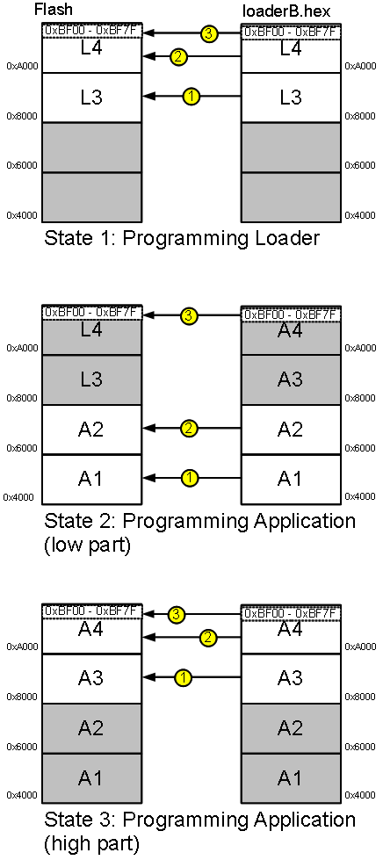
MelexCM base projects | MULAN2 base projects

Figure 2: MLX4 code mapping (numbers in yellow circles show the writing sequence: 1, 2 and then 3)

Basic operations

Reading
Reading data from memory is as follows. There are several kinds of memory (Flash, EEPROM / NVRAM, RAM and Table), each having their own read command that just return a status and the data requested.

The length of the block read is stored on 16 bits in the LIN message but the LIN protocol limits the maximum length of the reply to 4093 bytes of data (without taking in account the status byte).

Any read operation can be done in any programming state. It is useful to verify the Flash after writing it.

Writing
Writing data requires more than just sending a write command with all necessary data because the device is not always able to write all the data in one step. The program needs to send a write request with the address and the number of bytes to write. The device will reply with the number of accepted bytes for this first block (which could be the size of the whole block requested or smaller). The program needs to send a data command with data for this first block only. Then it has to send a status command to get back the number of bytes accepted for the second block and so on until all bytes have been written.

The following is a flow chart of all the procedure to write a block of M bytes.
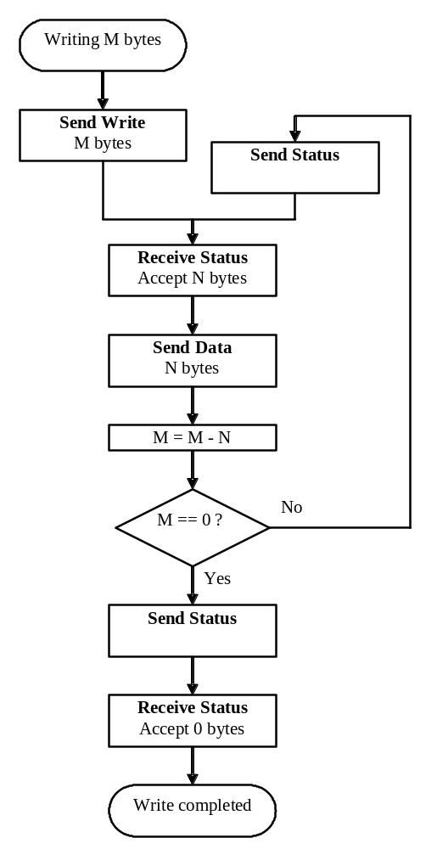
Figure 3: Write memory flow chart

If there are some errors while sending data, the LIN loader firmware exits from write mode and the send status command will reply with only a status byte without the number of bytes for the next block and the number of bytes remaining. The status byte will not report an error if the send data command fails but send status works.

MLX16 firmware

Source code is provided, hence the user can investigate the detailed operations. The main concepts are described next.

Loader state
As described in Section 2.2, the Flash programming tool needs to read and write the loader state.

To get loader state the programming tool shall send a read-word (16-bit) command with address 0x2436 on MelexCM and 0xBF66 on MULAN2. To change the loader state programming tool shall use a write-word command with address 0x2436 on MelexCM and 0xBF66 on MULAN2. Normally, the programming tool changes state from 0 to 1 to disable application and from 3 to 0 to enable the application. Other state transitions are done implicitly when vector table is updated.

Loader state is checked on startup and the user program (main function) is called only if the device is running in normal mode (state 0). Otherwise the LIN is initialized and the software waits for LIN messages only as the device is in one of the programming states. Also loader state is checked on each LIN interrupt (all other interrupts have been disabled), and the user LIN message handlers (mlu functions) are called only in normal mode (state 0).

Interrupts

MelexCM:
The programming software needs the reset and the LIN interrupt only. All other interrupts should be disabled or not generated (for level 0 interrupts) so they can be changed at any time during the programming procedure.

The LIN interrupt is not in the same block as the reset interrupt. It is mandatory that the LIN interrupt always jumps to address 0x0010 which is an unused word in the Mlx4 area where a jump is put to the real address of the interrupt routine. This address can be mapped to the physical address 0x0010 or 0x4010. The reset routine selects this and will get at the same time the right Mlx4 program and Mlx16 LIN interrupt.

MULAN2:
LIN interrupt is only used in state 0 of the loader. In other states (from 1 to 3) polling of the LIN interrupt pending flag is performed.

Updating loader state

The block containing reset vector and loader state (0x2400 to 0x247F on MelexCM and 0xBF00 to 0xBF7F on MULAN2) must be the last block written. It is written after each programming state transition. It contains the loader state and the reset routine that selects correct copy of the loader to be executed. So everything is switched at the same time. If the software crashes before writing this block, the device will restart in the previous state with the old program. If the software crashes just after writing this block, the device will restart in the new state with the complete new program.

Code placement and restrictions

When generating software that can be reprogrammed through the LIN, it is necessary that all startup code and code used to reprogram the Flash is in a particular place (first half of the flash) to avoid overwriting it. All this code has to be selected based on the name of the source files or the sections name and put in the linker definition file in the right place.

The developer needs to take care of the C libraries functions. As it is not easy to know which functions are really useful and to select them, all standard C functions must be avoided in the loader code.

Loader functions should NOT use initialized global and static variables. Use un-initialized variables instead (will be linked to .bss section) and initialize them as needed in the code.

Rationale: Initialized variables with static storage class (global and static variables) are linked into .data or .dp.data sections and their initialization lists are stored at load address (LMA) in the Flash. Since there is no control on the position of the load address, the linker might link it to the second half of the Flash. Thus initialization lists will be overwritten during state 1 of the Flash reprogramming

Power shortage
The Flash is programmed per block of 128 bytes and there is a guarantee that a block can be fully programmed even in case of an unexpected power off. This is necessary to guarantee the function of the NVRAM and is useful while programming the Flash.

When a power off is detected, a level 0 interrupt is generated and the software can take emergency actions knowing that it still has enough energy to write at least one block of Flash. This energy is stored in an external capacitor charged before removing reset.

Loader protection
The LIN Loader can be protected with the key. The security mechanism goal is preventing of unwanted reading/writing of Flash/NVRAM.

Application provides protection key which is hard coded to Flash. Application reserves space into NVRAM area for unlocking key. The keys length can be 32-bit or 64-bit.

LIN Loader is protected with key if the following two cases are true:
- If protection key’s high part is different from low part;
- If unlocking key in NVRAM is different from protection key.
Otherwise, Loader isn’t protected with key, i.e. all commands available for executing.

The commands which can be executed when Loader is protected:
- Enter programming mode
- Read by identifier
- Set Key
- Restart
Other commands are potentially dangerous or are not useful without following dangerous commands. Device will reply with ‘incorrect operation’ error if forbidden operation was required.

Set Key message is designed to write the unlocking key into NVRAM area.

LIN messages
The message used to enter the programming mode uses a diagnostic frame.

All messages in programming mode use data dump frame and are always 8 bytes long.

Master to slave messages

Enter programming mode
ID | NAD | PCI | SID | D1 | D2 | D3 | D4 | D5 | Reply
3C | NAD | 06 | B2 | 33 | 13 | 00 | FE | CA | Enter programming mode

This message is the only one that must be used outside the programming mode (exception for Read by identifier message). It asks the device to enter programming mode. The device has to send a reply if it has entered the programming mode. See Section 4.2.1 for more details.

Read by identifier
ID | NAD | PCI | SID | D1 | D2 | D3 | D4 | D5 | Reply
3C | NAD | 06 | B2 | 0 | Supplier ID (LSB) | Supplier ID (MSB) | Function ID (LSB) | Function ID (MSB) | Read by identifier

This message requests the product identifiers from device. Loader has the following identifiers:
- Supplier ID (Melexis) = 0x0013
- Function ID (Loader) = 0xCAFE

The device supports wildcards which can be used to send this message with some unspecified properties. Wildcards are supported only when device into programming mode or Loader state is not equal to zero.
- NAD = 0x7F
- Supplier ID = 0x7FFF
- Function ID = 0xFFFF

Restart
ID | NAD | PCI | SID | D1 | D2 | D3 | D4 | D5 | Reply
3C | NAD | 03 | B4 | C1 | State | FF | FF | FF | None

This message resets the device (and exits from the programming mode). There is no reply message for this request and the device needs some time before being able to reply to a new message.

The message includes State value. The device ignores reset message if State value is equal to Loader’s state. Selective reset depending of Loader’s state is required to increase reliability during multiple ICs uploading. Such approach can prevent ICs from uploading with the data designed for different Loader state.

Exit
ID | NAD | PCI | SID | D1 | D2 | D3 | D4 | D5 | Reply
3C | NAD | 02 | B4 | 42 | FF | FF | FF | FF | Status

This message exits from the programming mode, restarting the user program.

Status
ID | NAD | PCI | SID | D1 | D2 | D3 | D4 | D5 | Reply
3C | NAD | 02 | B4 | 80 | FF | FF | FF | FF | Status

This message requests the status in programming mode.

Set Key
ID | NAD | PCI | LEN | SID | D1 | D2 | D3 | D4 | Reply
3C | NAD | 10 | 0A | B4 | 14 | KEY7 | KEY6 | KEY5 | None
ID | NAD | PCI | D5 | D6 | D7 | D8 | D9 | D10 | None
3C | NAD | 21 | KEY4 | KEY3 | KEY2 | KEY1 | KEY0 | FF | None

This message sends a 64 bits unlocking key (KEY7 is the most significant byte and KEY0 the least significant byte) to the device enabling some programming functions like writing and reading the flash. See also Loader protection.

The Loader can be protected with 32-bit and 64-bit keys. If device’s key length is 64 bits, then all 8 data bytes into Set Key message will be written to NVRAM key area. If device key length is 32 bits, then only low 4 data bytes into Set Key message will be written to NVRAM key area. So, when 32 bit key is used, high 4 bytes in NVRAM area for unlocking key will not be corrupted and can be used for other purposes.

Fast protocol
ID | NAD | PCI | SID | D1 | D2 | D3 | D4 | D5 | Reply
3C | NAD | 03 | B4 | 03 | BaudRate[kBd] | FF | FF | FF | Status (with BaudRate)

This message requests to use a Melexis proprietary fast protocol not compatible with LIN but using the same wires. The D2 byte is required Baud Rate (in KiloBaud) for Fast protocol communication. Slave replies Status with Baud Rate which was applied. The device must be alone on the network.

Slow protocol
ID | NAD | PCI | SID | D1 | D2 | D3 | D4 | D5 | Reply
3C | NAD | 02 | B4 | C4 | FF | FF | FF | FF | None

This message requests to go back to the normal LIN protocol, described in this document.

Erase Flash
ID | NAD | PCI | SID | D1 | D2 | D3 | D4 | D5 | Reply
3C | NAD | 06 | B4 | 55 | AD1 | AD0 | LEN1 | LEN0 | Status (or Error)

This message erases a part of the Flash with the following parameters:
- A 16 bits address: the most significant byte is AD1 and the least significant byte is AD0. The address should be aligned on Flash page boundary (normally 128 bytes). If non-aligned address is used it will be converted to address of nearest lower boundary.
- A 16 bits length: the most significant byte is LEN1 and the least significant byte is LEN0. The size should be multiple of Flash page size (normally 128 bytes).

Write Flash
ID | NAD | PCI | SID | D1 | D2 | D3 | D4 | D5 | Reply
3C | NAD | 06 | B4 | 20 | AD1 | AD0 | LEN1 | LEN0 | Status

This message starts a write to the Flash procedure with the following parameters:
- A 20 bits address: the 4 most significant bits are in the 4 least significant bits of the command (0x20 see Section 4.3.2), the 8 following bits are in AD1 and the 8 least significant bits in AD0.
- A 16 bits length: most significant byte is LEN1, least significant byte is LEN0.

Read Flash / Read CRC
ID | NAD | PCI | SID | D1 | D2 | D3 | D4 | D5 | Reply
3C | NAD | 06 | B4 | F0 | AD1 | AD0 | LEN1 | LEN0 | Read Data / CRC

Read Flash
This message reads data from the Flash with the following parameters:
- A 20 bits address: the 4 most significant bits are in the 4 least significant bits of the command (0x20 see Section 4.3.2), the 8 following bits are in AD1 and the 8 least significant bits in AD0.
- A 16 bits length: most significant byte is LEN1, least significant byte is LEN0. The maximum length allowed in this command is 65535 bytes but LIN limits the number of data to 4093 bytes (maximum length of the frame = 4095 - 2 for PCI and status byte).

Slave replies with ‘Read Data’ message

Read CRC
After sending ‘Read Flash CRC’ message, the ‘Read Flash’ command becomes ‘Read CRC’. Then this modified ‘Read Flash’ command is used to get CRC of the area based on the requested length and start address. This message initializes CRC reading of the flash with the following parameters:
- A 20 bits address: the 4 most significant bits are in the 4 least significant bits of the command (0x20 see Section 4.3.2), the 8 following bits are in AD1 and the 8 least significant bits in AD0.
- A 16 bits length: most significant byte is LEN1, least significant byte is LEN0. The maximum length allowed in this command is 65535 bytes.

Slave replies with message containing CRC result (see Section 4.4.1). CRC calculation of a large memory area can take a long period of time. Slave will discard all messages while calculation.

Write Eeprom
ID | NAD | PCI | SID | D1 | D2 | D3 | D4 | D5 | Reply
3C | NAD | 06 | B4 | 47 | AD1 | AD0 | LEN1 | LEN0 | Status

This message starts a write to the EEPROM (called NVRAM on MelexCM) procedure with the following parameters:
- A 16 bits address: the most significant byte is AD1 and the least significant byte is AD0.
  - MelexCM NVRAM: 0xFC00 to 0xFC7F.
  - MULAN2 NVRAM: 0x1000 (or 0x1100 on some projects)
- A 16 bits length: the most significant byte is LEN1 and the least significant byte is LEN0.

Read Eeprom
ID | NAD | PCI | SID | D1 | D2 | D3 | D4 | D5 | Reply
3C | NAD | 06 | B4 | 08 | AD1 | AD0 | LEN1 | LEN0 | Read

This message reads data from the EEPROM (called NVRAM on MelexCM) with the following parameters:
- A 16 bits address: the most significant byte is AD1 and the least significant byte is AD0.
  - MelexCM NVRAM: 0xFC00 to 0xFC7F.
  - MULAN2 NVRAM: 0x1000 (or 0x1100 on some projects)
- A 16 bits length: the most significant byte is LEN1 and the least significant byte is LEN0. The maximum length allowed in this command is 65535 bytes but LIN limits the number of data to 4093 bytes (maximum length of the frame = 4095 - 2 for PCI and status byte).

Erase Eeprom
ID | NAD | PCI | SID | D1 | D2 | D3 | D4 | D5 | Reply
3C | NAD | 06 | B4 | 49 | AD1 | AD0 | LEN1 | LEN0 | Status

This message erases a part of the NVRAM with the following parameters:
- A 16 bits address: the most significant byte is AD1 and the least significant byte is AD0.
- A 16 bits length: the most significant byte is LEN1 and the least significant byte is LEN0.

On the MelexCM, the erase function is not required.

Erase All Eeprom
ID | NAD | PCI | SID | D1 | D2 | D3 | D4 | D5 | Reply
3C | NAD | 02 | B4 | CA | FF | FF | FF | FF | Status

Restore Eeprom (MelexCM only)
ID | NAD | PCI | SID | D1 | D2 | D3 | D4 | D5 | Reply
3C | NAD | 02 | B4 | 8B | FF | FF | FF | FF | Status

This message rereads the content of NVRAM from the Flash, as it is done automatically on reset and with the LoadNvRam function. This function and the following are useful because the Flash buffer used by the NVRAM is used for programming the Flash too. It must be saved and restored before and after using any Flash programming function.

This message is needed / implemented only on MelexCM based products.

Save Eeprom (MelexCM only)
ID | NAD | PCI | SID | D1 | D2 | D3 | D4 | D5 | Reply
3C | NAD | 02 | B4 | 4C | FF | FF | FF | FF | Status

This message saves the content of NVRAM to the Flash, as it is done automatically on power off and with the SaveNvRam function. These functions are useful because the Flash buffer used by the NVRAM is used for programming the Flash too. It must be saved and restored before and after using any Flash programming function.

This message is needed / implemented only on MelexCM based products.

Write Ram
ID | NAD | PCI | SID | D1 | D2 | D3 | D4 | D5 | Reply
3C | NAD | 06 | B4 | 0D | AD1 | AD0 | LEN1 | LEN0 | Status

This message starts a write to the RAM procedure with the following parameters:
- A 16 bits address: the most significant byte is AD1 and the least significant byte is AD0. It is the 16 bits address seen by the Mlx16 from 0xE000 to 0xE7FF.
- A 16 bits length: the most significant byte is LEN1 and the least significant byte is LEN0.

Read Ram
ID | NAD | PCI | SID | D1 | D2 | D3 | D4 | D5 | Reply
3C | NAD | 06 | B4 | 8E | AD1 | AD0 | LEN1 | LEN0 | Read

This message reads data from the RAM with the following parameters:
- A 16 bits address: the most significant byte is AD1 and the least significant byte is AD0. It is the 16 bits address seen by the Mlx16 from 0xE000 to 0xE7FF.
- A 16 bits length: the most significant byte is LEN1 and the least significant byte is LEN0. The maximum length allowed in this command is 65535 bytes but the LIN limits the number of data to 4093 bytes (maximum length of the frame = 4095 - 2 for PCI and status byte)

Execute Ram
ID | NAD | PCI | SID | D1 | D2 | D3 | D4 | D5 | Reply
3C | NAD | 04 | B4 | CF | AD1 | AD0 | FF | FF | Status

This message set the program counter to the value passed as parameter:
- A 16 bits address: the most significant byte is AD1 and the least significant byte is AD0.

It can be used to execute a program in RAM or a function already defined in the Flash.

Exist Table
ID | NAD | PCI | SID | D1 | D2 | D3 | D4 | D5 | Reply
3C | NAD | 03 | B4 | 50 | TAB | FF | FF | FF | Exist Table

This message check if the table number TAB (8 bits) exists and returns its size.

Note: only 8 tables are supported.

Write Table
ID | NAD | PCI | SID | D1 | D2 | D3 | D4 | D5 | Reply
3C | NAD | 06 | B4 | 11 | TAB | FF | LEN1 | LEN0 | Status

This message starts a write to a table procedure with the following parameters:
- A 8 bits table number: TAB, tables are numbered starting from 0.
- A 16 bits length: the most significant byte is LEN1 and the least significant byte is LEN0. It is limited by the size of the table.

The tables are located in Flash but it can be useful to use these functions in case the write Flash function is disabled without a key. A few tables could be defined to allow rewriting predefined part of the Flash without needing the key.

Read Table
ID | NAD | PCI | SID | D1 | D2 | D3 | D4 | D5 | Reply
3C | NAD | 06 | B4 | 92 | TAB | FF | LEN1 | LEN0 | Read

This message starts a reading of the table with the following parameters:
- A 8 bits table number: TAB, tables are numbered starting from 0.
- A 16 bits length: the most significant byte is LEN1 and the least significant byte is LEN0. The maximum length allowed in this command is 65535 bytes but the LIN limits the number of data to 4093 bytes (maximum length of the frame = 4095 - 2 for SID and status byte). It is also limited by the size of the table.

Note:
The byte 0 from Table 8 informs the programming tool that chip supports dynamic programming timeouts.
If Byte0 = 1, the chip will inform the programming tool in the response to the Write Flash command (see chapter 4.2.3) what time (in ms) is needed to the chip to complete this Write operation (see parameter TIM1/TIM0).

Data
ID | NAD | PCI | SID | D1 | D2 | D3 | D4 | D5 | Reply
3C | NAD | PCI | B4 | D3 | W0 | W1 | W2 | W3 | None

ID | NAD | PCI | LEN | SID | D1 | D2 | D3 | D4 | Reply
3C | NAD | PCI | LEN | B4 | D3 | W0 | W1 | W2 | None
ID | NAD | PCI | D5 | D6 | D7 | D8 | D9 | … | None
3C | NAD | PCI | W3 | W4 | W5 | W6 | … | … | None

This message is the only message sent by the master which has a variables number of arguments. This message is used to send all data to the device after getting the number of bytes accepted by the device in the status message. This message is irrespective of the memory written (flash, NVRAM, RAM and table).

If there are less than 4 bytes of data to send, a single frame message is sufficient; otherwise a first frame message is needed followed by continuous frame messages. If there is insufficient data to complete a frame, it has to be padded with FF.

Slave to master messages

Enter programming mode
ID | NAD | PCI | RSID | D1 | D2 | D3 | D4 | D5
7D | NAD | 06 | F2 | VER3 | VER2 | VER1 | VER0 | L

This message is the reply of the “enter programming mode” message with the following data:
- VER3: SW Platform version Major
- VER2: SW Platform version Minor
- VER1: SW Platform version Revision
- VER0: SW Platform version Build
- L: Loader state 0 to 3.

Read by identifier
ID | NAD | PCI | SID | D1 | D2 | D3 | D4 | D5
7D | NAD | 06 | F2 | Supplier ID (LSB) | Supplier ID (MSB) | Function ID (LSB) | Function ID (MSB) | Variant

This message is the reply with identifiers of the device in Loader mode. When device into programming mode or Loader state is not equal to zero then it will return the following identifiers:
- Supplier ID (Melexis) = 0x0013
- Function ID (Loader) = 0xCAFE
- Variant: 0x00 – Loader is into ROM; 0x01 – Loader is into Flash.

Status
This reply is used by several commands and has three variants:
- If a write command or Fast Protocol command have NOT been sent before, only the status byte is returned.

ID | NAD | PCI | RSID | D1 | D2 | D3 | D4 | D5
7D | NAD | 02 | F4 | ST | FF | FF | FF | FF

- If a write command was sent then it will send back the size of the next block accepted by the device and the remaining size

ID | NAD | PCI | RSID | D1 | D2 | D3 | D4 | D5
7D | NAD | 06 | F4 | ST | BLK1 | BLK0 | TIM1 | TIM0

- If Fast Protocol command was required then it will send back the device’s applied BaudRate[kBd]

ID | NAD | PCI | RSID | D1 | D2 | D3 | D4 | D5
7D | NAD | 03 | F4 | ST | BaudRate | FF | FF | FF

This message includes the following data:
- ST: Programming software status byte, see Section 4.3.3
- BLK1, BLK0: Size of the next block allowed
- TIM1,TIM0: time in ms which is needed to complete this operation (0 means use default settings specified in the programming tool)
- BaudRate: Returns baud rate which was applied for slave

Error
ID | NAD | PCI | RSID | D1 | D2 | D3 | D4 | D5
7D | NAD | 03 | 7F | ST | ERR | FF | FF | FF

This reply can be sent after any command in case of an error, the parameters are the following
- ST: Programming software status byte, see Section 4.3.3
- ERR: Error code, see Section 4.3.4

Exist Table
ID | NAD | PCI | RSID | D1 | D2 | D3 | D4 | D5
F0  7D | NAD | 04 | F4 | ST | LEN1 | LEN0 | FF | FF

This is the reply of the “Exist Table” message with the following data:
- ST: Programming software status byte, see Section 4.3.3
- LEN1:LEN0: the 16 bits size of the table requested.

Read Data
ID | NAD | PCI | RSID | D1 | D2 | D3 | D4 | D5
7D | NAD | PCI | F4 | ST | R0 | R1 | R2 | R3

ID | NAD | PCI | LEN | RSID | D1 | D2 | D3 | D4
7D | NAD | PCI | LEN | F4 | ST | R0 | R1 | R2
ID | NAD | PCI | D5 | D6 | D7 | D8 | D9 | D10
7D | NAD | PCI | R3 | R4 | R5 | R6 | R7 | …

This reply has a variable length. It is used for receiving data from the device after any read memory command (flash, NVRAM, RAM and table).

If there are less than 4 bytes of data to send, a single frame message is sufficient, otherwise a first frame message is needed followed by continuous frame messages. The first byte sent is the programming software status byte as described in Section 4.3.3. Unused places in the frame are filled with FF.

Message data

PCI
The PCI byte is calculated as follows:

Type | PCI type |  |  |  | Extra
Type | B7 | B6 | B5 | B4 | B3 | B2 | B1 | B0
Single frame | 0 | 0 | 0 | 0 | Length
First frame | 0 | 0 | 0 | 1 | Length / 256
Continuous frame | 0 | 0 | 1 | 0 | Frame counter

The length is the number of data bytes (including the command byte) plus one for the SID or RSID byte.

Command
The following table provides a summary of all the programming commands.

Command | P1 | P0 | D5 | D4 | D3 | D2 | D1 | D0 | Value
Status | 1 | 0 | 0 | 0 | 0 | 0 | 0 | 0 | 0x80
Restart | 1 | 1 | 0 | 0 | 0 | 0 | 0 | 1 | 0xC1
Exit | 0 | 1 | 0 | 0 | 0 | 0 | 1 | 0 | 0x42
Fast protocol | 0 | 0 | 0 | 0 | 0 | 0 | 1 | 1 | 0x03
Slow protocol | 1 | 1 | 0 | 0 | 0 | 1 | 0 | 0 | 0xC4
Write Flash | ? | ? | 1 | 0 | ? | ? | ? | ? | ??
Read Flash | ? | ? | 1 | 1 | ? | ? | ? | ? | ??
Write Eeprom | 0 | 1 | 0 | 0 | 0 | 1 | 1 | 1 | 0x47
Read Eeprom | 0 | 0 | 0 | 0 | 1 | 0 | 0 | 0 | 0x08
Erase Eeprom | 0 | 1 | 0 | 0 | 1 | 0 | 0 | 1 | 0x49
Erase All Eeprom | 1 | 1 | 0 | 0 | 1 | 0 | 1 | 0 | 0xCA
Restore Eeprom | 1 | 0 | 0 | 0 | 1 | 0 | 1 | 1 | 0x8B
Save Eeprom | 0 | 1 | 0 | 0 | 1 | 1 | 0 | 0 | 0x4C
Write Ram | 0 | 0 | 0 | 0 | 1 | 1 | 0 | 1 | 0x0D
Read Ram | 1 | 0 | 0 | 0 | 1 | 1 | 1 | 0 | 0x8E
Execute Ram | 1 | 1 | 0 | 0 | 1 | 1 | 1 | 1 | 0xCF
Exist Table | 0 | 1 | 0 | 1 | 0 | 0 | 0 | 0 | 0x50
Write Table | 0 | 0 | 0 | 1 | 0 | 0 | 0 | 1 | 0x11
Read Table | 1 | 0 | 0 | 1 | 0 | 0 | 1 | 0 | 0x92
Data | 1 | 1 | 0 | 1 | 0 | 0 | 1 | 1 | 0xD3
Set Key | 0 | 0 | 0 | 1 | 0 | 1 | 0 | 0 | 0x14
Erase Flash | 0 | 1 | 0 | 1 | 0 | 1 | 0 | 1 | 0x55
Protocol Extension | 1 | 1 | 0 | 1 | 0 | 1 | 1 | 0 | 0xD6

The bits D3, D2, D1 and D0 for “Read Flash” and “Write Flash” commands are used for the 4 most significant bits of the address. If these bits are null, the values are respectively 0xF0 and 0x20, otherwise these need to be computed.

The bits P1 and P0 are parity bits computed from the value of the lowest significant bits using the same algorithm used in the LIN protocol. The formulas are the following:
- P1 = 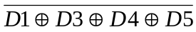
- P0 = 

Status
The programming software status bit is defined as follows.

B7 | B6 | B5 | B4 | B3 | B2 | B1 | B0
Error | 0 | 0 | 0 | 0 | 0 | Loader state

The error bit is set to 1 only in the error reply and in this case the following byte gives additional information about the error.

Error
The error byte sent in the error reply is defined as follows.

B7 | B6 | B5 | B4 | B3 | B2 | B1 | B0
Mlx16 error |  |  |  | Mlx4 error

The 4 bit error codes for MLX16 and MLX4 CPUs are as follows.

Code | Mlx16 error
0x1 | Table doesn’t exist
0x2 | Too many data frame received
0x3 | Frame counter error
0x4 | Unable to enter fast protocol mode
0x5 | Writing to flash failed
0xB | Invalid PCI byte
0xC | Too many continuous frame
0xD | Incorrect operation
0xE | Not in programming mode
0xF | No error

Code | Mlx4 error
0x0 | No error
0x1 | Short state has been seen on the bus
0x2 | LIN task crashed, try to reboot
0x3 | Parity error in ID field received
0x4 | Checksum error in message received
0x5 | Data collision during transmit cycle
0x6 | Stop or Start bit error while receiving data
0x7 | Stop bit error on the ID field
0x8 | Sync field timing error
0x9 | Message received but buffer is full
0xA | Short detected on LIN bus
0xB | Response timeout
0xC | Break in frame
0xF | Wakeup pulse while entering in sleep state

Protocol extension messages
In order to extend LIN Loader functionality Protocol Extension (PE) command was added (0xD6 see Section 4.3.2).

Protocol Extension message have the following common structure:

ID | NAD | PCI | SID | D1 | D2 | D3 | D4 | D5
3C | NAD | PCI | B4 | D6 | PE Code | PE Value | Optional | Optional

The following table provides a summary of Protocol Extension functionality for LIN Loader.

Protocol Extension functionality | PE Code | PE Value | Comments
‘Read Flash’ command redefining
Read Flash Normal | 0x00 | 0x00 | Sets default ‘Read Flash’ command behavior
Read Flash CRC | 0x00 | 0x01 | Redefines ‘Read Flash’ command to ‘Read CRC’
Flash Margin changing
Margin Set Offset | 0x01 | 0x00 | Adds offset to the previous Flash Margin value

Read Flash CRC
ID | NAD | PCI | SID | D1 | D2 | D3 | D4 | D5 | Reply
3C | NAD | 04 | B4 | D6 | 00 | 01 | FF | FF | Status

This message redefines default ‘Read Flash’ command behavior. The slave device must send a status reply to this message with no errors.

The ‘Read Flash’ message must be send after ‘Read Flash CRC’. Slave will calculate and return CRC of the memory block based on the requested length and start address according to ‘Read Flash’ master to slave message. (See also ‘Read Flash / Read CRC’ message description).

Slave replies to redefined ‘Read Flash’ command (Read CRC) with the following message containing CRC result:

ID | NAD | PCI | RSID | D1 | D2 | D3 | D4 | D5
7D | NAD | 06 | F4 | RDY | CRC1 | CRC0 | LEN1 | LEN0

This message includes the following data:
- RDY = 0xFF when CRC was calculated
- CRC1: MSB of CRC word
- CRC0: LSB of CRC word
- LEN1: MSB of the memory block length
- LEN0: LSB of the memory block length

The ‘Read Flash Normal’ command is designed to set default behavior of ‘Read Flash’ command.

Read Flash Normal
ID | NAD | PCI | SID | D1 | D2 | D3 | D4 | D5 | Reply
3C | NAD | 04 | B4 | D6 | 00 | 00 | FF | FF | Status

This message sets default behavior of ‘Read Flash’ command. The slave device must send a status reply with no errors.

Note: Some data dump operations (SID = 0xB4) also set default behavior of ‘Read Flash’. So using of other data dump operations between ‘Read Flash CRC’ and ‘Read Flash’ are ineligible.

Margin Set Offset
ID | NAD | PCI | SID | D1 | D2 | D3 | D4 | D5 | Reply
3C | NAD | 05 | B4 | D6 | 01 | 00 | Offset | FF | Margin Set Offset Reply

This message adds signed offset to the previous Flash threshold (IREF) for Margin Read validation test. Absolute value of Flash threshold (IREF) could be in the range of [0, 63].

Slave replies with the following message:

ID | NAD | PCI | RSID | D1 | D2 | D3 | D4 | D5
7D | NAD | 06 | F4 | FF | FF | FF | New IREF | Prev. IREF

This message includes the following data:
- New IREF: New Flash threshold (IREF) which was set in the slave;
- Prev. IREF: Previous Flash threshold (IREF) which was changed.

Original value of Flash threshold (IREF) could be restored by chip reset. ‘Restart’ message could be sent for this.

Note: Flash Error could be detected after ‘Margin Set Offset’ message which will cause the chip reset.

Loader’s Read be identifier message will be answered outside of programming mode

