User guide
on demo example of new features
LIN library MULAN2

History records

Date | Revision | Comments
November 8, 2026 | 0.1 | First edition

Table of Contents
1. New features 2
2. Demo example 3

New features

There are new features (TODO: version of PLTF MULAN2).

- possibility set unique NAD for LIN Loader;
- autobaud rate LIN mode;
- check power voltage supply before writing flash memory;
- Download/Upload NVRAM memory.

Possibility set unique NAD for LIN Loader lets to have individual access (upload, download, etc) to each solution (see Fig.1.1) in LIN network by unique NAD.

Lin Master
Solution 1
Solution 2
Solution N
…
LIN
Fig.1.1

Autobaud rate lets to work with solution on any LIN speed.

Check power voltage supply before writing flash memory lets to execute flash “Upload” operation more security. Low threshold of power supply defined as 12V minus 2% (accurate of ADC).

Download/Upload NVRAM operation let to read or write NVRAM memory to/from HEX-file.

Demo example

We need to install MPT (TODO: version) and build example from MULAN2 source folder products/81300/examples/LIN_Unique_Loader_NAD.

After building the example we’ll have two HEX-file (“LIN_NAD_02H.hex” and “LIN_NAD_0BH.hex”). This is simple application that sets loader’s NAD (function SetLoaderNAD()) in values equal 02H and 0BH and blink LEDs on IO5 and IO4 with frequency on depends of value NAD.

Load this HEX-files in two solution (for example MLX81300BA EVB V1.0) using Mini E-Mlx. Connect the solutions and LIN Master on one LIN bus.

In MPT select LIN protocol, target platform MULAN2 and set unique NAD (see Fig.2.1). You will have access to individual solution. Try Loader operation such as Download, Upload and Verify or Download/Upload of NVRAM memory.

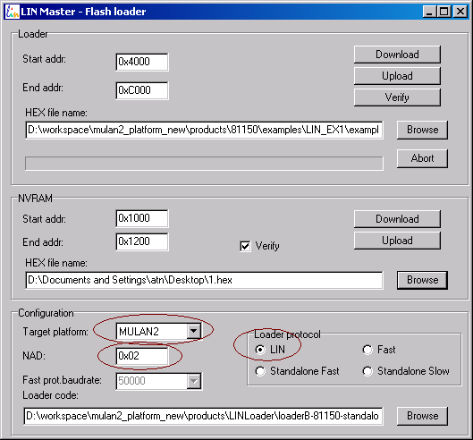
Fig. 2.1

To check autobaud rate you may select any LIN speed in MPT (see Fig.2.2) and repeat previous operations.

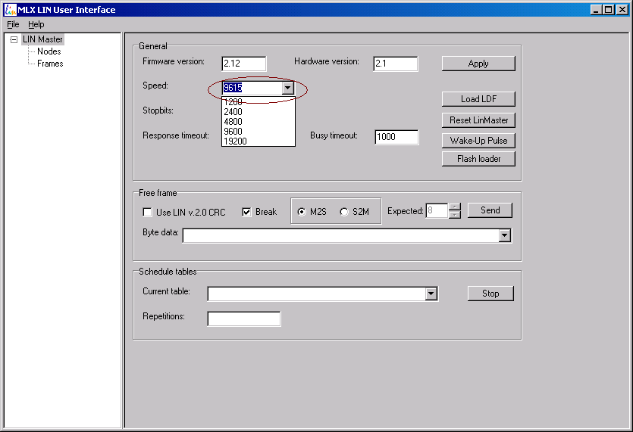
Fig.2.2

If you change power supply before or during flash upload operation about below 12V then flash will not be written and MPT will output error message box (see Fig.2.3).

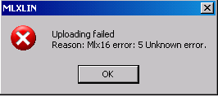
Fig.2.3

Integer square root

Integer exponent (power) with base 2

For the functions vecsumU48_U32 and vecsumI48_I32, there is no internal check on overflow of msw which could only be applicable for vector lengths ≥ 2¹⁶.
For the function norm1vectorU48_I32, there is no internal check on overflow of msw which could only be applicable for vector lengths ≥ 2¹⁶.
For the functions norm2vectorU48_U16byU16 and norm2vectorU48_I16byI16, there is no internal check on overflow of msw which could only be applicable for vector lengths ≥ 2¹⁶.
Note that upon return the array p_in will not be filled with init_value itself but with a modified value as to allow the full input range support and efficient implementation of the firnnn_I16 functions. I.e. these functions constitute a true abstraction API.
Classical filter theory specifies first order IIR as out[k] = (1+a) * in – a * out[k-1]. The BIBO stability condition is |a| < 1 , and no overflow and underflow will be exercised for a < 0. In the math library, a is implicitly negated.
This supporting function is not declared in mathlib.h. The return type and value range may change in a future release of the library.
This supporting function is not declared in mathlib.h. The return type and value range may change in a future release of the library.
This supporting function is not declared in mathlib.h. The return type and value range may change in a future release of the library.
This supporting function is not declared in mathlib.h. The return type and value range may change in a future release of the library.

